Appendix S1:
Main article: Djeghri, N., P. Pondaven, M. Stockenreiter, S. Behl, J.Y.T. Huang, T. Hansen, S. Patris, G. Ucharm, H. Stibor. Isotopic and elemental compositions reveal density-dependent nutrition pathways in a population of mixotrophic jellyfish. Ecosphere.
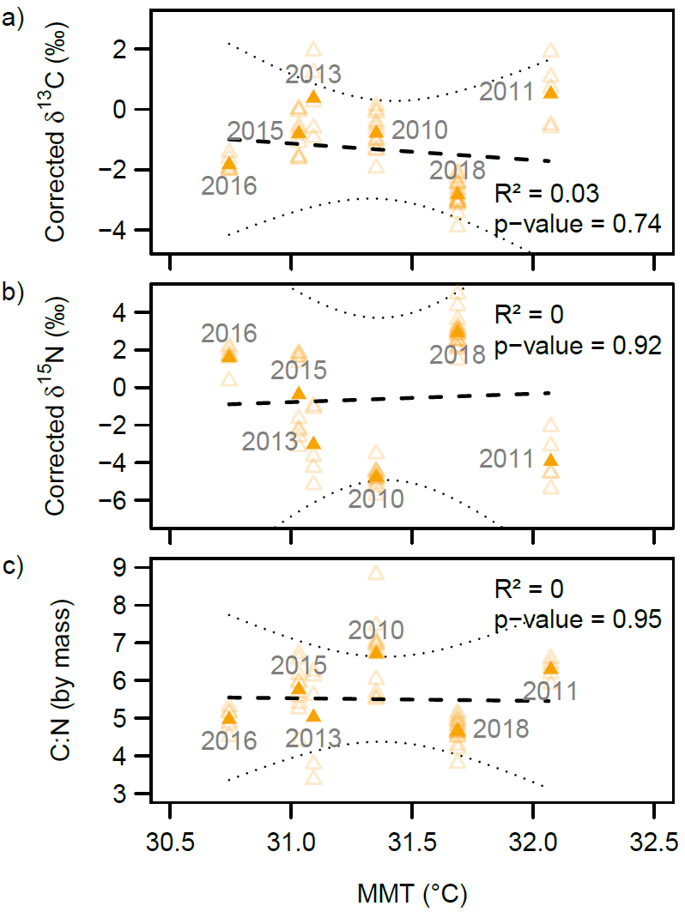
Fig. S1 Relationship between corrected δ¹³C (a), corrected δ¹⁵N (b) and mass C:N ratios (c) of Mastigias papua etpisoni holobiont and mean mixolimnion temperature (MMT, °C) in Ongeim’l Tketau across different sampling years. Regressions have been performed on the weighted means of each year (weighted by the number of medusae sampled; n = 12, 5, 5, 10, 6 and 18 for respectively 2010, 2011, 2013, 2015, 2016 and 2018). Empty symbols are the individual data from each year; full symbols are the means of each sampling event. Dotted lines are 95 % C. I. around regressions.

