SUPPLEMENTARY INFORMATION
A database of 2,476 publications related to trait-based approaches was extracted from a search on Web of Science (TS=(functional trait OR trait-based) AND TS=(aquatic OR marine OR ocean OR coastal OR deep-sea OR pelagic OR benthic OR fresh water OR lake OR river OR limnology)) AND DOCUMENT TYPES: (Article) – on 11.29.2018). Publications were classified into 8 main scientific fields grouped from their Web of Science research areas. A similar search on Web of Science of all freshwater and marine ecology articles was carried out and the percentage of articles related to trait-based approaches computed over time. These informations have been illustrated in Figure S2.

The network (Figure S1) was created using ©VOSviewer version 1.6.8 (van Eck and Waltman 2010). To create the network, data were cleaned using a thesaurus file, merging keywords into more general terms and homogenizing them (removing plurals, merging synonyms). For example “trait plasticity”, “trait evolution”, “trait ecology”, “trait adaptation”, “quantitative trait”, “biological trait approach” are closely related terms and were merged into “trait”. This step is important to increase the overlap between publications. The analysis method relied upon an incidence matrix of 13,337 keywords, appearing in at least 26 publications. Based on this threshold, 100 top-keywords of the highest co-occurrence were identified. A network was built based on co-occurrence calculations (i.e. nodes correspond to keywords, edges correspond to the strength of the links between keywords) and for its representation the diameter of the corresponding circle was plotted as proportional to their total occurrence in the 2,476 publications. The association strength method (also called proximity index, for computation see van Eck and Waltman 2009) was used to normalize the strength of the links between keywords. There were 3 clusters (blue, orange and purple), identified as minimizing the distance between nodes (for the weighted and parameterized variant of modularity-based clustering method used for bibliographic networks, see Waltman et al. 2010), with a minimum size defined as 20 keywords for easier interpretation.

Trait-based modeling
Trait-based ecological models can simulate functional traits as a continuum of trait values according to particular trade-offs (Follows and Dutkiewicz 2011). In such models, the numerical analog of an “individual” is the numerical entity defined by a unique vector of parameters that constitute its numerical traits. These models then simulate the response of individual phenotypic plasticity to environmental forcing and frequently rely on optimization for maximizing individual fitness (Smith et al. 2011). When parameters can vary to represent genotypic variability, these models can also be used to model trait adaptation and evolution (such as temperature optimum trait of phytoplankton growth, e.g. Grimaud et al. 2015). Most of these trait-based models focused on protists, as it may be easier to describe in a mechanistic way the functional traits and associated trade-offs of unicellular organisms (Merico et al. 2009; Follows and Dutkiewicz 2011). However, trait-based models were also developed for multicellular organisms such as copepods (Prowe et al. 2019) or even fish (e.g. Andersen et al. 2016). In these models, the traits that are the most commonly simulated are morphological and/or physiological traits, in particular traits that relate to size and allometric relationships (e.g. Hartvig et al. 2011; Acevedo-Trejos et al. 2015; Andersen et al. 2016; Blanchard et al. 2017) and/or to resource acquisition, including assimilation rates (e.g. Fiksen et al. 2013) or light-harvesting vs nutrient-harvesting investment for protists (with usually a focus on pigment-related traits, e.g. (Litchman et al. 2007; Hickman et al. 2010) or more recently on mixotrophy (e.g. Chakraborty et al. 2017; Leles et al. 2018). Some models have also focused on modeling life history traits, such as copepod dormancy (Maps et al. 2014) or bivalve fecundity and age at maturity (Sarà et al. 2013). Another type of trait-based model relies on traits to define functional groups whose dynamics are explicitly simulated, such as the Plankton Ecology Group (PEG) models (Sommer et al. 1986, 2012) or the Plankton Functional Type (PFT) models (Le Quere et al. 2005; Hood et al. 2006). In these models, traits are usually fixed parameters (e.g. size, nutrient assimilation rates, trophic regime) that are used in a mechanistic approach of ecological and physiological processes relying on trade-offs between the fundamental functions of the organisms (e.g. Smith et al. 2014). Functional types based on size, feeding modes and ecosystem engineering (bioturbation) have also been used for modeling benthic fauna (e.g. Chardy and Dauvin 1992; Rosenberg 2001; Alexandridis et al. 2017). Dynamic Energy Budget (DEB) models (Nisbet et al. 2000) could also be seen as trait-based models that rely on the DEB theory (Kooijman and Kooijman 2000) and its trade-offs among energy allocation. Several models actually borrow from both approaches by defining, for example, a few groups of organisms for which life-cycle strategies or peculiar trade-offs are hardwired, while allometric relationships to the size master trait allow for inter-individual or inter-specific variability within the functional groups (e.g. Ward et al. 2012). Finally, statistical trait-based models (involving statistical relationships rather than differential equations based on mechanistic assumptions) have also been developed, for instance for relating functional traits to body trace metal concentrations in freshwater invertebrates (Peter et al. 2018) .
Trait-based models were used for simulating the distribution of traits at the community scale (Andersen and Beyer 2006), emergent trait biogeography (Follows et al. 2007; Record et al. 2013), size spectrum (e.g. Andersen et al. 2016), competition among species and/or seasonal dynamics (Merico et al. 2009; Terseleer et al. 2014; Leblanc et al. 2018), impact of traits on biogeochemical cycles (Stamieszkin et al. 2015; Coles et al. 2017), or impact of human pressures such as fishing on trait and trophic structure (Andersen and Pedersen, 2010). Trait-based models can also be used for estimating unknown traits, for instance from phylogeny (Bruggeman 2011) or for estimating the inter- and intra-specific variability of traits (Maps et al. 2014). A description of some examples of trait-based models developed in marine ecology can be found in Kiørboe et al. (2018), with a special focus on optimality-based resource acquisition in unicellular plankton and size-based trophic dynamics of fish communities. To our knowledge, mechanistic trait-based models developed for benthic organisms remain relatively scarce (e.g. Sarà et al. 2013) and have considered size, ecosystem engineering, adult motility, fecundity and dispersal. A few statistical trait-based models have also been developed for these organisms (e.g. Peter et al. 2018).
With the exception of a few studies (e.g. Maps et al. 2014; Banas and Campbell 2016), the intra-specific variability of the traits is poorly or not taken into account, mainly because of the lack of empirical information on this variability. A first perspective for trait-based modeling could then be to tackle this question of inter-individual variation of traits and its impact on ecosystem structure and functioning. Trait-based models can for instance be used to quantify the impact of environmental changes on the intra- and inter-specific variability of functional traits (e.g. inter-individual variability of lipid content and inter-specific variability of size of Arctic copepods in the Barents Sea, Renaud et al. 2018). A second perspective would be the development of a new generation of trait-based models using -omics data (Mock et al. 2016; Stec et al. 2017; Coles et al. 2017). Metatranscriptomic data could for instance be used to identify physiological traits of phytoplankton, combined to a mechanistic model of the phytoplankton cell, and used to construct a trait-based global marine ecosystem model (Mock et al. 2016). Emergent communities of marine microbes (from bacteria to phytoplankton) have also been predicted by directly simulating their metagenomes and metatranscriptomes (Coles et al. 2017). Such models could then be used for estimating functional trait plasticity across ecosystems. The idea of improving ecosystem models using -omics is not new (Hood et al. 2006), but functional trait-based approaches could constitute the common framework needed for modellers, observers, molecular biologists, and ecologists working in limnology and oceanography.

SUPPLEMENTARY TABLE
Suppl. Table 1: Main definitions related to traits and commonly used in trait-based studies. Examples are given in grey. For clarity and consistency in trait-based aquatic ecology, we recommend the use of the definitions indicated in bold (cf Table 1 in the main manuscript).

Term | Definitions | References | Examples
Trait | Any morphological, physiological or phenological feature measurable at the individual level, from the cell to the whole-organism level, without reference to the environment or any other level of organization. | (Violle et al. 2007)
 | A well-defined, measurable property of organisms, usually measured at the individual level and used comparatively across species. | (McGill et al. 2006)
Functional trait | Any trait that impacts fitness indirectly via its effects on growth, reproduction and survival. | (Violle et al. 2007)
 | Morphological, biochemical, physiological, structural, phenological, or behavioral characteristics that are expressed in phenotypes of individual organisms and are considered relevant to the response of such organisms to the environment and/or their effects on ecosystem properties. | (Díaz et al. 2013)
 | Characteristics of an organism that are considered relevant to its response to the environment and/or its effects on ecosystem functioning. | (Dı́az and Cabido 2001)
 | Components of an organism’s phenotype that influence ecosystem level processes. | (Petchey and Gaston 2006)
 | Any trait that strongly influences organismal performance. | (McGill et al. 2006)
 | Any trait directly influencing organismal performance. | (Mouillot et al. 2013)
Performance trait | Any functional trait directly influencing organismal performance | (Violle et al. 2007) | Somatic biomass, reproductive output, such as offspring biomass or number, and survival.
Effect trait | Traits that determine effects of [organisms] on ecosystem functions. | (Lavorel and Garnier 2002)
 | Traits that are usually relevant at the ecosystem level | (Hébert et al. 2017) | Respiration, excretion, clearance rate.
 | Any trait which reflects the effects of [an organism] on environmental conditions, community or ecosystem properties. | (Violle et al. 2007)
Response trait | Any trait whose value varies in response to changes in environmental conditions | (Violle et al. 2007)
 | Traits associated with the response of [organisms] to environmental factors such as resources and disturbances. | (Lavorel and Garnier 2002)
 | Traits that are usually most relevant at the community level | (Hébert et al. 2017) | Behavior-related traits.
Realized  trait | Trait actually measured in situ or in the laboratory | (Reu et al. 2011)
Potential trait | Trait described from the literature, usually at the species level, and ideally covering a large variety of environmental conditions. | (Reu et al. 2011)
Biological traits | Traits that describe the biological attributes of the species. | (Mondy and Usseglio-Polatera 2014) | For instance, for freshwater invertebrates: size, life span, number of reproductive cycle per year, type of aquatic stages, reproduction strategy, and dispersal strategy, resistance forms, respiration mode, locomotion or substratum relation, and feeding mode.
Ecological traits | Traits that refer to habitat or environmental requirements. | (Beauchard et al. 2017)
 | Traits that describe the species-habitat relationships. | (Mondy and Usseglio-Polatera 2014) | For instance for freshwater invertebrates: altitudinal, substratum, temperature and salinity preferences, or acidification tolerance.
Demographic traits | Traits that are relevant at the population level | (Hébert et al. 2017) | Generation time.
Life history traits | Traits referring to life history, such as the type of reproduction (sexual versus asexual) or the ability to form resting stages. | (Litchman and Klausmeier 2008)
 | Traits that are relevant at the individual level | (Hébert et al. 2017) | Fitness-related traits.
Morphological trait | Traits related to the morphology of organisms, | (Litchman and Klausmeier 2008) | Cell size, cell shape.
Physiological trait | Traits related to the physiology of organisms, | (Litchman and Klausmeier 2008) | Nutrient acquisition, response to light.
Behavioral trait | Traits related to the behavior of organisms, | (Litchman and Klausmeier 2008) | Motility.

SUPPLEMENTARY FIGURES

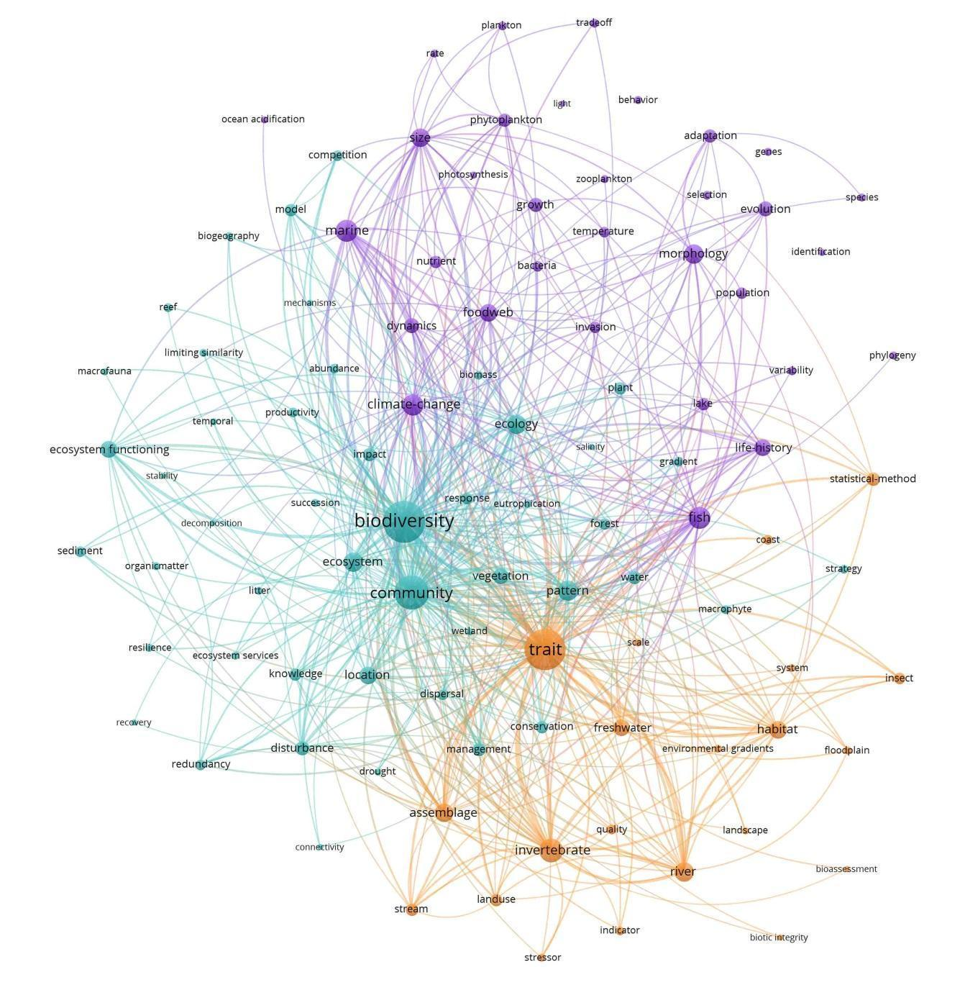Figure S1: Bibliographic network representing the database of publications on trait-based approaches. Three clusters of co-occurring keywords were identified within this network. The first (in orange) and the second (in purple) clusters mainly refer to two different ecosystems. The “freshwater”, “river” and “stream” ecosystems drive the first cluster as well as “invertebrate” organisms, while the second cluster refers to “marine” ecosystems with “fish”, “zooplankton” and “phytoplankton” organisms. These clusters highlight different ecological questions either linked to “indicators” and “land-use” (cluster 1 in orange) or to “food webs” and “climate-change” (cluster 2 in purple). The third cluster (in blue) is mainly associated with theoretical ecology, grouping “biodiversity”, “community”, “ecology”, “ecological functioning” and “pattern” showing numerous links rather evenly distributed between freshwater and marine ecosystem studies. This third cluster also refers to “sediment” or “organic matter”, two components transcending both limnology and oceanography.
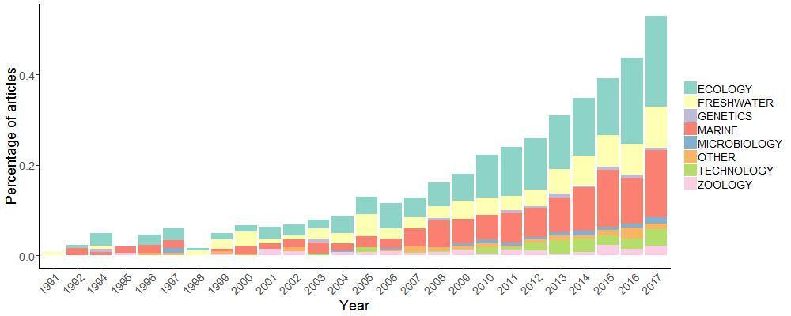

Figure S2: The percentage of publications relative to all the ones published in freshwater and marine ecology showing an increase over time, based on a literature survey (described in Supplementary Information). This percentage has increased over time, reaching about 0.5% in 2017. More recently, these two terms began to appear in the Web of Science research fields identified as: “genetics”, “microbiology” and “technology” (Figure S1).

Supplementary references (not cited in the main manuscript):

Acevedo-Trejos, E., G. Brandt, J. Bruggeman, and A. Merico. 2015. Mechanisms shaping size structure and functional diversity of phytoplankton communities in the ocean. Sci. Rep. 5: 8918. doi:10.1038/srep08918
Alexandridis, N., J. M. Dambacher, F. Jean, N. Desroy, and C. Bacher. 2017. Qualitative modelling of functional relationships in marine benthic communities. Ecol. Model. 360: 300–312. doi:10.1016/j.ecolmodel.2017.07.021
Andersen, K. H., and J. E. Beyer. 2006. Asymptotic Size Determines Species Abundance in the Marine Size Spectrum. Am. Nat. 168: 54–61. doi:10.1086/504849
Andersen, K. H., and M. Pedersen,. 2010. Damped trophic cascades driven by fishing in model marine ecosystems. Proc. R. Soc. B Biol. Sci. 277: 795–802. doi:10.1098/rspb.2009.1512
Blanchard, J. L., R. F. Heneghan, J. D. Everett, R. Trebilco, and A. J. Richardson. 2017. From Bacteria to Whales: Using Functional Size Spectra to Model Marine Ecosystems. Trends Ecol. Evol. 32: 174–186. doi:10.1016/j.tree.2016.12.003
Bruggeman, J. 2011. A Phylogenetic Approach to the Estimation of Phytoplankton Traits1. J. Phycol. 47: 52–65. doi:10.1111/j.1529-8817.2010.00946.x
Chakraborty, S., L. T. Nielsen, and K. H. Andersen. 2017. Trophic Strategies of Unicellular Plankton. Am. Nat. 189: E77–E90. doi:10.1086/690764
Chardy, P., and J.-C. Dauvin. 1992. Carbon flows in a subtidal fine sand community from the western English Channel: a simulation analysis. Mar. Ecol. Prog. Ser. 81: 147–161.
Díaz, S., A. Purvis, J. H. C. Cornelissen, G. M. Mace, M. J. Donoghue, R. M. Ewers, P. Jordano, and W. D. Pearse. 2013. Functional traits, the phylogeny of function, and ecosystem service vulnerability. Ecol. Evol. 3: 2958–2975. doi:10.1002/ece3.601
van Eck, N. J., and L. Waltman. 2009. How to normalize cooccurrence data? An analysis of some well‐known similarity measures. J. Am. Soc. Inf. Sci. Technol. doi:10.1002/asi.21075
van Eck, N. J., and L. Waltman. 2010. Software survey: VOSviewer, a computer program for bibliometric mapping. Scientometrics 84: 523–538. doi:10.1007/s11192-009-0146-3
Fiksen, Ø., M. J. Follows, and D. L. Aksnes. 2013. Trait-based models of nutrient uptake in microbes extend the Michaelis-Menten framework. Limnol. Oceanogr. 58: 193–202. doi:10.4319/lo.2013.58.1.0193
Follows, M. J., and S. Dutkiewicz. 2011. Modeling Diverse Communities of Marine Microbes. Annu. Rev. Mar. Sci. 3: 427–451. doi:10.1146/annurev-marine-120709-142848
Follows, M. J., S. Dutkiewicz, S. Grant, and S. W. Chisholm. 2007. Emergent biogeography of microbial communities in a model ocean. Science 315: 1843–1846. doi:10.1126/science.1138544
Grimaud, G. M., V. Le guennec, S.-D. Ayata, F. Mairet, A. Sciandra, and O. Bernard. 2015. Modelling the effect of temperature on phytoplankton growth across the global ocean. IFAC-Pap. 48: 228–233. doi:10.1016/j.ifacol.2015.05.059
Hartvig, M., K. H. Andersen, and J. E. Beyer. 2011. Food web framework for size-structured populations. J. Theor. Biol. 272: 113–122. doi:10.1016/j.jtbi.2010.12.006
Hickman, A. E., S. Dutkiewicz, R. G. Williams, and M. J. Follows. 2010. Modelling the effects of chromatic adaptation on phytoplankton community structure in the oligotrophic ocean. Mar. Ecol. Prog. Ser. 406: 1–17. doi:10.3354/meps08588
Kooijman, S. A. L. M., and S. A. L. M. Kooijman. 2000. Dynamic Energy and Mass Budgets in Biological Systems, Cambridge University Press.
Le Quere, C., S. P. Harrison, I. Colin Prentice, and others. 2005. Ecosystem dynamics based on plankton functional types for global ocean biogeochemistry models. Glob. Change Biol. 0: 051013014052005-??? doi:10.1111/j.1365-2486.2005.1004.x
Leblanc, K., B. Quéguiner, F. Diaz, and others. 2018. Nanoplanktonic diatoms are globally overlooked but play a role in spring blooms and carbon export. Nat. Commun. 9: 953. doi:10.1038/s41467-018-03376-9
Leles, S. G., L. Polimene, J. Bruggeman, J. Blackford, S. Ciavatta, A. Mitra, and K. J. Flynn. 2018. Modelling mixotrophic functional diversity and implications for ecosystem function. J. Plankton Res. 40: 627–642. doi:10.1093/plankt/fby044
Merico, A., J. Bruggeman, and K. Wirtz. 2009. A trait-based approach for downscaling complexity in plankton ecosystem models. Ecol. Model. 220: 3001–3010. doi:10.1016/j.ecolmodel.2009.05.005
Mondy, C. P., and P. Usseglio‐Polatera. 2014. Using fuzzy-coded traits to elucidate the non-random role of anthropogenic stress in the functional homogenisation of invertebrate assemblages. Freshw. Biol. 59: 584–600. doi:10.1111/fwb.12289
Nisbet, R. M., E. B. Muller, K. Lika, and S. a. L. M. Kooijman. 2000. From molecules to ecosystems through dynamic energy budget models. J. Anim. Ecol. 69: 913–926. doi:10.1111/j.1365-2656.2000.00448.x
Record, N. R., A. J. Pershing, and F. Maps. 2013. Emergent copepod communities in an adaptive trait-structured model. Ecol. Model. 260: 11–24. doi:10.1016/j.ecolmodel.2013.03.018
Rosenberg, R. 2001. Marine benthic faunal successional stages and related sedimentary activity. Sci. Mar. 65: 107–119. doi:10.3989/scimar.2001.65s2107
Sarà, G., V. Palmeri, V. Montalto, A. Rinaldi, and J. Widdows. 2013. Parameterisation of bivalve functional traits for mechanistic eco-physiological dynamic energy budget (DEB) models. Mar. Ecol. Prog. Ser. 480: 99–117. doi:10.3354/meps10195
Smith, S. L., A. Merico, K. W. Wirtz, and M. Pahlow. 2014. Leaving misleading legacies behind in plankton ecosystem modelling. J. Plankton Res. 36: 613–620. doi:10.1093/plankt/fbu011
Smith, S. L., M. Pahlow, A. Merico, and K. W. Wirtz. 2011. Optimality-based modeling of planktonic organisms. Limnol. Oceanogr. 56: 2080–2094. doi:10.4319/lo.2011.56.6.2080
Sommer, U., R. Adrian, L. De Senerpont Domis, and others. 2012. Beyond the Plankton Ecology Group (PEG) Model: Mechanisms Driving Plankton Succession. Annu. Rev. Ecol. Evol. Syst. 43: 429–448. doi:10.1146/annurev-ecolsys-110411-160251
Sommer, U., Z. M. Gliwicz, W. Lampert, and A. Duncan. 1986. The PEG-model of seasonal succession of planktonic events in fresh waters.
Stamieszkin, K., A. J. Pershing, N. R. Record, C. H. Pilskaln, H. G. Dam, and L. R. Feinberg. 2015. Size as the master trait in modeled copepod fecal pellet carbon flux. Limnol. Oceanogr. 60: 2090–2107. doi:10.1002/lno.10156
Terseleer, N., J. Bruggeman, C. Lancelot, and N. Gypens. 2014. Trait-based representation of diatom functional diversity in a plankton functional type model of the eutrophied southern North Sea. Limnol. Oceanogr. 59: 1958–1972. doi:10.4319/lo.2014.59.6.1958
Waltman, L., N. J. van Eck, and E. C. M. Noyons. 2010. A unified approach to mapping and clustering of bibliometric networks. J. Informetr. 4: 629–635. doi:10.1016/j.joi.2010.07.002
Ward, B. A., S. Dutkiewicz, O. Jahn, and M. J. Follows. 2012. A size-structured food-web model for the global ocean. Limnol. Oceanogr. 57: 1877–1891. doi:10.4319/lo.2012.57.6.1877

