[Paleoceanography and Paleoclimatology]
Supporting Information for
[Fates of paleo Antarctic Bottom Water during the early Eocene ―based on a Lagrangian analysis of IPSL-CM5A2 climate model simulations]

- Yurui Zhang^{1*}, Nicolas Grima¹, Thierry Huck¹

¹Univ Brest, CNRS, IRD, Ifremer, Laboratoire d’Océanographie Physique et Spatiale (LOPS), IUEM, Brest, France

*Correspondence: Yurui Zhang (yurui.zhang@univ-brest.fr)

Contents of this file

Description of the IPSL-CM5A2 model and simulations
Table S1 Summary of Lagrangian experiments
Table S2 Fates of North Atlantic Deep Water (NADW) and Antarctic Bottom Water (AABW) under PI
Figure S1 Travel time of water parcels.
Figure S2 Distribution of water transport per salinity and temperature
Figure S3 Geographical distribution of large depth change in the abyssal ocean and link to the bathymetry pattern.
Figure S4 Wind stress curl (N/m³) and tropical upwelling.
Abbreviations

On IPSL-CM5A2 model and simulations
The simulations used in this study are performed with the IPSL-CM5A2 Earth system model, in which IPSL stands for “Institut Pierre Simon Laplace” (Sepulchre et al., 2020). The atmospheric component is the Laboratoire de Météorologie Dynamique zoom (LMDZ) model (Hourdin et al., 2013), and is coupled to the land surface model ORCHIDEE (Krinner et al., 2005). The oceanic component of IPSL-CM5A2 is the version v3.6 of the Nucleus for European Modelling of the Ocean (NEMO) (Madec and the NEMO team, 2016) that has been coupled to the sea-ice model LIM2 (Fichefet & Maqueda, 1997) and to the PISCES (standing for Pelagic Interaction Scheme for Carbon and Ecosystem Studies) biogeochemical model (Aumont et al., 2015). The simulations were performed using IPSL-CM5A2 in its standard resolution, i.e. NEMO is thus run at a nominal resolution of 2°, increased down to 0.5° at the Equator, and with 31 levels representing increasing thickness from the surface to abyss. On top of background diapycnal mixing and TKE (Turbulent Kinetic Energy) scheme for surface induced mixing, the tidal mixing (M2), obtained from the tidal model simulations of Green & Huber (2013), was applied under a bilinear interpolation. A full description of the IPSL-CM5A2 model can be found in Sepulchre et al. (2020) and in Madec and NEMO team (2016) for the ocean model, and a full description of the paleo simulations and their evaluations can be found Zhang et al. (2020).

Table SI Summary of Lagrangian experiments. The main experiment for Eocene is highlighted in grey.

Period |  | Eocene |  | PI
Experiment |  | paleo-AABW-fate (main) | paleo-AABW-sources (auxiliary) | NADW-fate  (testing) | AABW-fate  (testing)
initial section | Latitude | 60°S | 60°S | 56°N | 65°S
 | depth (m) | below 1900 | below 1900 | below 750 | below 1400
 | Direction | Northward | southward | southward | northward
sections^{1#} |  | Initial(60Sbl), MLB, 60Sab | Initial(60Sbl), MLB, 60Sab | Initial-N, MLB, ab-N | Initial-S, MLB, ab-S
Domain |  | north of 60°S | south of 60°S | south of 56°N | north of 65°S
integration direction |  | Forward | backward | forward | forward
number of particles |  | 4797 | 2687 | 752 | 2931
assigned transport (Sv) |  | 85.69 | 49.83 | 17.00 | 24.20
^{1#} These sections are defined in Figure 2 (Eocene) and Figure 3 (PI).

Table S2 Fates (in Sv) of North Atlantic Deep Water (NADW) and Antarctic Bottom Water (AABW). Initial_gross is the total amount of water that leaves the initial section; Initial_N (initial_S) is the initial section; above_N (above_S) is the section above the initial section (as defined in Figure 3); MLB, the base of the mixed-layer.
 | Initial_gross | Initial_N/S | Above_N/S | MLB
NADW | 17.0 | 5.4 | 2.3 | 9.2
AABW | 34.5 | 7.2 | 0.3 | 27.0

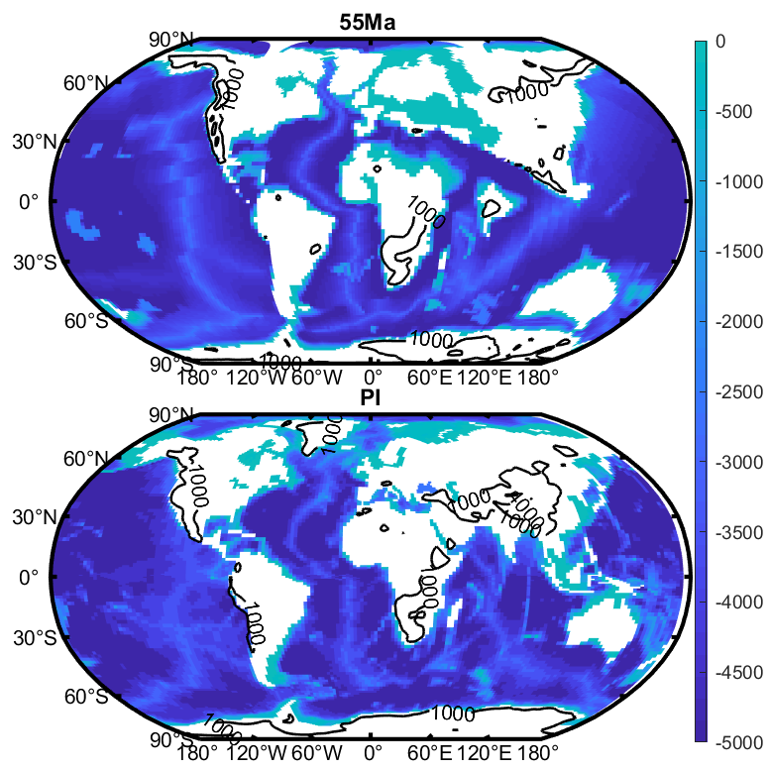

Figure S1. Bathymetry/topography (m) boundary conditions used in the 55 Ma (top, based on Herold et al., 2014) and PI simulations (bottom), adjusted from Fig. 1 of Zhang et al. (2020). The black contours indicate the 1000 and the 4000m altitude.
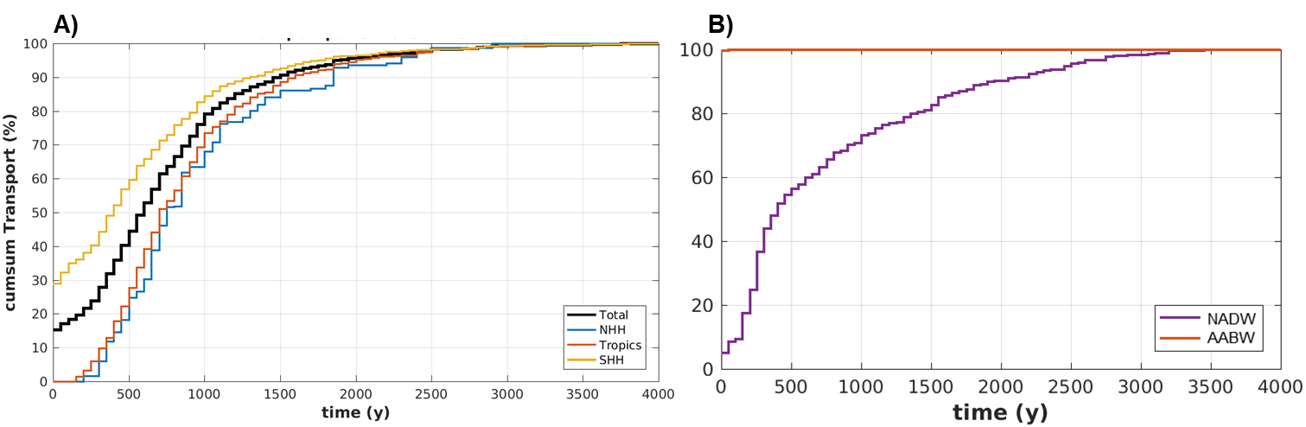

Figure S2. Travel time of water parcels, shown as accumulated transport over time (year). (A) and (B) are for the Eocene and present-day respectively.

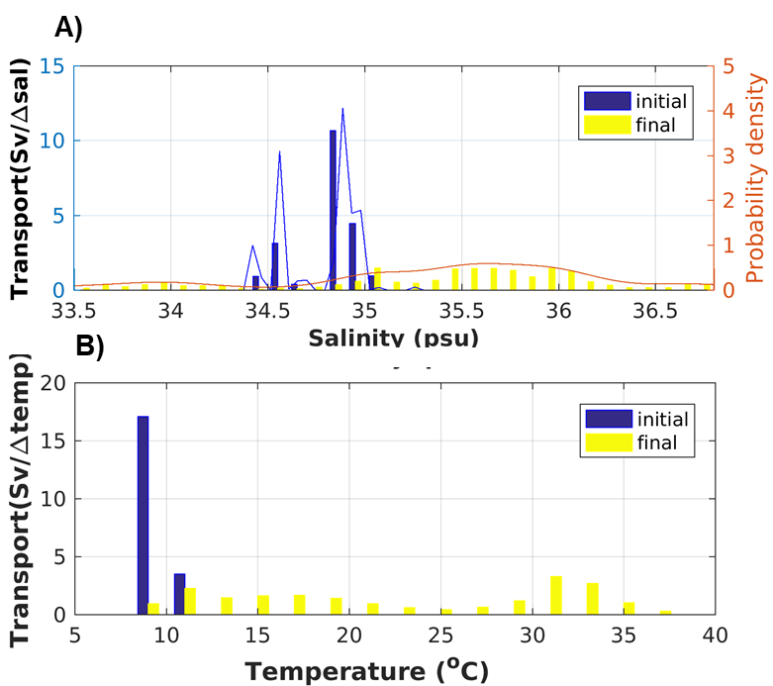

Figure S3. Transport distribution (weighted by volume-transport) of water parcels as a function of initial (blue) and final (yellow) salinity (A) and temperature (B). Probability density distribution (curve) is overlaid in (A) to illustrate their relationship to transport distribution.

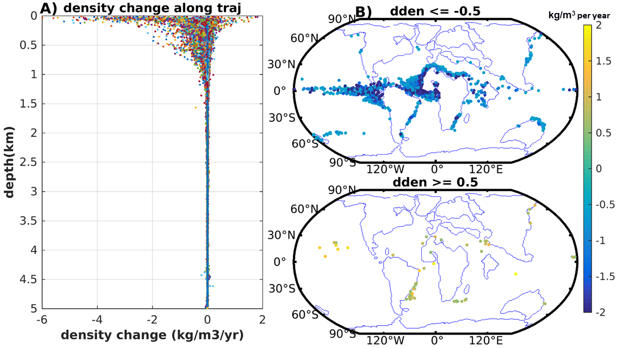

Figure S4. Density transformation along the full-range trajectory of paleo-AABW parcels entering the mixed layer with yearly time step. The caption is the same as Figure 6.

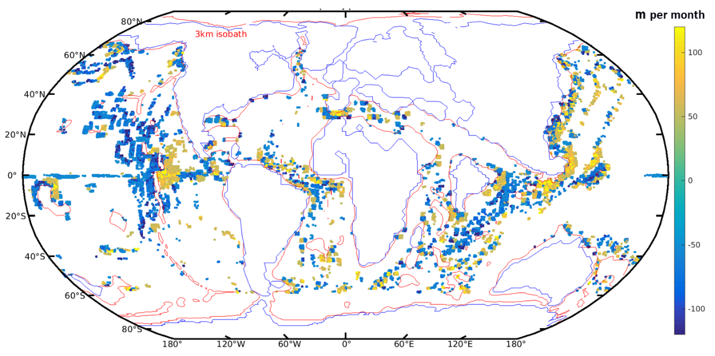

Figure S5. Geographical distribution of large depth changes along the trajectory in the abyssal ocean (i.e. for particles with depth larger than the threshold value of ±50 m per month when they are at deeper than 3000 m) and link to the bathymetry pattern. Positive (negative) values are downward (upward), which illustrates seafloor topography explains large upward and downward transport.
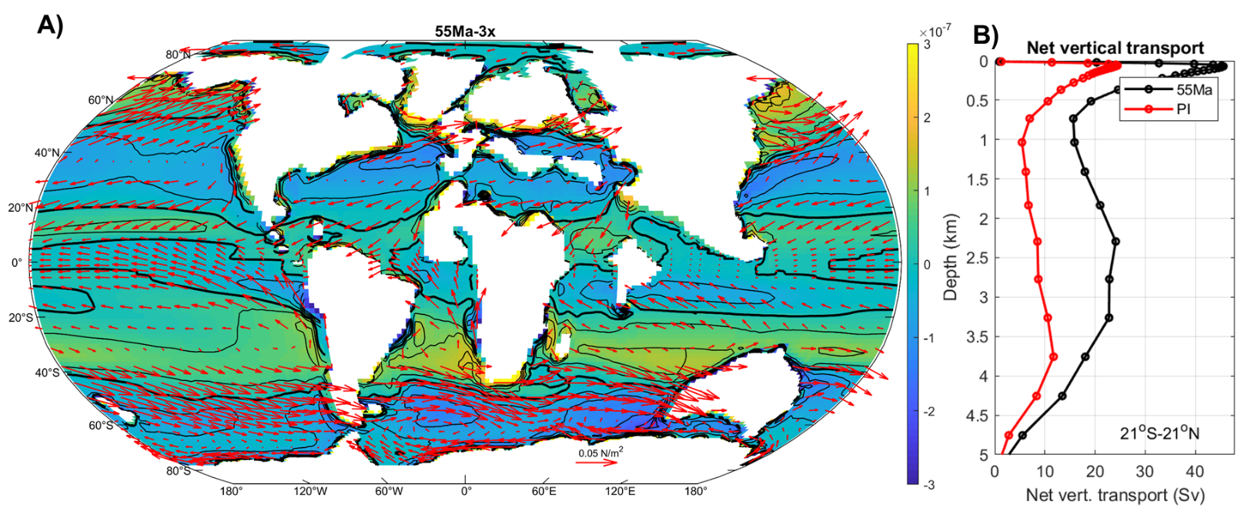

Figure S6. A) Wind stress (vectors in N/m²) and wind stress curl (color and contour in N/m³), with the thick black line highlighting the zero-contour. B) Tropical net vertical transport (Sv, calculated as surface integral of vertical transport) between the Eocene and PI, showing a strong Eocene upwelling.

Abbreviations
AABW Antarctic Bottom Water
ACC Antarctic Circumpolar Currents
AMOC Atlantic Meridional Overturning Circulation
CFC chlorofluorocarbon
DeepMIP Deep-Time Model Inter-comparison Project
GFDL model Geophysical Fluid Dynamics Laboratory model
IPSL-CM5A2 Institut Pierre Simon Laplace Climate Model (A in IPLS-CM5A represents a direct extension of IPSL-CM4, distinguish from IPSL-CM5B)
LIM3 model the Louvain-la-Neuve Sea Ice Model
LMDz model Laboratoire de Météorologie Dynamique zoom model
MLB mixed-layer base
MOC Meridional Overturning Circulation
NADW North Atlantic Deep Water
NEMO model Nucleus for European Modelling of the Ocean
NHH Northern Hemisphere high latitudes
OGCM Ocean General Circulation Model
ORCHIDEE Organising Carbon and Hydrology In Dynamic Ecosystems
Paleo-AABW paleo Antarctic Bottom Water
PISCES Pelagic Interaction Scheme for Carbon and Ecosystem Studies
RMSD root mean square deviation
SST Sea surface temperature
OASIS coupler Ocean Atmosphere Sea Ice Soil coupler

Reference:
Fichefet, T., & Maqueda, M. A. M. (1997). Sensitivity of a global sea ice model to the treatment of ice thermodynamics and dynamics. Journal of Geophysical Research: Oceans, 102(C6), 12609–12646. https://doi.org/10.1029/97JC00480
Green, J. A. M., & Huber, M. (2013). Tidal dissipation in the early Eocene and implications for ocean mixing: EOCENE TIDES. Geophysical Research Letters, 40(11), 2707–2713. https://doi.org/10.1002/grl.50510
Hourdin, F., Grandpeix, J.-Y., Rio, C., Bony, S., Jam, A., Cheruy, F., et al. (2013). LMDZ5B: the atmospheric component of the IPSL climate model with revisited parameterizations for clouds and convection. Climate Dynamics, 40(9–10), 2193–2222. https://doi.org/10.1007/s00382-012-1343-y
Krinner, G., Viovy, N., de Noblet-Ducoudré, N., Ogée, J., Polcher, J., Friedlingstein, P., et al. (2005). A dynamic global vegetation model for studies of the coupled atmosphere-biosphere system. Global Biogeochemical Cycles, 19, GB1015. https://doi.org/10.1029/2003GB002199
Madec, G., & the NEMO team. (2016). NEMO ocean engine. Retrieved from https://www.nemo-ocean.eu/wp-content/uploads/NEMO_book.pdf (last access: 13 July 2020), 2016.
Zhang, Y., Huck, T., Lique, C., Donnadieu, Y., Ladant, J.-B. Rabineau, M., & Aslanian, D. (2020). Early Eocene vigorous ocean overturning and its contribution to a warm Southern Ocean. Climate of Past, 16, 1263–1283. https://doi.org/10.5194/cp-16-1263-2020

