Striking forest revival at the end of the Roman Period in north-western Europe
Supplementary material

Lambert C.^{1,2*}, Penaud A.¹, Vidal M.¹, Gandini C.^{3,4}, Labeyrie L.², Chauvaud L.⁵, Ehrhold A.⁶

¹ Univ. Brest (UBO), CNRS, UMR 6538 Laboratoire Géosciences Océan (LGO), F-29280 Plouzané, France
² Univ. Vannes (UBS), UMR 6538 Laboratoire Géosciences Océan (LGO), F-56000 Vannes, France
³ Univ. Brest (UBO), Centre de Recherche Bretonne et Celtique (CRBC), Brest, France
⁴ AOROC - UMR 8546, CNRS, École Normale Supérieure, Paris
⁵ Univ. Brest (UBO), CNRS, IRD, UMR 6539 Laboratoire des Sciences de l’Environnement Marin (LEMAR), F-29280 Plouzané, France
⁶ Géosciences Marines, Centre de Brest, IFREMER, France

Environmental setting

The Bay of Brest (BB), located in north-western Brittany (NW France, NW Europe) is a shallow semi-enclosed basin of 180 km² surrounded by a 230 km long coastline. During the Quaternary, the BB was subjected to alternations of glacial lowstands and interglacial highstands; the last transgressive episode thus corresponded to a Holocene sedimentary infilling of the BB¹.
Today, the BB is characterized by a macrotidal influence. Grain-size analyses performed on modern BB sediments reflect specific hydrodynamic conditions mainly related to tidal currents². In the stream direction, sedimentation is mainly composed of sands and gravels². On either side of this axis, the current speed is strongly reduced and grain-size is characterized by fine to very fine sediments (silts and clays)^{2,3}. In its easternmost part, the BB receives its main freshwater supplies from the Aulne and the Elorn (Supplementary Fig. S1) whose outflows contribute to up to 85% of the total river discharges into the BB⁴.
Modern climate
The Brittany coasts, located in the north-eastern Atlantic, are subject to a temperate oceanic climate. The vicinity of the ocean carries humid air masses from westerly winds (westerlies) to them throughout the year and low thermal seasonal amplitude is recorded between winter and summer months. Despite moderate inter-annual variations in temperatures, mean annual values are about 10- 11°C⁵. Annual prevailing winds mainly have a southwestern origin. Since Brittany is subject to regular oceanic rainfall, annual cumulative precipitation ranges from 600 to more than 1,600 mm/year in the inner part⁵. Moreover, the climate of Brittany is created by the combined influences of fluctuating atmospheric (North Atlantic Oscillation, NAO) and oceanic (AMOC and gyre dynamics) patterns^{6,7}.
The NAO is the major atmospheric circulation pattern controlling climatic variability in western Europe. It affects wind, precipitation and winter temperatures⁸. Positive (/negative) phases (NAO +; high gradient between sea-level pressure over Iceland and the Azores anticyclonic centre) are characterized by strengthened (/weakened) mid-latitude westerlies over northern Europe, giving rise to a storm corridor over Brittany and to mild (/cold) and moist (/dry) winters^{8,9}. Positive phases of the NAO are conventionally associated with above-average continental precipitation in northwestern Europe (i.e. north of the Loire watershed) and with droughts further south^{6,10}.
Moreover, on decadal to multi-decadal timescales, variations in North Atlantic SST appear to control much of the climate variability on the continent^{7,11}. This oscillation is related to the energy (i.e. solar irradiance) received by intertropical water masses and its redistribution by major Atlantic Ocean currents¹². A stronger (/weaker) NAC (North Atlantic Current) and SPG (subpolar gyre) lead to greater (/lesser) heat transport from the tropics to the north and higher (/lower) North Atlantic SST⁷. SST therefore impacts both rainfall and atmospheric temperatures^{13,14}.

Supplementary material references
- Gregoire, G., Le Roy, P., Ehrhold, A., Jouet, G., & Garlan, T. Control factors of Holocene sedimentary infilling in a semi-closed tidal estuarine-like system: the bay of Brest (France). Mar. Geol., 385, 84-100 (2017).
- Gregoire, G., Ehrhold, A., Le Roy, P., Jouet, G., & Garlan, T. Modern morpho-sedimentological patterns in a tide-dominated estuary system: the Bay of Brest (west Britanny, France). J. Maps, 12(5), 1152-1159 (2016).
- Lambert, C. et al. Modern palynological record in the Bay of Brest (NW France): Signal calibration for palaeo-reconstructions. Rev. Palaeobot. Palynol., 244, 13-25 (2017).
- Delmas, R., & Treguer, P. Evolution saisonnière des nutriments dans un écosystème eutrophe d'Europe occidentale (la rade de Brest). Interactions marines et terrestres. Oceanol. acta, 6(4), 345-356 (1983).
- Belleguic, K., Conseil, C., Eveno, T., Lorge, S. & Baraer, F. Le Changement climatique en Bretagne (ed. Météo France). 85 pp (Paris, 2012).
- Tréguer, P., et al. Large and local-scale influences on physical and chemical characteristics of coastal waters of Western Europe during winter. J. Marine Syst., 139, 79-90 (2014).
- Ruprich-Robert, Y., & Cassou, C. Combined influences of seasonal East Atlantic Pattern and North Atlantic Oscillation to excite Atlantic multidecadal variability in a climate model. Climate Dyn., 44(1-2), 229-253 (2015).
- Hurrell, J. W., Kushnir, Y., Ottersen, G. & Visbeck, M. in North Atlantic Oscillation: Climate Significance and Environmental Impact (eds Hurrell, J. W., Kushnir, Y., Ottersen, G. & Visbeck, M.) 1–35 (Geophys. Monogr. 134, American Geophysical Union, 2003).
- Morley, A., Rosenthal, Y., & DeMenocal, P. Ocean-atmosphere climate shift during the mid-to-late Holocene transition. Earth Planet. Sci. Lett., 388, 18-26 (2014).
- Rodriguez‐Puebla, C., Encinas, A. H., Nieto, S., & Garmendia, J. Spatial and temporal patterns of annual precipitation variability over the Iberian Peninsula. Int. J. Climatol., 18(3), 299-316 (1998).
- Knight, J. R., Folland, C. K., & Scaife, A. A. Climate impacts of the Atlantic multidecadal oscillation. Geophys. Res. Lett., 33(17) (2006).
- Knudsen, M. F., Jacobsen, B. H., Seidenkrantz, M. S., & Olsen, J. Evidence for external forcing of the Atlantic Multidecadal Oscillation since termination of the Little Ice Age. Nature Comm., 5(1), 1-8 (2014).
- Kerr, R. A. A North Atlantic climate pacemaker for the centuries. Science, 288(5473), 1984-1985 (2000).
- Msadek, R., & Frankignoul, C. Atlantic multidecadal oceanic variability and its influence on the atmosphere in a climate model. Climate Dyn., 33(1), 45-62 (2009).

Supplementary Fig. S1 :
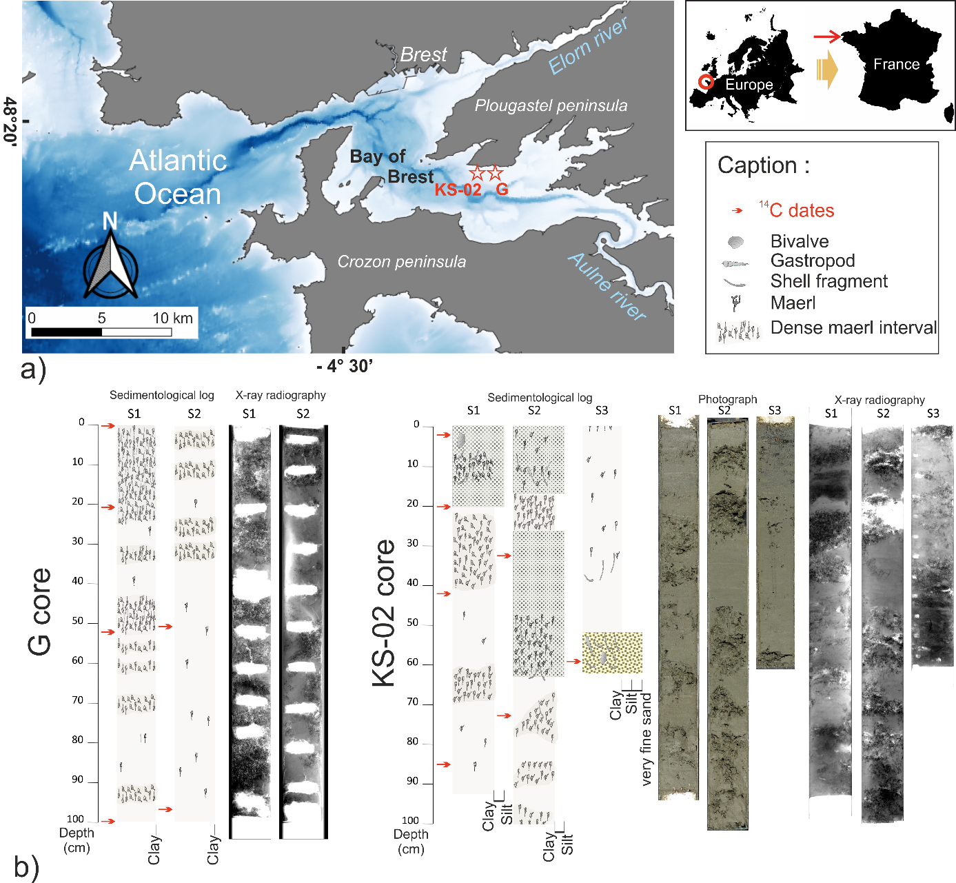

Supplementary Fig. S2 :

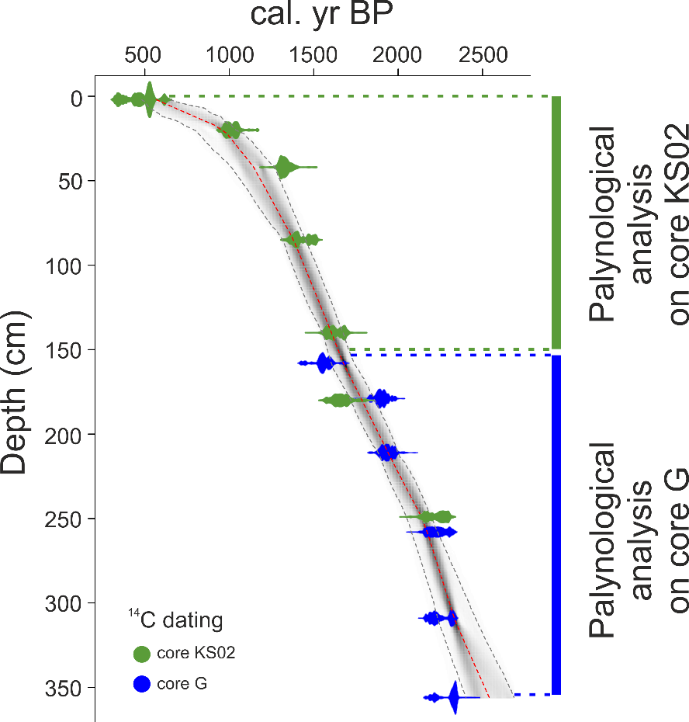

Supplementary Fig. S3 :

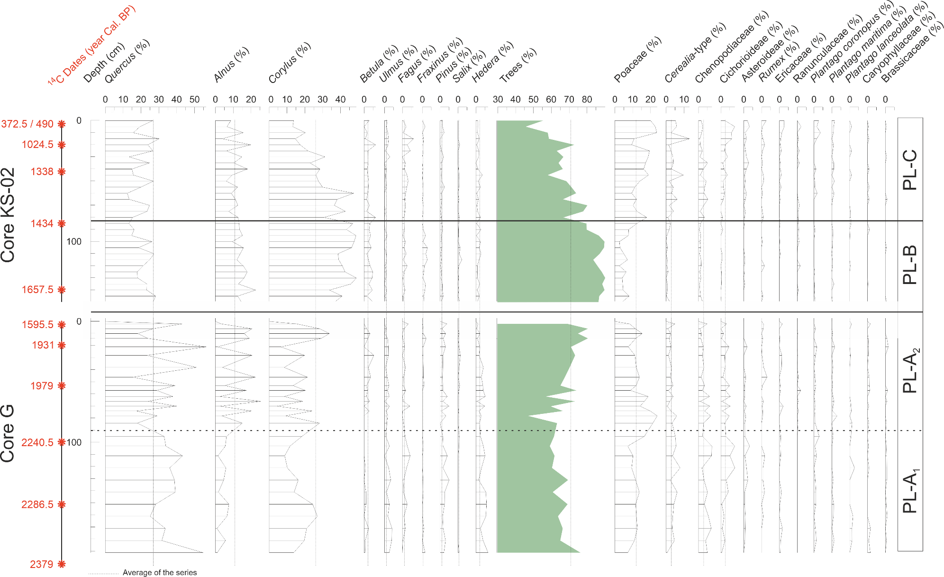
Supplementary Table S1:
Name | Latitude | Longitude | Depth | Lenght | Coring date
G | 48°19’14’’ N | 4°23’5’’ W | 7.4 m | 358 cm | 2003
EssCALICO-KS02 | 48°18’46’’ N | 4°24’27’’ W | 8 m | 253.5 cm | 2010

Supplementary Table S2:
Lab code | Depth (cm) | material | Age ¹⁴C | Error | Age cal. BP | Age cal. AD/BC
Poz-85159 | 2 | Gastropod | 690 | 30 | 289-456  (372.5) | 1577.5 AD
SacA47759 | 2 | Gastropod | 835 | 35 | 420-560  (490) | 1460 AD
SacA49423 | 20 | Gastropod | 1430 | 30 | 924-1125  (1024.5) | 925.5 AD
SacA47761 | 42 | Gastropod | 1740 | 40 | 1238-1438  (1338) | 612 AD
Poz-78153 | 85-86 | Gastropod | 1850 | 30 | 1338-1530  (1434) | 516 AD
SacA45632 | 140-141 | Gastropod | 2040 | 30 | 1546-1769  (1657.5) | 292.5 AD
Poz-78154 | 180-181 | Gastropod | 2075 | 35 | 1575-1814  (1694.5) | 255.5 AD
SacA45633 | 249-250 | Gastropod | 2515 | 30 | 2124-2320  (2222) | 272 BC
Core KS-02

Lab code | Depth (cm) | Material | Age 14C | Error | Age cal. BP | Age cal. AD/BC
Poz-42846 | 0-1 | Gastropod | 1980 | 30 | 1494-1697  (1595.5) | 354.5 AD
SacA45629 | 20-23 | Gastropod | 2275 | 30 | 1824-2038  (1931) | 19 AD
Poz-73703 | 53 | Gastropod | 2310 | 30 | 1869-2089  (1979) | 29 BC
Poz-42847 | 100 | Gastropod | 2545 | 35 | 2136-2345  (2240.5) | 290.5 BC
Poz-73704 | 150-152 | Gastropod | 2580 | 30 | 2166-2407  (2286.5) | 336.5 BC
Poz-42848 | 198.5 | Gastropod | 2625 | 30 | 2274-2484  (2379) | 429 BC
Core G

Supplementary Table S3:
Age (Cal. BP) | Trees (%) | Corylus (%) | Riparian trees (%) | L. machaerophorum (%) | API (%) | API without Cerealia-type (%) | Cerealia-type (nb.cm⁻³)
521 | 55,409 | 13,720 | 11,609 | 16,062 | 7,916 | 2,639 |  | 631,758
612 | 44,292 | 14,612 | 13,699 | 46,154 | 17,352 | 13,242 |  | 1061,704
635 | 45,676 | 13,243 | 6,486 | 50,265 | 8,378 | 2,432 |  | 1576,723
680 | 54,645 | 13,661 | 22,951 | 6,897 | 7,650 | 6,557 |  | 126,352
748 | 58,065 | 20,276 | 17,512 | 22,535 | 2,765 | 0,000 |  | 260,600
771 | 51,337 | 13,904 | 17,112 | 41,935 | 4,813 | 4,278 |  | 94,764
864 | 58,687 | 14,672 | 4,633 | 20,833 | 13,900 | 0,772 |  | 427,922
887 | 63,571 | 25,714 | 16,786 | 15,789 | 5,714 | 5,000 |  | 57,911
956 | 73,881 | 17,413 | 9,453 | 24,706 | 3,234 | 1,741 |  | 2606,000
993 | 69,649 | 16,613 | 24,281 | 53,226 | 3,195 | 2,556 |  | 163,514
1009 | 63,056 | 21,667 | 8,333 | 35,833 | 4,444 | 1,667 |  | 210,588
1049 | 66,794 | 31,298 | 17,176 | 33,898 | 4,580 | 0,763 |  | 434,333
1089 | 64,080 | 22,989 | 12,644 | 32,824 | 4,598 | 0,575 |  | 601,440
1129 | 66,766 | 28,443 | 20,060 | 35,294 | 2,994 | 0,000 |  | 1336,410
1161 | 58,530 | 26,247 | 12,073 | 30,986 | 11,811 | 2,100 |  | 1135,371
1188 | 68,860 | 27,632 | 9,211 | 17,391 | 3,070 | 1,316 |  | 397,105
1217 | 71,820 | 29,925 | 15,461 | 34,320 | 3,990 | 0,000 |  | 1096,851
1244 | 73,947 | 47,368 | 11,053 | 55,385 | 3,684 | 0,526 |  | 613,176
1271 | 67,064 | 38,186 | 13,126 | 18,269 | 7,637 | 1,432 |  | 747,964
1299 | 80,240 | 36,527 | 15,569 | 35,417 | 1,796 | 0,000 |  | 1051,160
1326 | 77,861 | 42,786 | 8,955 | 19,892 | 5,224 | 0,995 |  | 944,379
1353 | 67,602 | 30,612 | 19,898 | 33,898 | 2,551 | 1,531 |  | 272,523
1379 | 80,124 | 46,998 | 16,977 | 43,210 | 3,313 | 0,828 |  | 720,447
1401 | 80,058 | 43,353 | 16,763 | 70,000 | 1,734 | 0,000 |  | 714,789
1422 | 86,910 | 48,706 | 19,178 | 55,046 | 0,609 | 0,152 |  | 223,923
1442 | 89,827 | 47,619 | 12,121 | 21,818 | 0,433 | 0,433 |  | 0,000
1463 | 84,169 | 7,916 | 35,884 | 30,645 | 2,639 | 1,055 |  | 453,094
1483 | 87,862 | 38,587 | 16,304 | 37,037 | 0,000 | 0,000 |  | 0,000
1504 | 85,638 | 39,007 | 16,667 | 45,714 | 1,064 | 0,355 |  | 94,418
1524 | 86,258 | 41,015 | 19,450 | 42,188 | 2,748 | 2,114 |  | 279,214
1544 | 88,298 | 42,553 | 22,766 | 56,881 | 1,489 | 0,426 |  | 373,205
1565 | 90,580 | 48,913 | 21,014 | 58,333 | 0,000 | 0,000 |  | 0,000
1585 | 88,550 | 45,802 | 15,725 | 55,422 | 0,763 | 0,000 |  | 1380,857
1605 | 90,275 | 33,827 | 27,696 | 32,530 | 1,268 | 0,423 |  | 262,239
1625 | 86,888 | 40,900 | 14,090 | 38,519 | 0,978 | 0,783 |  | 69,917
1644 | 87,546 | 36,630 | 20,879 | 33,333 | 2,930 | 0,733 |  | 496,381
1685 | 69,061 | 15,470 | 3,315 | 20,000 | 7,182 | 2,210 |  | 657,841
1705 | 80,488 | 28,293 | 21,951 | 15,556 | 1,951 | 0,976 |  | 262,239
1726 | 74,936 | 33,760 | 19,949 | 22,727 | 2,558 | 0,000 |  | 2481,905
1746 | 80,519 | 29,221 | 21,212 | 26,829 | 3,247 | 1,515 |  | 694,933
1781 | 70,968 | 6,452 | 1,613 | 19,355 | 4,301 | 1,613 |  | 831,499
1815 | 73,348 | 19,824 | 27,313 | 18,699 | 2,423 | 1,101 |  | 1341,099
1866 | 70,270 | 8,408 | 6,907 | 34,615 | 4,204 | 1,201 |  | 1290,556
1906 | 67,584 | 21,407 | 25,994 | 21,649 | 5,505 | 3,058 |  | 2560,281
1940 | 65,122 | 13,415 | 7,805 | 25,397 | 4,390 | 0,488 |  | 887,594
1961 | 73,987 | 20,256 | 19,616 | 27,612 | 2,559 | 1,279 |  | 737,051
1988 | 56,908 | 8,553 | 3,947 | 28,000 | 4,605 | 0,658 |  | 768,993
2007 | 73,311 | 18,750 | 28,378 | 49,275 | 4,392 | 2,365 |  | 4710,104
2028 | 59,364 | 4,594 | 2,827 | 21,905 | 1,767 | 1,060 |  | 106,194
2049 | 66,441 | 24,068 | 23,390 | 28,235 | 4,407 | 1,695 |  | 2967,131
2070 | 46,884 | 9,199 | 3,561 | 27,731 | 7,122 | 1,187 |  | 1492,691
2101 | 63,229 | 28,251 | 15,022 | 25,610 | 5,157 | 1,794 |  | 3127,200
2153 | 61,538 | 18,315 | 6,960 | 34,653 | 5,861 | 0,733 |  | 1508,267
2182 | 59,167 | 11,667 | 6,111 | 22,430 | 7,222 | 1,667 |  | 758,531
2207 | 61,818 | 8,727 | 1,455 | 26,000 | 6,182 | 2,545 |  | 390,420
2238 | 60,392 | 10,196 | 6,667 | 23,684 | 12,157 | 4,314 |  | 1290,556
2270 | 69,380 | 16,279 | 4,651 | 41,322 | 3,876 | 1,550 |  | 724,052
2301 | 60,784 | 14,006 | 2,801 | 43,333 | 7,843 | 1,681 |  | 1254,135
2333 | 69,106 | 24,390 | 8,672 | 39,759 | 4,878 | 0,542 |  | 674,905
2375 | 63,721 | 26,977 | 6,512 | 44,737 | 7,442 | 3,721 |  | 1361,465
2419 | 66,387 | 21,008 | 3,361 | 42,718 | 4,622 | 1,261 |  | 723,465
2464 | 65,000 | 19,667 | 6,333 | 33,113 | 6,667 | 2,000 |  | 1315,681
2509 | 76,302 | 13,802 | 2,083 | 36,496 | 0,521 | 0,000 |  | 121,464

Supplementary material legends
Figure 1: a) Location of the core sampling sites (red stars) on the bathymetric map of the Bay of Brest (source of bathymetric data: https://data.shom.fr). b) Sedimentological descriptions, X-Ray radiographies and photographs of G and KS-02 cores. Map was created using QGIS software version 3.4.5 (https://www.qgis.org).
Figure 2: Age-depth model for the composite “G-KS02” sequence using six 14C-AMS dates for G core (blue code) and eight 14C-AMS dates for KS-02 core (green code) using Bayesian statistics. Vertical lines delimit analysed sections of each core. The age-depth model was made using R 3.5.0 (R Core Team, 2018), the rbacon package⁴³.
Figure 3: Detailed pollen diagram as function of depth in the cores G and KS-02 composite sequence. Pollen rates are expressed in percentages compared to the total sum. Only the major taxa are represented (< 2%). The green curve represents the total percentage reached by tree pollen grains (i.e. Quercus, Alnus, Corylus, Betula, Ulmus, Fagus, Fraxinus, Pinus, Salix). Anthropogenic pollen indicators used in figure 2 are Cerealia-type, Plantago lanceolata, Rumex, Brassicaceae, Ranunculaceae, Asteroideae and Cichorioideae. Palynozones (PL for ‘Plougastel peninsula’) were defined based on major changes in pollen percentages of trees, poaceae and Cerealia-type. Plalynozone PL-B contains the '1.7–1.4 ka AP event'. ¹⁴C dates are represented by red stars on the vertical scale.
Table 1: Positions and characteristics of the sediment cores studied.
Table 2: For each 14C date: depth of sampling in the core, dated material, 14C date, error, age calibrated in BP, age calibrated in BC / AD.
Table 3 : Palynological data produced during current study

