

*Paleoceanography and Paleoclimatology]*

Supporting Information for

**Atlantic Ocean ventilation change across the last deglaciation and carbon cycle implications**

**L. C. Skinner\*1, E. Freeman1, D. Hodell1, C. Waelbroeck2, N. Vazquez Riveiros3, A.E. Scrivner1**

1 Godwin Laboratory for Palaeoclimate Research, Department of Earth Sciences, University of Cambridge, CB2 3EQ, UK.

2 Laboratoire d’Océanographie et du Climat: Expérimentation et Approches Numériques, LOCEAN/IPSL, Sorbonne Université-CNRS-IRD-MNHN, UMR7159, Paris,France.

3 Laboratoire Géodynamique et enregistrement Sédimentaire (PDG-REM-GM-LGS), IFREMER, Brest, France.

**Contents of this file**

Figures S1 to S6

Tables S1 to S5 (captions)

**Introduction**

This file includes supplementary figures illustrating stratigraphic alignments and chronologies for Iberian Margin and Brazil Margin cores, and captions for supplementary tables that include all new data presented in this study (tables included as separate files).

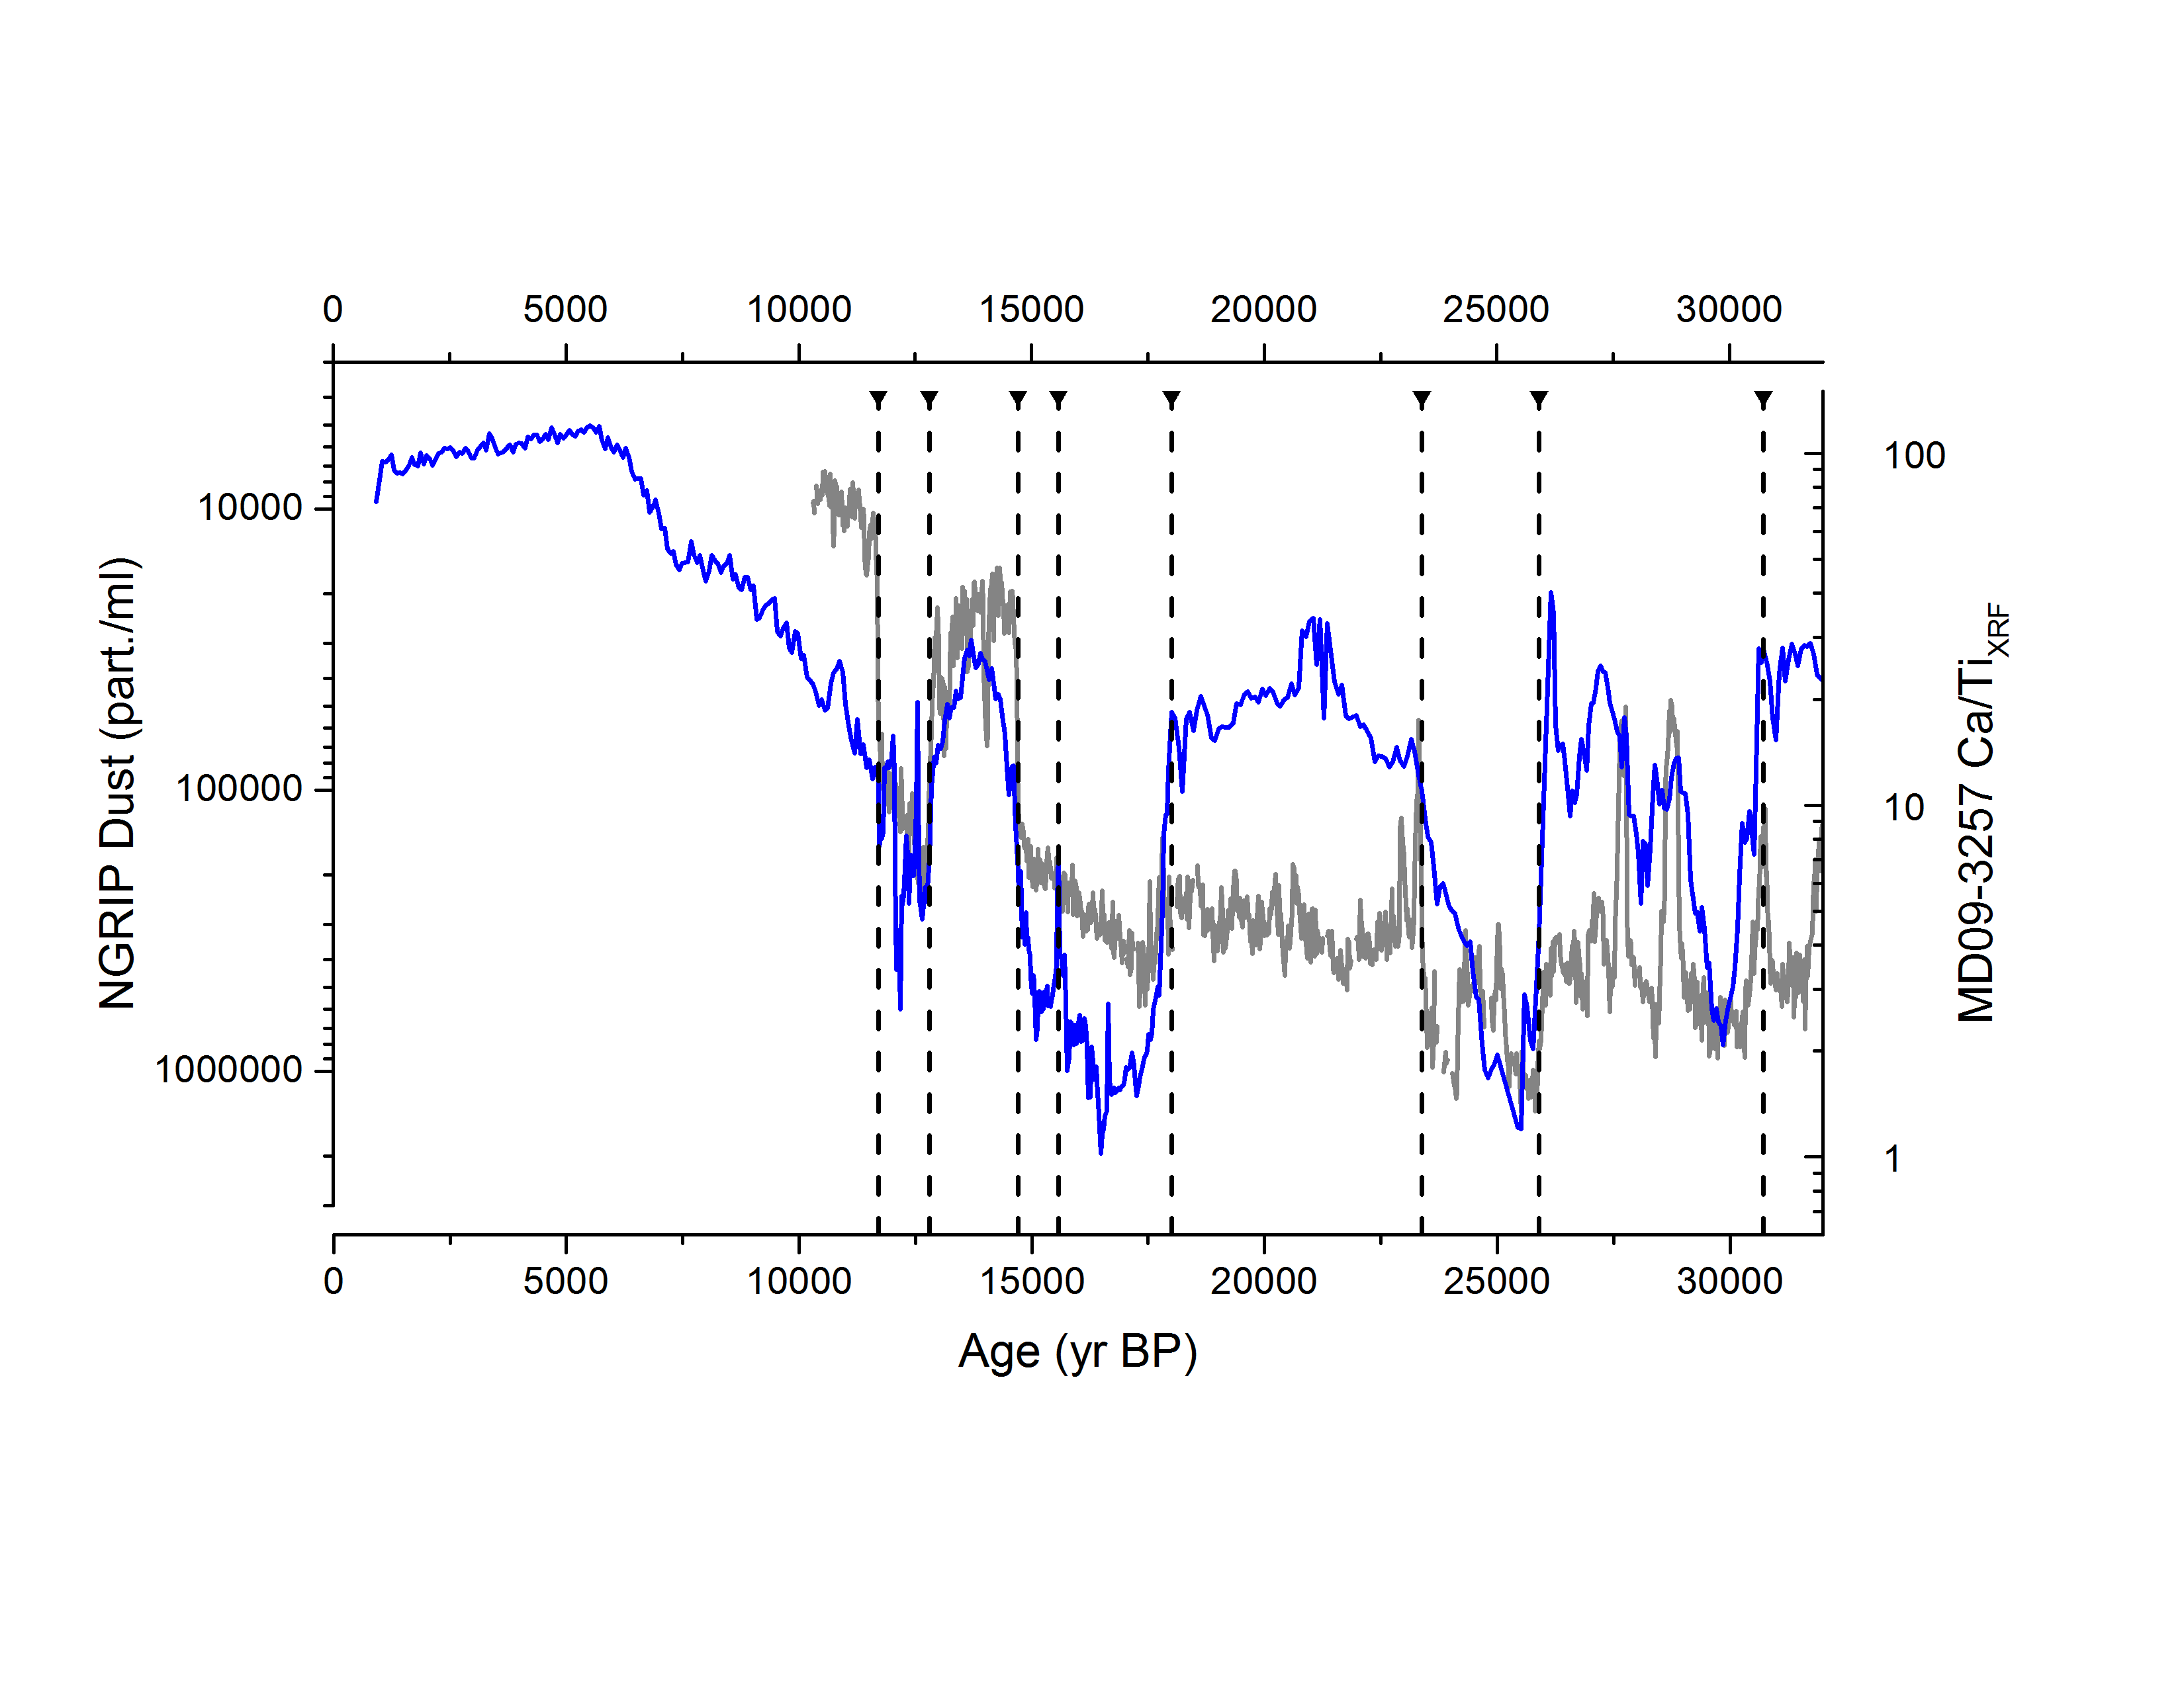Figure S1. Alignment of MD09-3257 Ca/TiXRF (an indication of marine biogenic versus terrigenous sediment input; this study) to the NGRIP dust record [*Ruth et al.*, 2003], on the GICC05 age-scale [*Svensson et al.*, 2008], for the purpose of evaluating past reservoir age variability. Black triangles and dashed lines indicate tie points.

***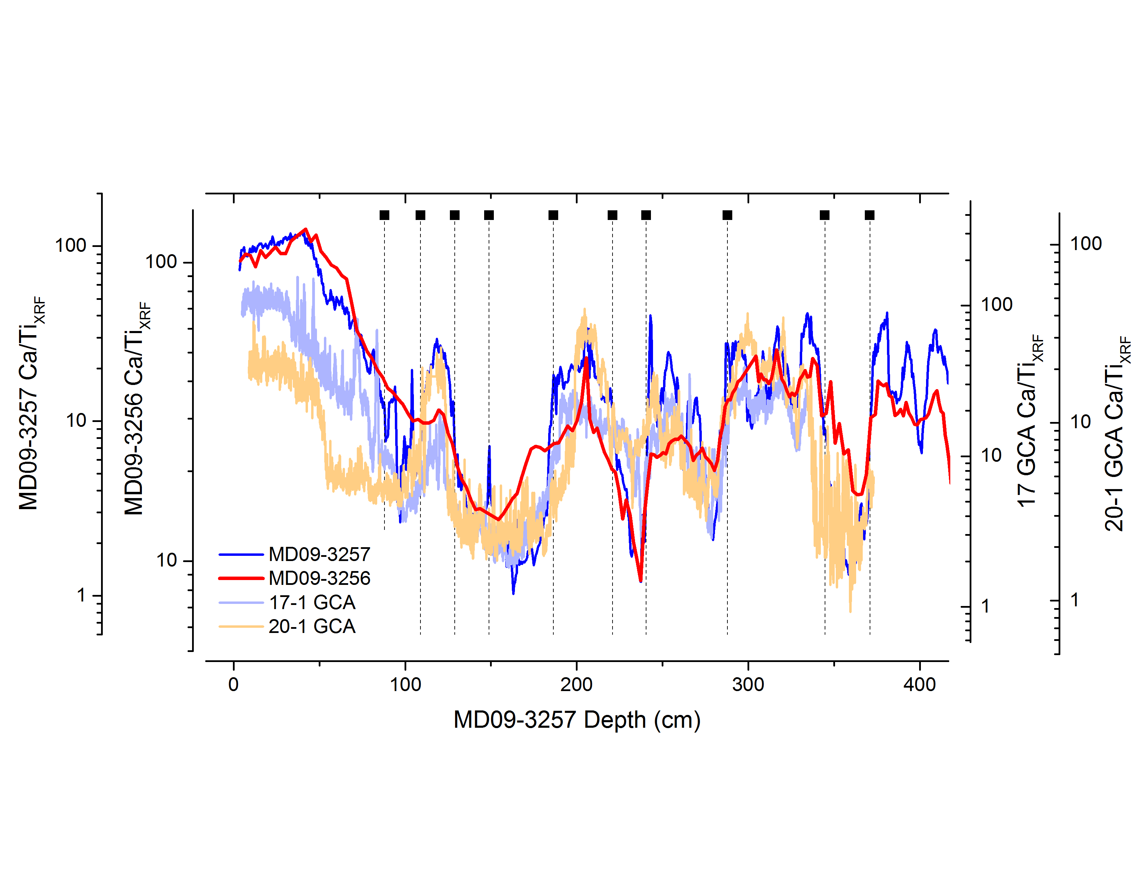***

**Figure S2.** Alignment of sediment cores from the Brazil Margin using Ca/TiXRF, allowing the transferal of calendar ages from core MD09-3257 to all other Brazil Margin cores, for the purpose of evaluating past reservoir age variability. Black squares and vertical dashed lines indicate tie-points (cores were also assumed to have the same core-top age).

**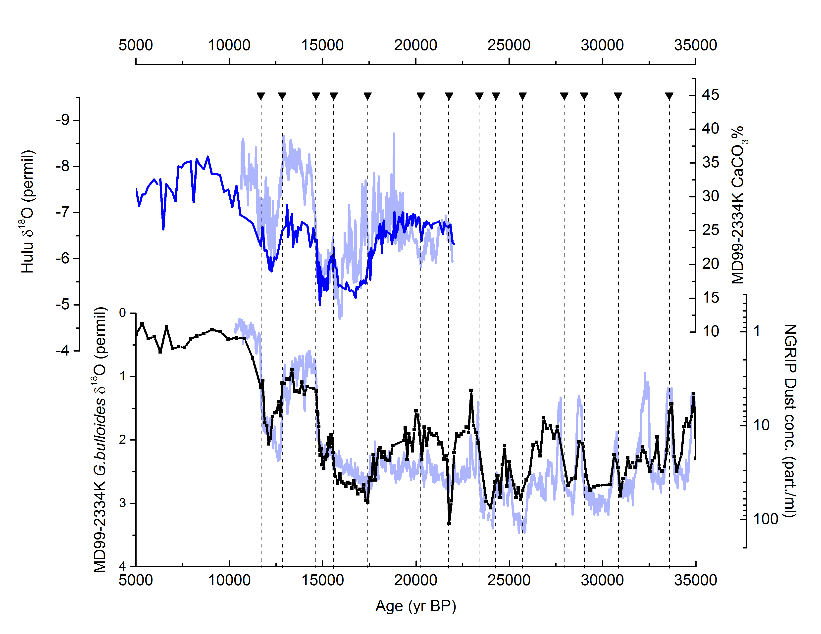**

**Figure S3.** Stratigraphic alignment of sedimentary CaCO3 content in core MD99-2334K (upper plot, dark blue line) to the Hulu speleothem record [*Southon et al.*, 2012] (upper pot, light blue line), and the parallel alignment of planktonic δ18O from MD99-2334K (lower plot, black line and symbols) to the NGRIP dust concentration record [*Ruth et al.*, 2003] on the GICC05 age-scale [*Svensson et al.*, 2008] (lower plot, light blue line), for the purpose of evaluating past reservoir age variability. Tie points are indicated by black triangles and dashed lines.

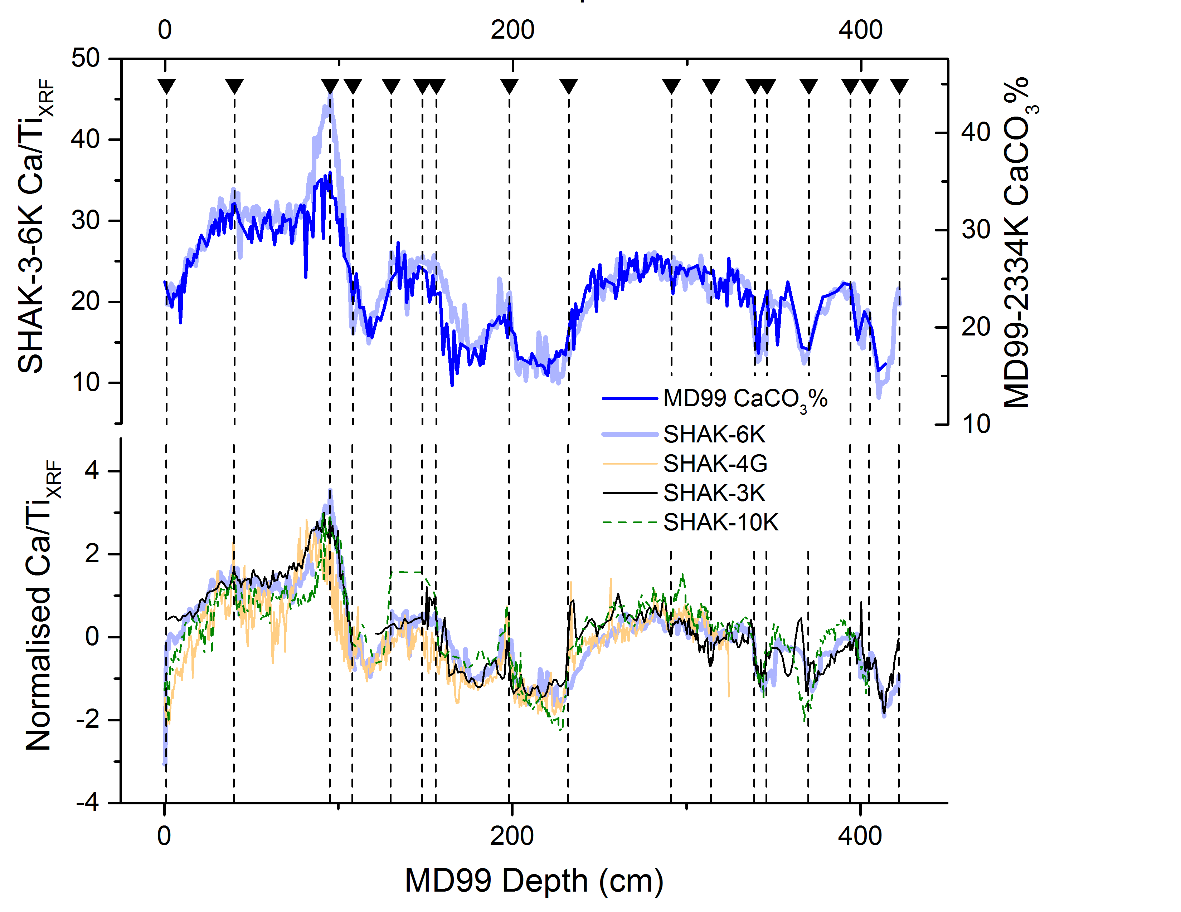

**Figure S4.** Alignment of Iberian margin cores using Ca/TiXRF, and the alignment of Ca/TiXRF in core SHAK-3-6K to CaCO3% measured in core MD99-2334K, allowing the transferral of calendar ages from MD99-2334K to all other Iberian Margin cores, for the purpose of evaluating past reservoir age variability. Black triangles and vertical dashed lines indicate tie-points.

**New%20Figures/Fig%20S5_IM%20errors.pdf**

**Figure S5.** Illustration of uncertainties associated with the final radiocarbon-based chronologies for the Iberian Margin sediment cores. The bottom plot shows NGRIP dust on the GICC05 age-scale compared with MD99-2334K planktonic (*Globigerina bulloides*) stable isotopes, plotted on the median (solid grey line), and 2.5/97.5% cumulative probability (dashed grey lines) *Bchron* chronologies, showing the chronostratigraphic implications of the uncertainties in the final radiocarbon-based sediment depth-age model for this core. The top plots show the final *Bchron* chronology for core MD99-2334 (solid blue line), including the 2.5% and 97.5% cumulative probability range (shaded area), as well as the uncertainty in the final chronology for MD99-2334K (solid grey line), estimated as half of the 2.5-97.5% probability range. Symbols show the calendar age uncertainties for sediment depths corresponding to radiocarbon dates in all Iberian Margin cores (see legend).

New%20Figures/Fig%20S6_Br%20errors.pdf

Figure S6. Illustration of uncertainties associated with the final radiocarbon-based chronologies for the Brazil Margin sediment cores. The bottom plot shows NGRIP dust on the GICC05 age-scale, compared with MD09-3257 Ca/TiXRF ratios that are plotted on the median (solid blue line), and 2.5/97.5% cumulative probability (dashed blue lines) *Bchron* chronologies, as well as the stratigraphic alignment (solid yellow line) used to obtain initial reservoir estimates; illustrating the chronostratigraphic implications of the uncertainties in the final radiocarbon-based sediment depth-age model, as well as the use of modelled reservoir ages from [*Butzin et al.*, 2017] (which introduce a delay in what is interpreted to correspond to the BA onset). The middle plot shows the final radiocarbon-based *Bchron* chronology for core MD09-3257 (solid blue line), including the 2.5% and 97.5% cumulative probability range (shaded area). The top plot shows uncertainties in the final chronology for MD09-3257 (solid grey line), estimated as half of the 2.5-97.5% probability range; symbols show the calendar age uncertainties for sediment depths corresponding to radiocarbon dates all Brazil Margin cores (see legend).

Table S1. Age pins and R-ages (separate file)

Table S2. Sediment core age models, based on *Bchron* sediment-depth age models using R-age corrected radiocarbon calibration curves as described in the main text. (separate file)

Table S3. Radiocarbon data (separate file)

Table S4. Stable carbon isotope data (separate file)

Table S5. Time-slice averages for B-Atm age offsets and δ13C data (separate file)

**Supplementary references**

Butzin, M., P. Köhler, and G. Lohmann (2017), Marine radiocarbon reservoir age simulations for the past 50,000 years, Geophys. Res. Lett., 44(16), 8473-8480, doi: doi:10.1002/2017GL074688.

Ruth, U., D. Wagenbach, J. P. Steffensen, and M. Bigler (2003), Continuous record of microparticle concentration and size distribution in the central Greenland NGRIP ice core during the last glacial period, Journal of Geophysical Research: Atmospheres, 108(D3), doi: 10.1029/2002JD002376.

Southon, J., A. L. Noronha, H. Cheng, R. L. Edwards, and Y. Wang (2012), A high-resolution record of atmospheric C-14 based on Hulu Cave speleothem H82, Quat. Sci. Rev., 33, 32-41, doi: 10.1016/j.quascirev.2011.11.022.

Svensson, A., et al. (2008), A 60,000 year Greenland stratigraphic ice core chronology, Clim. Past, 4, 47-57.