Geophysical Research Letters
Supporting Information for
Global Microbarom Patterns: a First Confirmation of the Theory for Source and Propagation
M. De Carlo^{1,2}, P. Hupe³, A. Le Pichon¹, L. Ceranna³ and F. Ardhuin⁴
¹CEA, DAM, DIF, F-91297 Arpajon, France.
²Université de Bretagne Occidentale, Brest, France.
³BGR, B4.3, Hannover, Germany.
⁴University of Brest, CNRS, Laboratoire d’Océanographie Physique et Spatiale (LOPS), IUEM, Brest, France.
Contents of this file

Text S1
Figures S1 to S3
Table S1
Introduction
This supporting information gives more details about the binarization of the model spectrum and the choice of the threshold. Figures S1 and S2 represent intermediate steps to obtain the CPO, and Figure S3 displays the CPO differences distributions for various thresholds.

Text S1. Threshold choice for the metric
The normalized directional spectrum is binarized using a threshold. The model is false, respectively true, if the amplitude is lower, resp. larger, than a given threshold, respectively. The azimuth-time cells are divided into four categories (Figures S1 and S2):
- Model true with observations (MTOT - green dots) – hits
- Model true without observations (MTOF - white color) – false alarms
- Model false with observations (MFOT - red dots) – misses
- Model false without observations (MFOF - grey color) – correct rejections
A quantity of interest is the ratio of predicted observations:
$CPO=\frac{MTOT}{MTOT+MFTOT}$ (S1)
To determine the optimal threshold, we define a score enhancing the positive impact when the model is in agreement with the observations (MTOT or MFOF) and the negative impact otherwise (MTOF and MFOT). We define the normalized cost function C as:
$C\left(i\right)=MTOT_{st}\left(i\right)+MFOF_{st}\left(i\right)-MTOF_{st}\left(i\right)-MFOT_{st}(i)$ (S2)
where $X_{st}\left(i\right)=\frac{X\left(i\right)-\underset{i}{mean}{(X\left(i\right))}}{\max_{i}{(X\left(i\right))}}$, X denoting the standardized distribution of MTOT, MFOF, MTOF or MFOT amongst the different thresholds$i$.
The cost function is calculated for different thresholds (from 0.1 to 0.9 with a step of 0.1, Table S1), leading to an optimal value of 0.4.
Fig. S3 compares the CPO difference for WW3, wind and source model parameters and different thresholds. The main results are not changed, but the higher the threshold the larger is the impact of the source model.
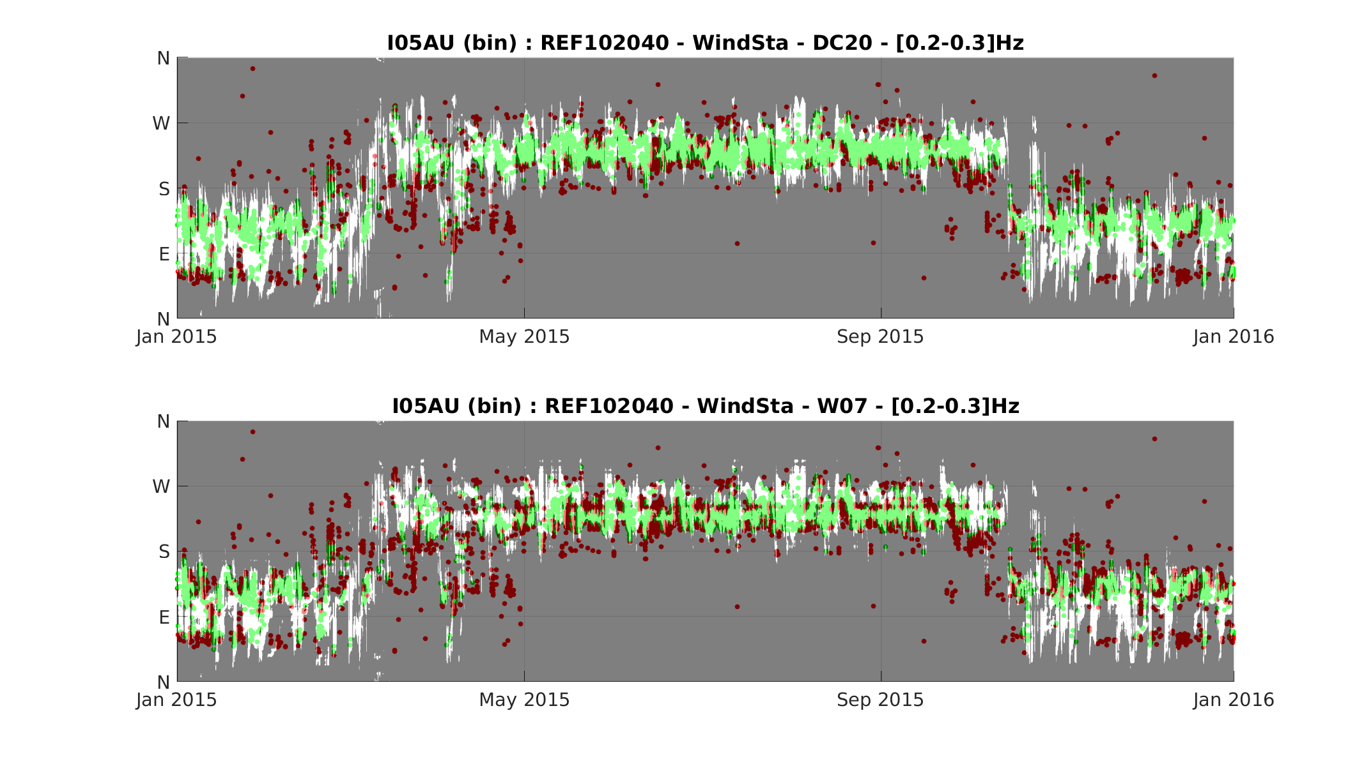Figure S1. Results of the binarization at I05AU between 0.2 Hz and 0.3 Hz for 2015 with a threshold of 0.4. MTOF and MFOF are shown in white and grey, respectively. Green and red dots are predicted (MTOT) and unpredicted (MFOT) observations, respectively. The model uses the configuration with coastal reflection ‘REF102040’ and wind at the station. The source model corresponds to DC20 for the top panel and to W07 for the bottom panel. 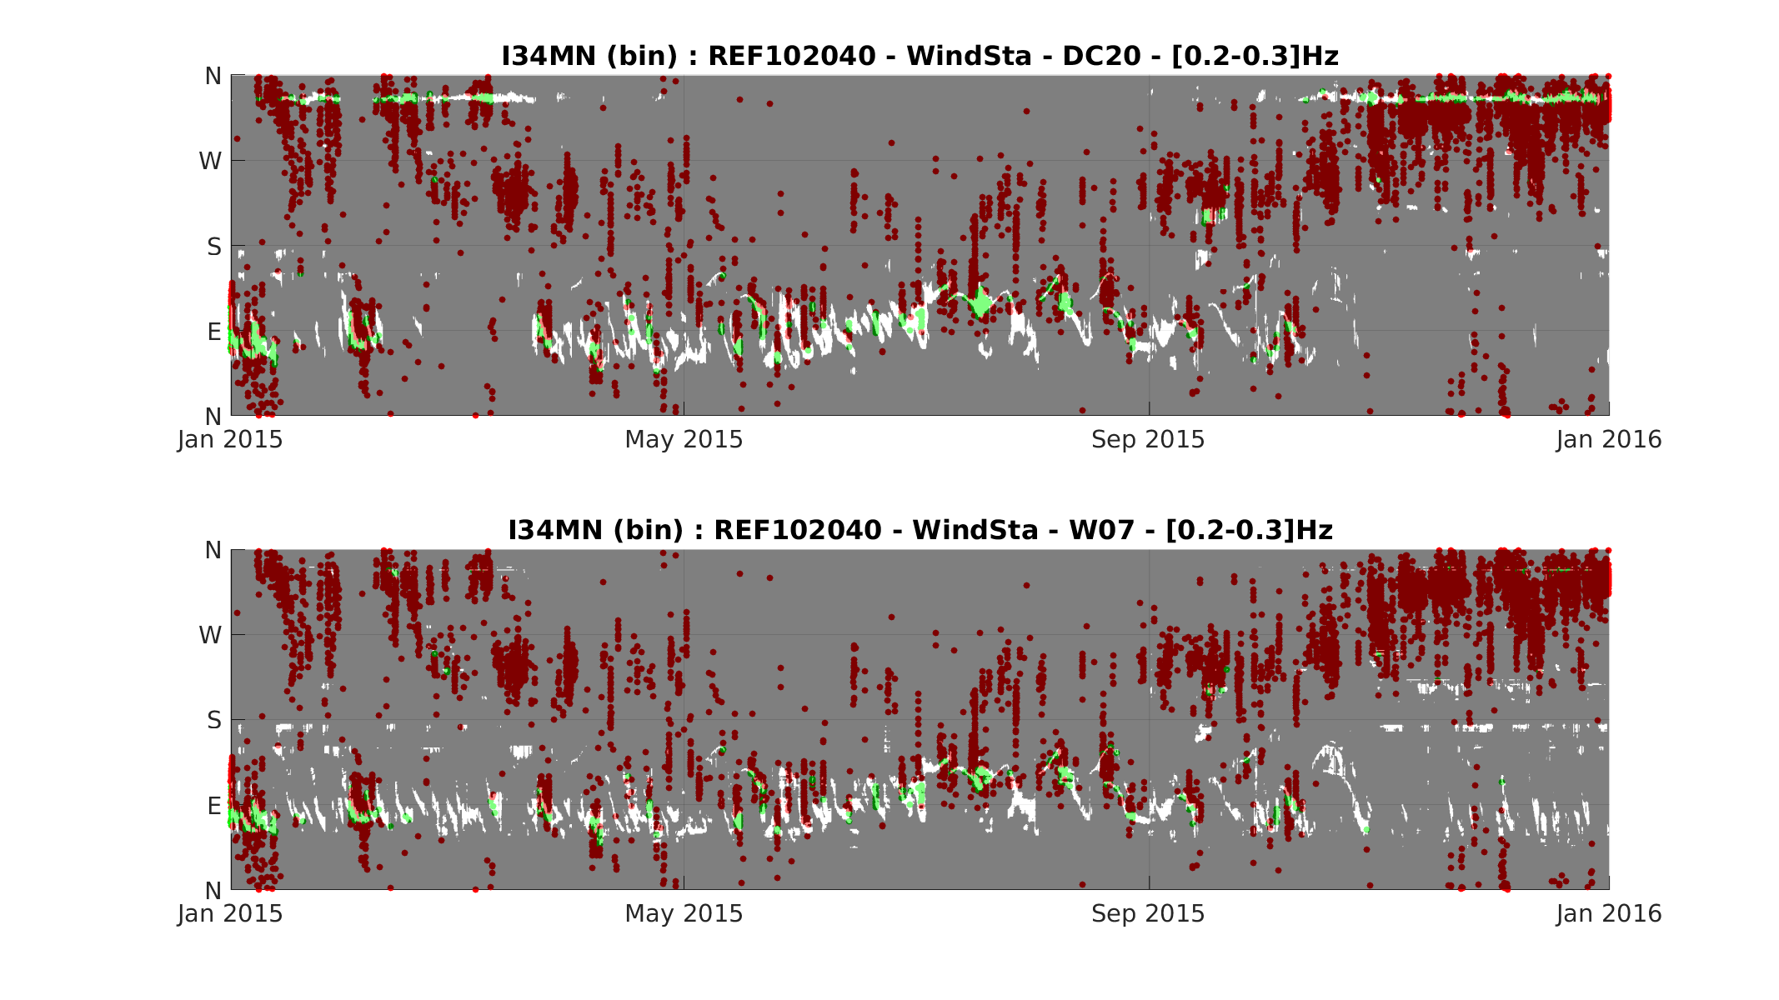Figure S2. Same as Figure S1 at I34MN.

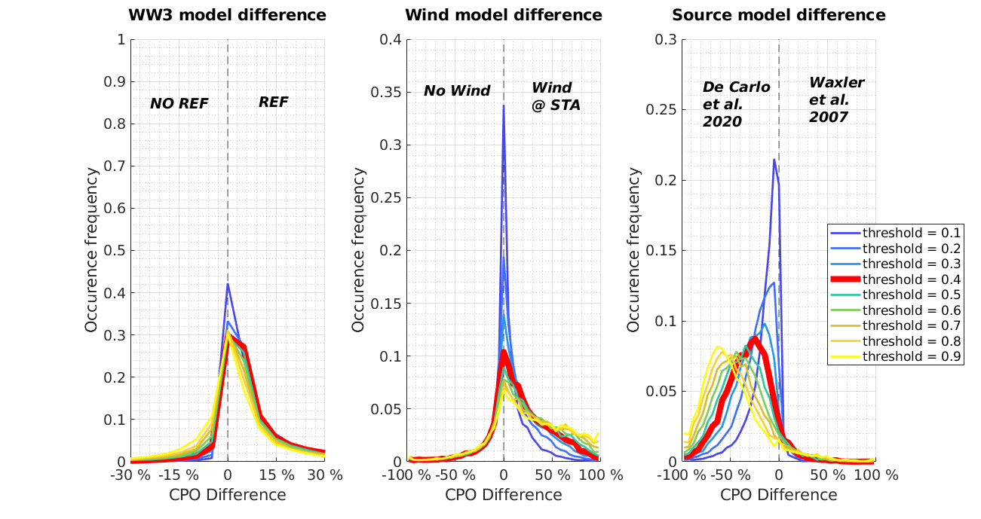

Figure S3. Repartition of the CPO difference for all three parameters, normalized by the number of detections – the 1st, 2nd and 3rd columns correspond to the WW3 coastal reflection, stratospheric wind and the source model parameters, respectively. The colored curves represent different thresholds, the chosen threshold is identified in bold red. For each panel, the x-axis denotes the CPO difference between the right-hand (minuend) and the left-hand parameter run (subtrahend), relative to the maximum CPO of the two parameter runs.

Threshold i | Cost $C(i)$
0.1 | -0.5276
0.2 | 0.1537
0.3 | 0.3496
0.4 | 0.3538
0.5 | 0.2638
0.6 | 0.1247
0.7 | -0.0457
0.8 | -0.2345
0.9 | -0.4378

Table S1. Comparison of cost function for different thresholds.

