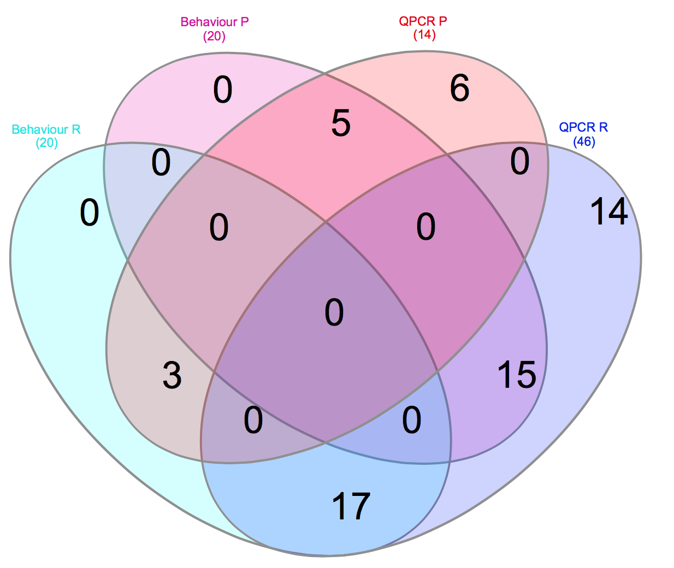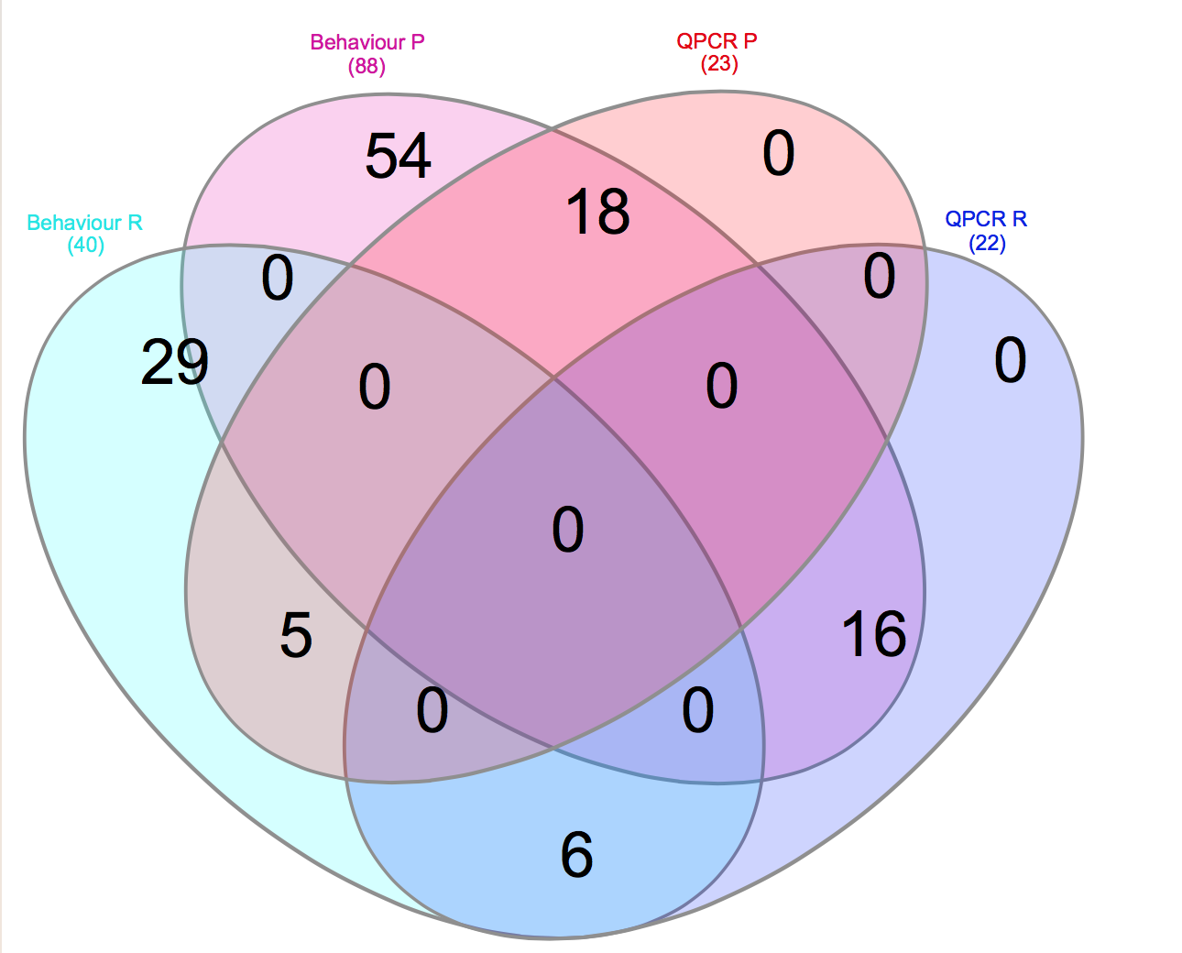

**b)**

**a)**

**Supporting\_Figure1**. **Individual personality identification by both behavior test and QPCR assay**. Unique individual running number were used to identified proactive animals with both behavior boldness and behavior gene markers positive. a) S.salar proactive individuals N=18; b) D.labrax proactive individuals N= 5.

Macintosh HD:Users:xingkunj:Dropbox:ComparaCod:RESULTS:Brain RNA-Seq:Figures&Tables:copewell-busco.pdf

**Supporting\_Figure2. Completeness estimation of Trinity assemblies of Illumina RNA-Seq by BUSCO.** Abbreviation: Ss: *S. salar*; Dl: *D. labrax*; Trans: transcriptome; Geno: Genome.

Macintosh HD:Users:xingkunj:Dropbox:ComparaCod:RESULTS:Brain RNA-Seq:Zebrafish_proactiv_ctl_for_limma:D.rerio brain plot density before correction.pdf

Macintosh HD:Users:xingkunj:Dropbox:ComparaCod:RESULTS:Brain RNA-Seq:Zebrafish_proactiv_ctl_for_limma:d.rerio brain plot densities after correction.pdf

**a-ii)**

**a-i)**

Macintosh HD:Users:xingkunj:Dropbox:ComparaCod:RESULTS:Brain RNA-Seq:Zebrafish_proactiv_ctl_for_limma:D.rerio brain log2 intensity before correction.pdf

Macintosh HD:Users:xingkunj:Dropbox:ComparaCod:RESULTS:Brain RNA-Seq:Zebrafish_proactiv_ctl_for_limma:D.rerio brain log2 intensity after correction.pdf

**b-ii)**

**b-i)**

**Supporting\_Figure3. Between-microarrays normalization of *D. rerio* brain transcriptome**. a) Distribution densities of probe intensities were compared before- (a-i) and after (a-ii) normalization; b) Log2-transformed intensities of each microarray were shown before before- (b-i) and after (b-ii) normalization.



**Supporting\_Figure4. Transcriptomic gene list of D.rerio brain with annotations.** The numbers of annotated genes obtained by Microarray approach (Rey, Boltana et al. 2013) were shown in orange; while the ones obtained by Illumina RNA-Seq (Wong, McLeod et al. 2014) were shown in Dark Green.

**References**

Rey, S., S. Boltana, R. Vargas, N. Roher and S. MacKenzie (2013). "Combining animal personalities with transcriptomics resolves individual variation within a wild-type zebrafish population and identifies underpinning molecular differences in brain function." Molecular Ecology **22**(24): 6100-6115.

Wong, R. Y., M. M. McLeod and J. Godwin (2014). "Limited sex-biased neural gene expression patterns across strains in Zebrafish (Danio rerio)." BMC Genomics **15**(1): 1-9.

Macintosh HD:Users:xingkunj:Dropbox:ComparaCod:RESULTS:Brain RNA-Seq:Figures&Tables:seabass-diffExpr.P0.05_C0.matrix.log2.sample_cor_matrix.pdf

Macintosh HD:Users:xingkunj:Dropbox:ComparaCod:RESULTS:Brain RNA-Seq:Figures&Tables:salmon-diffExpr.P0.05_C0.matrix.log2.sample_cor_matrix.pdf

**b**

**a**

**Supporting\_Figure 5. Spearman Correlation estimation of DEGs within each species sequenced by Illumina platform.**

Heat map showing the hierarchically clustered Spearman correlation matrix resulting from comparing the transcript expression values (TMM-normalized FPKM) for each pair of samples from both species: i.e. a) *S. salar*; b) *D. labrax*.