Journal of Geophysical Research - Oceans
Supporting Information for
Assimilation of ocean-colour plankton functional types to improve marine ecosystem simulations

S. Ciavatta^{1,2}, R. J. W. Brewin^{1,2}, J. Skakala^{1,2}, L. Polimene¹, L. de Mora¹, Y. Artioli¹ and J. I. Allen^{1,2}

¹ Plymouth Marine Laboratory, PL1 3DH Plymouth, UK
² National Centre for Earth Observation, Plymouth Marine Laboratory, UK

Contents of this file

Figures S1 to S3
Table S1

Introduction
We report here additional figures relative to the skill assessment of the assimilation of plankton functional types (PFTs), for areas of the model domain other than the upper-shelf waters (Figure S1). We report also some additional figures relative to the numerical experiment presented in the Appendix 1 of the paper, for completeness (Figures S2 and S3). The numerical experiment consisted in the assimilation of total chlorophyll from ocean colour into a configuration of the model ERSEM that used the parameterization by Blackford et al. [2004] , instead of the novel parameterization by Butenschön et al [2016] (see the differences between the two parameterizations in Table S1).

A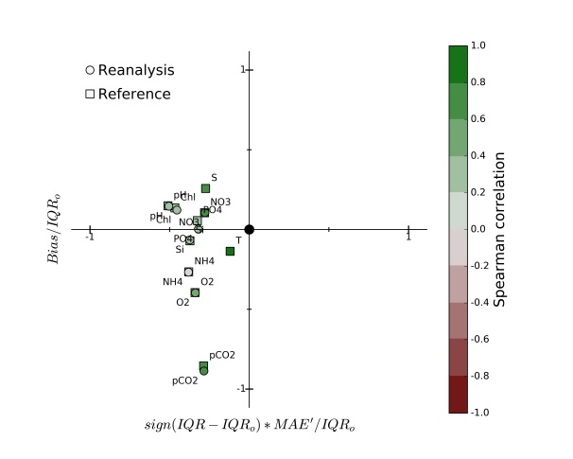 | B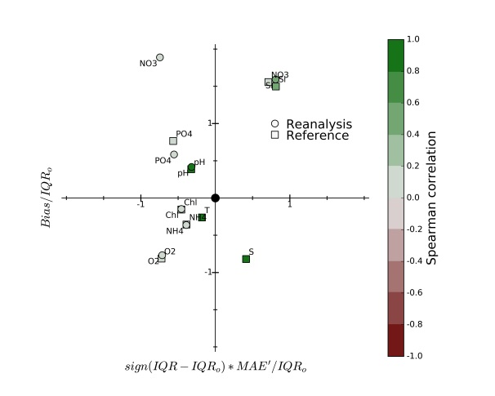
C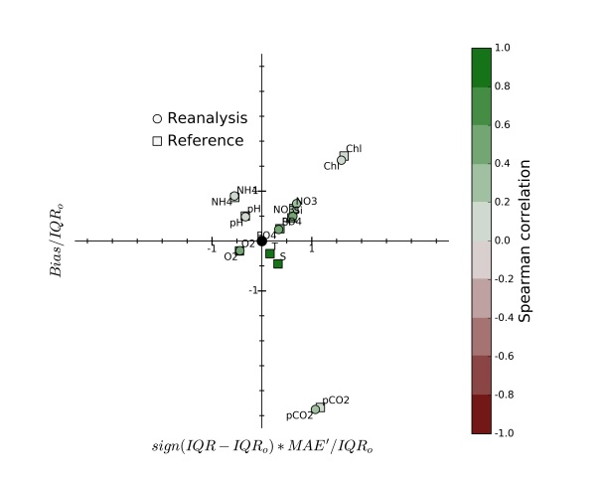 | D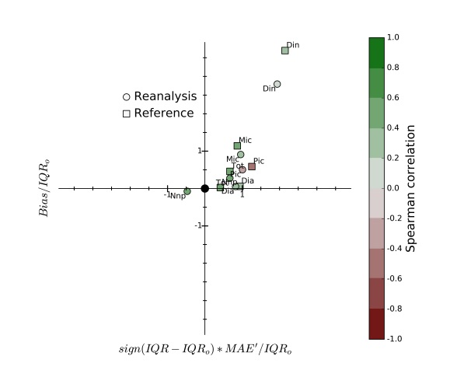
E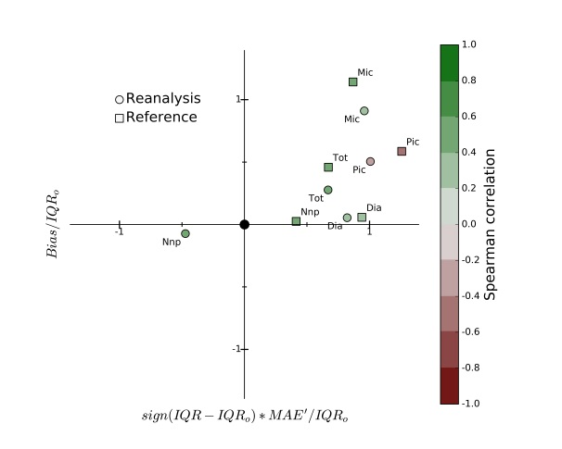 | F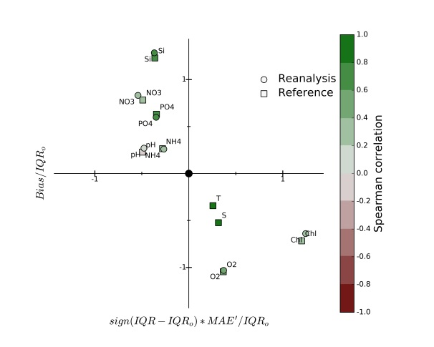
Figure S1. Comparison of the skills of the reanalysis (circle) and reference (squares) simulations in estimating in situ biogeochemical and PFT data measured in different areas of the model domain: A) Coastal waters: biogeochemical and physical variables; B) deeper-shelf waters: biogeochemical and physical variables; C) upper-ocean waters: biogeochemical and physical variables; D) upper-ocean waters: PFT data; E) upper-ocean waters: PFT data excluding dinoflagellates; F) deeper-ocean waters: biogeochemical and physical variables. The notation of the variables is defined in Figure 6 of the manuscript. The robust metrics represented in the skill diagrams are defined in Section 2.4 of the Methods.

.
Diatoms, new parameterization  31% (66%) | Diatoms, old parameterization  40% (60%)
Dinoflagellates, new parameterization  47% (51%) | Dinoflagellates, old parameterization  50% (47%)
Nanoflagellates, new parameterization  45% (53%) | Nanoflagellates, old parameterization  47% (51%)

Figure S2. Percentage changes of reference RMSD when assimilating total chlorophyll using the new Butenschön et al. [2016] (left) and previous Blackford et al. [2004] (right) parameterizations. The numbers indicate the percentage of the shelf area where assimilation improved (deteriorated) the reference simulation.
New Parametrization of the PFTs | Previous parameterization of the PFTs
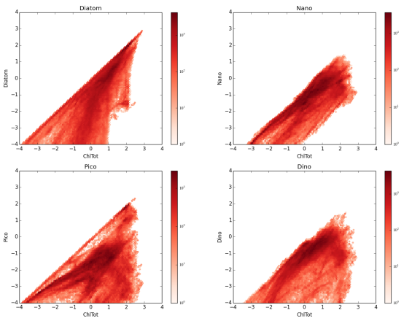 | 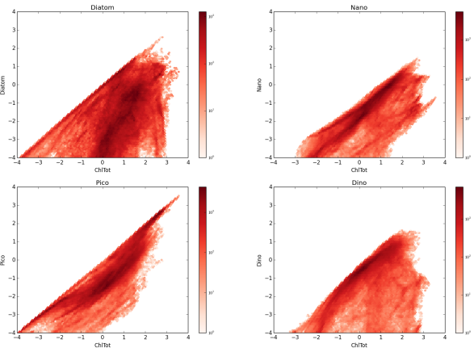
Figure S3: Density scatterplots of the log-transformed chlorophyll concentration of PFTs (y-axis, clockwise: diatoms, nanoplankton, dinoflagellates, picoplankton) versus total chlorophyll (x-axis, ChlTot). The concentrations are ensembles forecasts in the assimilative simulations for year 1998 using the new [Butenschön et al., 2016] and previous [Blackford et al., 2004] parameterization of the PFTs in ERSEM. The plots of picoplankton are shown also in Figure A3 of Appendix 1 in the paper.

Parameter | Notation | a | b
Initial slope of PI-curve for diatoms[mg C m^2 /mg Chl/W/d] | alphaP1X | 4.00E+00 | 2.98E+00
Initial slope of PI-curve for nanophytoplankton [mg C m^2 /mg Chl/W/d] | alphaP2X | 5.00E+00 | 2.98E+00
Initial slope of PI-curve for picophytoplankton [mg C m^2 /mg Chl/W/d] | alphaP3X | 6.00E+00 | 2.98E+00
Initial slope of PI-curve for microphytoplankton [mg C m^2 /mg Chl/W/d] | alphaP4X | 3.00E+00 | 2.98E+00
Photo-inhibition parameter for diatoms [mg C m^2 /mg Chl/W/d] | betaP1X | 7.00E-02 | 2.00E-02
Photo-inhibition parameter for nanophytoplankton [mg C m^2 /mg Chl/W/d] | betaP2X | 1.00E-01 | 2.00E-02
Photo-inhibition parameter for picophytoplankton [mg C m^2 /mg Chl/W/d] | betaP3X | 1.20E-01 | 2.00E-02
Photo-inhibition parameter for microphytoplankton [mg C m^2 /mg Chl/W/d] | betaP4X | 6.00E-02 | 2.00E-02
Michaelis-Menten constant for Silicate limitation [mmol Si/m^3] | chP1sX | 2.00E-01 | 3.00E-01
Level of nutrient limitation below which diatoms subside | esNIP1X | 7.00E-01 | 7.00E-01
Level of nutrient limitation below which medium size phytoplankton subsides | esNIP2X | 7.00E-01 | 7.50E-01
Level of nutrient limitation below which small phytoplankton subsides | esNIP3X | 7.00E-01 | 7.50E-01
Level of nutrient limitation below which large phytoplankton subsides | esNIP4X | 7.00E-01 | 7.50E-01
photosynthetically available fraction of irradiation | peir_eowX | 5.00E-01 | 5.00E-01
Maximal effective chlorophyll to carbon photosynthesis ratio of diatoms [mg Chl/mg C] | phimP1X | 6.00E-02 | 3.50E-02
Maximal effective chlorophyll to carbon photosynthesis ratio of nanophytoplankton [mg Chl/mg C] | phimP2X | 2.50E-02 | 3.50E-02
Maximal effective chlorophyll to carbon photosynthesis ratio of picophytoplankton [mg Chl/mg C] | phimP3X | 1.50E-02 | 3.50E-02
Maximal effective chlorophyll to carbon photosynthesis ratio of microphytoplankton [mg Chl/mg C] | phimP4X | 4.50E-02 | 3.50E-02
Excreted fraction of primary production by diatoms | pu_eaP1X | 2.00E-01 | 5.00E-02
Excreted fraction of primary production by medium size phytoplankton | pu_eaP2X | 2.00E-01 | 2.00E-01
Excreted fraction of primary production by small phytoplankton | pu_eaP3X | 2.00E-01 | 2.00E-01
Excreted fraction of primary production by large phytoplankton | pu_eaP4X | 2.00E-01 | 5.00E-02
Respired fraction of primary production by diatoms (activity respiration) | pu_raP1X | 2.00E-01 | 1.00E-01
Respired fraction of primary production by medium size phytoplankton (activity respiration) | pu_raP2X | 2.00E-01 | 2.50E-01
Respired fraction of primary production by small phytoplankton (activity respiration) | pu_raP3X | 2.00E-01 | 2.50E-01
Respired fraction of primary production by large phytoplankton (activity respiration) | pu_raP4X | 2.00E-01 | 2.50E-01
Regulating temperature factor Q10 for diatoms | q10P1X | 2.00E+00 | 2.00E+00
Regulating temperature factor Q10 for medium size phytoplankton | q10P2X | 2.00E+00 | 2.00E+00
Regulating temperature factor Q10 for small phytoplankton | q10P3X | 2.00E+00 | 2.00E+00
Regulating temperature factor Q10 for large phytoplankton | q10P4X | 2.00E+00 | 2.00E+00
Minimal iron to carbon ratio of diatoms [umol Fe/mg C] | qflP1cX | 5.00E-05 | 2.50E-04
Minimal iron to carbon ratio of medium size phytoplankton [umol Fe/mg C] | qflP2cX | 1.00E-04 | 9.00E-05
Minimal iron to carbon ratio of small phytoplankton [umol Fe/mg C] | qflP3cX | 1.50E-04 | 5.00E-05
Minimal iron to carbon ratio of large phytoplankton [umol Fe/mg C] | qflP4cX | 5.00E-05 | 2.50E-04
Maximal/optimal iron to carbon ratio of diatoms [umol Fe/mg C] | qfRP1cX | 5.00E-04 | 5.00E-04
Maximal/optimal iron to carbon ratio of medium size phytoplankton [umol Fe/mg C] | qfRP2cX | 3.00E-04 | 3.00E-04
Maximal/optimal iron to carbon ratio of small phytoplankton [umol Fe/mg C] | qfRP3cX | 5.00E-04 | 5.00E-04
Maximal/optimal iron to carbon ratio of large phytoplankton [umol Fe/mg C] | qfRP4cX | 5.00E-04 | 5.00E-04
Minimal nitrogen to carbon ratio for diatoms [mmol N/mg C] | qnlP1cX | 4.20E-03 | 6.87E-03
Parameter | Notation | a | b
Minimal nitrogen to carbon ratio for medium size phytoplankton [mmol N/mg C] | qnlP2cX | 5.00E-03 | 6.87E-03
Minimal nitrogen to carbon ratio for small phytoplankton [mmol N/mg C] | qnlP3cX | 6.00E-03 | 6.87E-03
Minimal nitrogen to carbon ratio for large phytoplankton [mmol N/mg C] | qnlP4cX | 4.20E-03 | 6.87E-03
Inverse Redfield ratio of nitrogen to carbon [mmol N/mg C] | qnRPIcX | 1.26E-02 | 1.26E-02
Minimal phosphorus to carbon ratio for diatoms [mmol P/mg C] | qplP1cX | 1.00E-04 | 4.29E-04
Minimal phosphorus to carbon ratio for medium size phytoplankton [mmol P/mg C] | qplP2cX | 2.25E-04 | 4.29E-04
Minimal phosphorus to carbon ratio for small phytoplankton [mmol P/mg C] | qplP3cX | 3.50E-04 | 4.29E-04
Minimal phosphorus to carbon ratio for large phytoplankton [mmol P/mg C] | qplP4cX | 1.00E-04 | 4.29E-04
Inverse Redfield ratio of Phosphorus to carbon [mmol P/mg C] | qpRPIcX | 7.86E-04 | 7.86E-04
Maximal silicon to carbon ratio of diatoms [mmol Si/mg C] | qsP1cX | 1.18E-02 | 3.00E-02
Nitrate affinity of diatoms [m^3/mg C/d] | quP1n3X | 2.50E-03 | 2.50E-03
Ammonium affinity of diatoms [m^3/mg C/d] | quP1n4X | 2.50E-03 | 1.00E-02
Nitrate affinity of medium size phytoplankton [m^3/mg C/d] | quP2n3X | 4.00E-03 | 2.50E-03
Ammonium affinity of medium size phytoplankton [m^3/mg C/d] | quP2n4X | 4.00E-03 | 1.00E-02
Nitrate affinity of small phytoplankton [m^3/mg C/d] | quP3n3X | 6.00E-03 | 2.50E-03
Ammonium affinity of small phytoplankton [m^3/mg C/d] | quP3n4X | 7.00E-03 | 2.00E-02
Nitrate affinity of large phytoplankton [m^3/mg C/d] | quP4n3X | 2.00E-03 | 2.50E-03
Ammonium affinity of large phytoplankton [m^3/mg C/d] | quP4n4X | 2.00E-03 | 1.00E-02
Specific affinity constant of diatoms for iron [m^3/mg C/d] | qurP1fX | 3.00E-04 | 4.00E-04
Phosphate affinity of diatoms [m^3/mg C/d] | qurP1pX | 3.00E-03 | 2.50E-03
Specific affinity constant of medium size phytoplankton for iron [m^3/mg C/d] | qurP2fX | 4.00E-04 | 4.00E-04
Phosphate affinity of medium size phytoplankton [m^3/mg C/d] | qurP2pX | 4.00E-03 | 2.50E-03
Specific affinity constant of small phytoplankton for iron [m^3/mg C/d] | qurP3fX | 6.00E-04 | 4.00E-04
Phosphate affinity of small phytoplankton [m^3/mg C/d] | qurP3pX | 6.00E-03 | 2.50E-03
Specific affinity constant of large phytoplankton for iron [m^3/mg C/d] | qurP4fX | 2.00E-04 | 4.00E-04
Phosphate affinity of large phytoplankton [m^3/mg C/d] | qurP4pX | 2.00E-03 | 2.50E-03
Maximal subsiding velocity of diatoms [m/d] | resP1mX | 5.00E+00 | 5.00E+00
Maximal subsiding velocity of medium size phytoplankton [m/d] | resP2mX | 0.00E+00 | 0.00E+00
Maximal subsiding velocity of small phytoplankton [m/d] | resP3mX | 0.00E+00 | 0.00E+00
Maximal subsiding velocity of large phytoplankton [m/d] | resP4mX | 5.00E+00 | 5.00E+00
1.1 of minimal specific lysis rate of diatoms [1/d] | sdoP1X | 5.00E-02 | 5.00E-02
1.1 of minimal specific lysis rate of medium size phytoplankton [1/d] | sdoP2X | 5.00E-02 | 5.00E-02
1.1 of minimal specific lysis rate of small phytoplankton [1/d] | sdoP3X | 5.50E-02 | 5.00E-02
1.1 of minimal specific lysis rate of large phytoplankton [1/d] | sdoP4X | 4.50E-02 | 5.00E-02
Specific tendency of luxury uptake of nutrients towards maximum quota (1/d) | sNPlux | 1.00E+00 | 1.00E+00
Specific rest respiration of diatoms at reference temperature [1/d] | srsP1X | 4.00E-02 | 5.00E-02
Specific rest respiration of medium size phytoplankton at reference temperature [1/d] | srsP2X | 4.00E-02 | 5.00E-02
Specific rest respiration of small phytoplankton at reference temperature [1/d] | srsP3X | 4.50E-02 | 5.00E-02
Specific rest respiration of large phytoplankton at reference temperature [1/d] | srsP4X | 3.50E-02 | 5.00E-02
Specific maximal productivity of diatoms at reference temperature [1/d] | sumP1X | 1.38E+00 | 2.50E+00
Parameter | Notation | a | b
Specific maximal productivity of medium size phytoplankton at reference temperature [1/d] | sumP2X | 1.63E+00 | 2.70E+00
Specific maximal productivity of small phytoplankton at reference temperature [1/d] | sumP3X | 2.00E+00 | 3.30E+00
Specific maximal productivity of large phytoplankton at reference temperature [1/d] | sumP4X | 1.13E+00 | 1.50E+00
Factor of qpRPIcX giving the threshold for phosphorus limitation of diatoms | xqcP1nX | 1.00E+00 | 1.00E+00
Factor of qnRPIcX giving the threshold for nitrogen limitation of diatoms | xqcP1pX | 1.00E+00 | 1.00E+00
Factor of qpRPIcX giving the threshold for phosphorus limitation of medium size phytoplankton | xqcP2nX | 1.00E+00 | 1.00E+00
Factor of qnRPIcX giving the threshold for nitrogen limitation of medium size phytoplankton | xqcP2pX | 1.00E+00 | 1.00E+00
Factor of qpRPIcX giving the threshold for phosphorus limitation of small phytoplankton | xqcP3nX | 1.00E+00 | 1.00E+00
Factor of qnRPIcX giving the threshold for nitrogen limitation of small phytoplankton | xqcP3pX | 1.00E+00 | 1.00E+00
Factor of qpRPIcX giving the threshold for phosphorus limitation of large phytoplankton | xqcP4nX | 1.00E+00 | 1.00E+00
Factor of qnRPIcX giving the threshold for nitrogen limitation of large phytoplankton | xqcP4pX | 1.00E+00 | 1.00E+00
Factor of qnRPIcX giving the maximal nitrogen to carbon ratio for diatoms | xqnP1X | 1.08E+00 | 2.00E+00
Factor of qnRPIcX giving the maximal nitrogen to carbon ratio for medium size phytoplankton | xqnP2X | 1.08E+00 | 2.00E+00
Factor of qnRPIcX giving the maximal nitrogen to carbon ratio for small phytoplankton | xqnP3X | 1.05E+00 | 2.00E+00
Factor of qnRPIcX giving the maximal nitrogen to carbon ratio for large phytoplankton | xqnP4X | 1.10E+00 | 2.00E+00
Factor of qpRPIcX giving the maximal phosphorus to carbon ratio for diatoms | xqpP1X | 2.00E+00 | 2.00E+00
Factor of qpRPIcX giving the maximal phosphorus to carbon ratio for medium size phytoplankton | xqpP2X | 2.00E+00 | 2.00E+00
Factor of qpRPIcX giving the maximal phosphorus to carbon ratio for small phytoplankton | xqpP3X | 1.50E+00 | 2.00E+00
Factor of qpRPIcX giving the maximal phosphorus to carbon ratio for large phytoplankton | xqpP4X | 2.70E+00 | 2.00E+00

Table S1. Parameterization of the PFTs in (a) Butenschön et al. [2016] and (b) in Blackford et al. [2004].

