SUPPORTING INFORMATION B
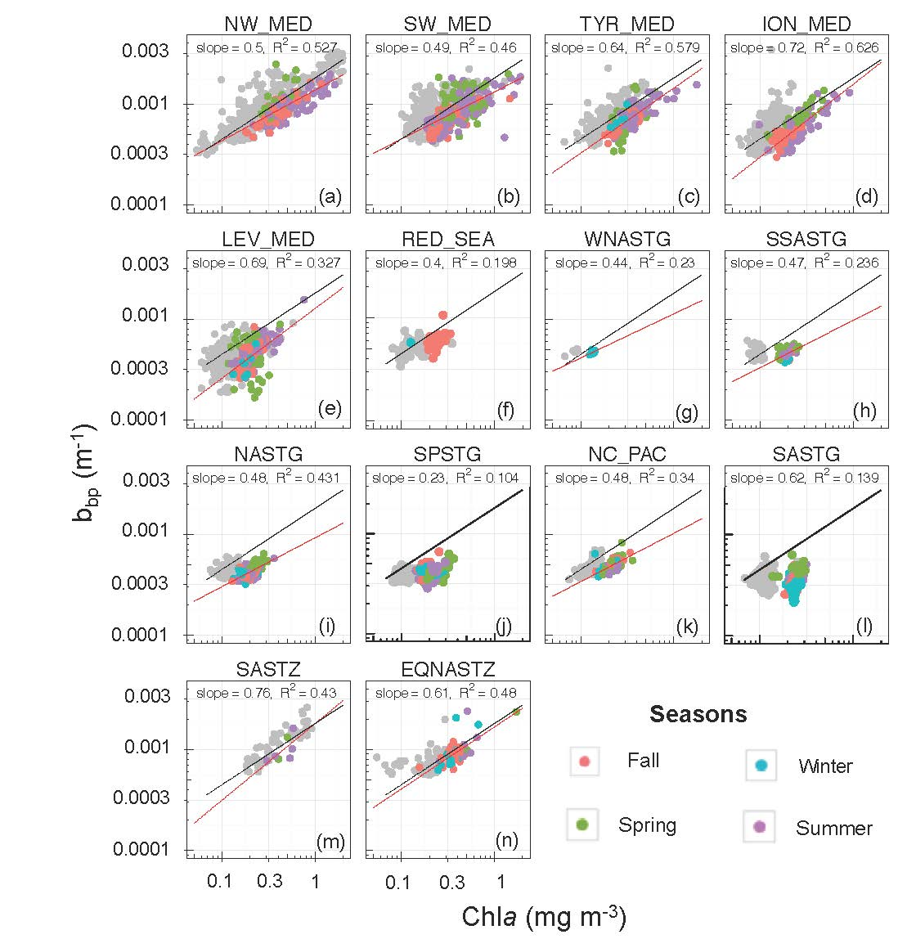
Figure B1: Log-log scatterplot of the particulate backscattering coefficient at 700 nm (b_{bp}) as a function of the chlorophyll a concentration (Chla) within the DCM layer for each bioregion. The color code indicates the season. The black line represents the average relationship calculated for the DCM layer and the red line the regression model calculated in this layer for each bioregion (shown only if R²>0.2). The data points for the productive layer are shown in grey.

