Global Biogeochemical Cycles
Supporting Information for
Carbon-based estimate of nitrogen fixation-supported net community production in N-depleted ocean gyres

Young Ho Ko¹, Kitack Lee¹*, Taro Takahashi², David M. Karl³,

Sung-Ho Kang⁴, Eunil Lee⁵

¹Division of Environmental Science and Engineering, Pohang University of Science and Technology, Pohang, Republic of Korea
²Lamont-Doherty Earth Observatory of Columbia University, Palisades, NY 10964, United States
³Daniel K. Inouye Center for Microbial Oceanography: Research and Education, University of Hawaii, Honolulu, Hawaii 96822, United States
⁴Division of Polar Ocean Sciences, Korea Polar Research Institute, KIOST, Incheon, Republic of Korea

⁵Ocean Research Division, Korea Hydrographic and Oceanographic Agency, Busan, Republic of Korea

Contents of this file

Text S1
Table S1
Table S2
Figure S1
Figure S2

Additional Supporting Information (Files uploaded separately)
Captions for Dataset S1 & Dataset S2

1. Supplemental Text
S1. Net air-sea CO₂ flux
Following the procedure described by Takahashi et al. (2009), the net air-sea CO₂ flux (F) is estimated using F = k α ΔpCO₂ = Tr ΔpCO₂, where k is the CO₂ gas transfer velocity; α is the solubility of CO₂ in seawater; Tr is the air-sea gas transfer coefficient; and ΔpCO₂ is the air-sea pCO₂ difference (pCO_{2air} – pCO_{2SW}) in the reference year 2005. Tr is calculated using the equation:

Tr (g C m⁻² month⁻¹ μatm⁻¹) = 0.585 ∙ α ∙ (Sc)^{−1/2} ∙ (U₁₀)²
where α is the solubility of CO₂ in seawater (mol liter⁻¹ atm⁻¹, (Weiss, 1974)), Sc is the Schmidt number, and U₁₀ is the wind speed (meter s⁻¹) at 10 m. The constant 0.585 is a unit conversion factor that takes into account the scaling factor for the gas transfer rate of 0.26; the conversion from (mol liter⁻¹ atm⁻¹) to (g–C m⁻³ μatm⁻¹) in CO₂ solubility in seawater; and the conversion form (cm hr⁻¹) to (m month⁻¹) in gas transfer piston velocity; and a reference Schmidt number of (660^{1/2}).

Table S1. Net air-sea CO₂ flux and diffusive C_{T} and NO₃⁻ fluxes
Basinª | Area^{b}  (10¹² m²) | Net air-sea CO₂ flux^{c} |  |  | Diffusive C_{T} and NO₃⁻ flux
 |  | (mol C m⁻²  8–month⁻¹) | Total  (Pg C 8–month⁻¹) |  | C_{T} gradient  (mmol C m⁻⁴) | NO₃⁻ gradient  (mmol N m⁻⁴) | C:N ratio of C_{T} and NO₃⁻ flux | Net C_{T} flux^{d}  (Pg C 8–month⁻¹)
North Pacific | 26.3 | 0.09 | 0.04 |  | 0.26 | 0.037 | 7.2 | 0.00
South Pacific | 15.0 | 0.08 | 0.03 |  | 0.24 | 0.024 | 10.3 | 0.01
North Atlantic | 10.6 | 0.04 | 0.00 |  | 0.20 | 0.030 | 6.7 | 0.00
South Atlantic | 8.3 | −0.12 | −0.05 |  | 0.17 | 0.049 | 3.1 | −0.01
Indian | 10.9 | 0.05 | 0.01 |  | 0.39 | 0.037 | 10.5 | 0.01
ªNet air-sea CO₂ flux was estimated using the pCO₂ climatology compiled by Takahashi et al. (2014) for each basin where C_{T} removal occurred in the absence of NO₃⁻. To calculate the diffusive C_{T} and NO₃⁻ fluxes the vertical C_{T} and NO₃⁻ profiles for each basin were separately estimated for the North Pacific (15°N–30°N, 140°E–140°W); the South Pacific (30°S–15°S, 160°E–120°W); the North Atlantic (15°N–30°N, 70$°$W–30°W); the South Atlantic (30°S–15°S, 30°W–0°W); and Indian (30°S–15°S, 20°E–90°E and 10°S–20°N, 30°E–90°E) oceans.
^{b}Total area of each basin for which NCP_{N2fix} values were available
^{c}Positive values indicate fluxes of CO₂ into the ocean, whereas negative values indicate fluxes of CO₂ out of the ocean.
^{d}Calculated using an eddy diffusivity coefficient Kv of 0.2 cm² s⁻¹ and a C:N ratio of 7.

Table S2. Estimates of horizontal C_{T} fluxes
Basin | Regionª | Zonal  nC_{T} gradient^{b}  (μmol kg⁻¹ km⁻¹) | Meridional  nC_{T} gradient^{b}  (μmol kg⁻¹ km⁻¹) | Zonal Ekman and geostrophic flow^{c}  (km day⁻¹) | Meridional Ekman and geostrophic flow^{c}  (km day⁻¹) | Net C_{T} flux^{d}  (Pg C 8–month⁻¹)
North Pacific | W | 0.0010 | 0.0097 | −5.3 | 3.6 | 0.07
 | C | 0.0043 | 0.0059 | −5.9 | 5.0
 | E | 0.0083 | 0.027 | −6.2 | 3.3
South Pacific | W | −0.0010 | −0.025 | −1.2 | −2.4 | 0.13
 | E | 0.0069 | −0.044 | 0.2 | −2.1
North Atlantic | N | 0.0078 | 0.027 | 0.2 | −0.7 | −0.04
 | S | 0.012 | 0.0023 | −5.3 | 2.0
South Atlantic | N | 0.012 | −0.011 | −4.9 | −1.8 | −0.04
 | S | 0.0055 | −0.053 | 3.2 | 1.2
Indian | Eq | 0.0051 | −0.0025 | 7.0 | −4.2 | 0.04
 | W | 0.0053 | −0.020 | −2.3 | −4.7
 | E | 0.0044 | −0.025 | −3.7 | −3.8
ªEach region is shown in Figure S1 (W: Western basin; C: Central basin; E: Eastern basin; N: Northern basin; S: Southern basin;
Eq: Equatorial region).
^{b}Positive values for Zonal (Meridonal) nC_{T} gradients indicate an eastward (northward) increase in nC_{T}.
^{c}Positive values for Zonal (Meridonal) flow indicate eastward (northward) flow.
^{d}Positive values indicate that the horizontal C_{T} flux increased seasonal nC_{T} drawdown.
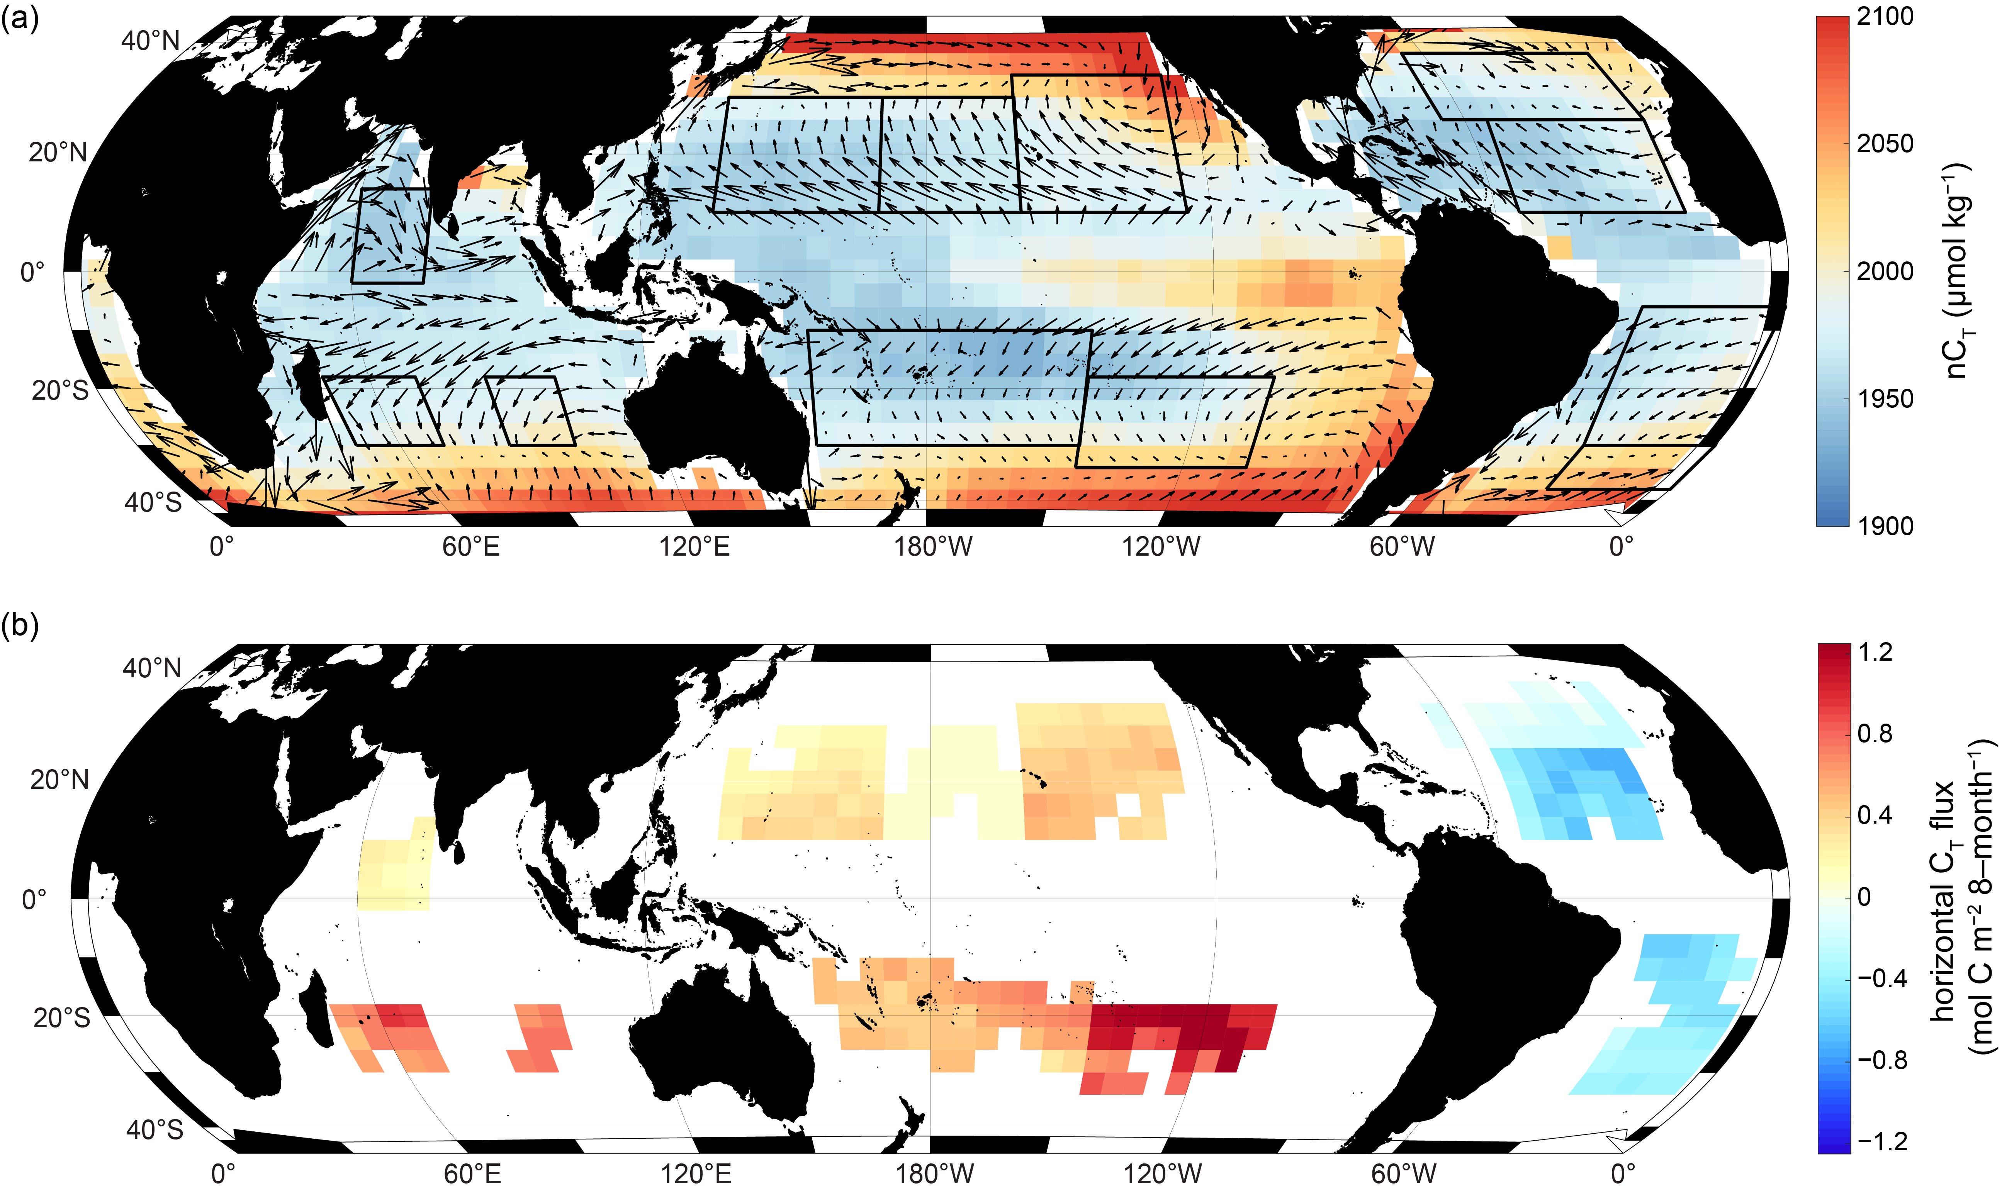
Figure S1. (a) Surface current velocities (black arrows) and horizontal nC_{T} gradients, and (b) horizontal C_{T} fluxes. Horizontal nC_{T} flues were estimated from mean horizontal velocities and horizontal nC_{T} gradients in the sub-regions indicated by the solid black boxes. Positive values of the net C_{T} flux indicate increased seasonal nC_{T} drawdown.
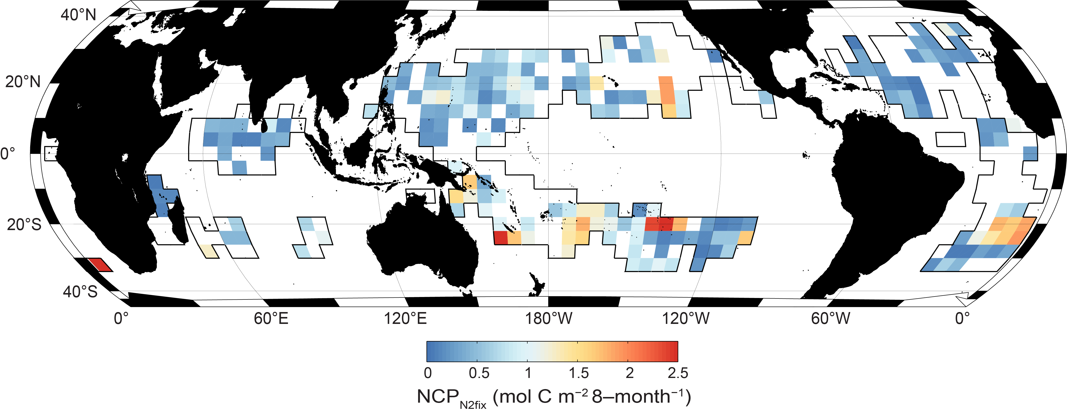
Figure S2. NCP_{N2fix} calculated based on PO₄³⁻ reduction in the N-depleted ocean (NO₃⁻ concentrations < 0.2 μmol kg⁻¹ are indicated as black solid boxes). White pixels within the solid boxes indicate no PO₄³⁻ drawdown during the warming period.

Dataset S1. NCP_{N2fix} estimates for each pixel based on the mixed layer nC_{T} reduction in the N-depleted ocean.
Dataset S2. NCP_{N2fix} estimates for each pixel based on the mixed layer PO₄³⁻ reduction in the N-depleted ocean.

