Supplementary materials
band | intercept | slope | MAPD | r² | N
412 | 0.000 | 0.998 | 0.374% | 1.000 | 1242
443 | 0.000 | 1.004 | 0.370% | 1.000 | 1242
490 | 0.000 | 1.002 | 0.252% | 1.000 | 1242
560 | 0.000 | 1.001 | 0.186% | 1.000 | 1242
665 | 0.000 | 0.999 | 0.136% | 1.000 | 1242
709 | 0.000 | 0.997 | 0.679% | 1.000 | 1242
780 | 0.000 | 0.004 | 0.2606% | 1.000 | 1242
Table S1: Statistical metrics derived from the comparison of MERIS and OLCI-S3 bands convoluted from a dataset of 1242 TriOS water reflectance measurements in coastal waters (RBINS TriOS dataset).

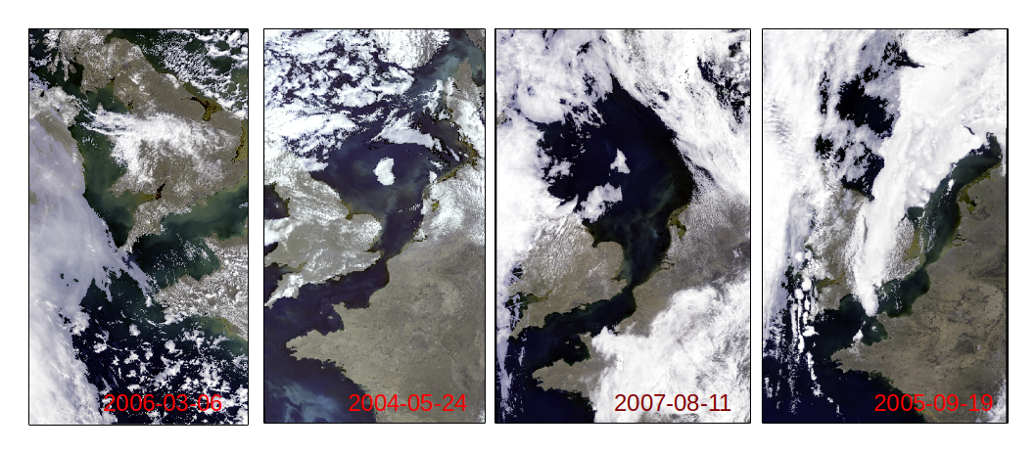
Figure S1: MERIS RGB images corresponding to images presented in Figures 12 and 13.

Figure S2: OLCI-1 RGB image corresponding to image presented in Figure 14 (2017/06/18).

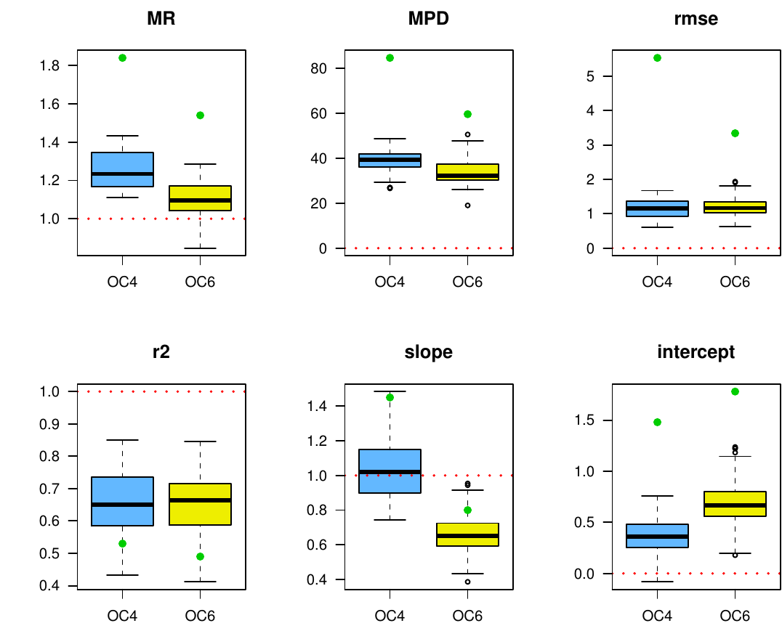
Figure S3: Box-plots comparing the performances of the OC4 (blue), OC6 (yellow) algorithms on the subset of points which pass QC tests. Green point represents the median metric value when all the points are considered (before QC tests). OC6 algorithm for MERIS is defined by O’Reilly and Werdell (2019). A dedicated QC test was developed for this algorithm on the basis of QC tests developed for OC4 and OC5.

Figure S4: Analysis of the impact of modification of the benefit function (Equation 6). QC boundary lines have been recalculated when the absolute percent difference (APD) breaks in the benefit function are changed to 30% - 40% - 50% (green lines) and 30% - 50% - 70% (blue lines). Red lines represent the boundary lines calculated in the study when APD breaks are 30% - 50% -100%. L_{R12_OC4} and L_{R12_OC5} are drawn in panel A and L_{logR5_OCA} and L_{logR5_OC5} are drawn in panel B (solid and dotted lines respectively). For NIR-RED algorithm, L_{Chl/NIR_RED} and L_{R6/NIR_RED} are referred respectively by vertical and horizontal lines respectively, in panel C. Note that in panel C, lines are almost overlaid.

