Global Biogeochemical Cycles
Supporting Information for
The spatiotemporal dynamics of the sources and sinks of CO₂ in the global coastal ocean
Alizée Roobaert¹, Goulven G. Laruelle¹, Peter Landschützer², Nicolas Gruber³, Lei Chou¹, and Pierre Regnier¹
¹Department of Geosciences, Environment & Society (DGES), Université Libre de Bruxelles, Brussels, CP160/02, Belgium.
²Max Planck Institute for Meteorology, Bundesstr 53, Hamburg, 20146, Germany.
³Environmental Physics, Institute of Biogeochemistry and Pollutant Dynamics, ETH Zürich, Universitätstrasse 16, 8092 Zürich, Switzerland.

Contents of this file

Figures S1 to S2
Table S1

Introduction
The supporting information includes two figures and one table. The first figure (figure S1) represents, for each latitudinal band, the contribution of the different drivers to the seasonal FCO₂ variability. In Table S1, FCO₂ (in mol C m⁻² yr⁻¹) and integrated FCO₂ (in Tg C yr⁻¹) are calculated in this study, by Laruelle et al. (2014) and by Bourgeois et al. (2016) and are compared for the different MARCATS regions. Figure S2 presents a comparison between the FCO₂ (in mol C m⁻² yr⁻¹) calculated in these studies at the MARCATS scale.
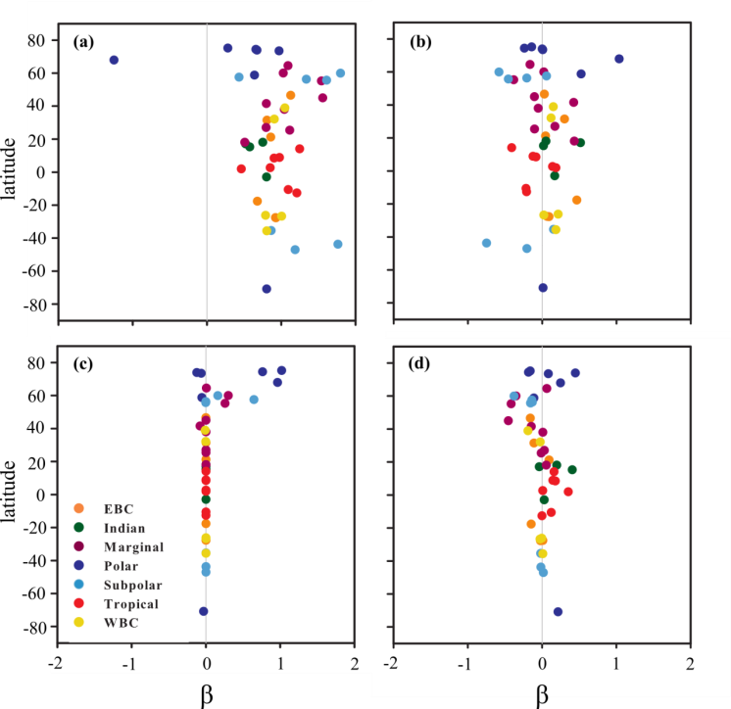

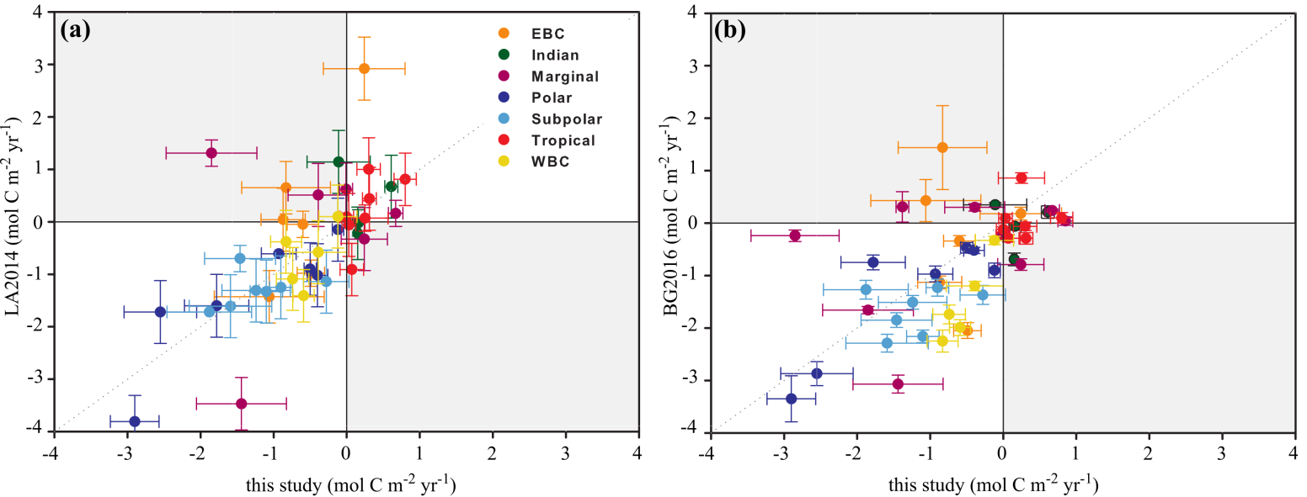
Figure S1. Contributions of the different drivers (β_{x} with x = (a) ΔpCO₂, (b) the wind speed, (c) the sea-ice cover and (d) the cross-correlation between the 3 terms) to the seasonal ${FCO}_{2}^{'}$ for each MARCATS region, plotted by latitude. Colors correspond to the seven major MARCATS classes (see Figure 1, Liu et al., 2010). For each MARCATS and driver, β is calculated using equation 8. A value close to one indicates that the term contributes strongly to ${FCO}_{2}^{'}$ whereas a value of 0 shows that ${FCO}_{2}^{'}$ is insensitive to that term. Negative values indicate that the term is anti-correlated with ${FCO}_{2}^{'}$.

Figure S2. Comparison of the air-sea CO₂ exchange rate (FCO₂, mol C m⁻² yr⁻¹) calculated for the different MARCATS regions in this study with that of (a) Laruelle et al. (2014, LA2014) and that of (b) Bourgeois et al. (2016, BG2016). Colors correspond to the seven major MARCATS classes (see Figure 1, Liu et al., 2010). Error bars in the LA2014 study correspond to the uncertainties associated to the data coverage in time and space when deriving FCO₂. For BG2016, it corresponds to the FCO₂ interannual variability for the 1993-2012 period. In this study, FCO₂ uncertainties are calculated according to section 2.5.
N° | System name | Class | Surface area  (10³ km²) |  |  | FCO₂ (mol C m⁻² yr⁻¹) |  |  |  |  |  | Integrated FCO₂ (Tg C yr⁻¹)
 |  |  | BG  2016 | LA  2014 | This study | BG2016 |  | LA2014 |  | This study |  | BG2016 |  | LA  2014 | This study
 |  |  |  |  |  | mean | σ | mean | σ | mean | σ | mean | σ |  | mean | σ
1 | North East Pacific | Subpolar | 397 | 350 | 394 | -2.29 | 0.17 | -1.61 | 0.25 | -1.59 | 0.6 | -10.94 | 0.82 | -6.78 | -7.53 | 2.67
2 | Californian current | EBC | 118 | 208 | 186 | -0.34 | 0.10 | -0.05 | 0.50 | -0.60 | 0.2 | -0.48 | 0.15 | -0.14 | -1.33 | 0.48
3 | Tropical East Pacific | Tropical | 152 | 183 | 162 | -0.12 | 0.05 | 0.09 | 0.60 | 0.00 | 0.1 | -0.22 | 0.10 | 0.19 | 0.00 | 0.18
4 | Peruvian upwelling current | EBC | 138 | 143 | 121 | 1.44 | 0.80 | 0.65 | 0.60 | -0.83* | 0.6 | 2.39 | 1.33 | 1.07 | -1.20 | 0.88
5 | Southern America | Subpolar | 1126 | 1190 | 1163 | -1.51 | 0.13 | -1.31 | 0.50 | -1.24 | 0.5 | -20.46 | 1.71 | -18.72 | -17.38 | 6.53
6 | Brazilian current | WBC | 475 | 484 | 497 | -0.33 | 0.08 | 0.10 | 0.25 | -0.12 | 0.3 | -1.87 | 0.48 | 0.57 | -0.72 | 1.55
7 | Tropical West Atlantic | Tropical | 479 | 488 | 490 | 0.86 | 0.10 | 0.07 | 0.60 | 0.25 | 0.3 | 4.93 | 0.55 | 0.39 | 1.49 | 1.86
8 | Caribbean Sea | Tropical | 303 | 358 | 289 | 0.10 | 0.10 | 0.81 | 0.60 | 0.80 | 0.2 | 0.37 | 0.35 | 3.46 | 2.77 | 0.53
9 | Gulf of Mexico | Marginal sea | 469 | 532 | 501 | -0.79 | 0.11 | -0.33 | 0.50 | 0.24 | 0.3 | -4.48 | 0.63 | -2.10 | 1.42 | 1.90
10 | Florida upwelling | WBC | 545 | 591 | 804 | -2.25 | 0.21 | -0.38 | 0.25 | -0.83 | 0.2 | -14.69 | 1.35 | -2.72 | -8.00 | 2.04
11 | Sea of Labrador | Subpolar | 576 | 638 | 342 | -1.27 | 0.18 | -1.72 | 0.60 | -1.88 | 0.6 | -8.81 | 1.24 | -13.17 | -7.70 | 2.38
12 | Hudson Bay | Marginal sea | 998 | 1064 | 1013 | 0.31 | 0.29 | - | - | -1.38 | 0.1*** | 3.76 | 3.42 | - | -16.81 | 1.04
13 | Canadian Archipelago | Polar | 1001 | 1145 | 1020 | -0.52 | 0.06 | -1.02 | 0.60 | -0.40 | 0.1 | -6.23 | 0.75 | -13.99 | -4.91 | 1.65
14 | North Greenland | Polar | 544 | 602 | 572 | -0.97 | 0.15 | -0.61 | 0.50 | -0.93 | 0.2 | -6.33 | 1.00 | -4.40 | -6.38 | 0.63
15 | South Greenland | Polar | 238 | 262 | 248 | -3.35 | 0.44 | -3.81 | 0.50 | -2.90 | 0.3 | -9.56 | 1.26 | -11.97 | -8.61 | 0.99
16 | Norwegian Basin | Polar | 141 | 162 | 142 | -2.87 | 0.23 | -1.72 | 0.25 | -2.55 | 0.5 | -4.86 | 0.40 | -3.34 | -4.34 | 0.83
17 | North East Atlantic | Subpolar | 1020 | 1073 | 1040 | -2.16 | 0.12 | -1.33 | 0.25 | -1.10 | 0.2 | -26.50 | 1.42 | -17.17 | -13.68 | 2.77
18 | Baltic Sea | Marginal sea | 324 | 364 | 336 | 0.30 | 0.07 | 0.51 | 0.50 | -0.39 | 0.4 | 1.18 | 0.29 | 2.25 | -1.58 | 1.66
19 | Iberian upwelling | EBC | 251 | 267 | 251 | -1.13 | 0.12 | 0.04 | 0.25 | -0.87 | 0.3 | -3.39 | 0.35 | 0.12 | -2.64 | 0.91
20 | Mediterranean Sea | Marginal sea | 423 | 529 | 474 | -0.24 | 0.06 | 0.62 | 0.60 | -0.01 | 0.1 | -1.20 | 0.33 | 3.93 | -0.07 | 0.51
21 | Black Sea | Marginal sea | 131 | 172 | 104 | -0.24 | 0.11 | - | - | -2.85 | 0.6 | -0.38 | 0.17 | - | -3.55 | 0.75
22 | Moroccan upwelling | EBC | 177 | 206 | 179 | 0.18 | 0.12 | 2.92 | 0.50 | 0.24** | 0.6 | 0.39 | 0.26 | 7.22 | 0.52 | 1.20
23 | Tropical East Atlantic | Tropical | 225 | 259 | 259 | 0.09 | 0.08 | -0.06 | 0.60 | 0.03 | 0.1 | 0.24 | 0.21 | -0.17 | 0.09 | 0.29
24 | South West Africa | EBC | 300 | 298 | 295 | 0.43 | 0.40 | -1.43 | 0.50 | -1.06 | 0.8 | 1.54 | 1.45 | -5.10 | -3.76 | 2.66
25 | Agulhas current | WBC | 189 | 239 | 228 | -1.20 | 0.09 | -0.58 | 0.60 | -0.39 | 0.4 | -2.73 | 0.21 | -1.66 | -1.07 | 1.07
26 | Tropical West Indian | Tropical | 46 | 68 | 60 | -0.06 | 0.08 | 1.00 | 0.60 | 0.30 | 0.2 | -0.03 | 0.04 | 0.82 | 0.22 | 0.12
27 | West Arabian Sea | Indian margins | 82 | 92 | 81 | 0.35 | 0.04 | 1.14 | 0.60 | -0.11** | 0.4 | 0.34 | 0.04 | 1.26 | -0.11 | 0.42
28 | Red Sea | Marginal sea | 158 | 174 | 165 | 0.24 | 0.03 | 0.16 | 0.60 | 0.67 | 0.1 | 0.46 | 0.07 | 0.33 | 1.33 | 0.20
29 | Persian Gulf | Marginal sea | 208 | 233 | 217 | 0.04 | 0.08 | - | - | 0.85 | 0.1*** | 0.09 | 0.20 | - | 2.20 | 0.26
30 | East Arabian Sea | Indian margins | 298 | 317 | 317 | 0.21 | 0.12 | 0.67 | 0.60 | 0.61 | 0.1*** | 0.75 | 0.43 | 2.56 | 2.31 | 0.34
31 | Bay of Bengal | Indian margins | 197 | 203 | 204 | -0.69 | 0.12 | -0.22 | 0.60 | 0.15 | 0.03*** | -1.64 | 0.28 | -0.53 | 0.36 | 0.08
32 | Tropical East Indian | Indian margins | 727 | 763 | 755 | -0.06 | 0.07 | -0.02 | 0.60 | 0.16 | 0.1 | -0.48 | 0.57 | -0.17 | 1.46 | 0.74
33 | Leeuwin current | EBC | 81 | 117 | 112 | -2.05 | 0.15 | -0.98 | 0.25 | -0.49 | 0.2 | -2.01 | 0.15 | -1.38 | -0.66 | 0.25
34 | South Australia | Subpolar | 392 | 436 | 429 | -1.37 | 0.18 | -1.14 | 0.50 | -0.28 | 0.3 | -6.44 | 0.86 | -5.98 | -1.44 | 1.60
35 | East Australian current | WBC | 98 | 130 | 133 | -1.74 | 0.18 | -1.09 | 0.25 | -0.74 | 0.2 | -2.04 | 0.21 | -1.70 | -1.18 | 0.35
36 | New Zealand | Subpolar | 263 | 286 | 266 | -1.23 | 0.16 | -1.25 | 0.50 | -0.90 | 0.2 | -3.88 | 0.50 | -4.27 | -2.88 | 0.49
37 | North Australia | Tropical | 2278 | 2292 | 2369 | -0.29 | 0.11 | 0.44 | 0.60 | 0.31 | 0.1 | -7.87 | 3.11 | 12.12 | 8.72 | 2.68
38 | South East Asia | Tropical | 2130 | 2160 | 2196 | -0.29 | 0.07 | -0.91 | 0.60 | 0.07 | 0.2 | -7.34 | 1.91 | -23.61 | 1.77 | 4.22
39 | China Sea and Kuroshio | WBC | 1132 | 1129 | 1172 | -1.99 | 0.15 | -1.41 | 0.60 | -0.59 | 0.1 | -27.05 | 1.99 | -19.10 | -8.30 | 2.03
40 | Sea of Japan | Marginal sea | 233 | 147 | 249 | -3.07 | 0.17 | -3.47 | 0.50 | -1.44 | 0.6 | -8.61 | 0.48 | -6.11 | -4.32 | 1.84
41 | Sea of Okhotsk | Marginal sea | 933 | 952 | 953 | -1.66 | 0.07 | 1.31 | 0.60 | -1.85 | 0.6 | -18.62 | 0.76 | 1.50 | -21.18 | 7.10
42 | North West Pacific | Subpolar | 1025 | 1000 | 1058 | -1.85 | 0.14 | -0.70 | 0.60 | -1.46 | 0.5 | -22.76 | 1.73 | -8.42 | -18.58 | 6.17
43 | Siberian Shelves | Polar | 1848 | 1889 | 1864 | -0.47 | 0.10 | -0.90 | 0.60 | -0.50 | 0.1 | -10.50 | 2.12 | -20.32 | -11.12 | 1.82
44 | Barents and Kara seas | Polar | 1559 | 1680 | 1609 | -0.75 | 0.14 | -1.60 | 0.60 | -1.78 | 0.4 | -14.18 | 2.59 | -32.23 | -34.41 | 7.75
45 | Antarctic Shelves | Polar | 2452 | 2936 | 2693 | -0.90 | 0.14 | -0.15 | 0.50 | -0.12 | 0.1 | -26.63 | 3.99 | -5.38 | -3.80 | 2.55
* Due to the scarcity of the data in SOCATv4 dataset for this region, the pCO₂ product of Laruelle et al. (2017) underestimates the observed pCO₂ and does not reproduce the high FCO₂ source (5.7 mol C m⁻² yr⁻¹) of the region observed by Friederich et al. (2008).
** A pCO₂ underestimation is also observed for these two regions because of the scarcity in data to train the algorithm for MARCATS 22 (Laruelle et al., 2017) and given that the monsoon-driven summer upwelling in coastal seas is not captured by the SOM-FFN in MARCATS 27.
*** The scarcity in data in MARCATS 12, 29, 30 and 31 does not allow one to calculate $σ_{pCO2}$ for these regions in the total FCO₂ uncertainty calculation.

Table S1. Surface area (10³ km²), air-sea CO₂ exchange rate (FCO₂, mol C m⁻² yr⁻¹) and integrated FCO₂ (Tg C yr⁻¹) calculated for each MARCATS regions. BG2016 and LA2014 refer to the study of Bourgeois et al. (2016) and of Laruelle et al. (2014), respectively. σ in the LA2014 study corresponds to the uncertainties associated to the data coverage in time and space when they derived FCO₂. For BG2016, uncertainty corresponds to the FCO₂ interannual variability for the 1993-2012 period. In this study, FCO₂ uncertainties are calculated according to section 2.5.

