Evaluation of CNRM Earth-System model, CNRM-ESM2-1: role of Earth system processes in present-day and future climate

—Supplementary Information—

1. CMIP6 experiments used in this work

MIPS | Simulations | Description | CNRM-CM6-1 | CNRM-ESM2-1
DECK | piControl | Preindustrial control | 1 | 1
 | historical | CMIP6 reconstruction of the insdustrial-era climate | 10 | 5
 | 1pctCO2 | 1% per year rising CO2 | 1 | 1
 | abrupt-4xCO2 | Instantaneous quadrupling CO2 from preindustrial level | 1 | 1
RFMIP/AerChemMIP | piClim-control | Preindustrial control with fixed sea-surface temperatures (SST) and sea-ice cover (SIC) | 1 | 1
 | piClim-ghg | Increase of greenhouse gases from preindustrial level up to present-day (2014) level with fixed preindustrial sea-surface temperatures (SST) and sea-ice cover (SIC) | 1 | 1
 | piClim-4xCO2 | Quadrupling of atmospheric CO2 from preindustrial level with fixed preindustrial sea-surface temperatures (SST) and sea-ice cover (SIC) | 1 | 1
 | piClim-lu | Change in land-cover disturbance from preindustrial level up to present-day (2014) level with fixed preindustrial sea-surface temperatures (SST) and sea-ice cover (SIC) | 1 | 1
 | piClim-aer | Increase of aerosol emissions from preindustrial level up to present-day (2014) level with fixed preindustrial sea-surface temperatures (SST) and sea-ice cover (SIC) | 1 | 1
 | piClim-anthro | Increase of anthropogenic climate forcers (ghg and aerosols) from preindustrial level up to present-day (2014) level with fixed preindustrial sea-surface temperatures (SST) and sea-ice cover (SIC) | 1 | 1
C4MIP | 1pctCO2-bgc | 1% per year rising CO2 “seen” solely by carbon cycle; radiative code sees preindustrial CO2 | 1 | 1
ScenarioMIP | ssp119 | Multi-gas and aerosols scenarios reaching a radiative forcing of 1.9 W m⁻² by 2100 | 0 | 5
 | ssp126 | Multi-gas and aerosols scenarios reaching a radiative forcing of 2.6 W m⁻² by 2100 | 6 | 5
 | ssp245 | Multi-gas and aerosols scenarios reaching a radiative forcing of 4.5 W m⁻² by 2100 | 6 | 5
 | ssp370 | Multi-gas and aerosols scenarios reaching a radiative forcing of 7.0 W m⁻² by 2100 | 6 | 5
 | ssp434 | Multi-gas and aerosols scenarios reaching a radiative forcing of 3.4 W m⁻² by 2100 | 0 | 5
 | ssp460 | Multi-gas and aerosols scenarios reaching a radiative forcing of 6.0 W m⁻² by 2100 | 0 | 5
 | ssp534-over | Multi-gas and aerosols scenarios reaching a radiative forcing of 3.4 W m⁻² by 2100 after an overshoot in 2050 | 0 | 5
 | ssp585 | Multi-gas and aerosols scenarios reaching a radiative forcing of 8.5 W m⁻² by 2100 | 6 | 5
Table S1: Model experiments used in this study. The last two columns indicate the ensemble size used for CNRM-CM6-1 or CNRM-ESM2-1.

2. Representation of the plant functional type simulated by ISBA

Vegetation type
Temperate broadleaf cold-deciduous
Boreal needleleaf evergreen
Tropical broadleaf evergreen
C3 crops
C4 crops
Irrigated crops
C3 grass
C4 grass
wetlands
Tropical broadleaf dry-deciduous
Temperate broadleaf evergreen
Temperate needleleaf evergreen
Boreal broadleaf cold-deciduous
Boreal needleleaf cold-deciduous
Boreal grass
Deciduous shrub
Table S2: Name of the 16 plant functional types taken into account in ISBA.

3. Representation of the ocean biophysical coupling
As explained in Section 2.5, the chlorophyll concentrations as simulated by PISCESv2-gas intervene in the computation of the solar warming rate across the water column, $δQ\left(z\right)$, by modulating the amount of downwelling solar radiation, $I\left(z\right)$, at a giving depth level, $z$, following:
$δQ\left(z\right)=\frac{1}{ρ_{0}C_{p}}∆zI\left(z\right)$ (1)
where $ρ_{0}$ is the ocean density and $C_{p}$ the heat capacity of sea water.
$I\left(z\right)=I_{IR}e^{-k_{IR}z}+I_{R}\left(z-1\right)e^{-k_{R}∆z}+I_{G}\left(z-1\right)e^{-k_{G}∆z}+I_{B}\left(z-1\right)e^{-k_{B}∆z}$ (2)
where $I_{IR},I_{R},I_{G}$ and $I_{B}$ stand for the fraction of downwelling solar radiation assigned to infrared (all but 300-700 nm), red (]600, 700] nm), green (]500, 600] nm) and blue (]600, 700] nm) wavelengths. $k_{IR},k_{R},k_{G}$and $k_{B}$, are the chlorophyll-dependent attenuation coefficients for the infrared, red, green and blue wavelengths.
This parameterization assumes that 48 % of the downwelling solar radiation is split evenly between the red, green and blue wavelength bands (16 % each). An amount of 52% of the downwelling solar radiation is used to derive $I_{IR}$. The chlorophyll-dependent attenuation coefficients, $k_{R},k_{G}$and $k_{B}$, are derived from the formulation proposed in Morel and Maritorena (2001):
$k_{WLB}=\sum_{λ_{1}}^{λ_{2}}{}\left(k_{sw}\left(λ\right)+χ\left(λ\right){\left[Chl\right]}^{e\left(λ\right)}\right)$ (3)
where WLB means the wavelength bands, namely red (R), green (G) and blue (B) that are bounded by the wavelength $λ_{1}$ and $λ_{2}$. $k_{sw}\left(λ\right)$ is the attenuation coefficients for optically pure sea water. $χ\left(λ\right)$ and $e\left(λ\right)$ are fitted coefficients from Morel and Maritorena (2001) which allows to determine the attenuation coefficients due to chlorophyll pigments into sea water. Consistently with Séférian et al. (2018), these coefficients have been corrected in order to avoid overlaps between red, green and blue wavelength bands as used in the previous version of PISCES (see Figure S1).

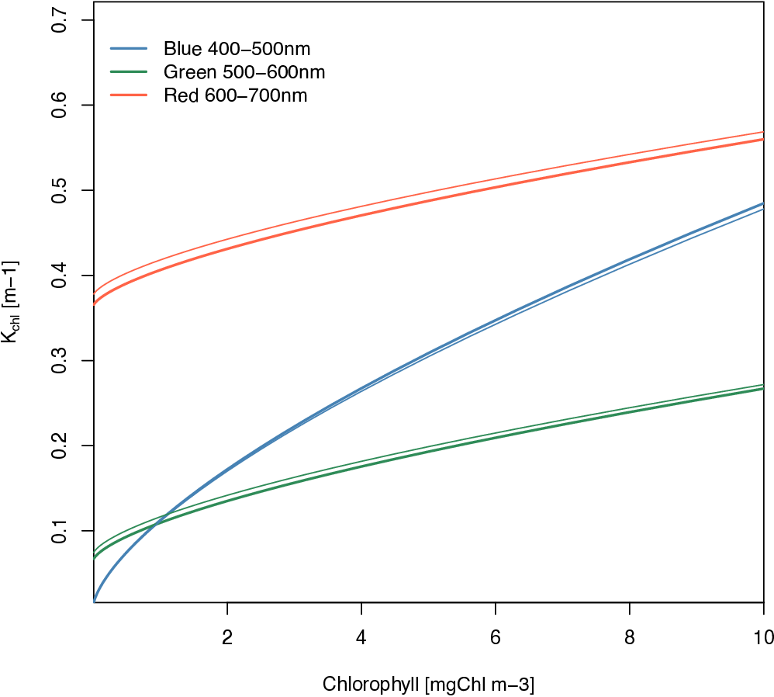
Figure S1: Revised absorption coefficients (K) as function of chlorophyll concentrations (thick lines) as used in the radiative transfer scheme of NEMOv3.6-GELATOv6-PISCESv2-gas (ocean component of CNRM-ESM2-1) for red, green blue wavelength bands. The former absorption coefficients (K_{chl}) for the same wavelengths are given with thin lines.

4. Climate-feedbacks analysis

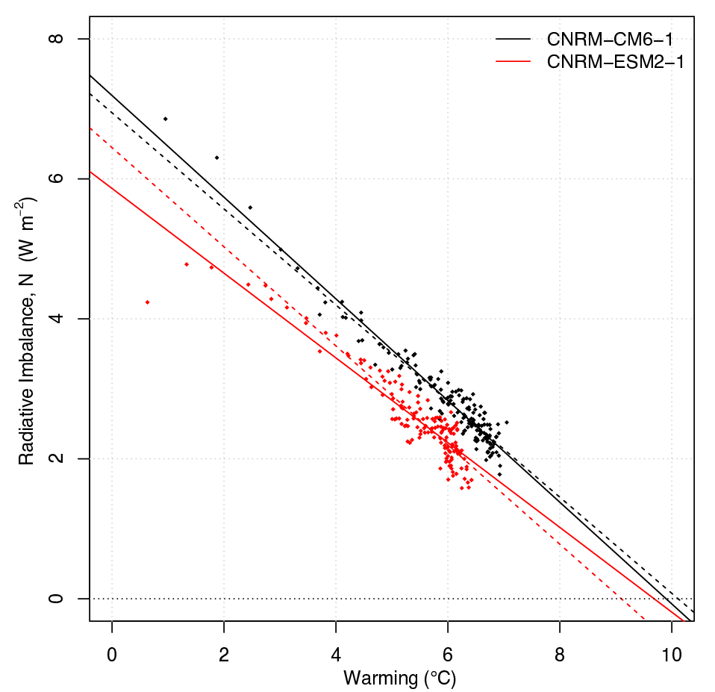
Figure S2: Relationships between the change in net top-of-atmosphere radiative flux, the radiative imbalance, and the change in global-mean surface-air-temperature change (warming), after an instantaneous quadrupling of CO2 for CNRM-CM6-1 (black) and CNRM-ESM2-1 (red). Data points are global-annual-means. Lines represent the ordinary least squares regression fits over years 1-150 (solid) and 10-150 (dashed) as indicated in Table 4. The intercept at a net zero radiative imbalance gives the equilibrium temperature. The equilibrium climate sensitivity (ECS) at 2xCO₂ is then deduced by halfen the equilibrium temperature.

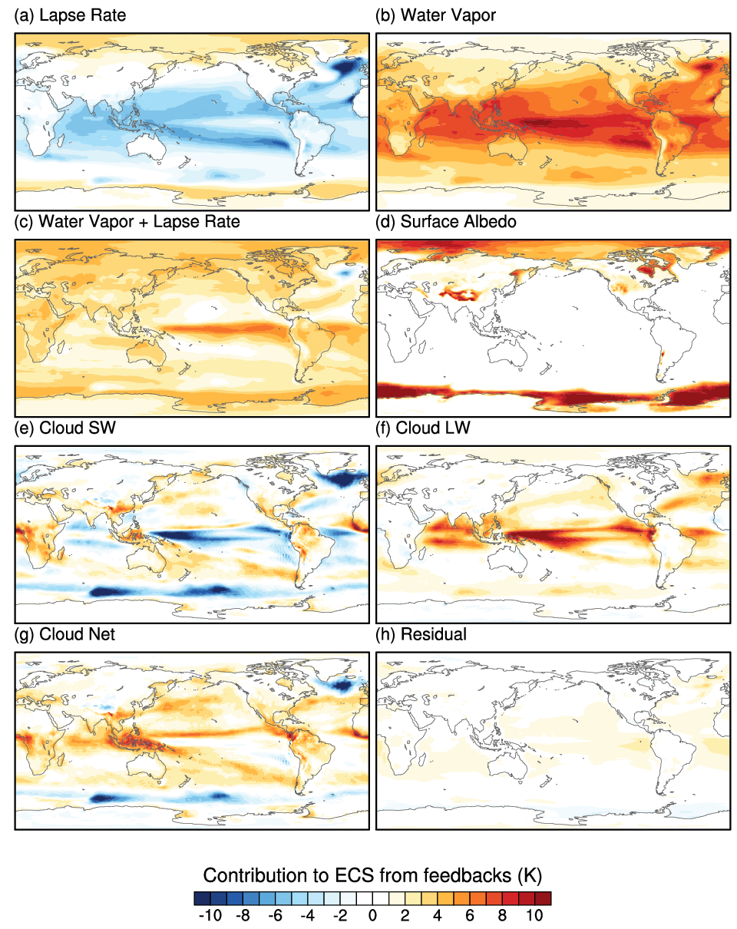
Figure S3: Contributions to equilibrium climate sensitivity for CNRM-CM6-1 following the approach in Vial et al. (2013) arising from the feedbacks: (a) lapse rate, (b) water vapor, (c) water vapor + lapse rate, (d) surface albedo, (e) shortwave cloud, (f) longwave cloud, (g) net cloud and (h) residual.

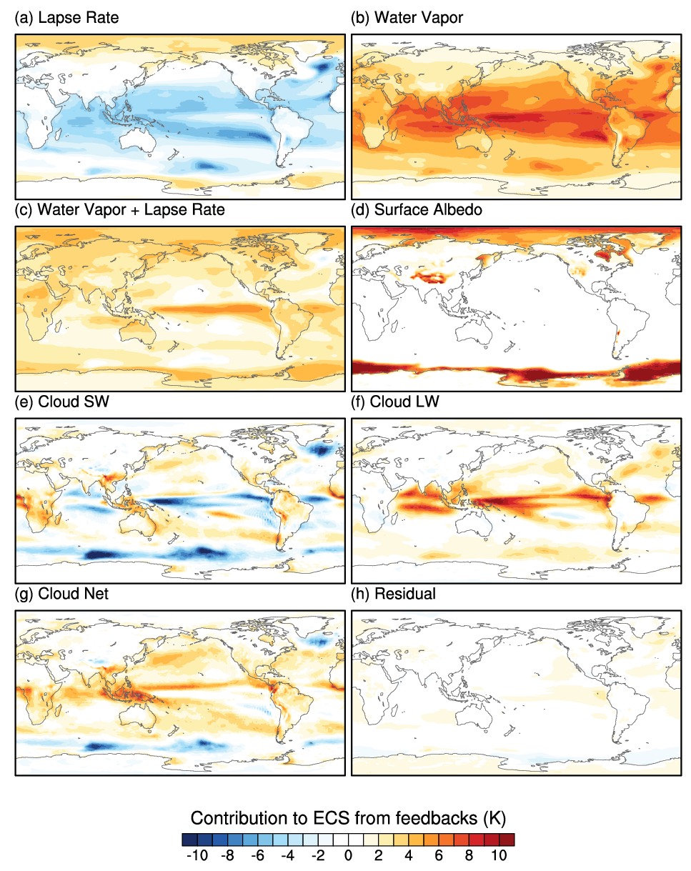

Figure S4: Same as Figure S3 but for CNRM-ESM2-1.

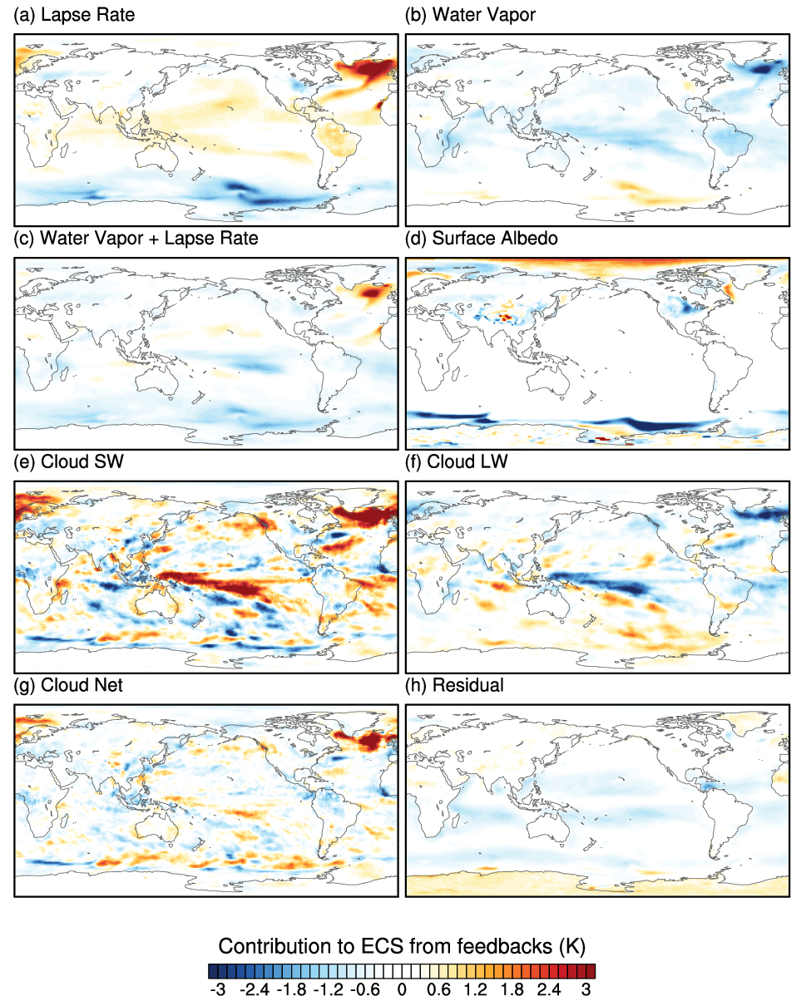
Figure S5: Same as Figure S3 and S4 but for the difference between CNRM-ESM2-1 and CNRM-CM6-1. Red shading indicates that CNRM-ESM2-1’s feedbacks contribute to stronger warming (or weaker cooling) than that of CNRM-CM6-1 whereas blue shading means the opposite.

5. Decomposition of CO₂-water-stomatal feedbacks
To decompose the CO₂-water-stomatal feedback, we use available transient experiments of CMIP6-DECK and C4MIP where the atmospheric CO₂ increase with a constant rate of 1% per year. In 1pctCO2 of CMIP6-DECK both land vegetation and atmosphere radiative code see the increase in CO₂ whereas in the C4MIP 1pctCO2-bgc only the vegetation sees its increase. in the C4MIP 1pctCO2-bgc, the CO₂ use by the atmosphere radiative code is held constant to its preindustrial level.

As shown in Figure S6, we decompose the CO₂-water-stomatal feedback into:
1- The response of vegetation transpiration to rising atmospheric CO₂ including climate change. It is called “Transpiration-CO₂” in Figure 12.
2- The response of the vegetation carbon uptake to rising atmospheric CO₂ excluding climate change. It is called “Assimilation-CO₂” in Figure 12.
3- The relationship between the vegetation transpiration and the vegetation carbon uptake under rising atmospheric CO₂ condition and preindustrial climate. It is called “Transpiration-Assimilation” in Figure 12.
3- The relationship between the vegetation transpiration and warming under rising atmospheric CO₂ condition and climate change. It is called “Transpiration-Climate” in Figure 12.

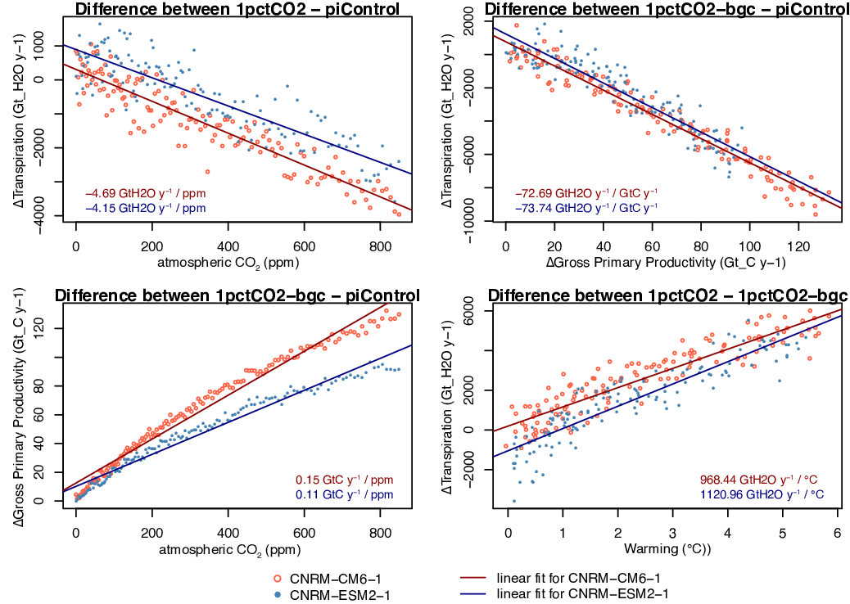
Figure S6: Decomposition of the various feedbacks parameters as used to diagnose difference in CO₂-stomata-water feedbacks between CNRM-CM6-1 and CNRM-ESM2-1 as shown in Figure 13.
Top panels are used to estimate the relationships Transpiration-CO₂ (left) and Transpiration-Assimilation of Carbon (right). Bottom panels are used to estimate the relationships Assimilation of Carbon-CO₂ (left) and Transpiration-Climate (right).

6. Disentangling the role of aerosols in the climate response of CNRM-CM6-1 and CNRM-ESM2-1

As described in Section 3, CNRM-CM6-1 uses prescribed monthly-mean AODs produced by AMIP-type simulations of CNRM-ESM2-1. From 2014 onwards, the sea-surface temperatures used are those of a former run of CNRM-CM5.1 (Voldoire et al., 2013) which displayed a lower climate sensitivity (3.3 °C) than CNRM-CM6-1 (Figure S7, see also Table 4). Thus, the interactive sea-salt emission scheme has been driven by a weaker sea-surface temperature trend (reaching up to 0.8 °C over 2081-2100).
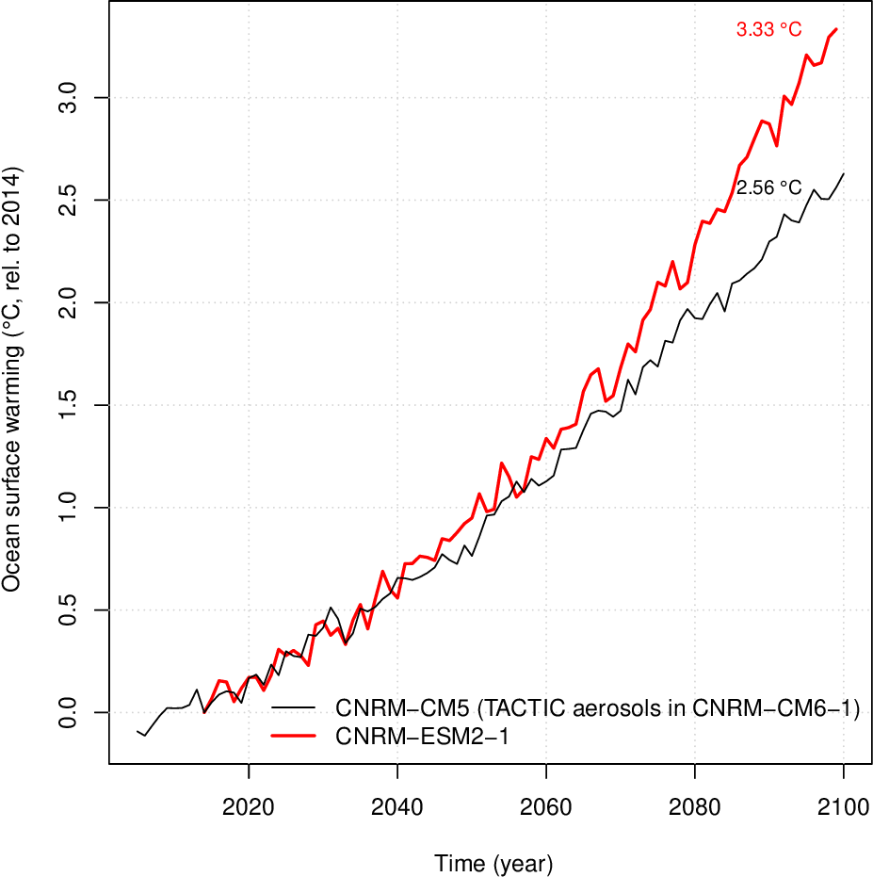
Figure S7: Ocean surface warming as simulated by CNRM-ESM2-1 (red) and CNRM-CM5 (black, Voldoire et al., 2013) under the ssp585 and rcp85 future scenario, respectively. Here, the mean ocean surface warming is used as a proxy to explain differences in aerosols optical depth between CNRM-CM6-1 and CNRM-ESM2-1 because the parameterization of local sea-salt emissions as used in TACTIC depends on local sea-surface temperature (Grythe et al., 2014; Jaéglé et al., 2011). Higher sea surface temperature results in a higher rate of sea-salt emissions.

Because of the difference of ocean warming, the load of sea-salt as used in CNRM-CM6-1 and simulated interactively in CNRM-ESM2-1 differ. It leads to different aerosol optical depth at 550 nm as shown in Figure S8a. However, as shown in Figure S8b, the role of aerosols in the global radiative forcing remains small compared to CO₂ and other well-midex greenhouse gases. As a consequence, the influence of different AOD between CNRM-ESM2-1 and CNRM-CM6-1 explains a small part of the inter-model difference in future projections (Figure S8c).

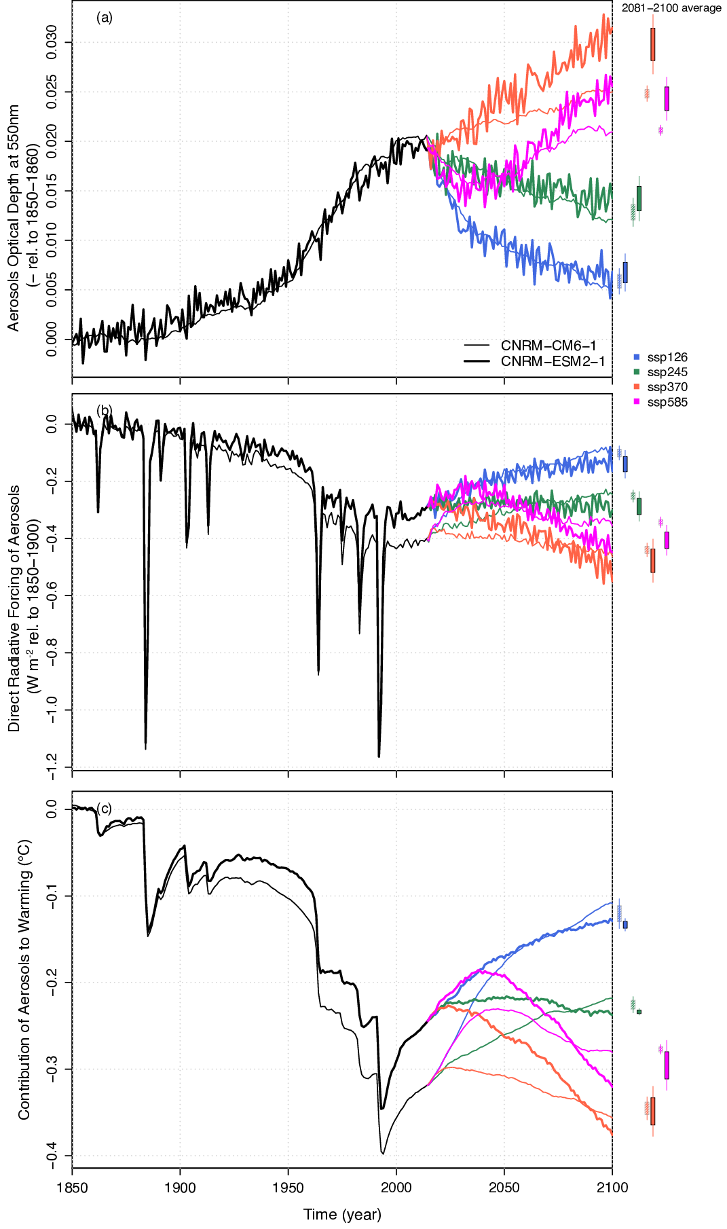Figure S8: Evolution of aerosol (a) optical depth at 550nm, (b) direct radiative forcing and (c) contribution to global warming as predicted by CNRM-ESM2-1 (thick solid lines) and CNRM-CM6-1 (thin solid lines) for several ScenarioMIP future scenarios. Only one realization (r1i1p1f2) by future scenario is shown. This aerosol contribution to global warming is estimated as in Absolute Global Temperature Potential for non-CO₂ (Myrhe et al. 2013, SM 11.2).

References:
Grythe, H., Ström, J., Krejci, R., Quinn, P., and Stohl, A.: A review of sea-spray aerosol source functions using a large global set of sea salt aerosol concentration measurements, Atmos. Chem. Phys., 14, 1277-1297, https://doi.org/10.5194/acp-14-1277-2014, 2014.
Jaeglé, L., Quinn, P. K., Bates, T. S., Alexander, B., and Lin, J.-T.: Global distribution of sea salt aerosols: new constraints from in situ and remote sensing observations, Atmos. Chem. Phys., 11, 3137-3157, https://doi.org/10.5194/acp-11-3137-2011, 2011.
Morel, A. and Maritorena, S.: Bio-optical properties of oceanic waters: A reappraisal, Journal of Geophysical Research-Oceans, 1 106(C4), 7163–7180, doi:10.1029/2000JC000319, 2001.
Myhre, G., D. Shindell, F.-M. Bréon, W. Collins, J. Fuglestvedt, J. Huang, D. Koch, J.-F. Lamarque, D. Lee, B. Mendoza, T. Nakajima, A. Robock, G. Stephens, T. Takemura and H. Zhang, 2013: Anthropogenic and Natural Radiative Forcing Supplementary Material. In: Climate Change 2013: The Physical Science Basis. Contribution of Working Group I to the Fifth Assessment Report of the Intergovernmental Panel on Climate Change [Stocker, T.F., D. Qin, G.-K.Plattner, M. Tignor, S.K. Allen, J. Boschung, A. Nauels, Y. Xia, V. Bex and P.M. Midgley (eds.)]. Available from www.climatechange2013.org and www.ipcc.ch.
Séférian, R., Baek, S., Boucher, O., Dufresne, J.-L., Decharme, B., Saint-Martin, D., and Roehrig, R.: An interactive ocean surface albedo scheme (OSAv1.0): formulation and evaluation in ARPEGE-Climat (V6.1) and LMDZ (V5A), Geosci. Model Dev., 11, 321-338, https://doi.org/10.5194/gmd-11-321-2018, 2018.
Vial, J., J. L. Dufresne, and S. Bony, 2013: On the interpretation of inter-model spread in CMIP5 climate sensitivity estimates. Clim. Dyn., 41, 3339–3362, doi:10.1007/s00382-013-1725-9. http://link.springer.com/10.1007/s00382-013-1725-9.
Voldoire, A., and Coauthors, 2013: The CNRM-CM5.1 global clismate model: Description and basic evaluation. Clim. Dyn., 40, 2091–2121, doi:10.1007/s00382-011-1259-y. http://www.springerlink.com/index/10.1007/s00382-011-1259-y.

