Global variability of optical backscattering by non-algal particles from a Biogeochemical-Argo dataset

M. Bellacicco^{1,2}, M. Cornec², E. Organelli², R.J.W. Brewin^{3.4}, G. Neukermans², G. Volpe⁵, M. Barbieux², A. Poteau², C. Schmechtig², F. D’Ortenzio², S. Marullo¹, H. Claustre² and J. Pitarch⁶

¹Italian National Agency for New Technologies, Energy and Sustainable Economic Development (ENEA), Via E. Fermi 45, 00044, Frascati, Italy.
²Sorbonne Université, CNRS, Laboratoire d’Océanographie de Villefranche, LOV, F-06230 Villefranche-sur-Mer, France.
³College of Life and Environmental Science, University of Exeter, Penryn, Cornwall, TR10 9FE, UK
⁴Plymouth Marine Laboratory, Prospect Place, The Hoe, Plymouth PL1 3DH, UK.
⁵Institute of Marine Sciences (ISMAR)-CNR, Via Fosso del Cavaliere, 100, 00133, Rome, Italy.
⁶NIOZ Royal Netherlands Institute for Sea Research, Department of Coastal Systems, and Utrecht University, Den Burg, Texel, the Netherlands.

*Corresponding author mail-address: marco.bellacicco@enea.it

Supplementary Materials

- The first paragraph described the quality control and processing of the BGC-Argo dataset.
- The second paragraph described the derivation of quantities such as the surface layer as seen by satellite, the euphotic layer and the bottom layer.
The supplementary material reports also the $b_{bp}^{k}$estimations in the different cases of study:
- Figures S1 and S2 show the scatter plot between Chl and b_{bp} for each area and in both layers with information about the model performance in terms of RMS (in m⁻¹). In each Figure are shown the linear and non-linear models fit. The non-linear model (the approach then here selected and used for $b_{bp}^{k}$computations) is more efficient with respect to the linear approach in case of both layers and in the most productive areas.
- Figures S3 and S4 show the plot density of each area in both the layer of study with the $b_{bp}^{k}$estimations and two-standard deviation as confidence limit (±2σ). In each panel are also reported the RMS (in m⁻¹) for describing the model performance and the number of observations (N).
- Table S1 contains the first guess and parameters bounds (lower and upper) for the regression fit as described by Eq. 2 in the manuscript.
- Table S2 contains the $b_{bp}^{k}$for the deep layer ±2σ as confidence limit. Having in mind that the $b_{bp}^{k}$ is computed as the median value of the b_{bp} in order to minimize the effect of the outliers, while the standard deviation considers extreme values for its intrinsic definition. For these reasons, the uncertainties of $b_{bp}^{k}$ display high values with respect to the $b_{bp}^{k}$ estimations in the other layers.
- Tables S3 and S4 contain $b_{bp}^{k}$ (interval of confidence at 95% and number of observations) for each month and each area for surface and euphotic layers. For each estimation, we also report the RMS (in m⁻¹). Table S5 refers to $b_{bp}^{k}$ in the bottom layer. In case of the bottom layer, the $b_{bp}^{k}$ is computed as the median value of the b_{bp} in order to minimize the effect of the outliers.
- The reader must note that for the cases of monthly $b_{bp}^{k}$ computations (Table S3, S4, S5), for each $b_{bp}^{k}$ is reported the interval of confidence at 95%, instead of ±2σ, that gives to the reader the entire range of variability of the computation (upper and lower bounds of the interval of confidence).
- Quality control of vertical profiles
Vertical profiles of T (units of ºC) and S (units of PSU) were quality-controlled following Argo protocols as detailed in Wong et al. (2010). Vertical profiles of FChla and b_{bp} were all processed and quality controlled from initial raw data (numerical counts) as transmitted by the sensors, using the same protocols regardless of the sensor type. Such procedure ensures therefore to derive an interoperable dataset. Hereafter, the detailed step-by-step protocols for FChla and b_{bp} are described.

The FChla vertical profiles were processed and quality controlled as follows:
(1) Numerical counts were converted into Chl concentration (units of mg m⁻³) by subtracting the dark counts and multiplying by a scale factor. Both dark counts and scale factors were specific to each sensor of each float, and were provided by the manufacturer.
(2) Time-series of vertical profiles of Chl for each float were visually checked to identify and remove any profile affected by sensor malfunction or biofouling, which increased noise and spike occurrence. Malfunction and biofouling affected only 9.6% of the profiles.
(3) Profiles with less than 15 records per profile (3% of the database) were removed, being inadequate for further treatment and statistical analysis.
(4) Out-of-range values were removed as detailed in Schmechtig et al., (2014).
(5) Potential instrument drift was checked on time series of Chl within the 950-1000 m layer as collected by the float when in drift mode following Organelli et al. (2017). Any drift was corrected by applying the time-dependent offset determined from the linear regression of the median values between 950-1000m as a function of time.
(6) Vertical profiles were further corrected for any non-zero values observed at depth. To adjust the profile, the procedure as detailed in Schmechtig et al. (2014) was applied but in particular situations and/or regions. In the subtropical gyres, Chl slightly increased with depth below the euphotic zone where it was expected to be 0. In this case, following Xing et al. (2017), the absolute minimum of the profile was considered as the dark’s reference and thus substracted from the whole profile and all the values deeper than the depth of this minimum value were set to 0. In the Oxygen Minimum Zones (i.e., Arabian Sea and Bay of Bengal), the secondary peak of Chl often observed at depth was first detect and preserved by applying the method by Wojtasiewicz et al. (2018), and then the whole profile was corrected following Xing et al. (2017). Lastly, a specific correction was applied to profiles acquired in regions characterized by late winter/early spring intense vertical mixing (i.e., North Atlantic subpolar gyre and Western Mediterranean Sea) in which a significant signal of Chl can be found below the euphotic zone. In these cases, deep (950 - 1000m) median values of Chl were computed for the time series of float profiles. A robust linear regression on these values as a function of time was applied, and anomalies were identified as the residuals exceeding the 85th percentile. Only when anomalies were associated with a mixed layer depth (MLD, see computation below) deeper than 600m, the profiles were corrected for the intercept of the robust linear regression.
(7) All the Chl profiles were corrected for the global bias in factory calibration by multiplying for the correction factor of 0.5 (Roesler et al., 2017).
(8) Finally, Chl profiles were corrected for Non-Photochemical Quenching following Xing et al. (2018). The maximum Chl value found in the thinner layer between the Mixed Layer and the euphotic layer (Zeu, see computation below) was extrapolated up to the surface.

The b_{bp} vertical profiles were processed and quality controlled as follows:

- Numerical counts were converted to the angular scattering coefficients measured at an angle of 124º and for the wavelength 700 m, $β$($124$,$700$), by using calibration factors (i.e., slope factor) as provided by the manufacturer. The particulate backscattering coefficient, b_{bp} (700), was then calculated as (units of m⁻¹):

$b_{bp}\left(700\right)=χ\left(124\right)×2π ×\left\{β\left(124,700\right)-β_{sw}(124,700)\right\}$

- where $χ$(124) is the conversion factor from a single measurement and is equal to 1.076 (Sullivan et al., 2016); $β_{sw}$is the contribution of pure sea water which was calculated following Zhang et al. (2009).
- As some b_{bp} sensors may present high calibration uncertainties on the slope factor (Poteau et al., 2017), all b_{bp} profiles still not reprocessed with the corrected calibration factor provided by the manufacturer (Schmechtig et al., 2018) were removed (17 % of profiles). This step ensured to get the most accurate and homogeneous dataset.
- Similar to Chl quality control procedure, vertical profiles of b_{bp} and time series were checked to identify and remove profiles affected by sensor malfunction or biofouling.
- Out-of-range values were removed as detailed in Schmechtig et al., (2014).
- Similar to the Chl procedure, also profiles with less than 15 records per profile were removed and any instrument drift identified and corrected.

- Derived quantities
The depth of the mixed layer, MLD (m), was estimated using a threshold criterion of 0.03 kg m⁻³ with respect to a density reference value at 10 m (DeBoyer-Montégut, 2004). The depth of euphotic zone, Z_{eu} (units of m), which is the depth where PAR reaches 1% of its surface value, was estimated from the Chl profile through the iterative process described in Morel and Maritorena (2001). Subsequently, the first optical depth, Z_{pd} (units of m), was calculated as Z_{eu}/4.6 (Morel, 1988). Finally, for each profile, the mean and standard deviation of Chl and b_{bp} were calculated within: i) the surface layer: the layer between sea surface and the first optical depth; ii) the euphotic layer: the layer between sea surface and euphotic zone; and iii) the bottom layer: the layer between 950 and 1000 m.

Figure Content:
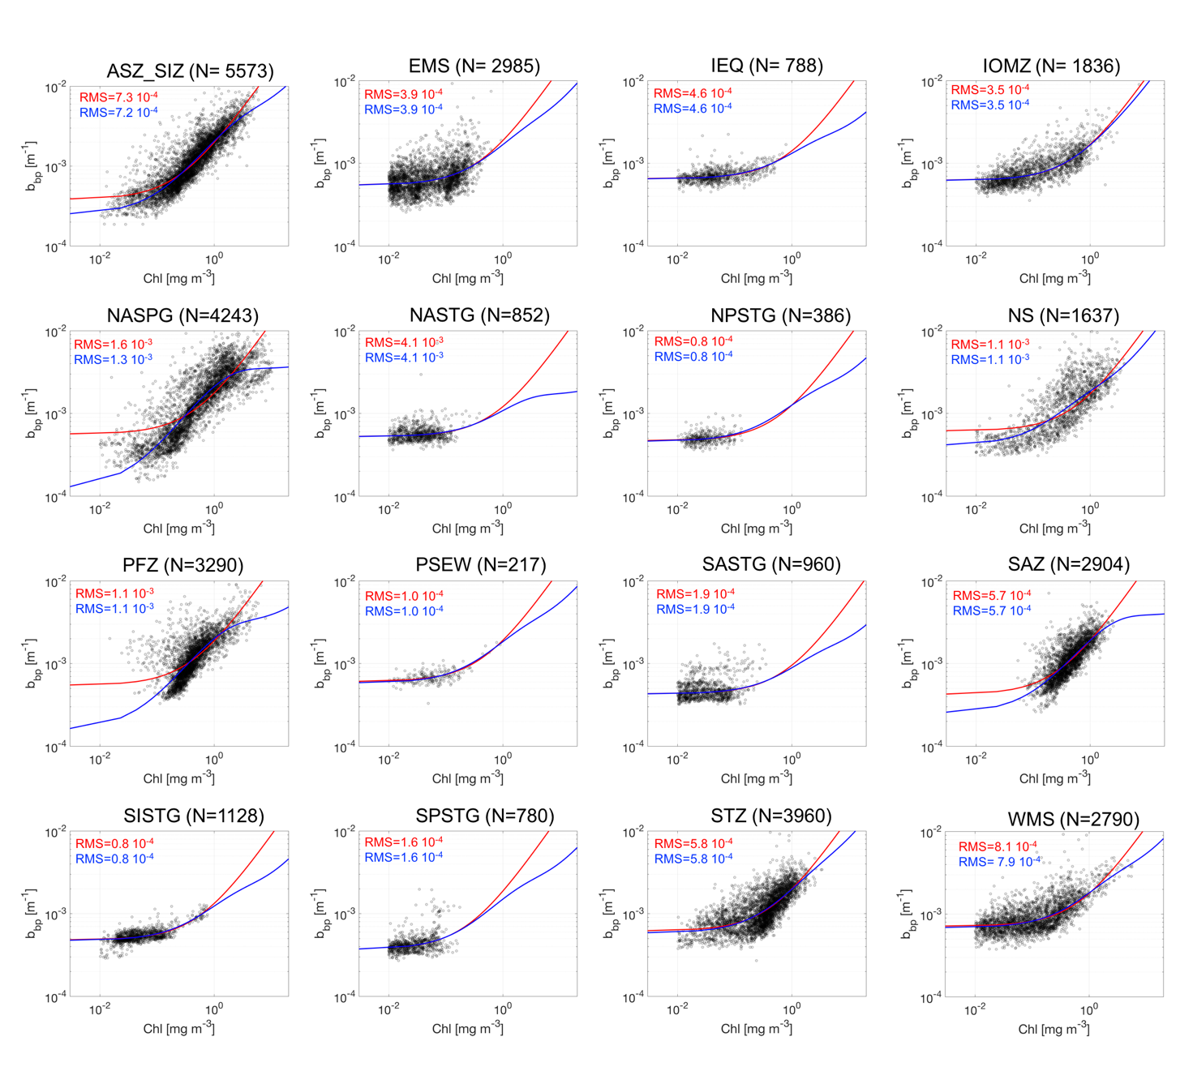
Figure S1: Scatter plot between Chl (mg m⁻³) and b_{bp} (700; m⁻¹) within the surface layer for 16 bioregions. The linear model is depicted with the red line, while the non-linear model is denoted by the blue line. The number of observations (N) is reported for each area. In each panel are also indicated the RMS errors computed here to define the model performances. ASEW and BAFF area are not included in this preliminary analysis due the absence/limited number of observations that prevents the description of the annual cycle.

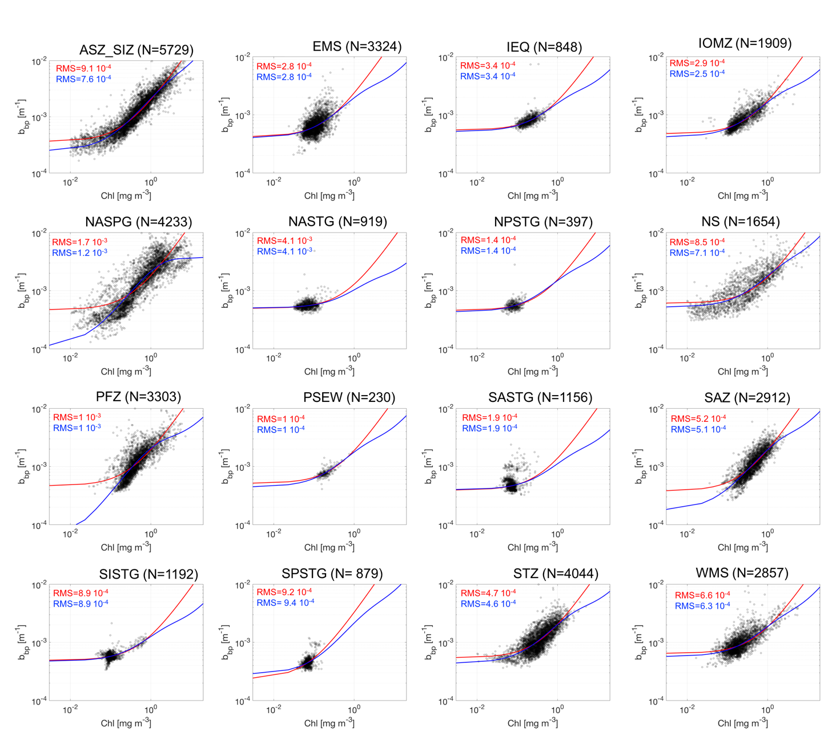
Figure S2: Scatter plot between Chl (mg m⁻³) and b_{bp} (700; m⁻¹) within the euphotic layer for 16 bioregions. The linear model is depicted with the red line, while the non-linear model is denoted by the blue line. The number of observations (N) is reported for each area. In each panel are also indicated the RMS errors computed here to define the model performances. ASEW and BAFF area are not included in this preliminary analysis due the absence/limited number of observations that prevents the description of the annual cycle.
.

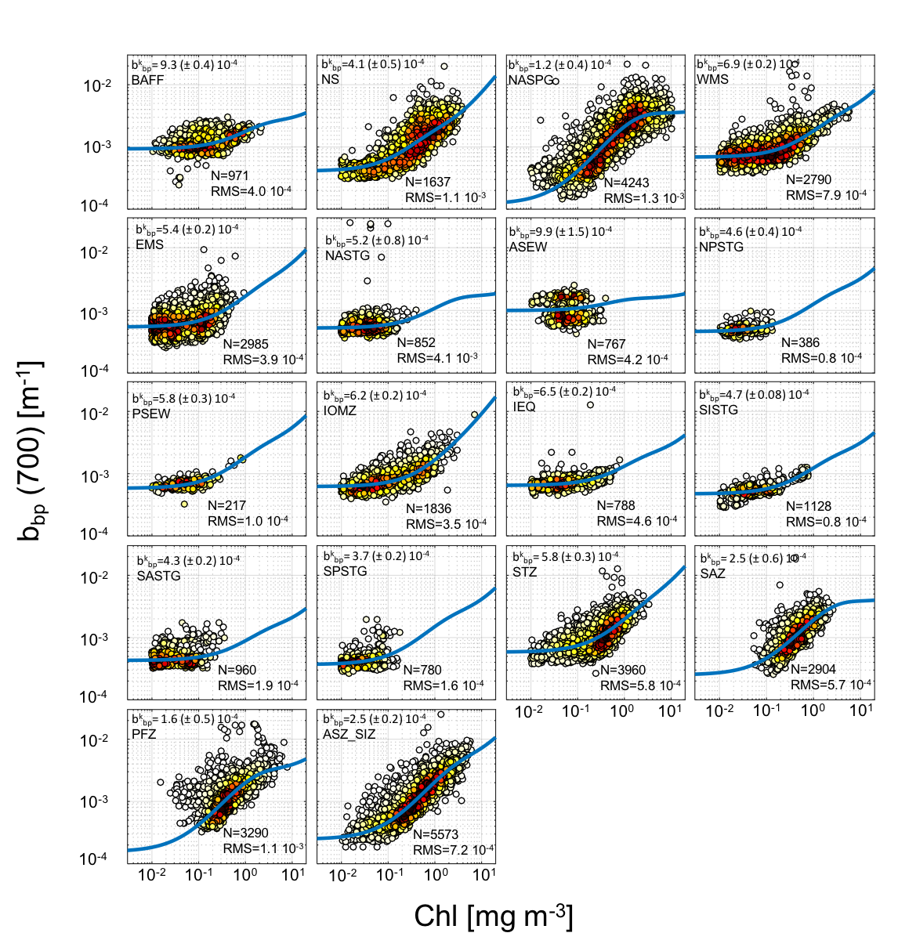
Figure S3: Plot density between Chl and b_{bp} (700) within the surface layer. In each panel indicates the number of observations (N) and the RMS coefficient (in m⁻¹). The $b_{bp}^{k}$ estimations (in m⁻¹) with two standard deviation as confidence limits (±2σ) is also indicated. Chl values less than 0.01 mg m⁻³ are not included in the fits computations. All these values are reported into the manuscript in Figure 3a. Dot density is indicated as color from white (low density) to black (high density).

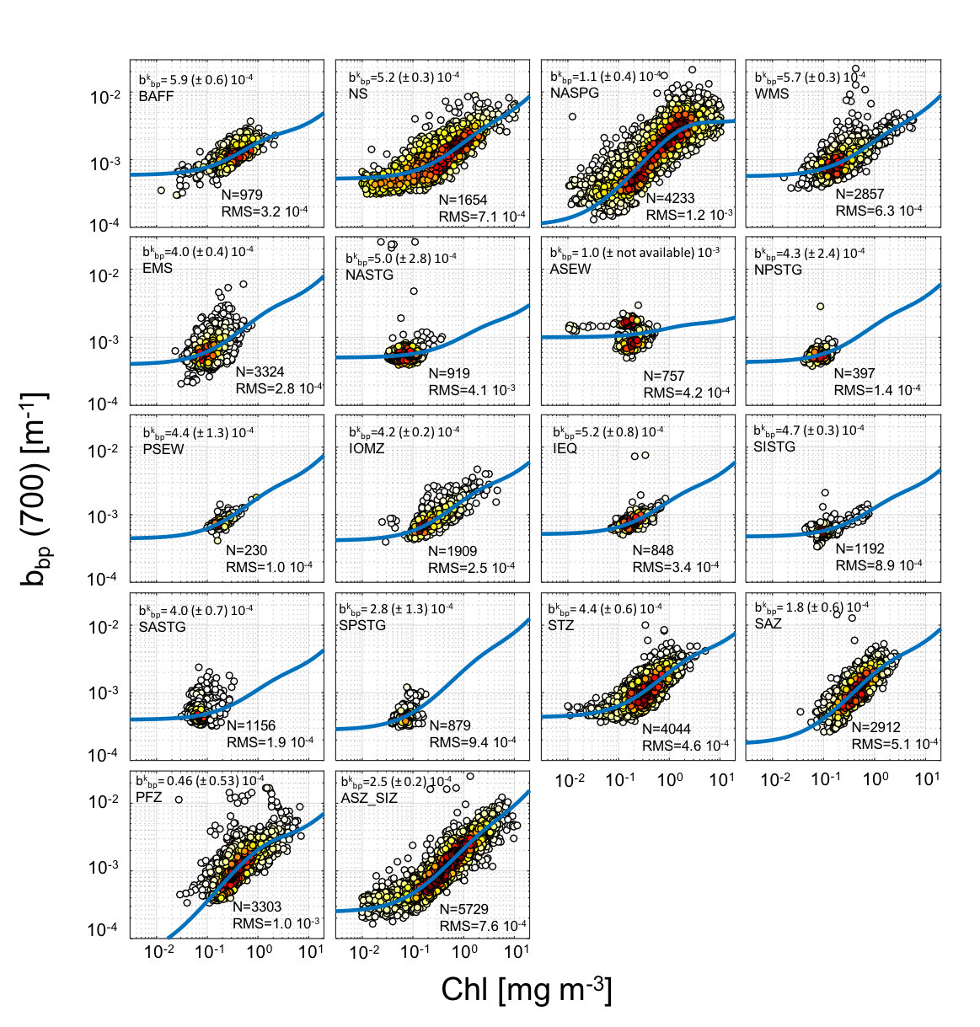
Figure S4: Plot density between Chl and b_{bp} (700) within the euphotic layer. In each panel indicates the number of observations (N) and the RMS coefficient (in m⁻¹). The $b_{bp}^{k}$estimation (in m⁻¹) with two standard deviation as confidence limit (±2σ) is also indicated. Chl values less than 0.01 mg m⁻³ are not included in the fits computations. All these values are reported in the manuscript in Figure 3a. Dot density is indicated as color from white (low density) to black (high density).

Table S1: the parameter bounds and initial guess for the regression fit (see Eq.2 in the manuscript).

Areas | $b_{bp}^{k}$ (·10⁻⁴; m⁻¹) | N
BAFF | 3.4 ± 6.7 | 918
NS | 3.7 ± 2.6 | 1999
NASPG | 2.6 ± 12.0 | 3742
WMS | 2.8 ± 8.0 | 2488
EMS | 2.7 ± 4.3 | 2834
NASTG | 2.1± 90.0 | 730
ASEW | 2.8 ± 11.0 | 796
NPSTG | 2.2 ± 0.9 | 395
PSEW | 2.2 ± 0.7 | 230
IOMZ | 3.1± 1.8 | 1754
IEQ | 3.0 ± 9.3 | 846
SISTG | 2.5 ± 2.4 | 335
SASTG | 1.7 ± 2.4 | 1150
SPSTG | 2.0 ± 0.9 | 879
STZ | 3.0 ± 17.0 | 3111
SAZ | 2.9 ± 11.0 | 2876
PFZ | 2.7 ± 24.0 | 3058
ASZ_SIZ | 2.4 ± 16.0 | 5752
Table S2: $b_{bp}^{k}$ assessment (in m⁻¹) in the bottom layer with ±2σ as confidence limit. For each area, we also report the number of observations (N).

ASZ_SIZ | $$b_{bp}^{k}$$ | N | RMS (·10⁻⁴)
January | Not available | 693 | 14.0
February | 0.00071 (0.00052 ↔ 0.00090) | 511 | 9.6
March | 0.00033 (0.00024 ↔ 0.00041) | 473 | 6.0
April | 0.00029 (0.00016 ↔ 0.00042) | 469 | 4.0
May | 0.00035 (0.00027 ↔ 0.00044) | 462 | 2.3
June | 0.00037 (0.00031 ↔ 0.00043) | 397 | 2.1
July | 0.00035 (0.00030 ↔0.00039) | 335 | 1.7
August | 0.00031 (0.00026 ↔ 0.00036) | 300 | 2.0
September | 0.00027 (0.00022 ↔ 0.00032) | 312 | 1.4
October | 0.00026 (0.00020 ↔ 0.00033) | 498 | 2.5
November | 0.00028 (0.00017 ↔ 0.00038) | 541 | 4.2
December | 0.00057 (0.00037 ↔ 0.00077) | 582 | 7.3
SAZ | $$b_{bp}^{k}$$ | N | RMS (·10⁻⁴)
January | 0.00086 (0.00053 ↔ 0.00120) | 285 | 5.4
February | 0.00052 (-0.00003 ↔ 0.00106) | 204 | 5.3
March | 0.00044 (-0.00049 ↔ 0.00137) | 193 | 4.9
April | 0.00044 (-0.00010 ↔ 0.00099) | 203 | 2.9
May | 0.00039 (-0.00012 ↔ 0.00089) | 212 | 2.0
June | 0.00033 (0.00013 ↔ 0.00054) | 193 | 1.4
July | 0.00030 (0.00016 ↔0.00043) | 221 | 1.2
August | 0.00023 (0.00001 ↔ 0.00044) | 255 | 1.9
September | 0.00025 (0.00003 ↔ 0.00046) | 260 | 5.1
October | 0.00039 (0.00012 ↔ 0.00065) | 295 | 3.6
November | 0.00063 (0.00009 ↔ 0.00117) | 277 | 11.8
December | 0.00091 (0.00068 ↔ 0.00114) | 306 | 5.1
STZ | $$b_{bp}^{k}$$ | N | RMS (·10⁻⁴)
January | 0.00063 (0.00056 ↔ 0.00070) | 489 | 8.7
February | 0.00061 (0.00052 ↔ 0.00069) | 342 | 4.8
March | 0.00052 (0.00046 ↔ 0.00058) | 393 | 3.1
April | 0.00045 (0.00038 ↔ 0.00051) | 384 | 2.4
May | 0.00050 (0.00037 ↔ 0.00063) | 349 | 2.6
June | 0.00040 (0.00019 ↔ 0.00061) | 301 | 3.9
July | 0.00033 (0.00012 ↔0.00054) | 271 | 2.1
August | 0.00026 (0.00002 ↔ 0.00049) | 226 | 2.4
September | 0.00040 (0.00019 ↔ 0.00061) | 219 | 3.1
October | 0.00060 (0.00047 ↔ 0.00074) | 346 | 8.7
November | 0.00081 (0.00064 ↔ 0.00099) | 293 | 6.1
December | 0.00079 (0.00070 ↔ 0.00088) | 347 | 4.6
PFZ | $$b_{bp}^{k}$$ | N | RMS (·10⁻⁴)
January | Not available | 311 | 6.3
February | 0.00098 (0.00058 ↔ 0.00076) | 240 | 3.9
March | 0.00059 (0.00038 ↔ 0.00062) | 228 | 4.4
April | 0.00049 (0.00034 ↔ 0.00067) | 240 | 3.0
May | 0.00031 (0.00019 ↔ 0.00070) | 246 | 2.3
June | 0.00022 (0.00013 ↔ 0.00064) | 249 | 1.8
July | 0.00021 (0.00005 ↔ 0.00061) | 232 | 1.3
August | 0.00017 (-0.00005 ↔ 0.00062) | 230 | 3.5
September | 0.00024 (0.00006 ↔ 0.00067) | 259 | 2.3
October | 0.00043 (0.00017 ↔ 0.00076) | 313 | 3.7
November | 0.00090 (0.00075 ↔ 0.00071) | 337 | 5.8
December | Not available | 405 | 25.4
IOMZ | $$b_{bp}^{k}$$ | N | RMS (·10⁻⁴)
January | 0.00053 (0.00047 ↔ 0.00058) | 185 | 2.1
February | 0.00055 (0.00048 ↔ 0.00062) | 201 | 2.8
March | 0.00061 (0.00055 ↔ 0.00067) | 184 | 4.0
April | 0.00060 (0.00050 ↔ 0.00070) | 130 | 1.6
May | 0.00056 (0.00048 ↔ 0.00064) | 140 | 2.3
June | 0.00057 (0.00054 ↔ 0.00061) | 164 | 2.5
July | 0.00054 (0.00045 ↔ 0.00062) | 144 | 3.0
August | 0.00058 (0.00049 ↔ 0.00067) | 145 | 4.4
September | 0.00064 (0.00052 ↔ 0.00076) | 131 | 4.8
October | 0.00062 (0.00053 ↔ 0.00071) | 141 | 4.4
November | 0.00059 (0.00051 ↔ 0.00067) | 132 | 2.5
December | 0.00056 (0.00048 ↔ 0.00063) | 139 | 2.3
NASPG | $$b_{bp}^{k}$$ | N | RMS (·10⁻⁴)
January | 0.00033 (0.00027 ↔ 0.00040) | 201 | 2.0
February | 0.00030 (0.00021 ↔ 0.00039) | 218 | 2.5
March | 0.00007 (0.00001 ↔ 0.00014) | 426 | 2.0
April | 0.00001 (-0.00007 ↔ 0.00010) | 527 | 5.1
May | 0.00030 (-0.00001 ↔ 0.00062) | 570 | 13.7
June | 0.00085 (0.00018 ↔ 0.00152) | 602 | 23.7
July | Not available | 456 | 11.0
August | 0.00100 (0.00040 ↔ 0.00160) | 325 | 7.6
September | 0.00093 (0.00052 ↔ 0.00135) | 297 | 7.2
October | 0.00052 (0.00011 ↔ 0.00093) | 180 | 3.8
November | 0.00032 (0.00010 ↔ 0.00055) | 238 | 7.4
December | 0.00031 (0.00022 ↔ 0.00041) | 203 | 2.9
NS | $$b_{bp}^{k}$$ | N | RMS (·10⁻⁴)
January | 0.00043 (0.00013 ↔ 0.00072) | 41 | 1.4
February | 0.00040 (0.00022 ↔ 0.00058) | 44 | 1.5
March | 0.00040 (0.00028 ↔ 0.00051) | 111 | 5.8
April | 0.00041 (0.00031 ↔ 0.00051) | 144 | 2.9
May | 0.00064 (0.00039 ↔ 0.00089) | 169 | 6.3
June | Not available | 150 | 11.2
July | Not available | 179 | 19.4
August | Not available | 198 | 12.3
September | 0.00100 (0.00049 ↔ 0.00150) | 189 | 5.2
October | 0.00069 (0.00049 ↔ 0.00089) | 187 | 3.3
November | 0.00044 (0.00036 ↔ 0.00053) | 145 | 1.3
December | 0.00042 (0.00028 ↔ 0.00057) | 80 | 1.1
WMS | $$b_{bp}^{k}$$ | N | RMS (·10⁻⁴)
January | 0.00045 (0.00005 ↔ 0.00086) | 265 | 7.0
February | 0.00050 (0.00003 ↔ 0.00097) | 214 | 22.0
March | 0.00084 (0.00068 ↔ 0.00101) | 271 | 4.6
April | 0.00089 (0.00079 ↔ 0.00100) | 224 | 4.6
May | 0.00079 (0.00073 ↔ 0.00085) | 264 | 3.3
June | 0.00072 (0.00067 ↔ 0.00077) | 230 | 2.1
July | 0.00067 (0.00059 ↔ 0.00076) | 229 | 1.7
August | 0.00059 (0.00050 ↔ 0.00068) | 208 | 1.7
September | 0.00060 (0.00043 ↔ 0.00077) | 202 | 1.8
October | 0.00045 (0.00022 ↔ 0.00069) | 196 | 5.2
November | 0.00054 (0.00025 ↔ 0.00083) | 218 | 10.4
December | 0.00056 (0.00043 ↔ 0.00068) | 269 | 5.1
EMS | $$b_{bp}^{k}$$ | N | RMS (·10⁻⁴)
January | 0.00034 (0.00016 ↔ 0.00052) | 271 | 5.4
February | 0.00055 (0.00031 ↔ 0.00080) | 219 | 5.9
March | 0.00071 (0.00063 ↔ 0.00078) | 254 | 2.8
April | 0.00065 (0.00059 ↔ 0.00070) | 209 | 3.1
May | 0.00070 (0.00063 ↔ 0.00076) | 284 | 2.9
June | 0.00060 (0.00039 ↔ 0.00080) | 283 | 2.0
July | 0.00047 (0.00022 ↔ 0.00072) | 206 | 2.0
August | 0.00031 (0.00022 ↔ 0.00040) | 262 | 1.9
September | 0.00032 (0.00018 ↔ 0.00047) | 241 | 5.6
October | 0.00037 (0.00027 ↔ 0.00047) | 246 | 2.6
November | 0.00028 (0.00018 ↔ 0.00037) | 246 | 2.2
December | 0.00033 (0.00019 ↔ 0.00047) | 264 | 2.7
IEQ | $$b_{bp}^{k}$$ | N | RMS (·10⁻⁴)
January | 0.00065 (0.00058 ↔ 0.00072) | 92 | 1.6
February | 0.00063 (0.00052 ↔ 0.00074) | 48 | 1.1
March | 0.00060 (0.00029 ↔ 0.00090) | 41 | 2.4
April | 0.00060 (0.00054 ↔ 0.00066) | 52 | 0.9
May | 0.00051 (0.00007 ↔ 0.00094) | 55 | 16.1
June | 0.00050 (0.00038 ↔ 0.00062) | 57 | 1.6
July | 0.00050 (0.00036 ↔ 0.00064) | 59 | 1.3
August | 0.00050 (0.00039 ↔ 0.00061) | 58 | 1.2
September | 0.00050 (0.00040 ↔ 0.00060) | 59 | 1.5
October | 0.00059 (0.00049 ↔ 0.00068) | 70 | 1.3
November | 0.00065 (0.00058 ↔ 0.00071) | 95 | 2.0
December | 0.00067 (0.00058 ↔ 0.00075) | 102 | 1.4
NASTG | $$b_{bp}^{k}$$ | N | RMS (·10⁻⁴)
January | 0.00045 (0.00034 ↔ 0.00057) | 116 | 1.0
February | 0.00047 (0.00033 ↔ 0.00061) | 62 | 1.1
March | 0.00050 (-0.00042 ↔ 0.00142) | 72 | 47.5
April | 0.00057 (-0.00034 ↔ 0.00148) | 61 | 31.7
May | 0.00050 (0.00020 ↔ 0.00080) | 58 | 1.1
June | 0.00045 (-0.00526 ↔ 0.00615) | 57 | 55.7
July | 0.00050 (0.00017 ↔ 0.00083) | 66 | 1.0
August | 0.00047 (-0.01093 ↔ 0.01187) | 63 | 124.4
September | 0.00051 (0.00012 ↔ 0.00091) | 50 | 1.1
October | 0.00052 (0.00023 ↔ 0.00081) | 77 | 1.3
November | 0.00046 (-0.00024 ↔ 0.00115) | 72 | 7.6
December | 0.00053 (-0.00026↔ 0.00132) | 98 | 20.3
NPSTG | $$b_{bp}^{k}$$ | N | RMS (·10⁻⁴)
January | 0.00043 (0.00016 ↔ 0.00071) | 28 | 0.6
February | 0.00043 (0.00003 ↔ 0.00082) | 28 | 1.0
March | 0.00043 (0.00026 ↔ 0.00061) | 30 | 0.7
April | 0.00043 (-0.00045 ↔ 0.00130) | 28 | 0.7
May | 0.00043 (-0.00017 ↔ 0.00104) | 37 | 0.5
June | 0.00050 (-0.00053 ↔ 0.00153) | 29 | 0.9
July | 0.00050 (-0.00015 ↔ 0.00115) | 32 | 0.7
August | 0.00050 (0.00014 ↔ 0.00086) | 34 | 1.3
September | 0.00050 (0.00023 ↔ 0.00077) | 35 | 0.8
October | 0.00050 (-0.00029 ↔ 0.00129) | 36 | 0.8
November | 0.00043 (0.00016 ↔ 0.00070) | 34 | 0.7
December | 0.00043 (0.00011 ↔ 0.00074) | 35 | 0.6
PSEW | $$b_{bp}^{k}$$ | N | RMS (·10⁻⁴)
January | 0.00050 (0.00018 ↔ 0.00082) | 23 | 1.2
February | 0.00050 (0.00009 ↔ 0.00109) | 13 | 1.1
March | 0.00050 (-0.00004 ↔ 0.00104) | 22 | 0.6
April | 0.00050 (0.00007 ↔ 0.00093) | 21 | 1.2
May | 0.00050 (0.00015 ↔ 0.00085) | 16 | 0.9
June | 0.00050 (0.00015 ↔ 0. 00085) | 15 | 0.9
July | 0.00050 (-0.00021 ↔ 0.00121) | 11 | 1.3
August | 0.00050 (-0.00040 ↔ 0.00140) | 12 | 1.6
September | 0.00050 (-0.00104 ↔ 0.00204) | 10 | 0.7
October | 0.00050 (-0.00030 ↔ 0.00130) | 16 | 1.2
November | 0.00050 (-0.00003 ↔ 0.00103) | 19 | 1.6
December | 0.00050 (-0.00047 ↔ 0.00074) | 39 | 1.2
SASTG | $$b_{bp}^{k}$$ | N | RMS (·10⁻⁴)
January | 0.00044 (-0.00005 ↔ 0.00092) | 65 | 1.4
February | 0.00042 (-0.00027 ↔ 0.00112) | 53 | 1.3
March | 0.00043 (-0.00009 ↔ 0.00095) | 67 | 1.3
April | 0.00043 (0.00027 ↔ 0.00060) | 84 | 1.2
May | 0.00038 (0.00011 ↔ 0.00065) | 94 | 1.2
June | 0.00035 (-0.00013 ↔ 0. 00083) | 91 | 1.3
July | 0.00032 (-0.00046 ↔ 0.00110) | 95 | 1.4
August | 0.00032 (0.00005 ↔ 0.00059) | 66 | 1.6
September | 0.00038 (0.00018 ↔ 0.00059) | 56 | 2.8
October | 0.00044 (0.00031 ↔ 0.00057) | 102 | 2.4
November | 0.00046 (0.00032 ↔ 0.00060) | 105 | 1.4
December | 0.00039 (0.00015 ↔ 0.00062) | 82 | 1.3
SISTG | $$b_{bp}^{k}$$ | N | RMS (·10⁻⁴)
January | 0.00042 (0.00033 ↔ 0.00052) | 53 | 0.8
February | 0.00050 (-0.00017 ↔ 0.00117) | 40 | 0.9
March | 0.00041 (0.00013 ↔ 0.00068) | 52 | 0.9
April | 0.00045 (0.00031 ↔ 0.00058) | 45 | 0.7
May | 0.00042 (0.00032 ↔ 0.00051) | 51 | 1.2
June | 0.00041 (0.00030 ↔ 0. 00053) | 41 | 1.1
July | 0.00044 (0.00042 ↔ 0.00046) | 333 | 0.6
August | 0.00045 (0.00041 ↔ 0.00049) | 145 | 0.7
September | 0.00048 (0.00046 ↔ 0.00050) | 150 | 0.6
October | 0.00048 (0.00046 ↔ 0.00051) | 120 | 0.7
November | 0.00050 (0.00042 ↔ 0.00058) | 51 | 1.1
December | 0.00046 (0.00039 ↔ 0.00053) | 47 | 0.5
SPSTG | $$b_{bp}^{k}$$ | N | RMS (·10⁻⁴)
January | 0.00034 (-0.00009 ↔ 0.00078) | 49 | 1.9
February | 0.00027 (-0.00022 ↔ 0.00076) | 32 | 3.1
March | 0.00040 (0.00014 ↔ 0.00066) | 40 | 1.9
April | 0.00030 (0.00019 ↔ 0.00040) | 97 | 1.4
May | 0.00040 (0.00021 ↔ 0.00060) | 80 | 0.7
June | 0.00040 (0.00016 ↔ 0. 00065) | 81 | 0.8
July | 0.00037 (0.00024 ↔ 0.00049) | 76 | 0.7
August | 0.00036 (0.00028 ↔ 0.00043) | 63 | 0.6
September | 0.00039 (0.00029 ↔ 0.00049) | 56 | 0.8
October | 0.00037 (0.00032 ↔ 0.00042) | 69 | 0.6
November | 0.00041 (0.00006 ↔ 0.00077) | 68 | 0.7
December | 0.00030 (-0.00008 ↔ 0.00068) | 69 | 1.8
Table S3: The monthly $b_{bp }^{k}$assessment (in m⁻¹) for the surface layer. The interval of confidence at 95% (↔), number of observations (N) and RMS error (·10⁻⁴; in m⁻¹) are also reported. Negative values for the lower bound of the interval of confidence are due to the $b_{bp }^{k}$ statistical distribution. In red are highlighted the cases where the model iteration returns confidence intervals out of the initial condition and thus are without of range and cannot be considered in the analysis.

ASZ_SIZ | $$b_{bp }^{k}$$ | N | RMS (·10⁻⁴)
January | 0.00073 (0.00053 ↔ 0.00093) | 746 | 14.4
February | 0.00044 (0.00030 ↔ 0.00058) | 552 | 9.6
March | 0.00028 (0.00021 ↔ 0.00035) | 487 | 6.1
April | 0.00028 (0.00017 ↔ 0.00040) | 479 | 7.6
May | 0.00037 (0.00030 ↔ 0.00043) | 468 | 2.3
June | 0.00038 (0.00033 ↔ 0.00043) | 396 | 1.8
July | 0.00035 (0.00032 ↔0.00038) | 331 | 1.1
August | 0.00032 (0.00028 ↔ 0.00035) | 291 | 1.5
September | 0.00028 (0.00024 ↔ 0.00032) | 307 | 1.6
October | 0.00019 (0.00013 ↔ 0.00024) | 502 | 2.4
November | 0.00024 (0.00015 ↔ 0.00033) | 563 | 7.8
December | 0.00003 (-0.00026 ↔ 0.00031) | 607 | 6.8
SAZ | $$b_{bp }^{k}$$ | N | RMS (·10⁻⁴)
January | 0.00054 (0.00014 ↔ 0.00094) | 287 | 4.3
February | 0.00039 (-0.00044 ↔ 0.00121) | 204 | 5.0
March | 0.00042 (-0.00053 ↔ 0.00136) | 193 | 4.1
April | 0.00044 (-0.00009 ↔ 0.00097) | 203 | 2.6
May | 0.00040 (-0.00005 ↔ 0.00084) | 212 | 2.2
June | 0.00035 (0.00017 ↔ 0.00052) | 194 | 1.3
July | 0.00031 (0.00018 ↔ 0.00043) | 221 | 1.2
August | 0.00022 (0.00001 ↔ 0.00044) | 255 | 3.4
September | 0.00027 (-0.00001 ↔ 0.00055) | 260 | 8.6
October | 0.00027 (0.00007 ↔ 0.00047) | 296 | 3.2
November | 0.00046 (-0.00025 ↔ 0.00117) | 278 | 8.5
December | 0.00056 (0.00019 ↔ 0.00094) | 309 | 4.2
STZ | $$b_{bp }^{k}$$ | N | RMS (·10⁻⁴)
January | 0.00048 (0.00039 ↔ 0.00057) | 508 | 6.1
February | 0.00036 (0.00025 ↔ 0.00047) | 355 | 3.7
March | 0.00038 (0.00029 ↔ 0.00048) | 397 | 2.5
April | 0.00036 (0.00026 ↔ 0.00045) | 385 | 3.0
May | 0.00048 (0.00029 ↔ 0.00067) | 354 | 2.5
June | 0.00040 (0.00018 ↔ 0.00062) | 301 | 3.5
July | 0.00033 (0.00011 ↔ 0.00055) | 271 | 1.8
August | 0.00027 (0.00002 ↔ 0.00052) | 226 | 2.1
September | 0.00038 (0.00012 ↔ 0.00064) | 219 | 2.8
October | 0.00053 (0.00038 ↔ 0.00067) | 351 | 6.8
November | 0.00047 (0.00028 ↔ 0.00066) | 307 | 5.3
December | 0.00053 (0.00041 ↔ 0.00064) | 370 | 4.0
PFZ | $$b_{bp }^{k}$$ | N | RMS (·10⁻⁴)
January | Not available | 313 | 6.0
February | 0.00072 (0.00037 ↔ 0.00107) | 240 | 3.8
March | 0.00048 (0.00021 ↔ 0.00075) | 228 | 3.6
April | 0.00050 (0.00038 ↔ 0.00063) | 241 | 3.4
May | 0.00032 (0.00020 ↔ 0.00044) | 246 | 3.8
June | 0.00024 (0.00009 ↔ 0.00038) | 249 | 7.3
July | 0.00021 (0.00008 ↔ 0.00035) | 232 | 1.1
August | 0.00023 (-0.00009 ↔ 0.00055) | 230 | 9.2
September | 0.00008 (-0.00009 ↔ 0.00024) | 259 | 1.9
October | 0.00035 (0.00010 ↔ 0.00059) | 315 | 3.4
November | 0.00077 (0.00062 ↔ 0.00092) | 339 | 4.7
December | Not Available | 411 | 22.6
IOMZ | $$b_{bp }^{k}$$ | N | RMS (·10⁻⁴)
January | 0.00037 (0.00027 ↔ 0.00046) | 186 | 2.5
February | 0.00040 (0.00027 ↔ 0.00053) | 202 | 1.8
March | 0.00039 (0.00026 ↔ 0.00051) | 194 | 2.5
April | 0.00044 (0.00025 ↔ 0.00063) | 153 | 1.3
May | 0.00034 (0.00024 ↔ 0.00045) | 168 | 1.5
June | 0.00038 (0.00031 ↔ 0.00046) | 167 | 1.6
July | 0.00036 (0.00027 ↔ 0.00045) | 149 | 3.0
August | 0.00041 (0.00027 ↔ 0.00054) | 145 | 3.1
September | 0.00043 (0.00020 ↔ 0.00066) | 132 | 3.3
October | 0.00041 (0.00024 ↔ 0.00058) | 141 | 2.7
November | 0.00038 (0.00014 ↔ 0.00062) | 132 | 2.5
December | 0.00040 (0.00030 ↔ 0.00050) | 140 | 2.2
NASPG | $$b_{bp }^{k}$$ | N | RMS (·10⁻⁴)
January | 0.00031 (0.00025 ↔ 0.00037) | 197 | 1.3
February | 0.00029 (0.00020 ↔ 0.00038) | 214 | 3.2
March | 0.00008 (0.00002 ↔ 0.00015) | 425 | 1.8
April | Not available | 527 | 5.0
May | 0.00021 (-0.00010 ↔ 0.00051) | 570 | 13.8
June | 0.00069 (-0.00003 ↔ 0.00140) | 602 | 22.4
July | 0.00076 (0.00018 ↔ 0.00134) | 456 | 10.3
August | 0.00100 (0.00060 ↔ 0.00139) | 325 | 6.5
September | 0.00082 (0.00056 ↔ 0.00108) | 297 | 6.7
October | 0.00049 (0.00021 ↔ 0.00078) | 180 | 6.6
November | 0.00031 (0.00017 ↔ 0.00045) | 237 | 2.4
December | 0.00029 (0.00021 ↔ 0.00037) | 203 | 2.2
NS | $$b_{bp }^{k}$$ | N | RMS (·10⁻⁴)
January | 0.00044 (0.00005 ↔ 0.00084) | 33 | 1.1
February | 0.00041 (0.00021 ↔ 0.00065) | 38 | 2.2
March | 0.00040 (0.00021 ↔ 0.00050) | 105 | 3.8
April | 0.00045 (0.00021 ↔ 0.00055) | 145 | 2.7
May | 0.00058 (0.00021 ↔ 0.00073) | 175 | 5.2
June | Not available | 173 | 10.3
July | 0.00100 (0.00069 ↔ 0.00131) | 185 | 10.9
August | 0.00096 (0.00077 ↔ 0.00116) | 201 | 8.0
September | 0.00072 (0.00057 ↔ 0.00088) | 192 | 3.3
October | 0.00059 (0.00050 ↔ 0.00067) | 187 | 2.2
November | 0.00046 (0.00040 ↔ 0.00052) | 145 | 1.1
December | 0.00044 (0.00029 ↔ 0.00059) | 75 | 0.9
WMS | $$b_{bp }^{k}$$ | N | RMS (·10⁻⁴)
January | 0.00041 (-0.00002 ↔ 0.00085) | 265 | 5.3
February | 0.00044 (0.00001 ↔ 0.00088) | 214 | 18.9
March | 0.00070 (0.00053 ↔ 0.00086) | 274 | 4.0
April | 0.00071 (0.00058 ↔ 0.00084) | 225 | 4.0
May | 0.00054 (0.00045 ↔ 0.00063) | 273 | 2.8
June | 0.00062 (0.00050 ↔ 0.00074) | 252 | 2.0
July | 0.00057 (0.00042 ↔ 0.00073) | 251 | 1.5
August | 0.00051 (0.00031 ↔ 0.00071) | 218 | 1.4
September | 0.00050 (0.00018 ↔ 0.00082) | 202 | 1.3
October | 0.00039 (-0.00021 ↔ 0.00098) | 196 | 2.7
November | 0.00035 (-0.00010 ↔ 0.00079) | 218 | 6.3
December | 0.00052 (0.00031 ↔ 0.00073) | 269 | 4.0
EMS | $$b_{bp }^{k}$$ | N | RMS (·10⁻⁴)
January | 0.00032 (0.00008 ↔ 0.00055) | 271 | 14.4
February | 0.00047 (0.00005 ↔ 0.00089) | 219 | 9.6
March | 0.00059 (0.00043 ↔ 0.00075) | 255 | 6.1
April | 0.00049 (0.00033 ↔ 0.00064) | 232 | 7.6
May | 0.00035 (0.00016 ↔ 0.00055) | 371 | 2.3
June | 0.00041 (0.00004 ↔ 0.00078) | 362 | 1.8
July | 0.00016 (-0.00022 ↔0.00054) | 306 | 1.1
August | 0.00030 (0.00004 ↔ 0.00056) | 305 | 1.5
September | 0.00016 (-0.00039 ↔ 0.00071) | 247 | 1.6
October | 0.00013 (-0.00031 ↔ 0.00057) | 246 | 2.4
November | 0.00020 (-0.00011 ↔ 0.00051) | 246 | 7.8
December | 0.00028 (0.00003 ↔ 0.00053) | 264 | 6.8
IEQ | $$b_{bp }^{k}$$ | N | RMS (·10⁻⁴)
January | 0.00047 (0.00001 ↔ 0.00095) | 99 | 1.1
February | 0.00046 (-0.00057 ↔ 0.00149) | 56 | 0.8
March | 0.00046 (-0.00010 ↔ 0.00101) | 59 | 0.9
April | 0.00044 (-0.00009 ↔ 0.00097) | 58 | 1.0
May | 0.00018 (-0.00197 ↔ 0.00234) | 59 | 8.4
June | 0.00044 (0.00003 ↔ 0.00085) | 58 | 0.9
July | 0.00045 (-0.00025 ↔0.00115) | 62 | 0.7
August | 0.00043 (-0.00030 ↔ 0.00117) | 60 | 0.7
September | 0.00044 (0.00005 ↔ 0.00084) | 62 | 1.0
October | 0.00045 (-0.00003 ↔ 0.00093) | 72 | 1.4
November | 0.00048 (0.00022 ↔ 0.00074) | 99 | 1.5
December | 0.00059 (-0.00027 ↔ 0.00144) | 104 | 6.5
NASTG | $$b_{bp }^{k}$$ | N | RMS (·10⁻⁴)
January | 0.00040 (0.00001 ↔ 0.00080) | 116 | 0.5
February | 0.00043 (0.00010 ↔ 0.00076) | 64 | 0.7
March | 0.00046 (-0.00127 ↔ 0.00219) | 74 | 46.9
April | 0.00055 (-0.00080 ↔ 0.00190) | 72 | 29.2
May | 0.00047 (0.00004 ↔ 0.00091) | 71 | 0.8
June | 0.00018 (-0.01483 ↔ 0.01520) | 73 | 49.7
July | 0.00045 (-0.00037 ↔0.00128) | 76 | 0.6
August | 0.00035 (-0.07733 ↔ 0.07803) | 74 | 120.5
September | 0.00046 (-0.00075 ↔ 0.00167) | 52 | 0.9
October | 0.00045 (-0.00132 ↔ 0.00222) | 77 | 0.8
November | 0.00041 (-0.00180 ↔ 0.00262) | 72 | 5.0
December | 0.00052 (-0.00134 ↔ 0.00238) | 98 | 20.5
NPSTG | $$b_{bp }^{k}$$ | N | RMS (·10⁻⁴)
January | 0.00040 (-0.00419 ↔ 0.00499) | 28 | 0.6
February | 0.00041 (-0.00274 ↔ 0.00356) | 28 | 1.0
March | 0.00041 (-0.00065 ↔ 0.00148) | 30 | 0.8
April | 0.00041 (-0.00076 ↔ 0.00158) | 28 | 0.8
May | 0.00041 (-0.00010 ↔ 0.00093) | 40 | 0.5
June | 0.00044 (-0.00124 ↔ 0.00212) | 31 | 0.6
July | 0.00045 (-0.00427 ↔ 0.00518) | 36 | 0.6
August | 0.00046 (-0.00086 ↔ 0.00177) | 36 | 0.8
September | 0.00045 (-0.00303 ↔ 0.00393) | 35 | 0.7
October | 0.00043 (-0.00282 ↔ 0.00369) | 36 | 0.5
November | 0.00039 (-0.01351 ↔ 0.01428) | 34 | 3.9
December | 0.00040 (-0.00150 ↔ 0.00230) | 35 | 0.6
PSEW | $$b_{bp }^{k}$$ | N | RMS (·10⁻⁴)
January | 0.00042 (-0.00159 ↔ 0.00243) | 23 | 0.8
February | 0.00043 (-0.00686 ↔ 0.00771) | 14 | 0.7
March | 0.00044 (-0.00710 ↔ 0.00797) | 22 | 0.6
April | 0.00043 (-0.02126 ↔ 0.02212) | 21 | 1.1
May | 0.00044 (-0.01533 ↔ 0.01621) | 17 | 0.8
June | 0.00050 (-0.00601 ↔ 0.00701) | 18 | 1.1
July | 0.00045 (-0.00322 ↔ 0.00412) | 15 | 0.7
August | 0.00050 (-0.00651 ↔ 0.00751) | 12 | 1.4
September | 0.00050 (-0.06977 ↔ 0.07077) | 12 | 1.7
October | 0.00044 (-0.00060 ↔ 0.00148) | 17 | 0.6
November | 0.00050 (-0.00440 ↔ 0.00540) | 19 | 1.3
December | 0.00048 (-0.00020 ↔ 0.00115) | 40 | 1.4
SASTG | $$b_{bp }^{k}$$ | N | RMS (·10⁻⁴)
January | 0.00041 (-0.00116 ↔ 0.00198) | 106 | 1.6
February | 0.00037 (-0.00378 ↔ 0.00452) | 71 | 1.6
March | 0.00034 (-0.00269 ↔ 0.00336) | 95 | 1.4
April | 0.00036 (-0.00170 ↔ 0.00242) | 92 | 1.1
May | 0.00035 (-0.00743 ↔ 0.00812) | 94 | 1.2
June | 0.00034 (-0.00339 ↔ 0.00407) | 91 | 1.3
July | 0.00030 (-0.00203 ↔ 0.00262) | 95 | 1.5
August | 0.00029 (-0.00030 ↔ 0.00089) | 66 | 1.6
September | 0.00036 (-0.00035 ↔ 0.00106) | 61 | 3.5
October | 0.00031 (-0.00097 ↔ 0.00160) | 117 | 2.5
November | 0.00042 (-0.00055 ↔ 0.00139) | 149 | 1.6
December | 0.00041 (-0.00028 ↔ 0.00109) | 119 | 1.6
SISTG | $$b_{bp }^{k}$$ | N | RMS (·10⁻⁴)
January | 0.00044 (-0.00076 ↔ 0.00164) | 58 | 0.8
February | 0.00044 (-0.00174 ↔ 0.00262) | 48 | 1.0
March | 0.00043 (-0.00084 ↔ 0.00170) | 57 | 1.0
April | 0.00043 (0.00016 ↔ 0.00070) | 50 | 1.0
May | 0.00041 (0.00020 ↔ 0.00061) | 51 | 0.9
June | 0.00040 (0.00005 ↔ 0.00074) | 41 | 0.8
July | 0.00040 (0.00035 ↔ 0.00046) | 335 | 1.0
August | 0.00041 (0.00028 ↔ 0.00053) | 149 | 0.8
September | 0.00047 (0.00040 ↔ 0.00053) | 150 | 0.6
October | 0.00046 (0.00035 ↔ 0.00058) | 138 | 0.7
November | 0.00046 (0.00013 ↔ 0.00080) | 59 | 0.7
December | 0.00044 (-0.00104 ↔ 0.00191) | 56 | 0.5
SPSTG | $$b_{bp }^{k}$$ | N | RMS (·10⁻⁴)
January | 0.00035 (-0.00270 ↔ 0.00339) | 62 | 0.9
February | 0.00034 (-0.00604 ↔ 0.00673) | 42 | 1.6
March | 0.00039 (-0.00130 ↔ 0.00208) | 55 | 1.5
April | 0.00032 (-0.00085 ↔ 0.00149) | 103 | 1.1
May | 0.00035 (-0.00489 ↔ 0.00559) | 80 | 0.6
June | 0.00035 (-0.00190 ↔ 0.00260) | 82 | 0.7
July | 0.00033 (-0.00274 ↔ 0.00340) | 78 | 0.5
August | 0.00033 (-0.00022 ↔ 0.00088) | 66 | 0.5
September | 0.00034 (-0.00037 ↔ 0.00104) | 63 | 0.5
October | 0.00034 (0.00005 ↔ 0.00063) | 80 | 0.5
November | 0.00036 (-0.00140 ↔ 0.00211) | 83 | 0.5
December | 0.00037 (-0.00711 ↔ 0.00784) | 85 | 1.0

Table S4: The monthly $b_{bp }^{k}$estimates (in m⁻¹) for the euphotic layer. The interval of confidence at 95% (↔), number of observations (N) and RMS error (·10⁻⁴; in m⁻¹) are also reported. Negative values for the lower bound of the interval of confidence are due to the $b_{bp }^{k}$ statistical distribution. In red are highlighted the cases where the model iteration returns confidence intervals out of the initial condition and thus are without of range and cannot be considered in the analysis.

ASZ_SIZ | $$b_{bp }^{k}$$ | N
January | 0.00026 (-0.00082 ↔ 0.00135) | 722
February | 0.00027 (0.00008 ↔ 0.00045) | 526
March | 0.00026 (-0.00007 ↔ 0.00059) | 478
April | 0.00026 (-0.00126 ↔ 0.00177) | 477
May | 0.00024 (-0.00271 ↔ 0.00320) | 467
June | 0.00023 (0.00208 ↔ 0.00254) | 399
July | 0.00023 (0.00002 ↔ 0.00044) | 356
August | 0.00023 (-0.00084 ↔ 0.00129) | 335
September | 0.00021 (0.00002 ↔ 0.00041) | 336
October | 0.00021 (0.00008 ↔ 0.00034) | 508
November | 0.00023 (-0.00020 ↔ 0.00066) | 554
December | 0.00025 (-0.00276 ↔ 0.00326) | 594
EMS | $$b_{bp }^{k}$$ | N
January | 0.00026 (-0.00008 ↔ 0.00059) | 261
February | 0.00028 (-0.00013 ↔ 0.00068) | 215
March | 0.00028 (-0.00018 ↔ 0.00074) | 241
April | 0.00029 (-0.00064 ↔ 0.00122) | 221
May | 0.00029 (-0.00013 ↔ 0.00070) | 340
June | 0.00029 (-0.00002 ↔ 0.00060) | 240
July | 0.00029 (-0.00001 ↔ 0.00057) | 198
August | 0.00027 (-0.00001 ↔ 0.00055) | 200
September | 0.00026 (-0.00001 ↔ 0.00052) | 195
October | 0.00025 (0.00001 ↔ 0.00050) | 231
November | 0.00025 (-0.00010 ↔ 0.00061) | 234
December | 0.00026 (-0.00017 ↔ 0.00069) | 258
IEQ | $$b_{bp }^{k}$$ | N
January | 0.00030 (0.00025 ↔ 0.00036) | 99
February | 0.00031 (0.00007 ↔ 0.00055) | 56
March | 0.00031 (0.00026 ↔ 0.00035) | 59
April | 0.00031 (0.00025 ↔ 0.00036) | 58
May | 0.00030 (0.00025 ↔ 0.00035) | 59
June | 0.00030 (0.00025 ↔ 0.00035) | 58
July | 0.00030 (0.00016 ↔ 0.00044) | 62
August | 0.00029 (0.00022 ↔ 0.00037) | 60
September | 0.00030 (0.00023 ↔ 0.00036) | 62
October | 0.00030 (0.00023 ↔ 0.00036) | 71
November | 0.00030 (0.00023 ↔ 0.00037) | 98
December | 0.00030 (0.00022 ↔ 0.00038) | 104
IOMZ | $$b_{bp }^{k}$$ | N
January | 0.00030 (0.00018 ↔ 0.00041) | 176
February | 0.00029 (0.00011 ↔ 0.00048) | 145
March | 0.00030 (0.00019 ↔ 0.00040) | 164
April | 0.00029 (0.00016 ↔ 0.00043) | 152
May | 0.00030 (0.00020 ↔ 0.00040) | 143
June | 0.00030 (0.00013 ↔ 0.00047) | 144
July | 0.00031 (-0.00002 ↔ 0.00065) | 148
August | 0.00032 (0.00017 ↔ 0.00048) | 142
September | 0.00033 (0.00018 ↔ 0.00048) | 132
October | 0.00033 (0.00022 ↔ 0.00043) | 138
November | 0.00031 (0.00002 ↔ 0.00061) | 130
December | 0.00031 (0.00020 ↔ 0.00041) | 140
NASPG | $$b_{bp }^{k}$$ | N
January | 0.00022 (-0.00014 ↔ 0.00058) | 197
February | 0.00022 (-0.00058 ↔ 0.000101) | 219
March | 0.00022 (-0.00228 ↔ 0.000271) | 318
April | 0.00023 (-0.00009 ↔ 0.00055) | 419
May | 0.00025 (-0.00008 ↔ 0.00058) | 502
June | 0.00031 (-0.00025 ↔ 0.00087) | 519
July | 0.00033(-0.00011 ↔ 0.00076) | 399
August | 0.00033 (0.00002 ↔ 0.00063) | 322
September | 0.00028 (-0.00240 ↔ 0.00296) | 296
October | 0.00029 (-0.00096 ↔ 0.00154) | 178
November | 0.00025 (-0.00120 ↔ 0.00169) | 200
December | 0.00024 (-0.0002 ↔ 0.00050) | 173
NASTG | $$b_{bp }^{k}$$ | N
January | 0.00021 (0.00014 ↔ 0.00028) | 99
February | 0.00022 (0.00015 ↔ 0.00029) | 48
March | 0.00022 (-0.01049 ↔ 0.01093) | 55
April | 0.00021 (-0.00601 ↔ 0.00642) | 55
May | 0.00022 (0.00009 ↔ 0.00034) | 54
June | 0.00021 (-0.01019 ↔ 0.01061) | 55
July | 0.00021(0.00012 ↔ 0.00030) | 57
August | 0.00021 (-0.02721 ↔ 0.02763) | 57
September | 0.00022 (0.00011 ↔ 0.00033) | 45
October | 0.00021 (-0.00007 ↔ 0.00049) | 62
November | 0.00021 (0.00013 ↔ 0.00029) | 61
December | 0.00021 (-0.00440 ↔ 0.00482) | 82
NPSTG | $$b_{bp }^{k}$$ | N
January | 0.00020 (0.00012 ↔ 0.00028) | 28
February | 0.00020 (0.00013 ↔ 0.00028) | 28
March | 0.00020 (0.00011 ↔ 0.00029) | 30
April | 0.00020 (0.00011 ↔ 0.00028) | 28
May | 0.00022 (0.00014 ↔ 0.00031) | 38
June | 0.00020 (0.00012 ↔ 0.00028) | 31
July | 0.00026 (0.00017 ↔ 0.00034) | 36
August | 0.00026 (0.00015 ↔ 0.00038) | 36
September | 0.00026 (0.00017 ↔ 0.00034) | 35
October | 0.00027(0.00017 ↔ 0.00036) | 36
November | 0.00023 (0.00015 ↔ 0.00031) | 34
December | 0.00025 (0.00017 ↔ 0.00034) | 35
NS | $$b_{bp }^{k}$$ | N
January | 0.00037 (0.00013 ↔ 0.00061) | 145
February | 0.00037 (-0.00002 ↔ 0.00075) | 131
March | 0.00036 (0.00027 ↔ 0.00045) | 154
April | 0.00036 (0.00020 ↔ 0.00051) | 152
May | 0.00036 (0.00023 ↔ 0.00050) | 175
June | 0.00037 (-0.00003 ↔ 0.00077) | 173
July | 0.00037 (0.00002 ↔ 0.00073) | 185
August | 0.00038 (0.00015 ↔ 0.00062) | 201
September | 0.00038 (0.00019 ↔ 0.00056) | 192
October | 0.00038 (0.00006 ↔ 0.00070) | 187
November | 0.00037 (0.00011 ↔ 0.00063) | 154
December | 0.00038 (0.00020 ↔ 0.00055) | 150
PFZ | $$b_{bp }^{k}$$ | N
January | 0.00030 (0.00009 ↔ 0.00051) | 145
February | 0.00030 (-0.00002 ↔ 0.00062) | 131
March | 0.00030 (-0.00017 ↔ 0.00076) | 154
April | 0.00028 (-0.00348 ↔ 0.00403) | 152
May | 0.00028 (-0.00285 ↔ 0.00340) | 175
June | 0.00026 (-0.00596 ↔ 0.00649) | 173
July | 0.00026 (-0.00270 ↔ 0.00321) | 185
August | 0.00024 (-0.00068 ↔ 0.00116) | 201
September | 0.00024 (-0.00038 ↔ 0.00086) | 192
October | 0.00023 (0.00010 ↔ 0.00037) | 187
November | 0.00025 (0.00008 ↔ 0.00042) | 154
December | 0.00029 (-0.00013 ↔ 0.00071) | 150
PSEW | $$b_{bp }^{k}$$ | N
January | 0.00022 (0.00016 ↔ 0.00028) | 23
February | 0.00024 (0.00018 ↔ 0.00030) | 14
March | 0.00022 (0.00018 ↔ 0.00027) | 22
April | 0.00021 (0.00006 ↔ 0.00036) | 21
May | 0.00022 (0.00014 ↔ 0.00030) | 17
June | 0.00022 (0.00018 ↔ 0.00026) | 18
July | 0.00021 (0.00017 ↔ 0.00025) | 15
August | 0.00021 (0.00017 ↔ 0.00028) | 12
September | 0.00022 (0.00018 ↔ 0.00026) | 12
October | 0.00022 (0.00013 ↔ 0.00031) | 17
November | 0.00022 (0.00014 ↔ 0.00030) | 19
December | 0.00022 (0.00016 ↔ 0.00027) | 40
SASTG | b^{k}_{bp} | N
January | 0.00017 (-0.00005 ↔ 0.00040) | 106
February | 0.00017 (-0.00007 ↔ 0.00041) | 71
March | 0.00016 (-0.00005 ↔ 0.00037) | 95
April | 0.00016 (-0.00004 ↔ 0.00035) | 92
May | 0.00016 (-0.00005 ↔ 0.00037) | 93,
June | 0.00016 (-0.00010 ↔ 0.00041) | 91
July | 0.00015 (-0.00016 ↔ 0.00045) | 95
August | 0.00017 (-0.00017 ↔ 0.00051) | 66
September | 0.00016 (-0.00013 ↔ 0.00046) | 61
October | 0.00017 (-0.00006 ↔ 0.00041) | 116
November | 0.00018 (-0.00002 ↔ 0.00038) | 149
December | 0.00018 (-0.00005 ↔ 0.00041) | 115
SAZ | $$b_{bp }^{k}$$ | N
January | 0.00030 (-0.00063 ↔ 0.00123) | 286
February | 0.00029 (-0.00181 ↔ 0.00240) | 204
March | 0.00030 (0.00009 ↔ 0.00050) | 186
April | 0.00029 (-0.00287 ↔ 0.00345) | 197
May | 0.00029 (-0.00054 ↔ 0.00113) | 204
June | 0.00029 (-0.00023 ↔ 0.00081) | 191
July | 0.00029 (0.00014 ↔ 0.00043) | 219
August | 0.00028 (-0.00101 ↔ 0.00157) | 255
September | 0.00028 (0.00014 ↔ 0.00041) | 258
October | 0.00028 (0.00016 ↔ 0.00040) | 294
November | 0.00030 (0.00008 ↔ 0.00052) | 275
December | 0.00029 (-0.00001 ↔ 0.00060) | 307
SISTG | $$b_{bp }^{k}$$ | N
January | 0.00026 (-0.00064 ↔ 0.00116) | 19
February | 0.00025 (0.00018 ↔ 0.00033) | 17
March | 0.00025 (0.00017 ↔ 0.00033) | 19
April | 0.00025 (0.00017 ↔ 0.00033) | 16
May | 0.00025 (0.00015 ↔ 0.00035) | 16
June | 0.00025 (0.00020 ↔ 0.00029) | 12
July | 0.00025 (0.00020 ↔ 0.00030) | 76
August | 0.00025 (0.00020 ↔ 0.00030) | 37
September | 0.00025 (0.00020 ↔ 0.00030) | 44
October | 0.00025 (0.00020 ↔ 0.00030) | 42
November | 0.00025 (0.00020 ↔ 0.00030) | 19
December | 0.00025 (-0.00012 ↔ 0.00062) | 18
SPSTG | $$b_{bp }^{k}$$ | N
January | 0.00019 (0.00012 ↔ 0.00025) | 62
February | 0.00020 (0.00013 ↔ 0.00026) | 42
March | 0.00020 (0.00014 ↔ 0.00026) | 55
April | 0.00022 (0.00014 ↔ 0.00030) | 103
May | 0.00022 (0.00013 ↔ 0.00031) | 80
June | 0.00021 (0.00004 ↔ 0.00038) | 82
July | 0.00020 (0.00013 ↔ 0.00028) | 78
August | 0.00020 (0.00012 ↔ 0.00028) | 66
September | 0.00020 (0.00013 ↔ 0.00027) | 63
October | 0.00019 (0.00011 ↔ 0.00026) | 80
November | 0.00019 (0.00012 ↔ 0.00025) | 83
December | 0.00020 (0.00011 ↔ 0.00029) | 85
STZ | $$b_{bp }^{k}$$ | N
January | 0.00031 (-0.00322 ↔ 0.00384) | 338
February | 0.00030 (-0.00010 ↔ 0.00069) | 246
March | 0.00030 (-0.00037 ↔ 0.00097) | 252
April | 0.00029 (0.00008 ↔ 0.00050) | 285
May | 0.00031 (0.00013 ↔ 0.00049) | 279
June | 0.00028 (-0.00125 ↔ 0.00181) | 207
July | 0.00027 (-0.00192 ↔ 0.00246) | 195
August | 0.00029 (0.00001 ↔ 0.00057) | 188
September | 0.00028 (0.00001 ↔ 0.00056) | 201
October | 0.00030 (-0.00278 ↔ 0.00338) | 296
November | 0.00030 (0.00013 ↔ 0.00046) | 293
December | 0.00030 (0.00007 ↔ 0.00053) | 331
WMS | $$b_{bp }^{k}$$ | N
January | 0.00028 (-0.00053 ↔ 0.00109) | 228
February | 0.00029 (-0.00190 ↔ 0.00248) | 191
March | 0.00031 (-0.00017 ↔ 0.00078) | 259
April | 0.00030 (-0.00036 ↔ 0.00096) | 205
May | 0.00029 (-0.00014 ↔ 0.00071) | 254
June | 0.00029 (-0.00006 ↔ 0.00065) | 222
July | 0.00027 (-0.00012 ↔ 0.00066) | 227
August | 0.00029 (-0.00010 ↔ 0.00067) | 180
September | 0.00028 (-0.00032 ↔ 0.00088) | 162
October | 0.00027(-0.00005 ↔ 0.00060) | 166
November | 0.00027 (-0.00028 ↔ 0.00082) | 182
December | 0.00028 (-0.00041 ↔ 0.00097) | 212
Table S5: Monthly median $b_{bp }^{k}$values in the bottom layer. The interval of confidence at 95% and the number of observations (N) are reported for each estimation. Bear in mind that the $b_{bp }^{k}$ is here defined solely as the median of b_{bp} in the bottom layer due to Chl is zero.

References

- De Boyer Montégut, C., Madec, G., Fischer, A. S., Lazar, A., & Iudicone, D. (2004). Mixed layer depth over the global ocean: An examination of profile data and a profile‐based climatology. Journal of Geophysical Research: Oceans, 109(C12).
- Roesler, C., Uitz, J., Claustre, H., Boss, E., Xing, X., Organelli, E., ... & D'Ortenzio, F. (2017). Recommendations for obtaining unbiased chlorophyll estimates from in situ chlorophyll fluorometers: A global analysis of WET Labs ECO sensors. Limnology and Oceanography: Methods, 15(6), 572-585.
- Schmechtig, C., Claustre, H., Poteau, A., & D'Ortenzio, F. (2014). Bio-Argo quality control manual for the Chlorophyll-A concentration.
- Schmechtig, C., Poteau, A., Claustre, H., D'Ortenzio, F., Dall'Olmo, G., & Boss, E. (2018). Processing BGC-Argo particle backscattering at the DAC level. Version 1.4, 07 March 2018.
- Sullivan, J. M., Twardowski, M. S., Ronald, J., Zaneveld, V., & Moore, C. C. (2013). Measuring optical backscattering in water. In Light scattering reviews 7 (pp. 189-224). Springer, Berlin, Heidelberg.
- Wong, A., Keeley, R., & Carval, T. (2018). Argo Quality Control Manual for CTD and Trajectory Data, Version 3.1, 16 January 2018.
- Wojtasiewicz, B., Trull, T. W., Bhaskar, T. U., Gauns, M., Prakash, S., Ravichandran, M., ... & Hardman-Mountford, N. J. (2018). Autonomous profiling float observations reveal the dynamics of deep biomass distributions in the denitrifying oxygen minimum zone of the Arabian Sea. Journal of Marine Systems.
- Xing, X., Claustre, H., Boss, E., Roesler, C., Organelli, E., Poteau, A., ... & D'Ortenzio, F. (2017). Correction of profiles of in‐situ chlorophyll fluorometry for the contribution of fluorescence originating from non‐algal matter. Limnology and Oceanography: Methods, 15(1), 80-93.
- Xing, X., Briggs, N., Boss, E., & Claustre, H. (2018). Improved correction for non-photochemical quenching of in situ chlorophyll fluorescence based on a synchronous irradiance profile. Optics express, 26(19), 24734-24751.
- Zhang, X., Hu, L., & He, M. X. (2009). Scattering by pure seawater: effect of salinity. Optics Express, 17(7), 5698-5710.

