Journal of Advances in Modeling Earth Systems
Supporting Information for

The ECCO-Darwin Data-assimilative Global Ocean Biogeochemistry Model:
Estimates of Seasonal to Multi-decadal Surface Ocean pCO₂ and Air-sea CO₂ Flux

D. Carroll^{1,2}, D. Menemenlis², J. F. Adkins³, K. W. Bowman², H. Brix^{4,5}, S. Dutkiewicz^{6,7}, M. M. Gierach², C. Hill⁶, O. Jahn⁶, P. Landschützer⁸, J. M. Lauderdale⁶, J. Liu², M. Manizza⁹, J. D. Naviaux³, C. Rödenbeck¹⁰, D. S. Schimel², T. Van der Stocken², H. Zhang²

¹Moss Landing Marine Laboratories, San José State University, Moss Landing, California, USA.
²Jet Propulsion Laboratory, California Institute of Technology, Pasadena, California, USA.
³Division of Geological and Planetary Sciences, California Institute of Technology, Pasadena, California, USA.
⁴Institute of Coastal Research, Helmholtz-Zentrum Geesthacht, Geesthacht, Germany.
⁵Joint Institute for Regional Earth System Science and Engineering (JIFRESSE), University of California Los Angeles, Los Angeles, California, USA.
⁶Department of Earth, Atmospheric and Planetary Sciences, Massachusetts Institute of Technology, Cambridge, Massachusetts, USA.
⁷Center for Global Change Science, Massachusetts Institute of Technology, Cambridge, Massachusetts, USA.
⁸Max Planck Institute for Meteorology, Hamburg, Germany.
⁹Geosciences Research Division, Scripps Institution of Oceanography, University of California, San Diego, La Jolla, California, USA.
¹⁰Max Planck Institute for Biogeochemistry, Jena, Germany.

Contents of this file

- Figures S1 to S8
- Tables S1 to S2

Additional Supporting Information (files uploaded separately)

- Caption for Dataset S1
- Caption for Large Table S1

Introduction. The supporting information included here gives additional information about: (1) the ECCO LLC270 physical ocean state estimate, which underlies ED (Figures S1–S5 and Data Set S1), (2) monthly climatological fields of surface ocean pCO₂ and air-sea CO₂ flux for ED and the interpolation-based products (Figures S6 and S7), (3) air-sea CO₂ flux time series for ED and the interpolation-based products showing model spin-up, (4) the ECCO-Darwin (ED) interim optimization (Table S1), and (5) air-sea CO₂ flux trends for 1995–2017 (Table S2).

Data Set S1. As a complement to Section “2.2 ED Physical Model”, which describes the ECCO LLC270 physical ocean state estimate, we provide the so-called “ECCO standard analysis”. The ECCO standard analysis is an extensive suite of model diagnostics developed by Forget et al. (2015), which documents: (1) the fit of ECCO solutions to observations; (2) volume, heat, and salt transports; (3) mean and variance maps; (4) global, zonal, and regional averages; (5) volume, heat, and salt budget terms; (6) mixed layer depth fields; and (7) sea-ice and snow fields. Similar to the ECCO version 4 solution described in Forget et al. (2015), the ECCO LLC270 solution is based on an iterative, adjoint-method-based optimization. The specific ECCO LLC270 solution used as the physical basis of ECCO-Darwin in the present study and documented in Data Set S1 is “iteration 42”.

Large Table S1. Subset of available ED physical and biogeochemical fields. Biogeochemical fields include both prognostic and diagnostic variables.

References

de Boyer Montégut, C., G. Madec, A. S. Fischer, A. Lazar, and D. Iudicone (2004), Mixed layer depth over the global ocean: An examination of profile data and a profile‐based climatology, J. Geophys. Res., 109, C12003.

Fay, A. R., G. A. McKinley, and N. S. Lovenduski (2014), Southern Ocean carbon trends: Sensitivity to methods, Geophys. Res. Lett., 41, 6833–6840.

Forget G., J. Campin, P. Heimbach, C. N. Hill, R. Ponte, and C. Wunsch (2015), ECCO version 4: an integrated framework for non-linear inverse modeling and global ocean state estimation, Geosci. Model Dev., 8(10), 3071–3104.

Hosoda, S., et al. (2010), Improved description of global mixed-layer depth using Argo profiling floats, J. Oceanogr., 66, 773–787.

Krakauer, N. Y., J. T. Randerson, F. W. Primeau, N. Gruber, and D. Menemenlis (2006), Carbon isotope evidence for the latitudinal distribution and wind speed dependence of the air‐sea gas transfer velocity, Tellus, 58B, 390–417.

Wanninkhof, R. (1992), Relationship between wind speed and gas exchange over the ocean, J. Geophys. Res., 97, 7373–7382.

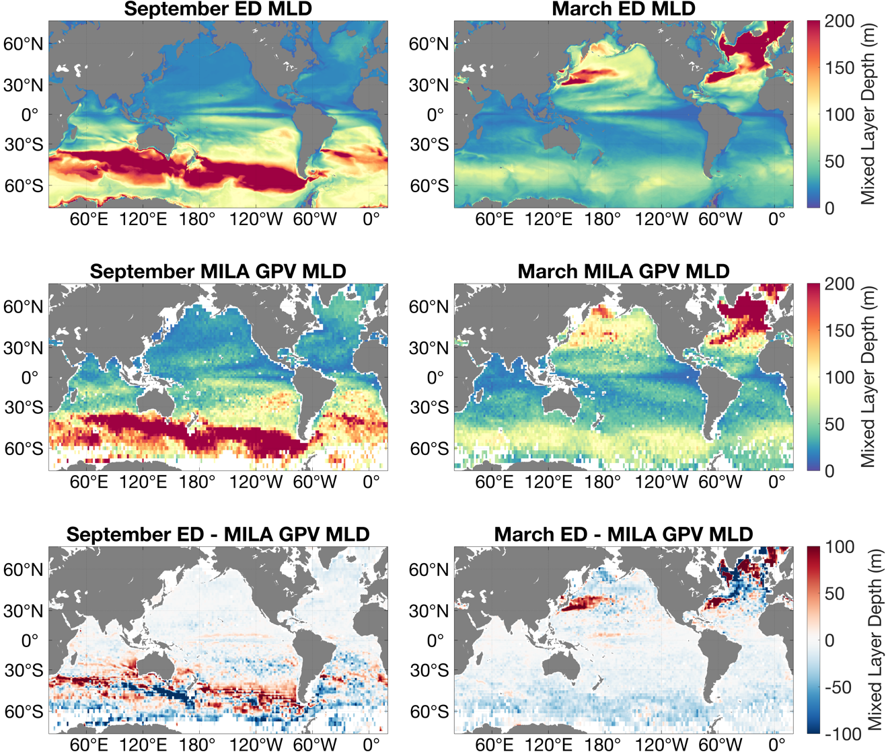

Figure S1. Mixed Layer Depth (MLD) comparison between the ED simulation and the MIxed Layer data set for Argo, Grid Point Value (MILA GPV; Hosoda et al., (2010)) for September (left column) and March (right column). The top row shows ED MLD, the middle row shows MILA GPV, and the bottom panel shows the difference between ED MLD and MILA GPV; positive values indicate that ED MLD is deeper than MILA GPV. ED MLD computations are based on the 0.03 kg m⁻³ density change criterion of de Boyer Montégut et al. (2004) applied to the mean 2004–2017 September and March temperature and salinity profiles.

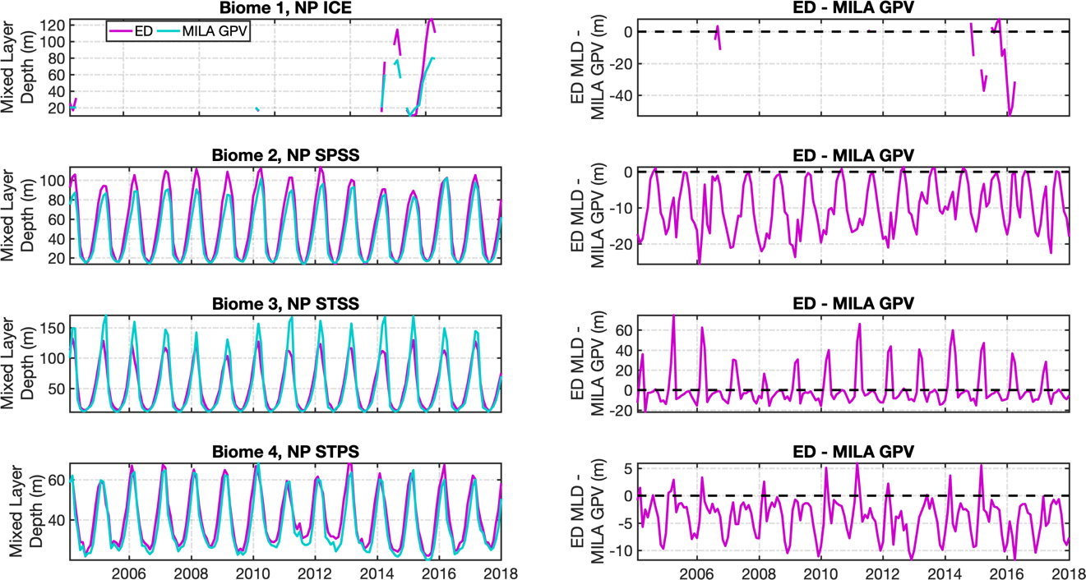

Figure S2. Biome-averaged Mixed Layer Depth (MLD) comparison between ED and the MIxed Layer data set for Argo, Grid Point Value (MILA GPV; Hosoda et al., 2010). Rows 1–4 correspond to Fay and McKinley (2014) open-ocean biomes 1–4. Left column shows mixed layer depth in m for ED (magenta line) and MILA GPV (cyan line).Right column shows the difference between ED and MILA GPV mixed layer depth; positive values indicate that ED MLD is deeper than MILA GPV. ED MLD computations are based on the 0.03 kg m⁻³ density change criterion of de Boyer Montégut et al. (2004) applied to monthly-mean temperature and salinity profiles.
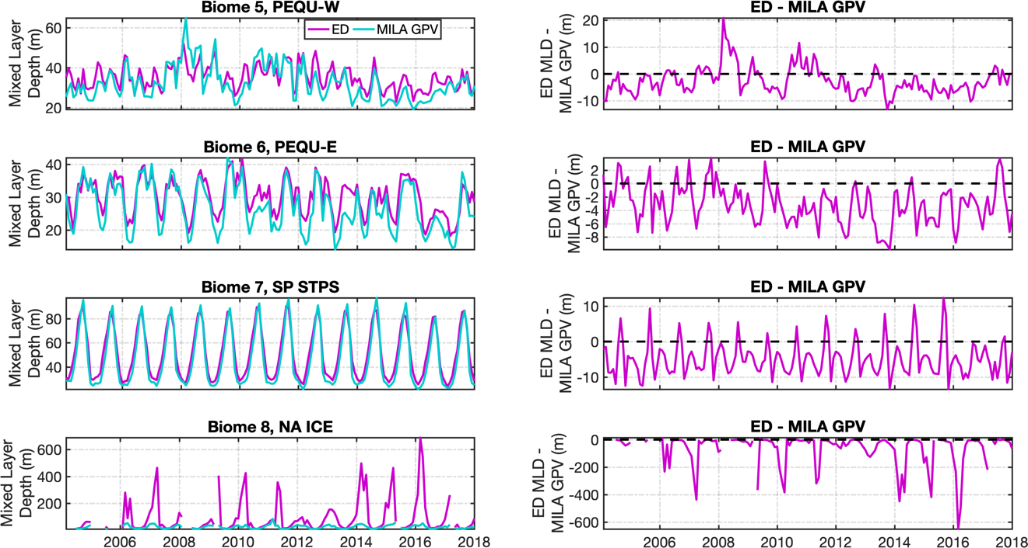

Figure S3. Same as Figure S2 but for biomes 5–8.

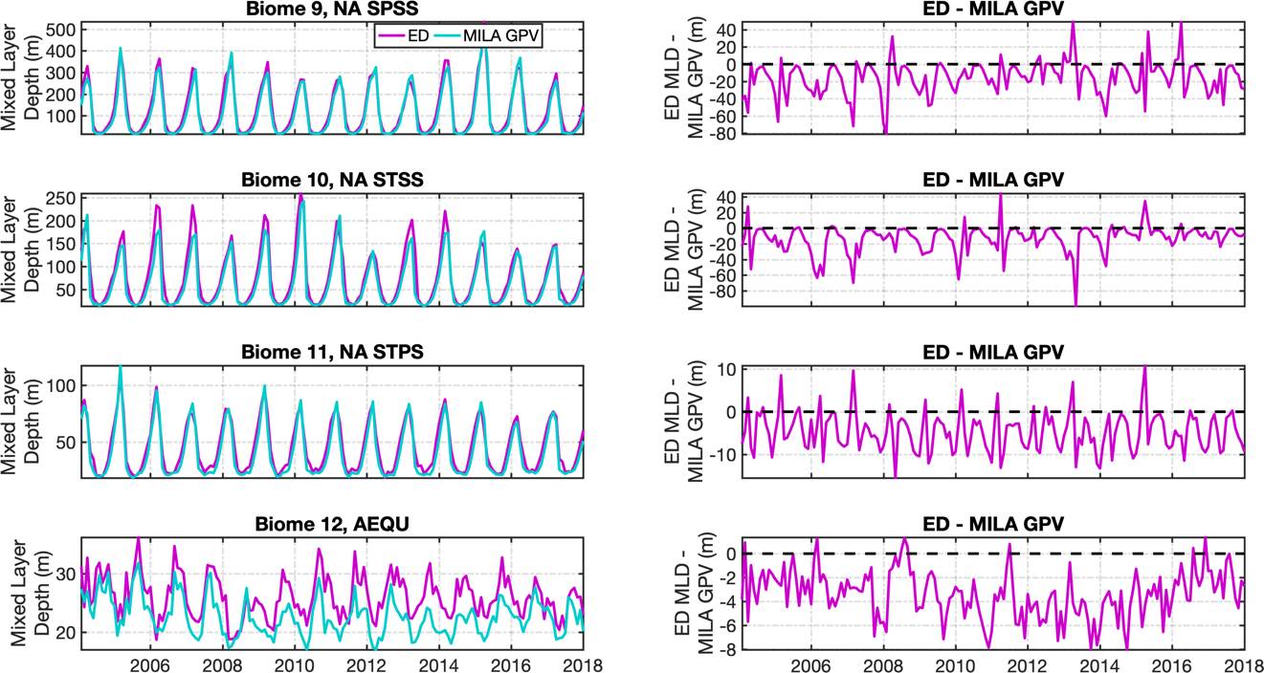

Figure S4. Same as Figure S2 but for biomes 9–12.

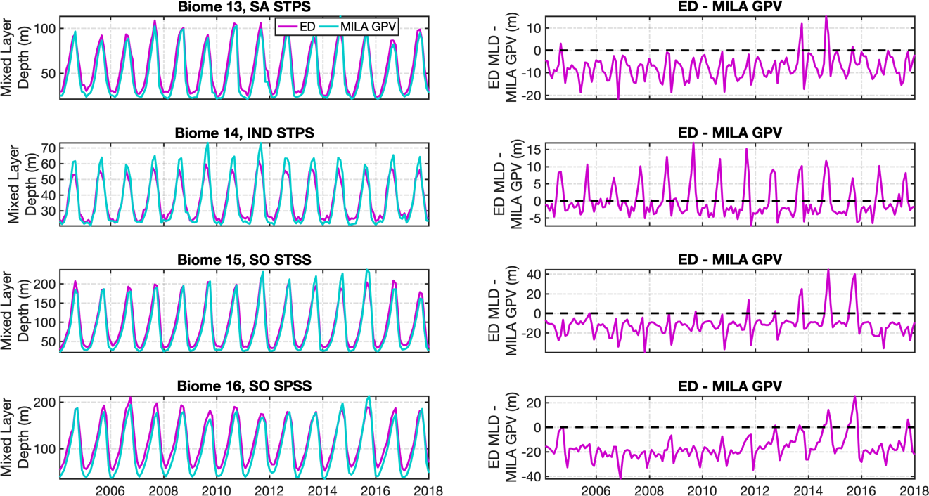

Figure S5. Same as Figure S2 but for biomes 13–16.

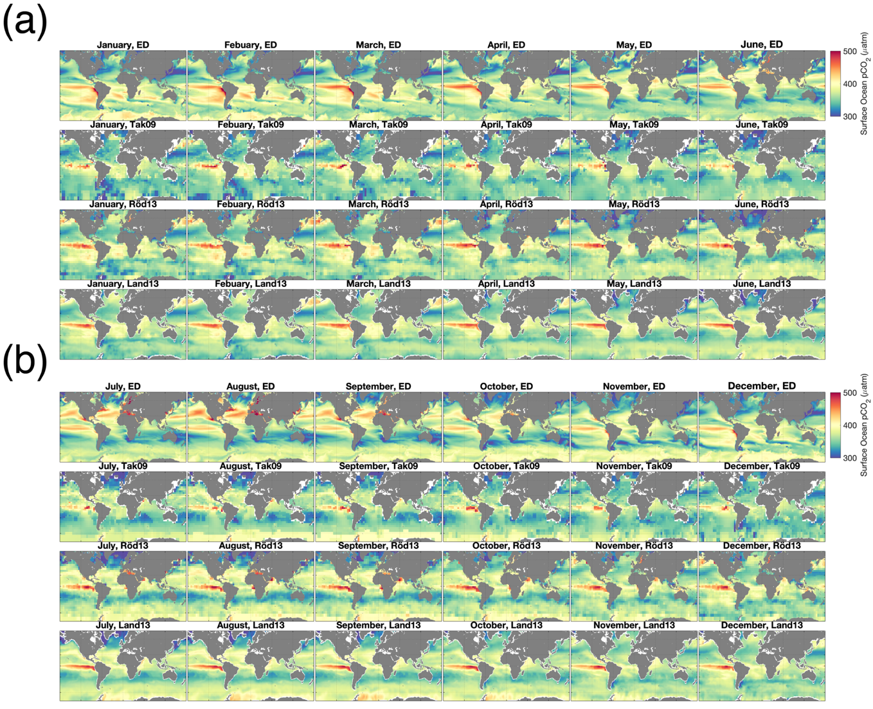

Figure S6. Surface ocean pCO₂ monthly climatology for (a) January–June and (b) July–December for ED, Tak09, Röd13, and Land13. Tak09 is referenced to year 2000; ED, Röd13, and Land13 are time-averaged from January 1995 to December 2017.

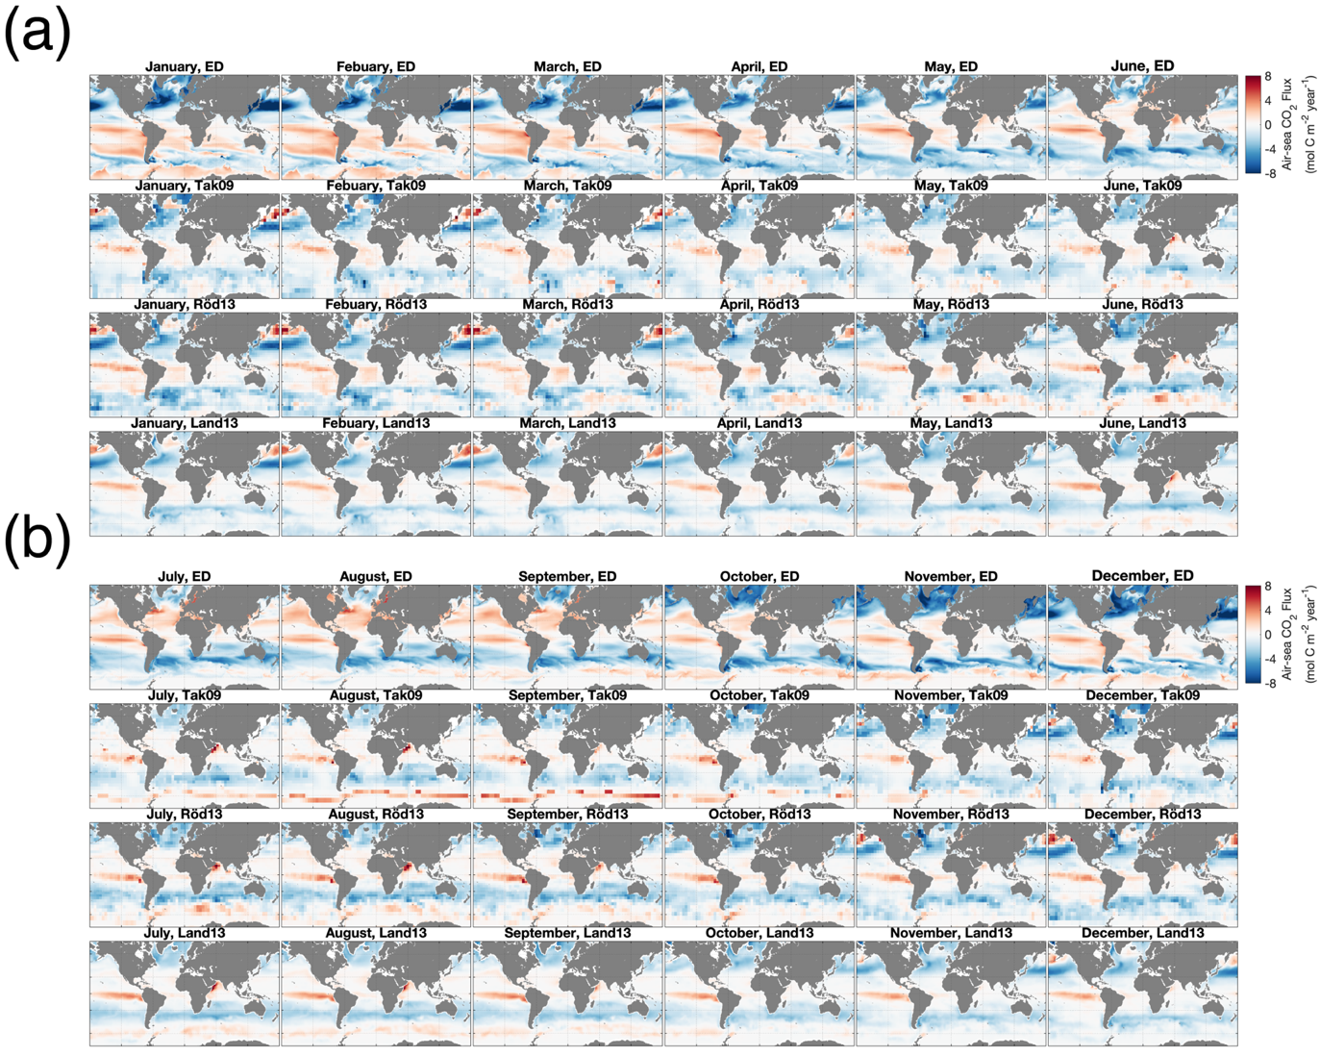

Figure S7. Air-sea CO₂ flux monthly climatology for (a) January–June and (b) July–December for ED, Tak09, Röd13, and Land13. Positive values represent outgassing (red) and negative

values are uptake (blue). Tak09 is referenced to year 2000; ED, Röd13, and Land13 are time-averaged from January 1995 to December 2017.

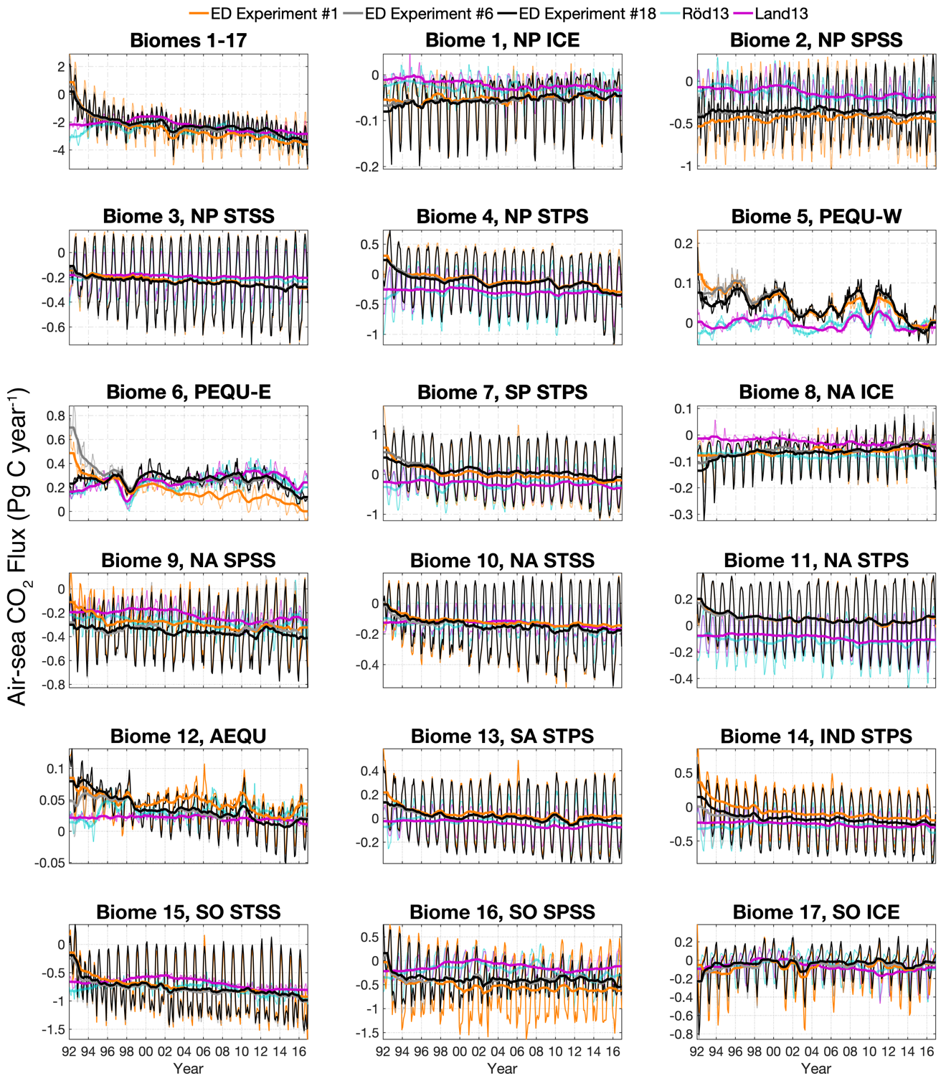

Figure S8. Air-sea CO₂ flux time series for ED Experiment #1 (orange), ED Experiment #6 (gray), ED Experiment #18 (black), Röd13 (cyan), and Land13 (magenta) in each biome. ED experiment numbers refer to Table 1 in the main text. Air-sea CO₂ fluxes are spatially integrated across their respective biomes. Positive values represent outgassing; negative values are uptake. Thin lines show monthly values and thick lines show interannual variability (12-month running mean). Similar y-axis scales are used for each individual ocean basin.

# | Initial Condition Experiments |  | Lin. Comb. Coeff.
L1 | Initial conditions from Brix et al. (2015) |  | 0.0858
L2 | Initial conditions starting from a four-year spin up of #1 |  | -0.1578
L3 | Initial conditions starting from a six-year spin up of #1 |  | -0.2655
2 | Initial conditions starting from a four-year spin up of #1 |  | 0.0114
3 | Initial conditions #2 with DIC/alkalinity + 150 mmol m⁻³ |  | -0.0065
4 | Initial conditions #2 with GLODAPv2 DIC/alkalinity |  | -0.2310
5 | Initial conditions #2 with GLODAPv2 |  | 1.5725
 |  | Parameter Value
# | Parameter Sensitivity Experiments | Brix et al. Value | Optimized Value
L4 | Iron dust solubility - 20% | 1 | 0.9273
13 | Iron scavenging rate × 5 | 3 | 9.3208
14 | Small phytoplankton growth rate + 10% | 0.7 | 0.6918
15 | Large phytoplankton growth rate + 10% | 0.4 | 0.4226
16 | Diatom palatability + 0.1 | 0.85 | 0.8456
17 | PIC/POC ratio + 20% | 0.04 | 0.0419

Table S1. Summary of the biogeochemical Green’s Functions interim optimization (Table 1, Experiment #6 in main text). The interim optimized ED simulation uses (1) biogeochemical initial conditions that are a linear combination of Experiments #L1–L3 and #2–5 according to the linear combination coefficients and (2) optimized parameter values listed in rows #L4 and #13–17. Experiments #L1–4 were carried out with the linear piston linear piston velocity formulation of Krakauer et al. (2006) as opposed to the quadratic formulation of Wanninkhof et al. (1992). Experiments #2–5 and #13–17 are as reported in Table 1.

Biome | ED  trend | ED  p-value | Röd13 trend | Röd13  p-value | Land13 trend | Land13  p-value
Global Ocean | -0.0653 | 0.0007 | -0.0451 | 0.0076 | -0.0584 | 0.0006
1–17 | -0.0560 | 0.0014 | -0.0429 | 0.0104 | -0.0545 | 0.0006
1, NP ICE | 0.0008 | 0.0093 | -0.0007 | 0.0545 | -0.0011 | 0.0170
2, NP SPSS | -0.0009 | 0.2545 | -0.0048 | 0.1443 | -0.0050 | 0.0155
3, NP STSS | -0.0034 | 0.0005 | -0.0021 | 0.0170 | -0.0012 | 0.0068
4, NP STPS | -0.0083 | 0.0170 | -0.0026 | 0.4128 | -0.0041 | 0.0227
5, PEQU-W | -0.0023 | 0.1091 | 0.0000 | 1.0000 | -0.0010 | 0.1649
6, PEQU-E | -0.0024 | 0.2697 | 0.0033 | 0.3364 | 0.0035 | 0.1544
7, SP STPS | -0.0121 | 0.0025 | -0.0042 | 0.2400 | -0.0067 | 0.0206
8, NA ICE | 0.0012 | 0.0249 | -0.0006 | 0.0810 | -0.0010 | 0.0206
9, NA SPSS | -0.0033 | 0.0273 | -0.0037 | 0.0462 | -0.0053 | 0.0155
10, NA STSS | -0.0031 | 0.0055 | -0.0026 | 0.0750 | -0.0026 | 0.0025
11, NA STPS | -0.0018 | 0.0942 | -0.0013 | 0.1760 | -0.0027 | 0.0035
12, AEQU | -0.0020 | 0.0015 | -0.0003 | 0.4334 | -0.0004 | 0.0115
13, SA STPS | -0.0024 | 0.0170 | -0.0016 | 0.1877 | -0.0036 | 0.0035
14, IND STPS | -0.0059 | 0.0004 | -0.0015 | 0.3546 | -0.0045 | 0.0008
15, SO STSS | -0.0091 | 0.0017 | -0.0088 | 0.0104 | -0.0128 | 0.0055
16, SO SPSS | -0.0013 | 0.6181 | -0.0088 | 0.0641 | -0.0052 | 0.1877
17, SO ICE | -0.0010 | 0.9432 | -0.0037 | 0.0357 | -0.0054 | 0.0273

Table S2. Theil-Sen trends (in Pg C year⁻²) for ED, Röd13, and Land13 in each open-ocean biome. Trends are computed for annual mean air-sea CO₂ flux during 1995–2017. Grey colors represent statistically significant trends at the 95% confidence level.

