Supplementary Materials

Title

The Southern Ocean with the largest uptake of anthropogenic nitrogen into the ocean interior

Authors
Xianliang L. Pan¹*, Bofeng F. Li², Yutaka W. Watanabe ²

Affiliations
¹ Graduate School of Environmental Science, Hokkaido University, Sapporo, Japan
² Faculty of Environmental Earth Science, Hokkaido University, Sapporo, Japan
* Corresponding author: panxianliang@ees.hokudai.ac.jp

Fig. S1

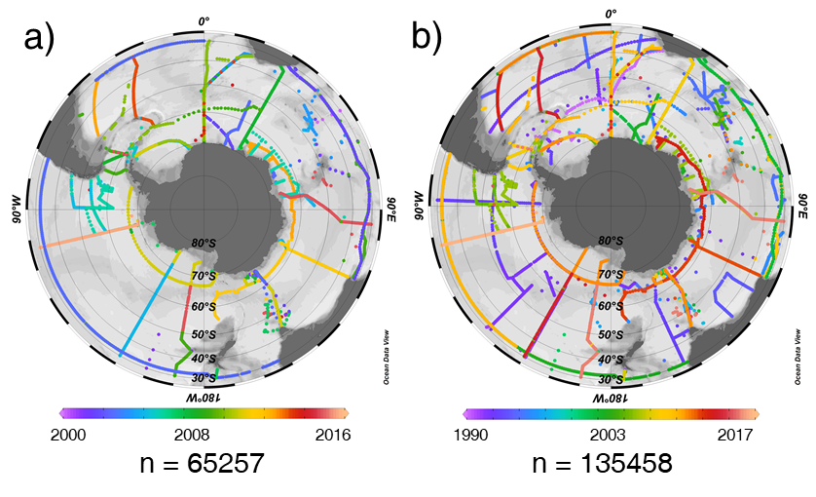

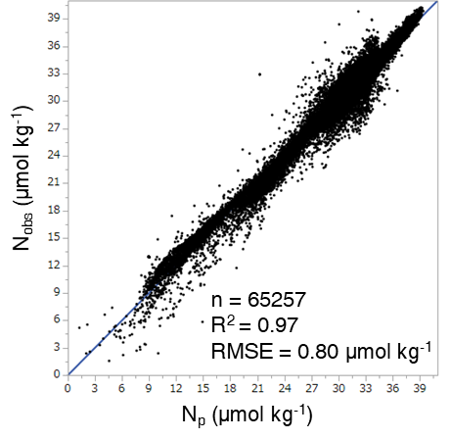
Fig. S2

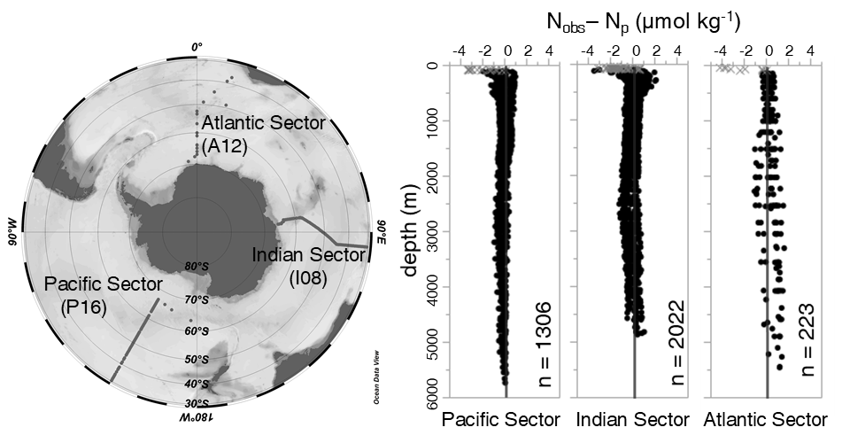
Fig. S3

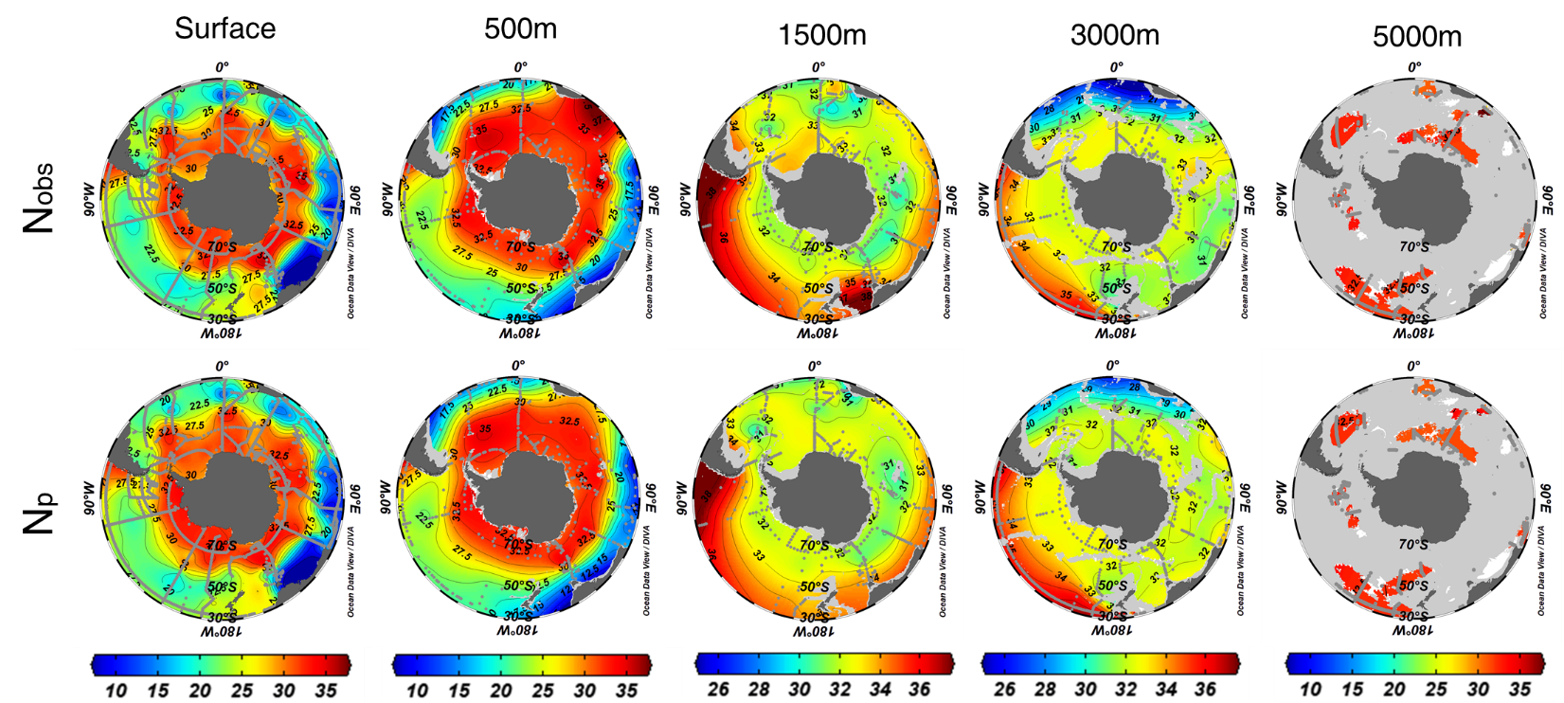
Fig. S4

Fig. S5
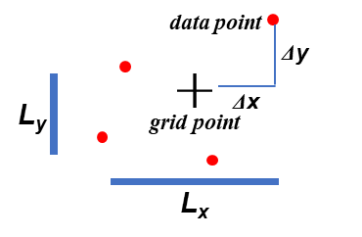
Fig. S6
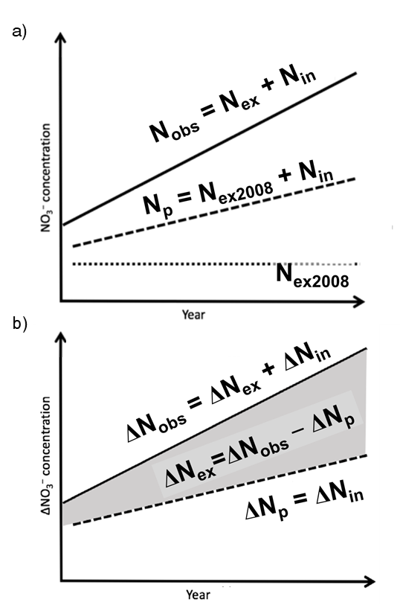
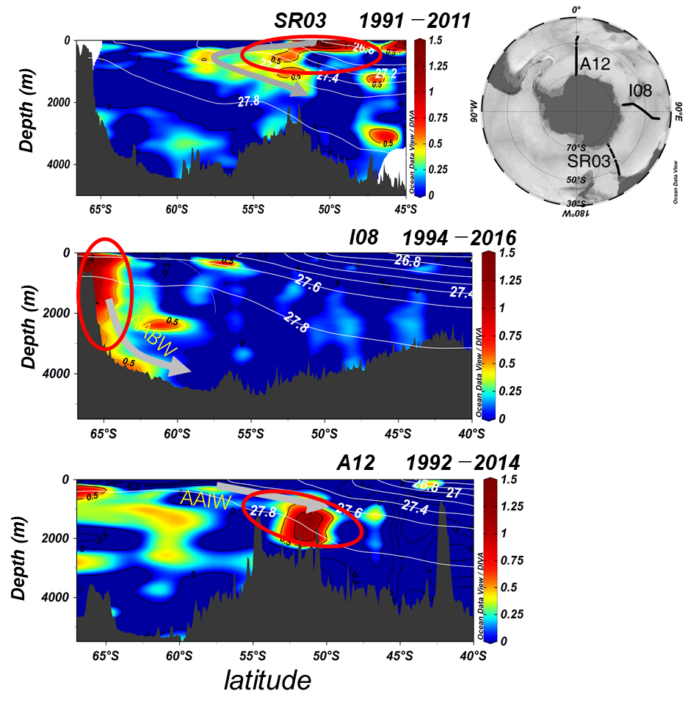
Fig. S7

Fig. S8
