SUPLEMENTARY MATERIAL

Extra information about data collection
Table S1. Calibration settings of the in-situ data collected from research vessels Ramón Margalef (1) and Emma Bardán (2). Target strength of reference target was -42.3, -40 and -39.9 dB at 38, 120 and 200 kHz, respectively. Allowed TS deviation was 5 dB and pulse duration was 1024 us. Hauls are identified by the ID code (yy: year and mnnn: station number).
Year | Survey | Hauls | Frequency | Power | Gain | S_{A} Correction
 |  | (yymnnn) | (kHz) | (W) | (dB) | (dB)
 |  |  | 38 | 1200 | 25.6 | -0.66
2010 | JUVENA¹ | 109050 | 120 | 256 | 26.8 | -0.26
 |  |  | 200 | 210 | 25.6 | -0.34
 |  | 115009, 115010,115011, 115013, 115014, 115040, 115044, 115049 | 38 | 1200 | 23.9 | -0.76
2011 | BIOMAN² |  | 120 | 250 | 26 | -0.43
 |  |  | 200 | 210 | 26.5 | -0.36
 |  |  | 38 | 1200 | 23.9 | -0.76
2012 | JUVENA² | 129205, 129213, 129222 | 120 | 250 | 26 | -0.43
 |  |  | 200 | 210 | 26.5 | -0.36
 |  |  | 38 | 1600 | 22.8 | -0.79
2013 | JUVENA² | 139230, 139233, 139235, 139236 | 120 | 250 | 26 | -0.43
 |  |  | 200 | 120 | 26.5 | -0.34
 |  | 145014, 145017, 145027, 145031, 145039, 145040, 145043, 145048, 145049 | 38 | 1200 | 23.9 | -0.73
 | BIOMAN² |  | 120 | 150 | 26 | -0.43
 |  |  | 200 | 120 | 26.2 | -0.25
 |  |  | 38 | 1400 | 25.5 | -0.68
2014 |  | 149011 | 120 | 200 | 25.9 | -0.4
 | JUVENA¹ |  | 200 | 90 | 27 | -0.23
 |  |  | 38 | 1200 | 23.9 | -0.73
 |  | 149201, 149222 | 120 | 150 | 26.1 | -0.33
 |  |  | 200 | 120 | 26.2 | -0.25
 |  |  | 38 | 1200 | 24 | -0.7
 | BIOMAN² | 155046 | 120 | 150 | 26.1 | -0.33
 |  |  | 200 | 120 | 26.2 | -0.25
2015 |  |  | 38 | 1200 | 24 | -0.7
 | JUVENA² | 159201, 159233, 159240 | 120 | 150 | 26.1 | -0.33
 |  |  | 200 | 120 | 26.2 | -0.25
 |  | 165041, 165044, 165011, 165019, 165020, 165034, 165037 | 38 | 1200 | 23.9 | -0.73
 | BIOMAN² |  | 120 | 150 | 26.3 | -0.29
2016 |  |  | 200 | 120 | 26.1 | -0.23
 |  |  | 38 | 1200 | 25.6 | -0.66
 | JUVENA¹ | 169002, 169009, 169015 | 120 | 125 | 26.6 | -0.35
 |  |  | 200 | 90 | 25.9 | -0.32
Year | Survey | Hauls | Frequency | Power | Gain | S_{A} Correction
 |  | (yymnnn) | (kHz) | (W) | (dB) | (dB)
 |  |  | 38 | 1200 | 23.9 | -0.79
 | BIOMAN² | 175014, 175032 | 120 | 150 | 26.3 | -0.29
2017 |  |  | 200 | 120 | 26.1 | -0.23
 |  |  | 38 | 1600 | 23.5 | -0.65
 | JUVENA¹ | 179002, 179004, 179005, 179009, 179019 | 120 | 200 | 26.8 | -0.25
 |  |  | 200 | 120 | 26.7 | -0.28
 |  |  | 38 | 1200 | 23.9 | -0.79
 | JUVENA² | 179215, 179223, 179234, 179236 | 120 | 150 | 26.3 | -0.29
 |  |  | 200 | 120 | 26.1 | -0.23

Table S2. Summary of the hauls and experiments used for the analysis, indicated by ID code (year and station number).

No | ID | Date | Survey | Anchovy catch | Mean length(SD) | Mean depth
 | (yymnnn) | (dd/mm/yyyy) |  | (%) | (cm) | (m)
1 | 115009 | 10/05/2011 | BIOMAN | 100 | 14.23(1) | 9.85
2 | 115010 | 10/05/2011 | BIOMAN | 90 | 15.49(1.1) | 11.79
3 | 115011 | 11/05/2011 | BIOMAN | 91 | 15.52(0.9) | 18.14
4 | 115013 | 11/05/2011 | BIOMAN | 95 | 14.9(0.8) | 14.64
5 | 115014 | 11/05/2011 | BIOMAN | 100 | 14.94(0.9) | 13.56
6 | 115040 | 23/05/2011 | BIOMAN | 96 | 13.4(0.7) | 9.91
7 | 115044 | 24/05/2011 | BIOMAN | 96 | 10(0.9) | 7.85
8 | 115049 | 27/05/2011 | BIOMAN | 98 | 13.4(0.7) | 13.85
9 | 145014 | 12/05/2014 | BIOMAN | 100 | 13.81(0.8) | 9.17
10 | 145017 | 13/05/2014 | BIOMAN | 100 | 14.17(0.9) | 13.75
11 | 145027 | 16/05/2014 | BIOMAN | 97 | 13.71(0.6) | 9.42
12 | 145031 | 17/05/2014 | BIOMAN | 91 | 15.94(0.9) | 9.85
13 | 145039 | 25/05/2014 | BIOMAN | 100 | 13.72(0.6) | 15.13
14 | 145040 | 25/05/2014 | BIOMAN | 100 | 13.83(0.5) | 13.96
15 | 145043 | 26/05/2014 | BIOMAN | 100 | 13.51(0.5) | 13.35
16 | 145048 | 28/05/2014 | BIOMAN | 100 | 13.93(0.8) | 9.82
17 | 145049 | 28/05/2014 | BIOMAN | 100 | 13.43(0.8) | 8.36
18 | 155046 | 26/05/2015 | BIOMAN | 100 | 12.75(1.5) | 10.66
19 | 165041 | 25/05/2016 | BIOMAN | 97 | 13.84(0.9) | 9.17
20 | 165044 | 26/05/2016 | BIOMAN | 85 | 15.39(0.9) | 18.65
21 | 165011 | 11/05/2016 | BIOMAN | 99 | 13.72(1.2) | 10.69
22 | 165019 | 15/05/2016 | BIOMAN | 92 | 12.79(1.3) | 9.23
23 | 165020 | 15/05/2016 | BIOMAN | 90 | 14.87(0.9) | 8.93
24 | 165034 | 23/05/2016 | BIOMAN | 95 | 13.78(1.2) | 8.64
25 | 165037 | 24/05/2016 | BIOMAN | 99 | 11.86(1.4) | 8.6
26 | 175014 | 11/05/2017 | BIOMAN | 87 | 13.5(1.3) | 9.1
27 | 175032 | 16/05/2017 | BIOMAN | 98 | 11.41(0.4) | 10.36
28 | 109050 | 27/09/2010 | JUVENA | 98 | 11.4(1) | 15.96
29 | 129205 | 04/09/2012 | JUVENA | 93 | 7.42(0.6) | 9.46
30 | 129213 | 11/09/2012 | JUVENA | 87 | 8.11(0.6) | 13.75
31 | 129222 | 17/09/2012 | JUVENA | 98 | 8.83(0.9) | 15.15
32 | 139230 | 21/09/2013 | JUVENA | 100 | 9.89(0.9) | 15.63
33 | 139233 | 23/09/2013 | JUVENA | 100 | 16.33(0.9) | 7.55
34 | 139235 | 24/09/2013 | JUVENA | 100 | 15.48(1.7) | 9.65
35 | 139236 | 24/09/2013 | JUVENA | 100 | 16.26(0.7) | 14.42
36 | 149011 | 09/09/2014 | JUVENA | 100 | 8.63(0.7) | 16.5
37 | 149201 | 03/09/2014 | JUVENA | 100 | 6.06(0.7) | 7.79
38 | 149222 | 18/09/2014 | JUVENA | 87 | 9.87(0.9) | 13.43
39 | 159201 | 30/08/2015 | JUVENA | 100 | 6.2(0.2) | 13.5
40 | 159233 | 20/09/2015 | JUVENA | 98 | 10.61(1.9) | 19.63
 | ID | Date | Survey | Anchovy catch | Mean length | Mean depth
41 | 159240 | 24/09/2015 | JUVENA | 99 | 12.11(0.4) | 15.11
42 | 169002 | 01/09/2016 | JUVENA | 98 | 6.25(0.6) | 13.29
43 | 169009 | 06/09/2016 | JUVENA | 91 | 8.48(1.4) | 19.17
44 | 169015 | 11/09/2016 | JUVENA | 90 | 7.34(1) | 13.56
45 | 179002 | 03/09/2017 | JUVENA | 97 | 9.96(0.7) | 13.18
46 | 179004 | 04/09/2017 | JUVENA | 100 | 8.03(0.7) | 19.32
47 | 179005 | 05/09/2017 | JUVENA | 97 | 11.01(0.9) | 14.12
48 | 179009 | 15/09/2017 | JUVENA | 100 | 8.54(1.3) | 14.54
49 | 179019 | 20/09/2017 | JUVENA | 87 | 9.97(1.2) | 14.77
50 | 179215 | 18/09/2017 | JUVENA | 100 | 5.85(0.4) | 9.05
51 | 179223 | 21/09/2017 | JUVENA | 99 | 9.82(0.8) | 13.33
52 | 179234 | 05/10/2017 | JUVENA | 100 | 15.65(1.8) | 10.2
53 | 179236 | 06/10/2017 | JUVENA | 99 | 12.41(1.3) | 7.95
54 | 12_n1 | 11/07/2012 | CAGE | 100 | 10.1(0.8) | 3.26
55 | 12_n2_1 | 19/07/2012 | CAGE | 100 | 10.1(0.8) | 2.61
56 | 12_n2_2 | 20/07/2012 | CAGE | 100 | 10.1(0.8) | 2.51
57 | 13_n3_1 | 20/02/2013 | CAGE | 98 | 10.9(1.1) | 2.58
58 | 13_n3_2 | 20/02/2013 | CAGE | 98 | 10.9(1.1) | 2.55

TS versus depth and length relationship

Target strength versus depth relationships were modelled using linear regression models, accounting also for fish age (juveniles, i.e., age = 0 and adults age ≥ 1). Preliminary results indicated a TS increase with depth at all frequencies (Fig. 10), contrarily to expectations of swimbladder compression with pressure increase for a physostomous fish such as anchovy. When building linear models of length against depth, we found a significant (p < 0.05 for adults and p < 0.005 for juveniles) increase of length also with depth (Fig. 10), which, as the TS generally increases with fish body length, might explain the unexpected TS-depth pattern observed. The objective of this analysis is hence to try to determine whether in this case the expected increase of TS with depth due to the observed length stratification should prevail over the expected decrease of TS with depth due to swimbladder compression, thus justifying the observed TS-depth relations.

Methodology

One possible way to do this would be to analyze TS against length and depth concurrently using multiple linear regression models. But the mentioned collinearity found between body length and depth of anchovy (Fig. 10), prevents from fitting such models due to violation of the independence assumption of the explanatory variables. To try to overcome this statistical limitation, an approach was attempted based on the prediction of TS values combining the observed TS-length relationship and the expected TS-depth relationship from theoretical swimbladder compression following Boyle’s law.

Extended TS versus depth and length relations for physostomous fish are typically modelled (e.g., Ona et al. 2003) as:
${TS}_{pred}\left(SL, z, γ\right)=a\log\left(SL\right)-10γ\log\left(1+z/10\right)+ b^{(0)}$ (S1)
Where z is the depth in meters and γ is the level of the swimbladder compression (γ = 0.67 representing Boyle’s law for a free balloon) and the super index ⁽⁰⁾ denotes the surface z = 0.
As the general expected TS versus length and depth relationship is supposed to depend on depth through Eq. S1, strictly, the single TS-length relation fitted with the empirical data following Eq. 1 (i.e., Table 6) is considered to be valid only for the range of mean depths at which the in situ experiments were done, and in particular for the average of the experimental depths (z ≈ 13 m), thus:
${TS}_{obs}(SL, z=13)=a\log\left(SL\right)+ b^{(13)}$ (S2)
Being the theoretical relationship between the intercepts at the surface and at the mean experimental depth as follows:
$b^{(0)}=b^{(13)}+10γ log⁡(1+13/10)$ (S3)
Substituting $b^{(0)}$ from Eq. S3 in Eq. S1, and after a few small arrangements, we obtain the following expression for the predicted TS values:
${TS}_{pred}\left(SL, z, γ\right)=a\log\left(SL\right)-10γ\log\left(\frac{10+z}{10+13}\right)+ b^{(13)}$ (S4)
In this approach, Eq. S4 was used to predict the TS values for mean lengths and mean depths existing at the in situ hauls, by combining the observed TS-length relationship of the in situ experiments (Table 6) and the assumption of a theoretical depth compression based on Boyle’s law for a free bubble. Then, we compared TS-depth relationships obtained with the predicted TS values in Eq. S4 and the observed ones to check whether the observed TS-depth relationships were consistent with the theoretical predictions under the existing conditions of the experiments. Finally, for quantitative comparison of slopes, observed and predicted TS-depth models were built following:
$TS\left( z, γ\right)=a\log\left(1+z/10\right)+ b$ (S5)
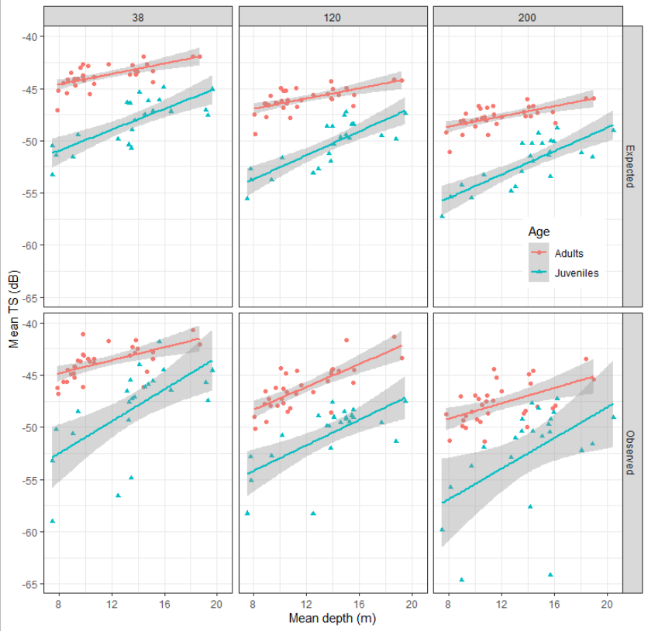
Fig. S1. Comparison between expected (${TS}_{pred}$) and observed (${TS}_{obs}$) relation between mean target strength and mean depth of the in situ experiments, distinguishing between age groups.

Results and discussion
The result showed that expected TS values increased with depth (Fig. S1), evidencing that the increase due to the length stratification dominated the decrease due to swimbladder compression. As a result, the length stratification shown by anchovy near the surface during the night, masks the TS vs depth due solely to swimbladder compression, which makes this work not appropriate to study this relationship. Therefore, further empirical measures, preferably covering a larger depth range, should be done to complete this important aspect of the target strength of anchovy.
Table S3. Summary of observed and predicted TS-depth regression models according to Eq. S5.
 | Frequency | Age | b | a | R2
 | (kHz)
Observed | 38 | Adults | -49.1*** | 16.4*** | 0.35
 | 120 | Adults | -55.8*** | 28.7*** | 0.56
 | 200 | Adults | -54.3*** | 19.4** | 0.26
Predicted | 38 | Adults | -48.0*** | 13.1*** | 0.42
 | 120 | Adults | -50.4*** | 12.9*** | 0.4
 | 200 | Adults | -52.1*** | 13.0*** | 0.4
Observed | 38 | Juveniles | -63.3*** | 41.1*** | 0.4
 | 120 | Juveniles | -62.7*** | 32.4*** | 0.44
 | 200 | Juveniles | -67.7*** | 40.5* | 0.23
Predicted | 38 | Juveniles | -58.0*** | 26.8*** | 0.57
 | 120 | Juveniles | -61.5*** | 29.9*** | 0.64
 | 200 | Juveniles | -63.5*** | 30.2*** | 0.63

Despite the similar tendency between predicted and observed TS increase with depth, observed slopes were higher for all frequencies and age groups (Table S3). Hence, the prediction based on the length stratification was not able to completely explain the observed TS increase. A reason for this could be the lack of depth resolution of the sampling collection in the in situ experiments. The vertical opening of the haul was 15-20 m for near-surface trawls, hence the same magnitude of the whole depth range of the study. Consequently, we might be losing part of the length stratification inside each haul, which would explain the smaller predicted slopes. Other factors that might have yield to such extra TS-depth slope could be for example a higher probability of failure of the single target detection filters with increasing depth or a change of behavior of anchovy with depth.

