Present and future potential habitat distribution of Carcharhinus falciformis and Canthidermis maculata by-catch species in the tropical tuna purse-seine fishery under climate change

NEREA LEZAMA-OCHOA^{1*}, HILARIO MURUA¹, GUILLEM CHUST¹, EMIEL VAN LOON², JON RUIZ¹, MARTIN HALL³, PIERRE CHAVANCE⁴, ALICIA DELGADO DE MOLINA⁵, ERNESTO VILLARINO¹

*Corresponding Author: tel: (+34) 679342974; e-mail: nlezamaochoa@gmail.com

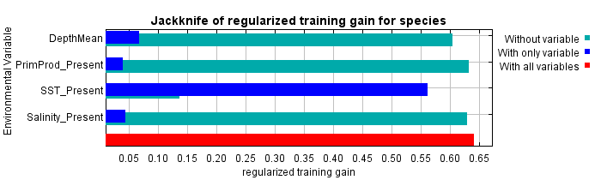
b)
a)
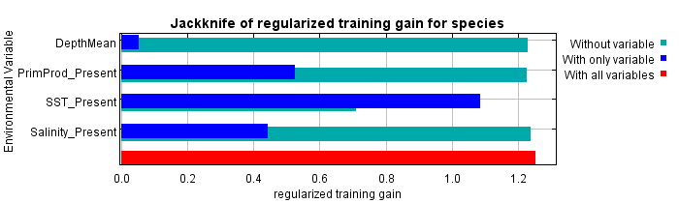
c)
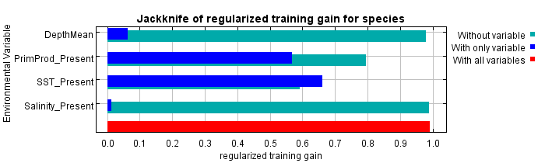
d)
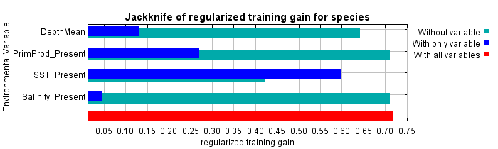
e)
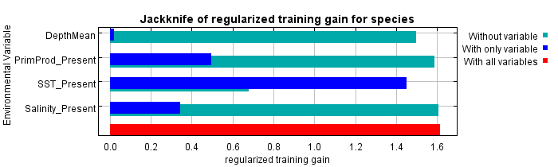
f)
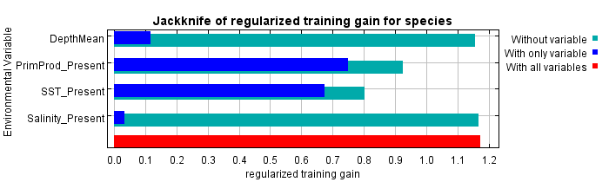

Supplementary material Figure 6. Contribution of the environmental variables to the MaxEnt model based on a jackknife procedure, providing the explanatory power of each variable when used in isolation for Carcharhinus falciformis in the Indian (a), Atlantic (b) and Eastern Pacific Ocean (c) and for Canthidermis maculata in the Indian (d), Atlantic (e) and Eastern Pacific Ocean (f).

