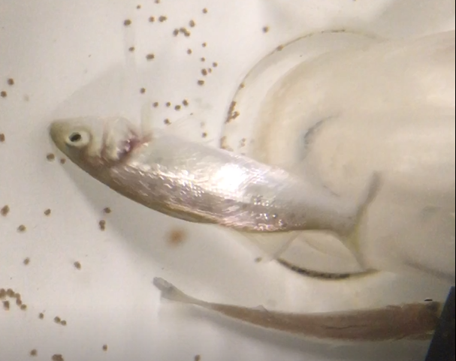
Video 1: Spiralling swimming pattern in European sea bass experimentally infected with nervous necrosis virus (NNV).

