SUPPLEMENTARY MATERIALS

TABLES

Supplementary Table 1: List of transects per year with their corresponding coordinates. Some transects have the same rounded coordinates, but the realised video sampling haul was not exactly at the same location. We thus considered there were no repeatedly sampled transects.

|  |  |  |  |
| --- | --- | --- | --- |
| Transect | Year | Long | Lat |
| 1 | 2014 | -5,7801 | 51,4225 |
| 2 | 2014 | -6,1371 | 51,1741 |
| 3 | 2014 | -6,4067 | 51,0902 |
| 4 | 2014 | -6,5228 | 51,7655 |
| 5 | 2014 | -9,8975 | 51,1510 |
| 6 | 2016 | -5,1103 | 51,0654 |
| 7 | 2016 | -5,5168 | 51,2675 |
| 8 | 2016 | -6,0210 | 48,4255 |
| 9 | 2016 | -6,1371 | 51,1741 |
| 10 | 2016 | -6,4895 | 51,1342 |
| 11 | 2016 | -6,7015 | 51,7843 |
| 12 | 2016 | -7,2148 | 49,9046 |
| 13 | 2016 | -7,4271 | 51,6295 |
| 14 | 2016 | -7,4869 | 51,3447 |
| 15 | 2016 | -9,9280 | 50,8193 |
| 16 | 2018 | -6,0210 | 48,4255 |
| 17 | 2018 | -6,5202 | 48,4173 |
| 18 | 2018 | -6,6127 | 48,3770 |
| 19 | 2018 | -6,7015 | 51,7843 |
| 20 | 2018 | -7,3177 | 48,8928 |
| 21 | 2018 | -8,3277 | 51,5247 |
| 22 | 2018 | -8,5911 | 50,4278 |
| 23 | 2018 | -9,4616 | 49,9274 |
| 24 | 2018 | -9,6321 | 50,9233 |
| 25 | 2018 | -9,7855 | 49,5207 |
| 26 | 2018 | -9,9280 | 50,8193 |
| 27 | 2018 | -10,0486 | 50,3014 |
| 28 | 2018 | -10,2050 | 50,0783 |
| 29 | 2018 | -10,4820 | 50,7173 |
| 30 | 2018 | -10,4998 | 49,7353 |
| 31 | 2018 | -10,5192 | 49,3240 |
| 32 | 2018 | -10,8239 | 50,3556 |
| 33 | 2019 | -5,1103 | 51,0654 |
| 34 | 2019 | -5,5168 | 51,2675 |
| 35 | 2019 | -6,0210 | 48,4255 |
| 36 | 2019 | -6,6462 | 48,7049 |
| 37 | 2019 | -6,8485 | 48,986 |
| 38 | 2019 | -6,9100 | 48,3875 |
| 39 | 2019 | -7,3083 | 49,6119 |
| 40 | 2019 | -7,4271 | 51,6295 |
| 41 | 2019 | -7,4433 | 49,0767 |
| 42 | 2019 | -7,8118 | 50,6567 |
| 43 | 2019 | -8,0292 | 49,0300 |
| 44 | 2019 | -8,0648 | 49,469 |
| 45 | 2019 | -8,0789 | 50,0828 |
| 46 | 2019 | -8,7049 | 49,9524 |
| 47 | 2019 | -9,0988 | 50,8894 |
| 48 | 2019 | -9,1707 | 48,9718 |
| 49 | 2019 | -9,6798 | 48,8031 |
| 50 | 2019 | -9,7855 | 49,5207 |
| 51 | 2019 | -9,9280 | 50,8193 |
| 52 | 2019 | -10,0529 | 50,5352 |
| 53 | 2019 | -10,2050 | 50,0783 |
| 54 | 2019 | -10,8239 | 50,3556 |

Supplementary Table 2: List of biological traits and assigned score in relation with sensitivity to trawling impact

|  |  |  |  |  |  |  |
| --- | --- | --- | --- | --- | --- | --- |
| Sensitivity score | Position | Feeding | Mobility | Size | Fragility | Longevity |
| 0 | Deep burrowing | Scavengers | Highly mobile, swimming | Small (<5cm) | Hardshell, vermiform, regeneration | <1year |
| 1 | Surface burrowing | Deposit feeders, predators, opportunistic scavengers | Mobile, crawling | Medium (5-10cm) | Softshell | 1-3years |
| 2 | Surface | Planktivores, filter feeders that can select their preys (eg. anemones) | Sedentary, can retract | Large (10-30cm) | No protection | 3-10years |
| 3 | Emergent, demersal | Filter feeders | Sessile, attached | Very large (>30cm) | Fragile shell, structure | >10years |

Supplementary Table 3: Number of individuals, score by trait and sensitivity score per taxa

|  |  |  |  |  |  |  |  |  |
| --- | --- | --- | --- | --- | --- | --- | --- | --- |
| Taxa | Number of individuals | Motility | Size | Feeding | Fragility | Position | Longevity | Sensitivity |
| *Actinauge* | 4489 | 3 | 1 | 3 | 2 | 3 | 3 | 15 |
| Hydrozoa | 4247 | 3 | 1 | 3 | 3 | 3 | 0 | 13 |
| Polychaeta | 3963 | 2 | 2 | 1 | 2 | 2 | 2 | 11 |
| *Caryophyllia* spp*.* | 1911 | 3 | 0 | 3 | 2 | 2 | 3 | 13 |
| Actiniaria | 1215 | 3 | 1 | 3 | 2 | 2 | 3 | 14 |
| *Scomber* spp*.* | 1042 | 0 | 2 | 1 | 2 | 3 | 3 | 11 |
| Paguroidea | 972 | 1 | 0 | 0 | 0 | 2 | 2 | 5 |
| Ophiuroidea | 555 | 1 | 1 | 0 | 3 | 2 | 2 | 9 |
| *Pennatula phosphorea* | 542 | 3 | 2 | 3 | 2 | 2 | 3 | 15 |
| *Funiculina quadrangularis* | 515 | 3 | 3 | 3 | 2 | 3 | 3 | 17 |
| Clupeiformes | 424 | 0 | 2 | 2 | 2 | 3 | 3 | 12 |
| Actinopterygii | 410 | 0 | 1 | 2 | 2 | 3 | 3 | 11 |
| Gastropoda | 343 | 1 | 1 | 0 | 0 | 2 | 3 | 7 |
| Asteroidea | 341 | 1 | 2 | 0 | 2 | 2 | 2 | 9 |
| *Trachurus* spp*.* | 295 | 0 | 3 | 1 | 2 | 3 | 3 | 12 |
| Crinoidea | 204 | 3 | 0 | 3 | 3 | 2 | 2 | 13 |
| Sabellidae | 188 | 3 | 2 | 3 | 3 | 3 | 2 | 16 |
| Pleuronectiformes | 179 | 0 | 3 | 0 | 2 | 1 | 3 | 9 |
| *Lepidorhombus* spp. | 136 | 0 | 2 | 1 | 2 | 2 | 3 | 10 |
| Caridea | 119 | 1 | 0 | 1 | 1 | 2 | 2 | 7 |
| Triglidae | 116 | 0 | 2 | 1 | 2 | 2 | 3 | 10 |
| *Melanogrammus aeglefinus* | 115 | 0 | 3 | 1 | 2 | 3 | 3 | 12 |
| *Capros aper* | 113 | 0 | 2 | 2 | 2 | 3 | 3 | 12 |
| *Trisopterus* spp*.* | 111 | 0 | 2 | 1 | 2 | 3 | 2 | 10 |
| Echinoidea | 108 | 2 | 2 | 1 | 3 | 2 | 2 | 12 |
| Decapodiformes | 86 | 0 | 2 | 1 | 2 | 3 | 1 | 9 |
| *Argentina* spp*.* | 73 | 0 | 2 | 2 | 2 | 3 | 3 | 12 |
| Brachyura | 54 | 1 | 1 | 0 | 1 | 2 | 3 | 8 |
| *Micromesistius poutassou* | 51 | 0 | 2 | 2 | 2 | 3 | 3 | 12 |
| Anthozoa | 47 | 3 | 1 | 3 | 3 | 3 | 3 | 16 |
| *Scyliorhinus* spp*.* | 46 | 0 | 3 | 0 | 2 | 2 | 3 | 10 |
| Octopodiformes | 42 | 0 | 2 | 1 | 2 | 2 | 2 | 9 |
| *Munida* spp*.* | 23 | 1 | 0 | 0 | 1 | 0 | 2 | 4 |
| *Maurolicus muellieri* | 21 | 0 | 1 | 2 | 2 | 3 | 2 | 10 |
| Veretillidae | 21 | 3 | 2 | 3 | 2 | 3 | 3 | 16 |
| Pectinidae | 18 | 1 | 1 | 3 | 0 | 2 | 3 | 10 |
| Alcyoniidae | 16 | 3 | 1 | 3 | 3 | 3 | 3 | 16 |
| *Nephrops norvegicus* | 16 | 1 | 2 | 0 | 1 | 0 | 2 | 6 |
| *Merlangius merlangus* | 14 | 0 | 3 | 1 | 2 | 3 | 3 | 12 |
| *Lophius* spp*.* | 12 | 0 | 3 | 1 | 2 | 1 | 3 | 10 |
| Bryozoa | 7 | 3 | 0 | 3 | 3 | 3 | 2 | 14 |
| *Merluccius merluccius* | 7 | 0 | 3 | 1 | 2 | 3 | 3 | 12 |
| Rajidae | 5 | 0 | 3 | 1 | 2 | 1 | 3 | 10 |
| *Atrina* spp*.* | 4 | 2 | 2 | 3 | 3 | 0 | 3 | 13 |
| *Gadiculus argenteus* | 4 | 0 | 1 | 2 | 2 | 3 | 2 | 10 |
| Selachii | 4 | 0 | 3 | 1 | 2 | 2 | 3 | 11 |
| Ascidiidae | 3 | 3 | 1 | 3 | 3 | 3 | 2 | 15 |
| Holothuria | 3 | 2 | 2 | 3 | 2 | 2 | 2 | 13 |
| *Scalpellum scalpellum* | 3 | 3 | 0 | 3 | 3 | 2 | 0 | 11 |
| *Conger conger* | 2 | 0 | 3 | 0 | 2 | 2 | 3 | 10 |
| Nudibranchia | 2 | 1 | 1 | 1 | 2 | 2 | 0 | 7 |
| Syngnathus | 2 | 0 | 2 | 1 | 2 | 2 | 1 | 8 |
| *Zeus faber* | 2 | 0 | 3 | 1 | 2 | 3 | 3 | 12 |
| *Maja* spp*.* | 1 | 1 | 2 | 0 | 1 | 2 | 2 | 8 |
| *Mullus surmuletus* | 1 | 0 | 2 | 1 | 2 | 3 | 3 | 11 |

FIGURES

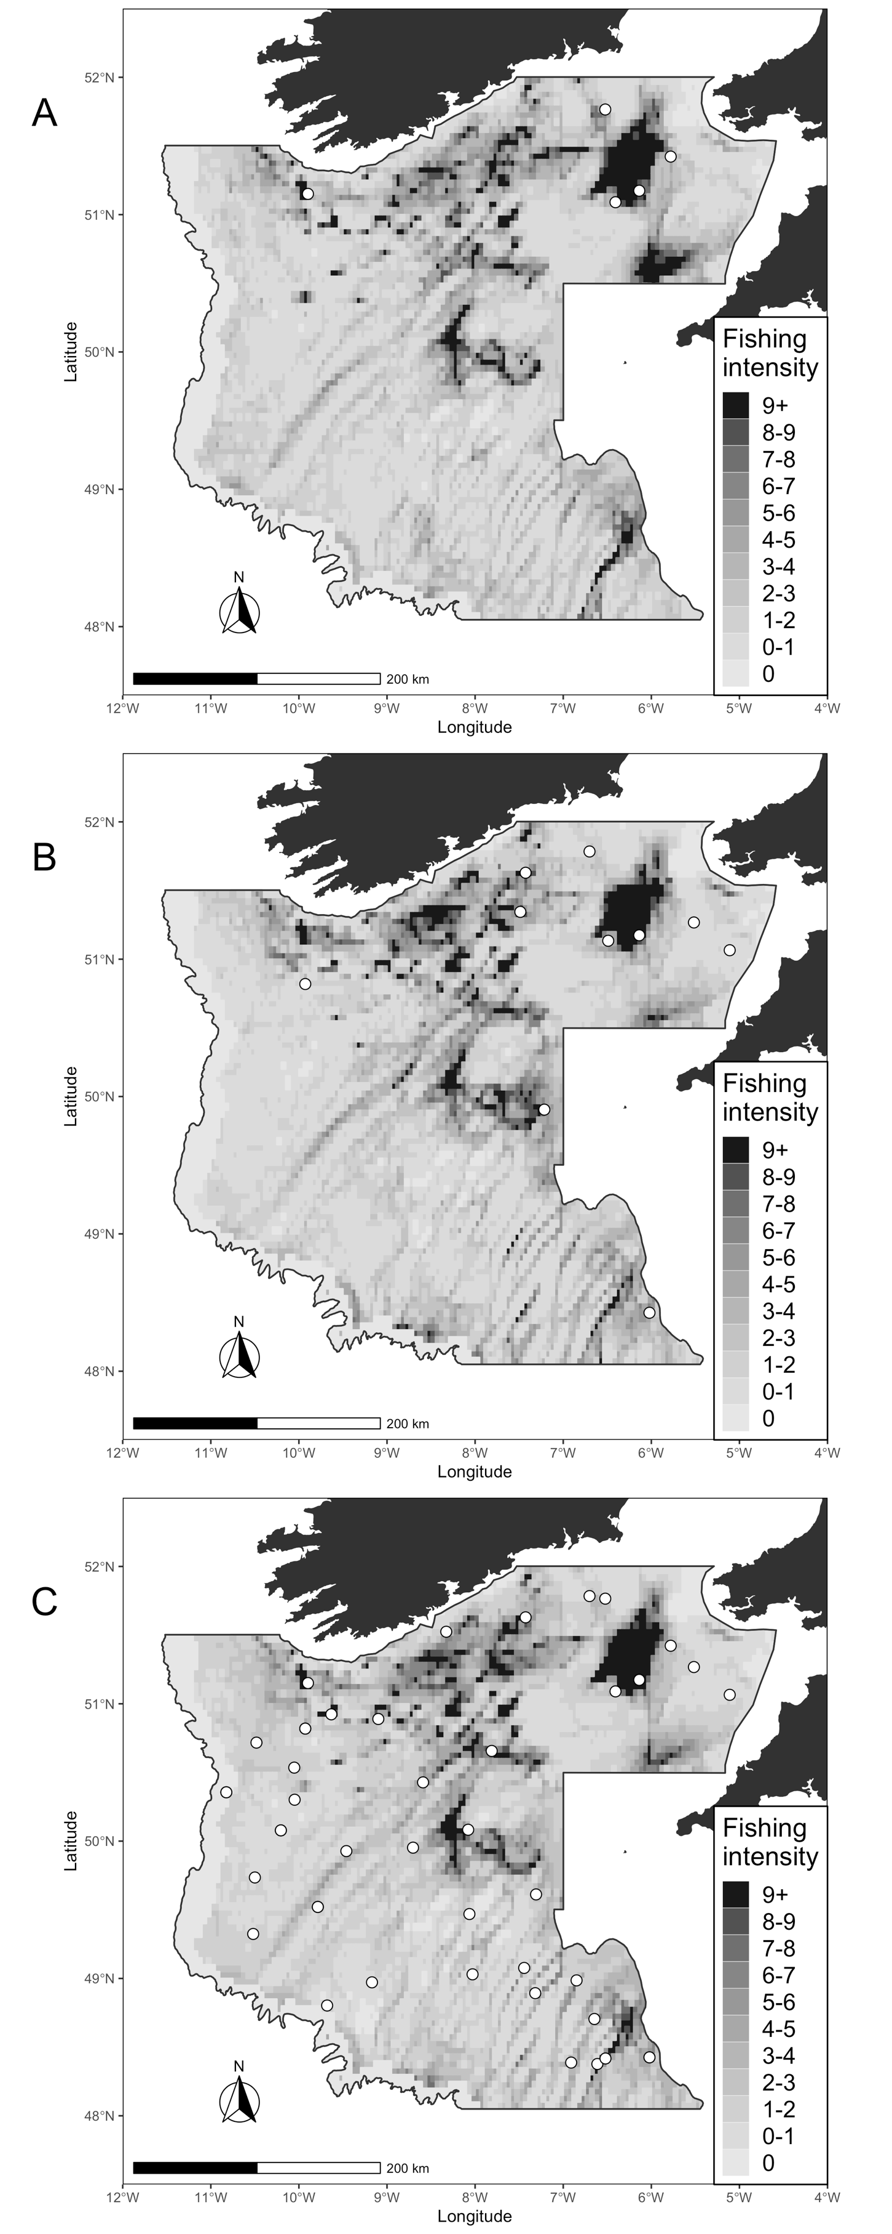

Supplementary Figure 1: Fishing intensity in the Celtic Sea, obtained from the ICES. Total Surface Swept Area Ratio (SurfSAR) in 2014 (A), 2016 (B), and mean SurfSAR using yearly values from 2013 to 2017 (C). In every map, the dots represent the transects for which fishing intensity values were extracted for the given year.

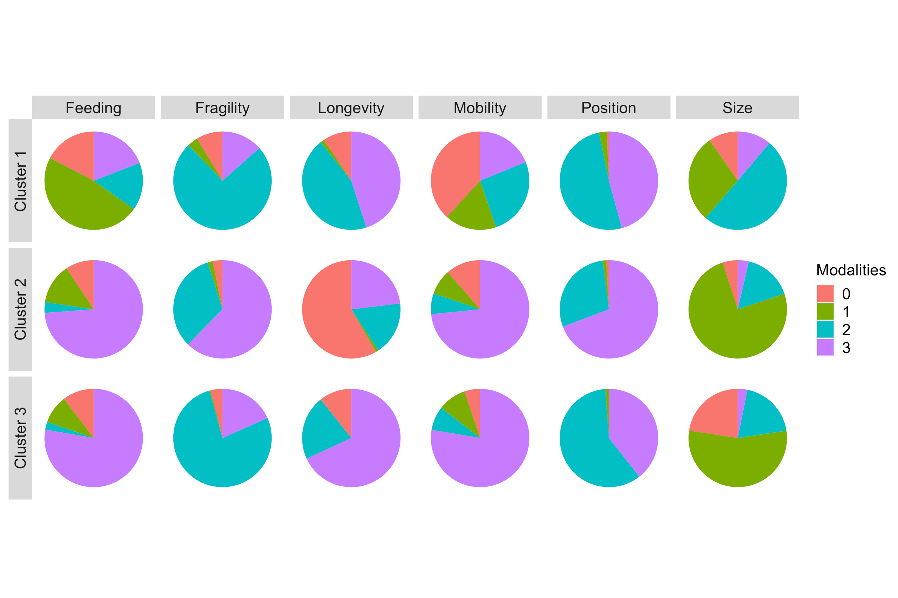

Supplementary Figure 2: Mean repartition of trait modalities in the three clusters. Categories corresponding to each score are presented in Supplementary Table 2.