Paleoceanography & Paleoclimatology
Supporting Information for
Changes in the intermediate water masses of the Mediterranean Sea during the last climatic cycle - New constraints from neodymium isotopes in foraminifera
Christophe Colin^{1*}, Maxence Duhamel¹, Giuseppe Siani¹, Quentin Dubois-Dauphin¹, Emmanuelle Ducassou², Zhifei Liu³, Jiawang Wu³, Marie Revel⁴, Arnaud Dapoigny⁵, Eric Douville⁵, Marco Taviani^{6,7,8}, Paolo Montagna^{9,10}
1. Université Paris-Saclay, CNRS, GEOPS, 91405, Orsay, France.
2. Université de Bordeaux, UMR-CNRS 5805-EPOC, Allée Geoffroy St Hilaire, 33615 Pessac Cedex, France.
3. State Key Laboratory of Marine Geology, Tongji University, Shanghai 200092, China
4. Université de la Cote d’Azur, CNRS, OCA, IRD, Geoazur, 250 rue Albert Einstein, 06500 Valbonne, France.
5. Laboratoire des Sciences du Climat et de l’Environnement, LSCE/IPSL, CEA-CNRS-UVSQ, Université Paris-Saclay, F-91191 Gif-sur-Yvette, France.
6. Institute of Marine Sciences, ISMAR-CNR, Via Gobetti 101, 40129 Bologna, Italy
7. Stazione Zoologica Anton Dohrn, Naples, Italy
8. Biology Department, Woods Hole Oceanographic Institution, Woods Hole, MA 02543, USA
9. Institute of Polar Sciences, ISP-CNR, Via Gobetti 101, 40129 Bologna, Italy
10. Lamont Doherty Earth Observatory, Columbia University, Palisades, NY, United States

*Corresponding author: Christophe Colin (Christophe.colin@universite-paris-saclyy.fr)

Contents of this file

Figures S1
Introduction
The supplementary figure 1 presents a comparison of εNd obtained on planktonic foraminiferas of core RECORD23 for the Holocene (this study) and of previous εNd values obtained from scleractinian cold-water corals (Madrepora oculata and Lophelia pertusa) from the same core (Dubois-Dauphin et al., 2017).

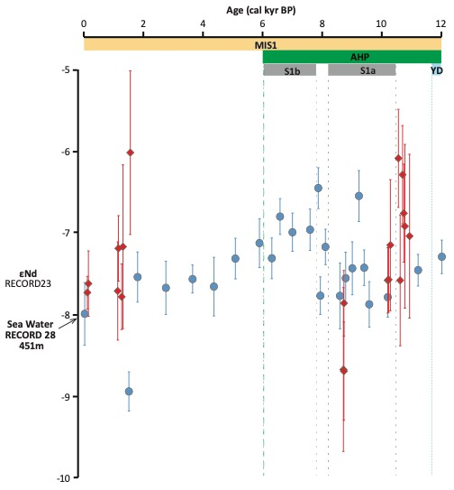

Figure S1. εNd results from foraminiferal record of core RECORD23 for the Holocene (blue circles), compared with published εNd values from cold-water corals of core RECORD23 (red diamonds, Dubois-Dauphin et al., 2017) and nearby modern seawater εNd at similar depth (451 m).

