Supplementary information and figures

Section 2.4 additional methodological details
Fe-Si minerals (e.g. serpentines) are highly sensitive to electron irradiation damage during analysis, including amorphization and oxidation of Fe⁺² to Fe⁺³, so it is important to discount this as an explanation for our finding of the poorly crystalline Fe-Si material shown in Figure 7.
During FIB sample preparation of the TEM lamellae, a surface layer on either side of the lamella suffers from ion-beam damage including amorphization of crystalline phases. The thickness of the beam damaged layer depends primarily on the acceleration voltage of the Ga+ ions, and secondly on the angle between the lamella and the ion beam. For the samples in this study, coarse thinning was performed at 30 kV, but the final thinning was performed first at 5 kV and then 2 kV on either side of the lamella to minimize surface damage. At 2 kV and 2° - 3° angle between the ion-beam and the plane of the lamella, the surface damaged layer typically has a thickness of 2-4 nm depending on the material. Hence, most of the volume contributing to the diffraction patterns and the spectroscopy data is material that is totally unmodified by the FIB preparation. The absence of significant ion beam damage from the FIB preparation can also be seen in the diffraction pattern in Supplementary Figure 1C that shows Bragg reflections but no primary amorphous halo from any amorphization.
Our EDS maps reveal that Si, O and Fe are the only elements present in appreciable amounts in in the poorly crystalline material shown in Figure 7. It is possible that this phase could represent a serpentine mineral. The mineral assemblage quartz + hematite is predominant throughout our samples.
During TEM characterization, many materials do not survive the impact from high energy electrons. Quartz for example, is highly unstable under a 200 kV electron beam and becomes amorphous followed by a volume expansion due to the significantly lower density of amorphous SiO₂ compared to crystalline quartz. Furthermore, neither reduction of the high voltage to 80 kV nor liquid nitrogen cooling help to avoid amorphization under the electron beam in the case of quartz. Many minerals such as olivine, beryl, etc. are beam sensitive. However, hematite does not suffer from beam damage such as amorphization under a 200 kV electron beam, unless the material is exposed to very high doses. Furthermore, beam damage such as amorphization of crystalline material is quite easy to recognize. The contrast in STEM images, and even more in TEM images where diffraction contrast is dominant, changes as a consequence of beam damage. Electron beam induced amorphization such as oxidation of Fe²⁺ to Fe³⁺ (e.g. Garvie et al., 2004) can be recognized by significant changes in both TEM and STEM images. In high angle annular dark field STEM images such beam damage leads to a darker contrast in the beam damaged region, simply because some of the atoms have been sputtered away from the lamella (which again gives the oxidation of iron from +2 to +3). In TEM mode these beam damaged regions also show a significant change of the contrast, such as loss of diffraction contrast. During the TEM characterizations we carefully imaged the regions where spectroscopy was performed both prior to and after spectroscopy to look for beam damage. Except for beam damage in quartz, we were not able to observe beam damage in any of the other phases present. Selective area electron diffraction (SAED) was performed prior to EELS. However, in contrast to nano beam diffraction and convergent electron beam diffraction where a focused electron beam is used, SAED exposes the sample to very low doses. The area contributing to the diffraction pattern is selected by a 10 µm aperture covering a circular region of ca. 150 nm in diameter, while the beam itself is spread almost to maximum to have the beam as parallel as possible. Hence, the sample is exposed to a low dose of electrons per area. Regarding EELS, dual EELS was performed, meaning that both a low loss spectrum including the zero loss peak and a core loss spectrum were taken (the low loss spectrum had an acquisition time that is neglectable compared to the acquisition time for the core loss spectrum). Energy drift and corrections were made based on the low loss spectrum and transferred to the high loss spectrum.
In conclusion, we are confident that even the poorly/semi crystalline Fe-Si-based phases we show are inherent phases that were not significantly modified by the Ga ion beam in the FIB or the high energy electron beam in TEM.
Reference
Garvie, L.A., Zega, T.J., Rez, P., & Buseck, P.R. (2004). Nanometer-scale measurements of Fe3+/ΣFe by electron energy-loss spectroscopy: A cautionary note. American Mineralogist, 89, 1610–1616.

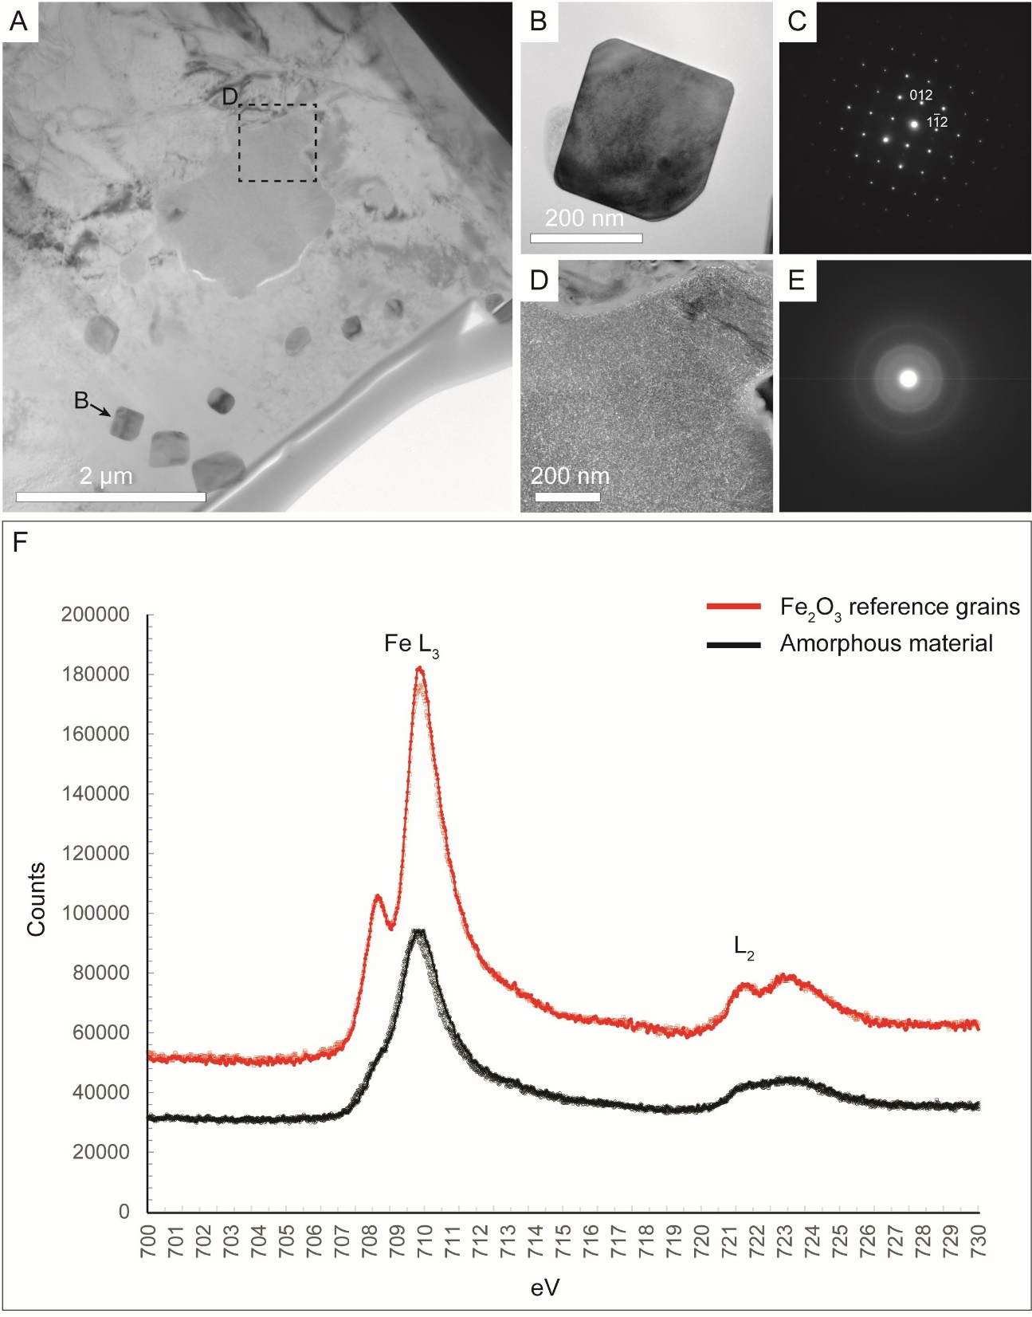
Supplementary Figure 1. TEM diffraction and EELS results. (A) TEM image of filament cross section shown in Fig. 4. (B) Close-up of one crystalline grain used to acquire Fe⁺³ reference EELS spectra. (C) Selected area diffraction pattern from grain shown in B; d-spacing of indexed reflectors is 3.69 Å, corresponding to lattice of hematite (cf. Blake et al., 1966). (D) Close-up of Fe-Si-phase in center of image A. (E) Selected area diffraction pattern acquired from Fe-Si phase shown in D; diffuse halos around bright center indicate that electrons are scattered randomly and that the phase is poorly crystalline. (F) EELS spectra from three locations in center of poorly crystalline Fe-Si-phase in D and two hematite reference grains. Ratio of Fe L₃/L₂ is similar in all spectra, and distance between L3 and L2 peaks is identical for hematite grains and poorly crystalline phase, indicating that poorly crystalline phase is primarily composed of Fe³⁺.

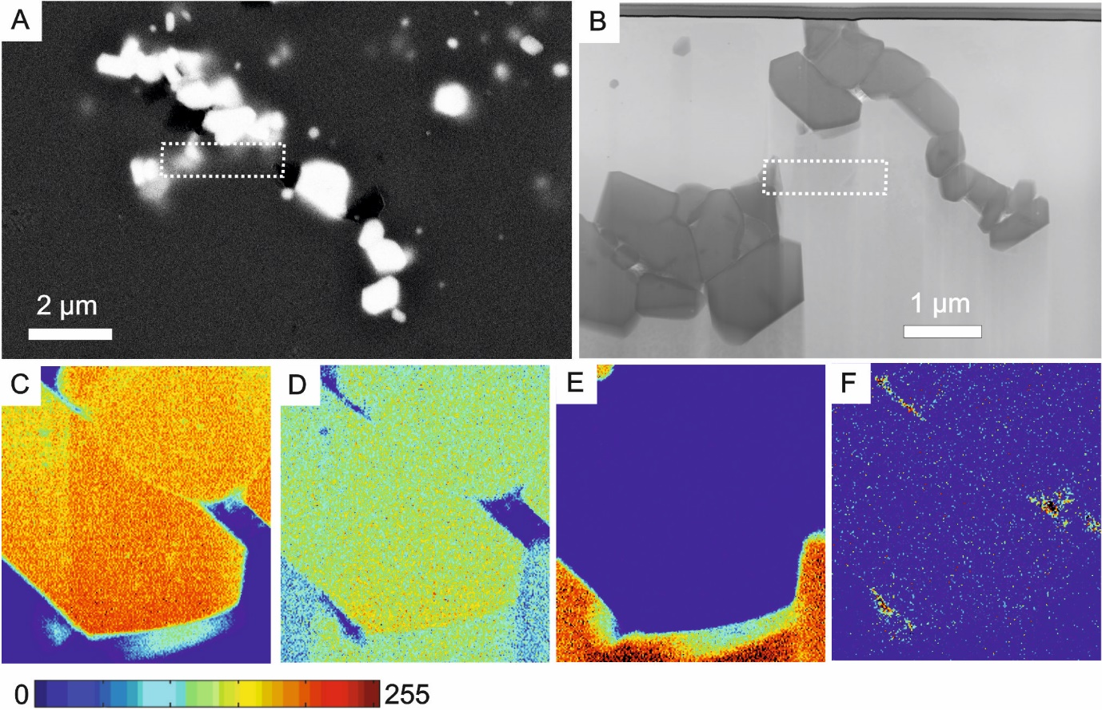
Supplementary Figure 2. Focused ion beam-transmission electron microscopy images of elongate cluster of hematite crystals from Verde Central jasper sample JS-05-3. (A) SEM-BSE image of analyzed area; inset shows area from which FIB foil was recovered. (B) Bright field STEM image of FIB foil from (A). (C-F) EDS maps of inset in B: (C) Fe Kɑ, (D) O Kɑ, (E) Si Kɑ, (F) C Kɑ. Width of maps in C-F is ca. 1 µm.

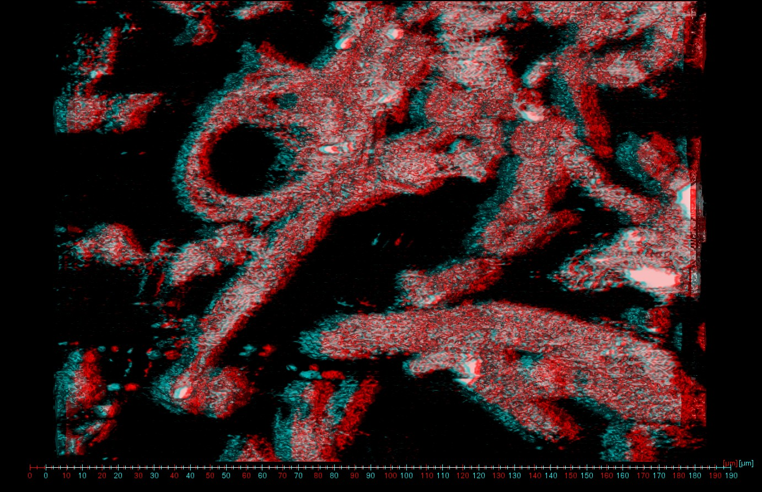
Supplementary Figure 3. Stereo anaglyph of filament loops shown in Figure 5C.

