Geophysical Research Letters
Supporting Information for
The intensifying role of high wind speeds on air-sea carbon dioxide exchange
Yuanyuan Gu^{1,2}, Gabriel G. Katul^{3,4}, Nicolas Cassar^{1,5}
¹Division of Earth and Ocean Sciences, Nicholas School of the Environment, Duke University, Durham, USA.

²College of Oceanography, Hohai University, Nanjing, China

³Nicholas School of the Environment, Box 90328, Duke University, Durham, NC, USA

⁴Department of Civil and Environmental Engineering, Duke University, Durham, NC, USA

⁵CNRS, Univ Brest, IRD, Ifremer, LEMAR, F-29280 Plouzané, France

Contents of this file
Table S1
Figures S1 to S11

Table s1. Parameters used to run scenarios of imposed changes in environmental factors that determine $∆X/X$ and their effects on the gas transfer velocity (k) and air-sea CO₂ flux (F) (i.e. $∆Y/Y)$.
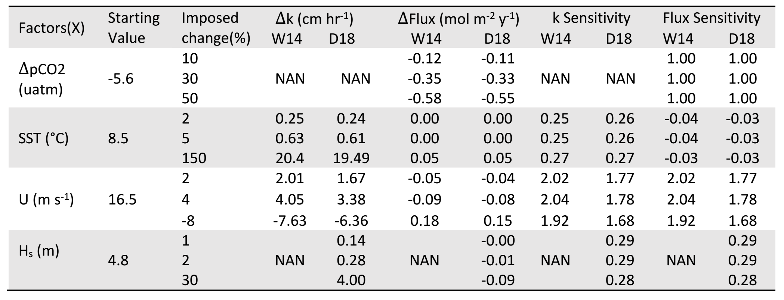

Figure S1. Maps of temporal trends in gas transfer velocity (k) and other environment factors during 1990-2018 period. Map of the temporal trend in (a) k_{D18} (cm hr⁻¹dec⁻¹), (b) k_{W14} (cm hr⁻¹dec⁻¹) and (c) the difference k_{D18} - k_{W14} (cm hr⁻¹dec⁻¹). Map of the trends in (d) wind speed U (m s⁻¹ dec⁻¹), (e) significant wave height $H_{s}$ (m dec⁻¹), and (f) sea surface temperture SST (°C dec⁻¹). The similarity in the spatial pattern of generally increasing trends in U and k suggests U plays a dominant role in explaining the spatial distribution of k .
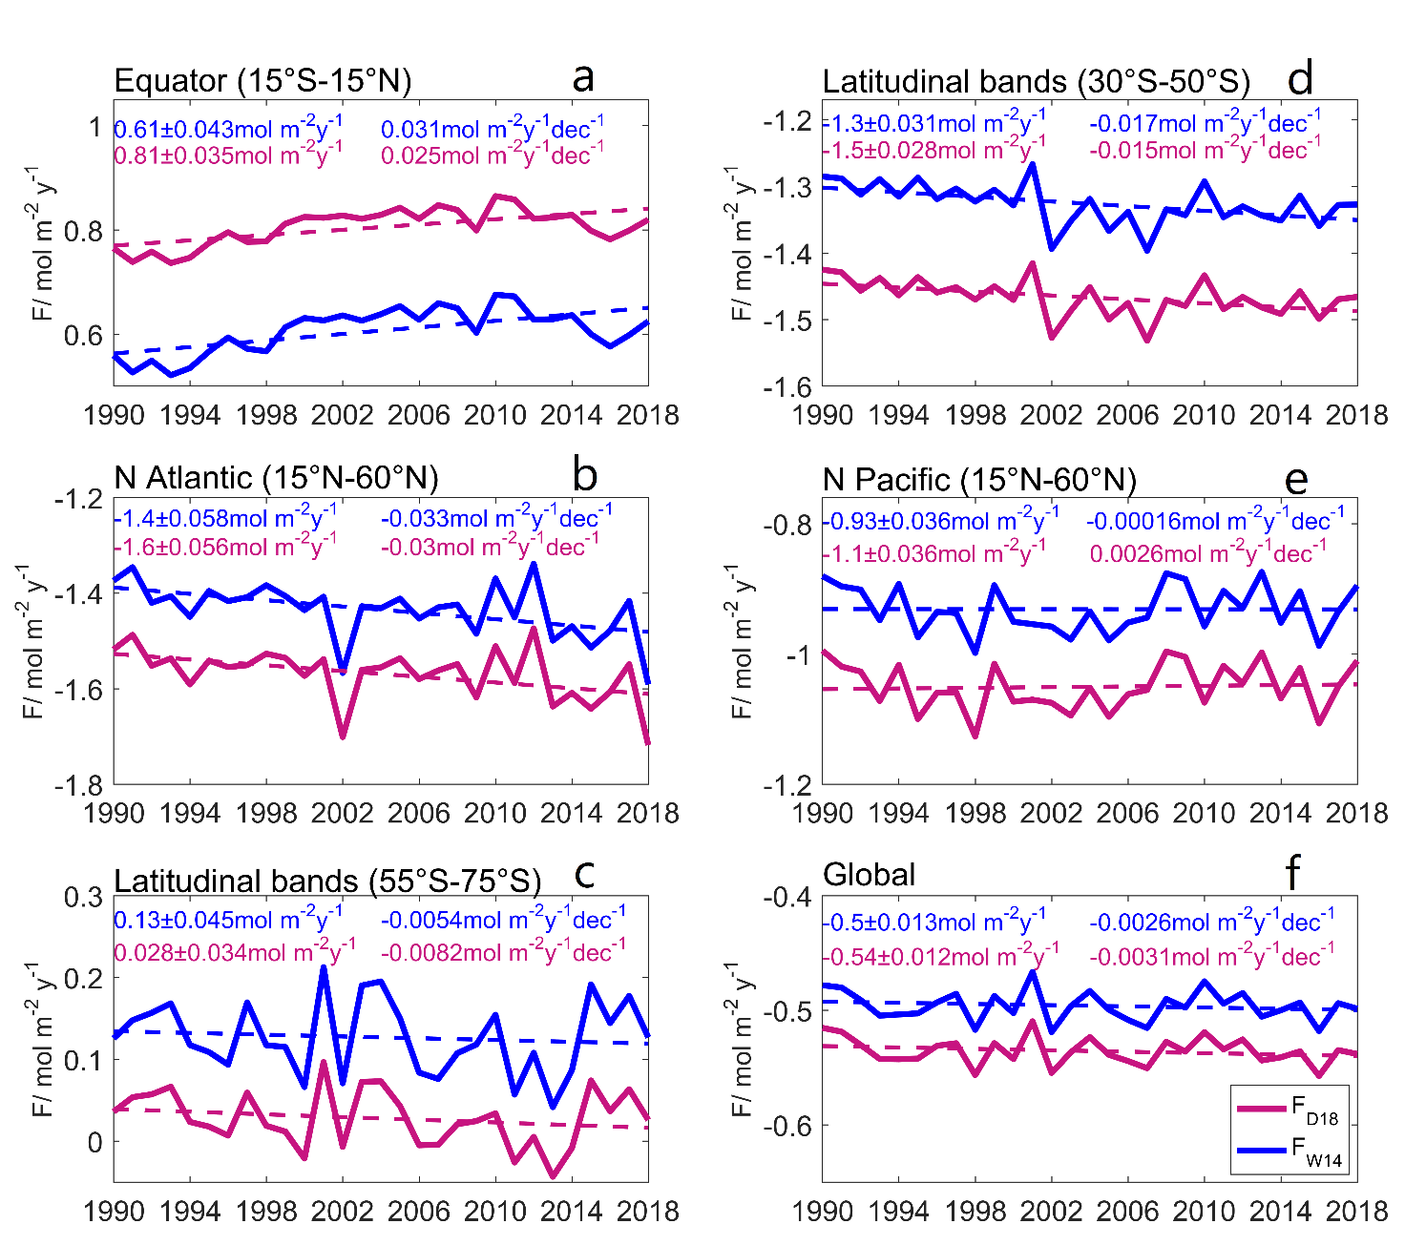

Figure S2. Annual variation of regional and global air-sea CO₂ flux (mol m⁻² y⁻¹), in (a) the equatorial region (15°S-15°N), (b) the North Atlantic (15-60°N; 300-360°E), (c) the latitudinal (55-75°S), (d) the latitudinal bands (30-50°S), (e) the North Pacific (15-60°N;120-240°E), (f) over the global ocean. Blue and magenta are for k_{W14} and k_{D18} formulations, respectively. The dashed line indicates the long-term trend. The values on the upper left of the graphs are the long term mean ± 1 standard deviation, and on the top right are the long term trend. Globally, there is a small overall increase of 0.01Pg C decade⁻¹ in CO₂ uptake, which is a result of the regional fluxes counteracting each other.

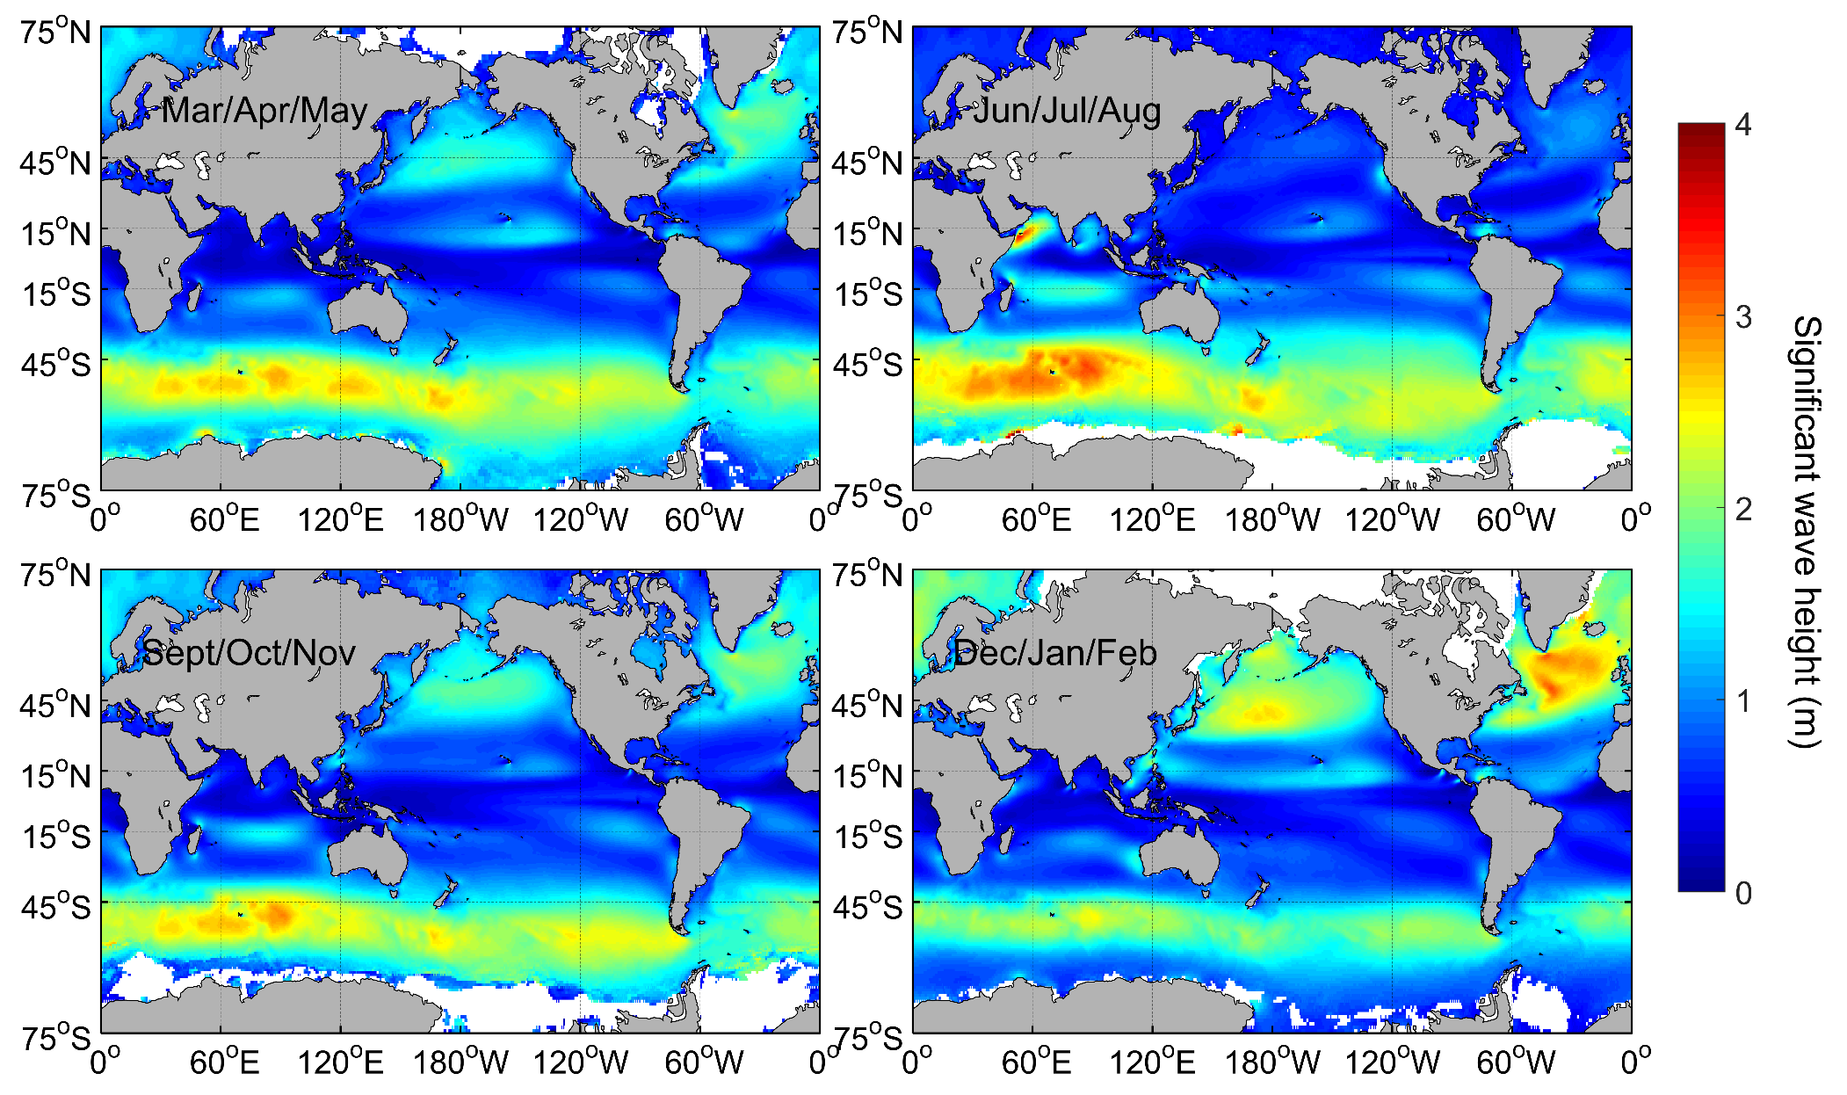
Figure S3. Climatological seasonal distribution of significant wave height (m).

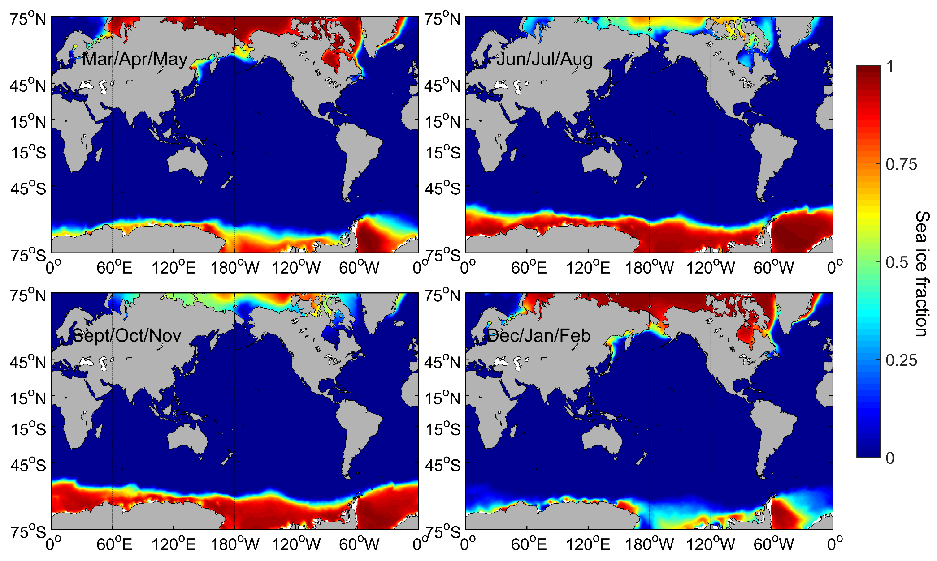
Figure S4. Climatological seasonal distribution of ice fraction (from ECMWF).

Figure S5. Probability density of long-term average (a) wind speed U (m s⁻¹), (b) significant wave height H_{s} (m) and (c) sea surface temperature SST ($°$C) at high wind speeds.

Figure S6. Measured and modelled gas transfer velocity adjusted to a Schmidt number of 660 for CO₂. (a) Gas transfer velocity versus the 10-m wind speed. The observed k₆₆₀ are in blue, k₆₆₀ derived from k_{W14} are in red and from k_{D18} are in green. The best power law fit is shown for each result. (b) The observed k₆₆₀ versus modelled k₆₆₀, k_{W14} in red and k_{D18} in green. (c) The k₆₆₀ of bubble and turbulent components seperated in k_{D18} expression plotted against wind speed. The data comes from the HiwinGs project, which aims to observe the air-sea interaction under high winds and took place in the Atlantic during October 2013 and November 2014 (Blomquist et al., 2017).

Figure S7. Temporal evolution of global annual mean air-sea gas transfer velocity at high wind speeds (cm⁻¹ hr⁻¹). Magenta and blue are for k_{D18} and k_{W14} formulations, respectively. The dashed line indicates the long-term linear trend. The values on the left hand side are the long term mean ± 1 standard deviation, and on the right side are the long term trend.

Figure S8. Mean annual variation of global SST at all wind speeds (in red) and at high wind speeds (in blue).

Figure S9. Spatial variation of climitological $∆$pCO₂ ($u$atm). The positive values indicate that the ocean is a source of CO₂ to the atmosphere, and the negative values indicate CO₂ sinks.

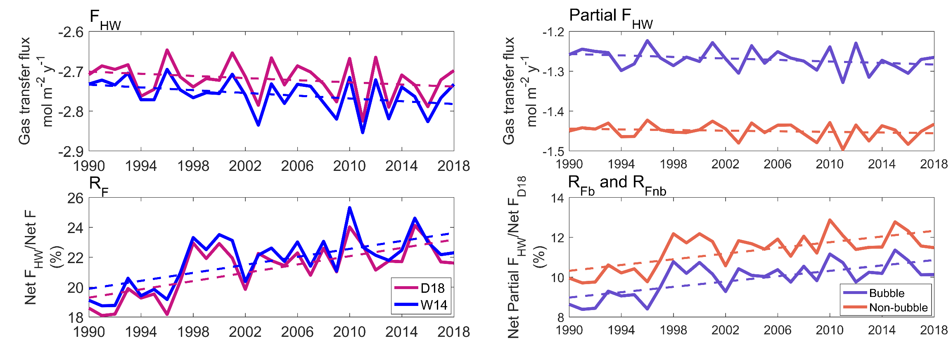
Figure S10. Annual variations of the same parameters as in Figure 3 but estimated using the averaged $∆$pCO₂ field from monthly $∆$pCO₂ spanning from 1982-2015 (Landschützer et al., 2014). The ratio of global CO₂ flux at high wind to flux at all wind conditions R_{F} also increases over time for both expressions, with R_{F} for k_{D18} and k_{W14} at about 21.5%. Both bubble and turbulence induced oceanic CO₂ uptake increase with time at HW. On average, the ratio of bubbles’ contribution to F_{D18}, R_{Fb} is around 47% at high U and about 34% at all U conditions.

Figure S11. Spatial variation of climatological gas transfer velocity and other environment factors during 1990-2018 period. Map of the climatological (a) k_{D18} (cm hr⁻¹), (b) k_{W14} (cm hr⁻¹), and (c) the difference between the two formulations (k_{D18} - k_{W14}) (cm hr⁻¹). Map of the climatological (d) wind speed U (m s⁻¹), (e) significant wave height H_{s} (m) and (f) sea surface temperature SST(°C).

