**Supplemental Information for:**

***Seascape genomics reveals candidate molecular targets of heat stress adaptation in three coral species***

Oliver Selmoni, Gaël Lecellier, Hélène Magalon, Laurent Vigliola, Nicolas Oury, Francesca Benzoni, Christophe Peignon, Stéphane Joost, Véronique Berteaux-Lecellier

**Table of Contents:**

|  |  |
| --- | --- |
| **Supplementary Figure 1.** | Page 2 |
| **Supplementary Figure 2.** | Page 3 |
| **Supplementary Figure 3.** | Page 4 |
| **Supplementary Figure 4.** | Page 5 |

**Supplementary Figure 1. Structure analysis of microsatellite genetic markers of the two *Pocillopora* species.** The barplot in (a) displays the results of the Structure assignment test. Each vertical bar corresponds to a sample: bars predominantly in light blue indicates samples assigned to the genetic cluster of *Pocillopora damicornis*, while bars predominantly in green to those assigned to the cluster of *Pocillopora acuta.* Samples are grouped by sampling location, and the symbols indexing sampling locations are displayed in the bottom of the barplot and on the map in (b).

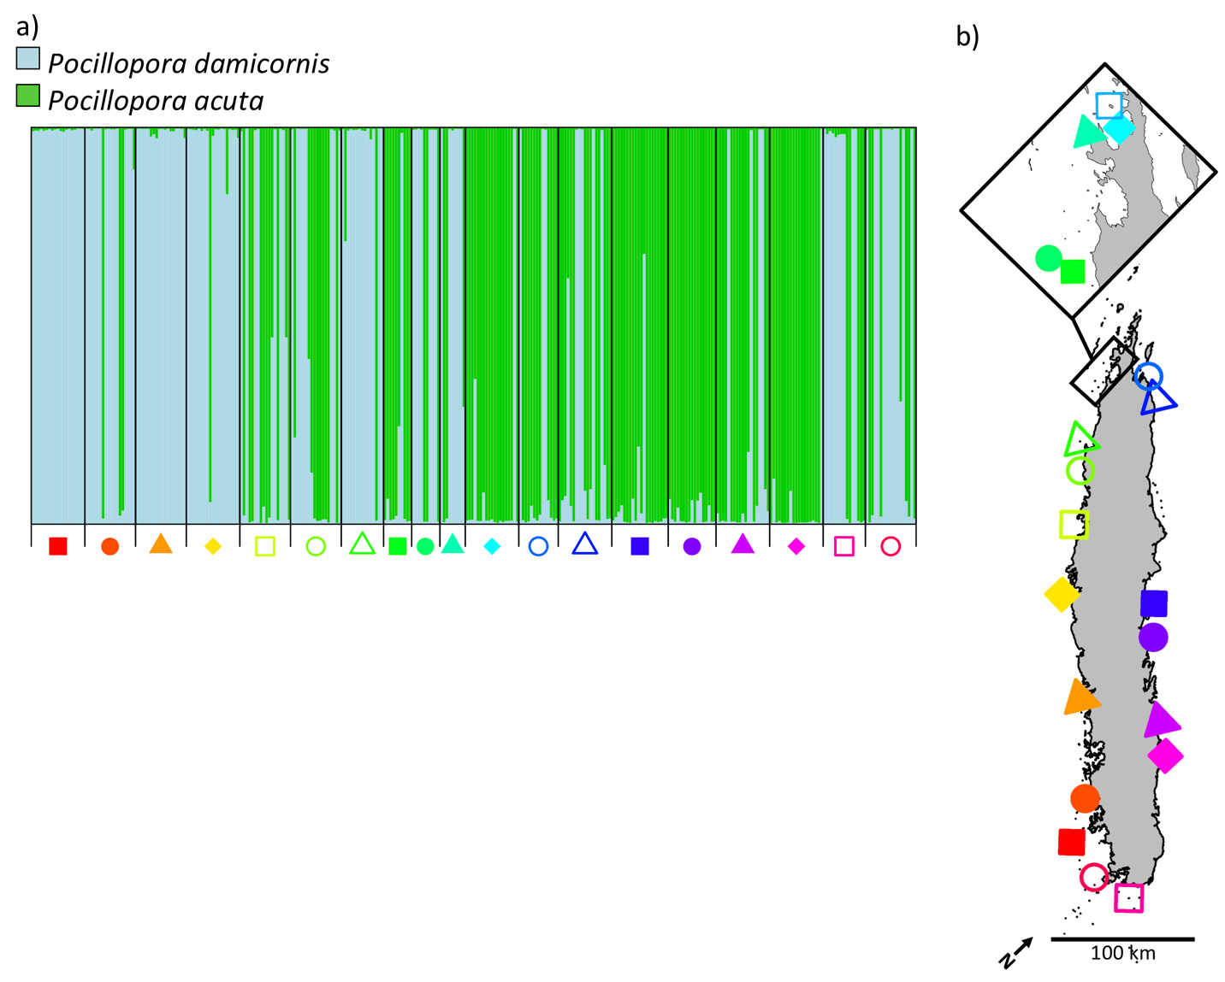

**Supplementary Figure 2. Cross-entropy comparison for the estimation of number of ancestral populations.** The graphs display the comparison of the quality of fit of admixture coefficients for different numbers of ancestral populations for the three species of interest. Lower cross-entropy criterion indicates a higher quality of fit.

|  |  |  |
| --- | --- | --- |
| 1. *A. millepora* | 1. *P. damicornis* | 1. *P. acuta* |

**Supplementary Figure 3. Number of genetic clusters suggested for the discriminant analysis of principal components (DAPC).** The graphs display the comparison of the Bayesian inference criterion (BIC) used to evaluate the optimal number of clusters (lower BIC) for DAPC of the three studied species.

|  |  |  |
| --- | --- | --- |
| 1. *A. millepora* | 1. *P. damicornis* | 1. *P. acuta* |

**Supplementary Figure 4. Minor allele frequency by sampling location.** The three boxplots display the minor allele frequency (MAF) at every sampling location having at least five samples for *Acropora millepora* (a), *Pocillopora damicornis* (b) and *Pocillopora acuta* (c). On the x-axes of each plot, sampling locations are represented by a symbol. The position of the sampling locations is shown by the corresponding symbols in (d).

