Supplementary Material

Social structure, habitat use and injuries of Indo-Pacific bottlenose dolphins (Tursiops aduncus) reveal isolated, coastal and threatened communities in the South Pacific
Claire Daisy Bonneville, Solène Derville, Jolanda A. Luksenburg, Marc Oremus, Claire Garrigue

Table S1: Distribution of survey effort from 1997 to 2019, initially dedicated to monitoring humpback whales during the austral winter (July-September) and during which dolphin sightings were also recorded. The number of survey days is indicated in the south-west lagoon, the south lagoon and the Isle of Pines study areas respectively. Dolphin data recorded opportunistically outside the humpback whale season (but for which exact sampling effort is not known) are indicated by stars. For these records, GPS positions and photos of individuals were used to assess social structure and external injuries, but habitat modelling was not performed.

 | 1997 | 1998 | 1999 | 2000 | 2001 | 2002 | 2003 | 2004 | 2005 | 2006 | 2007 | 2008 | 2009 | 2010 | 2011 | 2012 | 2013 | 2014 | 2015 | 2016 | 2017 | 2018 | 2019
January |  |  |  |  |  |  | 0*,0,0 |  |  |  |  |  | 0*,0,0 |  |  |  |  |  |  |  |  | 0,0*,0 | 0,0*,0
February |  |  |  |  |  |  |  | 0*,0,0
March
April |  |  |  |  |  |  |  |  |  |  |  |  | 0*,0*,0* | 0*,0,0
May |  |  |  |  |  |  |  | 0*,0,0 |  |  |  |  | 0,0*,0
June |  |  |  |  |  |  |  |  |  |  |  |  | 0*,0,0 | 0*,0,0
July | 0,16*,0 | 0*,25,0 | 0,22,0 | 0,17*,0 | 0,14,0 | 0*,12*,0 | 0,11,0 | 0*,0*,0 | 0,11*,0 | 1*,11*,0* | 1,14,0 | 0*,0,0 | 2,14,0 | 0,12,0 | 1,11,0 | 0,3,0 | 0,1*,0 | 0,14,0 |  | 0,10,0 | 3,13,0 |  | 0,3,,
August | 0,27,0 | 0,25,0 | 0,23,0 | 0,23,0 | 0,25,0 | 0,18,0 | 1,21*, |  | 2,21,0 | 2,21*,0 | 1,21,0 | 0,0*,0 | 2,18*,0 | 1,23,0 | 0,22,0 | 0,26,0 | 0,24,0 | 0,6,0 | 1,22,0 | 4,12,0 | 0*,21,0 | 3*,23, | 0,19,0
September | 0,1,0 | 0,9*,0 | 0,1,0 | 0,10*,0 | 0*,16,0 | 0,3*,0 | 0,7,0* |  | 0,1,0 | 0,9,0 | 2,13,0 | 0*,0*,0* | 0,0,0* | 1,1,0* | 2,6,0* |  |  | 1,9*,0 | 0,9,0 | 0,4*,0 | 1,5,0 |  | 2,5
October |  |  |  |  |  |  |  |  |  |  |  | 0,0,0*
November |  |  |  |  |  |  |  |  |  |  |  | 0*,0,0 |  |  |  |  |  |  |  |  |  | 0,10,0
December

Table S2: Selection of generalized additive models of dolphin habitat use. Models 2.4 and 3.4 were selected and respectively reported as M_{env} (best environmental model) and M_{env-spa} (best combined environmental-spatial model). For each model, we report: deviance explained, Df = estimated number of parameters in the model, AIC = Akaike Information Criterion and ΔAIC = change in AIC compared to the null model (M0 including only intercept of 1). All variables were included in the model with penalized thin plate regression splines s(): DIS_COAST x DIS_PATCH = interaction term between distance to the coast and distance to intermediate reef patches, DIS_BAR = distance to the barrier reef, DEPTH = bathymetry, SLOPE = slope, SED = percentage of sedimentary clay.
Model | Predictor | Deviance explained | df | AIC | ΔAIC
M0 |  | 0% | 1.0 | 1976
M1 | s(lon, lat) | 13.2% | 31.8 | 1777 | 199
M2.1 | s(DIS_COAST) + s(DIS_REEF) + s(DEPTH) + s(SLOPE) + s(SED) | 10.1% | 4.5 | 1775 | 201
M2.2 | s(DIS_COAST) + s(DIS_PATCH) + s(DIS_BAR) + s(SLOPE) + s(SED) | 10.8% | 6.2 | 1772 | 204
M2.3 | s(DIS_COAST, DIS_REEF) + s(DEPTH) + s(SLOPE) + s(SED) | 12.6% | 16.2 | 1758 | 218
M2.4 | s(DIS_COAST, DIS_PATCH) + s(DIS_BAR) + s(DEPTH) + s(SLOPE) + s(SED) | 12.7% | 16.3 | 1756 | 216
M3.4 | S(DIS_COAST, DIS_PATCH) + s(DIS_BAR) + s(DEPTH) + s(SLOPE) + s(SED) + s(lon, lat) | 14.9% | 27.4 | 1736 | 240

Table S3: Recaptures per individual photo-identified in the south-west lagoon, the south lagoon and the Isle of Pines in New Caledonia. Stars indicates that some individuals have been photo-identified both in the south-west and the south lagoons.
Recaptures per individual | # unique individuals
 | South-west lagoon | South lagoon | Isle of Pines | Total
1 | 64* | 240* | 39 | 338
2 | 16* | 158* | 16 | 185
3 | 7* | 107* | 8 | 119
4 | 1* | 81* | 3 | 84
>5 | 0 | 63 | 0 | 63

Figure S1. Categories of injuries found in Indo-Pacific bottlenose dolphins in the southern range of New Caledonia following the classification method in Luksenburg (2014). (a): linear severed dorsal fin; (b): non-linear severed dorsal fin; (c) straight deep cut; (d) opposing cuts; (e) parallel cuts; (f) collapse; (g) obtuse, short, cut-like indentation; (h) indentation; (i) round cuts; (j) jagged, shark-inflicted bite wound; (k) cookie-cutter shark bite wound; (l) wide v-shaped cuts. Arrows point to injuries

Figure S2. Spatial distribution of groups encountered in both the south-west lagoon and the south lagoon. Connectivity is illustrated by one individual displaying social interchange between communities (green: 1) and by four individuals with wide habitat use (turquoise: 2, 3, 4, 5).
Figure S3: Geographic position of Indo-Pacific bottlenose dolphins (bottom panel in blue) and humpback whales (top panel in pink) observed during the same winter surveys between 1997 and 2019. The humpback whale positions (n= 1,560) were used as background to model dolphin habitat use following the “target method” (Phillips et al., 2009).

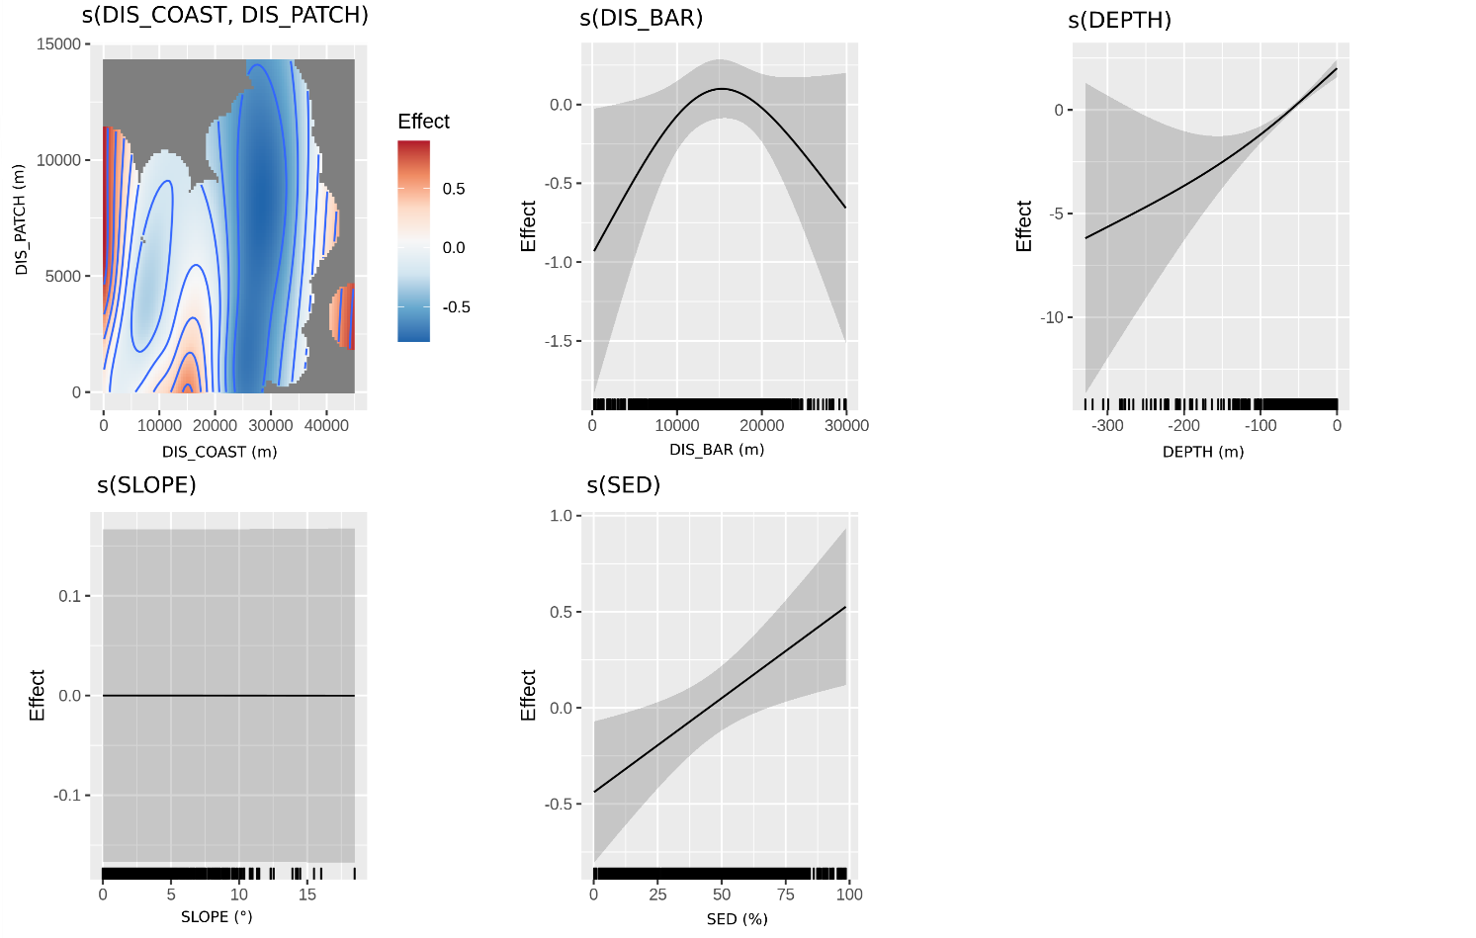
Figure S4: Smoothed functions estimated by the GAM environmental model M_{env} describing habitat use of Indo-pacific bottlenose dolphins in the southern range of New Caledonia. Predicted habitat suitability is shown on the y-axis (centered) with varying scales. Shaded bands reflect the 95% confidence intervals. Smooths over two interacting variables are represented on a colored scale, with red representing higher habitat suitability. Rug plots illustrate the distribution of values in the modelled dataset. Explanatory variables: DIS_COAST x DIS_PATCH = interaction term between distance to the coast and distance to intermediate reef patches, DIS_BAR = distance to the barrier reef, DEPTH = bathymetry, SLOPE = slope, SED = percentage of sedimentary clay.
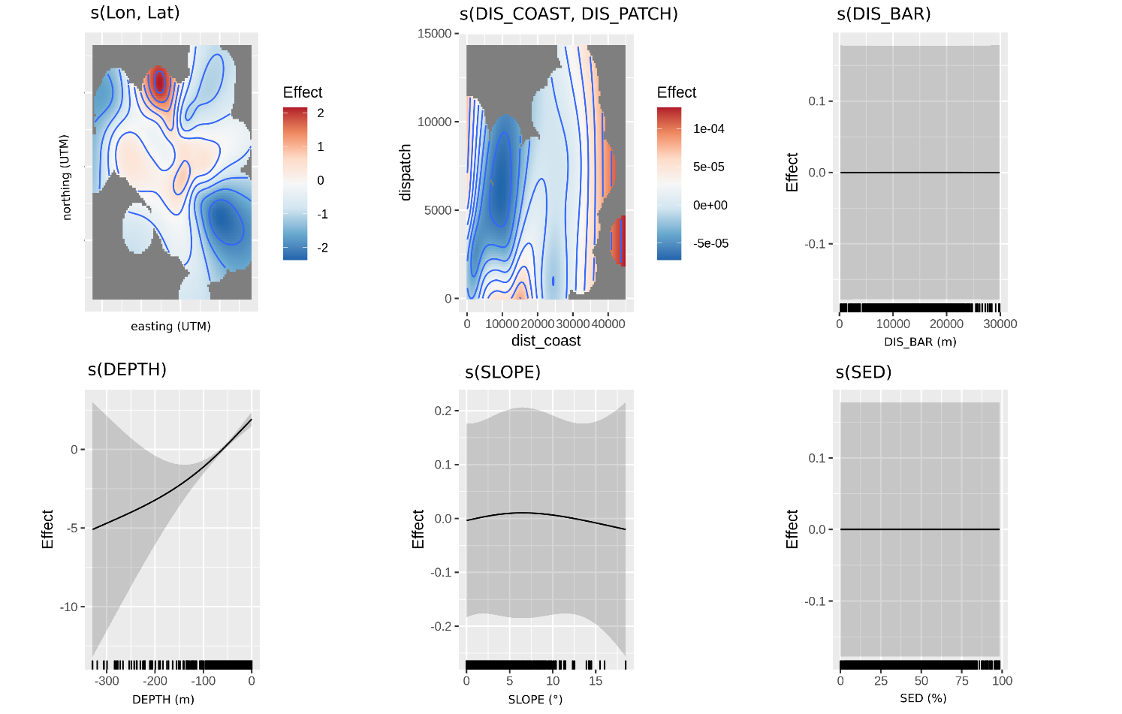
Figure S5: Smoothed functions estimated by the GAM combined environmental-spatial model M_{env-spa} describing habitat use of Indo-pacific bottlenose dolphins in the southern range of New Caledonia. Predicted habitat suitability is shown on the y-axis (centered) with varying scales. Shaded bands reflect the 95% confidence intervals. Smooths over two interacting variables are represented on a colored scale, with red representing higher habitat suitability. Rug plots illustrate the distribution of values in the modelled dataset. Explanatory variables: DIS_COAST x DIS_PATCH = interaction term between distance to the coast and distance to intermediate reef patches, DIS_BAR = distance to the barrier reef, DEPTH = bathymetry, SLOPE = slope, SED = percentage of sedimentary clay.

