

*Global Biogeochemical Cycles*

Supporting Information for

**Global trends in air-water CO2 exchange over seagrass meadows revealed by atmospheric Eddy Covariance**

**1Bryce Van Dam, 2Pierre Polsenaere, 3Aylin Barreras-Apodaca, 4Christian Lopes, 3Zulia Sanchez-Mejia, 5Tatsuki Tokoro, 6Tomohiro Kuwae,** **7Lucia** **Gutiérrez Loza, 7Anna Rutgersson, 4James Fourqurean, 1Helmuth Thomas**

1 Institute of Coastal Research, Helmholtz-Zentrum Geesthacht (HZG), Geesthacht, 21502, Germany

2 Ifremer, Laboratoire Environnement et Ressources des Pertuis Charentais (LER-PC), BP133, 17390, La Tremblade, France..

3 Instituto Tecnológico de Sonora, Ciudad Obregón, Sonora, México

4 Dept. of Earth and Environment and Southeast Environmental Research Center, Florida International University, 11200 SW 8th Street, Miami, FL 33199, USA

5 National Institute for Environmental Studies, Center for Global Environmental Research (CGER), Office for Atmospheric and Oceanic Monitoring, Onogawa, Tsukuba, Ibaraki, Japan

6 Coastal and Estuarine Environment Research Group, Port and Airport Research Institute, Yokosuka, Japan

7 Department of Earth Sciences, Uppsala University, Uppsala, Sweden

**Contents of this file**

Figures S1 and S2

**Introduction**

This supporting Information contains two figures which were not included in the main text of the manuscript.



**Figure S1**. Energy balance closure for all sites, where the size of the points corresponds to the range in tidal height for that 24 or 8 hour period.

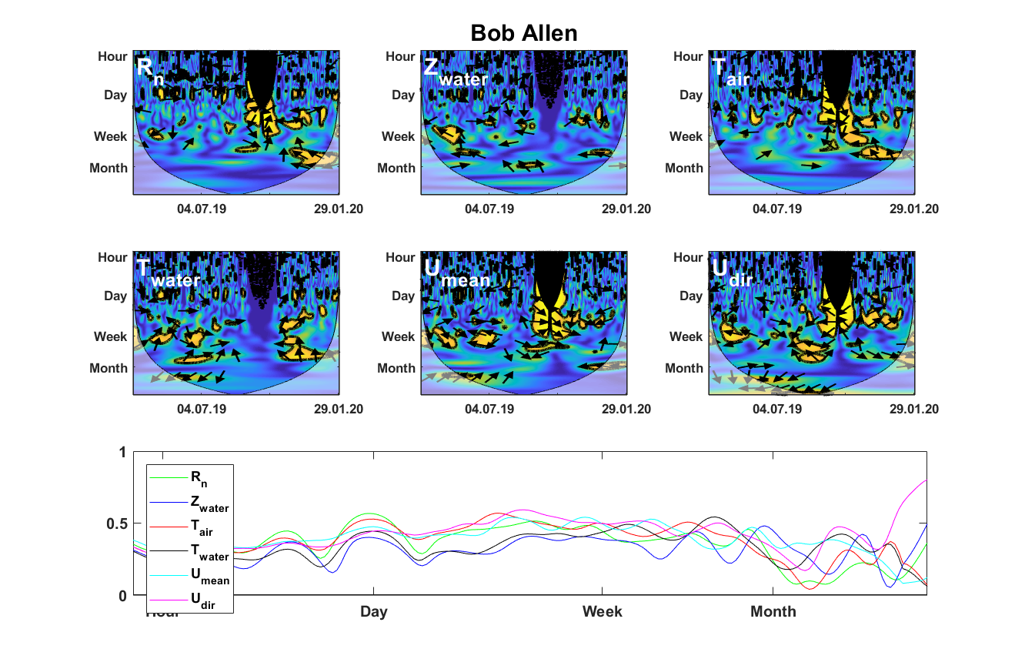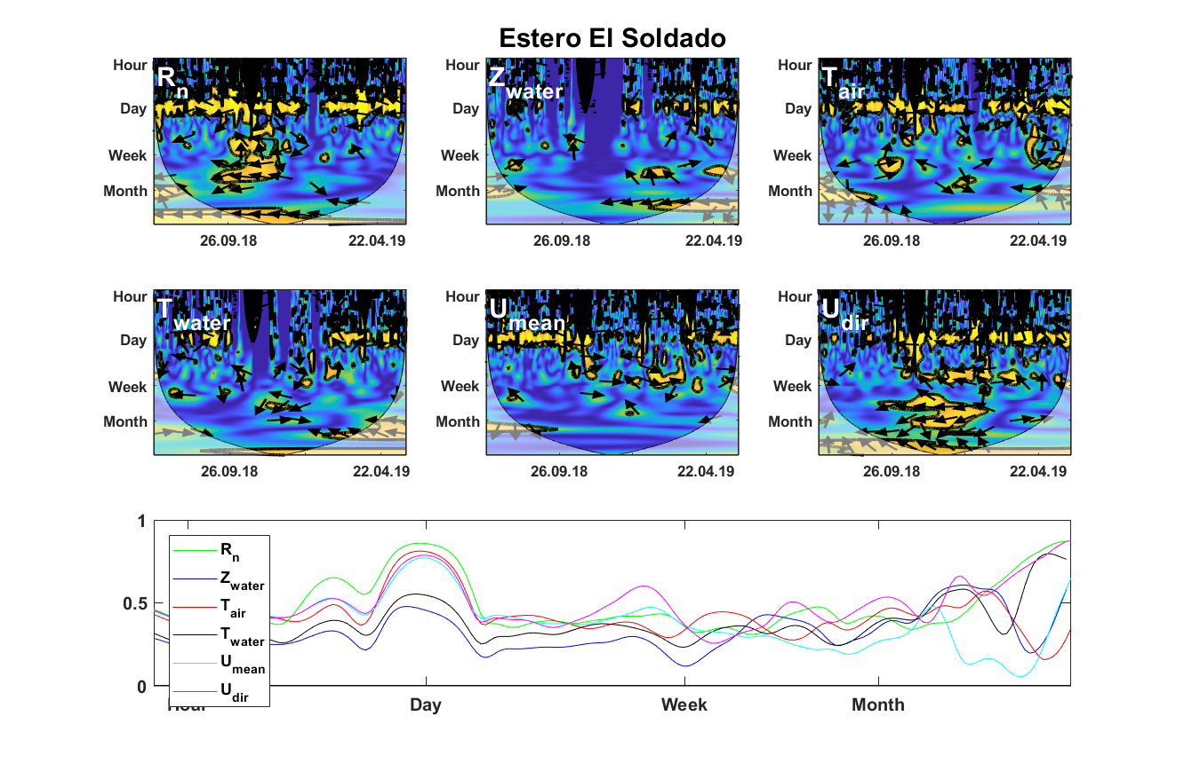

**Figure S2**. Detailed wavelet coherence analysis describing the relationship between normalized FCO2 and Rn, Zwater, Tair, Twater Umean and Udir. The yellow areas outlined by black are the regions where the correlation is significant at a 95% confidence level, while the arrows represent the phase of the respective correlation with FCO2 (in phase = 🡪, out of phase = 🡨, vertical arrow = FCO2 leads by 90°).

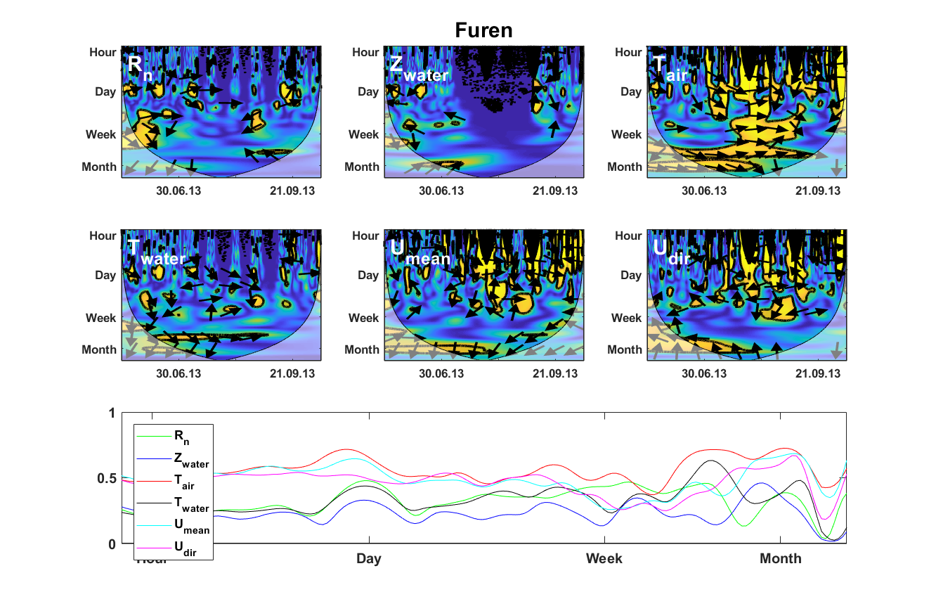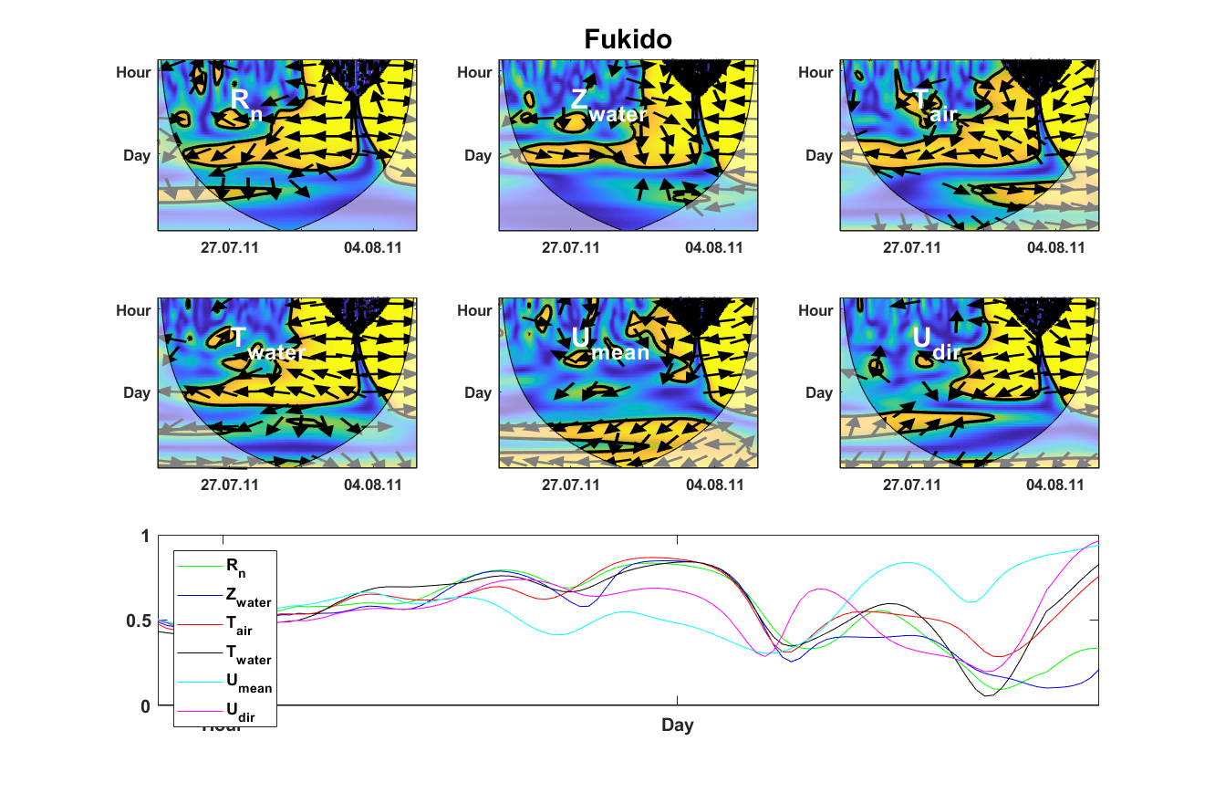

**Figure S2 (continued)**. Detailed wavelet coherence analysis describing the relationship between normalized FCO2 and Rn, Zwater, Tair, Twater Umean and Udir. The yellow areas outlined by black are the regions where the correlation is significant at a 95% confidence level, while the arrows represent the phase of the respective correlation with FCO2 (in phase = 🡪, out of phase = 🡨, vertical arrow = FCO2 leads by 90°).

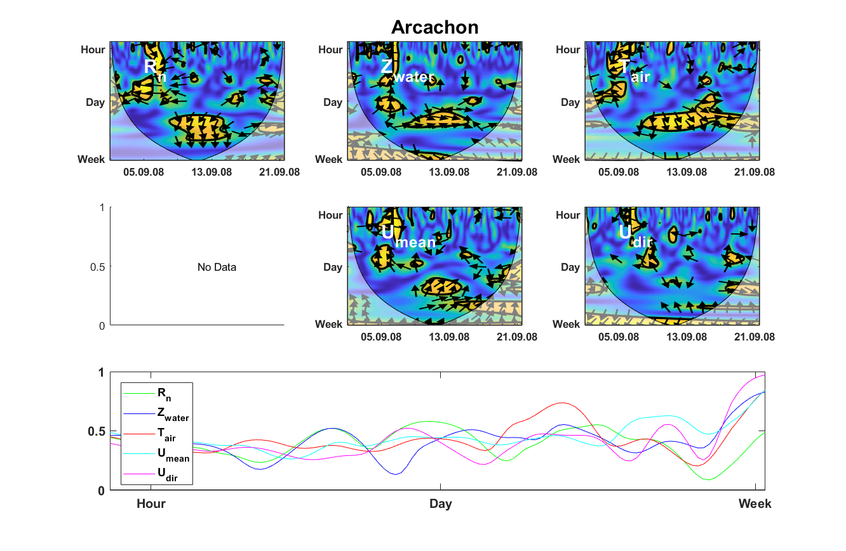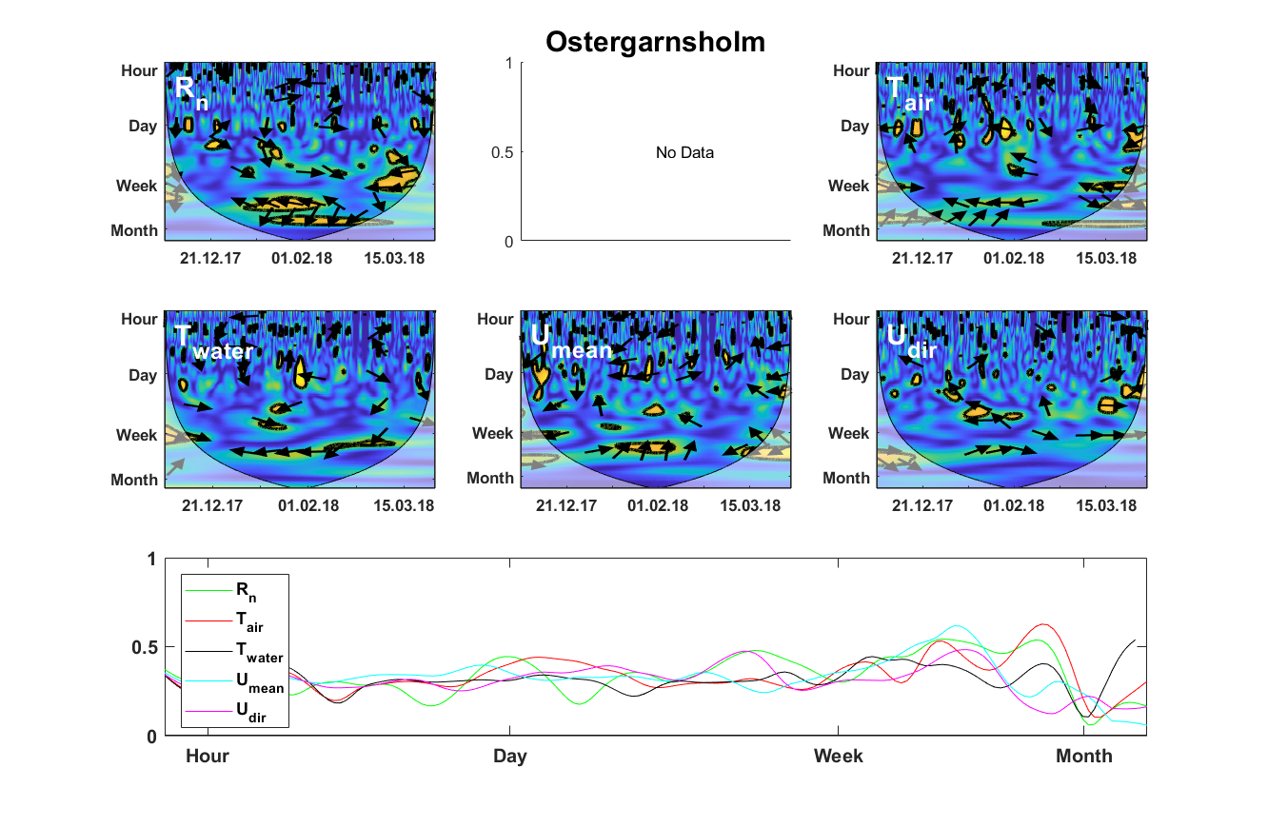

**Figure S2 (continued)**. Detailed wavelet coherence analysis describing the relationship between normalized FCO2 and Rn, Zwater, Tair, Twater Umean and Udir. The yellow areas outlined by black are the regions where the correlation is significant at a 95% confidence level, while the arrows represent the phase of the respective correlation with FCO2 (in phase = 🡪, out of phase = 🡨, vertical arrow = FCO2 leads by 90°).