[GRL]
Supporting Information for

Evaluating the glacial-deglacial carbon respiration and ventilation change hypothesis as a mechanism for changing atmospheric CO₂
Lowell D. Stott¹, Jun Shao¹, Jimin Yu², and Kathleen M. Harazin²
¹Department of Earth Sciences, University of Southern California, 3651 Trousdale Pkwy, Los Angeles, CA 90089
²Research School of Earth Sciences, The Australian National University, Canberra, ACT 2601, Australia

Contents of this file

Figures S1 to S2

Introduction
The supplemental figures referred to in the manuscript.
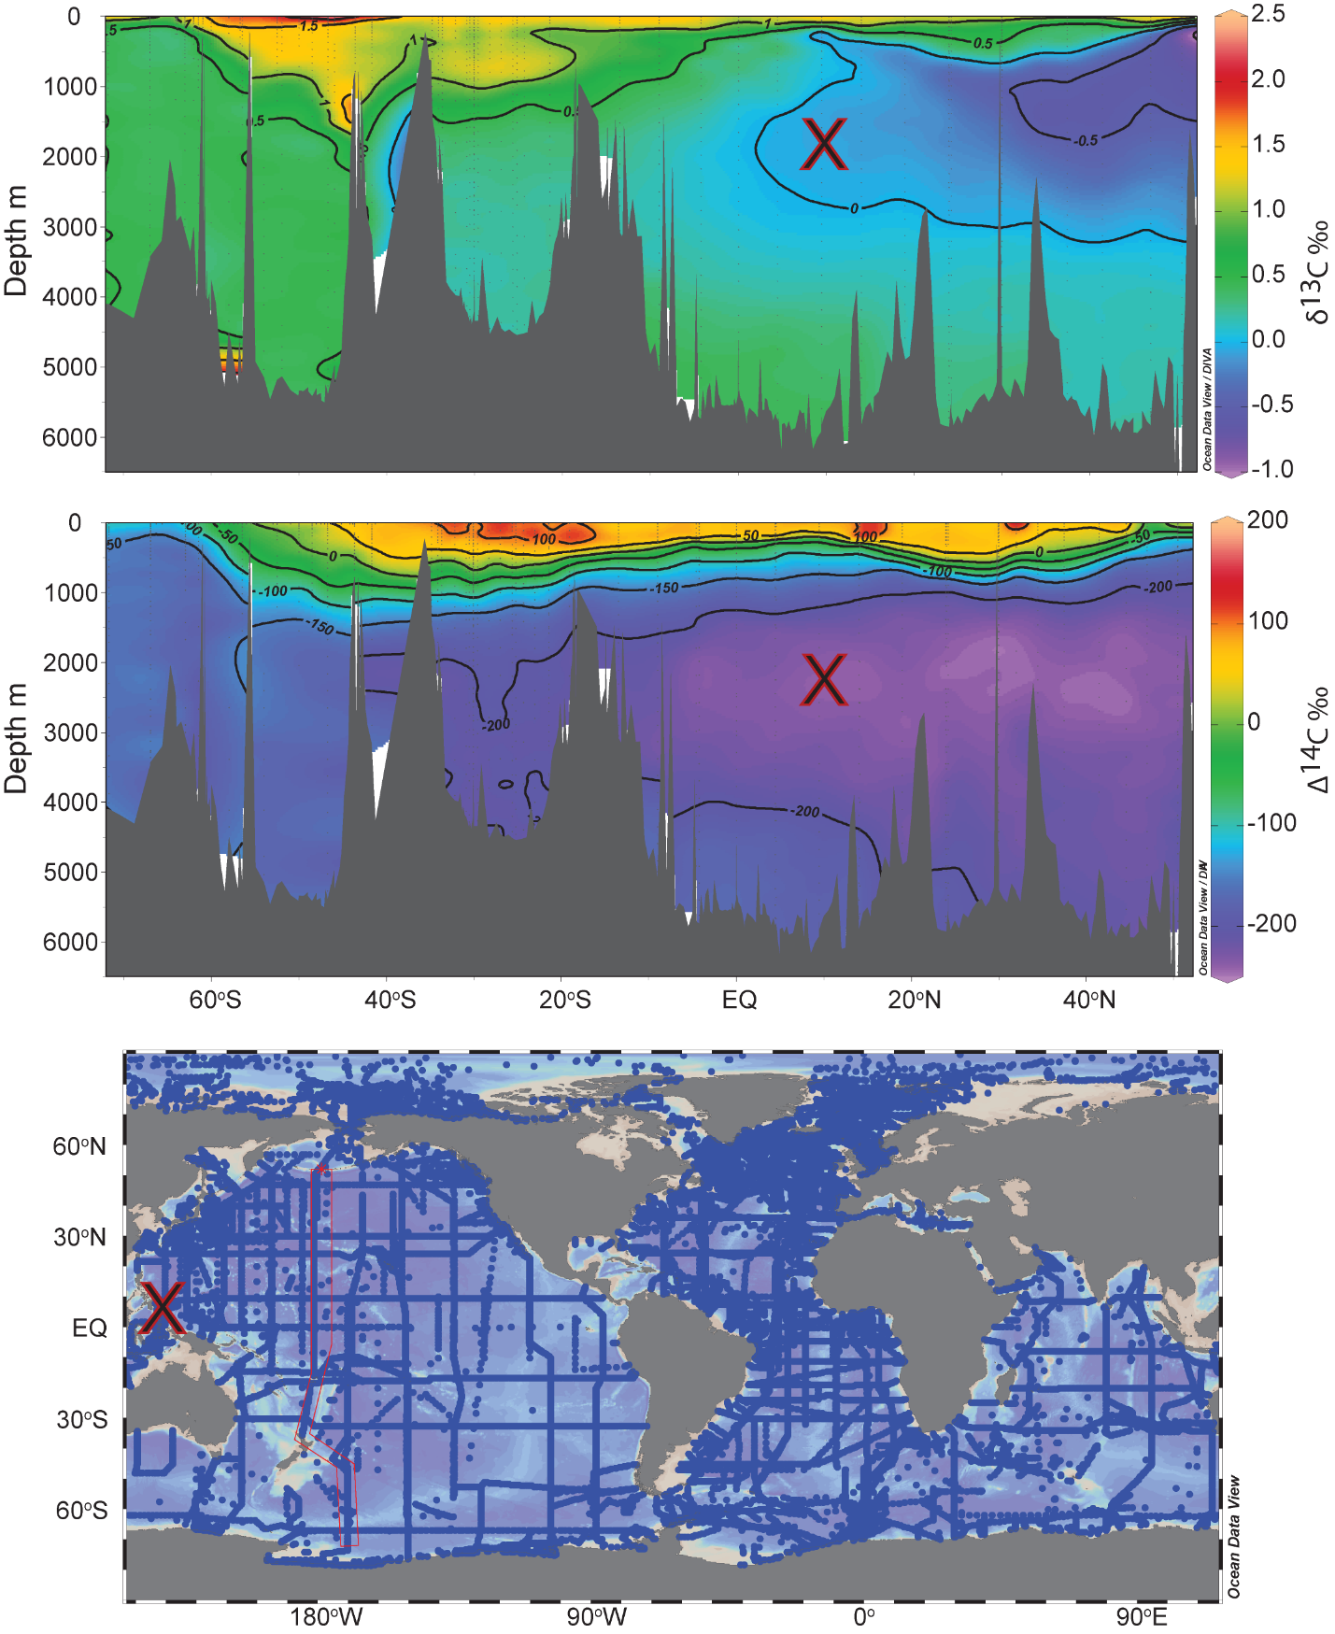
Supplemental Figure S1. GLODAP transect of δ¹³C_{DIC} (upper panel) Δ¹⁴C (middle panel) through the Pacific. The location and depth of the MD98-2181 site is marked with a red X.

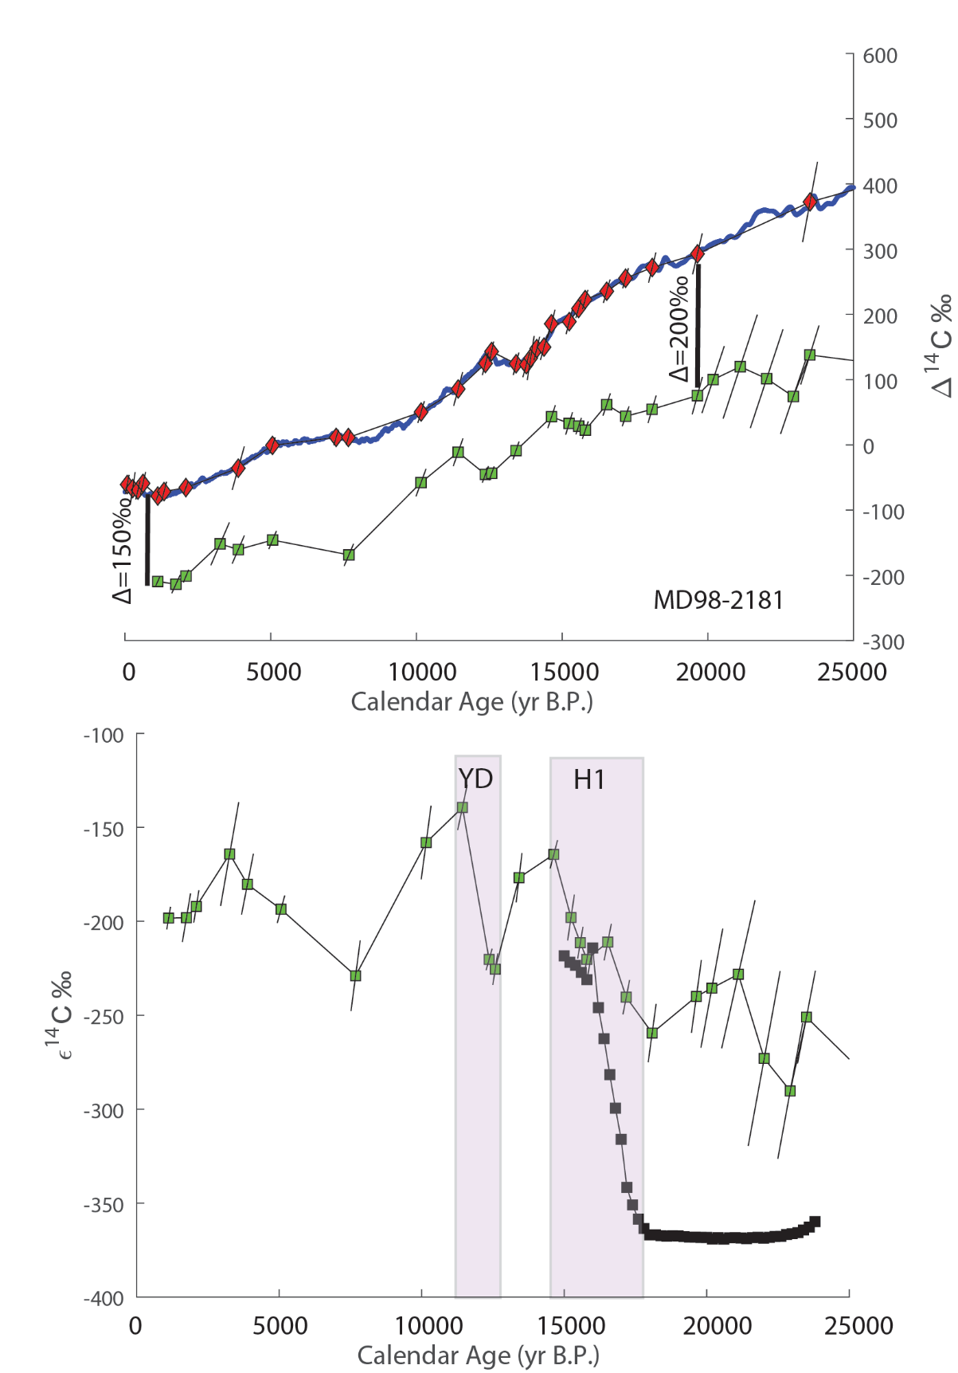
Supplemental Figure S2. Upper panel planktic Δ¹⁴C (red) and benthic Δ¹⁴C (green) with the Mar20 Δ¹⁴C record (blue). The quivers represent the combined age (horizonal) and radiometric (vertical) uncertainties (1σ). Lower panel shows MD98-2181 benthic ε¹⁴C (green) and the values from the LOVECLIM simulation of Menviel et al. (2018) (black). The shaded intervals mark the increases during the H1 and YD.

