Paleoceanography and Paleoclimatology
Supporting Information for
The North Atlantic Glacial Eastern Boundary Current as a key driver for ice-sheet - AMOC interactions and climate instability
S. Toucanne^{1*}, G. Soulet¹, N. Vázquez Riveiros¹, S.M. Boswell², B. Dennielou¹, C. Waelbroeck³, G. Bayon¹, M. Mojtahid⁴, M. Bosq^{1,5}, M. Sabine^{1,6}, S. Zaragosi⁶, J.F. Bourillet¹ and H. Mercier⁷
¹IFREMER, Unité de Recherche Géosciences Marines, Laboratoire Géophysique et enregistrement Sédimentaire, CS10070, F-29280 Plouzané, France, ²Lamont-Doherty Earth Observatory, United States, ³Laboratoire d’Océanographie et du Climat : Expérimentation et Approches Numériques, LOCEAN/IPSL, Sorbonne Université-CNRS-IRD-MNHN, UMR7159, Paris France, ⁴LPG-BIAF UMR-CNRS 6112, Université d’Angers, UFR Sciences, 2 bd Lavoisier 49045, Angers Cedex 01, France, ⁵PACEA, UMR 5199 CNRS - Université Bordeaux, Bâtiment B8, allée Geoffroy Saint Hilaire, 33615 Pessac, France, ⁶UMR-CNRS 5805 EPOC - OASU, Université de Bordeaux, CS50023, 33615 Pessac, France, ⁷CNRS, IFREMER, Université de Brest, IRD, Laboratoire d’Océanographie Physique et Spatiale (LOPS), Centre IFREMER de Bretagne, CS10070, F-29280, Plouzané, France.
*Corresponding author: Samuel Toucanne (stoucann@ifremer.fr)

Contents of this file

Text S1 to S3
Figures S1 to S9
Tables S1 to S6

Introduction
The supplementary information contains details about the sedimentological characteristics of the studied margin (Text S1), the applicability of the sortable silt for paleoceanographic reconstruction on the French Atlantic margin (Text S2), the methods (Text S3), and 9 figures (e.g. details for core locations and stratigraphy) and 6 tables (e.g. stable isotopes, Nd isotope ratios) to support the paper. All data are available in SEANOE repository: https://www.seanoe.org/data/00665/77667/

Text S1.
Sedimentological characteristics: Evidences for contourites on the French Atlantic margin
Sediments from the French Atlantic slope contain a mixture of biogenic (foraminifera) tests and terrigenous material, with a spectrum of detrital grain-sizes from clay and fine silt (median 6-8 µm) to coarse silt and fine sand (median 40-100 µm) (Figure 2). Clay-sized sediment, restricted to the final stage of the last glacial period (i.e. European deglaciation), are characterized by the deposition of regional-scale laminated facies by the Channel River ~20-19 ka and ~18-17 ka in response to the retreat of the southern European Ice-Sheet (Toucanne et al., 2010, 2015; Zaragosi et al., 2001). Note that the preservation of thousands of millimetre-scale laminae during these deglacial intervals highlights concomitant very low energy conditions on the margin. On the other hand, glacial s.s. and interglacial sediments are highly bioturbated (Scolicia and Planolites burrows dominate; A. Wetzel, pers. comm.), showing a succession of mud-, silt- (upper and mid-slope) and fine sand-dominant (shell-rich) facies (upper slope only) with irregular, coarser concentrations (silty lenses) observed (i.e. mottled facies). Layer contacts between the facies are usually gradational. Positive and negative gradational sequences up to >100 cm in thickness are common. Stratigraphy reveals that these sequences correlate from one site to another, especially in the upper slope (Figure S7). Such sedimentological characteristics, as well as the presence of sediment hiatuses (see Section 4, and Figures S3 and S5), are typical features for muddy to fine-sandy contourites (Stow & Holbrook, 1984), i.e. sediments deposited or substantially reworked by the persistent action (e.g. selective deposition, winnowing, erosion) of bottom currents (Rebesco et al., 2014). The positive relationship between and SS%, characterized by - SS% correlation coefficients ranging from 0.69 to 0.91, - SS% slopes of 0.20-0.47 and intercepts at 5.8-16.2 µm (Table S3), demonstrates that sorting processes at the studied sites are controlled by current flow dynamics (McCave, Manighetti, & Robinson, 1995; McCave & Hall, 2006; McCave & Andrews, 2019). Although the sedimentation rates of contourite deposits across the world vary significantly, the mean sedimentation rate of 60 ± 24 cm.kyr⁻¹ for the French Atlantic contourites is high but similar to those reported for Rockall Trough contourites (Howe et al., 1994). Based on the above, the sediments from the French Atlantic slope are likely to provide high-resolution paleocurrent reconstructions.

Text S2.
Testing the applicability of the sortable silt proxy for paleoceanographic reconstruction on the French Atlantic margin
The relevance of the grain-size variability of French Atlantic contourites for paleoceanographic reconstruction is tested by comparison of the flow speed proxy (using only ‘acceptable’ - SS% data according to McCave & Andrews, 2019; Figures 2 and S6) with current meter data. Although not modern, the youngest Holocene sediments available on the upper slope (~1,000 m water depth), corresponding to the uppermost (carbonate-rich) sediment of core MD99-2328 (n=5), CBT-CS10 (n=1), GIT-CS02 (n=2), BOB-CS05 (n=2) and BOB-CS03 (n=3) show a mean of 27.8 ± 2.3 µm. At 2,450 m, Holocene sediments for MD04-2842 (n=16) show a mean of 23.2 ± 1.8 µm. This reveals a difference in between ~1,000 and ~2,450 m water depth of 4.6 ± 2.9 µm for the Holocene period and indicates, by extension, faster flow speed at the shallow core sites (i.e. upper slope). This equates to a difference in mean flow speed (ΔU) of 6.3 ± 4.1 cm.s⁻¹ according to the calibration (i.e. overall sensitivity of 1.36 ± 0.19 cm.s⁻¹/μm) of McCave et al. (2017).
Residual currents of <10 cm.s⁻¹ have been recorded on the upper Biscay slope (500-1,000 m; close to site MD99-2328) by long-term moorings (Pingree & Le Cann, 1989, 1990), with episodic daily average current velocities reaching ~17-20 cm.s⁻¹ (ECOFER Experiment; Durrieu de Madron et al., 1999). Slower current velocities are recorded at ~2,000 m, both in the Bay of Biscay (~8 cm.s⁻¹ maximum according to monthly mean current; Pingree & Le Cann, 1989) and along the Goban Spur (up to ~12 cm.s⁻¹; McCave et al., 2001). The modern difference in maximum flow speed between the upper (~17-20 cm.s⁻¹) and lower slope (~10 cm.s⁻¹) is about 7-10 cm.s⁻¹, in agreement with the upper range of the ΔU estimated from the Holocene contourites deposited at ~1,000 and 2,450 m. All together, these results suggest that the variability of flow, and high-energy events, likely controls the sediment textures of the French Atlantic slope. This highlights, by extension, the critical role for the sedimentary record of the removal of finer material by winnowing (resuspension / deposition) events in addition to the (long-term) selective deposition (at flow speeds < 10-15 cm.s⁻¹; McCave et al., 1995; McCave & Hall, 2006). During the last glacial period, the relationship between flow variability and the sediment texture is supported by the overall good correspondence observed between water-mass ventilation (δ¹³C) and flow speed proxy (, Zr/Rb) records (Figure S8).

Text S3.
Calculation of the ice-volume corrected benthic δ¹⁸O (δ¹⁸O_{IVC})
We calculated the ice-volume corrected benthic δ¹⁸O (δ¹⁸O_{IVC}) for the last ~50 kyr (Figure 6d) according to the methodology detailed in Marcott et al. (2011). Benthic δ¹⁸O records combine bottom water δ¹⁸O and temperature changes. In turn, bottom water δ¹⁸O reflects both changes in ice volume and changes in local δ¹⁸O that have been assumed negligible in this study for lack of a better reconstruction. Thus, we assume that δ¹⁸O_{IVC} at the studied sites likely approximates bottom water temperature changes (e.g. Marcott et al., 2011). Methodologically, we have compiled multiple (n=7) high-resolution sea-level reconstructions (Arz et al., 2007; Clark et al., 2009; Grant et al., 2014; Siddall et al., 2003; Sierro et al., 2009) while assuming that a relative sea-level fall of 130 m (i.e. LGM equivalent) corresponds to a global mean water isotopic composition enrichment of 1 ‰ (Schrag et al., 2002).

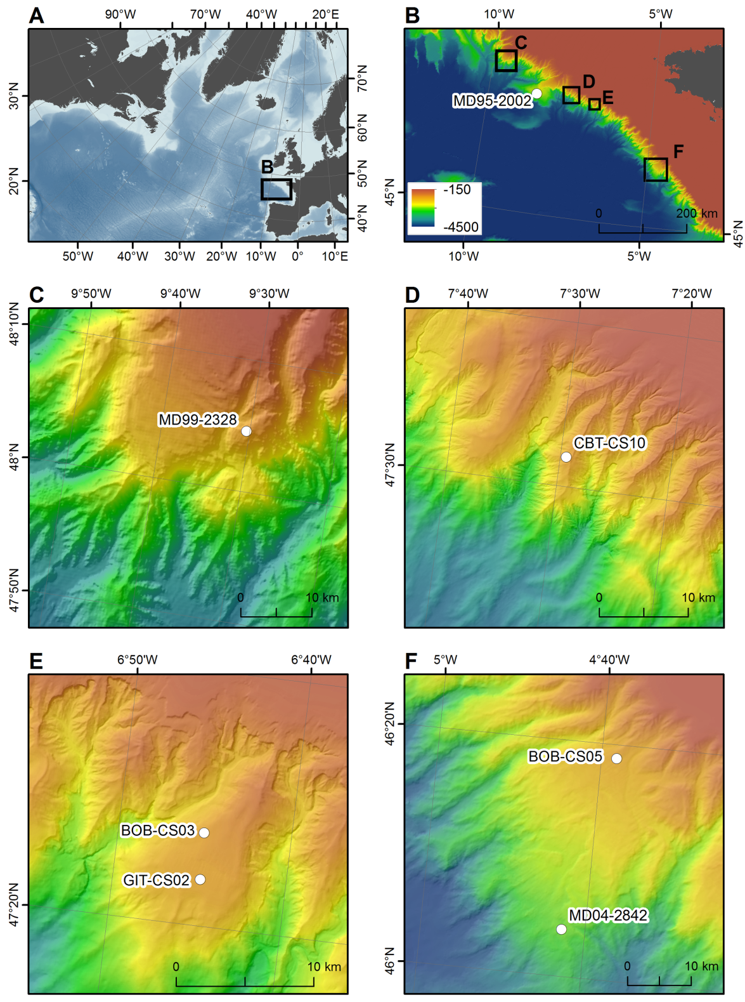
Figure S1. The northeast Atlantic sector (a), including the French Atlantic margin (b), and the location of the study cores (c to f; see Table 1 for details). Bathymetric data from Gebco (grid 926 m), Emodnet (grid 250 m), North Atlantic v2016 IFREMER/SHOM (grid 100 m) and BOBGEO cruises (Ifremer, 50 m; Bourillet et al., 2012). Coordinate system RGF93/Lambert-93. Correspondences between the long-piston cores and the cruises are the following (from north to south): MD99-2328: IMAGES V LEG 4-MD114 (Labeyrie et al., 1999); MD95-2002: IMAGE1-MD101 (Labeyrie et al., 1995); CBT-CS10: CABTEX (Dussud, 2010); BOB-CS03 and BOB-CS05: BOBGEO (Bourillet, 2009); GIT-CS02: GITAN (Toucanne, 2015); MD04-2842: MD142 / ALIENOR 2 (Turon & Bourillet, 2004).

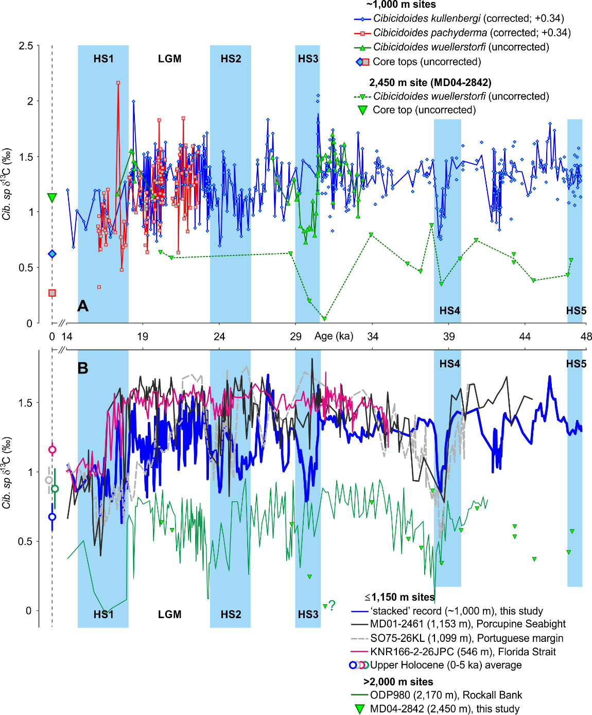

Figure S2. (A) Glacial δ¹³C data for Cibicidoides kullenbergi (blue), Cibicidoides pachyderma (red) and Cibicides wuellerstorfi (continuous green line) at ~1,000 m depth (cores MD99-2328, CBT-CS10, BOB-CS03, GIT-CS02, BOB-CS05), and C. wuellerstorfi (dashed green line) at site MD04-2842 (2,450 m). A correction factor of +0.34 ‰ (calculated on 21 paired analyses of C. kullenbergi and C. wuellerstorfi; standard deviation of 0.3) was applied to the δ¹³C results from C. kullenbergi and C. pachyderma to account for the relatively constant offset (i.e. vital and habitat preferences) with regard to C. wuellerstorfi (at ~1,000 m depth) that is considered as an epibenthic species that registers the δ¹³C of bottom-waters. C. kullenbergi and C. pachyderma show close δ¹³C signatures during the last glacial period. Uncorrected core top (i.e. Late Holocene to sub-modern) δ¹³C values are shown on the y-axis. Note that (uncorrected) δ¹³C at ~1,000 m is increased during the last glacial by ~0.3 (C. kullenbergi; site CBT-CS10) to 0.6 ‰ (C. pachyderma; site MD99-2328) compared to Late Holocene to sub-modern values, while an inverse pattern (δ ¹³C shift of ~0.6 ‰ between the last glacial period and the Late Holocene) is observed at 2,450 m. (B) Comparison of the δ¹³C data of the French Atlantic margin (A) with Cibicides wuellerstorfi δ¹³C data from ODP Site 980 (Rockall Bank; Crocker et al., 2016), MD01-2461 (Porcupine Seabight; Peck et al., 2007) and SO75-26KL (Portugueuse margin; Zahn et al., 1997). P. ariminensis δ¹³C data from KNR166-2-26JPC (Florida Strait; Lynch-Stieglitz et al., 2014) are also shown. All data sets plotted in (B) are shown on their original published age models. Vertical blue bands highlight Heinrich Stadials (HS). LGM: Last Glacial Maximum.

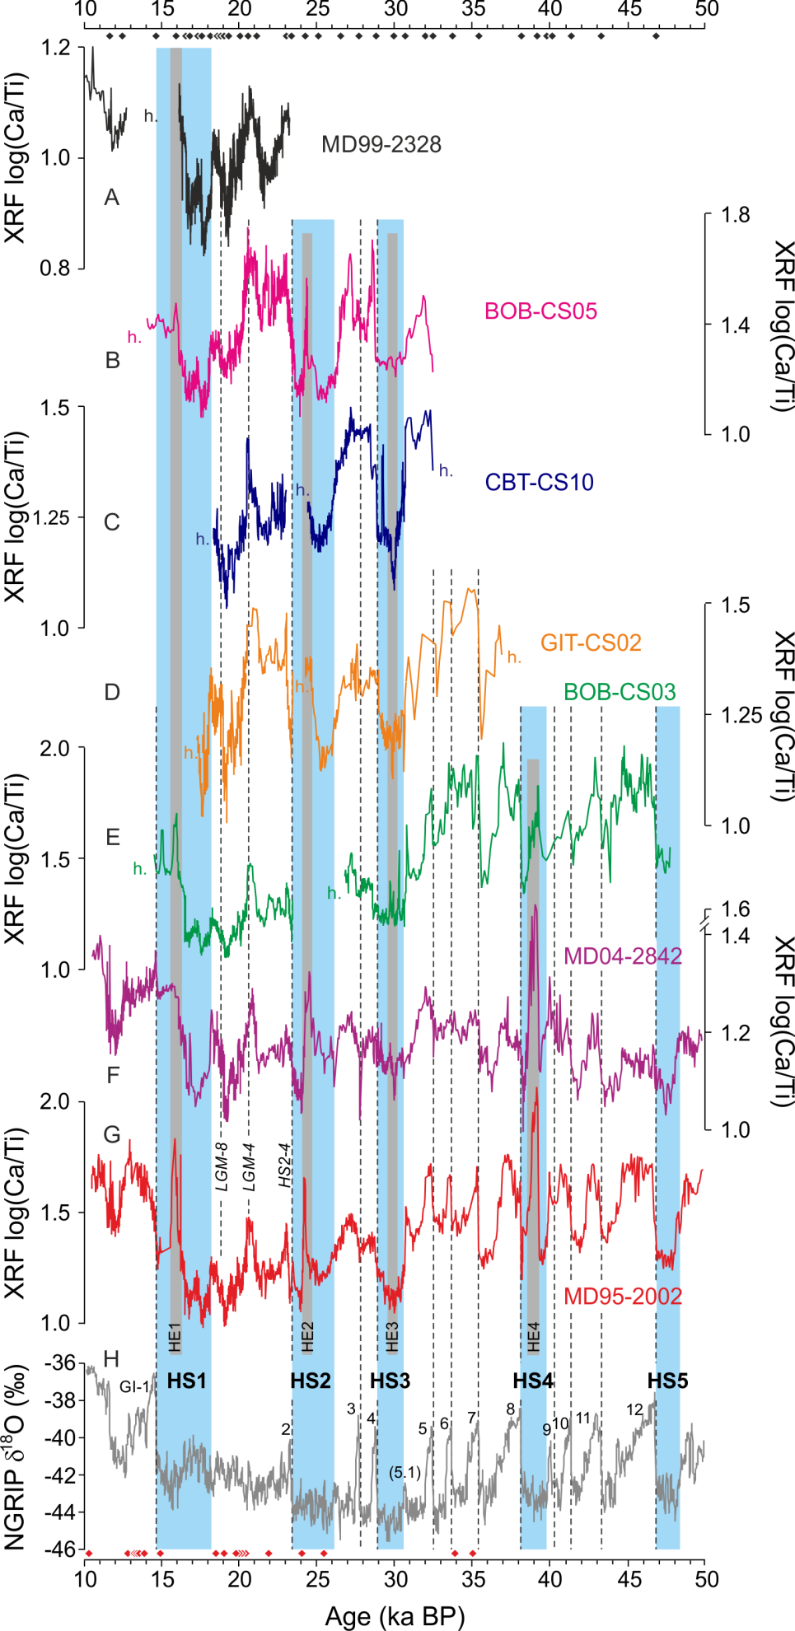
Figure S3. Stratigraphic correlation of cores MD99-2328 (r=0.84), BOB-CS05 (r=0.6), CBT-CS10 (r=0.72), GIT-CS02 (r=0.7), BOB-CS03 (r=0.88) (a-e; ~1,000 m depth), and MD04-2842 (r=0.5) (f; 2,450 m) with the reference core MD95-2002 (g) and the NGRIP δ¹⁸O (h) record (GICC05 chronology; Rasmussen et al., 2006; Svensson et al., 2008) based on the XRF log (Ca/Ti) ratio. The chronological tie points (e.g. LGM-4, LGM-8, HS2-4; see Table S2 and Figure S4 for details) are shown in the upper part of the figure (black diamonds). Radiocarbon constraints for MD95-2002 are shown in the lower part of the figure (red diamonds) and in Table S1. GI- (GI-1 to 12) refers to Greenland Interstadials. HS (HS1 to 5) refers to Heinrich Stadials (blue bands; Figure S4) during which the massive ice-rafting episodes known as Heinrich Events (HE) occurred. The Ca/Ti peaks observed during HE1, HE2 and HE4 (light grey bands) correspond to the ‘cemented marls’ of Hemming (2004), interpreted as discharge of icebergs from the Hudson Strait Ice Stream of the LIS to the North Atlantic. Sedimentary hiatuses (h) are shown for each record (e.g. 18-0, 24.5-23 and 57-32.5 ka BP in core CBT-CS10).

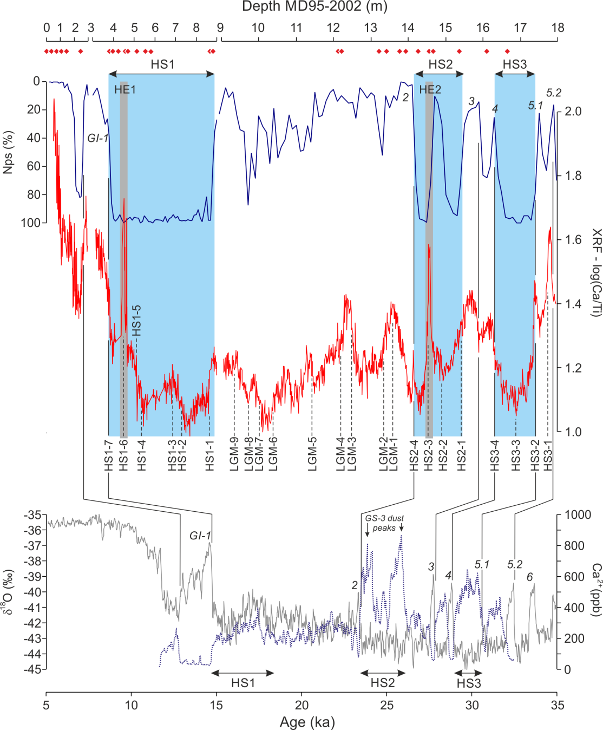

Figure S4. XRF log (Ca/Ti) tie-points (e.g. LGM-n, HS1-n, etc.) used for core-to-core correlations and their stratigraphic nature with regard to both to the abundance of the planktic polar foraminifera Neogloboquadrina pachyderma (Nps %) at site MD95-2002 (Toucanne et al., 2015 and reference therein) and the NGRIP δ¹⁸O (grey line) and Ca²⁺ (dashed blue line) records (GICC05 chronology; Rasmussen et al., 2006; Svensson et al., 2008). Radiocarbon constraints for MD95-2002 (Table S1) are marked by red diamonds on the depth scale. GI- (GI-1 to 6) and GS refer to Greenland Interstadials and Stadials, respectively. LGM- (1 to 9) refers to the Last Glacial Maximum. HS (HS1 to 3) refers to Heinrich Stadials (defined from the abundances of the planktic polar foraminifera N. pachyderma at site MD95-2002 and the NGRIP Ca²⁺ record). HE (1 to 2) refers to Heinrich Events. The Ca/Ti peaks observed during HE1 and HE2 (grey bands) correspond to the ‘cemented marls’ of Hemming (2004).

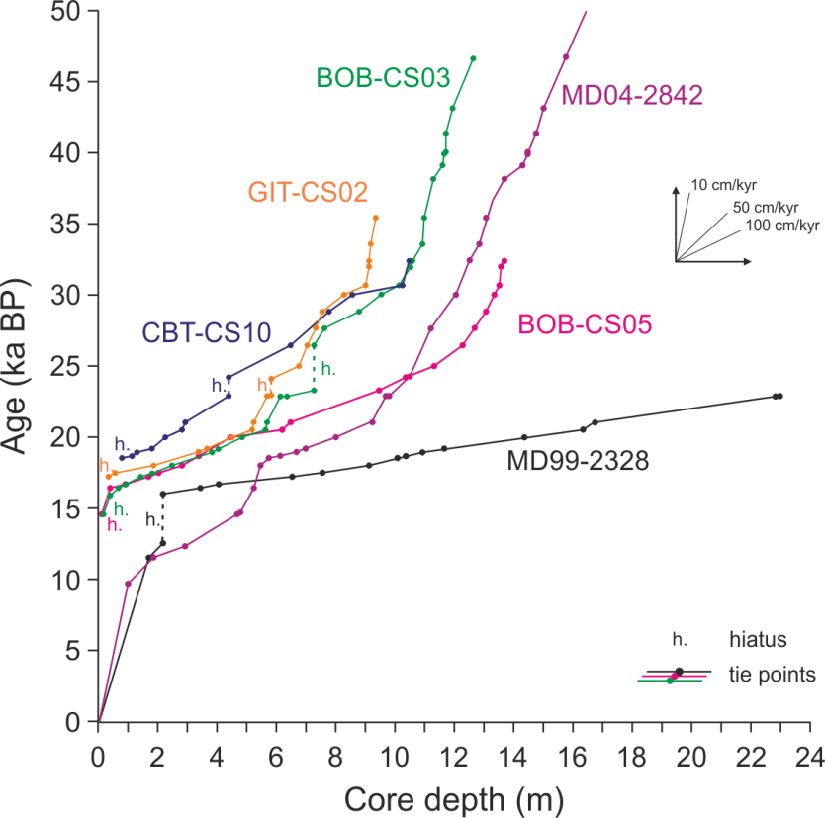

Figure S5. Age models for sediment cores MD99-2328, CBT-CS10, BOB-CS03, GIT-CS02, BOB-CS05 (~1,000 m depth) and MD04-2842 (2,450 m), French Atlantic margin, based on their synchronization to reference core MD95-2002 (Table S1) via the XRF log (Ca/Ti) ratio (Table S2; Figures S3 and S4).

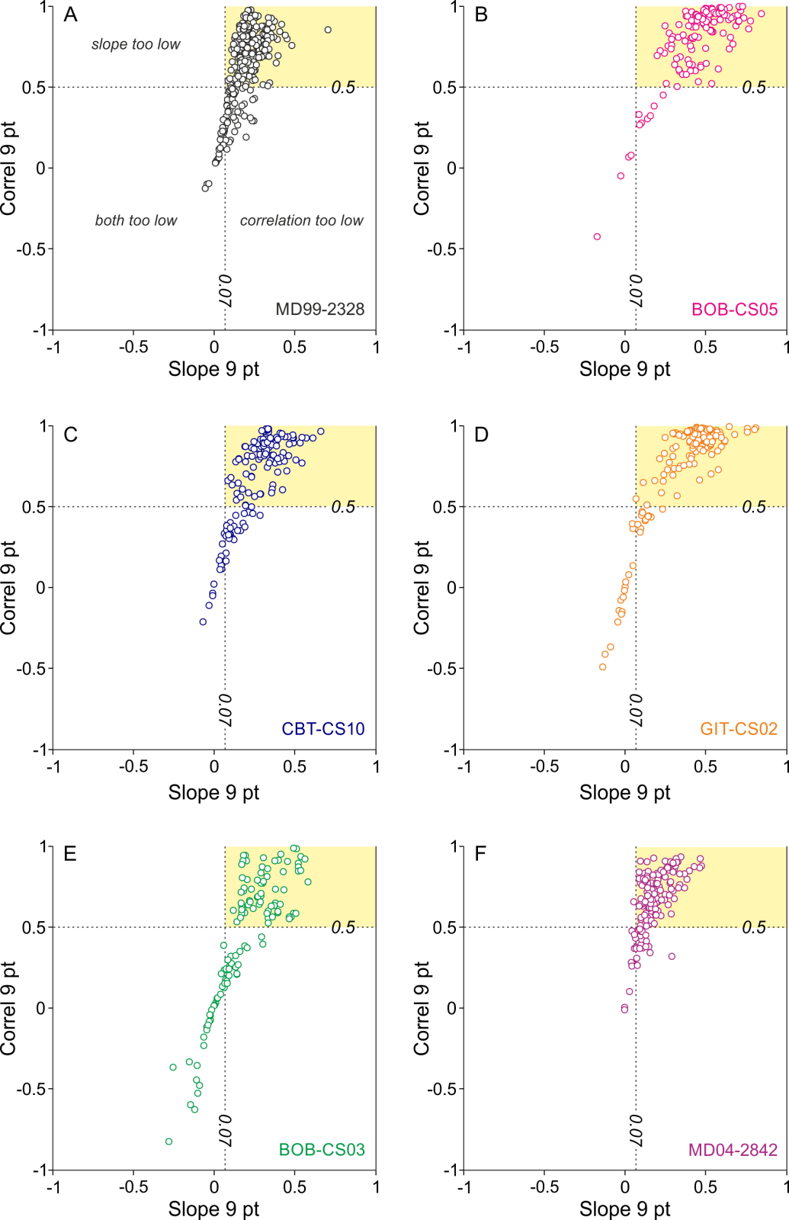

Figure S6. Running downcore correlation (Rrun; 9-point) (y-axis) vs - SS% slope (x-axis) for cores MD99-2328, BOB-CS05, CBT-CS10, GIT-CS02, BOB-CS03 (~1,000 m), and MD04-2842 (2,450 m). The - SS% data highlighted in the yellow boxes have both a running downcore correlation >0.5 and a slope relationship >0.07, thus demonstrating that the sorting process is controlled by current flow dynamics (McCave & Andrews, 2019). Note that this ‘test’ is achieved for 75% of the dataset (i.e. 794 of 1055 samples).
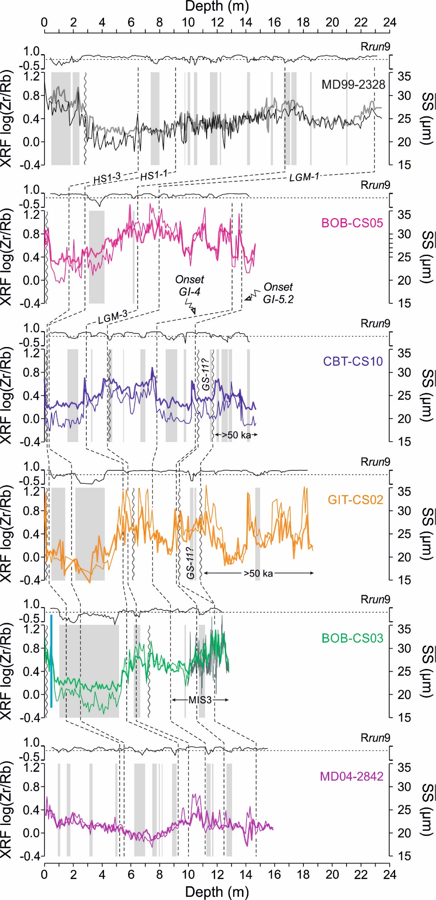
Figure S7. Sortable silt mean size () and XRF log (Zr/Rb) for cores MD99-2328, BOB-CS05, CBT-CS10, GIT-CS02, BOB-CS03 (~1,000 m), and MD04-2842 (2,450 m). Grey bars indicate the intervals for which the - SS% data have a running downcore correlation (Rrun; 9-point) <0.5 (as shown in the upper part of each core panel; see Figure S6 for details), thus demonstrating that the sorting process likely does not result from current flow dynamics (McCave & Andrews, 2019). Data ( and Zr/Rb) from these intervals are not used in the flow speed reconstruction (Figure 4b,e). Stratigraphic correlations (black dashed lines) are shown (see Figures S3 and S4 for details). Vertical wavy lines indicate sedimentary hiatuses. Local stratigraphic markers (i.e. LGM-n, HS1-n) are detailed in Table S2 and Figure S3). GI- / GS-: Greenland Interstadials / Stadials.

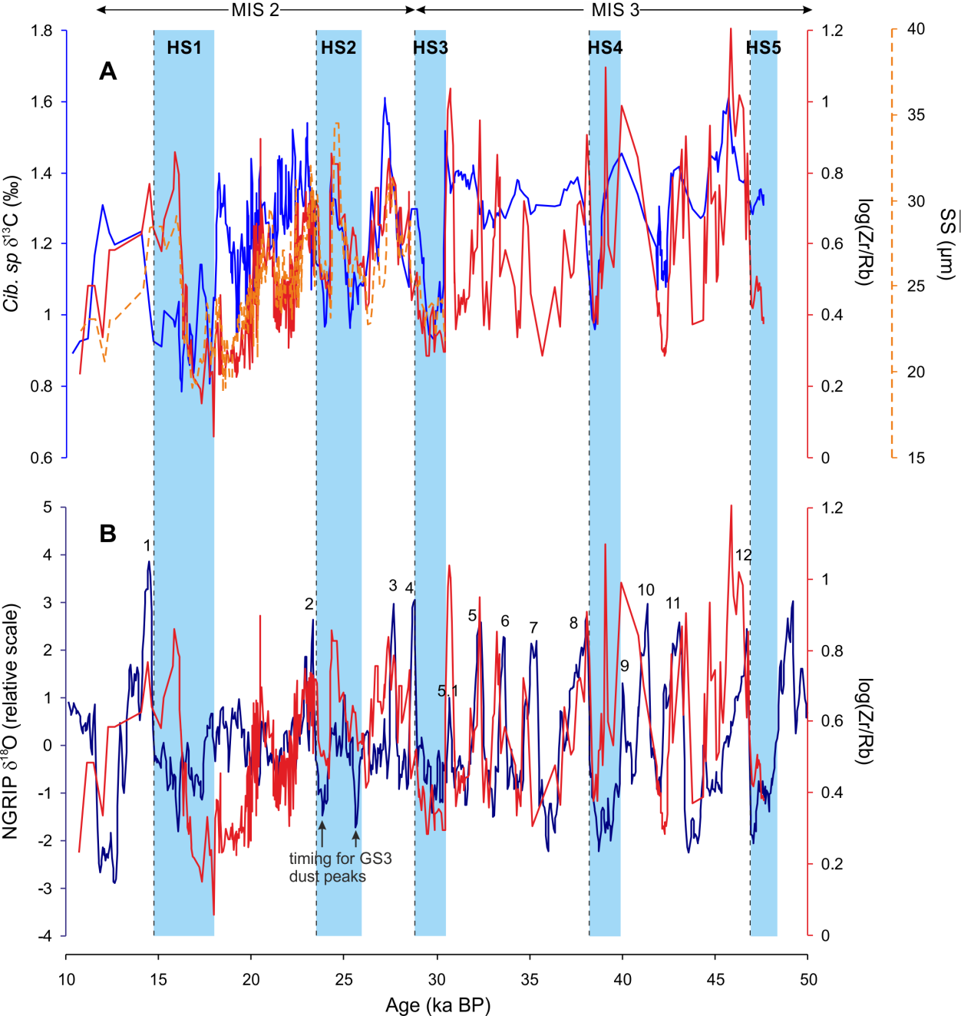

Figure S8: Comparison of the grain-size proxies ( and log Zr/Rb) from the upper slope of the French Atlantic margin (~1,000 m), interpreted as flow speed records of the GEBC, with (A) the benthic δ¹³C (from the same location) and (B) the (resampled and high-passed-filtered) NGRIP δ¹⁸O record (a zero-phase, high-pass Butterworth filter with a 7000 yr cutoff was implemented to preserve the size and timing of millennial-scale events in the NGRIP record while removing variations in the orbital band; Alley et al., 2001). The resolution of the (high-resolution) grain-size records have been adapted (i.e. lowered) to that of the (lower resolution in comparison) benthic δ¹³C. Despite some obvious mismatches in amplitude and/or structure (e.g. between HS4 and HS3 or during the late HS1 in A), the overall correspondence between these data suggest (i) a direct relationship between near-bottom flow speed and water-mass ventilation on the French Atlantic margin (A) and (ii) a close coupling between the vigor of the GEBC (i.e. upper branch of AMOC) and Greenland / North Atlantic climate at millennial timescale (B).
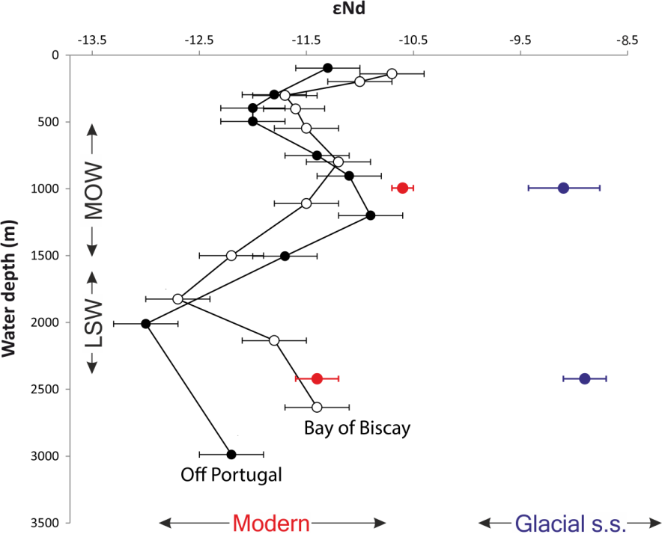

Figure S9. Core-top (i.e. ~modern) and glacial s.s. (48-20 ka) foraminiferal ε_{Nd} values (colored circles) from the French Atlantic margin (at ~1,000 m and 2,450 m based on cores BOB-CS03/05 and MD04-2842, respectively; Table S6) compared to ε_{Nd} value depth profiles (seawater) from off Portugal (black circles; OVIDE Station 15) and the Bay of Biscay (white circles; CAROLS Stations 34-40) (see Copard et al., 2011 and Dubois-Dauphin et al., 2017 for details). MOW: Mediterranean Outflow Water. LSW: Labrador Sea Water.

[TOO LARGE / SEE ATTACHED FILE]

Table S1. Age model for core MD95-2002. Calibration of ¹⁴C dates [Ref. 1: Zaragosi et al. (2001); 2: Zumaque et al. (2017); 4: Zaragosi et al. (2006); 5: Toucanne et al. (2008); 6: Eynaud et al. (2007); 7: Grousset et al. (2000); 9: Auffret et al. (2002)] was performed using Clam software (Blaauw, 2010) with the IntCal13 calibration curve (Reimer et al., 2013). Reservoir age correction from Stern & Lisiecki (2013) (see Toucanne et al., 2015 for details). NGRIP tie-points (i.e. onset of Greenland Interstadials, GI) and associated uncertainties (2σ) according to Rasmussen et al. (2006; Ref. 3 in the table), Andersen et al. (2006; Ref. 8) and Svensson et al. (2008; Ref. 10) and the GICC05 timescale.

[TOO LARGE / SEE ATTACHED FILE]

Table S2. Chronological framework (main tie-points) for cores MD99-2328, BOB-CS05, CBT-CS10, GIT-CS02, BOB-CS03 (~1,000 m depth), and MD04-2842 (2,450 m) based on their synchronization (depth scale) to reference core MD95-2002 (age scale; see Table S1 for details) via the XRF log (Ca/Ti) ratio. Tie-points used for correlations (e.g. LGM-n, HS1-n, etc.) are shown in Figures S3 and S4. GI- (GI-1 to 12) refers to Greenland Interstadials. LGM- (1 to 9) refers to the Last Glacial Maximum. HS (HS1 to 4) refers to Heinrich Stadials. HE (1 to 4) refers to Heinrich Events (i.e. discharge of icebergs from the Hudson Strait Ice Stream of the LIS to the North Atlantic). YD: Younger Dryas.

Core | SS% avg | avg | slope | intercept µm | r | n | instrument
CBT-CS10 | 38.2 ± 7.3 | 22.3 ± 2.7 | 0.312 | 10.38 | 0.836 | 113 | Malvern MS 3000
GIT-CS02 | 44.1 ± 9.6 | 25.9 ± 4.7 | 0.444 | 6.34 | 0.911 | 136 | Malvern MS 3000
MD99-2328 | 48.1 ± 8.5 | 23.7 ± 2.5 | 0.242 | 12.1 | 0.833 | 221 | Malvern MS 3000
BOB-CS03 | 43.8 ± 8.3 | 26.3 ± 2.7 | 0.229 | 16.21 | 0.693 | 75 | Malvern MS 3000
BOB-CS05 | 46.7 ± 7.8 | 27.9 ± 4.1 | 0.473 | 5.75 | 0.901 | 128 | Malvern MS 3000
MD04-2842 | 45.2 ± 8.1 | 22.1 ± 2.1 | 0.202 | 12.9 | 0.765 | 121 | Malvern MS 3000

Table S3. Slope and intercept data for vs SS% downcore data (Rrun > 0.5; n=794).

Core | SS% avg | avg | log (Zr/Rb) avg | n
CBT-CS10 | 40.5 ± 0.0 | 24.6 ± 0.0 | 0.69 ± 0.0 | 1
GIT-CS02 | 44.4 ± 6.0 | 26.5 ± 2.9 | 0.90 ± 0.2 | 2
MD99-2328 | 67.9 ± 4.4 | 29.7 ± 2.9 | 0.74 ± 0.1 | 5
BOB-CS03 | 55.1 ± 9.3 | 29.6 ± 2.1 | 0.77 ± 0.1 | 3
BOB-CS05 | 48.1 ± 2.8 | 28.6 ± 2.1 | 0.74 ± 0.1 | 2
- | 53.9 ± 5.5 | 27.8 ± 2.3 | 0.77 ± 0.1 | 13
MD04-2842 | 50.5 ± 5.6 | 23.2 ± 1.8 | 0.27 ± 0.1 | 16
- | 50.5 ± 5.6 | 23.2 ± 1.8 | 0.27 ± 0.1 | 16

Table S4. Holocene (0-11.7 ka) average values of our flow speed proxies.

[TOO LARGE / SEE ATTACHED FILE]

Table S5. Benthic foraminiferal δ¹⁸O and δ¹³C (expressed in ‰ with respect to the Vienna Pee-Dee Belemnite standard, VPDB) for cores MD99-2328, CBT-CS10, BOB-CS03, GIT-CS02, BOB-CS05 (~1,000 m water depth), and MD04-2842 (2,450 m). The ice-volume corrected benthic δ¹⁸O (δ¹⁸O_{IVC}) is also shown. See Text S3 for the detailed methodology.

Core | Depth (cm) | Age (ka BP) | ¹⁴³Nd/¹⁴⁴Nd | 2 σ | εNd | 2 σ
BOBGEO-CS03 | 0-1 | 5.00 | 0.512085 | 7.198E-06 | -10.6 | 0.1
BOBGEO-CS03 | 30-33 | 15.18 | 0.512119 | 8.473E-06 | -10.0 | 0.1
BOBGEO-CS03 | 60-63 | 16.39 | 0.512110 | 7.447E-06 | -10.1 | 0.1
BOBGEO-CS03 | 185-195 | 17.60 | 0.511998 | 1.125E-05 | -12.3 | 0.2
BOBGEO-CS03 | 620-623 | 22.98 | 0.512108 | 1.065E-05 | -10.2 | 0.2
BOBGEO-CS03 | 790-793 | 28.10 | 0.512170 | 1.041E-05 | -9.0 | 0.2
BOBGEO-CS03 | 910-915 | 29.48 | 0.512146 | 9.495E-06 | -9.4 | 0.1
BOBGEO-CS03 | 950-953 | 30.01 | 0.512201 | 8.854E-06 | -8.4 | 0.1
BOBGEO-CS03 | 1022 | 31.04 | 0.512154 | 1.000E-05 | -9.3 | 0.2
BOBGEO-CS03 | 1052 | 32.17 | 0.512157 | 8.000E-06 | -9.2 | 0.2
BOBGEO-CS03 | 1057 | 32.52 | 0.512162 | 1.000E-05 | -9.1 | 0.2
BOBGEO-CS03 | 1097 | 35.42 | 0.512151 | 9.000E-06 | -9.4 | 0.2
BOBGEO-CS03 | 1115-1116 | 37.64 | 0.512160 | 8.970E-06 | -9.2 | 0.1
BOBGEO-CS03 | 1120-1121 | 38.00 | 0.512164 | 5.769E-06 | -9.1 | 0.1
BOBGEO-CS03 | 1125-1126 | 38.24 | 0.512173 | 7.023E-06 | -8.9 | 0.1
BOBGEO-CS03 | 1135-1136 | 38.49 | 0.512179 | 7.660E-06 | -8.8 | 0.1
BOBGEO-CS03 | 1145-1146 | 38.75 | 0.512160 | 8.002E-06 | -9.2 | 0.1
BOBGEO-CS03 | 1155 | 38.99 | 0.512169 | 1.100E-05 | -9.0 | 0.2
BOBGEO-CS03 | 1168 | 41.18 | 0.512165 | 1.000E-05 | -9.1 | 0.2
BOBGEO-CS03 | 1172 | 41.94 | 0.512162 | 1.400E-05 | -9.1 | 0.3
BOBGEO-CS03 | 1186 | 43.10 | 0.512168 | 1.100E-05 | -9.0 | 0.2
BOBGEO-CS03 | 1193 | 43.82 | 0.512175 | 7.000E-06 | -8.9 | 0.1
BOBGEO-CS03 | 1245-1246 | 46.15 | 0.512170 | 1.071E-05 | -9.0 | 0.2
BOBGEO-CS03 | 1255-1256 | 46.53 | 0.512175 | 5.684E-06 | -8.9 | 0.1
BOBGEO-CS03 | 1265-1266 | 46.90 | 0.512180 | 1.302E-05 | -8.8 | 0.2
BOBGEO-CS03 | 1270-1271 | 47.09 | 0.512182 | 7.580E-06 | -8.7 | 0.1
BOBGEO-CS03 | 1278-1279 | 47.39 | 0.512174 | 6.434E-06 | -8.9 | 0.1
BOBGEO-CS03 | 1285 | 47.64 | 0.512176 | 8.000E-06 | -8.9 | 0.2
BOBGEO-CS05 | 30-33 | 15.90 | 0.512120 | 1.500E-05 | -10.0 | 0.3
BOBGEO-CS05 | 206 | 17.58 | 0.512018 | 1.495E-05 | -12.1 | 0.5
BOBGEO-CS05 | 336 | 18.72 | 0.512010 | 2.742E-05 | -12.2 | 0.5
BOBGEO-CS05 | 500 | 20.19 | 0.512078 | 1.592E-05 | -11.0 | 0.5
BOBGEO-CS05 | 550-560 | 20.33 | 0.512184 | 1.025E-05 | -8.7 | 0.2
BOBGEO-CS05 | 670-680 | 21.50 | 0.512147 | 9.587E-06 | -9.4 | 0.1
BOBGEO-CS05 | 740 | 22.33 | 0.512193 | 3.145E-05 | -8.6 | 0.6
BOBGEO-CS05 | 1015-1018 | 24.07 | 0.512172 | 1.228E-05 | -9.0 | 0.2
BOBGEO-CS05 | 1115 | 24.34 | 0.512175 | 1.906E-05 | -9.0 | 0.7
BOBGEO-CS05 | 1205-1208 | 26.30 | 0.512192 | 1.505E-05 | -8.7 | 0.3
BOBGEO-CS05 | 1255-1258 | 27.58 | 0.512179 | 1.805E-05 | -8.9 | 0.4
BOBGEO-CS05 | 1322-1328 | 29.68 | 0.512124 | 1.441E-05 | -10.0 | 0.3
BOBGEO-CS05 | 1355-1358 | 31.38 | 0.512138 | 1.631E-05 | -9.7 | 0.3
BOBGEO-CS05 | 1445-1448 | 32.45 | 0.512174 | 1.844E-05 | -9.0 | 0.4
MD04-2842 | 0 | 0.00 | 0.512048 | 1.200E-05 | -11.4 | 0.2
MD04-2842 | 20-22 | 1.28 | 0.512063 | 1.067E-05 | -11.2 | 0.2
MD04-2842 | 60 | 3.66 | 0.512045 | 1.000E-05 | -11.4 | 0.2
MD04-2842 | 120-125 | 7.45 | 0.512088 | 1.327E-05 | -10.6 | 0.2
MD04-2842 | 200-255 | 12.06 | 0.512148 | 7.196E-06 | -9.4 | 0.1
MD04-2842 | 400-405 | 13.86 | 0.512131 | 8.000E-06 | -9.7 | 0.1
MD04-2842 | 510-512 | 16.11 | 0.512108 | 1.197E-05 | -10.3 | 0.2
MD04-2842 | 755 | 19.69 | 0.512046 | 1.048E-05 | -11.5 | 0.4
MD04-2842 | 970 | 22.97 | 0.512181 | 1.105E-05 | -8.9 | 0.4
MD04-2842 | 1030-1032 | 23.95 | 0.512190 | 6.661E-06 | -8.7 | 0.1
MD04-2842 | 1060-1062 | 25.11 | 0.512175 | 9.061E-06 | -9.0 | 0.2
MD04-2842 | 1080-1082 | 26.35 | 0.512202 | 8.423E-06 | -8.5 | 0.2
MD04-2842 | 1120-1122 | 27.96 | 0.512174 | 6.829E-06 | -9.0 | 0.1
MD04-2842 | 1200 | 29.93 | 0.512198 | 6.000E-06 | -8.4 | 0.1
MD04-2842 | 1220 | 30.89 | 0.512173 | 5.000E-06 | -8.9 | 0.1
MD04-2842 | 1240 | 32.05 | 0.512162 | 7.000E-06 | -9.1 | 0.1
MD04-2842 | 1260 | 32.96 | 0.512169 | 9.000E-06 | -9.0 | 0.2
MD04-2842 | 1300 | 35.13 | 0.512165 | 5.000E-06 | -9.1 | 0.1
MD04-2842 | 1320 | 36.33 | 0.512180 | 6.000E-06 | -8.8 | 0.1
MD04-2842 | 1360 | 37.89 | 0.512172 | 8.000E-06 | -8.9 | 0.2
MD04-2842 | 1420 | 38.53 | 0.512171 | 6.000E-06 | -9.0 | 0.1
MD04-2842 | 1440 | 39.76 | 0.512185 | 7.000E-06 | -8.7 | 0.1
MD04-2842 | 1480 | 41.99 | 0.512185 | 6.000E-06 | -8.7 | 0.1
MD04-2842 | 1500 | 43.28 | 0.512182 | 7.000E-06 | -8.7 | 0.1
MD04-2842 | 1520 | 44.55 | 0.512175 | 8.000E-06 | -8.9 | 0.2
MD04-2842 | 1560 | 46.20 | 0.512165 | 7.000E-06 | -9.1 | 0.1
MD04-2842 | 1580 | 47.04 | 0.512151 | 5.000E-06 | -9.3 | 0.1
MD04-2842 | 1600 | 47.96 | 0.512158 | 8.000E-06 | -9.2 | 0.2

Table S6. Radiogenic neodymium isotope ratios of planktonic foraminifera (Figure 4d). See the main text for details about methods (Section 3.2).

References

Alley, R. B., Anandakrishnan, S., & Jung, A. P. (2001). Stochastic resonance in the North Atlantic. Paleoceanography, 16(2), 190–198.
Andersen, K. K., Svensson, A., Johnsen, S., Rasmussen, S. O., Bigler, M., Rothlisberger, R., et al. (2006). The Greenland Ice Core Chronology 2005, 15-42 kyr. Part 1: constructing the time scale. Quaternary Science Reviews, 25(23–24), 3246–3257.
Arz, H. W., Lamy, F., Ganopolski, A., Nowaczyk, N., & Patzold, J. (2007). Dominant Northern Hemisphere climate control over millenial-scale glacial sea-level variability. Quaternary Science Reviews, 26(3–4), 312–321.
Auffret, G., Zaragosi, S., Dennielou, B., Cortijo, E., Van Rooij, D., Grousset, F., et al. (2002). Terrigenous fluxes at the Celtic margin during the last glacial cycle. Marine Geology, 188(1–2), 79–108.
Blaauw, M. (2010). Methods and code for “classical” age-modelling of radiocarbon sequences. Quaternary Geochronology, 5, 512–518.
Bourillet, J. F. (2009). BOBGEO cruise, R/V Pourquoi Pas?. https://doi.org/10.17600/9030060.
Bourillet, J. F., de Chambure, L., & Loubrieu, B. (2012). Sur les traces des coraux d’eau froide du golfe de Gascogne: 8 cartes bathymorphologiques et géomorphologiques au 1/100 000. Editions Quae.
Clark, P. U., Dyke, A. S., Shakun, J. D., Carlson, A. E., Clark, J., Wohlfarth, B., et al. (2009). The Last Glacial Maximum. Science, 325, 710–714.
Copard, K., Colin, C., Frank, N., Jeandel, C., Montero‐Serrano, J., Reverdin, G., & Ferron, B. (2011). Nd isotopic composition of water masses and dilution of the Mediterranean outflow along the southwest European margin. Geochemistry, Geophysics, Geosystems, 12(6).
Crocker, A. J., Chalk, T. B., Bailey, I., Spencer, M. R., Gutjahr, M., Foster, G. L., & Wilson, P. A. (2016). Geochemical response of the mid-depth Northeast Atlantic Ocean to freshwater input during Heinrich events 1 to 4. Quaternary Science Reviews, 151, 236–254.
Dubois-Dauphin, Q., Colin, C., Bonneau, L., Montagna, P., Wu, Q., Van Rooij, D., et al. (2017). Fingerprinting Northeast Atlantic water masses using Neodymium isotopes. Geochimica et Cosmochimica Acta, 210, 267–288.
Durrieu de Madron, X., Castaing, P., Nyffeler, F., & Courp, T. (1999). Slope transport of suspended particulate matter on the Aquitanian margin of the Bay of Biscay. Deep Sea Research Part II: Topical Studies in Oceanography, 46(10), 2003–2027.
Dussud, L. (2010). CABTEX cruise, R/V Pourquoi Pas?. https://doi.org/10.17600/10030050.
Eynaud, F., Zaragosi, S., Scourse, J. D., Mojtahid, M., Bourillet, J. F., Hall, I. R., et al. (2007). Deglacial laminated facies on the NW European continental margin: the hydrographic significance of British Ice sheet deglaciation and Fleuve Manche paleoriver discharges. Geochemistry, Geophysics, Geosystems, 8, doi:10.1029/2006GC001496.
Grant, K. M., Rohling, E. J., Bronk Ramsey, C., Cheng, H., Edwards, R. L., Florindo, F., et al. (2014). Sea-level variability over five glacial cycles. Nature Communications, 5, 5076.
Grousset, F. E., Pujol, C., Labeyrie, L., Auffret, G., & Boelaert, A. (2000). Were the North Atlantic Heinrich events triggered by the behavior of the European ice sheets? Geology, 28(2), 123–126.
Hemming, S. R. (2004). Heinrich events: Massive late Pleistocene detritus layers of the North Atlantic and their global climate imprint. Reviews of Geophysics, 42(1), RG1005 1-43.
Howe, J., Stoker, M., & Stow, D. (1994). Late Cenozoic sediment drift complex, northeast Rockall Trough, north Atlantic. Paleoceanography, 9(6), 989–999.
Labeyrie, L., Turon, J. L., & Lancelot, Y. (1995). IMAGES 1-MD101 cruise, R/V Marion Dufresne. https://doi.org/10.17600/95200110.
Labeyrie, L., Jennings, A. E., & Anderson, D. (1999). IMAGES V LEG4-MD114 cruise, R/V Marion Dufresne. https://doi.org/10.17600/99200070.
Lynch-Stieglitz, J., Schmidt, M. W., Henry, L. G., Curry, W. B., Skinner, L. C., Mulitza, S., et al. (2014). Muted change in Atlantic overturning circulation over some glacial-aged Heinrich events. Nature Geoscience, 7(2), 144–150.
Marcott, S. A., Clark, P. U., Padman, L., Klinkhammer, G. P., Springer, S. R., Liu, Z., et al. (2011). Ice-shelf collapse from subsurface warming as a trigger for Heinrich events. Proceedings of the National Academy of Sciences, 108(33), 13415–13419.
McCave, I., Hall, I. R., Antia, A., Chou, L., Dehairs, F., Lampitt, R., et al. (2001). Distribution, composition and flux of particulate material over the European margin at 47–50 N. Deep Sea Research Part II: Topical Studies in Oceanography, 48(14–15), 3107–3139.
McCave, I., Thornalley, D., & Hall, I. (2017). Relation of sortable silt grain-size to deep-sea current speeds: Calibration of the ‘Mud Current Meter.’ Deep Sea Research Part I: Oceanographic Research Papers, 127, 1–12.
McCave, I. N., & Andrews, J. T. (2019). Distinguishing current effects in sediments delivered to the ocean by ice. I. Principles, methods and examples. Quaternary Science Reviews, 212, 92–107.
McCave, I. N., & Hall, I. R. (2006). Size sorting in marine muds : Processes, pitfalls, and prospects for paleoflow-speed proxies. Geochemistry, Geophysics, Geosystems, 7(10), 1–37, Q10N05, doi:10.1029/2006GC001284.
McCave, I. N., Manighetti, B., & Robinson, S. G. (1995). Sortable silt and fine sediment size/composition slicing: Parameters for palaeocurrent speed and palaeoceanography. Paleoceanography, 10, 593–610.
Peck, V. L., Hall, I. R., Zahn, R., & Scourse, J. D. (2007). Progressive reduction in NE Atlantic intermediate water ventilation prior to Heinrich events: Response to NW European ice sheet instabilities? Geochemistry, Geophysics, Geosystems, 8(1).
Pingree, R. D., & Le Cann, B. (1989). Celtic and Armorican slope and shelf residual currents. Continental Shelf Research, 23, 303–338.
Pingree, R. D., & Le Cann, B. (1990). Structure, strength and seasonality of the slope currents in the Bay of Biscay region. Journal of the Marine Biological Association of the United Kingdom, 70(4), 857–885.
Rasmussen, S. O., Andersen, K. K., Svensson, A. M., Steffensen, J. P., Vinther, B. M., Clausen, H. B., et al. (2006). A new Greenland ice core chronology for the last glacial termination. Journal of Geophysical Research, 111, D06102, doi:10.1029/2005JD006079.
Rebesco, M., Hernández-Molina, F. J., Van Rooij, D., & Wåhlin, A. (2014). Contourites and associated sediments controlled by deep-water circulation processes: state-of-the-art and future considerations. Marine Geology, 352, 111–154.
Reimer, P. J., Bard, E., Bayliss, A., Beck, J. W., Blackwell, P. G., Bronk Ramsey, C., et al. (2013). Intcal13 and Marine13 radiocarbon age calibration curves 0-50,000 years cal BP. Radiocarbon, 55(4), 1869–1887.
Schrag, D. P., Adkins, J. F., McIntyre, K., Alexander, J. L., Hodell, D. A., Charles, C. D., & McManus, J. F. (2002). The oxygen isotopic composition of seawater during the Last Glacial Maximum. Quaternary Science Reviews, 21(1–3), 331–342.
Siddall, M., Rohling, E. J., Almogi-Labin, A., Hemleben, C., Meischner, D., Scheizmer, I., & Smeed, D. A. (2003). Sea-level fluctuations during the last glacial cycle. Nature, 423, 853–858.
Sierro, F. J., Andersen, N., Bassetti, M. A., Berné, S., Canals, M., Curtis, J. H., et al. (2009). Phase relationship between sea level and abrupt climate changes. Quaternary Science Reviews, 28(25–26), 2867–2881.
Stern, J. V., & Lisiecki, L. E. (2013). North Atlantic circulation and reservoir age changes over the past 41,000 years. Geophysical Research Letters, 40, 3693–3697.
Stow, D., & Holbrook, J. (1984). North Atlantic contourites: an overview. Geological Society, London, Special Publications, 15(1), 245–256.
Svensson, A., Andersen, K. K., Bigler, M., Clausen, H. B., Dahl-Jensen, D., Davies, S. M., et al. (2008). A 60,000 year Greenland stratigraphic ice core chronology. Climate of the Past, 4, 47–57.
Toucanne, S. (2015). GITAN cruise, R/V Pourquoi Pas?. https://doi.org/10.17600/15017800.
Toucanne, S., Zaragosi, S., Bourillet, J. F., Naughton, F., Cremer, M., Eynaud, F., & Dennielou, B. (2008). Activity of the turbidite levees of the Celtic-Armorican margin (Bay of Biscay) during the last 30,000 years: Imprints of the last European deglaciation and Heinrich events. Marine Geology, 247(1–2), 84–103.
Toucanne, S., Zaragosi, S., Bourillet, J. F., Marieu, V., Cremer, M., Kageyama, M., et al. (2010). The first estimation of Fleuve Manche palaeoriver discharge during the last deglaciation: Evidence for Fennoscandian ice sheet meltwater flow in the English Channel ca 20-18 ka ago. Earth and Planetary Science Letters, 290, 459–473.
Toucanne, S., Soulet, G., Freslon, N., Silva Jacinto, R., Dennielou, B., Zaragosi, S., et al. (2015). Millennial-scale fluctuations of the European Ice Sheet at the end of the last glacial, and their potential impact on global climate. Quaternary Science Reviews, 123, 113–133.
Turon, J. L., & Bourillet, J. F. (2004). MD142 / ALIENOR 2 cruise, R/V Marion Dufresne. https://doi.org/10.17600/4200200.
Zahn, R., Schönfeld, J., Kudrass, H.-R., Park, M.-H., Erlenkeuser, H., & Grootes, P. (1997). Thermohaline instability in the North Atlantic during meltwater events: Stable isotope and ice‐rafted detritus records from Core SO75‐26KL, Portuguese Margin. Paleoceanography, 12(5), 696–710.
Zaragosi, S., Eynaud, F., Pujol, C., Auffret, G. A., Turon, J. L., & Garlan, T. (2001). Initiation of the European deglaciation as recorded in the northwestern Bay of Biscay slope environments (Meriadzek Terrace and Trevelyan Escarpment): a multi-proxy approach. Earth and Planetary Science Letters, 188(3–4), 493–507.
Zaragosi, S., Bourillet, J. F., Eynaud, F., Toucanne, S., Denhard, B., Van Toer, A., & Lanfumey, V. (2006). The impact of the last European deglaciation on the deep-sea turbidite systems of the Celtic-Armorican margin (Bay of Biscay). Geo-Marine Letters, 26(6), 317–329.
Zumaque, J., Eynaud, F., & de Vernal, A. (2017). Holocene paleoceanography of the Bay of Biscay: Evidence for west-east linkages in the North Atlantic based on dinocyst data. Palaeogeography, Palaeoclimatology, Palaeoecology, 468, 403–413.

