Supporting Information
The insecticide permethrin induces transgenerational behavioral changes linked to transcriptomic and epigenetic alterations in zebrafish (Danio rerio).
Mélanie Blanc¹⁻³, Philipp Antczak⁴, Xavier Cousin^{2,3}, Christoph Grunau⁵, Nikolai Scherbak^{1,6}, Joëlle Rüegg⁷, Steffen H. Keiter¹
¹Man-Technology-Environment Research Centre (MTM), School of Science and Technology, Örebro University, Fakultetsgatan 1, S-701 82 Örebro, Sweden
²MARBEC, University of Montpellier, CNRS, Ifremer, IRD, Route de Maguelone, F-34250 Palavas, France.
³Université Paris-Saclay, AgroParisTech, INRAE, GABI, Domaine de Vilvert, F-78350 Jouy-en-Josas, France
⁴Centre for Molecular Medicine Cologne, University of Cologne, 50931 Cologne, German
⁵IHPE, Univ. Montpellier, CNRS, Ifremer, Univ. Perpignan Via Domitia, Perpignan France
⁶Örebro Life Science Centre, School of Science and Technology, Örebro University, Fakultetsgatan 1, S-701 82 Örebro, Sweden
⁷Department of Organismal Biology, Uppsala University, Norbyv. 18A, 75236 Uppsala, Sweden

Text S1: Exposure and breeding protocol.

For generating the F0 generation, adult zebrafish (approx. 6 month-old) were pair-mated and 18 different spawns were mixed to create batches of 200 fertilized eggs. Stock solutions of permethrin were prepared in 100% DMSO at a concentration of 100 mg/L and 10 mg/L to reach the same final concentration of 0.01% DMSO in the PH and PL conditions, respectively. Each batch of eggs was directed to one of the three treatments (DMSO 0.01%, PL, or PH) and kept first in 3 L tanks containing 500 mL of exposure solution with a daily renewal rate of 50 %. The use of a DMSO concentration of 0.01% as a carrier is a standard in ecotoxicological studies and does not induce significant damage to organisms (OECD, 2013). It was shown to increase larval activity (Chen et al., 2011), suggesting that synergistic effects with permethrin may occur in our study. We, however, did not identify any significant behavioral alteration upon direct exposure to permethrin+DMSO 0.01% in a previous study (Blanc et al., 2020). Thus, it is unlikely that DMSO plays a major role in the observed effects.
At 5 dpf, larvae were transferred into 40 L tanks, with a daily exchange of 25 % of the total exposure solution volume until 28 dpf. Then, fish were kept one week in the exposure system with progressive exchange to regular water (depuration period). At 35 dpf, 75 fish per treatment were divided into two 40 L tanks, and further bred under regular conditions, with additional activated carbon treatment before water recirculation. During the exposure period, zebrafish were fed three time per day starting at 5 dpf, with food adapted to mouth size through development. On days 5 and 6, they were given liquid food containing a mixture of Dans’ feed (Seahorse Source) and Nobil fluid (JBL). From day 6 onwards, dry food (zmsystems) was progressively included in their diet, starting with particle size 80-200 microns (ZM-100; day 6-18), then 200-300 microns (ZM-200; day 16-35), then TetraMin baby fish food (Tetra) was included on day 31. Artemia were given from day 16 onwards. At approx. 4 month old, fertile exposed adults were mated to generate the F1 and F2 generations. Per treatment, seven spawns issued from different F0 fish pairs were used, and further bred under regular (unexposed) conditions in 40 L tanks. All fish groups were maintained in the same water system over the course of the study.

Text S2: Preliminary analyses were performed on total distance swam (cm) and time spent in the top third (s) as representative variables for global activity and anxiety, respectively. Multiple analysis of variance (MANOVA) output showed that the sex was a significantly contributing factor in both measurements and therefore may hinder the identification of sex-specific effects from the treatment. Thus, further statistics were performed on sex-specific datasets. See below for more details on MANOVA output.
Response score1 (Total distance swam (cm)):
Df Sum Sq Mean Sq F value Pr(>F)
sex 1 80867 80867 43.4614 4.975e-10 ***
treatment 2 19010 9505 5.1083 0.006985 **
generation 2 62355 31177 16.7561 2.213e-07 ***
Residuals 174 323754 1861
---
Signif. codes: 0 ‘***’ 0.001 ‘**’ 0.01 ‘*’ 0.05 ‘.’ 0.1 ‘ ’ 1

Response score2 (Time spent in the top third (s)):
Df Sum Sq Mean Sq F value Pr(>F)
sex 1 73135 73135 31.3540 8.249e-08 ***
treatment 2 300 150 0.0642 0.9378
generation 2 6157 3079 1.3198 0.2698
Residuals 174 405863 2333
---
Signif. codes: 0 ‘***’ 0.001 ‘**’ 0.01 ‘*’ 0.05 ‘.’ 0.1 ‘ ’ 1

Table S1: Behavioral metrics used for locomotor and exploratory behavioral analyses in the novel tank diving test.
Metric (symbol) | Unit | Description
Total distance | cm | Total distance travelled in arena
Distance top third | cm | Total distance travelled in top third zone of the tank
Time top third | s | Cumulative duration spent in top third on the tank
Time middle third | s | Cumulative duration spent in middle third on the tank
High mobility (>60% of the running average) | s | Cumulative duration spent being highly mobile
High mobility frequency | n/a | Number of high mobility episodes over the course of the experiment
Low mobility (<20% of the running average) | s | Cumulative duration spent being immobile
Transitions to top third | n/a | Number of transitions to top third of the tank
Transitions to middle third | n/a | Number of transitions to middle third of the tank
Latency to top third | s | Delay before entering the top third of the tank for the first time

Table S2: List of primers designed for qPCR validation of RNA-Seq results.
Gene | Forward primer | Reverse primer | Amplicon size
ar | ATCCGTACCCTAACGTGCCT | CTCCTCCCTCCGTCAAACCT | 94
chrne | CACCAACCTCATCTCCTTGAATG | GATGTGTTCCACGCAAGACG | 99
ciarta | AAAACCTGACCTTGGGGAGAAG | GTGCTGTCACGATGCTGAGG | 102
dnmt3aa | GCAAAGACCAGCACTACCCT | TGATCTACCCAGCAGCCTCT | 149
histh1l | CGAGGAAGAAGGCGACAAAG | TATCCACCACCTGCCAAAGC | 136
klf9 | CGCACTTCAGGGTTCACACC | TCAGTTCATCCGAGCGAGAG | 87
per1b | GACAAGTCAGAGCCAATCAGGAG | CAACAGTGAAGGTGGAGAGATCC | 90
ubap1la | ACCTTCCTCGCATGTTGTGC | GGCAGTGTGCAGGGTGTATC | 139
sox3 | GCAGAGCAGAACGAGACACA | CGTTGGCACTGTTGTTTTTG | 249
cry4 | GCACAGTGGGGAATCACACA | ACCTCTGGAAGTCCTCGATGC | 268
nocta | CGGTCAAACTCATCGCCTCT | AAAACCTCTCCGCACTCACG | 197
per1a | CATGGGTGTTGTTTGGACCTG | AACGTGTCCGTGTTTTGAAGG | 89
cry3a | GGACTTCTGGCCTCCGTACC | GCTGGTGCTGGTGTATTGGTC | 101
hells | CTACGACGGGGCAGTGAAAG | CACGCTTCTTGGCTTGATCC | 104
hsd17b12a | CCCTGATTTGGAAAACTTCATCAC | AGCTCTTGCCTCCATTCTGG | 100
sp9 | GGCTACGTCTATACTTGGGGAAGAG | TGCCAATTTTGTTGCAGGTC | 83
col4a4 | TCTGGACAGCATGGAAAACA | TCTGACCCCTGACACCTTTC | 160
fabp11a | ACGGCGGATGACAGAAAGAC | CACCACATCACCCATCTTGC | 150
grhl2a | GGCACGGTCAGGATGGTAAG | TGGACATCGGGGATGAAGAG | 124
sc5d | CATCGGTCTGATGGTGGTCA | CACGTTGCACCTGATTCTCC | 134
slc16a9b | GTCGGGCTCATTGCTAGTCC | TGAACATTGGGTGCAAAAGC | 128
rpl13a | TCTGGAGGACTGTAAGAGGTATGC | AGACGCACAATCTTGAGAGCAG | 164
b2m | ACAGGGGAAAGTCTCCACTCCGAA | AGGTCGGTCTGCTTGGTGTCC | 168

Table S3: Log2(fold-change(exposed/control)) in expression of selected genes obtained from qPCR and RNA-Seq analyses (technical validation of RNA-Seq experiment). Overall correlation was 86% between both techniques (Pearson correlation). Correlation oefficients within each sub-dataset were as follow: F0_M 93%; F0_F 81%; F1_M 98%; F1_F 94%; F2_M 85%; F2_F 75%.
 | qPCR | RNA-Seq
F0_M
grhl2a | -0,81 | -1,36
sc5d | -0,64 | -1,09
fabp11a | -0,14 | -0,79
cry3a | 0,95 | 0,45
ubap1la | 1,41 | 0,72
slc16a9b | 0,19 | -0,89
hsd17b12a | 0,44 | 0,40
F0_F
cry3a | 1,14 | 0,55
hsd17b12a | 0,52 | 0,55
ubap1la | 1,54 | 0,89
col4a4 | -0.42 | -1.49
fabp11a | 0,13 | 0,03
grhl2a | -0,15 | -0,53
sc5d | -0,06 | -0,53
slc16a9b | 0,51 | -0,90
F1_M
cry3a | 1,19 | 1,18
cry4 | 0,73 | 0,70
hells | 1,00 | 1,19
klf9 | -2,47 | -2,94
per1b | -0,40 | -0,86
ciarta | -0,39 | -1,21
nocta | -0,58 | -0,56
per1a | -1,16 | -1,41
F1_F
cry3a | 0,65 | 0,69
histh1l | 0,38 | 0,77
hsd17b12a | -0,18 | -0,54
klf9 | -1,89 | -3,64
nocta | -1,74 | -1,79
sox3 | 0,50 | 0,54
ciarta | -0,61 | -1,04
per1b | -0,10 | -0,46
cry4 | 0,01 | 0,32
per1a | -0,90 | -0,97
hells | 1,06 | 0,81
F2_M
ar | 0,83 | -0,73
chrne | 2,80 | 2,54
ciarta | 1,57 | 1,26
dnmt3aa | 0,40 | -0,70
histh1l | 0,58 | 0,68
cry4 | -0,51 | -0,40
klf9 | -0,34 | -1,36
per1a | 1,17 | 1,27
per1b | 1,31 | 0,70
ubap1la | 0,75 | 0,95
sox3 | 0,35 | 0,46
nocta | -0,36 | -0,54
F2_F
ar | 0,58 | -1,84
chrne | 2,57 | 3,19
ciarta | 1,04 | 0,98
dnmt3aa | 0,15 | -1,74
histh1l | 0,32 | 0,77
klf9 | -1,06 | -2,64
per1b | 1,33 | 0,56
ubap1la | 0,63 | 0,99
sox3 | -0,01 | 0,49
cry4 | -1,06 | -0,23
nocta | -0,47 | -0,84
per1a | 1,01 | 0,80

Table S4: Contribution of the different behavioral metrics to the principal components 1 (PC1) and 2 (PC2). Especially, PC1 is explained by the total distance swam, the mobility level, and the number of transitions to the middle and top zones of the tank, which are synonymous of a high exploration level. PC2 is in majority explained, in males, by the time spent and distance swam in the top zone of the tank, which are both validated indicators for monitoring the anxiety state of fish in response to a novel environment.
Behavioral metric | Contribution to PC1 in male (%) | Contribution to PC1 in female (%) | Contribution to PC2 in male (%) | Contribution to PC2 in female (%)
Total distance | 13.88 | 11.65 | 4.32 | 2.58
Distance top third (TotDisTop) | 9.66 | 14.85 | 19.62 | 3.72
Time top third (CumDurTop) | 3.99 | 10.85 | 34.51 | 12.70
Time middle third (CumDurMid) | 6.28 | 3.05 | 3.07 | 31.70
High mobility (HighMob) | 12.95 | 11.29 | 11.38 | 18.50
High mobility frequency (HighMobFQ) | 12.43 | 11.47 | 10.22 | 17.69
Low mobility (Immob) | 10.26 | 7.23 | 5.29 | 7.62
Transitions to top third (TransitMidTop) | 14.15 | 15.34 | 6.84 | 2.20
Transitions to middle third (TransitBotMid) | 16.18 | 14.23 | 6.84 | 3.18
Latency to top third (Latency) | 0,22 | 0,04 | 4,74 | 0,09

Table S5: 28 common DMRs in F0 male and female PH brains. Complete results from DMR identification are available in the Excel Tables S9-S14.
chr | chr (common name) | start | end | cis-regulated gene
CM002887.2 | chr3 | 48179401 | 48179700 | fn3krp
CM002890.2 | chr6 | 1631401 | 1631700 | zgc:123305
CM002891.2 | chr7 | 13553701 | 13554000 | ankdd1a
CM002896.2 | chr12 | 7601101 | 7601400 | slc16a9b
CM002897.2 | chr13 | 23423401 | 23423700 | khdrbs2
CM002899.2 | chr15 | 21716701 | 21717000 | zgc:162339
CM002902.2 | chr18 | 50689801 | 50690100 | rap2b
CM002904.2 | chr20 | 48307201 | 48307500 | efhc1
CM002905.2 | chr21 | 2217301 | 2217600 | zgc:113343
CM002908.2 | chr24 | 32196301 | 32196600 | vim
CM002909.2 | chr25 | 17535001 | 17535300 | trim35-40
CM002885.2 | chr1 | 7295701 | 7296000 | lancl1
CM002887.2 | chr3 | 54674401 | 54674700 | s1pr2
CM002888.2 | chr4 | 37696501 | 37696800 | n/a
CM002889.2 | chr5 | 12289801 | 12290100 | nos1
CM002891.2 | chr7 | 35325601 | 35325900 | slc12a4
CM002893.2 | chr9 | 18605401 | 18605700 | n/a
CM002895.2 | chr11 | 39164101 | 39164400 | tsc22d1
CM002896.2 | chr12 | 33164701 | 33165000 | c1qtnf1
CM002897.2 | chr13 | 16057201 | 16057500 | ikzf1
CM002897.2 | chr13 | 24669901 | 24670200 | znf511
CM002900.2 | chr16 | 50109601 | 50109900 | nr1d2a
CM002905.2 | chr21 | 8402401 | 8402700 | lhx2a
CM002906.2 | chr22 | 12197101 | 12197400 | ccnt2b
CM002906.2 | chr22 | 12867901 | 12868200 | stat1a
CM002906.2 | chr22 | 3246001 | 3246300 | gpr35.1
CM002909.2 | chr25 | 20222101 | 20222400 | tnnt2d
KZ114936.1 |  | 255601 | 255900 | n/a

Table S6: Inherited DMRs from F0 to F2 generations and predicted cis-regulated genes associated with them in Top: Males and Bottom: Females. Complete results from DMR identification are available in the Excel Tables S9-S14.

chr | chr (common name) | start | end | cis-regulated gene
CM002897.2 | chr13 | 16057201 | 16057500 | ikzf1
CM002908.2 | chr24 | 32196301 | 32196600 | vim
CM002897.2 | chr13 | 23423401 | 23423700 | khdrbs2
CM002909.2 | chr25 | 17535001 | 17535300 | trim35-40
CM002897.2 | chr13 | 19531201 | 19531500 | emx2
CM002904.2 | chr20 | 34733401 | 34733700 | pnocb
CM002896.2 | chr12 | 45689401 | 45689700 | gpx9
CM002905.2 | chr7 | 723901 | 724200 | oaz1b
CM002887.2 | chr3 | 45319201 | 45319500 | pdpk1a
CM002906.2 | chr22 | 3246001 | 3246300 | gpr35.1
CM002898.2 | chr14 | 19753501 | 19753800 | fmr1
CM002905.2 | chr21 | 8402401 | 8402700 | lhx2a
CM002887.2 | chr3 | 48179401 | 48179700 | fn3krp

chr | chr (common name) | start | end | cis-regulated gene
CM002896.2 | chr12 | 5572801 | 5573100 | itga3b
CM002888.2 | chr4 | 37696501 | 37696800 | n/a
CM002891.2 | chr7 | 23647501 | 23647800 | zgc:92429
CM002893.2 | chr9 | 18605401 | 18605700 | tsc22d1
CM002897.2 | chr13 | 16057201 | 16057500 | ikzf1
CM002901.2 | chr17 | 51760801 | 51761100 | odc1
CM002908.2 | chr18 | 32196301 | 32196600 | vim
CM002909.2 | chr25 | 17535001 | 17535300 | trim35-40

Table S7: Enrichment in glutamate signaling related gene sets in brains from all generations of males based on DNA methylation data. This table shows the adjusted p-value (padj) for each gene set as given by the g:profileR output. Headings refer to F0 males (F0_M), F1 males (F1_M) and F2 males (F2_M). Complete results from differential DNA methylation analyses are available in the Excel Tables S9-S14 and S18-S20.
Gene set | padj F0_M | padj F1_M | padj F2_M
Synaptic transmission, glutamatergic | 0.17
Glutamate receptor signaling pathway | 0.17
Ionotropic glutamate receptor signaling pathway | 0.17
AMPA glutamate receptor complex | 0.061 |  | 0.11
Ionotropic glutamate receptor complex | 0.068 |  | 0.15
AMPA glutamate receptor activity | 0.007 |  | 0.064
Ionotropic glutamate receptor activity |  |  | 0.09
Glutamate receptor activity | 0.013 |  | 0.17

Table S8: Numeric behavioral values presented as mean and standard error of the mean (SEM) for the respective measured endpoints described in the main manuscript: global swimming activity (Principal Component 1), anxiety-like behavior (Principal Component 2), Time spent in Top area and Distance travelled in Top area. n = number of replicate fish.
 | n | Score PC1 (a.u) | SEM PC1 | Score PC2  (a.u) | SEM PC2 | Time spent in Top area  (s) | SEM Time in Top | Distance travelled in Top area  (cm) | SEM Distance in Top
F0_M PH | 10 | -1.969 | 0.477 | 0.5150 | 0.5542
F0_M PL | 7 | 0.08797 | 0.4948 | 0.7224 | 0.4372
F0_M SC | 14 | 0.2817 | 0.7067 | -0.08371 | 0.3492
F1_M PH | 7 | 1.770 | 0.584 | -0.2000 | 0.3998 | 79.19 | 10.22 | 559.1 | 67.77
F1_M PL | 7 | 0.9574 | 0.5977 | -0.3104 | 0.3605 | 77.10 | 11.54 | 490.0 | 55.22
F1_M SC | 14 | 0.5291 | 0.5750 | -1.196 | 0.3321 | 47.81 | 9.86 | 313.7 | 64.91
F2_M PH | 10 | -0.04738 | 0.6153 | 0.8125 | 0.3150 | 75.0 | 11.19 | 403.0 | 60.58
F2_M PL | 10 | -0.7000 | 0.5534 | 0.4969 | 0.5093 | 67.26 | 18.33 | 404.4 | 116.1
F2_M SC | 10 | -0.3894 | 0.7547 | -0.2415 | 0.3177 | 43.54 | 9.759 | 296.7 | 77.35

Figure S1: Principal Component Analysis showing sample clustering based on RRBS data. In A, B, C: Samples Ax: F0 generation; Bx: F1 generation; Cx: F2 generation. 1-4, 9-12: Females; 5-8, 13-16: Males.
- Before any normalization (note the flow cell effect shown by the two circles). Blue=Control; Black=PH (permethrin 10 µg/L).
- After normalization using the buit-in correction from methylKit (note the remaining flow cell effect shown by the two circles). Red= Control; Blue=PH (permethrin 10 µg/L).
- After normalization using ComBat. Blue=Control; Black=PH (permethrin 10 µg/L).

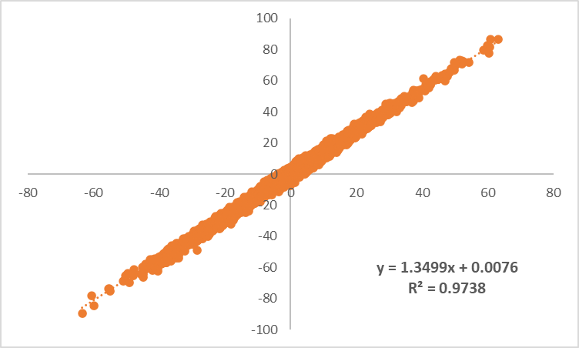
Figure S2: Correlation between % differential methylation obtained from normalized vs unnormalized RRBS results using a within-batch dataset (PH vs SC). As shown by a R² > 0.97, there was high correlation between % differential methylation obtained before and after correction.

Figure S3: PC1 individual loadings after novel tank diving test in female adult fish from the F0, F1 and F2 generations, which describes locomotor and exploratory activity. #: p<0.1. PL: Permethrin 1 µg/L; PH: Permethrin 10 µg/L; SC: Solvent Control (DMSO 0.01%).

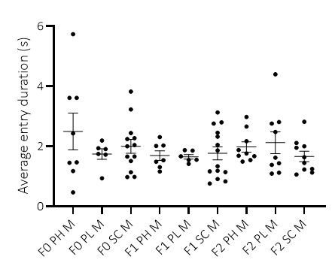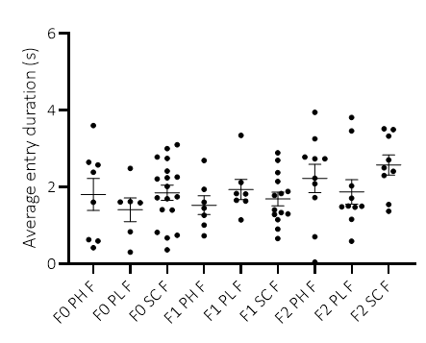
Figure S4: Average entry duration (Time spent in Top area/transitions to Top area) for males (left) and females (right) from the F0, F1, and F2 generations in the novel tank diving test. PL: Permethrin 1 µg/L; PH: Permethrin 10 µg/L; SC: Solvent Control (DMSO 0.01%).

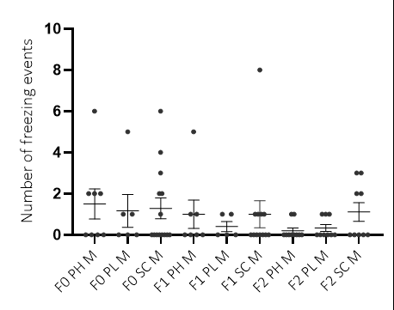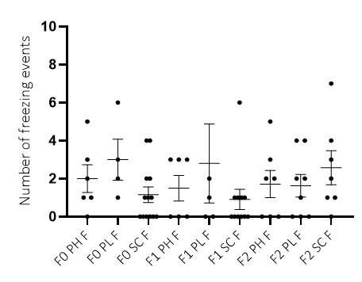
Figure S5: Number of freezing episodes shown by males (left) and females (right) from the F0, F1, and F2 generations in the novel tank diving test. PL: Permethrin 1 µg/L; PH: Permethrin 10 µg/L; SC: Solvent Control (DMSO 0.01%). Note that there was a lot of variability in this parameter even after outlier removal, which made it difficult to exploit.

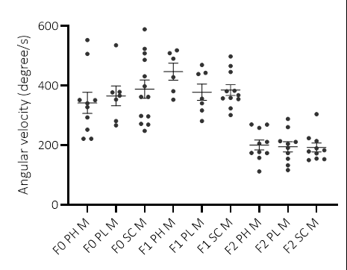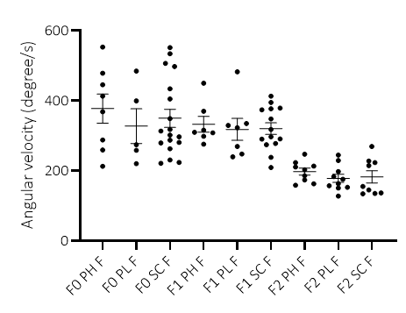
Figure S6: Angular velocity of fish males (left) and females (right) from the F0, F1, and F2 generations in the novel tank diving test, as an indirect measure of erratic movements. PL: Permethrin 1 µg/L; PH: Permethrin 10 µg/L; SC: Solvent Control (DMSO 0.01%).

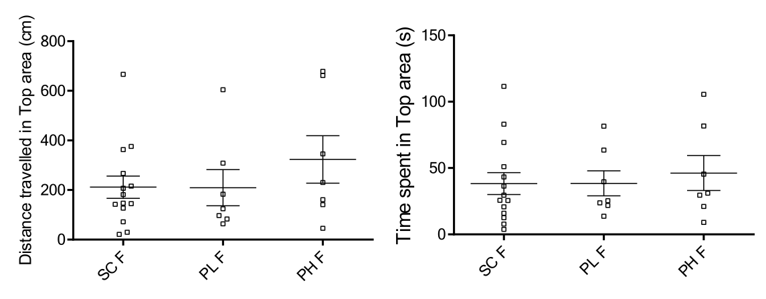
Figure S7: Distance travelled and Time spent in top area of the tank by females from the F1 generation in the novel tank diving test. PL: Permethrin 1 µg/L; PH: Permethrin 10 µg/L SC: Solvent Control (DMSO 0.01%).

Figure S8: Distance travelled and Time spent in the top area of the tank by females from the F2 generation in the novel tank diving test. PL: Permethrin 1 µg/L; PH: Permethrin 10 µg/L; SC: Solvent Control (DMSO 0.01%).

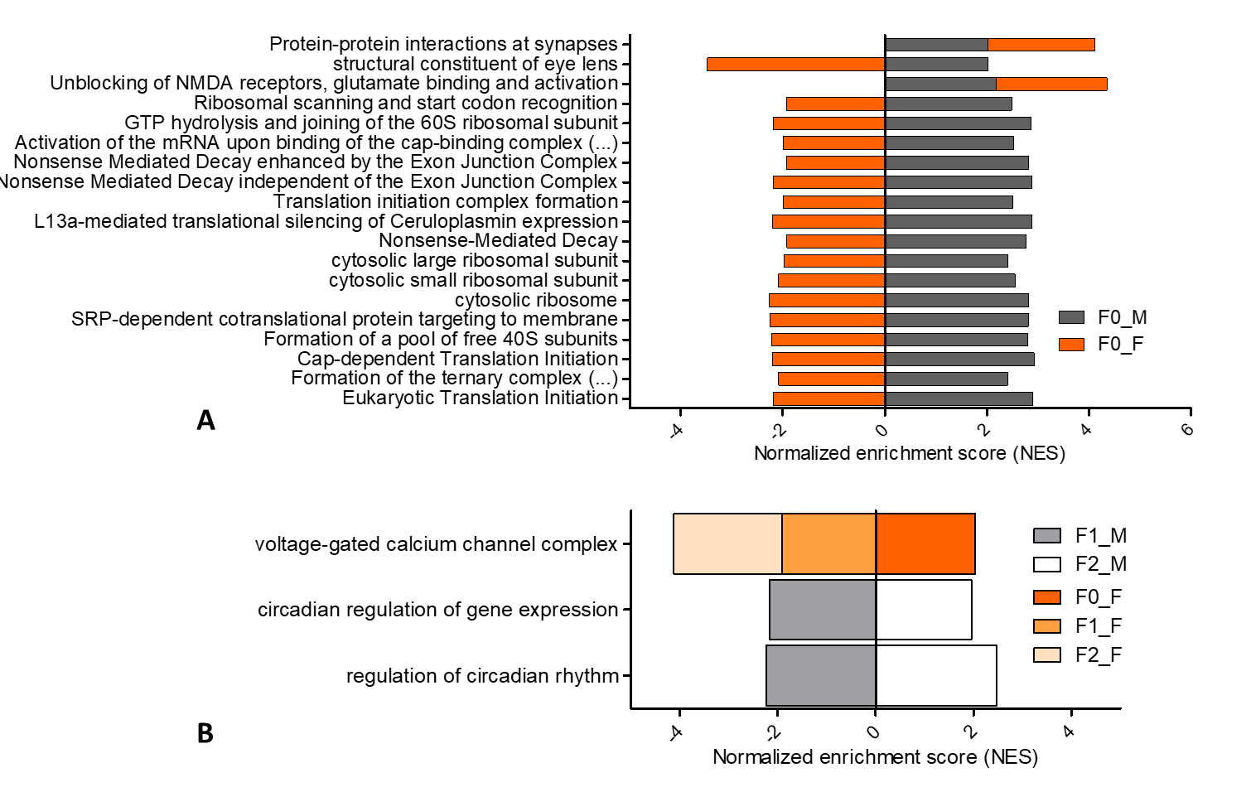
Figure S9: 19 gene sets enriched in both PH F0 male (F0_M) and female (F0_F) zebrafish brains after early life exposure to permethrin 10 µg/L. 16 relate to transcription/translation; 1 to eye development and 2 to synaptic activity. The length of the bar corresponds to the normalized enrichment score (PH/SC) given by GSEA output.

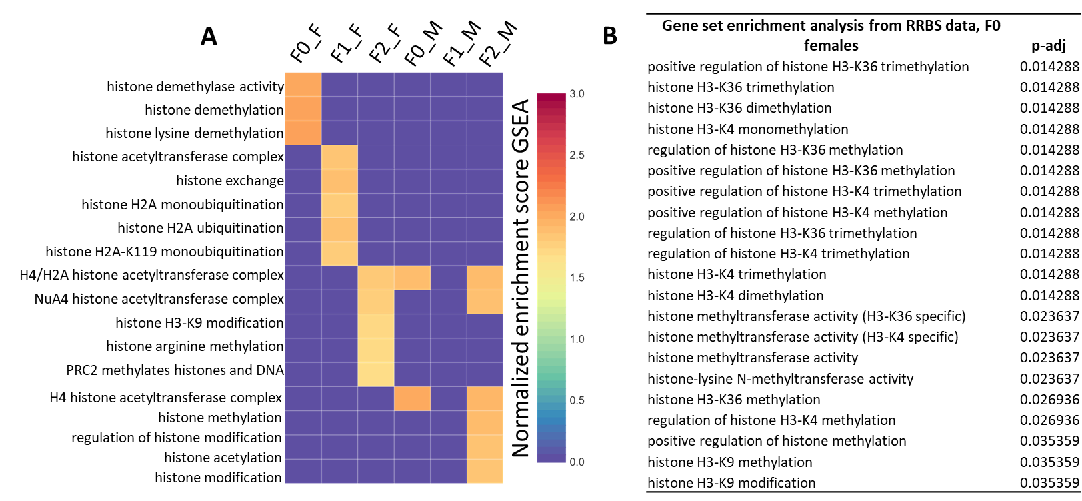
Figure S10: A. Enrichment in histone post-translational modification pathways from RNA-Seq data (padj≤0.05). Headings refer to F0 males (F0_M), F0 females (F0_F), F1 males (F1_M), F1 females (F1_F), F2 males (F2_M) and F2 females (F2_F). B. Enrichment in histone post-translational modification pathways from RRBS data in F0 females (padj≤0.05). Complete results from differential gene expression analyses and DMR identification are available in the Excel Tables S2-S7 and S9-S20.

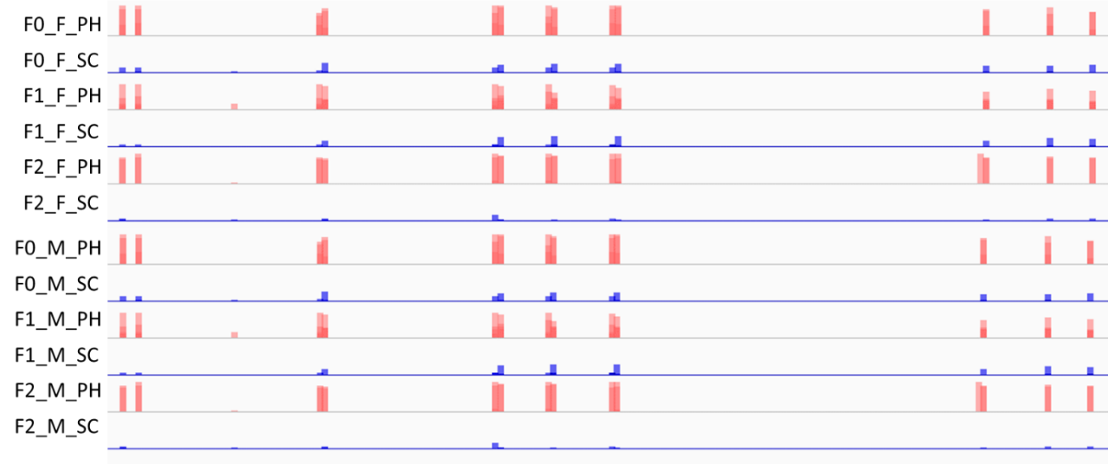
Figure S11: Methylation profile of the genomic region on chromosome 24 (32,196,220-32,196,420; +20071 bp from transcriptional start site of vim) obtained from RRBS analysis on zebrafish brain (n=4; except for treated F0 males where n=3). This region was identified as a DMR between the permethrin lineage (F0 exposure to 10 µg/L) and the control lineage (DMSO 0.01%), whatever the generation or sex. Row headings refer to F0 males (F0_M), F0 females (F0_F), F1 males (F1_M), F1 females (F1_F), F2 males (F2_M) and F2 females (F2_F) in exposed (PH) or control (SC) conditions. Numeric values are available in Excel Tables S9-S14.

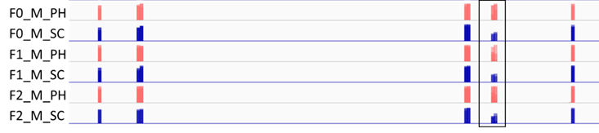
Figure S12: Methylation profile of the genomic region on chromosome 14 (13,753,501-19,753,800; -402691 bp from transcriptional start site of fmr1) obtained from RRBS analysis on zebrafish brain (n=4; except for treated F0 males where n=3). This region was identified as a DMR between the permethrin lineage (F0 exposure to 10 µg/L) and the control lineage (DMSO 0.01%) in all generations of males. Row headings refer to F0 males (F0_M), F1 males (F1_M), and F2 males (F2_M) in exposed (PH) or control (SC) conditions. Numeric values are available in Excel Tables S9, S11 and S13.

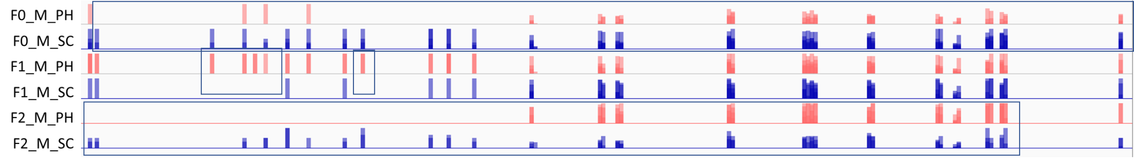
Figure S13: Methylation profile of the genomic region on chromosome 20 (34,733,401-34,733,700; located within exon 1 of pnocb) obtained from RRBS analysis on zebrafish brain. This region was identified as a DMR between the permethrin lineage (F0 exposure to 10 µg/L) and the control lineage (DMSO 0.01%) in all generations of males. As observed on the figure, and unlike most other DMRs identified in this study, methylation patterns vary over generations and the effects are the most visible in F0 and F2 generations. Row headings refer to F0 males (F0_M), F1 males (F1_M), and F2 males (F2_M) in exposed (PH) or control (SC) conditions. Numeric values are available in Excel Tables S9, S11 and S13.

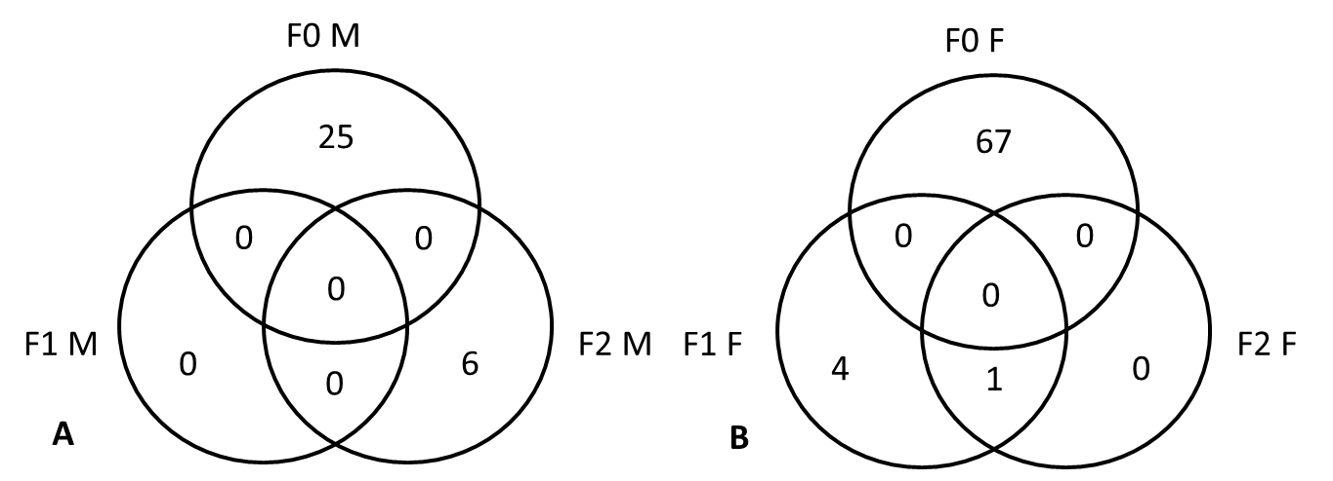
Figure S14: Pathway analysis results based on cis-regulated genes from identified differentially methylated regions (DMRs, padj≤0.05) in A. Males and B. Females. Headings refer to F0 males (F0_M), F0 females (F0_F), F1 males (F1_M), F1 females (F1_F), F2 males (F2_M) and F2 females (F2_F). Numeric values for males can be found in Excel Tables S18-S20.

References
Chen TH, Wang YH, Wu YH. Developmental exposures to ethanol or dimethylsulfoxide at low concentrations alter locomotor activity in larval zebrafish: Implications for behavioral toxicity bioassays. Aquatic Toxicology 2011; 102 (3–4): 162-166.

OECD. Test No. 236: Fish Embryo Acute Toxicity (FET) Test. OECD Guidel. Test. Chem. Sect. 2. OECD Publications, 2013.

