Global Biogeochemical Cycles
Supporting Information for
Deep Chlorophyll Maxima in the global ocean: occurrences, drivers and characteristics

M. Cornec¹, H. Claustre¹, A. Mignot², L. Guidi¹, L. Lacour³, A. Poteau¹, F. D’Ortenzio¹, B. Gentili¹, C. Schmechtig¹

¹ CNRS & Sorbonne Université, Laboratoire d'Océanographie de Villefranche, LOV, Villefranche‐sur‐Mer, France
² Mercator Océan International, Ramonville-Saint-Agne, France
³ Takuvik Joint International Laboratory, Laval University (Canada) - CNRS (France), Département de biologie et Québec-Océan, Université Laval, Québec, Canada

Contents of this file

Texts S1 to S10
Figures S1 to S25
Tables S1 to S7

Introduction
This supporting information:
- Presents the cloud-cover coefficients per month and per band of 10° latitude used to correct the model-estimated PAR profiles (Table S1);
- informs on the sensitivity of the two methods used for DAM and DBM detection as a function of the measurement of vertical resolution of [Chla] and b_{bp} (Text S1, Figures S1 – S5);
- details how the global bio-optical relationship between [Chla] and K_{d}(490) was regionally optimized to retrieve the PAR on floats for which no in situ PAR was measured. (Text S2, and Figures S6 and S7);
- explains the choice of the methods used for detection of nitracline depth and nitracline steepness (Text S3 and Figures S8 and S9);
- shows the relationship between the Brünt-Vaisala frequency and the nitracline steepness at the nitracline depth for DCM profiles (Figure S10);
- Shows the repartition of the profiles in 28 regions of the global ocean, defines the acronyms of the 28 regions, the criteria used for their delineation (both geographical and hydrological), and the characteristics of the BGC floats in each region (Text S4, Tables S2 - S4, and Figure S11);
- shows the different groups of regions resulting from a K-mean clustering method on DCM properties as a function of the a priori number of groups (Figure S12);
- explains how the density grids were calculated for Figures 6 and 10 and S10 (Text S5);
- shows and comments the relationship between b_{bp} and [Chla] at the DCM depth for the DAM and DBM profiles respectively (Text S6 and Figure S13);
- shows and comments the relationship between the DCM depth and the [Chla]_{sat} (Text S7 and Figure S14);
- presents the dispersion values of the DCM depth and [Chla] and b_{bp} at the DCM depth per 10°-latitudinal bands (Table S5);
- presents the dispersion values of the DCM descriptors (DCM depth and intensity, occurrence of DCM and DBM profiles) and environmental parameters (daily PAR at the nitracline depth, mean daily PAR in the Mixed Layer, nitracline steepness, and difference between the DCM depth and the nitracline) for the four groups of regions (Table S6);
- details the selection of regions and floats representative of Deep photoAcclimation Zone and Deep Biomass Zone groups for developing monthly climatological time series of DCMs (Text S8 and Figures S15 and S16);
- presents the dispersion values of the DCM, iPAR₂₀, and nitracline depths per month for the selected floats within the NASTG and ASEW regions (Table S7);
- presents the seasonal vertical distribution of the [Chla] and b_{bp} normalized by the DCM depth for the Atlantic SubEquatorial Waters and the North SubTropical Gyre regions (Text S9 and Figure S17);
- shows the stratification-period duration and the seasonal MLD amplitude per 10° latitude-bands (Figure S18);
- shows the percentage of each region’s contribution to 10°-latitude bands (Figure S19);
- details the Western Basin of the Mediterranean Sea and Baffin Bay special DCM features (Text S10);
- provides detailed information on DCM descriptors (occurrence, depth and magnitude) and environmental metrics (iPAR_{Ncline,} [Chla]_{sat}, m_{Nit}, relative position of the DCM with respect to nitracline depth) for each region (Figure S20 - S23);
- shows the seasonality of m_{Nit} in the North Atlantic SubTropical Gyre (Figure S24);
- shows the seasonality of DCM depth and of the MLD in the Atlantic SubEquatorial Waters and in the North Atlantic SubTropical Gyre (Figure S25).

Table S1. Table of the cloud coefficients factors applied over 10° latitude bands (rows) and per month (columns).

 | 1 | 2 | 3 | 4 | 5 | 6 | 7 | 8 | 9 | 10 | 11 | 12
-70° | 0.27 | 0.37 | 0.21 | 0.43 | 0.26 | 0.47 | 0.35 | 0.39 | 0.24 | 0.41 | 0.28 | 0.37
-60° | 0.41 | 0.42 | 0.35 | 0.44 | 0.37 | 0.45 | 0.41 | 0.42 | 0.38 | 0.45 | 0.4 | 0.45
-50° | 0.54 | 0.47 | 0.48 | 0.44 | 0.48 | 0.43 | 0.47 | 0.45 | 0.51 | 0.49 | 0.52 | 0.53
-40° | 0.63 | 0.57 | 0.6 | 0.49 | 0.49 | 0.61 | 0.4 | 0.49 | 0.58 | 0.57 | 0.61 | 0.66
-30° | 0.74 | 0.78 | 0.6 | 0.71 | 0.65 | 0.57 | 0.48 | 0.48 | 0.63 | 0.69 | 0.74 | 0.56
-20° | 0.87 | 0.88 | 0.89 | 0.83 | 0.84 | 0.86 | 0.83 | 0.88 | 0.91 | 0.86 | 0.85 | 0.86
-10° | 0.8 | 0.96 | 1.07 | 0.87 | 0.82 | 0.7 | 0.86 | 0.67 | 0.67 | 0.97 | 0.96 | 0.99
0° | 0.77 | 0.87 | 0.94 | 0.85 | 0.83 | 0.73 | 0.79 | 0.64 | 0.67 | 0.86 | 0.83 | 0.86
10° | 0.74 | 0.79 | 0.82 | 0.83 | 0.84 | 0.76 | 0.73 | 0.6 | 0.67 | 0.76 | 0.7 | 0.72
20° | 0.83 | 0.81 | 0.81 | 0.97 | 0.82 | 0.84 | 0.87 | 0.8 | 0.83 | 0.78 | 0.81 | 0.81
30° | 0.75 | 0.8 | 0.84 | 0.86 | 0.83 | 0.87 | 0.81 | 0.82 | 0.85 | 0.8 | 0.77 | 0.75
40° | 0.62 | 0.67 | 0.72 | 0.75 | 0.8 | 0.82 | 0.8 | 0.77 | 0.7 | 0.69 | 0.64 | 0.66
50° | 0.36 | 0.44 | 0.36 | 0.5 | 0.46 | 0.43 | 0.44 | 0.48 | 0.33 | 0.37 | 0.45 | 0.38
60° | 0.43 | 0.4 | 0.42 | 0.45 | 0.49 | 0.4 | 0.41 | 0.41 | 0.41 | 0.39 | 0.46 | 0.43
70° | 0.5 | 0.52 | 0.57 | 0.42 | 0.47 | 0.39 | 0.54 | 0.39 | 0.41 | 0.44 | 0.63 | 0.48

Table S2. Abbreviations used for regions.
ABBREVIATION | REGION
BAFF | Baffin Bay
ARCT | Arctic waters
NASPG | North Atlantic Subpolar Gyre
NPSPG | North Atlantic Subpolar Gyre
NAC | North Atlantic Current
NS | Northern Seas (Greenland, Barents and Norway seas)
NASTG | North Atlantic Subtropical Gyre
NPSTG | North Pacific Subtropical Gyre
KURIO | Kuroshio current
ASEW | Atlantic Subequatorial Waters
PSEW | Pacific Subequatorial Waters
SPSTG | South Pacific Subtropical Gyre
SASTG | South Atlantic Subtropical Gyre
SISTG | South Indian Subtropical Gyre
IEQ | Indian Equatorial waters
IOMZ | Indian Oxygen Minimum Zones (Arabian Sea and Bengal Bay)
AUSW | Australian waters
ARCH | Archipelagos waters
MOONS | Monsoon zone
SCS | South China Sea
WMS & EMS | Western & Eastern Mediterranean Sea
BKS | Black Sea
RDS | Red Sea
STZ | Subtropical Zone (in Southern Ocean)
SAZ | Subantarctic Zone
PFZ | Polar Frontal Zone (in Southern Ocean)
ASZ_SIZ | Antarctic Southern Zone and Seasonal Ice
Table S3. Geographic or hydrologic delineation of open-ocean regions.
REGION | LIM_1 | LIM_2
BAFF₁ | 65 < Lat < 70 | -50 < Lon < -72
BAFF₂ | 70 < Lat < 80 | -80 < Lon < -50
NAPSG | 50 < Lat < 65 | -65 < Lon < -12.5
NPSPG | 45 < Lat | Lon < -100
NS | 60 < Lat < 80 | -12.5 < Lon < 20
NASTG | 17.5 < Lat < 32.5 | -75 < Lon < -20
NAC | T₁₀₀ > 8°C | T₁₀₀ < 17.5°C
ARCT | T₁₀₀ < 3°C
NPSTG | 17.5 < Lat < 32.5 | -175 < Lon < -140
KURIO | T₁₀₀ > 7.5°C | T₁₀₀ < 15°C
ASEW | 0 < Lat < 17.5 | -35 < Lon < -10
PSEW | 0 < Lat < 17.5 | -140 < Lon < -100
SPSTG | -30 < Lat < -14 | -180 < Lon < -90
SASTG | -30 < Lat < -15 | -45 < Lon < 0
SISTG | -30 < Lat < -15 | 50 < Lon < 110
IEQ | -5 < Lat < 7.5 | 40 < Lon < 100
MOONS | -15 < Lat < -5 | 50 < Lon < 110
IOMZ | 7.5 < Lat < 24 | 43 < Lon < 100
WMS₁ | 35 < Lat < 43 | -5 < Lon < 6
WMS₂ | 35 < Lat < 45 | 5 < Lon < 16
EMS₁ | 30 < Lat < 45 | 16 < Lon < 22.5
EMS₂ | 30 < Lat < 40 | 22.5 < Lon < 35
EMS₃ | 41 < Lat < 46 | 12 < Lon < 15.5
EMS₄ | 30 < Lat < 37.5 | 10 < Lon < 10.5
BKS | 40.98 < Lat < 47.35 | 26.67 < Lon < 42.5
RDS | 10.78 < Lat < 30.86 | 32.78 < Lon < 42.4
AUSW | -30 < Lat < -7 | 110 < Lon < 160
SCS | 0 < Lat < 24 | 100 < Lon < 120
ARCH | -30 < Lat < -5 | 142 < Lon < 180
STZ | Lat < -30 | T₁₀₀ > 11°C
SAZ | T₁₀₀ < 11°C | T₄₀₀ > 5°C
PFZ | T₄₀₀ < 5°C | min(T_{0_200}) > 2°C
ASZ_SIZ | min(T_{0_200}) < 2°C

Table S4. Number of floats, profiles, and first/last profiles, dates per region.
ABBREVIATION | Nb. floats | Nb. profiles |  | Date first | Date last
BAFF | 16 | 1319 | 09/07/2016 |  | 25/06/2019
ARCT | 10 | 695 | 12/04/2011 |  | 15/12/2019
NASPG | 48 | 4995 | 18/04.2013 |  | 20/05/2019
NPSPG | 7 | 1122 | 18/06/2010 |  | 29/12/2019
NAC | 37 | 2046 | 18/04/2013 |  | 24/12/2019
NS | 16 | 1791 | 30/05/2010 |  | 31/12/2019
NASTG | 20 | 1626 | 24/10/2012 |  | 30/12/2019
NPSTG | 12 | 1531 | 20/05/2013 |  | 31/12/2019
KURIO | 3 | 123 | 03/09/2018 |  | 11/08/2019
ASEW | 7 | 920 | 10/10/2014 |  | 30/12/2019
PSEW | 3 | 297 | 27/03/2012 |  | 31/12/2019
SPSTG | 8 | 1163 | 21/03/2015 |  | 30/12/2019
SASTG | 14 | 1570 | 08/11/2012 |  | 31/12/2019
SISTG | 6 | 1571 | 31/08/2012 |  | 28/03/2017
IEQ | 14 | 1737 | 20/01/2013 |  | 30/12/2019
IOMZ | 39 | 4588 | 17/12/2011 |  | 31/12/2019
AUSW | 1 | 233 | 08/08/2017 |  | 04/11/2018
ARCH | 6 | 294 | 03/03/2015 |  | 21/10/2019
MOONS | 4 | 220 | 17/07/2016 |  | 31/12/2019
SCS | 3 | 572 | 27/06/2014 |  | 14/07/19
WMS | 35 | 3264 | 25/11/2012 |  | 30/12/2019
EMS | 28 | 4095 | 16/05/2013 |  | 31/12/2019
BKS | 5 | 985 | 16/12/2013 |  | 31/12/2019
RDS | 2 | 235 | 30/09/2015 |  | 19/02/2017
STZ | 71 | 5219 | 09/01/2011 |  | 31/12/2019
SAZ | 71 | 4244 | 13/09/2011 |  | 30/12/2019
PFZ | 82 | 4567 | 30/09/2011 |  | 31/12/2019
ASZ_SIZ | 130 | 8699 | 04/02/2012 |  | 31/12/2019

Text S1. Method for detecting DCM profiles adapted to low-resolution vertical profiles.

Two methods were tested.
Method 1 is primarily adapted to high-vertical-resolution measurements (i.e. resolution on average better than 3 m in the first 250 meters). The detection capacity of this method was tested for lower resolutions by gradually degrading the vertical resolution of high-resolution profiles (Fig. S1) by 0.5-meter increments until the vertical resolution of low-resolution profiles (i.e. on average 10 m in the first 250 meters) was reached. Identification of DCMs was then tested for each degraded resolution, and compared to that of high-resolution profiles through a confusion matrix: True Positives (TP, i.e. the percentage of correctly identified DCM profiles), True Negatives (TN, i.e. the percentage of correctly identified NO profiles), False Positives (FP, i.e. the percentage of NO profiles identified as DCM profiles), and False Negatives (FN, i.e. the percentage of DCM profiles identified as NO profiles). Method 1 tends to fail to detect DCMs as the vertical resolution decreases (~18 % FN for a vertical resolution of 10 m, Fig. S3 a).
Method 2 was developed to circumvent this flaw: the steps are similar to those of Method 1 (see Section 2.4), but without the initial step of smoothing the [Chla] and bbp profiles. Compared to method 1 (Fig. S2), method 2 presents an acceptable performance, despite the fact that it tends to detect non-existent DCMs (~5% of the profiles, Fig. S3 b). Indeed, with degraded resolution, method 2 performs better than method 1, for resolution higher than 3 meters (Fig. S4). The accuracy of method 2 in DCM-depth estimation was also tested. With respect to method 1, method 2 presents a maximum error range of 11 ± 25 m for 10-meter vertical-resolution profiles (Fig. S5). We therefore chose to use method 1 for profiles with a mean vertical resolution higher than 3 m in the first 250 meters, and method 2 for all others.

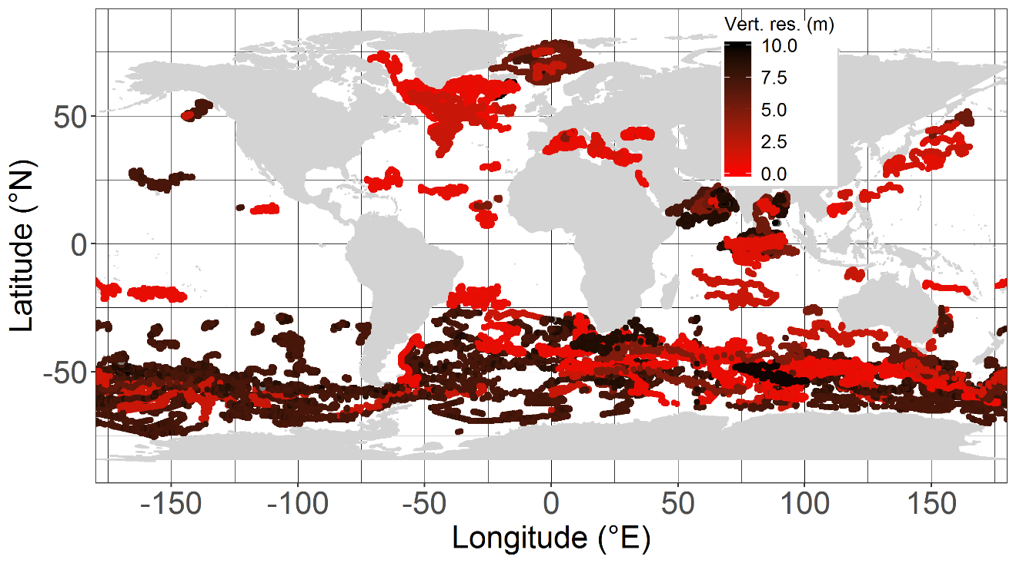
Figure S1. Map of mean vertical-resolution measurement of [Chla] and b_{bp} between 0 and 300 m.

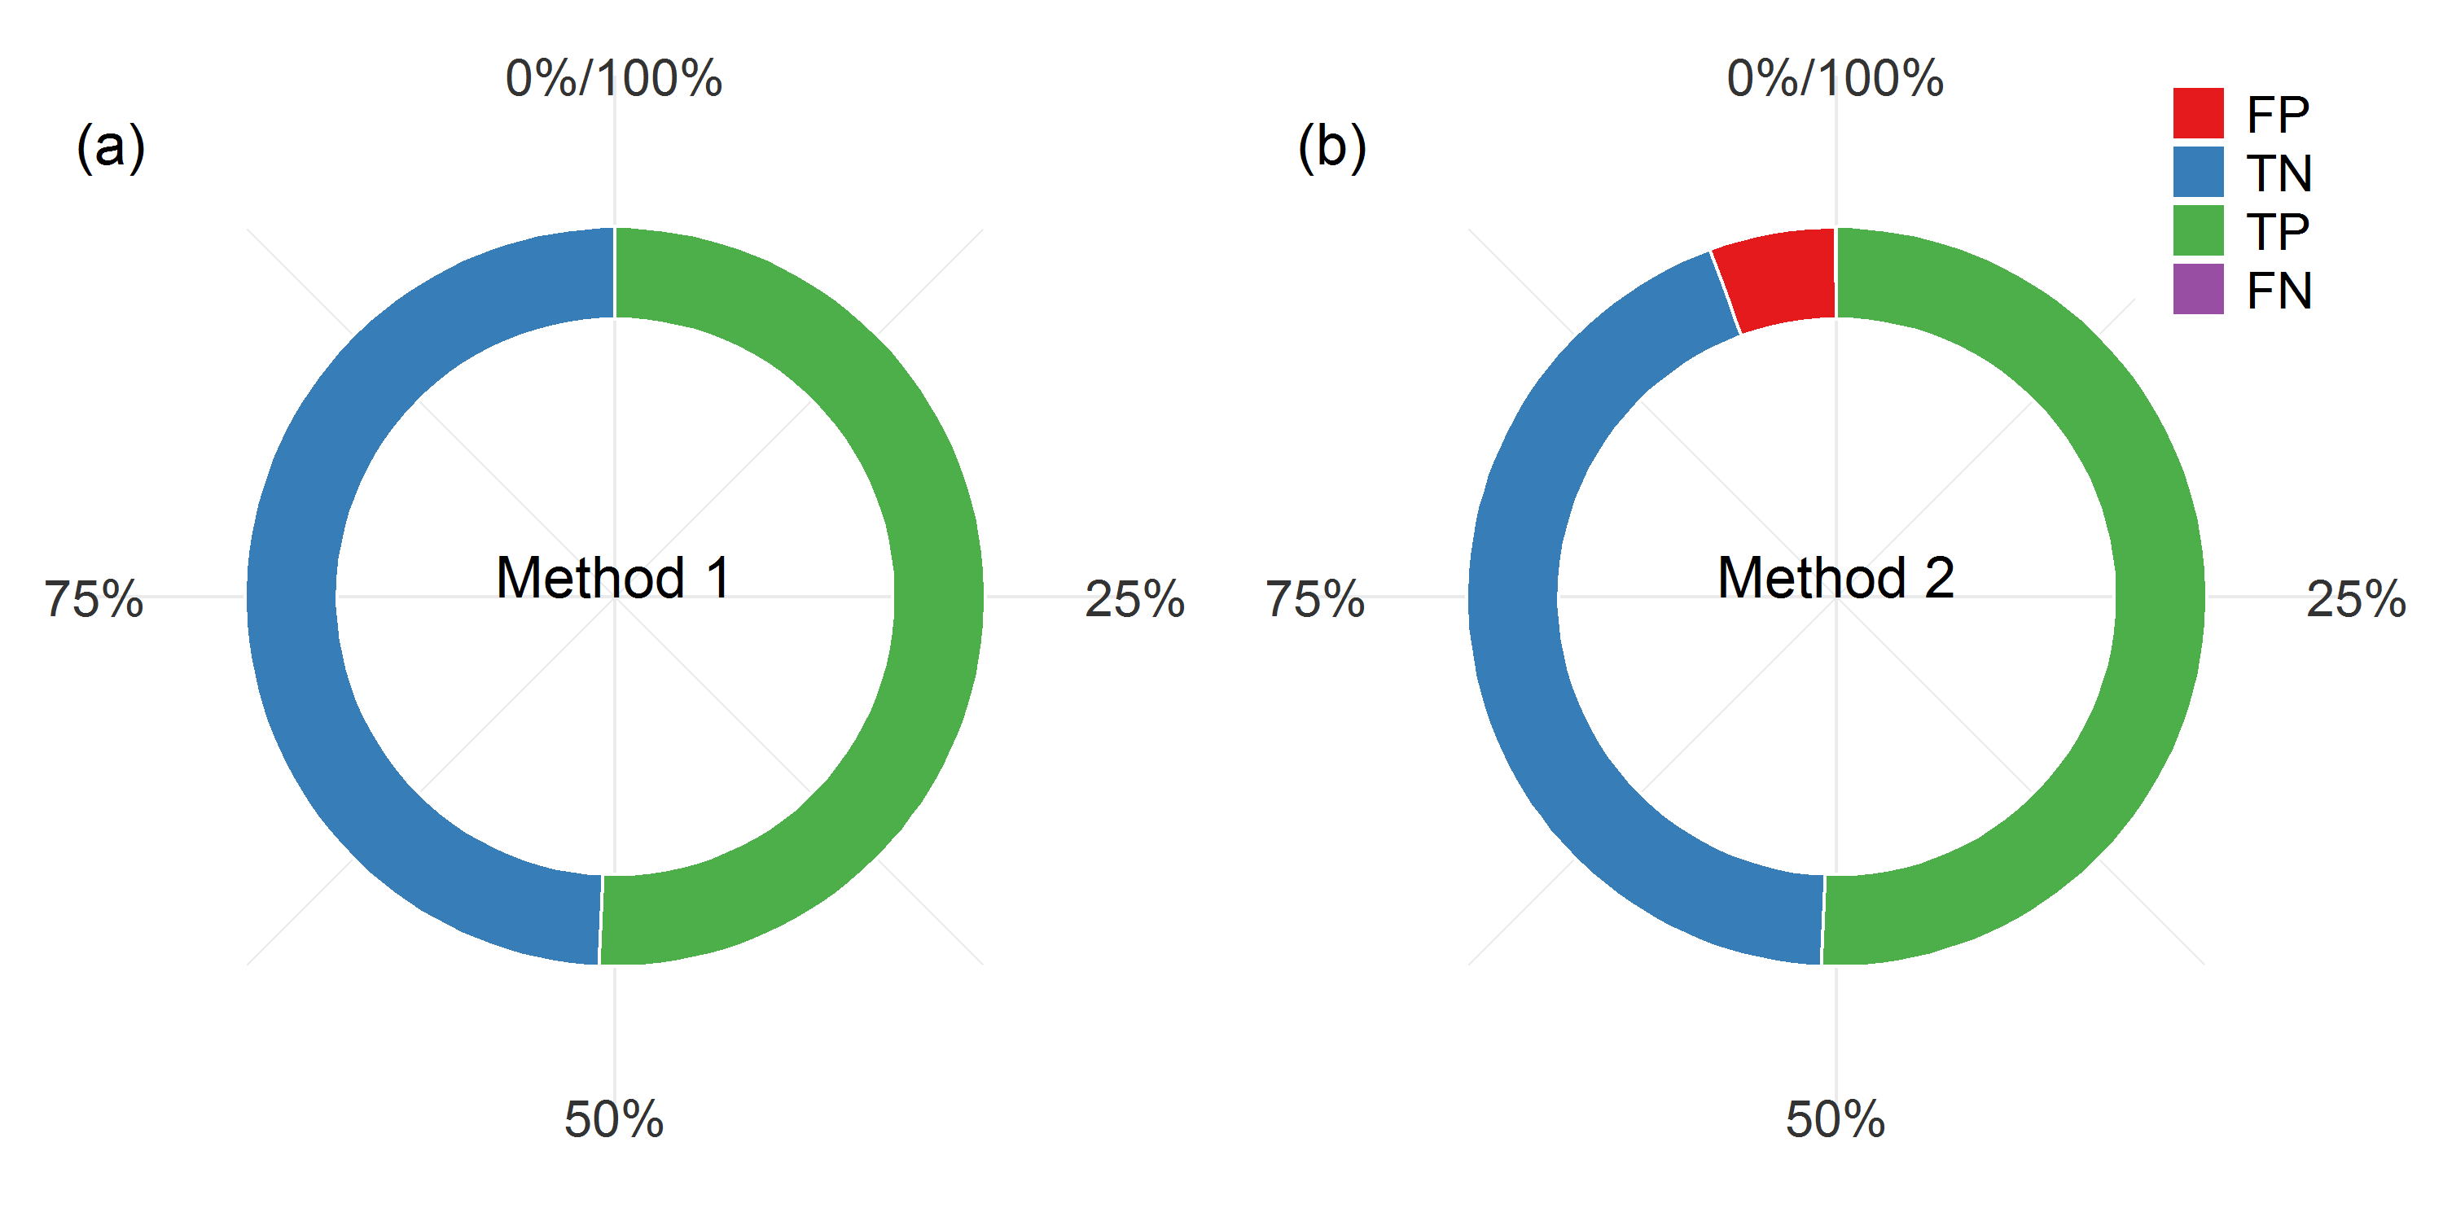
Figure S2. Confusion matrix for DCM identification on high-resolution profiles using the two methods ((a) and (b)), with method 1 as the reference detection method.

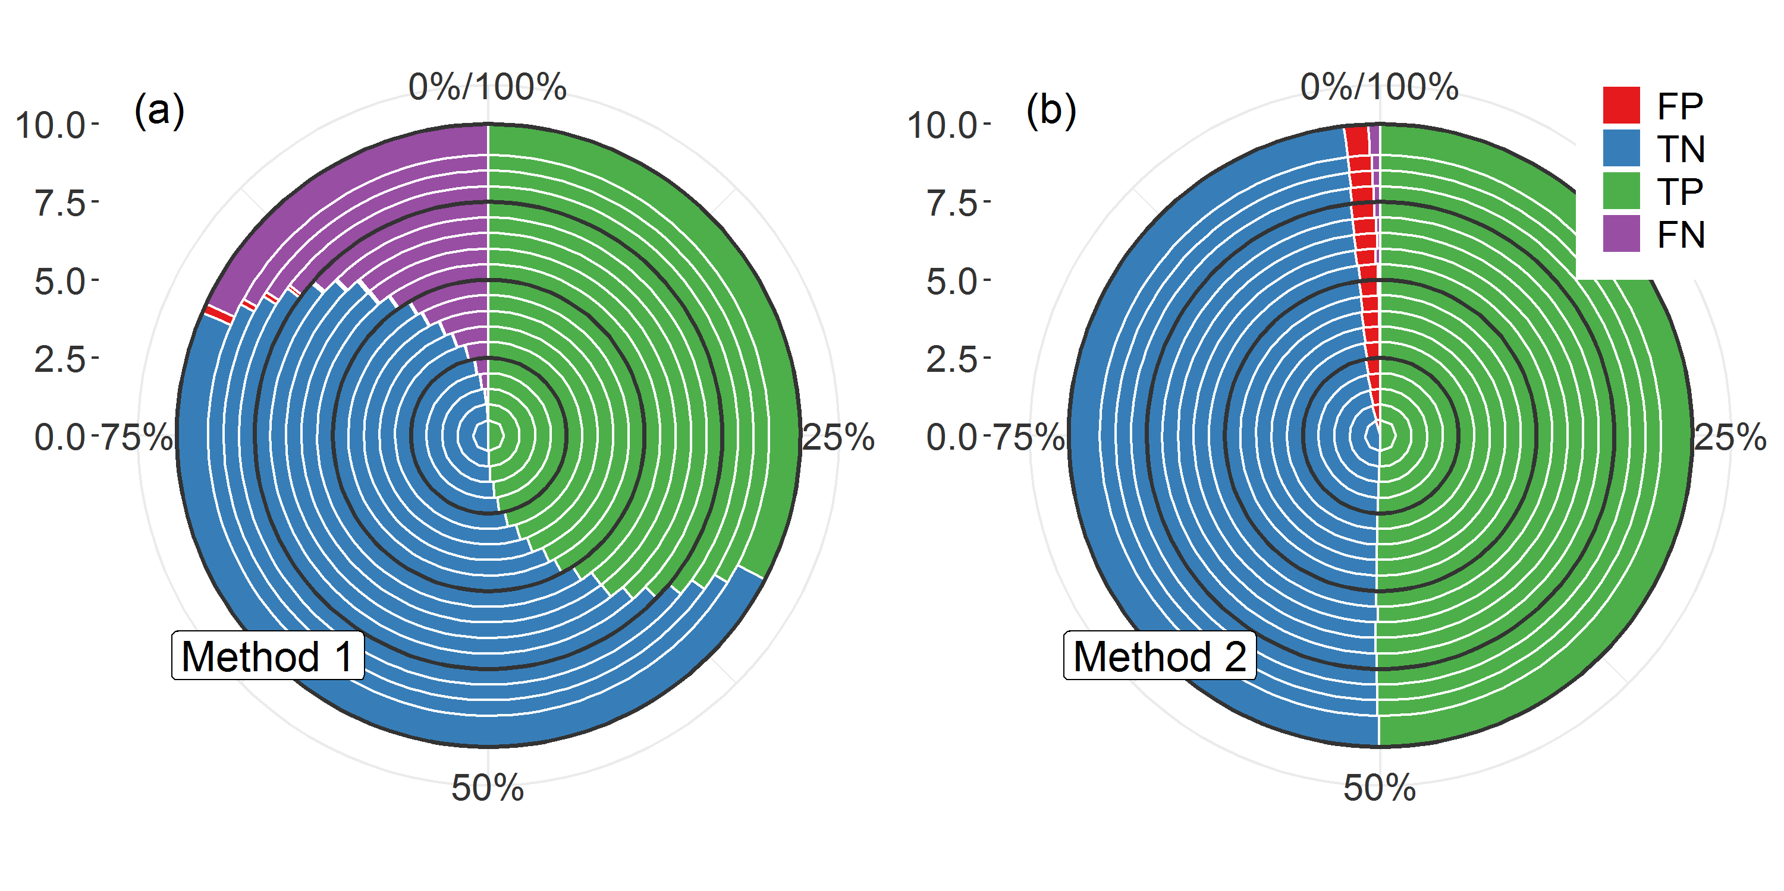

Figure S3. Confusion matrix for DCM identification on high-resolution profiles using the two methods ((a) and (b)) as a function of profile vertical resolution, using method 1 for high-resolution profiles as the reference detection method (see Fig. S3 a).
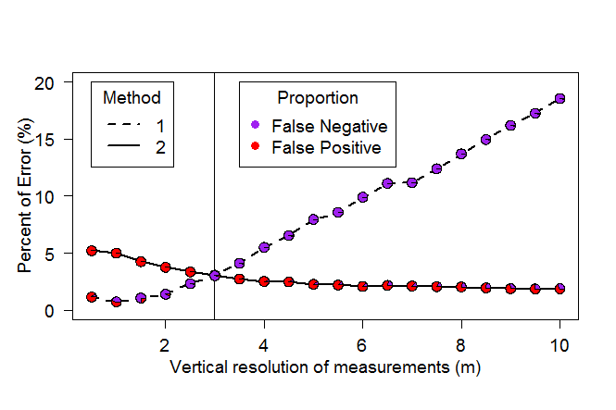
Figure S4. Percentages and qualitative proportions of error (i.e. percentages of False Positives and False Negatives) in the detection of DCM profiles for methods 1 and 2 as a function of vertical resolution, using method 1 for high-resolution profiles as the reference detection method (see Fig. S3(a)). The vertical line represents 3-meter resolution.

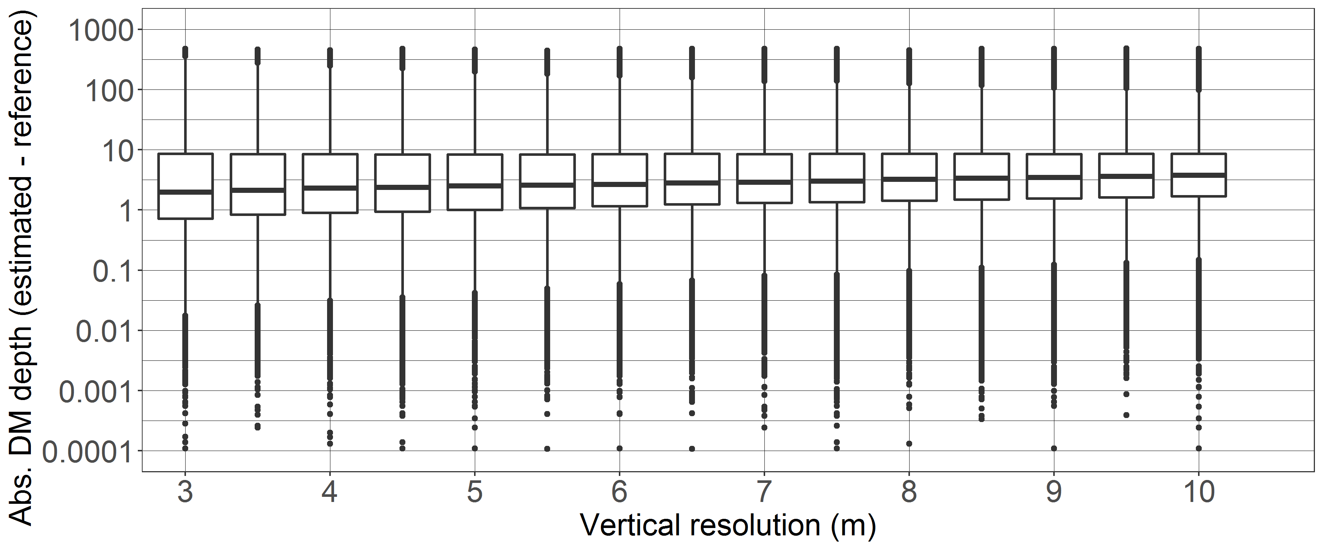

Figure S5. Quartile diagrams of error in DCM-depth detection (i.e. absolute difference between the DCM depths detected by methods 1 and 2 as a function of vertical resolution, using method 1 for high-resolution profiles as a reference.

Text S2. Estimation of PAR profiles

To estimate PAR profiles from [Chla] when potential variations in the [Chla] measured by the float though fluorescence with respect to true [Chla] are known (Roesler et al., 2017), we reassessed, at a regional scale, the global relationship linking the diffuse attenuation coefficient at 490 nm, K_{d}(490) to [Chla] (Morel & Maritorena, 2001). We used the dataset from the 176 floats equipped with PAR, E_{d}(490) and [Chla] sensors (Fig. S6). For each float time series and solely for the profiles with a DCM, we computed, at around noon, the mean vertical profiles at one-meter resolution (each individual profile being interpolated) for E_{d}(490), PAR and [Chla]. We then derived the mean K_{d}(490) profile from the E_{d}(490) profile, and retrieved K_{bio} (m⁻¹), the contribution of all organic components to the attenuation (Morel & Maritorena, 2001), via:

$$K_{bio}\left(490\right)=K_{d}\left(490\right)-K_{w}\left(490\right)$$

where K_{w}(490) is the pure seawater diffuse attenuation coefficient (equal to 0.0166, Morel et al., 2007b). A power-law relationship linking K_{bio}(490) to [Chla] was subsequently calculated (Morel, 1988) for each float:
$K_{bio}\left(490\right)=a{[Chla]}^{b}$
This calculation was restricted to a profile segment corresponding to depths between 10 % and 1 ‰ of the surface mean PAR value. This range allows the removal of variability in the upper layer, due both to variability in K_{bio} (e.g. wave focusing), and in [Chla] (e.g. variability in the NPQ correction), and to the increasing contribution of non-algal particles in the lower part of the profile. Finally, we computed the mean coefficients A and B for the floats for which the relationship had a R² higher than 0.5 and which belonged to the same group (i.e. SHAZ, DAZ, DBZ, and GHOZ; see Section 3.1.4; and for the specific regions Black Sea, Baffin Bay, Red Sea, and the Eastern Basin of the Mediterranean Sea, Fig. S7). Those zonal coefficients allowed re-estimation of K_{bio}(490) from the [Chla] profiles for the global database. K_{d}(490) was further back-retrieved from K_{bio}(490), and then converted to K_{d}(PAR) using the relation from Morel et al. (2007b):

$$K_{d}\left(PAR\right)=0.0665+0.874K_{d}\left(490\right)-0.00121{\left[K_{d}\left(490\right)\right]}^{-1}$$

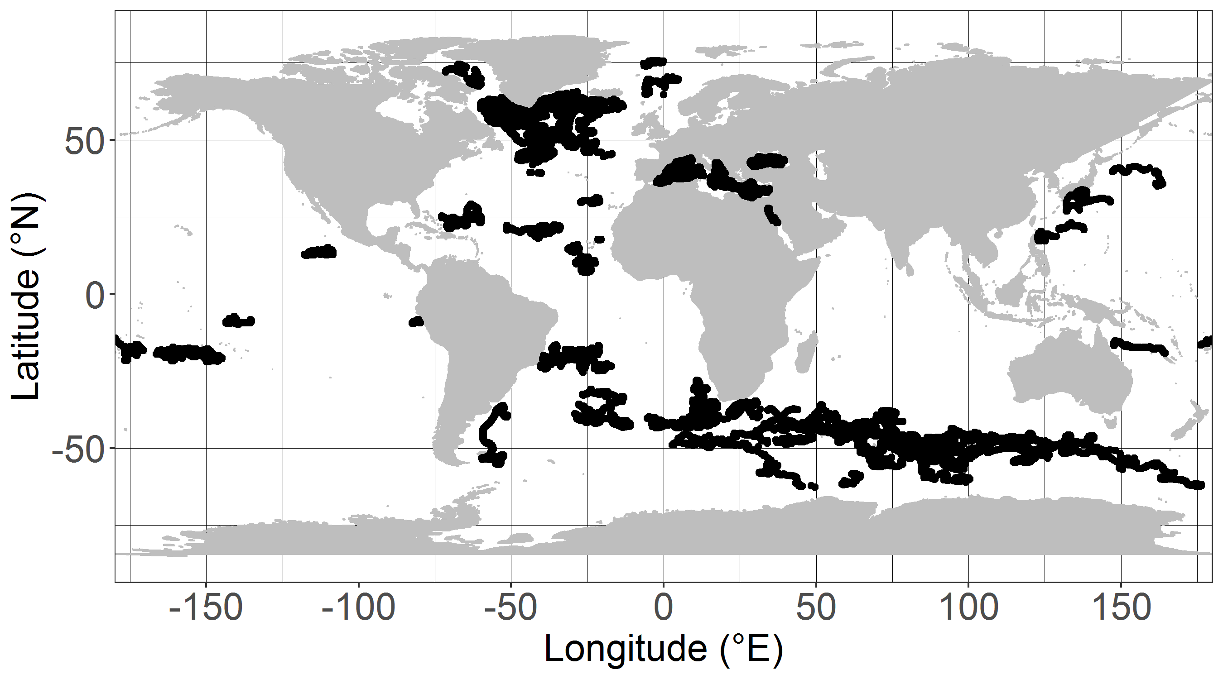

Figure S6. Map of locations of BGC-Argo profiles where PAR and downwelling irradiance at 490 nm are measured.

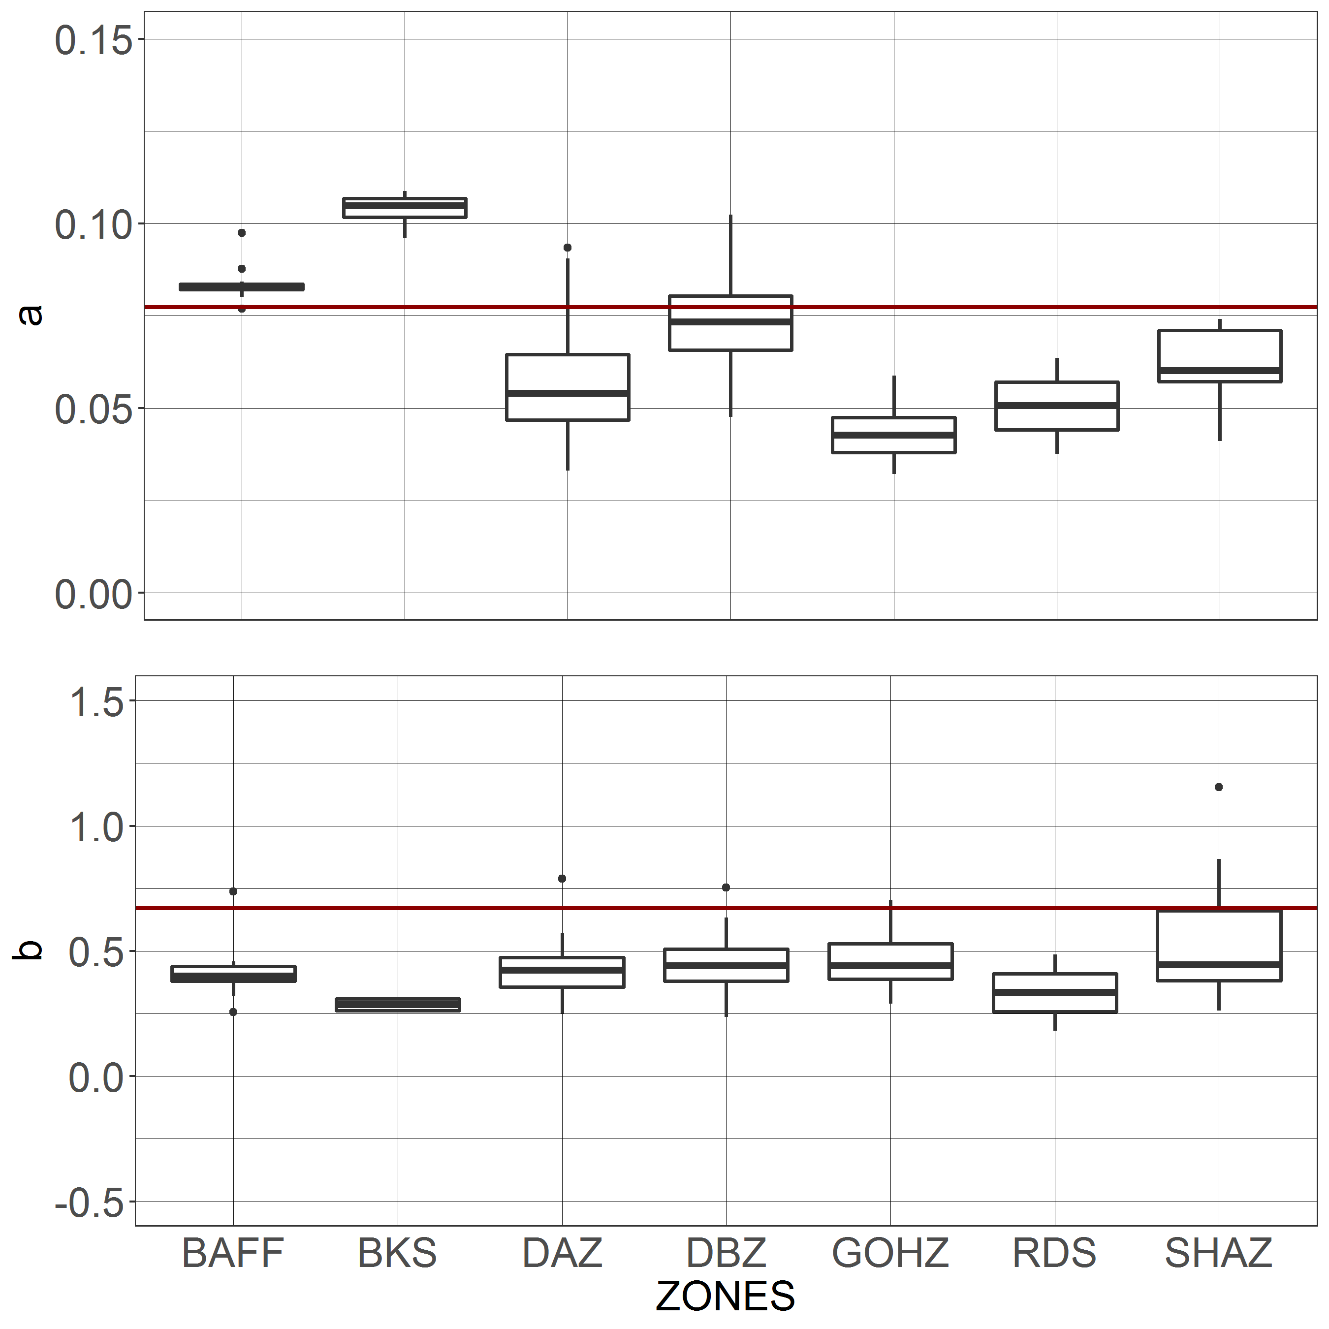
Figure S7. Quartile diagrams of the coefficients a and b of the power-law relation of K_{bio} as a function of [Chla] per group of regions. The continuous red line represents the value of the coefficients for the parametrization of Morel et al. (2007b) (a = 0.0773 & b = 0.6715) established from a global dataset (N= 1166).
Text S3. Methods for estimating the nitracline and its steepness

The nitracline is usually determined to delineate an upper layer depleted in nitrate from a deeper, repleted layer. The transition zone can either be rapid and abrupt or rather gradual, leading to the constitution of an extended transition layer at depth (see Omand & Mahadevan, 2015). The purpose here is to refer to the nitracline at a single depth metric and applicable to our global dataset. Four methods to estimate the nitracline depth were tested (Fig. S8) on selected vertical profiles representative of the 28 regions of this study: (1) the first depth at which the nitrate concentration reaches 1 µmol NO3 m⁻³ (Lavigne et al., 2015); (2) the first depth at which nitrate value is 1 µmol NO3 m⁻³ greater than the surface value (derived from the first method, but based on the relative values of the vertical profile; the surface value being defined as the mean of the nitrate values in the 10 first meters); (3) the depth at which the nitrate gradient with depth is the highest; (4) the depth at which the density gradient is the highest as a function of the density (as the nitrate-density relationship often appears to be more robust than the nitrate-depth one, Redfield, 1944; McGillicuddy et al., 1998). It appeared that the gradient-based methods (both nitrate and density) were too sensitive to the vertical-profile resolution, detecting very localized gradients, sometimes outside of the nitracline layer. The method based on the depth of 1 µmol NO3 m⁻³ obviously failed in HNLC waters (e.g. Southern Ocean), and furthermore, this threshold is close to the accuracy of nitrate-concentration retrieval by the CANYON-B method. We thus retained the method of a threshold of 1 µmol NO3 m⁻³ difference with reference to the surface (2), which gives a reliable estimation of the top of the nitracline independently from the absolute value of the nitrate-profile concentrations.

To estimate the nitracline steepness, a regression between nitrate concentration and depth was performed over three different layers: the nitracline depth and 1.1, 1.25, and 1.5 times the nitracline depth (Fig. S9). The 1.25 criterion was retained in this study because it offers a more accurate reflection of the slope of the nitrate profile below the nitracline depth. The results for the larger layer (1.5 criterion) tend to take into account nitrate outside the nitracline layer (Fig. S9 a), while more restricted layers (1.1 criterion) often do not take into account enough data to reflect the nitracline slope (Fig. S9 b).

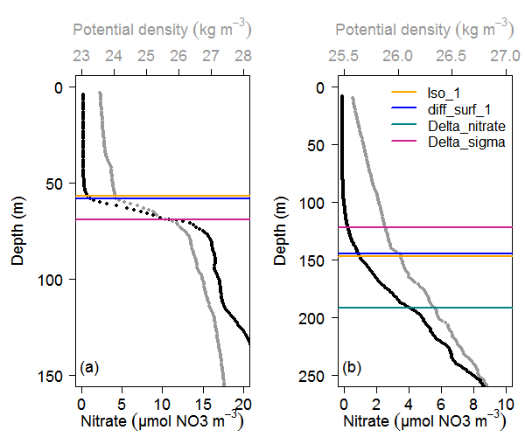

Figure S8. Example of nitracline depth estimation using four different methods (a) in the ASEW and (b) the NASTG. Method 1 (yellow): depth of 1 µmol L⁻¹; method 2 (blue): depth at which nitrate is 1 µmol L⁻¹ greater than the surface value; method 3 (green): depth at which the nitrate gradient with depth is the highest; method 4 (pink): depth at which the density gradient with density is the highest.

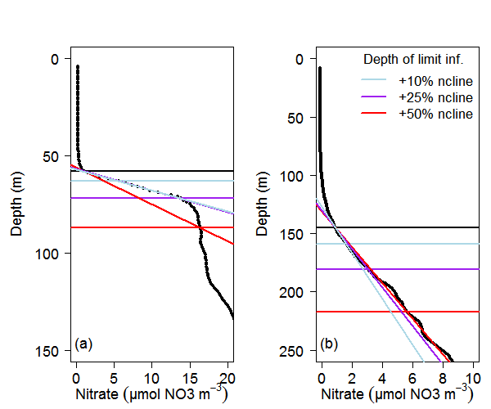
Figure S9. Example of nitracline steepness estimation using three different methods (a) in the ASEW and (b) the NASTG. The estimation is based on the slope of the nitrate vs depth regression over a layer between the nitracline depth (black line) and 1.1 times the nitracline depth (blue line), 1.25 times the nitracline depth (purple line), and 1.5 times the nitracline depth.
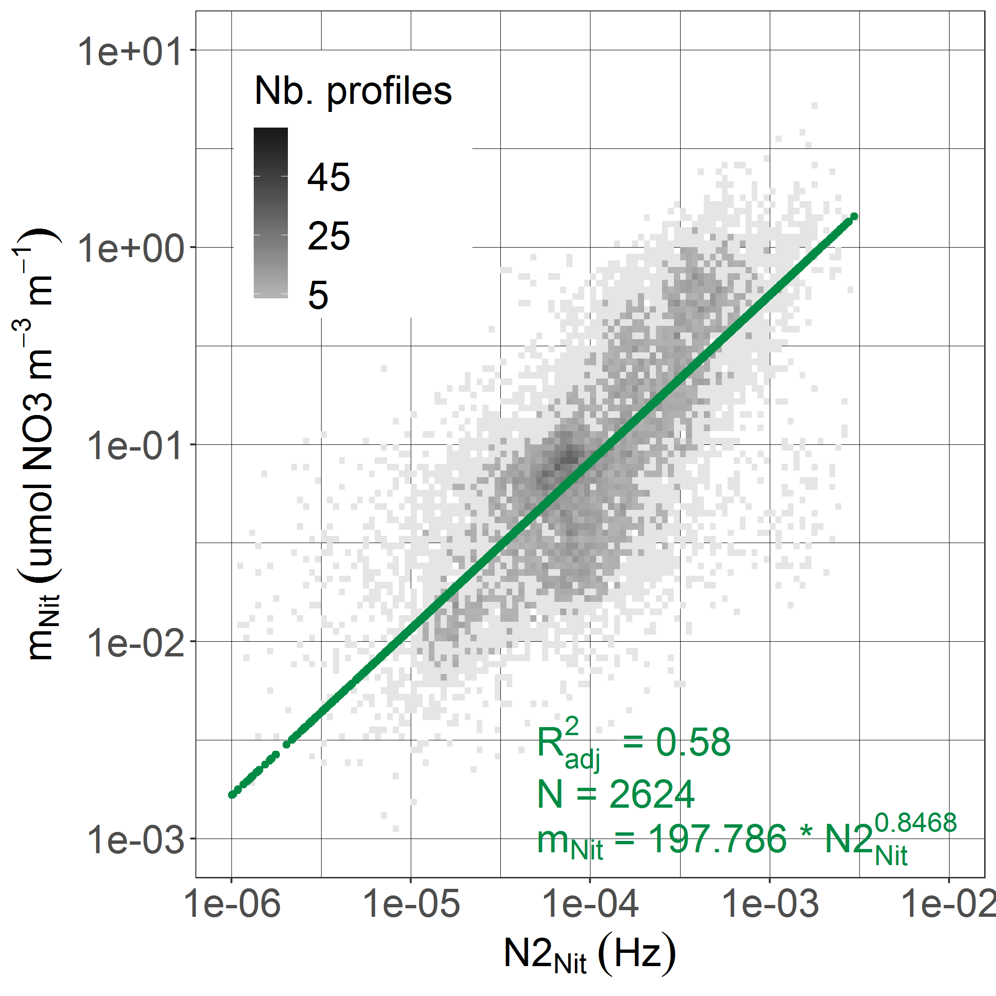

Figure S10. Relationship between nitracline steepness and the brunt-Väisälä frequency at the nitracline depth. The green line represents the power-law relation between both parameters and restricted to density-field squares having at least 5 values (scale of dark grey), with a p-value < 2.2 10⁻¹⁶ (F-statistic test).

Text S4. Regionalization of the BGC-Argo profiles into 28 regions of the global ocean.

The global open ocean is divided into 28 regions (Fig.S11), a priori presenting coherent hydrological and/or biogeochemical patterns (loosely adapted from or added to the Longhurst provinces, Longhurst, 1995). BGC-Argo profiles are allocated to these regions according to their geolocation (Table S3) The regions have been selected so that they contain at least one year of BGC-Argo profile measurements (Table S4). These regions are: Baffin Bay (BAFF); the North Atlantic Subpolar Gyre (NASPG); the Northern Seas (including the Greenland, Barents and Norway Seas, NS); the Western and Eastern Basins of the Mediterranean Sea (WMS and EMS); the North Atlantic and North Pacific Subtropical Gyres (NASTG and NPSTG); the Red Sea (RDS); the Black Sea (BKS), the Atlantic and Pacific Subequatorial Waters (ASEW, PSEW); the Indian Oxygen Minimum Zones (including the Arabian Sea and the Bengal Bay, IOMZ); the Indian Equatorial Waters (IEQ); the South China Sea (SCS); the Monsoon Indian waters (MOONS); the Western Australian Waters (AUSW); the Archipelagos waters (ARCH); the Southern Atlantic, Southern Pacific and Southern Indian Subtropical Gyres (SASTG, SPSTG and SISTG). Furthermore, in the Southern Ocean and on the basis of temperature profiles, the region below 30°S is further delineated into four sub-regions (Gray et al., 2018): (1) the Subtropical Zone (STZ) with a temperature above 11°C at 100 m; (2) the Subantarctic Zone (SAZ) with a temperature below 5°C at 400 m; (3) the Polar Frontal Zone (PFZ) with no temperature within the range of 2-5°C between 0 and 200 m; (4) the Antarctic Southern Zone and Seasonal Ice Zone (ASZ_SIZ) with no temperature above 2°C between 0 and 200 m. Similarly in the Atlantic Ocean, between 25°N and 50°N, the temperature at 100 m, between 8 and 17.5°C, is used to delineate the North Atlantic Drift Current (NAC). Above 66°N, the temperature under 3°C at 100 m distinguishes the Arctic waters (ARCT). Finally, in the Pacific Ocean, the temperature range between 7.5 to 15°C at 100 m is also used to isolate the Kuroshio current between 25°N and 65°N (KURIO).

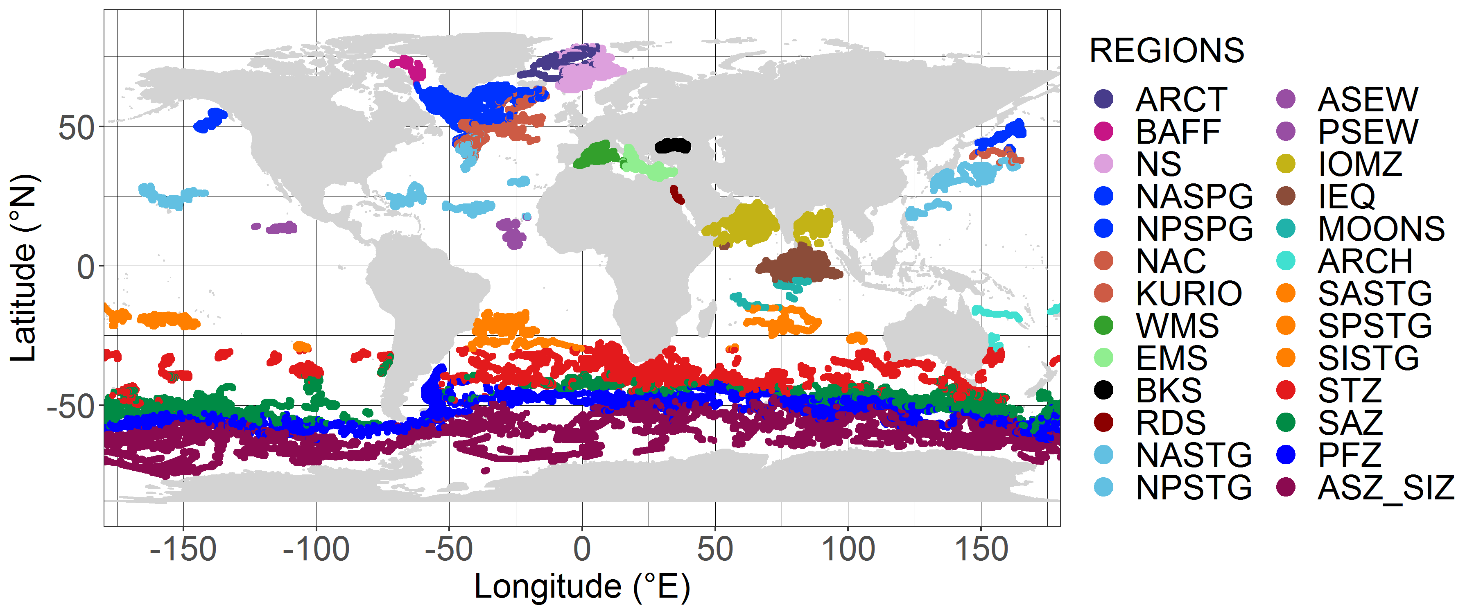Figure S11. Zonation of BGC-Argo profiles into 28 regions of the global ocean.

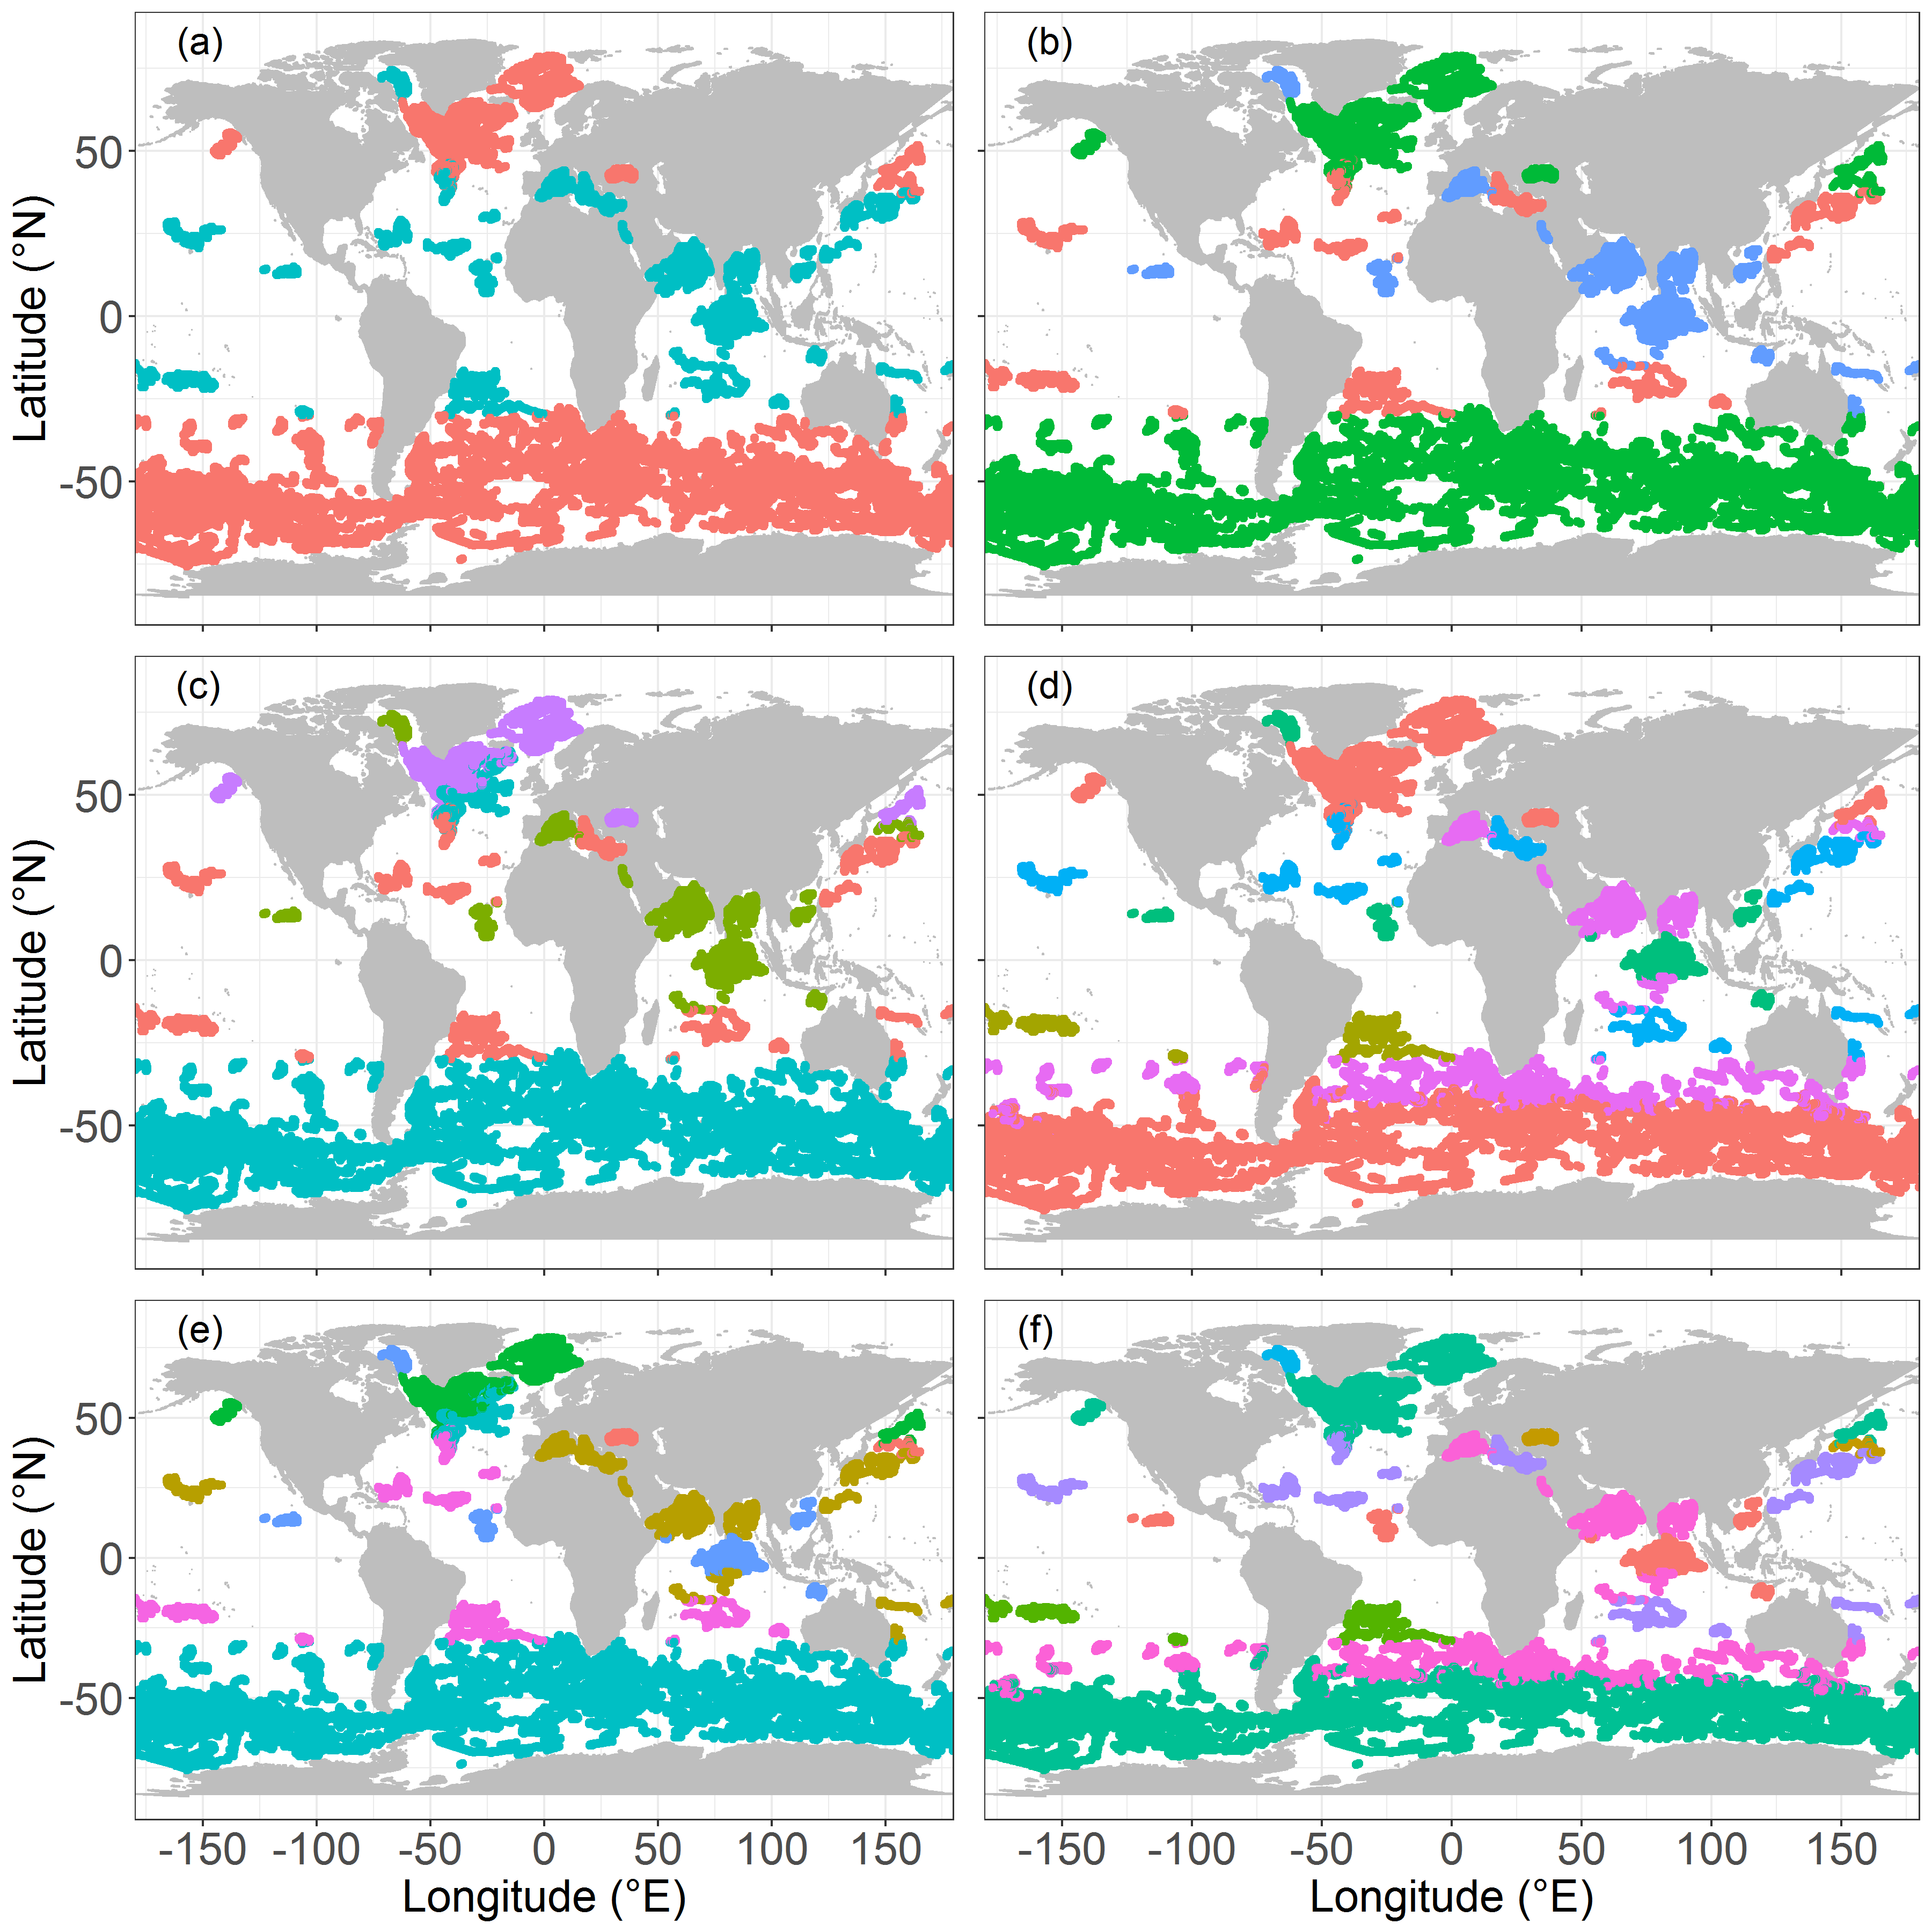
Figure S12. Clusters of regions according to DCM properties with 2 to 7 (a-f) a priori determined K-means groups. For each panel, a color corresponds to a group.

Text S5. Density-grids calculation

To evaluate the relationships between [Chla] and b_{bp} (Text S6 and Figure S13), DCM depth and [Chla]_{sat} (Text S7 and Figure S14), m_{Nit} and N2_{Nit} (Fig. S10), we used density grids to get rid of outlier values and to override ponderations due to the over-representation of certain values. For all cases, after applying the density grid, we took into account only the pixels containing at least 5 points to estimate the relations.
For Fig. S13, the density grid was defined as 200 breaks for both parameters on a logarithmic scale (from 10⁻¹ to 10⁰ mg chla m ⁻³ for [Chla], and from 10^{-3.75} to 10^{-1.75} m ⁻¹ for b_{bp}).
For Fig. S14, the density grid was defined as 200 breaks on a logarithmic scale from 10⁻² to 0 mg chla m ⁻³ for [Chla]_{sat} and from 0 to 200 m for DCM depth.
For Fig. S10, the density grid was defined as 200 breaks on a logarithmic scale from 1 10⁻⁵ to 1 10⁻³ Hz for N2_{Nit} and from 1 10⁻² to 1 µmol NO3 m⁻³ m⁻¹ for m_{Nit}.

Text.S6. Relationship between [Chla] and b_{bp} at the DCM depth

The relationships between [Chla] and b_{bp} at DCM depth are potentially informative about how actual changes in phytoplankton biomass (in terms of carbon, as tracked by b_{bp}) may drive the magnitude of [Chla] increase. In open-ocean waters whose optical properties are essentially driven by [Chla] and their byproducts (concept of case 1 waters, Morel & Prieur, 1977; Morel, 1988), these properties are generally analyzed against [Chla], through the use of power-law functions (e.g. Gordon & Morel, 1983; Loisel & Morel, 1998). Here, we used a similar approach to assess the degree of dependence of b_{bp} on [Chla] at DCM depth for the two types of DCM (i.e. DAM and DBM) at a global scale. To remove the influence of extreme and/or underrepresented profile intensities, this analysis was based on a density grid (Text. S5). The relationship observed for DBMs differs for DAMs (Fig. S13). The relation between b_{bp} and [Chla] at DCM depth is steeper for DBMs compared to DAMs with exponents of 0.86 and 0.69, respectively. This result confirms that [Chla] increase among DBMs is tightly linked to an increase in cellular carbon. Note that an exponent close to one would attest that carbon content increases with [Chla] content through a constant carbon-to-[Chla] ratio. This is actually not strictly the case, and the 0.87 exponent in fact reflects a progressive decrease of the phytoplankton carbon-to-[Chla] ratio with increasing [Chla] at DCM depth. The result here is very likely to be due to a change in phytoplankton communities, with [Chla] increasing as a shift occurs from picophytoplankton-dominated (low [Chla]) to diatom-dominated (high [Chla]) communities.

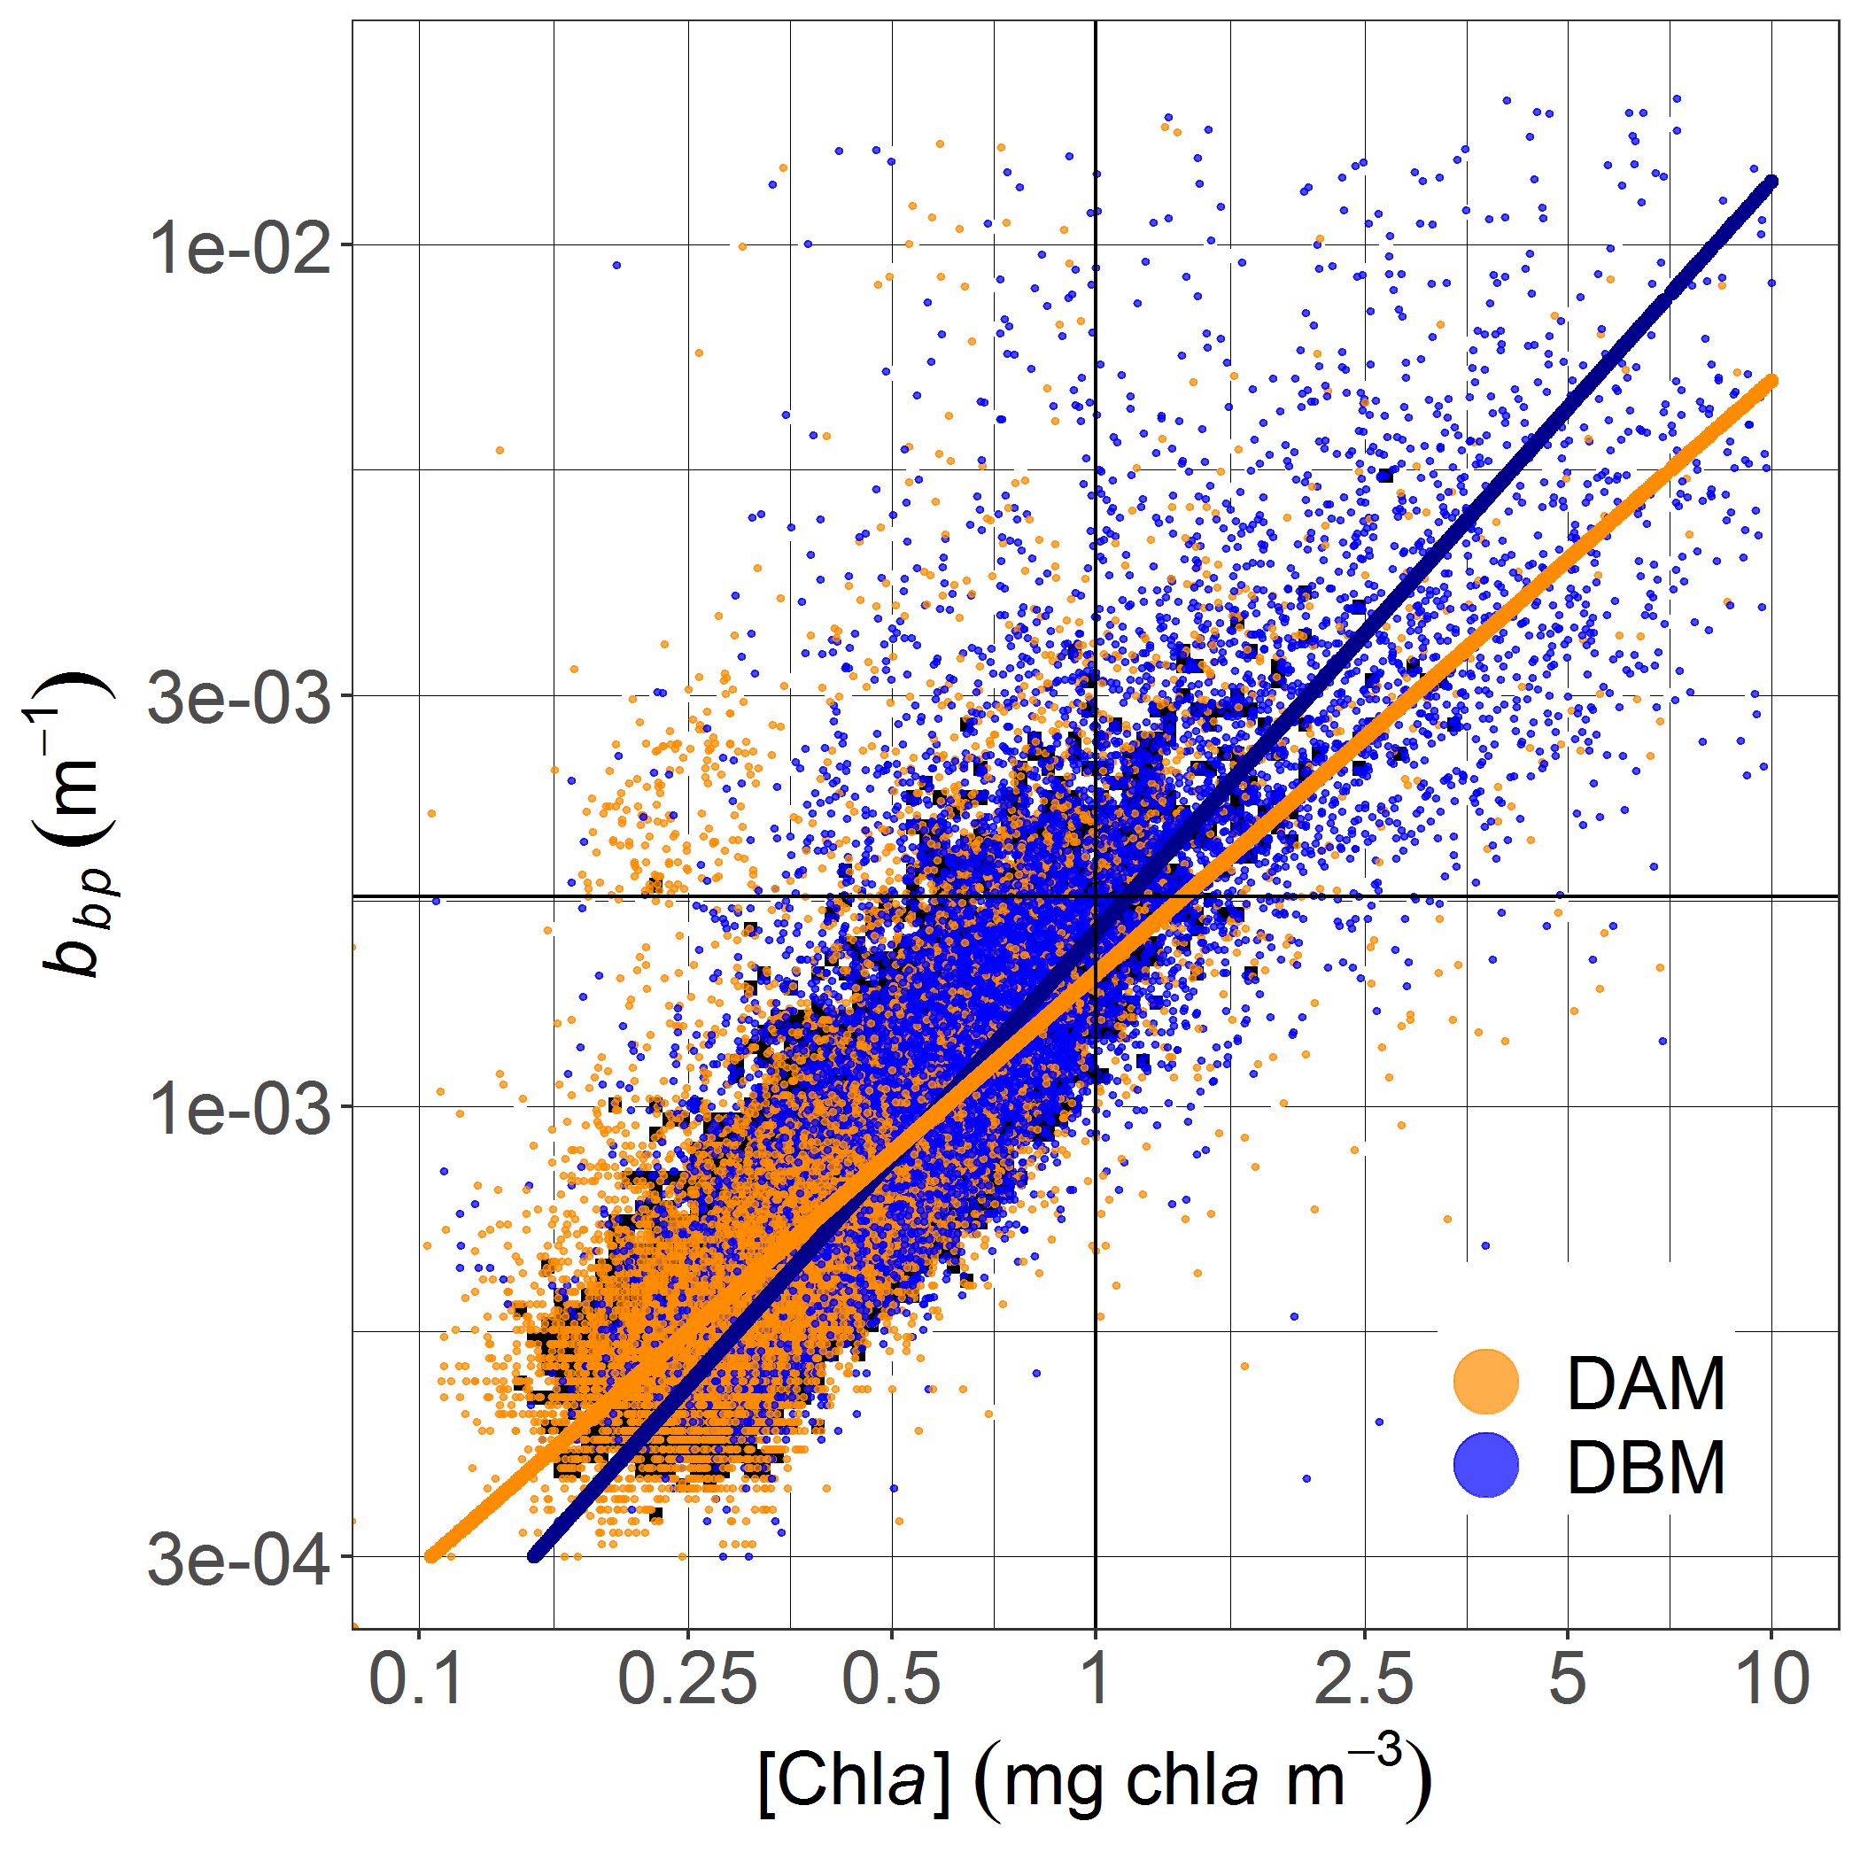
Figure S13. Relationship between b_{bp} and [Chla] at the DCM depth for DBMs (blue), and DAMs (orange). The lines represent the power-law relations between both parameters for profiles where the density parameters have more than 4 values (shaded background):
b_{bp} = 0.00159 [Chla]^{0.87213} (N = 395; R²_{adj} = 0.67) for the DBMs (blue); and b_{bp} = 0.00142 [Chla]^{0.68881} (N = 806; R²_{adj} = 0.48) for the DAMs (orange).

Text.S7. Relationship between [Chla]_{sat} and the DCM depth
The surface [Chla]_{sat} measured by remote sensing gives an index of phytoplankton-driven light attenuation in the upper-water column that ultimately controls light availability at DCMs. As shown by Mignot et al. (2011) on a HPLC [Chla] dataset, the depths of DCMs are clearly related to the surface [Chla], with low surface [Chla] associated to deep DCMs and reciprocally. We revisit and extend this relationship here (Fig. S14) by drawing on the database of BGC-Argo observations coincident with [Chla] measurements from satellite ([Chla]_{sat}). This relationship is well characterized by a two-degree polynomial function using a density grid (see Text S5). The global relationship between the [Chla]_{sat} and DCM depth obtained generally matches the one determined by Mignot et al. (2011) (for the values 0.02, 0.2 and 2 mg chla m⁻³, we obtained the respective DCM depth values of 25, 53 and 166 m, compared to 22, 50 and 178 m for Mignot et al. (2011).

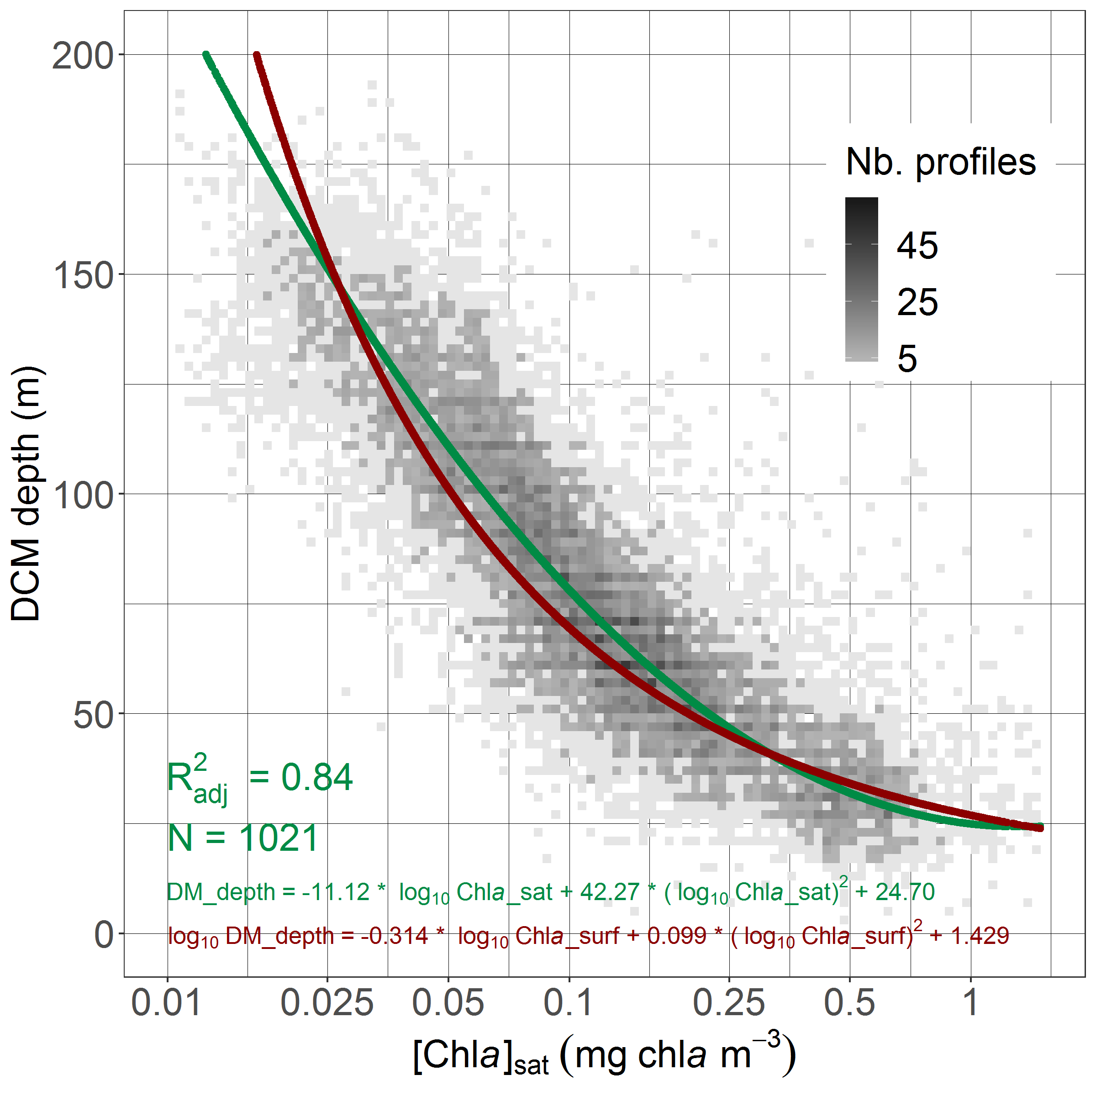
Figure S14. Density of DCM depth as a function of [Chla] surface concentration derived from monthly satellite match-ups with the corresponding profiles [Chla]_{sat}. The relationship between both parameters is assessed through a two-degree polynomial function (green curve) based on data where density-field squares have at least 5 values (scale of dark grey). The two-degree polynomial function proposed by Mignot et al. (2011) on the basis of the surface [Chla] derived from float profiles is represented as a red curve.

Table S5. Table of the mean/median values and standard deviations/ first and third quartiles of the DCM depth, [Chla] and b_{bp} at the DCM depth per 10°-latitudinal bands.

 |  | -70 | -60 | -50 | -40 | -30 | -20 | -10 | 0 | 10 | 20 | 30 | 40 | 50 | 60 | 70 | 80
[Chla]_{DCM}  (mg chla m⁻³) | q25 | 0.47 | 0.74 | 0.66 | 0.53 | 0.29 | 0.26 | 0.48 | 0.46 | 0.48 | 0.26 | 0.23 | 0.33 | 0.55 | 1.04 | 0.82 | 0.73
 | med. | 1.02 | 1.31 | 1 | 0.7 | 0.41 | 0.32 | 0.59 | 0.55 | 0.60 | 0.36 | 0.30 | 0.50 | 0.96 | 1.9 | 1.63 | 1.91
 | q75 | 2.42 | 2.27 | 1.61 | 0.93 | 0.64 | 0.38 | 0.74 | 0.66 | 0.77 | 0.61 | 0.40 | 0.78 | 1.83 | 3.68 | 3.38 | 3.59
b_{bpDCM}  (10 ³ m⁻¹) | q25 | 0.84 | 1.59 | 1.57 | 1.20 | 0.69 | 0.47 | 0.82 | 0.82 | 0.79 | 0.57 | 0.50 | 0.73 | 1.31 | 2.29 | 1.55 | 2.40
 | med. | 1.57 | 2.65 | 2.29 | 1.60 | 0.93 | 0.56 | 1 | 0.97 | 1 | 0.74 | 0.62 | 1.08 | 2.03 | 3.40 | 2.35 | 3.08
 | q75 | 3.10 | 4.26 | 3.46 | 2.09 | 1.45 | 0.66 | 1.16 | 1.17 | 1.27 | 1.15 | 0.80 | 1.63 | 3.53 | 5.17 | 3.50 | 4.91
DCM depth  (m) | mean | 53 | 63 | 64 | 65 | 98 | 124 | 67 | 64 | 59 | 84 | 94 | 65 | 41 | 53 | 39 | 54
 | sd | 26 | 21 | 26 | 24 | 31 | 23 | 20 | 15 | 16 | 38 | 24 | 24 | 20 | 73 | 36 | 71

Table S6. Table of the mean/median values and standard deviations/ first and third quartiles of the DCM descriptors and of the environmental parameters for the four groups of regions.

 |  | DAZ | DBZ | GOHZ | SHAZ
[Chla]_{DCM}  (mg chla m⁻³) | q25 | 0.38 | 0.68 | 1.1 | 1.01
 | med. | 0.46 | 0.78 | 1.28 | 2.01
 | q75 | 0.46 | 0.99 | 1.54 | 3.46
DCM depth  (m) | mean | 107 | 57 | 64 | 37
 | sd | 21 | 8 | 10 | 6
DCM occurrence (%) | mean | 86 | 78 | 14 | 17
 | sd | 9 | 14 | 10 | 15
DBM occurrence (%) | mean | 34 | 54 | 8 | 8
 | sd | 17 | 14 | 6 | 6
[Chla]_{sat}  (mg chla m⁻³) | q25 | 0.04 | 0.11 | 0.10 | 0.41
 | med. | 0.06 | 0.15 | 0.18 | 0.53
 | q75 | 0.08 | 0.25 | 0.27 | 0.65
iPAR_{Nit}  (E m⁻² d⁻¹) | q25 | 0.002 | 0.61 | 0.18 | 0.58
 | med. | 0.01 | 1.77 | 0.94 | 2.28
 | q75 | 0.04 | 4.29 | 3.68 | 6.20
m_{Nit}  (NO3 m⁻¹ m⁻³) | q25 | 0.02 | 0.13 | 0.04 | 0.04
 | med. | 0.04 | 0.29 | 0.08 | 0.10
 | q75 | 0.07 | 0.57 | 0.15 | 0.31
DCM depth - Z_{Nit} (m) | mean | -39 | 8 | -14 | 1
 | sd | 60 | 15 | 70 | 28

Text S8. Float selection for the seasonal-dynamics study in the DAZ and DBZ

To examine the seasonal dynamics of DCMs and their associated environmental context in depth, two representative regions were chosen for the dynamics of their DCM characteristics (depth, occurrence, and intensity): the NASTG and the ASEW (Fig. S15). In these regions, we selected floats with time series best describing the main seasonal trends of DCM depth and [Chla] at DCM depth (Fig. S16): WMO 6901175, WMO 3902122, and WMO 3902123 for the ASEW; and WMO 6901472, WMO 6901473, and WMO 6901474 for the NASTG. For each month and regardless of the year, the mean and standard deviation of the DCM depth, the depth of iPAR₂₀, and the depth of the nitracline (Z_{nit}), were calculated for the profiles showing a DCM.
To compare the respective seasonal evolution of these three clines, we normalized them by subtracting their respective annual mean from their monthly value. The quality of the seasonal relations established (Fig. 20) was quantified using the adjusted correlation coefficient (R²_{adj}), (1) the Mean Absolute Error (MAE), and (2) the Root Mean Square Error (RMSE):
$MAE=\frac{1}{n}\sum_{i=1}^{n}{\left|X_{i}-Y_{i}\right|}$ (1)
$RMSE=\sqrt{\frac{\sum_{i=1}^{n}{{\left(X_{i}-Y_{i}\right)}^{2}}}{n}}$ (2)

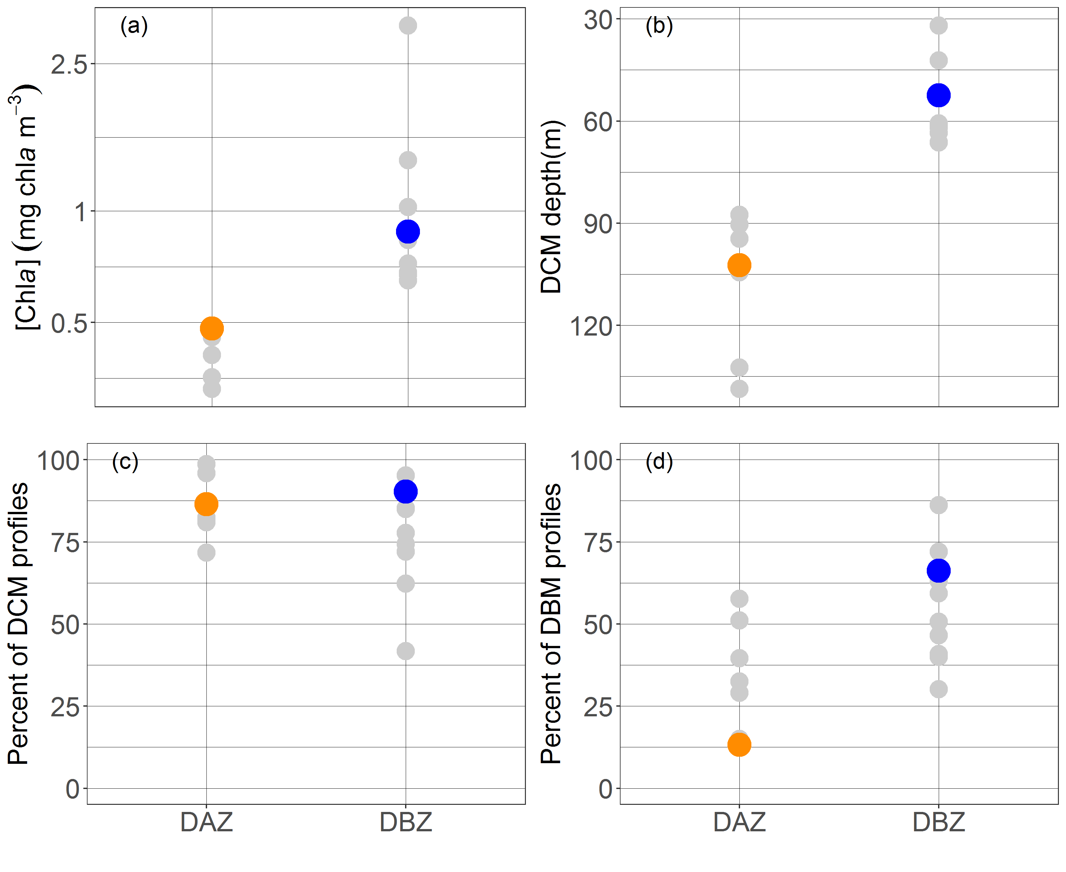

Figure S15. (a) Mean [Chla] at DCM depth, (b) mean DCM profiles, and (d) mean percentage of DBM profiles for the different regions of DBZ and DAZ groups. The mean properties of the ASEW (blue) and NASTG (orange) regions are specifically highlighted.
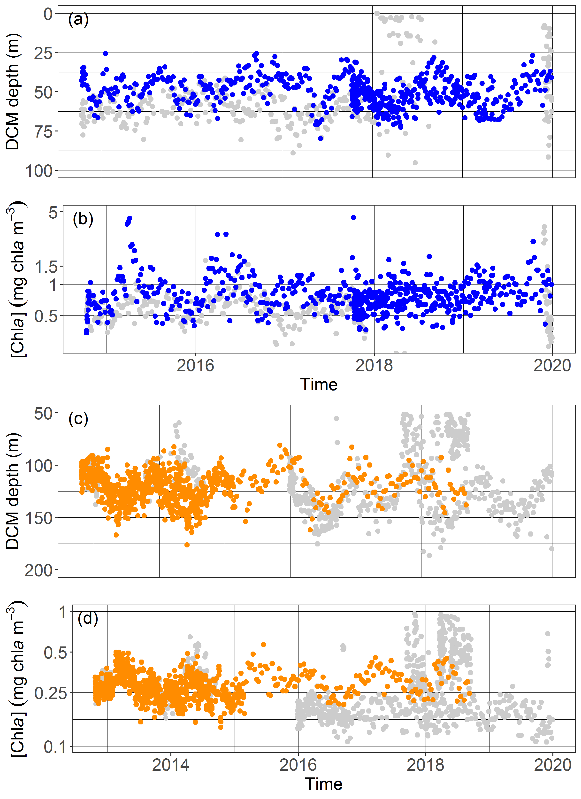
Figure S16. Time series of (a, c) DCM depth and (b, d) [Chla] at DCM depth for floats (a, b) in the NASTG, and (c, d) in the ASEW. The colored points correspond to float profiles used in the time-series calculation for each region and that are most representative of the regional mean seasonal trends: WMO 6901175, 3902122, and 3902123 color-coded in blue for the ASEW; 6901472, 6901473, and 6901474 color-coded in orange for the NASTG.
Text S9. Seasonal shapes of [Chla] and b_{bp} profiles in the NASTG and ASEW

To study the vertical distribution of [Chla] and b_{bp} and their seasonal evolution in the Atlantic Subequatorial Waters (ASEW) and North Atlantic Subtropical Gyre (NASTG) regions, we calculated their median profiles per season (Fig. S17). Each [Chla] and b_{bp} pair of profiles was first interpolated at a one-meter resolution between 0 and 300 m, and further normalized by subtracting the DCM depth from each profile depth. The choice of the normalization by the DCM depth has been made to remove the effects of the upward and downward displacements in the median profiles (due to seasonal, geographical, or localized features, such as mesoscale eddies or internal waves, Hense & Beckmann, 2008; Cullen, 2015). At each depth, the median, the first and the third quartiles were calculated for both parameters.
The two regions also differ in the vertical shapes of both [Chla] and b_{bp} profiles and their respective seasonality. In the ASEW, the vertical shape of [Chla] and b_{bp} is asymmetric, with a steeper increase of both parameters from the surface to the DCM depth, than from the DCM depth to bottom. Both shapes sharpen from autumn to spring, as the mean [Chla] and b_{bp} increase at the DCM depth (respectively from 0.63 to 0.90 mg chla m⁻³ for [Chla], and from 10.4 10⁻⁴ to 14.2 10⁻⁴ m⁻¹ for b_{bp}). Meanwhile, in the NASTG, the mean depth-normalized [Chla] profiles show a symmetric vertical structure around the DCM depth, also with sharpening reaching a peak in autumn (from 0.24 mg chla m⁻³ in autumn to 0.27 mg chla m⁻³ in spring). On the other hand, the b_{bp} profiles in the NASTG do not present a mean global shape through the year. In winter, the b_{bp} vertical distribution displays no mode, while it presents an increase around the DCM depth (5.5 10⁻⁴ m⁻¹) in spring. This maximum shifts to 10 m below the DCM depth in summer, and a second mode of higher intensity appears around 75 m above the DCM depth. In autumn, the deeper mode weakens and a local minimum in the b_{bp} concentration appears at the DCM depth (4.8 10⁻⁴ m⁻¹).

Table S7. Table of the mean values and standard deviations of the DCM, nitracline, and iPAR20 depths for the NASTG and ASEW floats as function of the months of the year.

 |  |  |  | Jan | Feb | Mar | Apr | May | Jun | Jul | Au | Sep | Oct | Nov | Dec
NASTG |  | DCM depth (m) | mean | 115 | 124 | 124 | 132 | 137 | 135 | 135 | 129 | 122 | 113 | 109 | 110
 |  |  | sd | 12 | 15 | 18 | 15 | 17 | 14 | 14 | 12 | 16 | 14 | 13 | 11
 |  | iPAR₂₀ depth (m) | mean | 17 | 24 | 31 | 36 | 38 | 39 | 38 | 36 | 33 | 26 | 20 | 16
 |  |  | sd | 2 | 3 | 3 | 2 | 2 | 2 | 2 | 2 | 2 | 2 | 3 | 2
 |  | Z_{Nit} (m) | mean | 151 | 149 | 151 | 159 | 163 | 151 | 159 | 156 | 152 | 150 | 154 | 152
 |  |  | sd | 18 | 16 | 23 | 25 | 15 | 18 | 25 | 21 | 26 | 17 | 21 | 19
ASEW |  | DCM depth (m) | mean | 52 | 52 | 55 | 56 | 55 | 53 | 45 | 42 | 40 | 47 | 50 | 51
 |  |  | sd | 9 | 8 | 9 | 10 | 8 | 9 | 6 | 8 | 9 | 8 | 7 | 8
 |  | iPAR₂₀ depth (m) | mean | 22 | 23 | 26 | 28 | 29 | 29 | 28 | 27 | 26 | 27 | 24 | 22
 |  |  | sd | 2 | 3 | 3 | 3 | 3 | 2 | 3 | 3 | 4 | 3 | 2 | 2
 |  | Z_{Nit} (m) | mean | 44 | 44 | 45 | 44 | 44 | 41 | 35 | 30 | 28 | 34 | 36 | 41
 |  |  | sd | 9 | 7 | 8 | 10 | 6 | 7 | 6 | 6 | 7 | 8 | 6 | 7

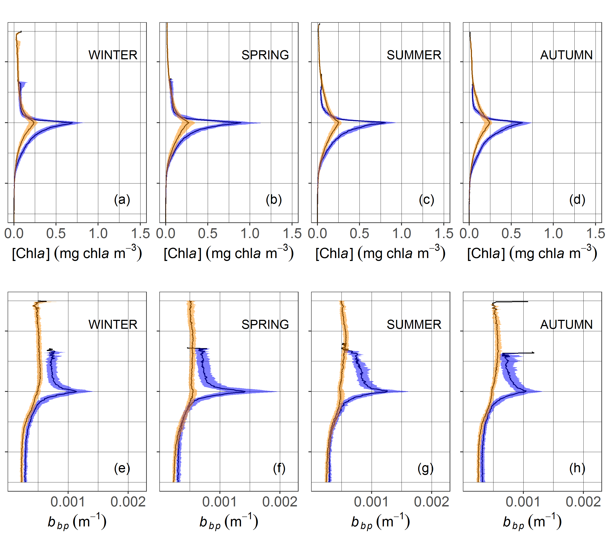
Figure S17. Vertical relative profiles with respect to DCM depth for the floats within for the floats in the Atlantic SubEquatorial Waters (blue) and in the North Atlantic Subtropical Gyre (orange), respectively representative of the Deep Biomass Zone, and of the Deep photoAcclimation Zone.The median, first and third quartiles of [Chla] (a-d) and b_{bp} (e-h) are represented for each season: winter (December-February); spring (March-May); summer (June-August); autumn (September-November)

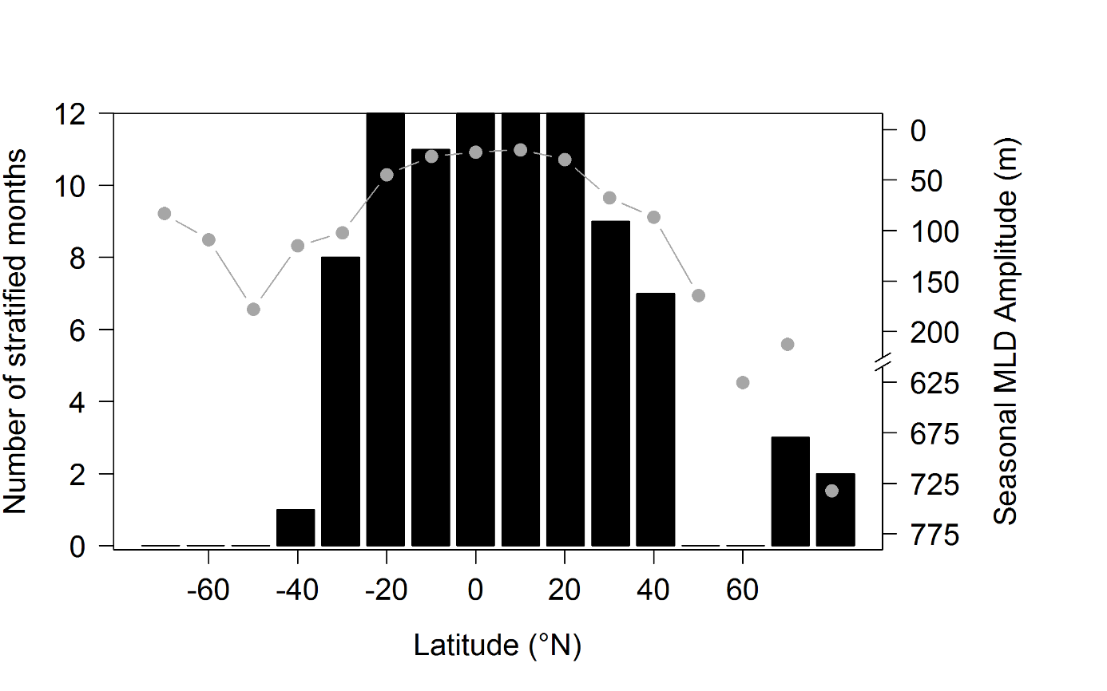

Figure S18. Stratification-period duration (black bars) and seasonal MLD amplitude (grey points and lines) per 10° latitude. The stratification period is calculated for each 10° band as the number of months where the percentage of DCM profiles is superior to 50 %. The amplitude is calculated as the difference between the monthly mean shallowest and deepest MLD per 10°-latitude band.

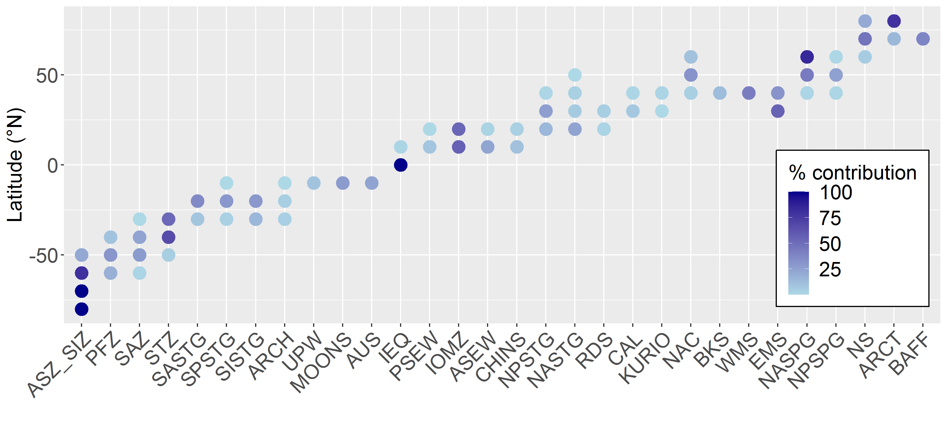
Figure S19. Percentage of the contribution made by each of the 28 regions to the 10°-latitudinal profile groups.

Text S10. Western Basin of the Mediterranean Sea and Baffin Bay special features
The Western Basin of the Mediterranean Sea differs from other regions in the zone by stronger seasonality for both DCM and DBM features (Fig. S20 and S21). These are absent during winter and show an increasing occurrence from spring to summer, then a decrease in autumn. The lack of DCMs during the winter period can be explained by the similarity of the region's seasonal dynamic to that of the North Atlantic SubPolar Gyre: strong vertical mixing events (Marty et al., 2002), which can lead to intense spring blooms (Morel & André, 1991). However lasting DBM presence (i.e. more than six months) is observable and regularly reported (Estrada et al., 1993; Lavigne et al., 2015; Barbieux et al., 2019). It can be explained by the lasting of stratification period (Estrada, 1996), as well as local cyclonic circulation in the northern part (Millot, 1999) combined with the presence of cyclonic eddies (Pujol & Larnicol, 2005) which enhance vertical inputs of local nutrients in a favorable light environment.

Baffin Bay also shows a high occurrence of shallow and intense DBMs during the summer (Fig. S21 and S22). This period corresponds to post-bloom timing of the sea-ice-free season (Ardyna et al., 2013). The position of the DCM below the nitracline (Fig. S23 d), as highlighted by Ardyna et al. (2011), suggests a close coupling between DCM dynamics and the nutrients from below (likely to be depleted in the upper layer by the spring bloom (Tremblay et al., 2008; Martin et al., 2010; Ardyna et al., 2011). These characteristics reflect dynamics that can be likened to those in the Shallow Maxima Zones. However, Baffin Bay is distinguished by its significant occurrence of DBMs (higher than 75% in July and August, Fig. S21). This may be due to enhanced haline stratification during the ice-free period (Carmack & Wassmann, 2006), which allows the establishment of stable and lasting conditions for DBMs.

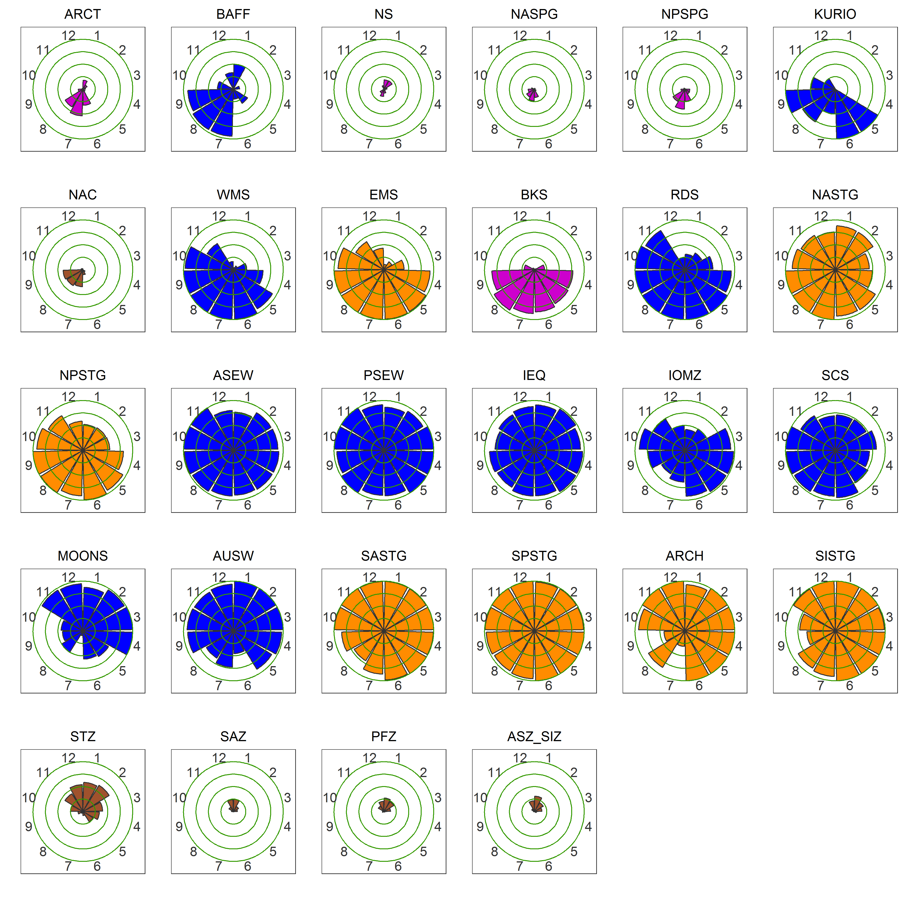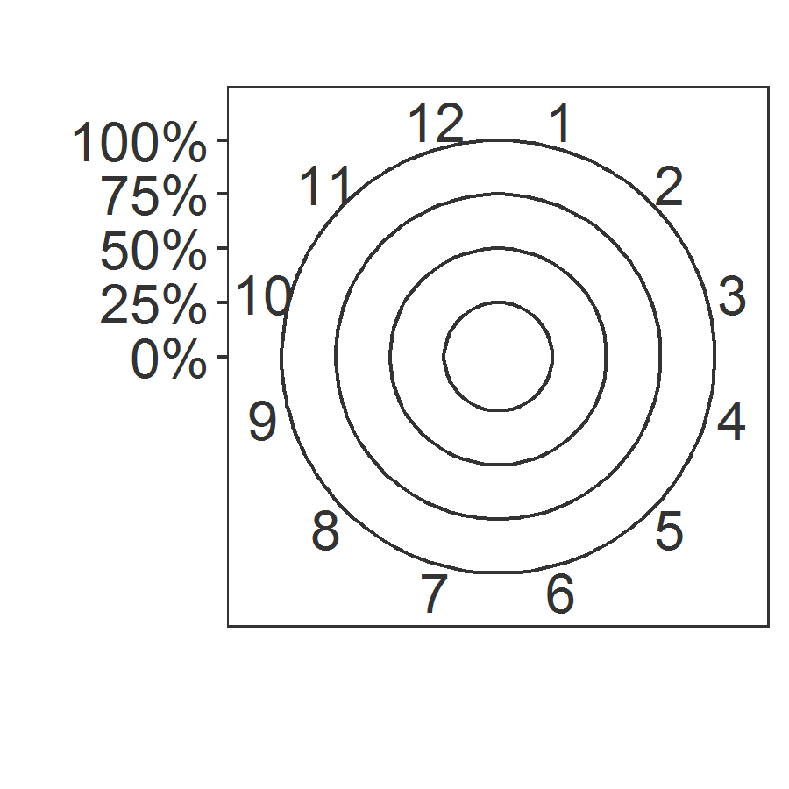
Figure S20. Monthly occurrence of DCM profiles per region classified into similar cluster groups. SHAZ: purple; GHOZ: brown; DAZ: orange; DBZ: blue.

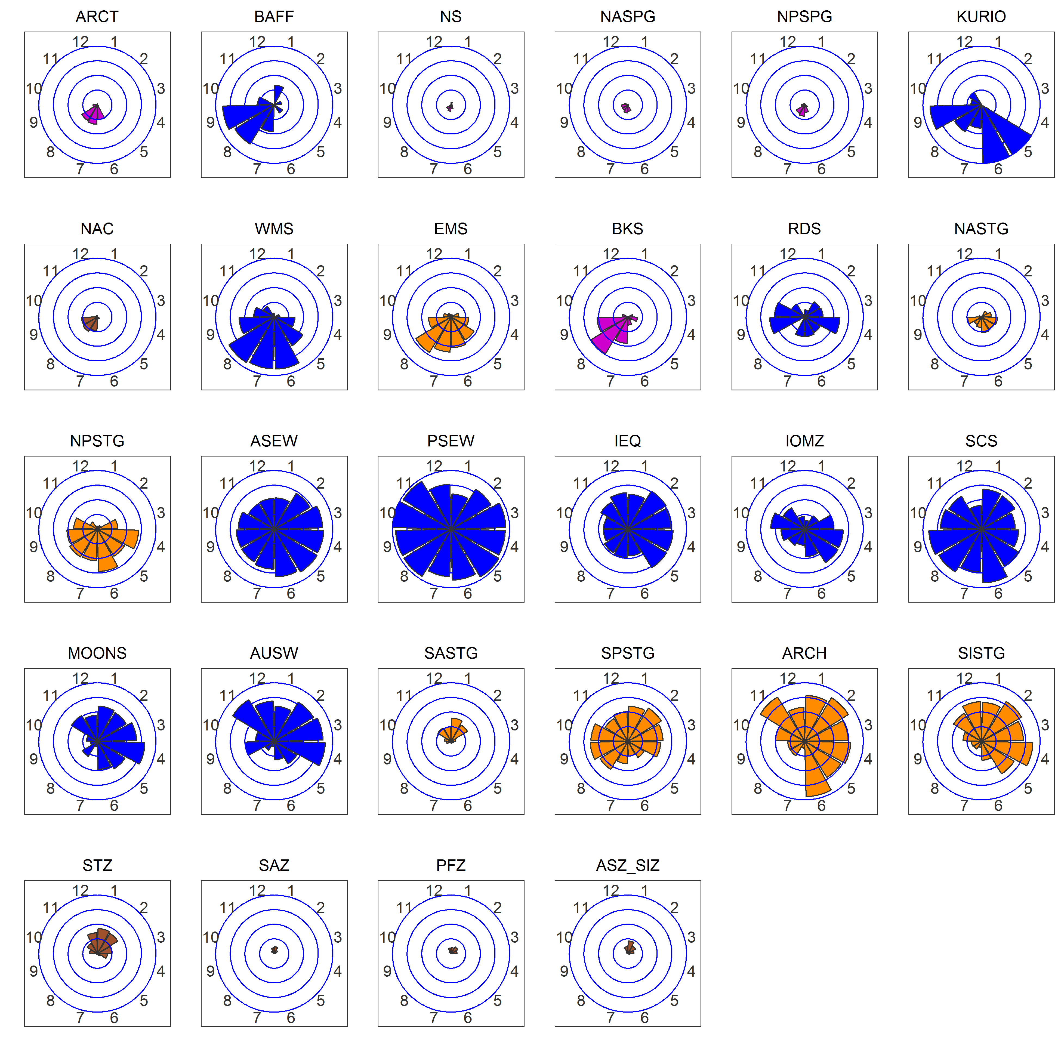
Figure S21. Monthly occurrence of DBM profiles per region classified into similar cluster groups. SHAZ: purple; GHOZ: brown; DAZ: orange; DBZ: blue.
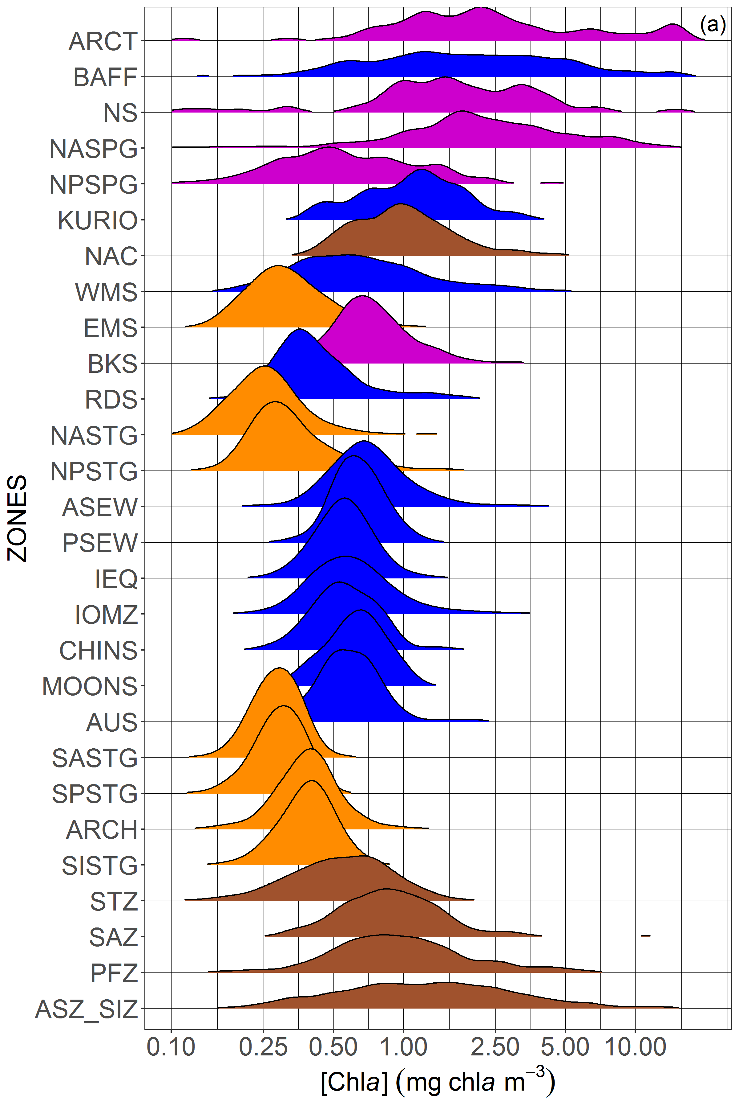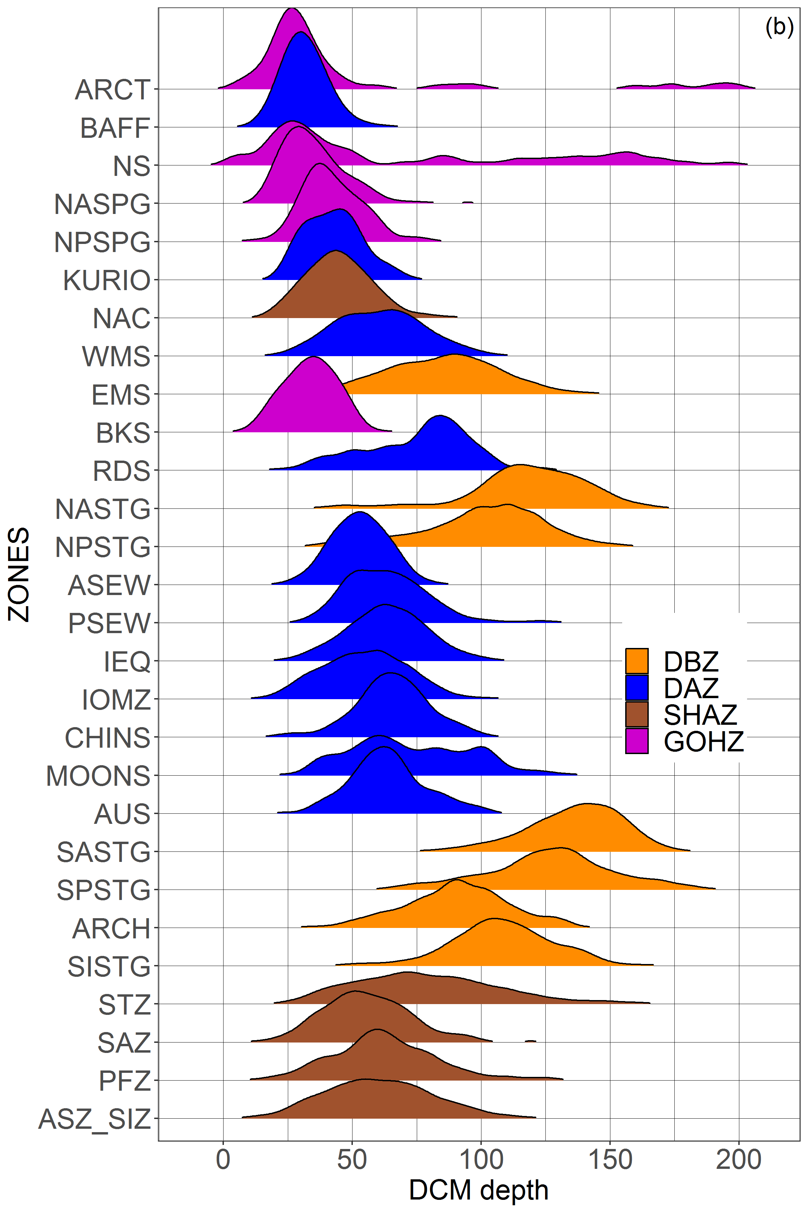

Figure S22. Distribution of [Chla] at (a) DCM depths and (b) DCM depths per region classified into similar cluster groups.
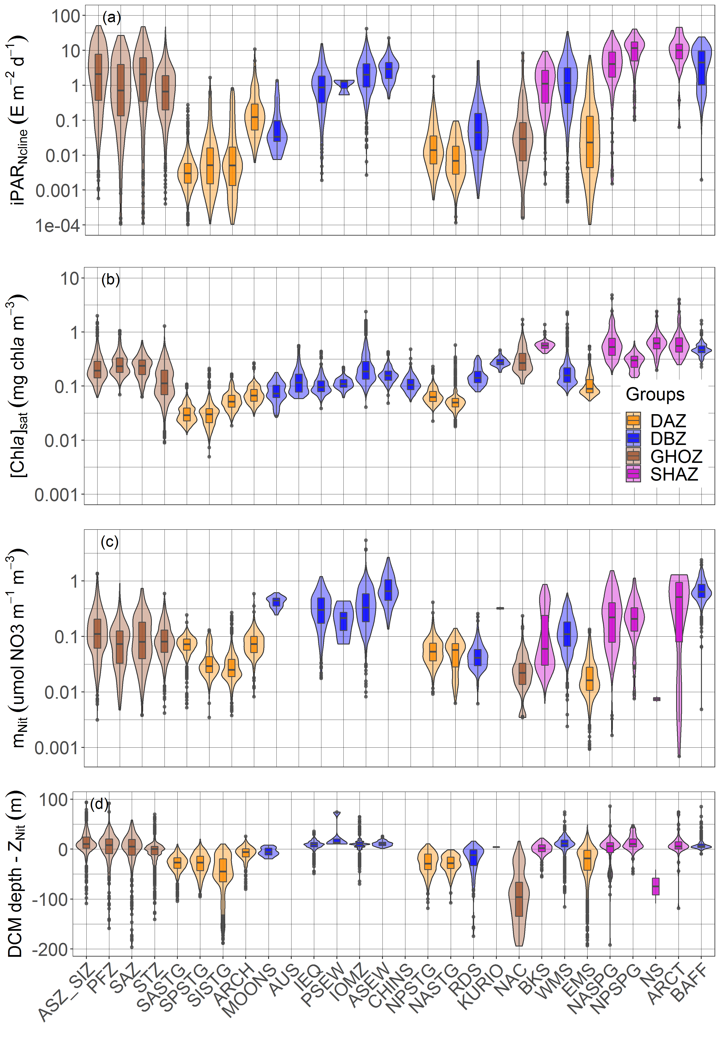
Figure S23. Quartile diagrams and density plots of DCM-profile environmental characteristics according to each region of the four cluster groups: (a) iPAR at the nitracline depth, (b) surface [Chla]_{sat} from satellite observations, (c) steepness of the nitracline, and (d) difference between the DCM and the nitracline depths.

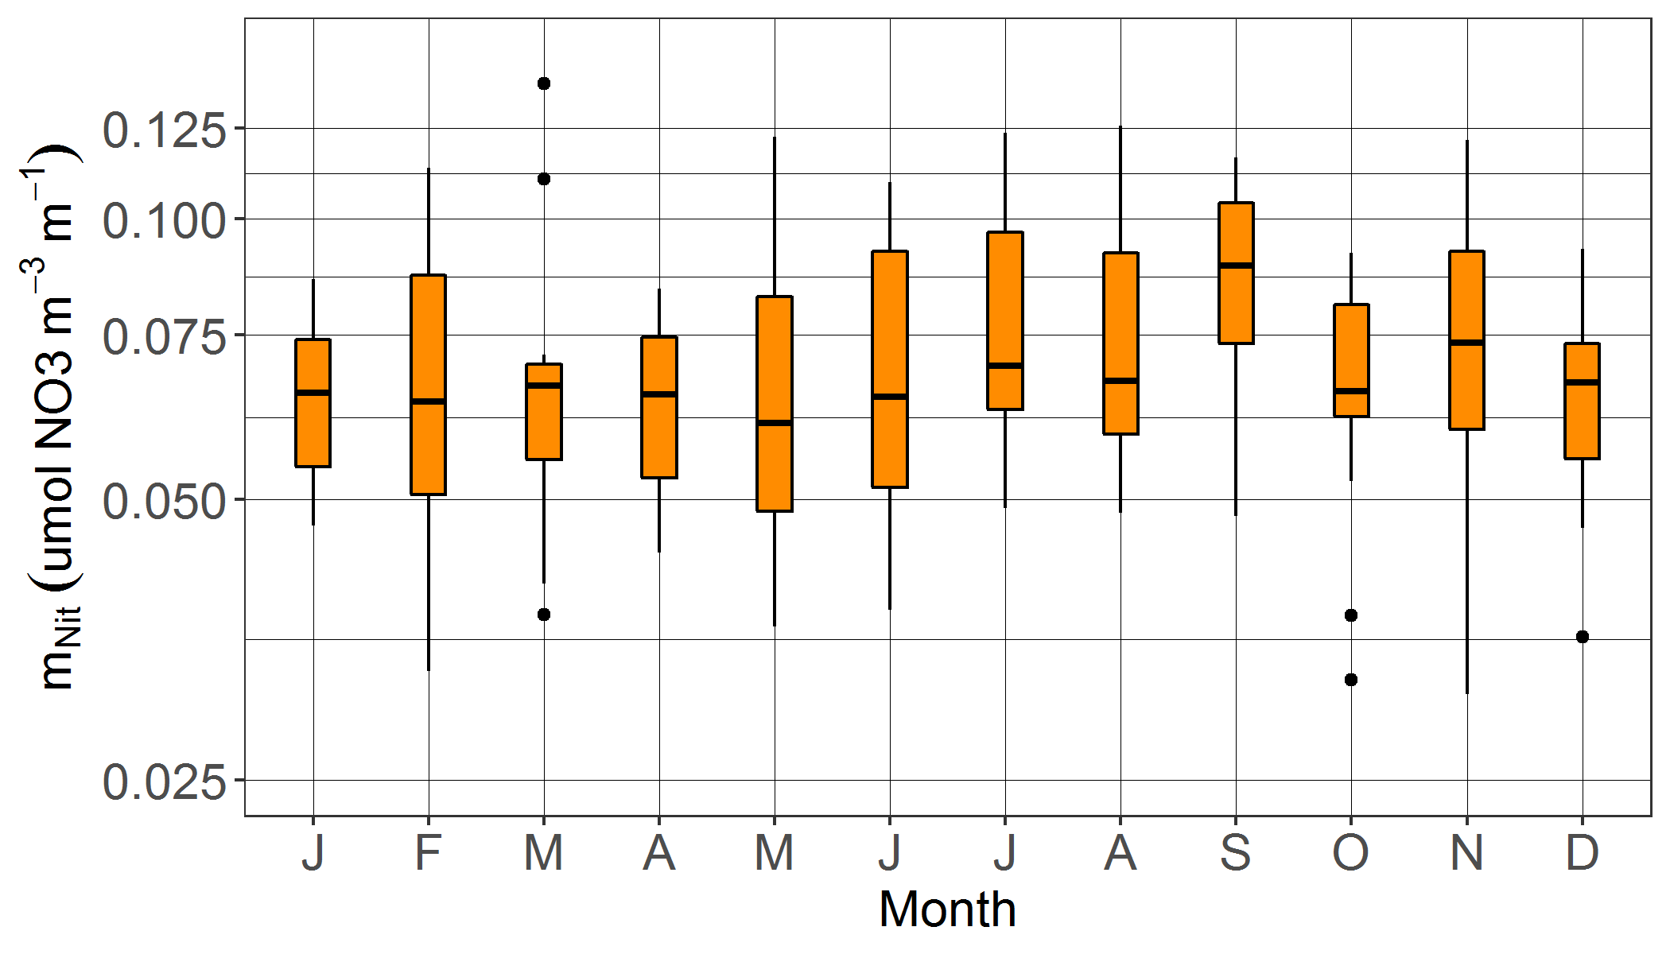
Figure S24. Mean nitracline steepness (m_{nit}) per Northern Hemisphere-phased month (regardless of the year) for the NASTG-region DCM profiles.

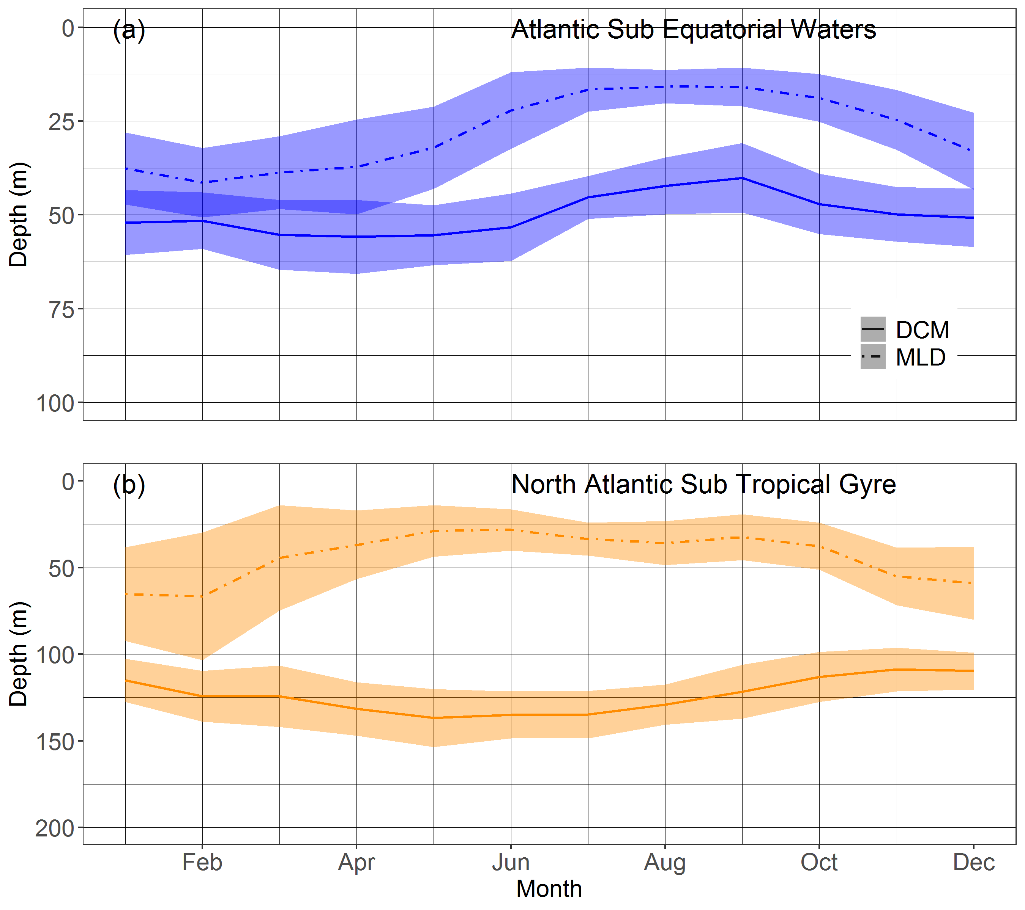
Figure 25. Mean and standard-deviation yearly climatology of the DCM depth and of the MLD for the floats in the Atlantic SubEquatorial Waters (a) and in the North Atlantic Subtropical Gyre (b), respectively representative of the Deep Biomass Zone, and of the Deep photoAcclimation Zone.

