*[JGR: Oceans]*



Supporting Information for

A freshwater plume in the northwestern tropical Atlantic in February 2020

Reverdin, G.1, L. Olivier1, G. R. Foltz2, S. Speich3, J. Karstensen4, J. Horstmann5, D. Zhang6, R. Laxenaire7, X. Carton8, H. Branger9, R. Carrasco5

1LOCEAN-IPSL, Sorbonne Université-CNRS-IRD-MNHN, Paris, France, Paris, France

2NOAA/Atlantic Oceanographic and Meteorological Laboratory, Miami, FL, USA,

3Laboratoire de Météorologie Dynamique, ENS-Ecole Polytechnique-CNRS-Sorbonne Université, Paris, France.

4GEOMAR Helmholz Centre for Ocean Research Kiel, Kiel, Germany

5Helmholtz-Zentrum Geesthacht, Geesthacht, Germany

6CICOES/University of Washington and NOAA/Pacific Marine Environmental Laboratory, Seattle, WA, USA

7Center for Ocean-Atmospheric Prediction Studies, Florida State University, Tallahassee, Florida, USA.

8Laboratoire d’Océanographie Physique et Spatiale, UBO-CNRS-IFREMER-IRD, Plouzané, France.

9IRPHE, CNRS-AMU, Luminy, France.

**Contents of this file**

Text S1 to S4 with associated figures S1a, S1b, S2a, S2b, S3 and S4

**Introduction**

* The supporting information contains: S1, information on the Ocarina profiles used to estimate an average Richardson profile in mixing depth; S2, uncertainties on the currents used to estimate cross-shelf transport; S3, illustration of the 7 other fresh plumes observed in 2010-2019; S4, MSM salinity section on Feb 2 2020

**Supporting Information S1: Ocarina on February 03 2020.**

On 03 February, the free drifting platform Ocarina (Bourras et al., 2019) was deployed from 06h00 to 17h00 local time (10h00 to 21h00 UTC). On that day, dry easterly trade winds with mesoscale sugar cloud patterns were observed. Measured friction velocity ranged from u*=0.28 m/s (during the first half part of the deployment) to u*=0.18 m/s (during the second part). Aerodynamic roughness height zo varied accordingly from 0.09 mm to 0.06 mm. Reconstructed wind speeds at z=10m from wind speeds recorded on board Ocarina at z=1.5m, taking into account the measured friction velocity and atmospheric stability, ranged from U10=8.5 m/s decreasing to 6.0 m/s. They were mainly directed from WSW, with a maximum at 09h00 local time and a minimum at 15h00 local time. The significant wave height recorded on the platform was around 1.5 m with dominant wave periods around 7s. Ocarina recorded both short-wave and long-wave downwards and upwards radiative fluxes. The net radiation fluxes show a positive budget (heating atmosphere, cooling ocean) with a maximum of 800 Watt/m2 near 13h00 local time. Measured latent heat fluxes were around 175 Watt/m2 from 07h00 to 11h00 local time and around 140 Watt/m2 from 13h00 to 17h00 local time. Buoyancy sensible heat fluxes decreased from 10 Watt/m2 to 7 Watt/m2 during the deployment with large fluctuations at medium time scale (5 min to 20 min). These fluctuations were found to be correlated with wind gusts which had a dominant period of 6 min.

Ocarina drifted westward from (54.14°W,6.83°N) to (54.34°W, 6.83°N), at relatively constant 0.6 m/s (+/- 0.1 m/s) speed. During the drift, the salinity measured at z=-0.2m increased linearly from 34.73 to 34.95 pss, and the reconstructed skin SST increased from 26.58°C to 26.88°C.

The Ocarina platform was equipped with a NORTEK Signature 1200 kHz ADCP to measure water current profiles at 0.5 m resolution between 0.3 m and 17.3m from the sea surface. The current-meter was associated with an inertial unit, compass, magnetometers, and measurements were corrected from platform motion. Data were acquired at a frequency rate of 8 Hz during 3 min, every 5 min. Only measurements with sufficient signal-to-noise-ratio, coherence between beams, and enough acoustic refracted power were retained. All the retained vertical profiles during the 3 minutes were averaged over 3 min to produce an average vertical profile. Thus, 132 ‘average’ vertical profiles were available that day. The ADCP measured an “apparent velocity”, i.e. the velocity beneath Ocarina. The “true” current velocity was reconstructed using the GPS drift recorded by the onboard GPS system.

Figure S1a shows the temporal evolution of the vertical profiles of the true velocity computed from the ADCP. There is veering of the direction and amplitude modifications with depth, which might be indicative of Ekman dynamics and coastal upwelling. There is a clear evidence of mixing layer beginning at the surface, with a quite vertical homogeneous profile. The height of the mixed layer seems to increase from 6 -7 m during the first half of the deployment to 13-14 m during the second half. The zonal component of the current is quite large near the surface: it increases from an eastward 45 cm/s at the beginning to an eastward 65 cm/s during the second half of the deployment. Surface eastward current were lower in the morning although friction velocity and wind were stronger, and surface current was higher in the afternoon although wind was lower. Below the mixing layer, a significant vertical shear occurs reaching sometimes 7 cm/s per m of depth.

During the deployment, there were three periods (morning, mid-day, and evening) when the RV Atalante MVP profiles of temperature and salinity and the ADCP current profiles from Ocarina were taken within a few kilometers of each other. The average of these 11 MVP density profiles shows a thoroughly mixed layer between 2 and 6 m thick. Below that it is continuously stratified (Fig. S1b, blue line) with a stratification dominated by salinity increase (from 34.8 pss at the surface to 35.2 pss at 17-m depth, with very weak temperature change in that layer between 26.53°C and 26.67°C). The corresponding currents (S1b, zonal component with black line), which were of 45 cm/s westward in the top 6 m, diminish to 19 cm/s at 17 m, indicating large shear across the salinity-stratified layer (red line). The individual curves are dimensioned in such a way that the blue line reaching the red line corresponds to a Richardson number of 0.2.

|  |
| --- |
|  |

Figure S1a: Temporal evolution of the vertical velocity profiles measured on-board Ocarina on 03 February. Top: True North component, bottom: True East Component.

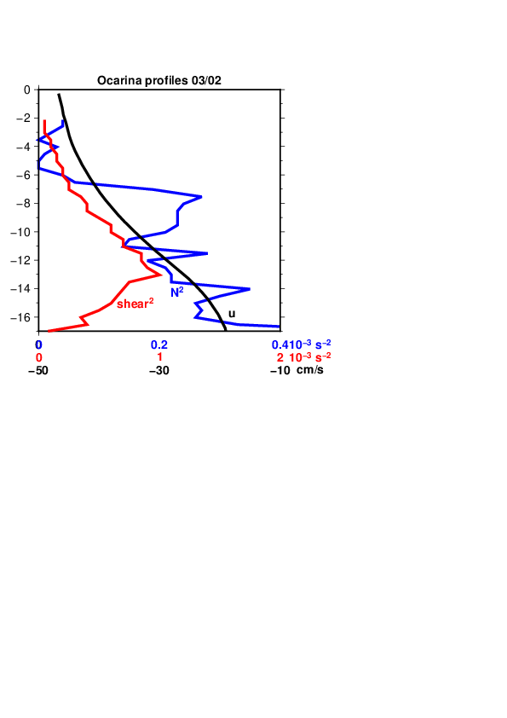

Figure S1b: Average profiles of Ocarina data from 0 to 17-m depth (black, zonal current; red, squared shear) at the times of 11 close-by MVP profiles (squared Brunt-Väisala frequency in blue).

**Supporting Information S2: Uncertainties on currents and transports**

In part 3.4 and Fig. 10 we presented the advective budget of the fresh water plume. Some approximations were done, and related uncertainties are presented below.

First, the Ekman transport is a large contribution to the transport of fresh water across the shelf break (roughly 50%). We used a constant value of the Ekman depth (20 m) to estimate the budget in Fig. 10. A conservative estimate of the uncertainty of a factor 2 in the actual depth at a given time (see for example the saildrone section in Fig. 9) would thus imply a 25% uncertainty in the flux estimate.

Other large uncertainties are associated with the geostrophic currents near the shelf break. We used near-real time geostrophic DUACS NRT currents derived from altimetry. This product integrates all altimetric data before a given date, but only for the next 6 days after, and thus is less certain than the delayed mode products. In both cases there are also uncertainties resulting from the spatial smoothing applied for the product (close to 100 km), time variability, and possible errors in the mean currents near the shelf and shelf-break.

To illustrate the uncertainties on the DUACS NRT geostrophic velocities, we compared the geostrophic currents derived from altimetry with the ones measured by the vessel mounted ADCPs (VM-ADCP) of RV Atalante and MSM on the 2nd of February, when the vessels were near A1 and the fresh plume and shelf break. To do so, we interpolated the Aviso currents along the RV Atalante and MSM tracks. From comparison between these currents and the ones measured by the top bin of the RV Atalante OS150 kHz VM-ADCP at 28.85-m deep and the MSM OS75kHz VM-ADCP at 18-m, we observe weaker currents in the satellite product away from the shelf. This is particularly true near anticyclone A1 (Fig. S2a) and along the shelf break where a jet visible on the ADCP data is not captured by the altimetry. On average the currents from altimetry are about 25-30% smaller than the ADCP ones for bottom depth greater than 100 m. On the shelf, the situation is different and the magnitude of the altimetric currents is closer to what is observed by MSM at 18-m. They are in some parts even a little bit overestimated. This is not so surprising considering the very shallow fresh surface layer, Ekman currents, and possibility of Ekman upwelling on the inner shelf (thus slope of surface sea level across the shelf), as well as bottom friction.  Thus, it is difficult to directly estimate an uncertainty for the currents of this product on the shelf. Although the differences are also related to high frequency variability sensed during the ADCP sections, similar features found with the two ships and the sections crossing the shelf break suggest a conservative estimate of the uncertainty of 30% for the component perpendicular to the shelf. This does not affect the overall conclusion that the geostrophic currents (see Fig. 3) had an off-shelf component near the shelf break in early February (see also fig. S2b) that contributed to the transport of the fresh water from the shelf to the open ocean.

Finally, when estimating the freshwater transport, there is uncertainty due to the mapping of salinity, but it is probably less important for the integration represented in the blue curve of Fig. 10 (uncertainty is on the order or less than 0.5 pss). This uncertainty might modulate the length of the segment of the shelf break over which the fresh water is transported, maybe with an uncertainty of 20% (larger near the beginning and end of the period). Taken together with the current uncertainties, the area advective flux has errors on the order of 50%. Some of it is probably random, but in the worst-case scenario the errors on cumulative flux (blue curve on Fig. 10) are also 50%. If it were just random, the best-case scenario, the resulting uncertainty would be much less (near the end, for example, a 15% error). In all cases, the errors on the area transport are much larger than the error on the area itself, which is difficult to estimate, but could be no more than 10%, based on estimating the daily seasonal product with different corrections, mapping parameters and corrections on the SMAP and SMOS data.

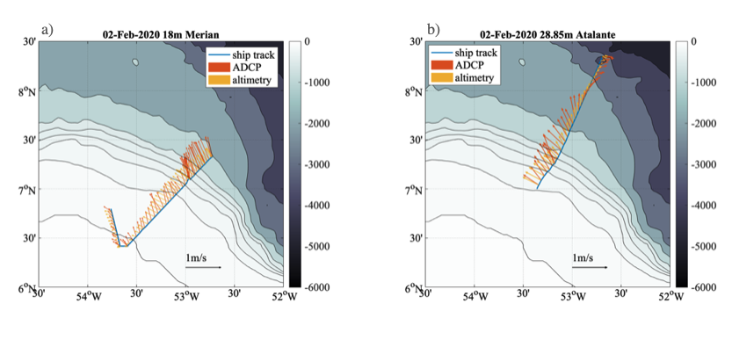

Figure S2a: Geostrophic velocities from altimetry interpolated along the MSM track (a) and RV Atalante (b) for the 2nd of February 2020 (yellow arrows). Red arrows represent the top bin velocities from the MSM (18m, a) and the Atalante VM-ADCP (28.85m, b).

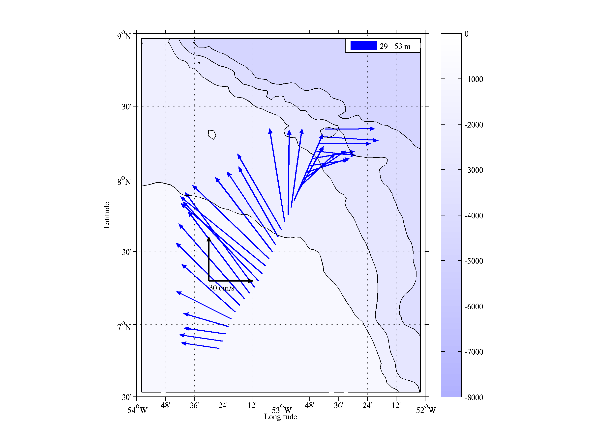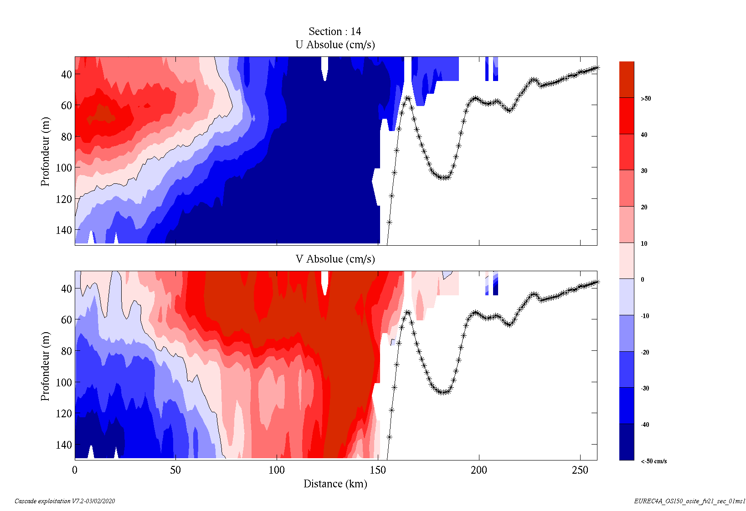

Figure S2b: Current section of RV Atalante on Feb 2 2020. The vertical sections for the two velocity components between 29m and 150m are shown on the right side (notice that shore is to the right), whereas the average currents are plotted on the left map. Notice that it does not extend south to the latitude of the surface front.

**Supporting Information S3: freshwater plumes in 2010-2019**

We illustrate (Fig. S3) weekly SSS for all occurrences of fresh plumes extending at least to 10°N and east of 56°W in January-March 2010-2019 (note that 2010, 2011 and 2013 don’t have events). The weekly SSS fields are generated by the Climate Change Initiative Sea Surface Salinity (CCI+SSS) project (doi:10.5285/4ce685bff631459fb2a30faa699f3fc5). For each event, the week retained corresponds to peak extension of the fresh plume. Notice that most of these plumes suggest the presence of an anticyclone to its east.

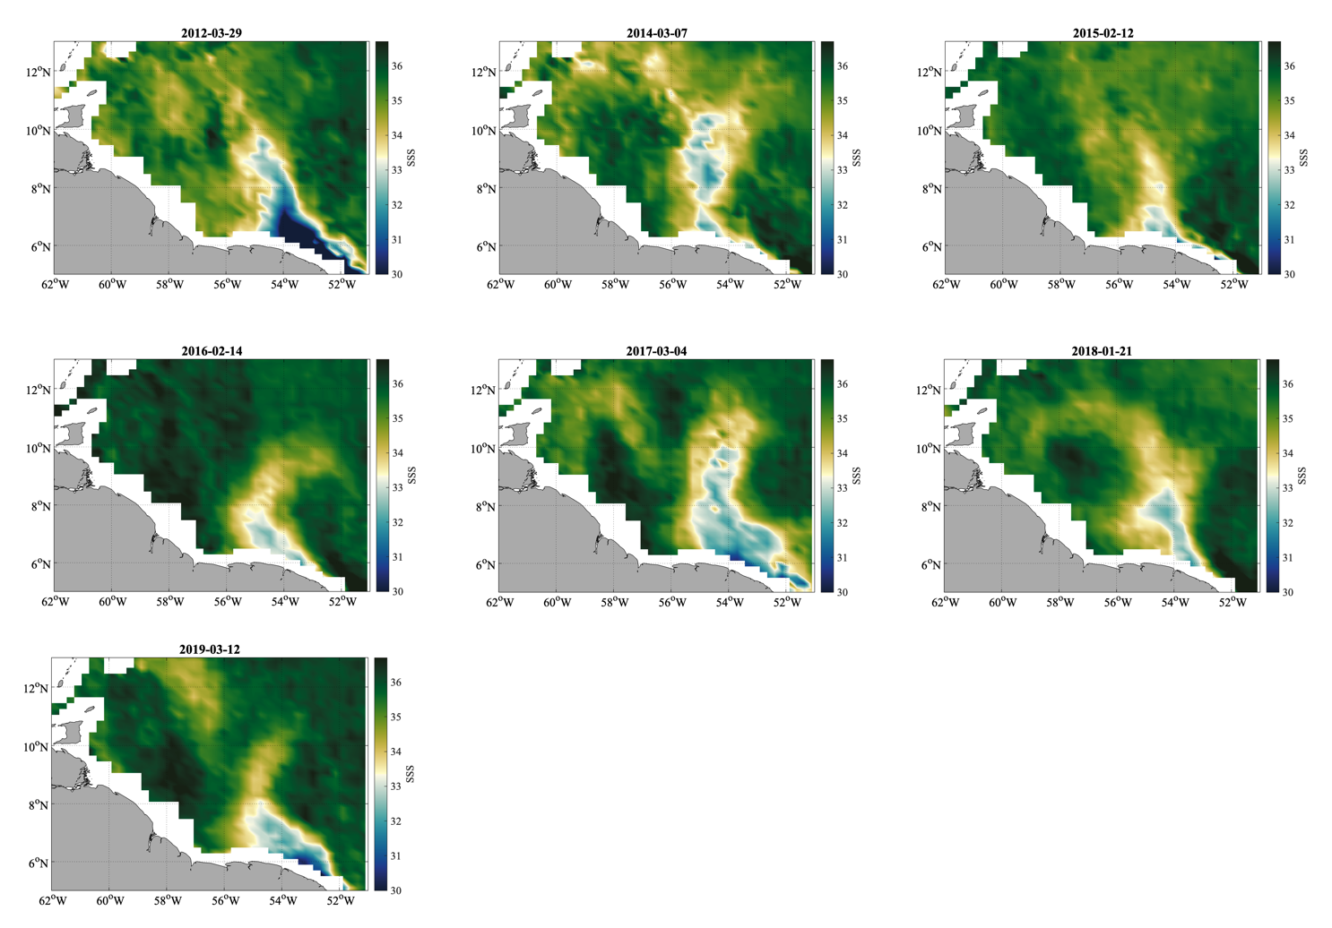

**Supporting information S4: MSM salinity section on Feb 2 2020**

This figure (S4) complements Fig. 7c (the dotted line here corresponds to the fresh water layer thickness of Fig. 7c). The salinity section combines uCTD profiles south of 53°15’W (squares on top axis) and MVP profiles further west (ticks on top axis). The dashed vertical line corresponds to the surface front location.

