[Geophysical Research Letters]
Supporting Information for
Revisit the vertical structure of the eddies and eddy-induced transport in the Leeuwin Current system
Yinghui He^{1, 3}, Ming Feng², Jieshuo Xie^{1, 3}, Qingyou He^{1, 3}, Junliang Liu^{1, 3}, Jiexin Xu^{1, 3}, Zhiwu Chen^{1, 3}, Ying Zhang^{1, 3} and Shuqun Cai^{1, 3, 4}*
¹ State Key Laboratory of Tropical Oceanography, South China Sea Institute of Oceanology, CAS, 164 West Xingang Road, Guangzhou 510301, China
² CSIRO Oceans and Atmosphere, Floreat, Western Australia, Australia
³ Southern Marine Science and Engineering Guangdong Laboratory (Guangzhou), Guangzhou 511458, China
⁴ University of Chinese Academy of Sciences, Beijing, 100049, China

Contents of this file

Text S1 to S3
Figure S1 to S6

Introduction
This supporting information is to provide details of methods to composite SSTA and calculate the eddy-induced volume transport, figures of Root Mean Square Error, climatological salinity profile, validation for geostrophic velocity, T-S diagram, eddy volume transport and SST climatology.
- Relationship between the goodness of regression and its coefficients
- Estimation of the eddy-induced volume transport
- Methods to composite SSTA
- Root Mean Square Error and its percentages of signal variance
- Climatological salinity profile and its vertical gradient
- Validation for geostrophic velocity
- T-S diagram in the averaged eddies
- Eddy volume transport
- SST climatology and its horizontal gradient
Text S1.
In a bivariate linear regression:
$$\begin{aligned}y=ax_{1}+bx_{2}+c+ε,\end{aligned}$$
where $x_{1}$ and $x_{2}$ are independent variables, $y$ is the dependent variable, $ε$ is the error term, $a$, $b$ and $c$ are unknown parameters. The predicted value is
$$\begin{aligned}\hat{y}=ax_{1}+bx_{2}+c.\end{aligned}$$
If $x_{1}$, $x_{2}$ and $ε$ are linearly independent, the correlation of $y$ and $\hat{y}$ is:
$$\begin{aligned}r\left(y,\hat{y}\right)=\frac{Cov\left(y,\hat{y}\right)}{\sqrt{Var\left[y\right]Var\left[\hat{y}\right]}}=\frac{1}{\sqrt{1+\frac{ε^{2}}{a^{2}∙Var\left[x_{1}\right]+b^{2}∙Var\left[x_{2}\right]}}},\end{aligned}$$
where $Cov(y,\hat{y})$ is the covariance of $y$ and $\hat{y}$, $Var[y]$ is the variance of $y$. In this study, $x_{1}$ and $x_{2}$ are the eddy-induced and background SSHA, which are approximately linearly independent. Therefore, the correlation coefficient $r\left(y,\hat{y}\right)$ can be determined by the square of regression coefficients and error term.

Text S2.
Calculation of $\vec{u_{d}}$ and $Γ_{trap}(z)$.
$\vec{u_{d}}:$ For an eddy e₁, if its centroid is at (x₁, y₁) at time t₁, and moves to (x₂, y₂) at the consecutive time t₂, the drift velocity at time t₁ is calculated as,
$$\vec{u_{d}}=\left(\frac{x_{2}-x_{1}}{t_{2}-t_{1}},\frac{y_{2}-y_{1}}{t_{2}-t_{1}}\right)$$
$Γ_{trap}(z)$: On a closed streamline $Γ(z)$ in eddy e₁, if $U(z)≥\left|\vec{u_{d}}\right|$, the fluid enclosed by this streamline can be trapped by eddy e₁. U(z) is the mean rotation speed on $Γ(z)$, which is calculated by equations (24) and (25). The closed streamline is replaced by the closed SLA contour for simplification. Therefor, $Γ_{trap}(z)$ is the outmost closed streamline satisfied $U(z)≥\left|\vec{u_{d}}\right|$.
For example, at a given depth z₀, there are three conditions as follows:
- If at the eddy edge line $U_{edge}(z_{0})≥\left|\vec{u_{d}}\right|$, the $Γ_{trap}(z_{0})$ is the eddy edge line.
- If $U_{spd}(z_{0})<\left|\vec{u_{d}}\right|$ at the eddy speed periphery, which is defined as the streamline in the eddy with maximal mean rotational speed, $Γ_{trap}(z_{0})$ is an empty set.
- If $U_{edge}\left(z_{0}\right)<\left|\vec{u_{d}}\right|≤U_{spd}(z_{0})$, we can find a outmost streamline $Γ_{trap}(z_{0})$ between the eddy speed periphery and eddy edge line, on which $U_{trap}\left(z_{0}\right)=\left|\vec{u_{d}}\right|$.
Text S3.
The pattern of eddy-induced SSTA is related to the direction of large-scale background SST gradient (Gaube et al., 2015). The climatological SST gradient is northwestward near coast but northeastward offshore (Supplementary Figure S6). The composite eddy-induced SSTA (Figure 7) was constructed in a rotated eddy-centered coordinate system. For each eddy realization, first we calculated the average background SST gradient within the eddy periphery. Then we rotated SSTA field around the eddy center to align the averaged background SST gradient to equatorward. Finally, we cut off a square of SSTA field whose center is the eddy center and whose side is 4R, where R is the eddy radius, and then normalized the length by R, thus we got a rotated and length-normalized SSTA field for this eddy realization. After all the eddy realizations were processed, the SSTA fields were composited according to the eddy polarity (Figures 7a, b).

Figure S1. Root Mean Square Error (solid lines in upper panels) and error variance as percentages of signal variance (lower panels) of density (left), temperature (middle) and salinity (right). For comparison, the standard deviation of Argo observed density, temperature and salinity are showed as solid lines in upper panels. Blue (red) lines denote values for CEs (AEs).

Figure S2. Vertical profile of regional averaged salinity (black line) and its vertical gradient (red solid line).
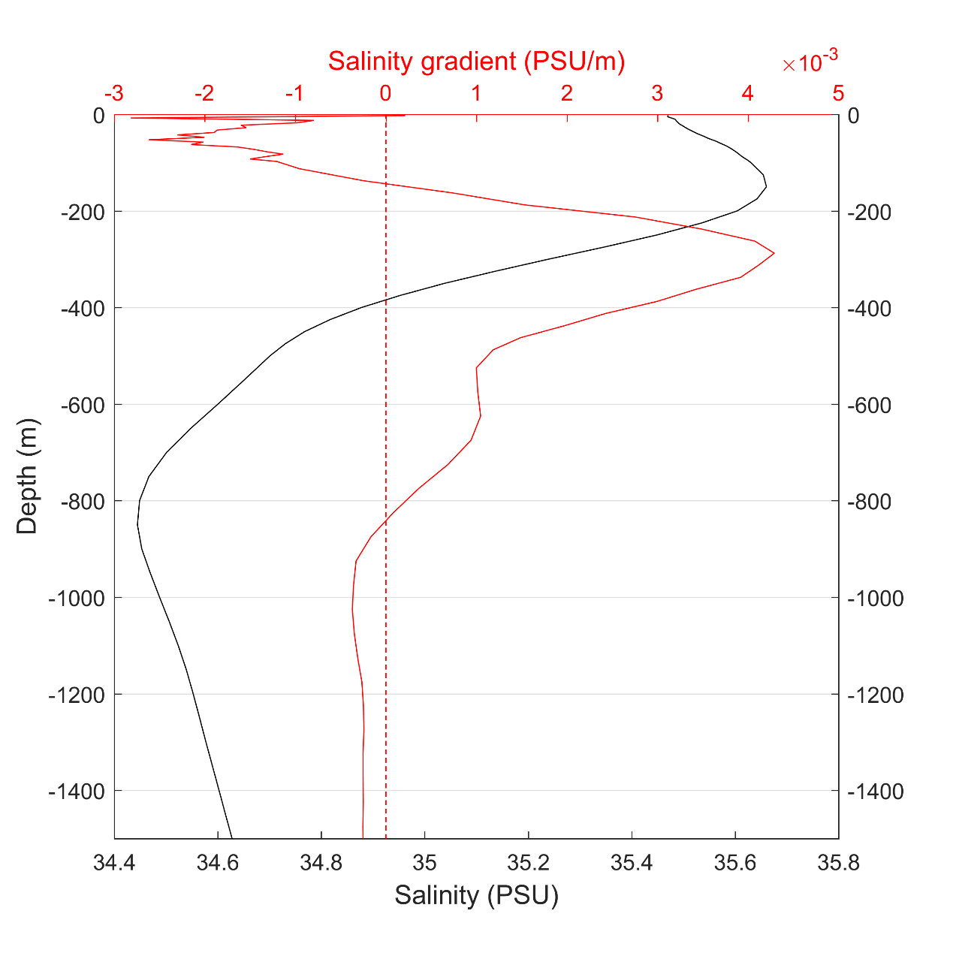

Figure S3. The reconstructed (left panels) and in-situ observed (right panels) vertical profile of azimuthal velocity of the AE (upper panels) and CE (lower panels) in October 10, 2003. (b) and (d) are adapted from Feng et al. (2007).

Figure S4. temperature-salinity relationship estimated from the region averaged profile of WOA2013 (green dots) and the reconstructed average AE (red dots) and CE (blue dots).
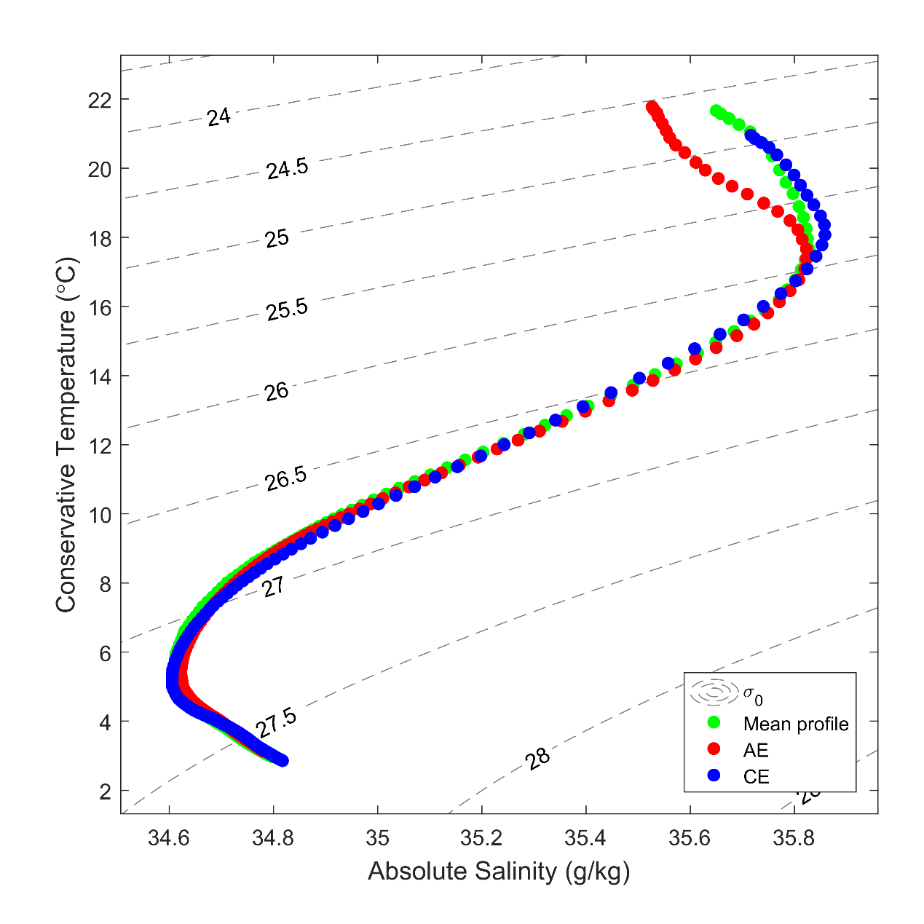

Figure S5. Eddy-induced volume transport (m²/s, vectors) and magnitude (m²/s, color shading) of all eddies. The trapping depth of each eddy is estimated using the average eddy propagation velocity.
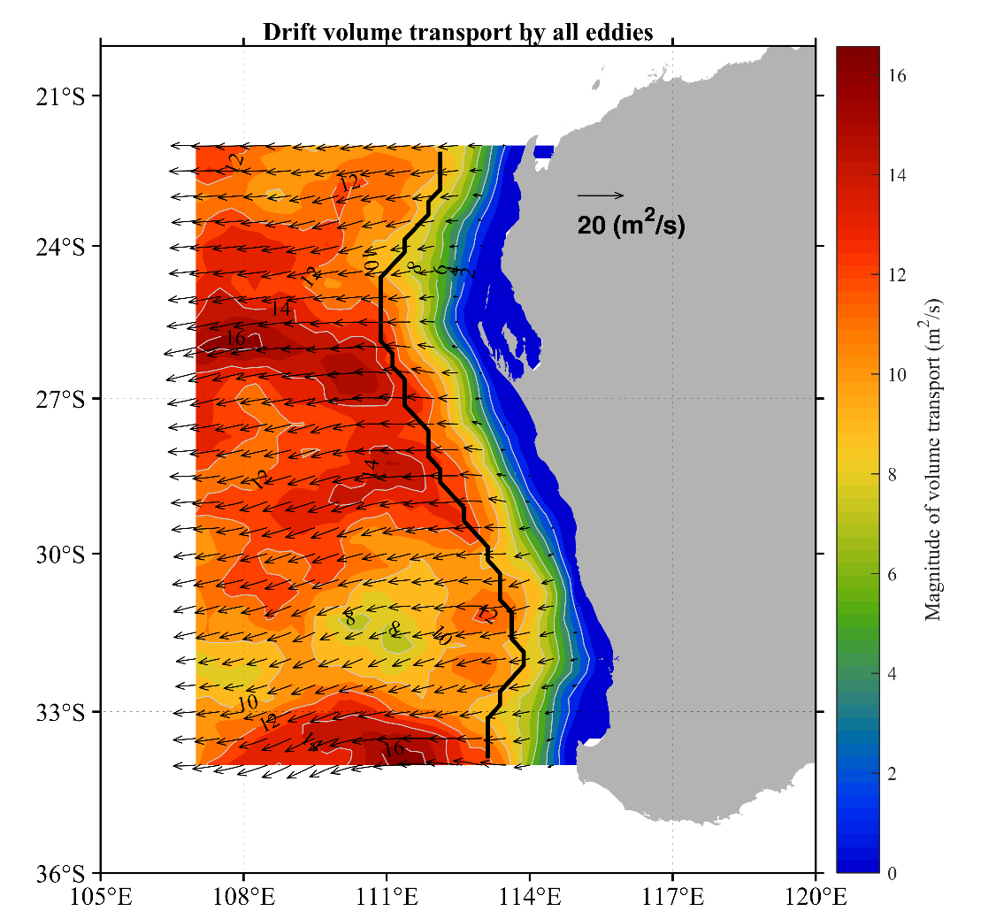
Figure S6. Distribution of climatological mean SST (unit in °C, color shaded) from 1993 to 2016 and its gradient (in white arrow).
