Geophysical Research Letters
Supporting Information for
Chlorophyll-based model to estimate underwater Photosynthetically Available Radiation for modeling, in-situ and remote-sensing applications
Xiaogang Xing¹, Emmanuel Boss²
1 State Key Laboratory of Satellite Ocean Environment Dynamics, Second Institute of Oceanography, Ministry of Natural Resources, Hangzhou, China
2 School of Marine Sciences, University of Maine, Orono, Maine, USA

Contents of this file

Text S1 to S2
Figures S1 to S8
Table S1 to S2

Introduction
This file contains supporting texts, figures and tables.
Text S1 describes the Uitz06 Chla profile estimate model from surface Chla. Test S2 describes the quality control procedures of float-observed Chla.
Figure S1 shows the BGC-Argo data distribution map. Figure S2 and S3 shows the flow chart of GCMM model and Uitz06 Chla profile model, respectively. Figure S4 shows the consistency test of satellite-retrieved K_{d}(iPAR,MLD/2) compared to the observed ones. Figure S5 and S6 show the sensitivity of the models to the solar zenith angle. Figures S7 shows the vertical distribution of averaged relative error for four PAR models in different regions. Figure S8 compares float-observed K_{d}(iPAR,MLD/2) to satellite-estimated ones with the GCMM model in the Southern Ocean, and shows that there is no systematic bias of satellite Chla retrieval.
Table 1 lists the criteria for regionalization of BGC-Argo data and profile numbers. Table 2 shows all the empirical coefficients used in the Uitz06 model.

Text S1. Uitz06 Chla profile model
Uitz et al. (2006) proposed a Chla profile estimate model derived from surface Chla and MLD. In this study, we modify slightly in the euphotic depth (z_{1%}) retrieval as shown in Figure S3. z_{1%} is first derived from satellite surface Chla based on Morel et al. (2007):
(S1)
where, X = log₁₀(Chla_{Sat}). Then, the model compares z_{1%} and MLD to identify the water types defined by Uitz et al. (2006). If z_{1%} > MLD, the Chla profile is assumed to have a DCM, and its shape normalized by z_{1%} and by the averaged Chla in the z_{1%} is defined as c(ζ):
(S2)
where, ζ represents z/z_{1%}, the depth-integrated Chla from surface to z_{1%} (<Chla>_{z1%}) is determined through Eq. (S3):
(S3)
and c(ζ) profile is estimated by an Gaussian-like function (Eq. S4) and five surface-Chla-dependent empirical coefficients (C_{b}, s, C_{max}, ζ_{max} and Δζ) are listed in Table S2.
(S4)
Finally, the Chla(ζ) profile is retrieved from Eq. S2, and then converted to the one at absolute depths, i.e. Chla(z). When z_{eu} ≤ MLD, the model assumes an homogenous Chla profile, i.e., Chla(z) = Chla_{Sat} in the whole water column.

Text S2. Float Chla quality control
Fluorescent-based chlorophyll-a concentration (FChla) data measured on BGC-Argo are quality controlled following Schmechtig et al. (2018), including a dark correction and a non-photochemical quenching (NPQ) correction (Xing et al., 2012, denoted by FChla_{NPQcor}). To avoid the problem associated with conversion of FChla to Chla at different locations (e.g. Roesler et al., 2017), we use satellite observations to scale the float’s profiles over its lifetime (e.g. Boss et al., 2008). For each profile with valid matchup MODIS Chla product (Chla_{Sat}, see Section 2.2), the ratio of the upper 10m averaged NPQ-corrected FChla to Chla_{Sat} is calculated; and then a single scale-factor (SF), is derived as the median value of all-profile ratios for each float:
. (S5)
where, i represents the profile number. Following this exercise the profiles of each float are recomputed as:
(S6)
where, Chla(z) represents the depth profile of ocean-color-scaled chlorophyll-a concentration. In this study, it is used for GCMM_{prof} model to retrieve the iPAR profile (Figure S2).

References
Boss, E., Swift, D., Taylor, L., Brickley, P., Zaneveld, R., Riser, S., et al. (2008). Observations of pigment and particle distributions in the western North Atlantic from an autonomous float and ocean color satellite. Limnol. Oceanogr., 53, 2112–2122.
Morel, A., Huot, Y., Gentili, B., Werdell, P. J., Hooker, S. B., & Franz, B. A. (2007). Examining the consistency of products derived from various ocean color sensors in open ocean (Case 1) waters in the perspective of a multi-sensor approach. Remote Sens. Environ., 111, 69-88.
Roesler, C. S., Uitz, J., Claustre, H., Boss, E., Xing, X., Organelli, E., et al. (2017). Recommendations for obtaining unbiased chlorophyll estimates from in situ chlorophyll fluorometers: A global analysis of WET Labs ECO sensors. Limnol. Oceanogr. Meth., 15, 572–585.
Schmechtig, C., Claustre, H., Poteau, A., & D'Ortenzio, F. (2018). Bio-Argo quality control manual for the Chlorophyll-A concentration. https://doi.org/10.13155/35385.
Uitz, J., Claustre, H., Morel, A., Hooker, S. B. (2006). Vertical distribution of phytoplankton communities in open ocean: An assessment based on surface chlorophyll. J. Geophys. Res., 111, C08005.
Xing, X., Claustre, H., Blain, S., D’Ortenzio, F. Antoine, D., Ras, J., & Guinet, C. (2012). Quenching correction for in vivo chlorophyll fluorescence acquired by autonomous platforms: A case study with instrumented elephant seals in the Kerguelen region (Southern Ocean). Limnol. Oceanogr. Methods, 10, 483–495.

Figures
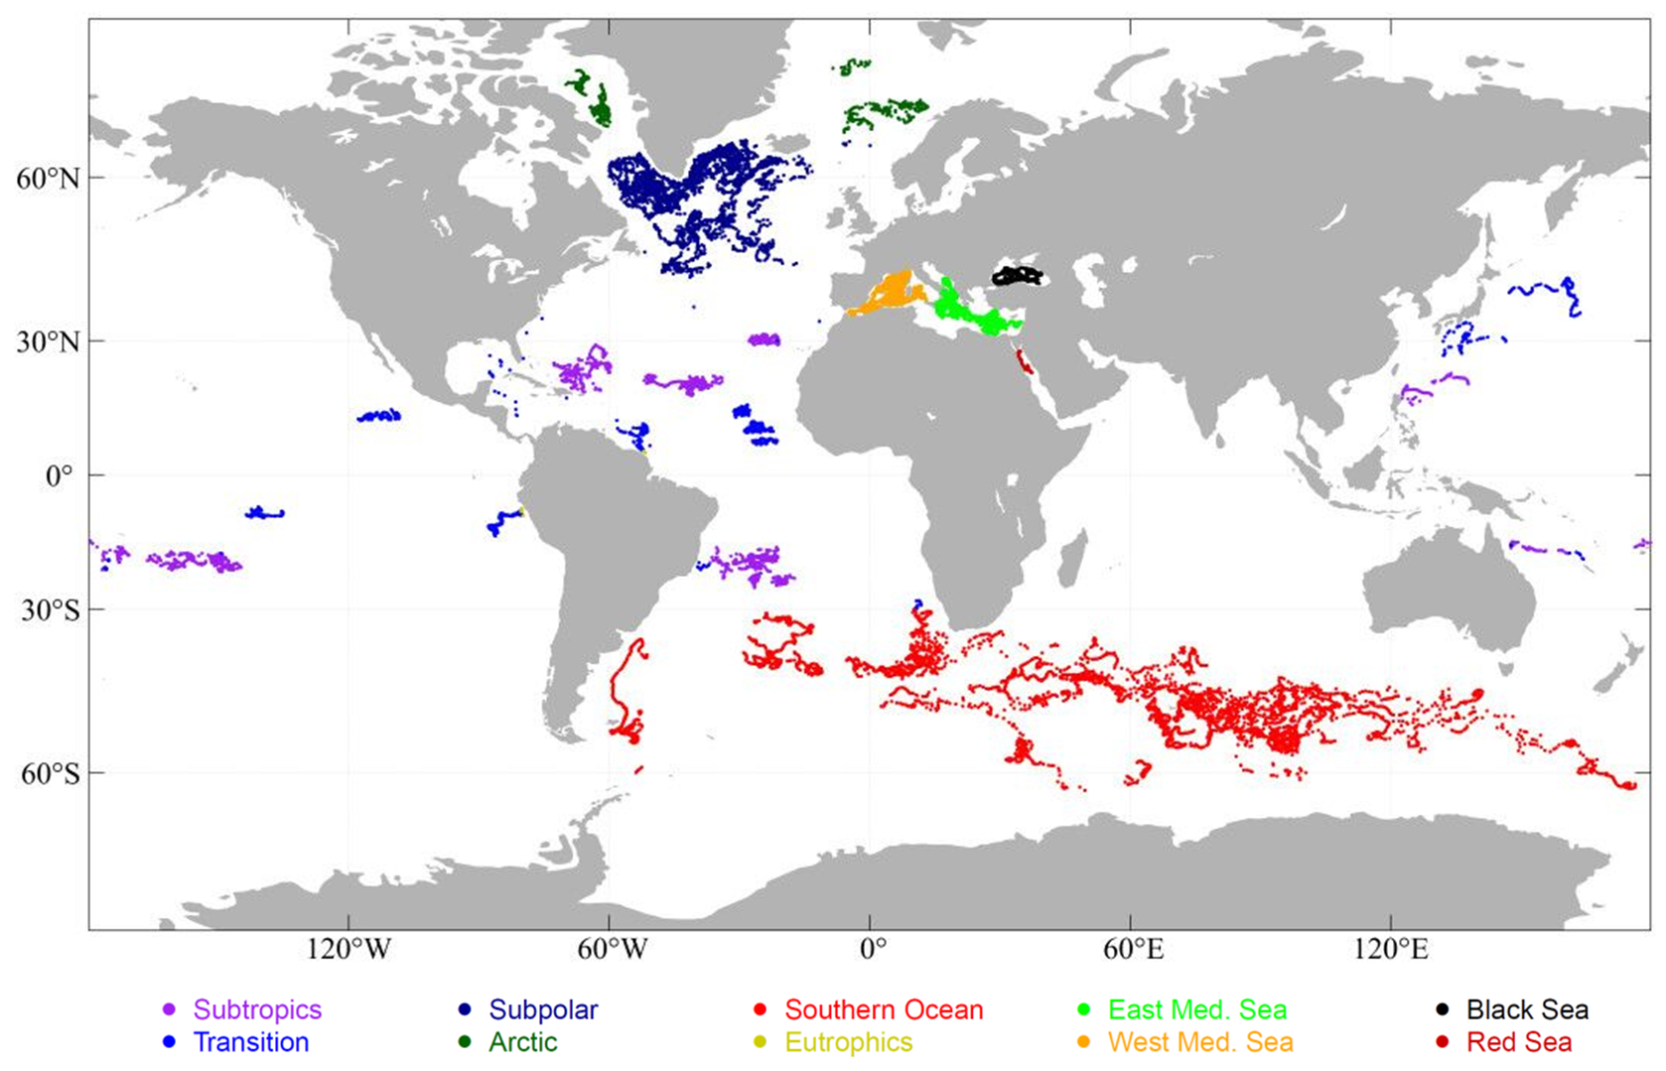

Figure S1. Distribution map of BGC-Argo radiometry data from October 2012 to March 2020 (23,674 profiles with Flag-1 or Flag-2 PAR data). The regions include the Arctic Ocean, Southern Ocean (SO), North Atlantic Subpolar gyre, Subtropical gyres, Eutrophic area, Transition region, western Mediterranean Sea (West Med Sea), eastern Mediterranean Sea (East Med Sea), Black Sea and Red Sea.

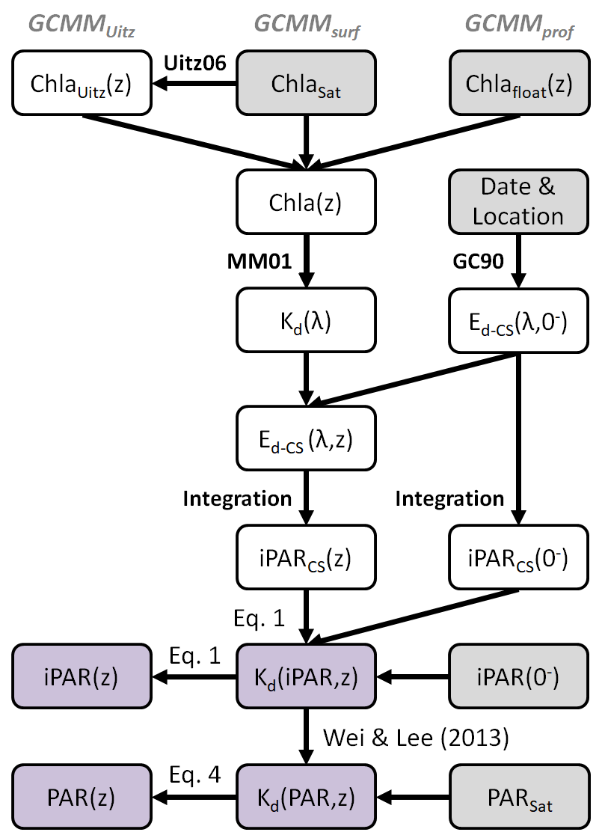

Figure S2. Flow chart of GCMM PAR model; MM01 represents the empirical hyper-spectral Chla-K_{d}(λ) relationships of Morel & Maritorena (2001); GC90 represents the clear-sky sea-surface downwelling irradiance model of Gregg & Carder (1990), CS represents the “clear-sky”; GCMM represents the model combining GC90 and MM01 as the Chl-based K_{d}(iPAR) retrieval method. Grey rectangles represent the model inputs, and purple ones represent outputs. Chla_{Sat} and Chla_{float}(z) represent the satellite-retrieved sea-surface Chla and float-observed Chla profile, respectively.
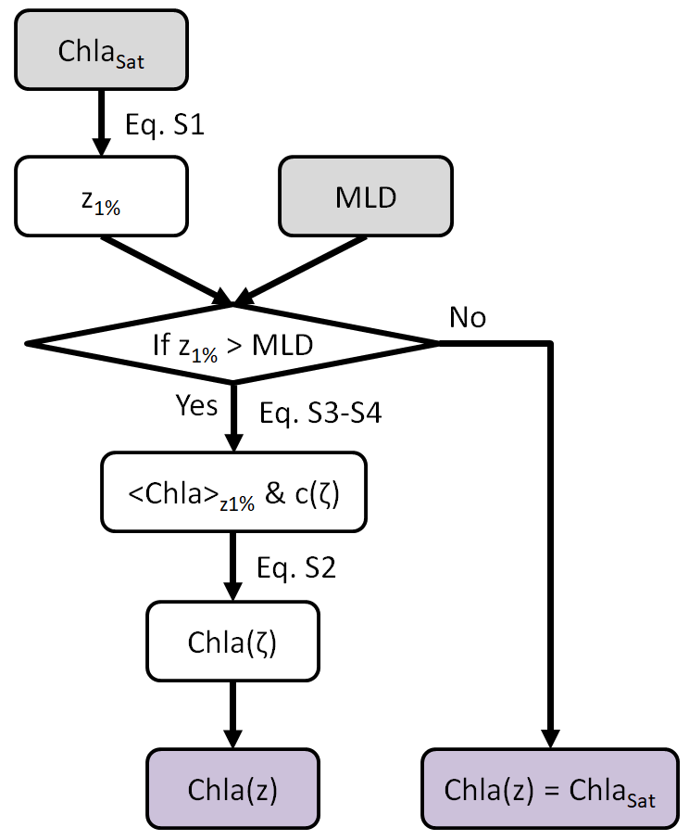

Figure S3. Flow chart of Uitz06 Chla profile model. Grey rectangles represent the model inputs, and purple ones represent outputs.
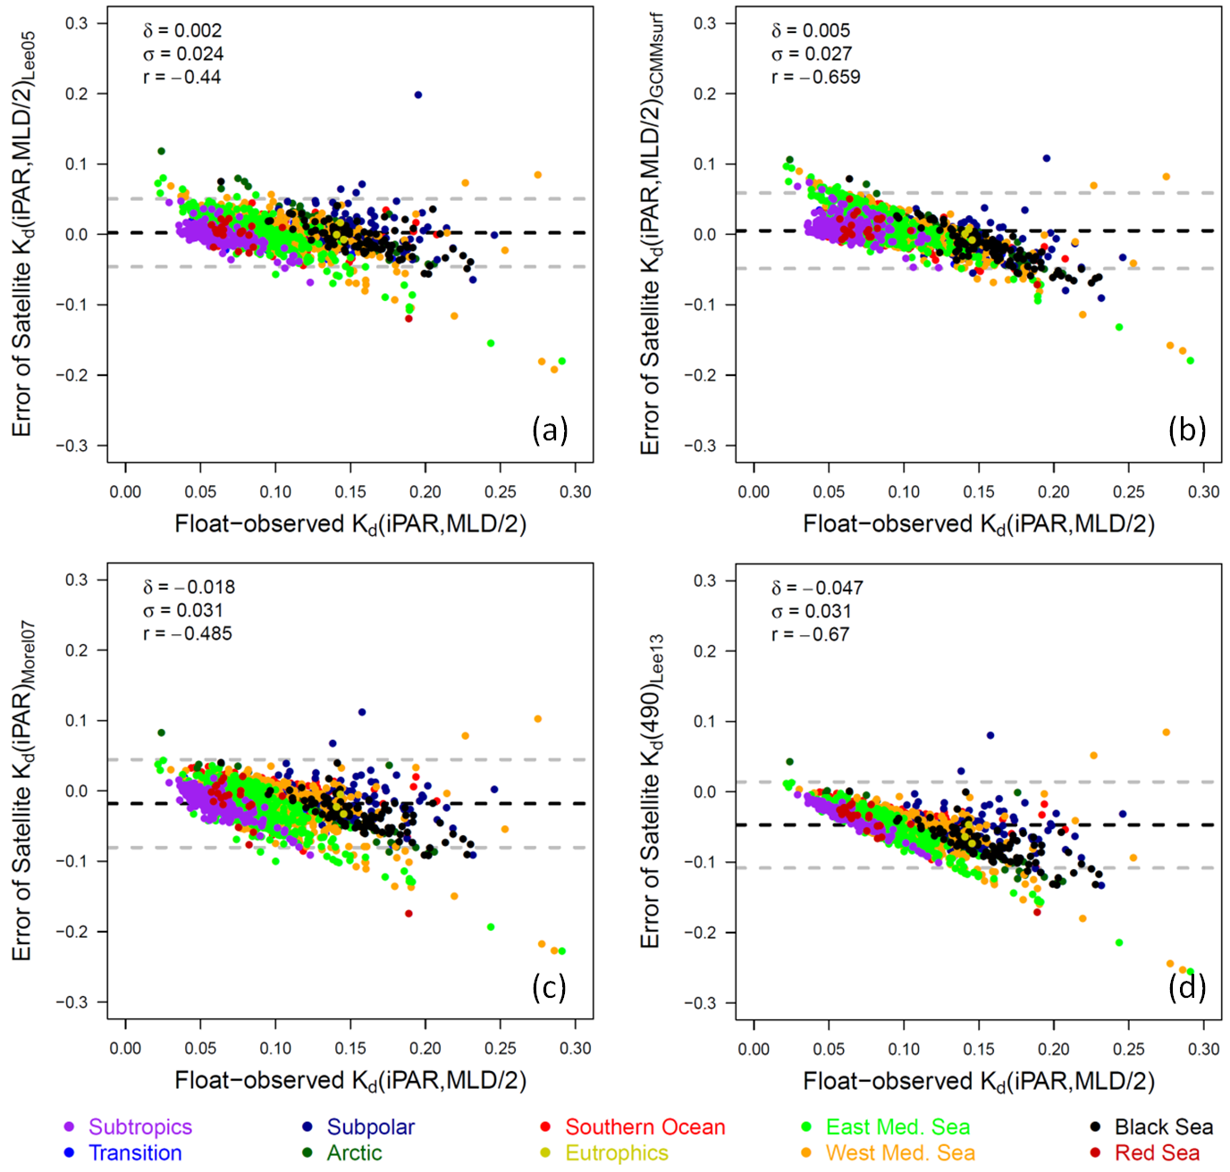

Figure S4. Consistency test between float-observed K_{d}(iPAR, MLD/2) vs. satellite-estimated ones with different models. (a) Lee05 model (Lee05), (b) GCMM model (GCMM_{surf}), (c) Morel07’s empirical K_{d}(490)-K_{d}(iPAR) relationship (Morel07), and (d) K_{d}(490) derived from Lee et al. (2013, Lee13) as the proxy. y axis is the error of each model, black dashed line represents the averaged error (δ), grey dashed lines represent the averaged error +/- 1.96*standard deviation of error (σ), r represents the correlation coefficient between float-observed K_{d}(iPAR, MLD/2) and the errors of each model.
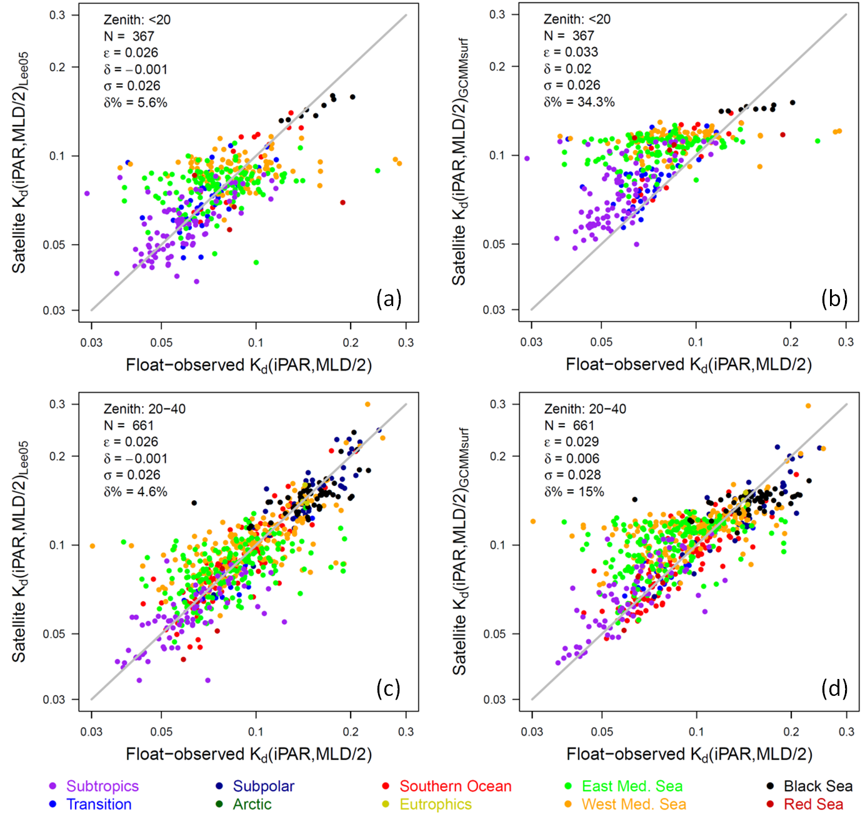

Figure S5. Scatter plot between float-observed K_{d}(iPAR, MLD/2) vs. satellite-estimated ones with the Lee05 model (Lee05, a & c) and GCMM model (GCMM_{surf}, b & d), for the zenith angle range of < 20° (a & b) and 20-40° (c & d), respectively.
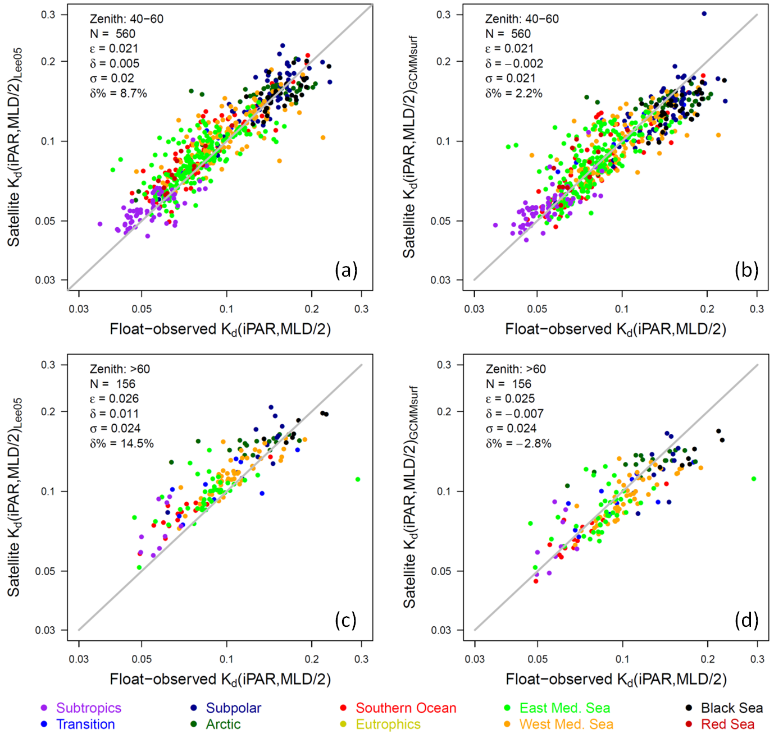

Figure S6. As same as Figure S5, but for the zenith angle range of 40-60° (a & b) and >60° (c & d), respectively.

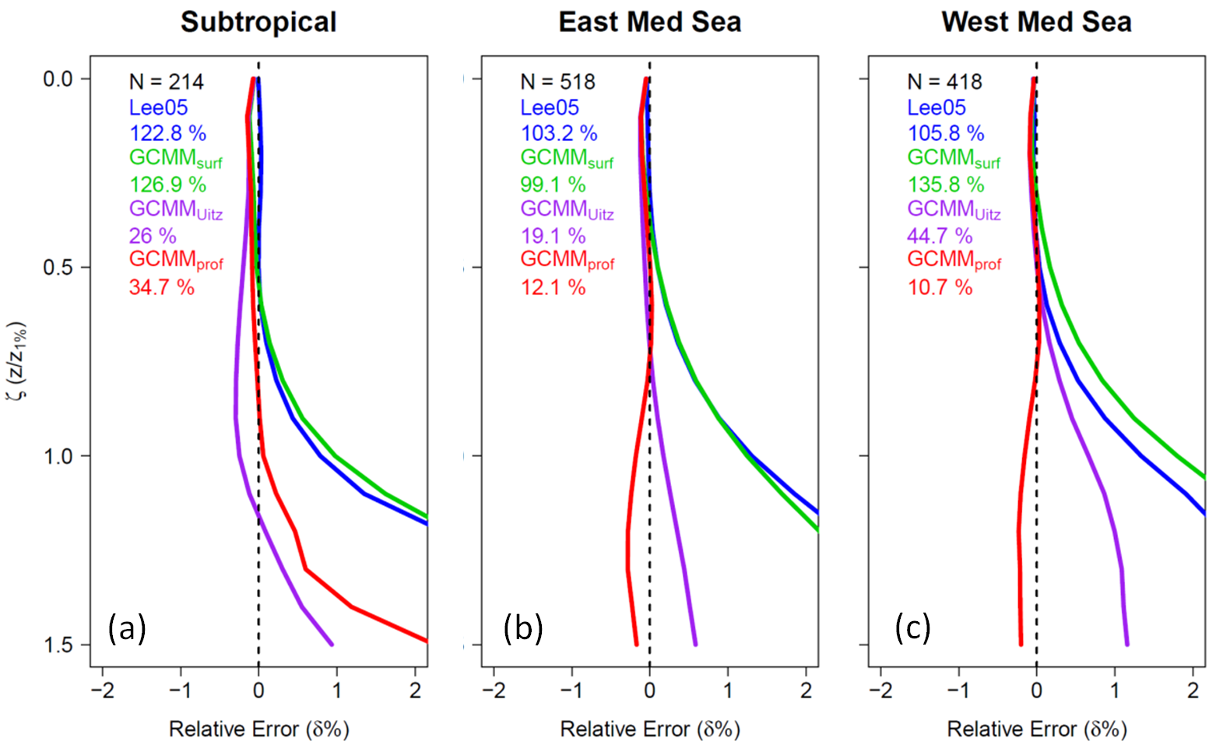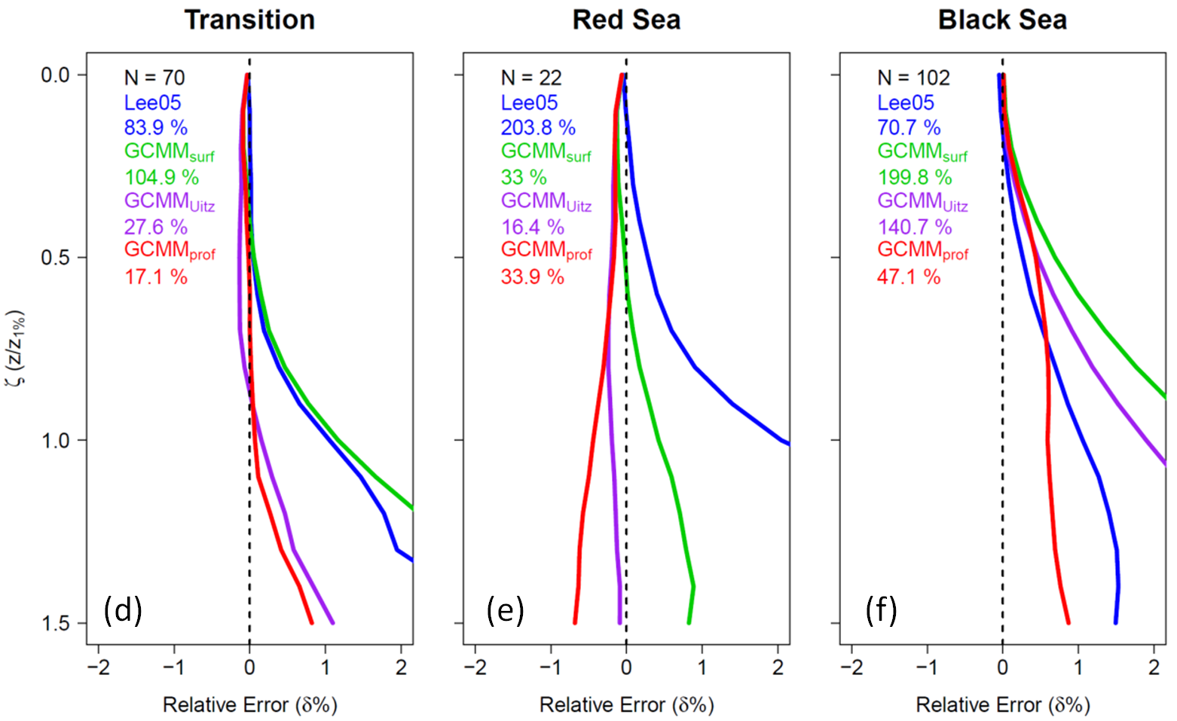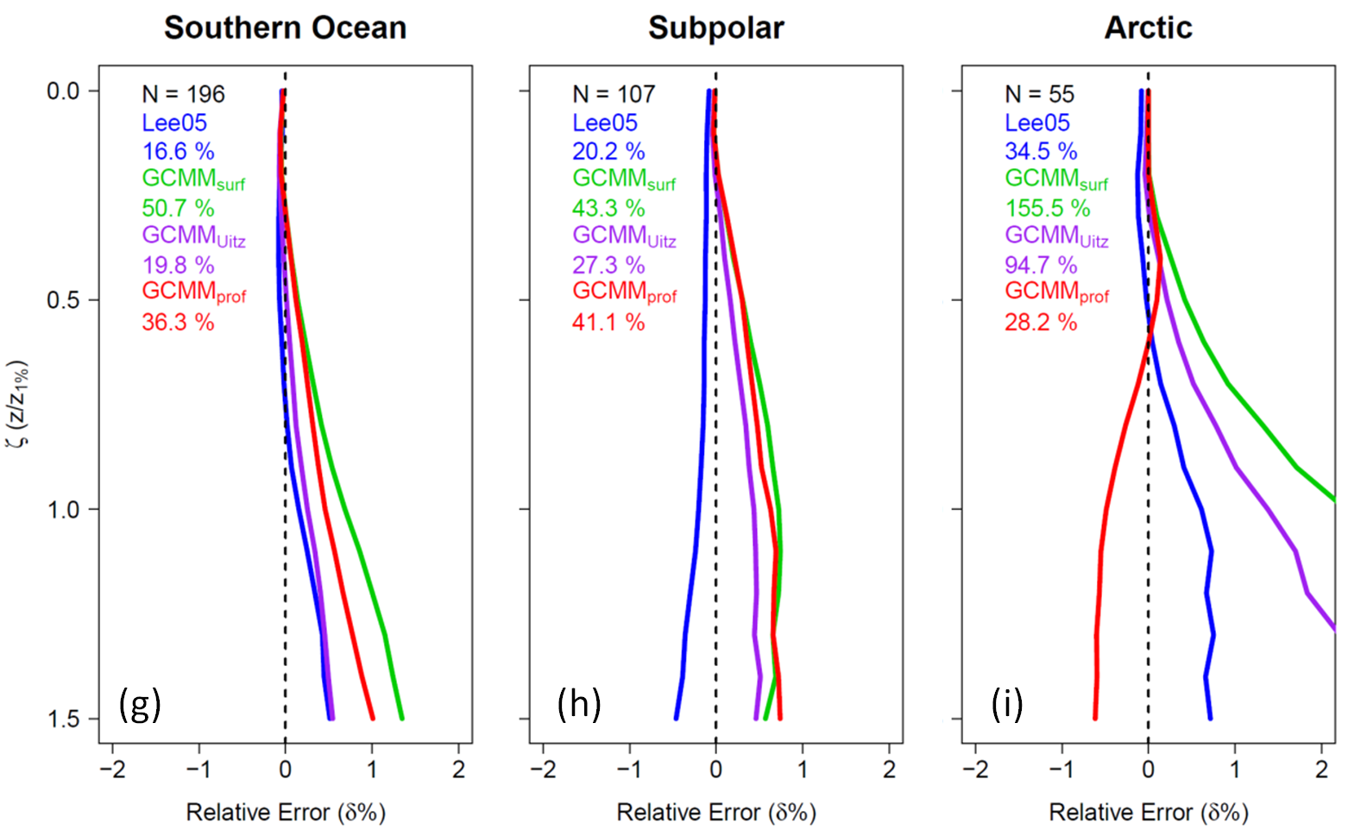

Figure S7. Averaged relative error (δ%) at each depth normalized by z_{1%} in different regions, for four estimated iPAR by the model satellite IOPs-based Lee05 (blue), satellite Chla-based GCMM_{surf} (green), satellite Chla and Uitz06-based GCMM_{Uitz} (purple) and float Chla-based GCMM_{prof} (red). The numbers in legend represent the relative error (δ%) averaged from surface to the 1.5-fold 1% light level depth (1.5z_{1%}). (a) Subtropical gyres, (b) Eastern and (c) Western Mediterranean Sea, (d) Transition areas, (e) Red Sea, (f) Black Sea, (g) the Southern Ocean, (h) Subpolar, and (i) the Arctic Ocean
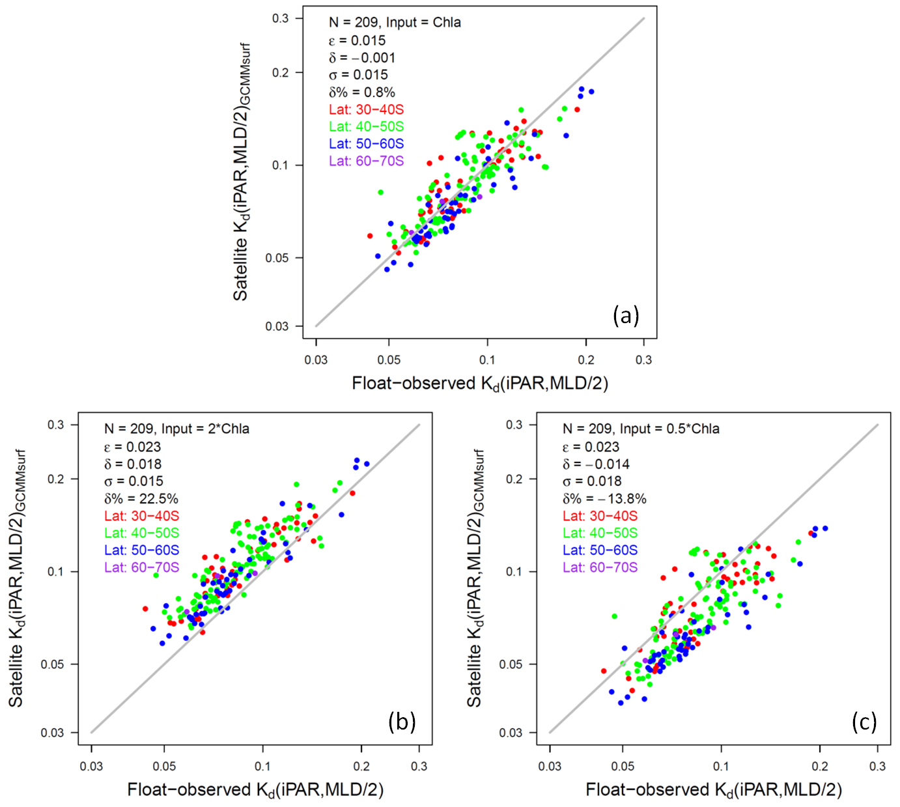

Figure S8. Scatter plot between float-observed K_{d}(iPAR,MLD/2) vs. satellite-estimated ones with the GCMM_{surf} model in the Southern Ocean, Input are satellite Chla (a), 2-fold Chla (b), and half Chla (c), respectively. Different colored points represent ones within different latitude ranges: 30-40°S (red), 40-50°S (green), 50-60°S (blue), and 60-70°S (purple).

Tables

Table S1. Criteria for regionalization and number of Flag-1 or 2 iPAR profiles
Region | Criteria | Profile Num of iPAR*
Arctic | Lat > 66 | 1,381 (60)
SO | Lat < -30 | 5,958 (209)
Subpolar | Lat > 42.6 & Lat < 66 & Chla** > 0.3 | 3,634 (111)
Transition | Lat > 42.6 & Lat < 66 & Chla > 0.1 & Chla < 0.3  Lat > -30 & Lat < 42.6 & Chla > 0.1 & Chla < 3 | 1,860 (74)
Subtropical | Lat > -30 & Lat < 42.6 & Chla < 0.1 | 2,832 (227)
Eutrophic | Lat > -30 & Lat < 42.6 & Chla > 3 | 35 (3)
West Med | Lat > 35 & Lat < 45 & Lon > -4 & Lon < 14 | 3,303 (420)
East Med | Lat > 31 & Lat < 43 & Lon > 15 & Lon < 35 | 3,756 (515)
Black Sea | Lat > 41 & Lat < 45 & Lon > 28 & Lon < 40 | 708 (104)
Red Sea | Lat > 15 & Lat < 30 & Lon > 30 & Lon < 45 | 207 (21)
TOTAL |  | 23,674 (1,744)
* The number in parentheses represents the profiles with valid iPAR(0⁻) obtained and valid match-up
satellite Chla and R_{rs} data
** Chla here represents the MODIS-Aqua annual climatology chlorophyll-a concentration data

Table S2. Coefficients in the Uitz06 model (Eq. S4)
Type | Criterion | C_{b} | s | C_{max} | ζ_{max} | Δζ
1 | Chla_{Sat} < 0.04 | 0.471 | 0.135 | 1.572 | 0.969 | 0.393
2 | 0.04 ≤ Chla_{Sat} < 0.08 | 0.533 | 0.172 | 1.194 | 0.921 | 0.435
3 | 0.08 ≤ Chla_{Sat} < 0.12 | 0.428 | 0.138 | 1.015 | 0.905 | 0.630
4 | 0.12 ≤ Chla_{Sat} < 0.20 | 0.570 | 0.173 | 0.766 | 0.814 | 0.586
5 | 0.20 ≤ Chla_{Sat} < 0.30 | 0.611 | 0.214 | 0.676 | 0.663 | 0.539
6 | 0.30 ≤ Chla_{Sat} < 0.40 | 0.390 | 0.109 | 0.788 | 0.521 | 0.681
7 | 0.40 ≤ Chla_{Sat} < 0.80 | 0.569 | 0.183 | 0.608 | 0.452 | 0.744
8 | 0.80 ≤ Chla_{Sat} < 2.20 | 0.835 | 0.298 | 0.382 | 0.512 | 0.625
9 | Chla_{Sat} > 2.20 | 0.188 | 0 | 0.885 | 0.378 | 1.081

