Electronic Supplementary Material

ESM 1: Biometric characteristics of the eleven specimens of Astarte moerchi used for either flesh [fatty acid (n=6)] or shell analyses [growth patterns(n=9), ¹⁸O stable isotopes(n=3), Δ¹⁴C radiocarbon (n=6) with number of samples per shell between parenthesis, trace elements = Ba/Ca (n=3)].

 | Biometry |  |  | Flesh analysis | Shell analyses
Label | Length (mm) | Width (mm) | Thickness (mm) | Fatty Acid (FA) on digestive gland | Growth patterns | δ¹⁸O | Δ¹⁴C | Ba/Ca
A10 | 17.99 | 23.77 | 8.28 | yes
A39 | 21.21 | 26.89 | 9.02 |  | yes |  | yes (2)
A41 | 23.15 | 28.73 | 9.88 | yes | yes | yes
A50 | 22.42 | 28.72 | 10.08 |  | yes |  | yes (3)
A59 | 21.53 | 26.56 | 9.07 |  | yes |  | yes (2)
A73 | 25.62 | 32.19 | 10.95 |  | yes |  |  | yes
A76 | 21.16 | 27.21 | 9.33 |  | yes | yes | yes (2)
A80 | 24.35 | 29.82 | 9.78 | yes | yes |  | yes (3) | yes
A90 | 23.03 | 26.57 | 9.64 | yes | yes |  |  | yes
A94 | 21.00 | 28.02 | 9.98 | yes | yes |  | yes (3)
A98 | 21.53 | 28.41 | 9.67 | yes |  | yes

Priority was given to favor multiple analyses on the same specimen (up to 4).

ESM 2a: Multiple Change Points Years (CPY) detection analyses (Lavielle 2017) performed on the increment width time-series of 9 A. moerchi shells.

Briefly, each time series is considered as a succession of periods whose number and dates of beginning and end (change points) have to be determined, and during which the annual growth of the shell is seen as constant with a random noise. Using a dynamic programming algorithm implemented with R language, we can obtain for each number of expected change points (between 0 and 20), the best estimation of the dates as well as the value of a cost function. We then look at the evolution of the cost function in relation to the number of change points considered (decreasing function). The choice of the number of change points relates on the decrease in the cost function stops being significant (adding a change point does not really lower the value of the cost function). By using this algorithm, we determined year (1 or plus) corresponding to this change point for each shell.

Significant CPY are illustrated by vertical red lines, horizontal blue lines to periods of similar growth regime.

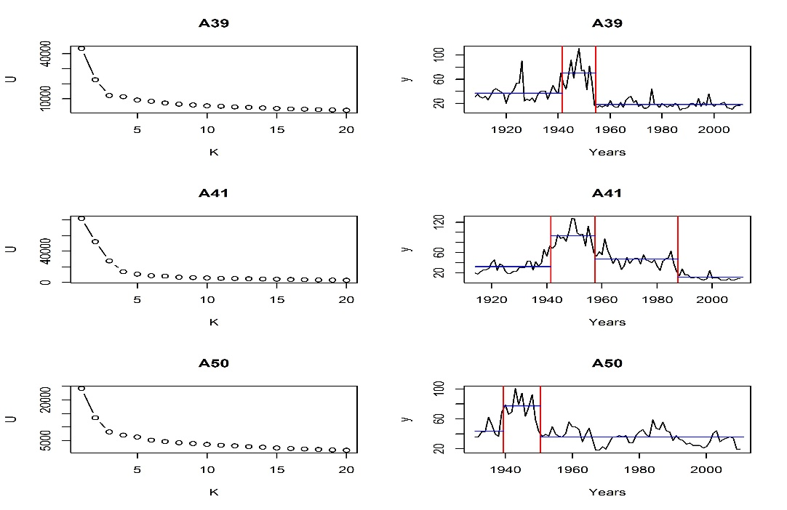

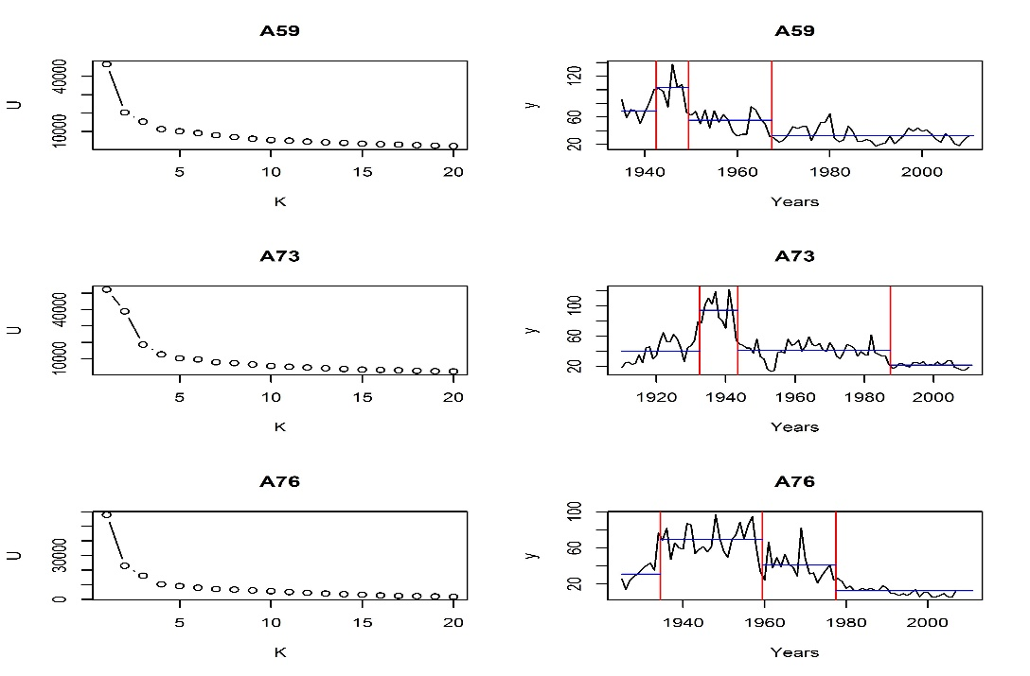
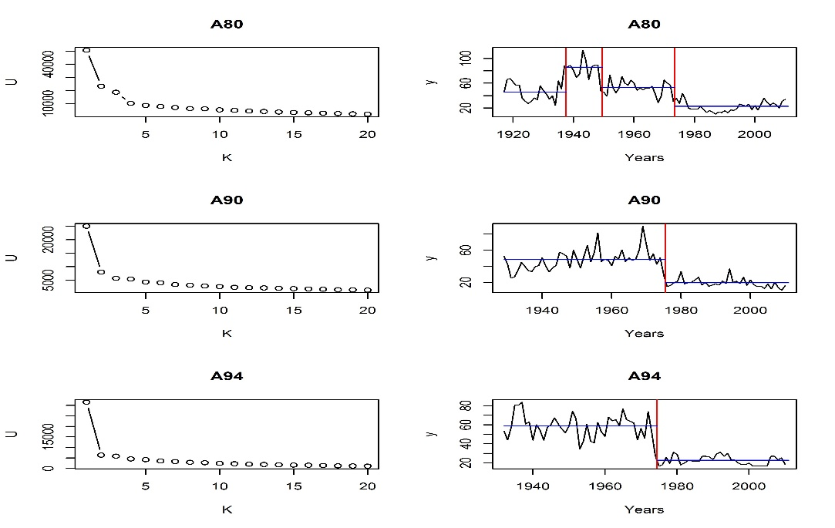

ESM 2b: Multiple Change Points Years (CPY) detection analyses (Lavielle 2017) performed on the Ba/Ca data of 3 A. moerchi shells.

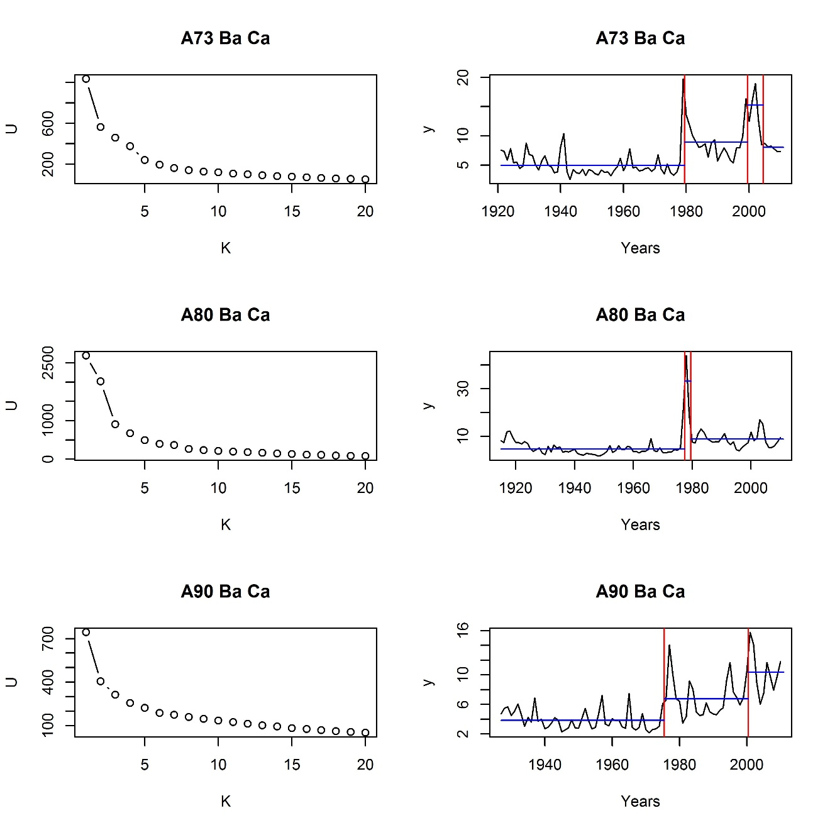

ESM 2c: Single Change Points Years (CPY) detection analyses (Trauth 2015) performed on the increment width time-series of 9 A. moerchi shells (see methods for details). Significant CPY are illustrated by vertical red lines, horizontal blue lines to periods of similar growth regime.

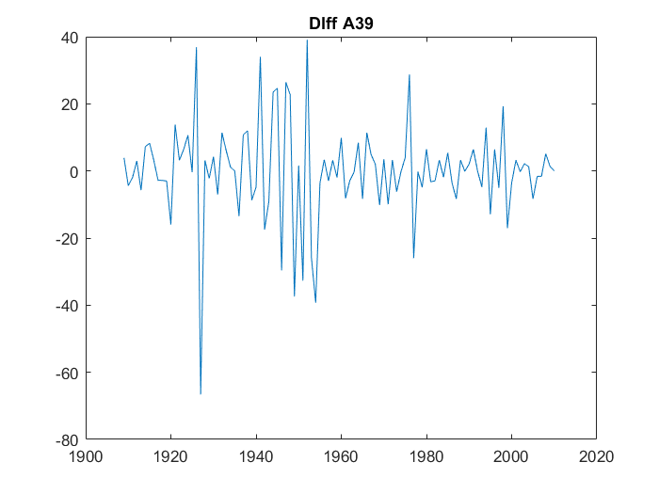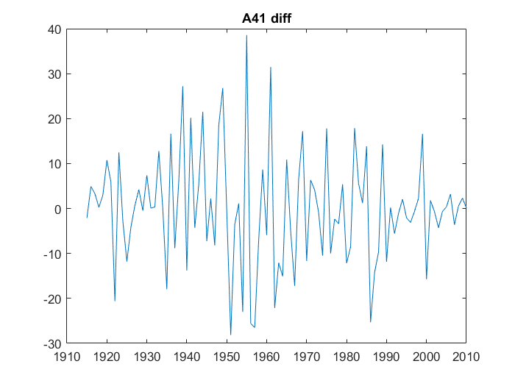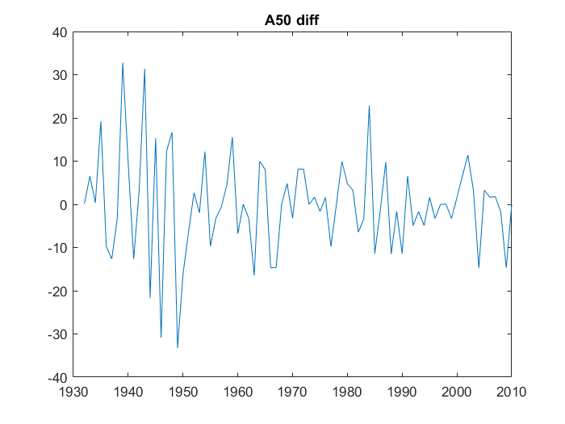

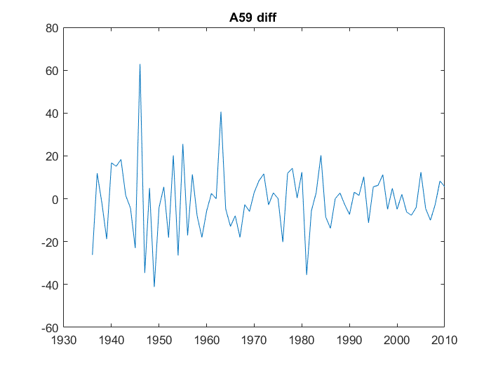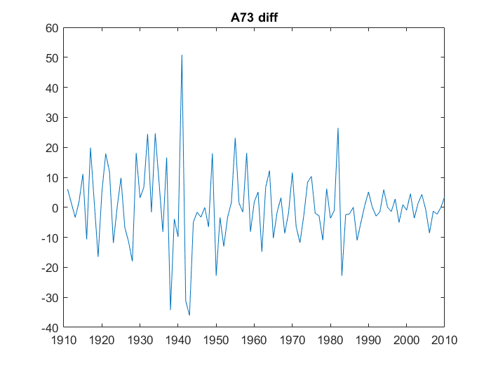

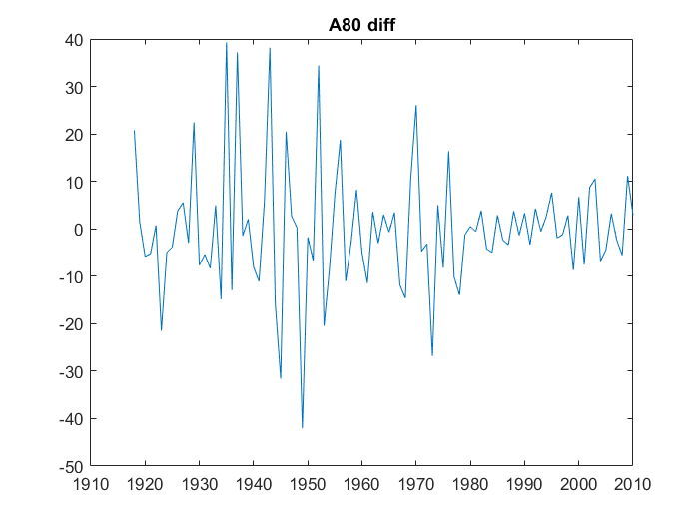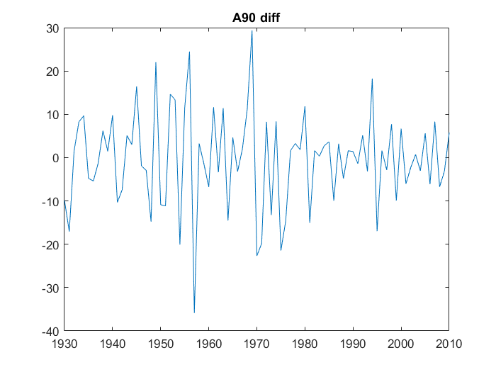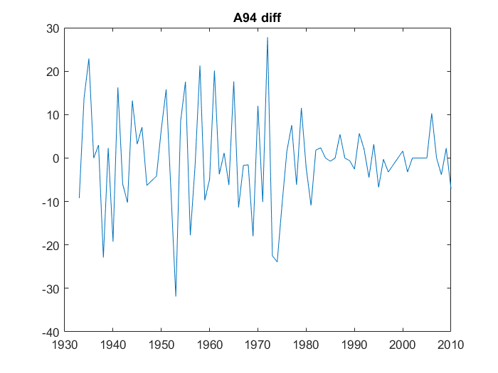

ESM 3: Detailed methods on monthly maps of primary production (PP) obtained from satellite-based PP model developed specifically for the Arctic Ocean.

Briefly, PP was estimated using a common photosynthesis-irradiance model (i.e., P vs. I curve) proposed by [1]. The light-saturated chlorophyll a (Chl a)-normalized carbon fixation rate (P^{B}_{max}) was set at 2 mg C (mg Chl)⁻¹ h⁻¹ based on the work of [2,3] in the Canadian Arctic. Furthermore, the saturation irradiance (E_{k}, μmol photons m⁻² s⁻¹) was modelled as a function of the averaged photosynthetic usable radiation at each depth following [4]. Surface Chl a and diffuse attenuation of downwelling irradiance (K_{d}) were derived from monthly ocean colour observations at 9.28 km resolution from SeaWiFS starting in 1998 to 2010 using semi-analytical algorithms: Garver-Siegel-Maritorena (GSM) for Chl a [5] and quasi-analytical algorithm (QAA) for K_{d} [6]. Downwelling spectral irradiance available for phytoplankton photosynthesis was estimated accounting for the presence of sea ice, total ozone concentration, cloud fraction, and cloud optical thickness. The latter two were derived every 3 h from satellite data (mainly from the advanced very high resolution radiometer; [7]) following the method developed by [8] and were obtained from the International Satellite Cloud Climatology Project web site. Daily satellite-derived SIC data from the Defense Meteorological Satellite Program (DMSP) Scanning Multichannel Microwave Radiometer (SMMR), F8 and F13 Special Sensor Microwave Imager (SSMI) (1984–2007) and F17 Special Sensor Microwave Imager/Sounder (SSMIS) (2008–2010) sensors were obtained from the National Snow and Ice Data Center (NSIDC) [9].

Trends in monthly PP over the 13 year SeaWiFS time series from 1998 to 2010 were calculated for each pixel using a nonlinear trends estimator as described in [10]. This is a non-parametric method that removes autocorrelation and outliers from the time series before calculating the trend using the Theil-Sen approach (TSA; Sen’s slope). The Mann-Kendall non-parametric test was then run on the resulting time series to test the significance of the trends.

- Platt T, Gallegos CL, Harrison WG. 1980 Photoinhibition of photosynthesis in natural assemblages of marine phytoplankton. J. Mar. Res., 38, 687-701.
- Harrison WG, Platt T. 1986 Photosynthesis-irradiance relationships in polar and temperate phytoplankton populations. Polar Biol., 5, 153-164. (doi: 10.1007/BF00441695).
- Huot Y, Babin M, Bruyant F. 2013 Photosynthetic parameters in the Beaufort Sea in relation to the phytoplankton community structure. Biogeosciences, 10, 3445-3454. (doi: 10.5194/bg-10-3445-2013).
- Arrigo KR, Worthen D, Schnell A, Lizotte MP. 1998 Primary production in Southern Ocean waters. J. Geophys. Res. Oceans, 103, 15587-15600. (doi: 10.1029/98JC00930).
- Maritorena S, Siegel DA, Peterson AR. 2002 Optimization of a semianalytical ocean color model for global-scale applications. Appl. Opt., 41, 2705-2714. (doi: 10.1364/ao.41.002705).
- Lee Z-P, Darecki M, Carder KL, Davis CO, Stramski D, Rhea WJ. 2005 Diffuse attenuation coefficient of downwelling irradiance: An evaluation of remote sensing methods. J. Geophys. Res. Oceans, 110, C02017. (doi: 10.1029/2004JC002275).
- Schweiger AJ, Lindsay RW, Key JR, Francis JA. 1999 Arctic clouds in multiyear satellite data sets. Geophys. Res. Lett., 26, 1845-1848. (doi: 10.1029/1999GL900479).
- Zhang Y, Rossow WB, Lacis AA, Oinas V, Mishchenko MI. 2004 Calculation of radiative fluxes from the surface to top of atmosphere based on ISCCP and other global data sets: Refinements of the radiative transfer model and the input data. J. Geophys. Res. Atmos., 109, D19105. (doi: 10.1029/2003JD004457).
- Bélanger S, Babin M, Tremblay J-É. 2013 Increasing cloudiness in Arctic damps the increase in phytoplankton primary production due to sea ice receding. Biogeosciences, 10, 4087-4101. (doi: 10.5194/bg-10-4087-2013).
- Zhang X, Vincent LA, Hogg WD, Niitsoo A. 2000 Temperature and precipitation trends in Canada during the 20th century. Atmos.-Ocean, 38, 395-429. (doi: 10.1080/07055900.2000.9649654).

ESM 4: Autocorrelation function performed on surface air temperature obtained from the National Centre for Environmental Prediction (NCEP) Re-analysis.

Because temperature change over time can be auto-correlated with time and thus not independent (as assumed in the linear model), we ran an autocorrelation function (AFC) against different lag sizes for the yearly average water temperature. Here are the obtained values:
ACF values for each lag (from 0 to 17) are:
Lag 0: 1,
Lag 1: 0.428,
Lag 2: 0.488,
Lag 3: 0.369,
Lag 4: 0.273,
Lag 5: 0.205,
Lag 6: 0.244,
Lag 7: 0.043,
Lag 8: 0.198,
Lag 9: 0.075,
Lag 10: 0.052,
Lag 11: 0.209,
Lag 12: 0.130,
Lag 13: 0.168,
Lag 14: 0.162,
Lag 15: 0.118,
Lag 16: 0.051,
Lag 17: 0.143
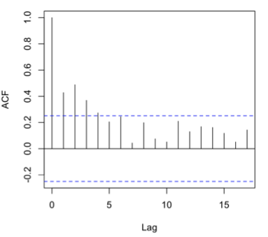
From this plot, we see that values for the Autocorrelation Function (ACF) are mostly within 95 percent confidence interval (represented by the solid blue line) for lags > 4, which shows that our data do not have autocorrelation after lag 4. However, a weak autocorrelation is visible for Lags 1 to 4. We thus just keep the linear regression to give the tendency of the relationship without giving any correlation coefficient.

