Determining the ecological status of benthic coastal communities: a case study in an anthropized sub-Arctic area

Supplementary Figure

Figure S1. Values of environmental indicators at each sampled station. Triangles and squares indicate shallow (< 15 m) and deep (> 15 m) stations, respectively. (A) total density, (B) total biomass, (C) W-Statistic index, (D) taxa richness, (E) Shannon index, (F) Margalef index, (G) Simpson index, (H) Pielou evenness, (I) taxonomic diversity, (J) functional richness, (K) functional evenness, (L) functional divergence, (M) AZTI Marine Biotic Index (AMBI) score, (N) Multivariate AZTI Marine Biotic Index (M-AMBI) score, (O) BENTIX score, (P) Benthic Opportunistic Polychaetes Amphipods Index (BOPA) score.

(next pages)

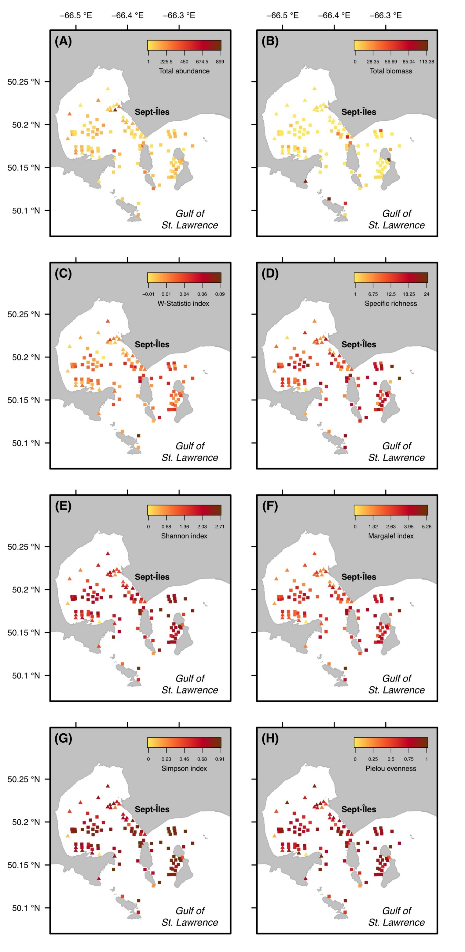
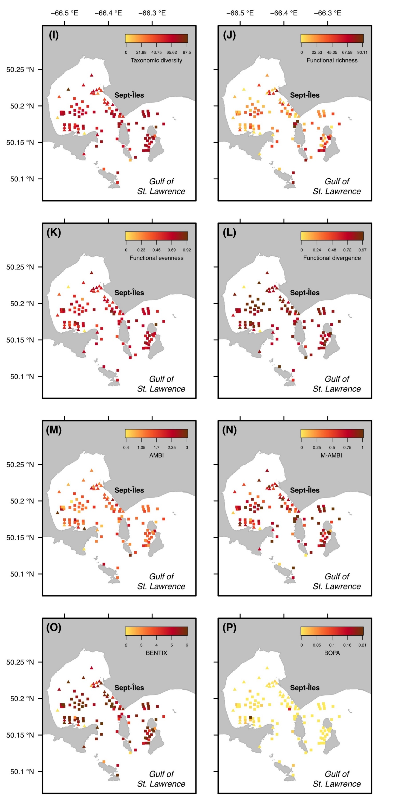

Supplementary Tables

Table S1. Classification of the sampled taxa into ecological groups defined by Borja et al. (2000), Dauvin and Ruellet (2007), Grall and Glemarec (1997) and Simboura and Zenetos (2002). Density corresponds to the number of individuals sampled per grab at shallow (< 15 m) and deep (> 15 m) stations. The confidence score goes from 3 (highest confidence) to 0 (lowest confidence) depending on the level of certainty for the taxon classification. AMBI = AZTI Marine Biotic Index, BOPA = Benthic Opportunistic Polychaetes Amphipods Index, CS = confidence score, S = sensitive, T = tolerant, SA = sensitive amphipod, OP = opportunistic polychaete, NA = not assigned.

(next page)
 | Density |  |  | Ecological groups
Taxon name | Shallow | Deep |  | AMBI | BENTIX | BOPA | References | CS
Aceroides (Aceroides) latipes | 3 | 54 |  | II | S | – | Borja et al. (2000) | 3
Akanthophoreus gracilis | 0 | 154 |  | I | S | – | Borja et al. (2000) | 3
Alamprops quadriplicatus | 2 | 0 |  | I | S | – | Borja et al. (2000) | 3
Ameritella agilis | 5 | 7 |  | II | S | – | Borja et al. (2000) | 3
Ameroculodes edwardsi | 0 | 9 |  | I | S | SA | Borja et al. (2000) | 3
Ampelisca vadorum | 0 | 1 |  | I | S | SA | Borja et al. (2000) | 3
Amphipoda | 30 | 86 |  | NA | NA | – | – | –
Anonyx lilljeborgi | 2 | 14 |  | II | S | – | Borja et al. (2000) | 3
Anthozoa | 0 | 1 |  | II | S | – | Borja et al. (2000) | 1
Arcteobia anticostiensis | 0 | 1 |  | II | S | – | Borja et al. (2000) (Polynoidae) | 2
Arrhoges occidentalis | 0 | 1 |  | I | S | – | Borja et al. (2000) (Aporrhais sp) | 2
Astarte sp | 0 | 9 |  | I | S | – | Borja et al. (2000) | 2
Axinopsida orbiculata | 18 | 80 |  | III | T | – | Borja et al. (2000) | 3
Axiothella catenata | 0 | 5 |  | I | S | – | Borja et al. (2000) (Axiothella sp) | 2
Bathymedon longimanus | 2 | 9 |  | II | S | – | Borja et al. (2000) | 3
Bathymedon obtusifrons | 1 | 14 |  | II | S | – | Borja et al. (2000) | 3
Boreochiton ruber | 0 | 24 |  | I | S | – | Borja et al. (2000) | 3
Brachydiastylis sp | 0 | 2 |  | II | S | – | Borja et al. (2000) | 2
Byblis gaimardii | 0 | 8 |  | I | S | SA | Borja et al. (2000) | 3
Cancer irroratus | 1 | 0 |  | II | S | – | Gittenberg & Van Loon (2013) (C. pagurus) | 1
Caprella septentrionalis | 277 | 0 |  | II | S | – | Borja et al. (2000) | 3
Chaetodermatida | 1 | 23 |  | NA | NA | – | – | –
Chionoecetes opilio | 0 | 2 |  | I | S | – | Borja et al. (2000) | 3
Chlamys islandica | 0 | 1 |  | I | S | – | Borja et al. (2000) | 3
Chone sp | 12 | 0 |  | II | S | – | Borja et al. (2000) | 2
Ciliatocardium ciliatum | 0 | 1 |  | I | S | – | Borja et al. (2000) | 3
Cirripedia | 3 | 0 |  | II | S | – | Borja et al. (2000) | 3
Cistenides granulata | 0 | 50 |  | II | S | – | Borja et al. (2000) | 3
Cossura longocirrata | 0 | 6 |  | IV | T | OP | Borja et al. (2000) | 3
Crassicorophium bonellii | 1 | 2 |  | III | T | – | Borja et al. (2000) | 3
Crenella decussata | 0 | 10 |  | I | S | – | Borja et al. (2000) | 3
Cumacea | 0 | 3 |  | I | S | – | Borja et al. (2000) | 3
Cyclocardia borealis | 0 | 5 |  | I | S | – | Borja et al. (2000) (C. thouarsii) | 2
Cyrtodaria siliqua | 0 | 1 |  | I | S | – | Gilkinson et al. (2005) | 2
Diastylis rathkei | 32 | 12 |  | III | T | – | Borja et al. (2000) | 3
Diastylis sculpta | 13 | 28 |  | II | S | – | Borja et al. (2000) | 3
Diastylis sp | 0 | 1 |  | I | S | – | Borja et al. (2000) | 1
Echinarachnius parma | 13 | 61 |  | I | S | – | Borja et al. (2000) (Echinoidea) | 2
Edotia montosa | 5 | 0 |  | II | S | – | Borja et al. (2000) | 3
Ennucula tenuis | 0 | 222 |  | II | S | – | Borja et al. (2000) | 3
Eteone sp | 0 | 6 |  | III | T | OP | Borja et al. (2000) | 2
Euchone sp | 32 | 0 |  | II | S | – | Borja et al. (2000) | 2
Eudorella emarginata | 0 | 9 |  | II | S | – | Borja et al. (2000) | 3
Eudorellopsis integra | 66 | 1092 |  | II | S | – | Tillin & Tyler-Walters (2014) (group of Bathyporeia elegans and E. deformis) | 2
Euspira pallida | 0 | 1 |  | II | S | – | Borja et al. (2000) | 3
Glycera capitata | 1 | 1 |  | II | S | – | Borja et al. (2000) | 3
Glycera sp | 8 | 4 |  | II | S | – | Borja et al. (2000) | 2
Goniada maculata | 1 | 101 |  | II | S | – | Borja et al. (2000) | 3
Guernea (Prinassus) nordenskioldi | 0 | 19 |  | III | T | – | de la Ossa Carretero et al. (2011)  (Dexamene spinosa) | 1
Halacaridae | 0 | 1 |  | I | S | – | Borja et al. (2000) | 2
Haminella solitaria | 0 | 1 |  | II | S | – | Borja et al. (2000) | 3
Hardametopa carinata | 1 | 0 |  | II | S | – | Borja et al. (2000) (Stenothoidae) | 1
Harmothoe sp | 0 | 3 |  | II | S | – | Borja et al. (2000) | 2
Harpacticoida | 105 | 117 |  | NA | NA | – | – | –
Hediste diversicolor | 18 | 19 |  | III | T | OP | Borja et al. (2000) | 3
Heteranomia squamula | 0 | 4 |  | I | S | – | Borja et al. (2000) | 3
Hiatella arctica | 1 | 5 |  | I | S | – | Borja et al. (2000) | 3
Holothuroidea | 1 | 5 |  | I | S | – | Borja et al. (2000) | 3
Idotea phosphorea | 13 | 0 |  | II | S | – | Borja et al. (2000) (Idotea sp) | 2
Ischyroceridae | 0 | 1 |  | II | S | – | Borja et al. (2000) (Ischyrocerus anguipes) | 2
Ischyrocerus anguipes | 138 | 0 |  | II | S | – | Borja et al. (2000) | 3
Isopoda | 0 | 1 |  | NA | NA | – | – | –
Lacuna vincta | 8 | 0 |  | II | S | – | Borja et al. (2000) | 3
Lamprops fuscatus | 7 | 16 |  | I | S | – | Borja et al. (2000) | 3
Lepeta caeca | 1 | 10 |  | I | S | – | Borja et al. (2000) | 3
Leucon (Leucon) nasicoides | 2 | 406 |  | II | S | – | Borja et al. (2000) | 3
Littorina littorea | 9 | 1 |  | II | S | – | Borja et al. (2000) | 3
Lumbrineridae | 7 | 7 |  | II | S | – | Borja et al. (2000) | 2
Lysianassidae | 3 | 1 |  | I | S | SA | Borja et al. (2000) | 2
Macoma calcarea | 168 | 407 |  | II | S | – | Borja et al. (2000) | 3
Maera danae | 1 | 0 |  | I | S | SA | Borja et al. (2000) (Maera sp) | 2
Maldane sarsi | 0 | 3 |  | II | S | – | Borja et al. (2000) | 3
Maldanidae | 4 | 185 |  | I | S | – | Borja et al. (2000) | 2
Micronephthys neotena | 741 | 1228 |  | II | S | – | Borja et al. (2000) | 3
Monoculopsis longicornis | 0 | 17 |  | II | S | – | Borja et al. (2000) | 3
Musculus discors | 0 | 1 |  | I | S | – | Borja et al. (2000) | 3
Mytilus sp | 128 | 10 |  | III | T | – | Borja et al. (2000) | 2
Nematoda | 271 | 773 |  | III | T | – | Borja et al. (2000) | 1
Nemertea | 0 | 16 |  | III | T | – | Borja et al. (2000) | 1
Neoleanira tetragona | 1 | 0 |  | II | S | – | Borja et al. (2000) | 3
Nephtyidae | 5 | 11 |  | II | S | – | Borja et al. (2000) | 2
Nephtys caeca | 4 | 7 |  | II | S | – | Borja et al. (2000) | 3
Nephtys incisa | 0 | 70 |  | II | S | – | Borja et al. (2000) | 3
Nephtys sp | 0 | 2 |  | II | S | – | Borja et al. (2000) | 2
Nuculana minuta | 0 | 13 |  | I | S | – | Borja et al. (2000) | 3
Nymphonidae | 0 | 1 |  | NA | NA | – | – | –
Oenopota sp | 2 | 8 |  | I | S | – | Borja et al. (2000) | 2
Oligochaeta | 53 | 89 |  | V | T | – | Borja et al. (2000) | 1
Ophelia limacina | 0 | 6 |  | I | S | – | Borja et al. (2000) | 3
Opheliidae | 0 | 3 |  | I | S | – | Borja et al. (2000) (Ophelia limacina) | 2
Ophiopholis aculeata | 0 | 2 |  | II | S | – | Borja et al. (2000) | 3
Ophiura robusta | 0 | 219 |  | II | S | – | Borja et al. (2000) | 3
Orchomenella minuta | 1 | 2 |  | II | S | – | Borja et al. (2000) | 3
Ostracoda | 2 | 331 |  | I | S | – | Bodegart et al. (1997), Ruiz et al. (2005), Gooday et al. (2009) | 1
Pagurus pubescens | 0 | 1 |  | II | S | – | Borja et al. (2000) | 2
Pagurus sp | 0 | 4 |  | II | S | – | Borja et al. (2000) | 3
Pandalus montagui | 0 | 1 |  | II | S | – | Borja et al. (2000) | 3
Parathyasira equalis | 0 | 2 |  | III | T | – | Borja et al. (2000) | 3
Parvicardium pinnulatum | 1 | 5 |  | I | S | – | Borja et al. (2000) | 3
Periploma leanum | 0 | 5 |  | II | S | – | Borja et al. (2000) (P. discus) | 2
Retusophiline lima | 0 | 1 |  | II | S | – | Borja et al. (2000) | 3
Philomedes sp | 0 | 5 |  | II | S | – | Borja et al. (2000) | 3
Pholoe longa | 13 | 0 |  | II | S | – | Borja et al. (2000) (Pholoe sp) | 2
Pholoe sp | 33 | 161 |  | II | S | – | Borja et al. (2000) | 2
Phoxocephalus holbolli | 48 | 25 |  | I | S | SA | Borja et al. (2000) | 3
Polynoidae | 17 | 61 |  | II | S | – | Borja et al. (2000) (Polynoidae) | 2
Pontogeneia inermis | 6 | 0 |  | II | S | – | Borja et al. (2000) (P. rostrata) | 2
Pontoporeia femorata | 152 | 164 |  | I | S | SA | Borja et al. (2000) | 3
Praxillella praetermissa | 1 | 41 |  | III | T | OP | Borja et al. (2000) | 3
Propebela turricula | 0 | 5 |  | I | S | – | Borja et al. (2000) | 3
Protomedeia fasciata | 6 | 38 |  | II | S | – | Borja et al. (2000) | 3
Protomedeia grandimana | 854 | 238 |  | II | S | – | Borja et al. (2000) | 3
Puncturella noachina | 0 | 4 |  | I | S | – | Borja et al. (2000) | 3
Quasimelita formosa | 5 | 97 |  | I | S | SA | Borja et al. (2000) (Melitidae) | 2
Quasimelita quadrispinosa | 0 | 2 |  | I | S | SA | Borja et al. (2000) | 3
Retusa obtusa | 6 | 3 |  | II | S | – | Borja et al. (2000) | 3
Sabellidae | 191 | 10 |  | I | S | – | Borja et al. (2000) | 2
Scoletoma fragilis | 14 | 17 |  | II | S | – | Borja et al. (2000) | 3
Scoletoma sp | 0 | 2 |  | II | S | – | Borja et al. (2000) | 2
Scoloplos | 0 | 1 |  | I | S | – | Borja et al. (2000) | 2
Serripes groenlandicus | 0 | 2 |  | I | S | – | Borja et al. (2000) | 3
Sipuncula | 0 | 29 |  | I | S | – | Borja et al. (2000) | 1
Solamen glandula | 0 | 1 |  | II | S | – | Borja et al. (2000) (S. columbianum) | 2
Solariella sp | 0 | 19 |  | I | S | – | Borja et al. (2000) | 2
Strongylocentrotus sp | 0 | 24 |  | I | S | – | Borja et al. (2000) (S. droebachiensis) | 3
Tachyrhynchus erosus | 0 | 1 |  | I | S | – | Borja et al. (2000) (Turritella sp) | 2
Thracia septentrionalis | 35 | 37 |  | I | S | – | Borja et al. (2000) | 3
Thyasira gouldi | 0 | 142 |  | I | S | – | Borja et al. (2000) | 3
Thyasira sp | 0 | 11 |  | II | S | – | Borja et al. (2000) | 1
Trichotropis bicarinata | 0 | 1 |  | II | S | – | Borja et al. (2000) (Euspira sp) | 2
Turritellopsis stimpsoni | 0 | 4 |  | I | S | – | Borja et al. (2000) (Turritella sp) | 2
Yoldia myalis | 0 | 3 |  | I | S | – | Borja et al. (2000) (Y. limatula) | 2

Table S2. Reference conditions used for the calculation of Multivariate AZTI Marine Biotic Index (M-AMBI), for shallow and deep stations. S = taxa richness, H = Shannon index, AMBI = AZTI Marine Biotic Index.

 | ‘Bad’ status | ‘High’ status
Shallow stations
S | 2.5 | 16.25
H’ | 0.35 | 2.01
AMBI | 2.88 | 0.72
Deep stations
S | 7 | 21.95
H’ | 1.14 | 2.54
AMBI | 2.43 | 0.78

Table S3. Mean (standard error) and extremum values of habitat parameters sampled (organic matter, grain-size classes) and modelled (heavy metal concentrations), calculated for shallow (< 15 m) and deep (> 15 m) stations. SE = standard error.

 | Shallow stations (n = 26) |  |  |  | Deep stations (n = 82)
Variable | Mean (SE) | Minimum | Maximum |  | Mean (SE) | Minimum | Maximum
Organic matter (%) | 1.09 (0.2) | 0.25 | 4.42 |  | 1.69 (0.1) | 0.23 | 3.71
Gravel (%) | 1.8 (0.7) | 0 | 12.4 |  | 3.7 (1.4) | 0 | 76.5
Sand (%) | 56.4 (5.1) | 0.8 | 96.8 |  | 47.8 (2.4) | 0 | 97
Silt (%) | 39.4 (4.8) | 3.2 | 86.9 |  | 46 (2.6) | 0 | 84.5
Clay (%) | 2.4 (1.7) | 0 | 37.1 |  | 2.5 (1.6) | 0 | 97.9
Arsenic (mg.kg⁻¹) | 3.48 (0.3) | 1.5 | 7.6 |  | 3.84 (0.3) | 1.4 | 16
Cadmium (mg.kg⁻¹) | 0.15 (0) | 0.08 | 0.23 |  | 0.13 (0) | 0.06 | 0.19
Chromium (mg.kg⁻¹) | 60.89 (3.8) | 28 | 110.7 |  | 55 (1.7) | 27.8 | 86.5
Copper (mg.kg⁻¹) | 12.93 (1.2) | 2.9 | 28.7 |  | 11.3 (0.5) | 3.6 | 21.4
Iron (g.kg⁻¹) | 53.55 (2.5) | 32.65 | 78.47 |  | 53.87 (1.8) | 28.36 | 151.23
Manganese (g.kg⁻¹) | 1.22 (0.1) | 0.46 | 3.44 |  | 1.1 (0.1) | 0.42 | 2.96
Mercury (mg.kg⁻¹) | 0.02 (0) | 0 | 0.05 |  | 0.02 (0) | 0 | 0.09
Lead (mg.kg⁻¹) | 5.8 (0.4) | 2.4 | 12.1 |  | 5.12 (0.2) | 1.7 | 9.3
Zinc (mg.kg⁻¹) | 63.79 (4.3) | 33.5 | 141 |  | 57.74 (1.7) | 27.6 | 93.9

