Global Biogeochemical Cycles
Supporting Information for
Nitrate supply routes and impact of internal cycling in the North Atlantic Ocean inferred from nitrate isotopic composition
F. Deman^{1,2}, D. Fonseca-Batista^{1,3}, A. Roukaerts¹, M. I. García-Ibáñez⁴, E. Le Roy⁵, E. P. D. N. Thilakarathne^{1,6}, M. Elskens¹, F. Dehairs¹, and F. Fripiat⁷
¹Analytical, Environmental, and Geochemistry, Earth System Sciences Research Group, Vrije Universiteit Brussel, Brussels, Belgium.
²Unité d’Océanographie Chimique, Freshwater and oceanic science unit of research, Université de Liège, Liège, Belgium.
³Department of Biology, Dalhousie University, Halifax, Nova Scotia, Canada.
⁴Instituto de Investigaciones Marinas, IIM-CSIC, Vigo, Spain.
⁵Department of Marine Chemistry and Geochemistry, Woods Hole Oceanographic Institution, Woods Hole, Massachusetts 02543, United States of America.
⁶Department of Animal Science, Uva Wellassa University, Badulla, Sri Lanka.
⁷Department of Geosciences, Environment and Society, Université Libre de Bruxelles, Brussels, Belgium.

Contents of this file

Figure S1

Additional Supporting Information (Files uploaded separately)

Caption for Table S1

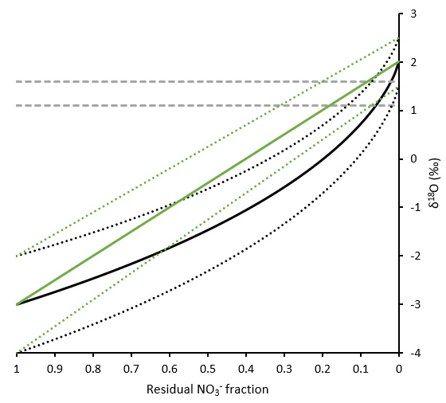

Figure S1. Evolution of (accumulated) product δ¹⁸O (‰) associated with the degree of NO₃⁻ consumption using both the Rayleigh model (black lines) or the steady-state model (green lines) compared to regenerated NO₃⁻ δ¹⁸O (grey dashed lines; being H₂O δ¹⁸O +1.1 ‰ with H₂O δ¹⁸O ranging from 0 to 0.5 ‰). Ranges of produced δ¹⁸O (‰) is given for both models (dotted lines) using isotope effects being 5 ± 0.5 ‰ and initial NO₃⁻ δ¹⁸O varying from 1.5 to 2.5 ‰. In high-latitude areas, partial consumption of NO3- lead to an increase in NO₃⁻ δ¹⁸O since regenerated NO₃⁻ δ¹⁸O is higher than exported product δ¹⁸O (‰). In low-latitude areas, complete consumption of NO₃⁻ leads to a decrease in NO₃⁻ δ¹⁸O since regenerated NO₃⁻ δ¹⁸O is lower than exported product δ¹⁸O (‰).

Table S1. (.xlsx file) provides all nitrate concentration ([NO₃⁻]; µmol l⁻¹) and isotopic composition (NO₃⁻ δ¹⁵N and NO₃⁻ δ¹⁸O; ‰) data presented in the manuscript.

