Supplementary material: Response and effect traits of coral reef fish

Supplementary Table 1. Results from papers looking at categorical response and effect traits or categorical disturbances and processes.
Citation | Trait | Process/  Disturbance | Results
Adam et al. 2015, Oecologia | Habitat type | Herbivory | Found distinct clusters of preferential substrate in feeding parrotfish - species with similar diets (herbivory) had different habitat preferences and feeding substrate.
Bejarano et al. 2017, Functional Ecology | Head morphology | Herbivory | Looked at the effect of the interaction of wave exposure and traits on herbivory - found grazers–detritivores were associated with laterally compressed body plans, whereas scrapers–small excavators occupied the full extent of fusiform body plans. See below (diet) for secondary link to herbivory rates.
Bejarano et al. 2017, Functional Ecology | Body morphology | Herbivory | Looked at the effect of the interaction of wave exposure and traits on herbivory - found grazers–detritivores were associated with laterally compressed body plans, whereas scrapers–small excavators occupied the full extent of fusiform body plans. See below (diet) for secondary link to herbivory rates.
Bejarano et al. 2017, Functional Ecology | Fin morphology | Herbivory | Looked at the effect of the interaction of wave exposure and traits on herbivory - found grazers–detritivores were associated with laterally compressed body plans, whereas scrapers–small excavators occupied the full extent of fusiform body plans. See below (diet) for secondary link to herbivory rates.
Bejarano et al. 2017, Functional Ecology | Diet/trophic level | Bioerosion | Feeding functional groups (here classified within diet trait) are assessed in relation to functioning at different wave exposures. Bioeroding species fed only at low wave exposures.
Bejarano et al. 2017, Functional Ecology | Diet/trophic level | Herbivory | Feeding functional groups (here classified within diet trait) are assessed in relation to functioning at different wave exposures. Grazer-detritivores and scrapers-small excavators greater herbivory at higher wave intensities.
Bellwood, Hoey and Choat 2003, Ecology Letters | Diet/trophic level | Herbivory | Naso unicornis = key consumer of erect brown macroalgae.
Bellwood, Hoey and Choat 2003, Ecology Letters | Diel activity | Herbivory | Diurnal higher than nocturnal.
Bellwood, Hughes and Hoey 2006, Current Biology | Diet/trophic level | Herbivory | Mixed: single species Platax pinnatus (key functional group) responsible for Sargassum removal, but normal herbivorous spp had little impact on macroalgal removal.
Brandl et al. 2016, Ecosphere | Diet/trophic level | Climate change: extreme weather | Omnivores and planktivores decline. Turf-feeders/detritivores,  macro-invertivores, and micro- invertivores increase.
Brandl et al. 2016, Ecosphere | Habitat type | Climate change: extreme weather | Fish dependent on live coral and loose coral rubble decrease, but weakly. Species associated with the underlying rocky reef matrix were likely to increase following cyclone.
Brandl et al. 2016, Ecosphere | Territoriality | Climate change: extreme weather | Non-territorial species were likely to benefit from the cyclone, while territoriality had no discernable effect.
Fox and Bellwood 2013, Coral Reefs | Head morphology | Herbivory | Rabbitfish slower than parrotfish and surgeonfish. Rabbitfish have elongate snout for crevices (slower).
Humphries, McClanahan and  McQuaid 2014, Marine Ecology Progress Series | Diet/trophic level | Herbivory | Herbivory rates lowest in fenced/caged areas.
Humphries, McClanahan and  McQuaid 2014, Marine Ecology Progress Series | Diet/trophic level | Fishing | Herbivory rates of grazers and scapers decreased with fishing pressure but not browsers.
Karkarey et al. 2017, Animal Behaviour | Feeding behaviour | Climate change: bleaching | Foraging mode greater than ambush mode in low structure sites.
Marshell and Mumby 2012, Coral Reefs | Diet/trophic level | Herbivory | Detritivore removed more turf than other grazers.
McClanahan and Hicks 2011, Fisheries Management and Ecology | Stage at maturity | Fishing | Gear type specific: positive (older at first maturity with fishing).
McClanahan and Hicks 2011, Fisheries Management and Ecology | Life span | Fishing | Gear type specific: positive.
McClanahan and Hicks 2011, Fisheries Management and Ecology | Generation time | Fishing | Gear type specific: positive.
McClanahan and Hicks 2011, Fisheries Management and Ecology | Size | Fishing | Gear type specific: negative.
McClanahan and Hicks 2011, Fisheries Management and Ecology | Natural mortality | Fishing | Gear type specific: negative.
McClanahan and Hicks 2011, Fisheries Management and Ecology | Growth rate | Fishing | Gear type specific: negative.
McClanahan and Hicks 2011, Fisheries Management and Ecology | Diet/trophic level | Fishing | South-coast sites increased in trophic level with fishing management.
Mellin et al. 2008, Ecological Modelling | Size | Fishing | Modelling approach. Large fish abundances and fish in size class 8-15cm lower with fishing.
Mellin et al. 2008, Ecological Modelling | Diet/trophic level | Fishing | Modelling approach. Macrocarnivore and piscivore abundances lower with fishing.
Mellin et al. 2008, Ecological Modelling | Stage at maturity | Fishing | Modelling approach. Late reproducing and early reproducing (life history categories 6 and 2) species abundances lower with fishing.
Mellin et al. 2008, Ecological Modelling | Growth rate | Fishing | Modelling approach. Slow-growing and fast-growing (life history categories 6 and 2) species abundances lower with fishing.
Mellin et al. 2008, Ecological Modelling | Natural mortality | Fishing | Modelling approach. Long-lived and short-lived (life history categories 6 and 2) species lower with fishing.
Mumby et al. 2006, Science | Diet/trophic level | Fishing | Double the number of parrotfish predators inside the reserve.
Mumby et al. 2006, Science | Size | Fishing | Individuals of the smaller bodied scarid species (max 23 cm) (Scarus iserti and Sparisoma aurofrenatum) were smaller inside the reserve. Scarids that reached consistently large adult sizes, such as the terminal-phase males of Sc. vetula and Sp. viride, exhibited no difference in their size across the reserve boundary. Parrotfishes that occupied a wide range of size categories (6 to 32 cm) were either larger in the reserve (Sp. viride intermediate phase) or larger outside the reserve (Sc. vetula IP).
Olivier et al. 2014, Frontiers in Zoology | Mouth morphology | Herbivory | Negative impact with c-ligament ablated.
Pereira et al. 2014, Reviews in Fish Biology and Fisheries | Size | Predation: predator | Small (\5.0 cm) and medium size classes (5.0–10.0 cm) fed more on small invertebrates such as copepoda, tanaidacea, amphipoda, and ostracoda. Larger individuals had a higher proportion of polychaete, brachyura, and fish fragments in their stomachs.
Pereira et al. 2014, Reviews in Fish Biology and Fisheries | Diet/trophic level | Predation: predator | Haemulon species were classified as mobile invertebrate feeders, capturing prey on the bottom or in the water column depending on their size, and having a variety of crustaceans and polychaetes in their stomachs.
Rasher, Hoey and Hay 2013, Ecology | Diet/trophic level | Herbivory | Bite rate higher for browsers than grazers.
Rocha et al. 2015, Coral Reefs | Space use | Predation: prey | Just above ground in water column = more predated on.
Streit, Hoey and Bellwood 2015, Coral Reefs | Mouth morphology | Herbivory | Larger gape, more bite power, ate whole macroalgal thallus.
Streit, Hoey and Bellwood 2015, Coral Reefs | Size | Herbivory | Longer fish ate macroalgal thallus and occasionally leaves only.

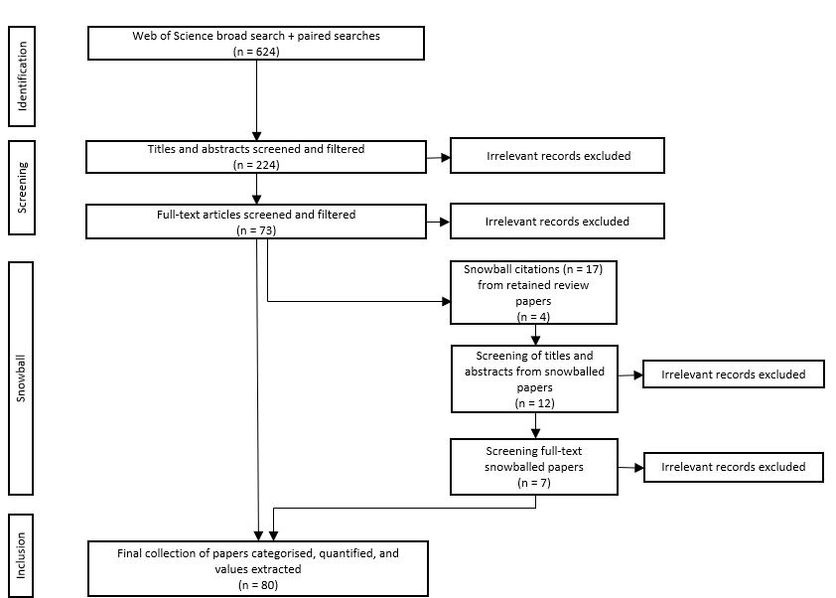
Figure S1 PRISMA flow diagram for systematic review paper inclusion

Figure S2 Three-stage network diagram showing the number of papers linking each disturbance and process to response and effect traits. Each disturbance and process correspond to a shape, where pollution = circle, climate change = rectangle, fishing = triangle, bioerosion = pentagon, herbivory = hexagon, and predation = diamond. The colour of trait points corresponds to broad trait groupings (blue: behavioural, yellow: life-history, red: morphological, grey: physiological, purple: diet)

Figure S3 Non-metric multidimensional (nMDS) ordination plot for traits of all papers. Four clusters show individual traits commonly used together in studies. Vectors show which disturbances and processes are driving these clusters. Colour of trait points corresponds to broad trait groupings (blue: behavioural, yellow: life-history, red: morphological, grey: physiological, purple: diet). The nMDS stress is 0.16

Figure S4 Mean ranking of five most central traits in network diagram, based on degree centrality, subgraph centrality (logged) and topological coefficient scores. The colour of trait node corresponds to broad trait groupings (blue: behavioural, yellow: life-history, red: morphological, grey: physiological, purple: diet)

