Appendix S1

GAPeDNA: Assessing and mapping global species gaps in genetic databases for eDNA metabarcoding

Table S1: Primer pairs used for the present study, with details on the marker, primer name, primer sequences, and reference paper.
Marker | Primer name | Forward (5'-3') | Reverse (5'-3') | Reference
12S | AcMDB07 | GCCTATATACCGCCGTCG | GTACACTTACCATGTTACGACTT | Bylemans et al, 2018
16S | 16S2 | GACCCTATGGAGCTTTAGAC | CGCTGTTATCCCTADRGTAACT | DiBattista et al, 2017
12S | Ac12s | ACTGGGATTAGATACCCCACTATG | GAGAGTGACGGGCGGTGT | Evans et al, 2015
16S | Ac16s | CCTTTTGCATCATGATTTAGC | CAGGTGGCTGCTTTTAGGC | Evans et al, 2015
12S | Am12s | AGCCACCGCGGTTATACG | CAAGTCCTTTGGGTTTTAAGC | Evans et al, 2015
16S | Ve16s | CGAGAAGACCCTATGGAGCTTA | AATCGTTGAACAAACGAACC | Evans et al, 2015
COI | LCO-1490/HCO-2198 | TAAACTTCAGGGTGACCAAAAAATCA | TAAACTTCAGGGTGACCAAAAAATCA | Folmer et al, 1994
COI | VF1d/VR1d | TTCTCAACCAACCACAARGAYATYGG | TAGACTTCTGGGTGGCCRAARAAYCA | Ivanova et al, 2006
COI | VF1i/VR1i | TTCTCAACCAACCAIAAIGAIATIGG | TGITTITTIGGICACCCAGAAGTCTA | Ivanova et al, 2006
COI | COI-1 | TTCTCCACCAACCACAARGAYATYGG | CACCTCAGGGTGTCCGAARAAYCARAA | Ivanova et al, 2007
12S | 12S_F1/12S_R1 | ACTGGGATTAGATACCCC | TAGAACAGGCTCCTCTAG | Kelly et al, 2014
16S | L2513/H2714 | GCCTGTTTACCAAAAACATCAC | CTCCATAGGGTCTTCTCGTCTT | Kitano et al, 2007
CytB | CytB_L14841/CytB_15149R | AAAAACCACCGTTGTTATTCAACTA | GCDCCTCARAATGAYATTTGTCCTCA | Kocher et al, 1989
18S | Fish_18S_1F/Fish_18S_3R | GAATCAGGGTTCGATTCC | CAACTACGAGCTTTTTAACTGC | MacDonald et al, 2014
16S | 16S-Fish | AGCGYAATCACTTGTCTYTTAA | CRBGGTCGCCCCAACCRAA | McInnes et al, 2017
CytB | L14912-CYB/H15149-CYB | TTCCTAGCCATACAYTAYAC | GGTGGCKCCTCAGAAGGACATTTGKCCYCA | Miya et al, 2000
12S | MiFish-U | GTCGGTAAAACTCGTGCCAGC | CATAGTGGGGTATCTAATCCCAGTTTG | Miya et al, 2015
16S | 16S | CGCCTGTTTATCAAAAACAT | CCGGTCTGAACTCAGATCACGT | Palumbi et al, 1996
16S | 16S1 | CGAGAAGACCCTWTGGAGCTTIAG | GGTCGCCCCAACCRAAG | Shaw et al, 2016
CytB | Fish2CBL/Fish2bCBR | ACAACTTCACCCCTGCAAAC | GATGGCGTAGGCAAACAAGA | Thomsen et al, 2012
CytB | Fish2degCBL/Fish2CBR | ACAACTTCACCCCTGCRAAY | GATGGCGTAGGCAAATAGGA | Thomsen et al, 2012
CytB | FishCB | TCCTTTTGAGGCGCTACAGT | GGAATGCGAAGAATCGTGTT | Thomsen et al, 2012
12S | Teleo | ACACCGCCCGTCACTCT | CTTCCGGTACACTTACCATG | Valentini et al, 2016
COI | FishF1/FishR1 | TCAACCAACCACAAAGACATTGGCAC | TAGACTTCTGGGTGGCCAAAGAATCA | Ward et al, 2005
COI | FishF2/FishR2 | TCGACTAATCATAAAGATATCGGCAC | ACTTCAGGGTGACCGAAGAATCAGAA | Ward et al, 2005

Table S2: All primers pairs with their percentage of coverage in freshwater, marine ecosystems and both, specifying whether they were kept for analysis or not. Percentages of sequenced species are based on the total number of freshwater (16,453), marine (15,975), or global bony fish species (32,525) from the fishbase database.
Marker | Primer_name | Number_seq_freshwater | Percent_seq_freshwater  (%) | Number_seq_marine | Percent_seq_marine  (%) | Number_seq_global | Percent_seq_global (%) | Kept
12S | Bylemans_12S | 2248 | 14 | 1990 | 12 | 4253 | 13 | Yes
16S | DiBattista_16S | 3323 | 20 | 4733 | 30 | 8073 | 25 | Yes
12S | Evans_12S_ac12s | 2072 | 13 | 2074 | 13 | 4159 | 13 | Yes
16S | Evans_16S_ac16s | 2182 | 13 | 1542 | 10 | 3735 | 11 | Yes
12S | Evans_12S_am12s | 2093 | 13 | 2062 | 13 | 4165 | 13 | Yes
16S | Evans_16S_ve16s | 206 | 1 | 214 | 1 | 426 | 1 | No
COI | Ianova_COI_VF1d | 281 | 2 | 386 | 2 | 669 | 2 | No
COI | Ianova_COI_vf1d | 1473 | 9 | 1308 | 8 | 2789 | 9 | Yes
12S | Kelly_12S | 2155 | 13 | 2373 | 15 | 4541 | 14 | Yes
16S | Kitano_16S | 2163 | 13 | 2053 | 13 | 4228 | 13 | Yes
CYTB | Kocher_CYTB | 1279 | 8 | 974 | 6 | 2258 | 7 | Yes
18S | Macdonalds_18S | 260 | 2 | 210 | 1 | 471 | 1 | No
16S | Mcinnes_16S | 4333 | 26 | 4721 | 30 | 9071 | 28 | Yes
CYTB | Miya_CYTB | 2533 | 15 | 1806 | 11 | 4344 | 13 | Yes
12S | Miya_12S | 2068 | 13 | 1992 | 12 | 4070 | 13 | Yes
16S | Palumbi_16S | 1800 | 11 | 1488 | 9 | 3296 | 10 | Yes
16S | Shaw_16S | 4336 | 26 | 4786 | 30 | 9139 | 28 | Yes
CYTB | Thomsen_CYTB_2cbl | 2113 | 13 | 981 | 6 | 3097 | 10 | Yes
CYTB | Thomsen_CYTB_2deg | 3059 | 19 | 1629 | 10 | 4696 | 14 | Yes
CYTB | Thomsen_CYTB_cb | 2562 | 16 | 706 | 4 | 3275 | 10 | Yes
12S | Valentini_12S | 2310 | 14 | 1918 | 12 | 4242 | 13 | Yes
COI | Ward_COI_f1 | 1156 | 7 | 809 | 5 | 1970 | 6 | Yes
COI | Ward_COI_f2 | 287 | 2 | 502 | 3 | 790 | 2 | No

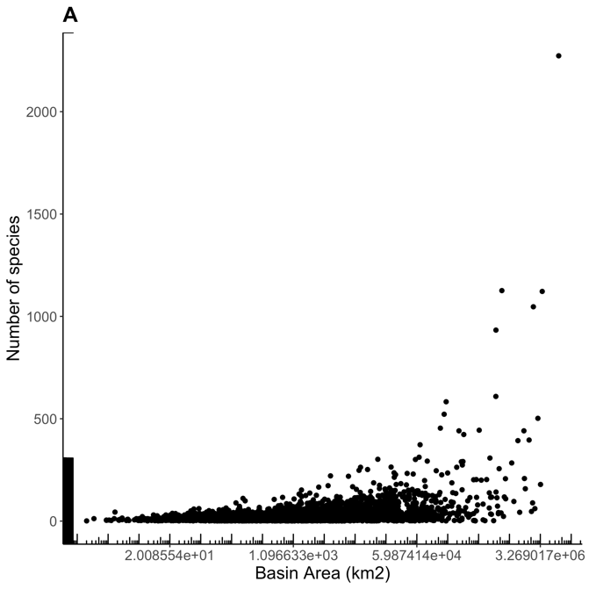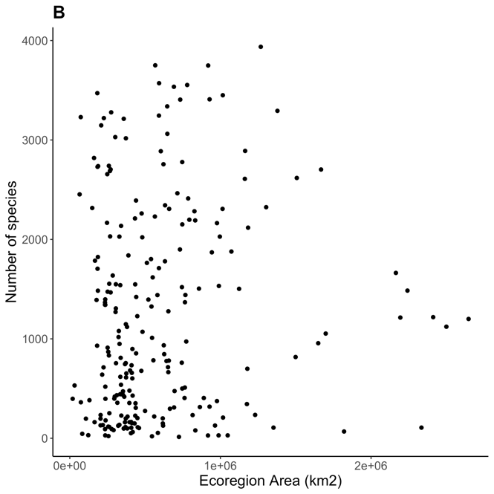
Fig S1: Relationship between area of polygons and the number of species for (A) freshwater with a log scale displayed for area and (B) marine ecosystems at the scale of ecoregions.
B
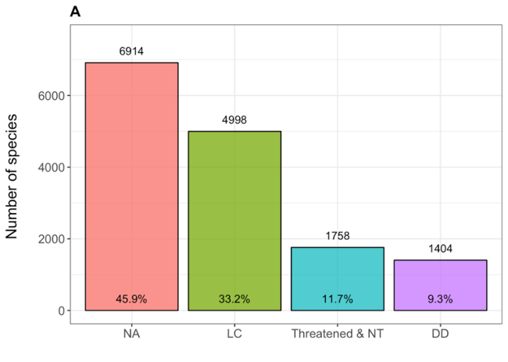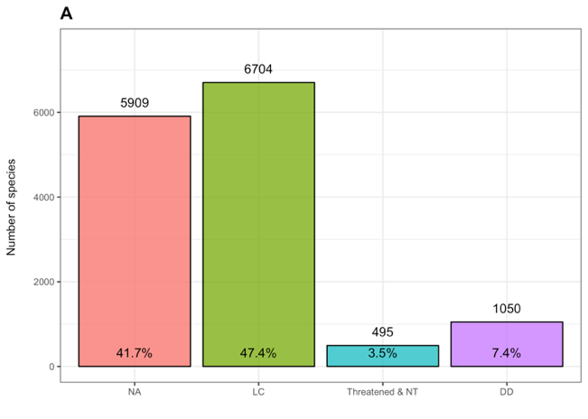

Fig S2: Repartition of species within IUCN categories for (A) freshwater and (B) marine species. The number above the bars and the percentage indicate the number of species in the category and the percentage of sequenced species respectively, with NA for unevaluated species (red), DD for Data Deficient (purple), LC for Least Concern (green) and Threatened & NT (blue) status among IUCN classification (http://www.iucnredlist.org.). The threatened category includes the categories Vulnerable (VU), Endangered (E) and CRitically endangered (CR).

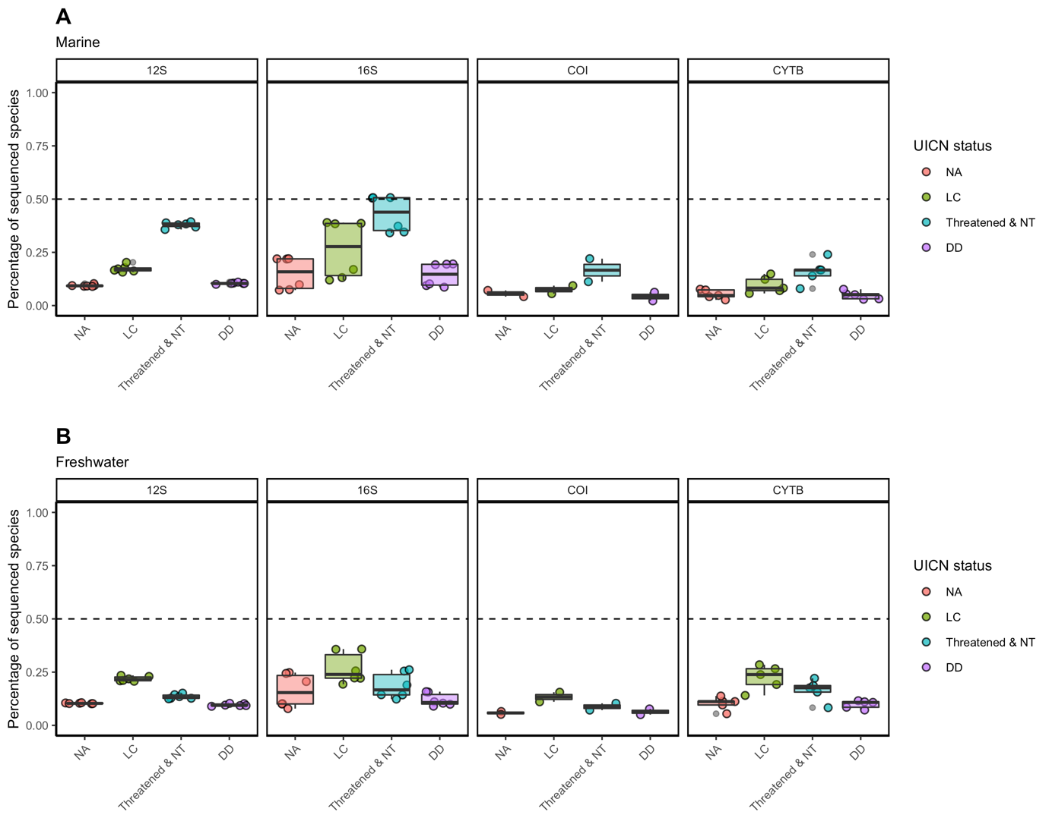

Fig. S3. Percentage of coverage in each IUCN category in genetics database according to the genetic marker and IUCN status for (A) marine species and (B) freshwater species, with NA for unevaluated species (red), DD for Data Deficient (purple), LC for Least Concern (green) and Threatened & NT (blue) status among IUCN classification (http://www.iucnredlist.org.). The threatened category includes the categories Vulnerable (VU), Endangered (E) and CRitically endangered (CR). Each dot represents one primer pair.
AD
B
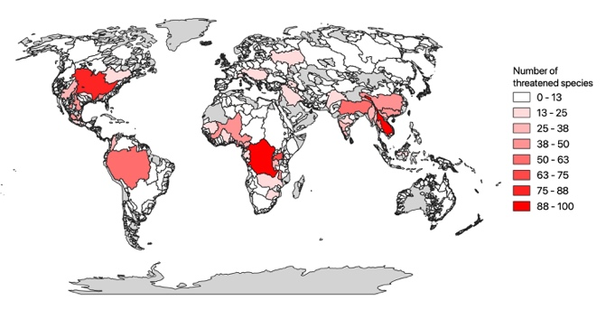 | 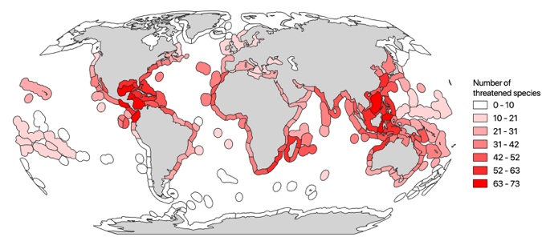
 | 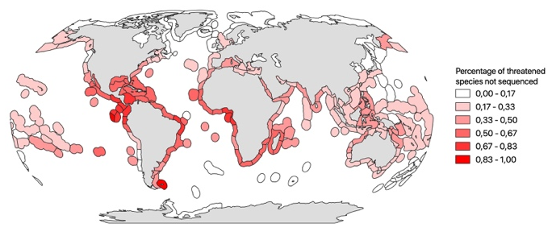
C
D
Fig. S4. Number of threatened species for (A) freshwater and (B) marine systems and the percentage of threatened species remaining to be sequenced for (C) freshwater and (D) marine systems.
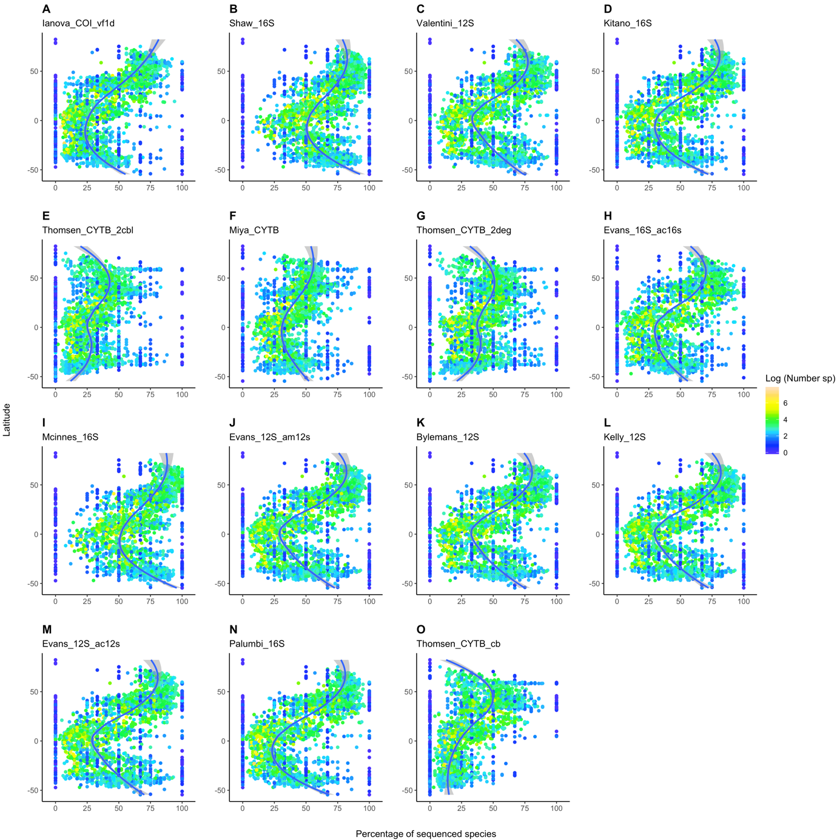

Fig. S5. Percentage of species coverage in genetic database for freshwater fish species according to latitude and total species richness for the 15 markers not displayed in main (A-O).
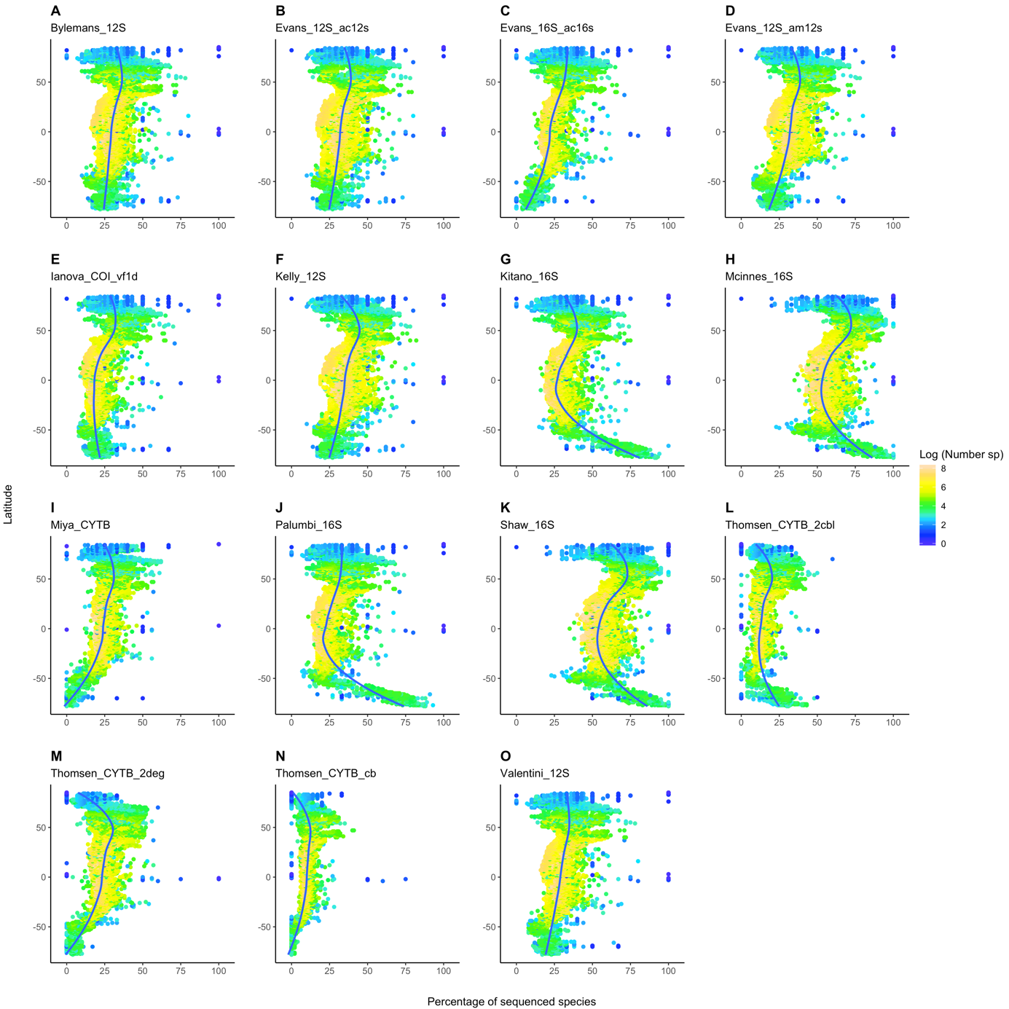
Fig. S6. Percentage of species coverage in genetic database for marine fish species according to latitude and total species richness for the 15 markers not displayed in main (A-O).

