Global Biogeochemical Cycles
Supporting Information for

Counteracting contribution of the Upper and Lower Meridional Overturning Limbs to the North Atlantic Nutrient Budgets: enhanced imbalance in 2010
L.I. Carracedo^{1,2}, H. Mercier¹, E. McDonagh^{2,3}, G. Rosón⁴, R. Sanders^{2,3}, C.M. Moore⁵, S. Torres-Valdés⁶, P. Brown², P. Lherminier¹, F.F. Pérez⁷
¹ University of Brest, CNRS, Ifremer, IRD, Laboratoire d'Océanographie Physique et Spatiale (LOPS), IUEM, Centre Ifremer de Bretagne, F-29280, Plouzané, France.
² National Oceanography Centre (NOC), Southampton SO14 3ZH, UK.
³ NORCE Norwegian Research Centre, Bjerknes Centre for Climate Research, Bergen, Norway.
⁴ Faculty of Marine Sciences, University of Vigo, Campus Lagoas-Marcosende, 36200 Vigo, Spain.
⁵ School of Ocean and Earth Science, National Oceanography Centre, University of Southampton, Southampton SO14 3ZH, UK.
⁶ Alfred Wegener Institute, Am Handelshafen 12, 27570 Bremerhaven, Germany.
⁷ Instituto de Investigaciones Marinas, CSIC, 36208 Vigo, Spain.

Contents of this file
Text S1 to S6
Figures S1 to S8
Tables S1 to S4
Introduction
This supporting material contains supplementary details on the estimate of the nutrient sources (Text S1), uncertainties (Text S2), the volume and salt conservation principles (Text S3), the representativeness of the 2004 and 2010 quasi-synoptic nutrient transport estimates with regards the seasonal and interannual aliasing (Text S4), the evaluation of the new joint inverse model (Text S5), and the sensitivity analysis (Test S6). Figures S1 to S8 show: the Ekman transport across both sections from different wind products (Figure S1), the schematics of the salt conservation constraint (Figure S2), the net evaporation in the North Atlantic (Figure S3), the volume transport comparison between the original 2004 and 2010 velocity fields at OVIDE and the consistency tests performed in this study (Figure S4), ,a summary of the sensitivity analysis for the transports across the A05-24.5°N and OVIDE sections (Figure S5) and for the nutrient budgets (Figure S6), the mooring-based Western Boundary Wedge velocity profiles at A05-24.5°N (Figure S7), the time series of the Western Boundary Wedge absolute transport at A05-24.5°N (Figure S8). Tables S1 to S4 contain: the GLODAPv2 quality control correction factors applied to oxygen and nutrient data (Table S1), the external sources (inputs) of silicate, nitrate and phosphate (Table S2), the list of hydrographic cruises used to estimate the organic nutrient transport across the Florida Straits (Table S3), the volume, salt and nutrient transports across the Davis Straits (Table S4a,b).

Text S1. Estimate of additional nutrient sources

S1.1 Atmospheric deposition: F_{N}^{air-sea}
In this study, we estimated the atmospheric deposition of inorganic nutrients in the North Atlantic (NA-box, Figure 1) by means of the deposition rates provided by previous studies (see values and references in Table S2). We inferred a total atmospheric nitrate input by using a mean atmospheric deposition of inorganic oxidized nitrogen (nitrate and nitric acid) in the North Atlantic of 0.12 g-N m⁻² y⁻¹ (Figure 2c in Yang & Gruber, 2016; Figure 3 middle column, top row, in Jickells et al., 2017), and a total area for the enclosed domain of around 16.6 x10¹² m². For phosphate, we used the model-based deposition rate of 27.9 Gg-P y⁻¹ by Mahowald et al. (2008). Finally, for silicate, we took into account the global value by Tréguer et al. (1995) and Tréguer & De La Rocha (2013) of 0.5 ± 0.5 Tmol Si y⁻¹ (i.e., 16 ± 16 kmol s⁻¹). From this global estimate (world’s ocean extension of 360 x10¹² m²), we inferred the proportional rate for the NA-box. Given the coarse assumption that silicate deposition rates are homogeneous over the world ocean, we assigned a 100% uncertainty to this estimate. To keep consistency for the three nutrients, same criteria (that is, 100% of the estimate taken as uncertainty) was followed for the nitrate and phosphate atmospheric inputs.

S1.2 Fluvial inputs: F_{N}^{runoff}
To obtain the nitrate and phosphate fluvial contribution to the open ocean, we considered 617 river sources within the limits of the NA-box (Mayorga et al., 2010; Sharples et al., 2016). Of the total fluvial input, around 75% (80%) of the nitrate (phosphate) supply escapes from the shelf to the open ocean (Sharples et al., 2016; Jickells et al., 2017). Based on these percentages, we calculated the nitrate and phosphate river inputs to the open ocean within the NA-box (Table S2). The values represent mean estimates, and the uncertainties account for twice the difference between the upper and lower bound estimates.
For silicate, we took into account the net silicate input of rivers to the global ocean by Tréguer & De La Rocha (2013) (5.8 ± 2.5 Tmol y⁻¹, i.e., 184 ± 79 kmol s⁻¹). Considering a global river discharge into the world oceans of 39.08 x10¹² m³ y⁻¹ (Dürr et al., 2011), which is consistent with the 38.86 x10¹² m³ y⁻¹ by Peucker‐Ehrenbrink (2009), and taking into account a river flux into the NA-box of 4.4 x 10¹² m³ y⁻¹ (as sum of Hudson Bay, Eastern North America and western Europe contributions, see Table 1 by Peucker‐Ehrenbrink, 2009), we inferred a silicate runoff input into the NA-box of 20 ± 9 kmol s⁻¹. That is equivalent to assuming that there is no spatial variation in the fluvial silicate concentration. To evaluate the validity of this coarse assumption, we computed a new value with the tracer concentration (μmol·kg⁻¹) from the sources (Hudson Bay, Eastern North America and western Europe contributions; Supplement in Dürr et al., 2011), along the freshwater runoff considered here (Peucker‐Ehrenbrink, 2009), obtaining a total silicate runoff into the NA-box of 15 kmol s⁻¹, yet consistent with the above (20 ± 9 kmol s⁻¹). Hawkings et al. (2017) recently pointed out to the Greenland ice-sheet melting as a missing source of silica to the subpolar ocean. They provided a silicate input estimate of about 0.2 Tmol y⁻¹ (i.e., 6.3 ± 6.3 kmol s⁻¹), which we summed with the river runoff (Table S2).

S1.3 Nutrient fluxes at Davis and Gibraltar Straits: F_{N}^{davis} and F_{N}^{gibraltar}
The NA-box, as defined in the present study, is an enclosed region but for the Davis and Gibraltar Straits (Figure 1). Note the Hudson Strait was not taken as an open boundary, but its contribution was included instead in the river runoff term.
The Davis Strait is the main Arctic Ocean gateway through which the major export of nutrients to the North Atlantic takes place (Torres-Valdés et al., 2013). Nutrient transport estimates by Torres-Valdés et al. (2013) pointed to net nutrient transport across the Davis Strait of 31.3 ± 3.6 kmol-N s⁻¹, 3.7 ± 0.4 kmol-P s⁻¹, and 42.9 ± 5.2 kmol-Si s⁻¹, corresponding to a net volume transport towards the Atlantic of 3.1 ± 0.7 Sv (Tsubouchi et al., 2012). These estimates, however, were based on a quasi-synoptic cruise carried out in summer 2005. Hence, they are subject to the velocity field calculated for that specific cruise. To better constrain the nutrient flux across Davis Strait for the years 2004 and 2010, we recomputed the net nutrient transports by using the 2004 and 2010 volume transport estimates by Curry et al. (2014) (year-round moored-based measurements) coupled with the 2005 property fields by Torres-Valdés et al. (2013). We estimated the nutrient transport in three vertical levels (upper, intermediate and deep; as in Torres-Valdés et al., 2013) as the product of the transport-weighted nutrients concentrations at each level multiplied by the Curry et al. (2014) transports. The total nutrient flux is the sum of the transport in the three levels (Table S4a).
The May 2005 – October 2008 average nutrient fluxes Gibraltar Strait based on 15 different cruises (Huertas et al., 2012) were used to close off the Gibraltar Strait (Table S2). The uncertainties are based on error propagation analysis (Huertas et al., 2012).

S1.4. Additional sources of silicate: ${\text{F}}_{\text{silicate}}^{\text{other}}$
Submarine groundwater, seafloor weathering, and deep-sea hydrothermal sources constitute additional silicate inputs (Tréguer and De La Rocha, 2013). To account for their contribution, we relied on the global estimates by Tréguer and De La Rocha (2013), from which we calculated input rates proportional to the NA-box area. We inferred a submarine groundwater input of 0.6 ± 0.6 Tmol-Si y⁻¹ (0.9 ± 0.9 kmol-Si s⁻¹); a seafloor weathering input of 1.9 ± 0.7 Tmol-Si y⁻¹ (2.8 ± 1.0 kmol-Si s⁻¹); and a deep-sea hydrothermal input of 0.6 ± 0.4 Tmol-Si y⁻¹ (0.9 ± 0.6 kmol-Si s⁻¹). Altogether, these additional sources of silicate accounted for the net silicate input (Table S2).

S1.5. N₂ fixation: ${\text{F}}_{\text{nitrate}}^{\text{N2-fixation}}$
In the North Atlantic, the nitrate:phosphate (N:P) ratio in thermocline waters may exceed that of the “average” Redfieldian organisms (N:P= 16:1; Hansell and Follows, 2008). Such imbalance is attributable to N₂ fixation, a biological process that provides a source of nitrogen that is unaccompanied by a concomitant input of phosphorous (Moore et al., 2013; Benavides & Voss, 2015). To account for such an additional source of nitrogen, we used two different N₂-fixation rate estimates: one based on the PlankTOM model (0.05 mol-N m⁻² y⁻¹, Jickells et al., 2017; see their Figure 2), from which we inferred a nitrogen source of 26.3 kmol s⁻¹; and, the second, based on the in situ N₂-fixation rate estimates by Singh et al. (2013) (12.2 ± 0.9 10¹¹ mol-N y⁻¹), from which we inferred a nitrogen source of 38.7 kmol s⁻¹. The final value used in this study was the average of both estimates (Table S2).

S1.6. Dissolved organic nutrients
High concentrations of dissolved organic nitrogen (DON) and phosphorus (DOP) generally occur in the upper ocean over the tropics where the mixed layer is thin, and become diluted at higher latitudes where the mixed layer is thick (Roussenov et al., 2006). From the tropics, DON and DOP are transported northwards as result of the Ekman wind-driven and overturning circulation (Roussenov et al., 2006). Of the total DON, less than 10% is semilabile (Mahaffey et al., 2004; Roussenov et al., 2006), which implies only a relatively small contribution to the nitrogen supply required for export production. However, about 95% of the newly formed DOP is semilabile (Roussenov et al., 2006; Torres‐Valdés et al., 2009). Therefore, the lateral supply from the tropics of this organic fraction (particularly DOP) might be of relevance to ‘close’ the nutrient budgets in the North Atlantic (Mahaffey et al., 2004; Mather et al., 2008; Letscher et al., 2013; Reynolds et al., 2014).
To assess the contribution of the organic fraction across the subtropical A05-24.5°N section, we evaluated the Florida Straits and the Atlantic Basin separately. For the Florida Straits, we used data from in situ total dissolved nitrogen, total dissolved phosphorus, nitrate and phosphate, and absolute velocities from eleven cruises carried out across between 2015 and 2017 (Table S3). We then estimated DON and DOP concentrations as the difference between the total nutrient concentrations minus the inorganic fraction. As in equation (1), the total DON and DOP transports across the Florida Straits were then estimated as the DON and DOP concentrations multiplied by the absolute volume transports. We obtained, as average of the 11 cruises (± standard deviation), total DON and DOP transports of 134 ± 26 kmol s⁻¹ and 3.5 ± 1.1 kmol s⁻¹, respectively. For transport of DON and DOP across the Atlantic Basin, we relied on the in-situ DOP estimates obtained during the 2015-DY040 cruise (Table S3), from which we calculated a DOP transport of -0.2 kmol s⁻¹ (total DOP transport in the upper 200 dbar, Ekman transport included). By assuming a 16:1 Redfield ratio, we then inferred a DON transport across the basin of about -3.7 kmol s⁻¹. These transports, summed up to the total DON (DOP) transports across the Florida Straits, and assuming that 10% (95%) of this DON (DOP) transport is available for the phytoplankton demand, lead to a total contribution to the nitrate (phosphate) budgets of about 13 ± 6 (3 ± 1) kmol-s⁻¹.

Text S2. Uncertainties on the tracer transport estimates
The uncertainties on the nutrient transports, $σF_{tracer}$, were computed as the root-sum-squared of the uncertainty on the nutrient transport due to the volume transport ${(σF_{tracer})}_{T }$ and the uncertainty on the nutrient transport due to nutrient uncertainties ${(σF_{tracer})}_{tracer}$:
$\text{σ}{\text{F}}_{\text{tracer}}\text{=}\sqrt{{\text{(}\text{σ}{\text{F}}_{\text{tracer}}\text{)}}_{\text{T}}^{\text{2}}\text{+}{\text{(}\text{σ}{\text{F}}_{\text{tracer}}\text{)}}_{\text{tracer}}^{\text{2}}}\text{=}\sqrt{{\text{[}\text{σ}\text{T}}^{ }\text{×(}\left\langle \text{tracer}\right\rangle \text{-}\left\langle \overline{\text{tracer}}\right\rangle \text{)]}\text{2}\text{+}\left[\text{std(}{{\text{perF}}_{\text{tracer}}\text{)}}_{ }\right]\text{2}}$ (1)
${(σF_{tracer})}_{T }$was given by the covariance matrix of errors for the volume transport (as obtained from the inverse model; Mercier, 1986). To account for ${(σF_{tracer})}_{tracer}$, we based on a Monte Carlo method similar to past studies (e.g. García-Ibáñez et al., 2015; Zunino et al., 2015), by which we simulated the nutrient transport estimates (${perF}_{tracer}$) by keeping the velocity field constant but randomly perturbing the tracer fields, tracer_{i} (i = 1,…,100), adding a normal distributed random noise to each discrete value (with zero mean and an accuracy-based standard deviation of 0.5% and 1% of the oxygen and nutrient value, respectively). ${(σF_{tracer})}_{tracer}$ was then estimated as the standard deviation of the Monte Carlo perturbation ensemble. Note the arbitrariness on the 100-perturbation choice was tested by increasing the number of perturbations by one order of magnitude (i.e., 1000 perturbations), which proved to have a negligible impact, since the total uncertainty $\text{σ}{\text{F}}_{\text{tracer}}$ is dominated (>95%) by the volume transport-derived uncertainty ${(σF_{tracer})}_{T}.$

Text S3. Volume and salt conservation constraints
The North Atlantic Ocean connects to the Pacific through the Bering Strait. For a given volume of water in the North Atlantic enclosed by a hydrographic section, mass conservation applies in steady-state (Siedler et al., 2001) according to:
$\sum_{\text{j=stp-first}}^{\text{stp-last}}{\text{Δ}{\text{x}}_{\text{j}}\int_{\text{z0}}^{\text{z}\text{bottom}}{{\text{ρ}}_{\text{j}}{\text{v}}_{\text{j}}\text{ dz + [P-E+R] = }{\text{T}}^{\text{interbasin}}}}$ (2)
The left-hand term represents mass transport across a section where: j refers to a station pair (mid-point between two hydrographic stations at which the velocity profile is obtained), stp-first and stp-last are the fist and last station pairs of the section, x j is the distance between station pairs, z0 and zbottom are depths (or densities if density is used as the vertical coordinate) from surface (z0) to bottom (zbottom), ρj and vj are in the situ density and velocity at station pair j. The second term represents freshwater water sources: P (precipitation), E (evaporation) and R (river runoff including ice melt). The right-hand term refers to the interbasin mass exchange across the Bering Strait. Note that conservation of mass (equation 2) and conservation of volume (homologous to equation 2, but omitting $\text{ρ}$) are often used as pseudonyms, since for macroscopic applications ocean is considered incompressible (Talley et al., 2007).
Similarly to mass (volume) conservation, salt conservation applies to a volume of ocean enclosed by a hydrographic section (Siedler et al., 2001) so that:
$\sum_{\text{j=stp1}}^{\text{stp2}}{\text{Δ}{\text{x}}_{\text{j}}\int_{\text{z1}}^{\text{z2}}{{\text{ρ}}_{\text{j}}{ \text{S}}_{\text{j}} {\text{v}}_{\text{j}}\text{ dz = }{\text{T}}_{\text{S}}^{\text{interbasin}}}}$ (3),
where the left-hand term accounts now for the salt transport perpendicular to the transoceanic section (in this study, salt transport across the OVIDE + Davis Strait or A05-24.5°N section, ${\text{T}}_{\text{S}}^{\text{ovide+davis}}\text{ or} {\text{T}}_{\text{S}}^{\text{24.5n}}$); and ${\text{T}}_{\text{S}}^{\text{interbasin}}$ represents the net salt input into the North Atlantic associated with the interbasin volume exchange across the Bering Strait. Contrarily to equation (2), conservation of salt is not affected by the transport into or out of the region due to E-P-R.
The net water transport across the Bering Straits (0.8 ± 0.1 Sv towards the Arctic Ocean, Woodgate & Aagaard, 2005) is associated with a salt flux towards the Arctic Ocean of 26 Sv psu (Woodgate et al., 2005) (Figure S2). To satisfy the salt conservation principle, the total salt transport across the northern and southern bounds of the NA-box (that is, the OVIDE section + the Davis Strait, and the A05-24.5°N section, respectively), should be of 26 Sv psu southwards.
First, we assessed the salt and volume conservation constraints across subpolar bound. Curry et al. (2014) provided quasi-synoptic estimates of the total volume transport across the Davis Strait towards the Labrador Basin of 2.0 ± 0.5 Sv in 2004 and 1.5 ± 0.5 Sv in 2010. These volume transports comprising total salt transports of 67.2 Sv psu and 50.1 Sv psu for 2004 and 2010, respectively (Table S4b). According to these values and the salt conservation principle, the net salt transport across the OVIDE section should be to the north, and its value of 41.2 Sv psu [-26 - (-67.2)] in 2004, and 24.1 Sv psu [-26 - (-50.1)] in 2010 (Figure S2). These values were used as constraints across the OVIDE section in the joint inversion, accompanied by a priori uncertainty of 35 Sv psu. This uncertainty was estimated as a section-average salinity of 35 multiplied by a volume uncertainty of 1 Sv, assuming the tracer error contribution is negligible. At OVIDE, 1-Sv transport error accounts for the standard error of the mean throughflow transport across the section (Mercier et al., 2015). We also included an a priori volume conservation constraint of 1.0 ± 3 Sv to the north (Lherminier et al., 2007, 2010; Mercier et al., 2015), with the 3-Sv uncertainty accompanying the volume transport constraint accounts for the accumulated effect of non-synopticity and ageostrophy (e.g. mesoscale baroclinic eddies) (Ganachaud, 2003). Note that even if it is implicit in the uncertainty term, it was shown by Treguier et al. (2006), and verified by Racapé et al. (2018), that the eddy term at OVIDE is negligeable, since the section cut the main currents perpendicularly. After inversion, the total salt transport across OVIDE was of 41.7 ± 31.0 Sv psu in 2004 and 26.4 ± 31.6 Sv psu in 2010 (both northwards), corresponding to northward throughflow volume transports of 0.9 ± 0.9 Sv and 0.4 ± 0.9 Sv, respectively. These values are consistent with the long-term mean throughflow across the OVIDE section by Mercier et al. (2015) of 1.0 ± 0.9 Sv northwards, as well as that used by Holliday et al. (2018) (0.8 Sv northwards).
Equivalently, we assessed the salt conservation constraint across subtropical bound. We applied a salt transport constraint of 26 ± 35 Sv psu southwards, with an a priori volume conservation constraint of 1 ± 3 Sv southwards. Note in this case, the 1-Sv error in the ± 35 Sv psu uncertainty relates to the mid-ocean transport error associated with a 1-Sv error in the combined Florida Straits and Ekman transport (Atkinson et al., 2012); whereas the 3-Sv uncertainty in the volume transport constraint accounts, similarly to OVIDE, for the accumulated effect of non-synopticity and ageostrophy (Ganachaud, 2003). After inversion, the total salt transport was of 23.4 ± 31.8 Sv psu in 2004 and 21.4 ± 31.7 Sv psu in 2010 (both southwards), associated with throughflow southward volume transports of 1.0 ± 0.9 Sv in 2004 and 0.8 ± 0.9 Sv in 2010.
By imposing both salt and volume conservations across the limits of the NA-box, we found a net freshwater gain in the North Atlantic of 0.1 Sv in 2004 and a net freshwater loss of 0.3 Sv in 2010, consistent with the results by McDonagh et al. (2015). We interpret these imbalance in the freshwater budget as P-E+R estimates and assessed these estimates by means of the independent computation of the P-E+R term in equation (2), to which we added the freshwater contribution from the Arctic, i.e. ice melt (I), of 0.23 ± 0.09 Sv (Serreze et al., 2006; Holliday et al., 2018). By means of the ERA-Iterim reanalysis data (https://www.ecmwf.int), we obtained a P-E+R estimate of -0.18 Sv in 2004, and -0.09 Sv in 2010 (P-E is shown in Figure S3, to which we added a river runoff contribution, R, of 0.06 Sv). Added to the freshwater contribution from the Arctic (I), this led to a net freshwater balance (P-E+R+I) within the limits of the NA-box (plus Mediterranean Sea) of 0.05 Sv in 2004 and 0.14 Sv in 2010, values that halves our freshwater imbalances after applying the salt and volume conservation constraints.

Text S4. Representativeness of the 2004 and 2010 quasi-synoptic nutrient transport estimates
The meridional transport of nutrients is subject to intra-annual to interannual variability. This is a particularly important consideration when combining hydrographic sections carried out in different times of the year with the purpose of assessing tracer budgets, since such variability could be aliasing the results. To better understand the representativeness of our quasi-synoptic cruise estimates compared to a mean state of circulation and the impact on our final budget estimates, in this section we aim to evaluate, to the extent of data availability and the methodological limitations, the intra to interannual range of variability.
At the OVIDE section, we obtained net nutrient transports of -11 ± 28 kmol-Si s⁻¹, 4.4 ± 16 kmol-N s⁻¹, and 1.1 ± 1.1 kmol-P s⁻¹ in 2004, and 81 ± 49 kmol-Si s⁻¹, 45 ± 19 kmol-N s⁻¹, and 6.7 ± 1.3 kmol-P s⁻¹ in 2010 (positive into the NA-box, i.e., southwards). In both 2004 and 2010 cruises, the magnitude of the MOC (MOC_{σ} of 16.4 Sv in 2004 and 16.9 Sv in 2010, Mercier et al. 2015; 16.6 ± 1.2 and 18.8 ± 1.5, this study) was not significantly different to the long-term MOC average of 16.0 ± 1 Sv (average of the 1997, 2002, 2004, 2006, 2008 and 2010 hydrographic repeats, Mercier et al. 2015), suggesting there was no interannual aliasing on the nutrient transports at this location.
Regards the seasonal signal, both the 2004 and 2010 cruises were carried out in spring-summer, when the Ekman transport is close to the annual mean (1 Sv southwards) (Treguier et al., 2006), and the MOC magnitude (17.0 ± 1 Sv; Mercier et al., 2015) is only reduced by 1 Sv with regards the annual average (18.1 ± 1.4 Sv; Mercier et al., 2015). To account for the impact of this 1-Sv reduced MOC_{σ} with regards the annual mean, we approximated the total nutrient transport across the OVIDE section by means of a simplified estimator equivalent to that used for heat (Mercier et al., 2015) and anthropogenic carbon transports (Zunino et al., 2014):
T_{N}^{estimator} = ΔN ρ₀ MOC_{σ} (7)
where ΔN is the difference between the mean value of the nutrient in the upper and lower limbs of the MOC (Table 5), ρ₀ is a reference density for seawater (ρ₀ = 1026 kg m⁻³), and MOC_{σ} is the intensity of the MOC computed as the maximum of the overturning streamfunction in density coordinates. Based on this simple estimator, we inferred a 6% (reduction) seasonal bias on the total transport of nutrients, which ultimately still lies within the range of the uncertainties of the in situ total nutrient transports (Table 4). Summarizing, the 2004 and 2010 nutrient transports across the OVIDE section are not significantly affected (within the range of uncertainties) by either seasonal or interannual variability of the ocean circulation.
Applying the same simplified estimator at A05-24.5ºN, and taking the MOC annual averages by the RAPID timeseries (Smeed et al., 2019) as year-round representative MOC estimates (17.8 [4.7] Sv in 2004, 12.8 [4.0] Sv in 2010; average [standard deviation] for the Jan-Dec annual period; Smeed et al., 2019), compared to the long-term MOC average of 17.0 [4.1] (Smeed et al., 2019), we inferred the impact of the interannual signal to be less than 5% of the total transports in 2004, but of more than 30% in 2010. Summarizing, 2004 is closer to the long-term mean and 2010 shows a strong interannual signal.
The net meridional nutrient transport across A05-24.5ºN is also subject of experiencing a distinct seasonal cycle, mainly following the seasonal pattern of the MOC (Kanzow et al., 2010). The 2004 cruise was carried out in spring, when the MOC reduces its magnitude by around 4 Sv with regards the annual average (MOC 2004 annual average of 17.8 Sv, Smeed et al., 2019). In terms of the net nutrient transport, that involves a seasonal bias of about 35 kmol-Si s⁻¹, 11 kmol-N s⁻¹ and 1 kmol-P s⁻¹, which is smaller than the uncertainties (±68 kmol-Si s⁻¹, ±40 kmol-N s⁻¹; ±3 kmol-P s⁻¹). The 2010 cruise was carried out in winter, when the seasonal amplitude of the MOC is just 1 Sv more intense than the annual average (Kanzow et al., 2010), hence the seasonal signal in the nutrient transports is even smaller than for the 2004 cruise (less than 10% bias compared to the total transport), which for both years represents a smaller bias than the uncertainties of the quasi-synoptic estimates (±66-68 kmol-Si s⁻¹, ±36-40 kmol-N s⁻¹, ±2.3-2-7 kmol-P s⁻¹, Table 4).
In view of the above, the seasonal aliasing in the total nutrient transport estimates can be disregarded for both cruises and locations, since it lied within the range of the quasi-synoptic uncertainty estimates. The 2010 cruise at 24.5ºN, however, captured a significant interannual signal.

Text S5. Comparison of absolute velocity fields
To guarantee fully consistent velocity estimates across both A05-24.5°N and OVIDE sections, we applied a joint box inverse model (details in Methods). Before applying the joint inversion, we ran three test inversions at OVIDE separately, to assess the differences between our results and those by Lherminier et al. (2010) and Mercier et al. (2015). The first test (test 1-control: Figure S4, grey numbers), consisted in using the same constraints and wind products as in Lherminier et al. (2010) and Mercier et al. (2015), so that we only tested consistency of the new inverse model routines. The second test (test 2: Figure S4, red numbers), consisted in using all the same constraints as in Lherminier et al. (2010) and Mercier et al. (2015), but adding the salt conservation constraint, using the CCMP wind product averaged annually, and using constant velocity in the bottom triangles instead of linear; and the third test (test 3: Figure S4, blue numbers), was equivalent to test 2, but instead of using the ADCP constraints, we used the after-inversion velocities at the reference level by Lherminier et al. (2010) and Mercier et al. (2015) as a priori velocities at the reference level in our model.
The original inversion by Lherminier et al. (2010) and Mercier et al. (2015) did not show significant differences with the control, nor the other two additional tests 2 and 3, which positively satisfied conservation of salt and volume after inversion. In view of these results, and to be consistent with the no-use of ADCP constraints at A05-24.5°N, we chose not to use ADCP constraints at OVIDE either, but to use instead the velocities at the reference level obtained by the original inversion by Lherminier et al. (2010) and Mercier et al. (2015) as a priori velocities at the reference level for our joint inversion and the associated error covariance matrix taking de facto into account the ADCP information.

Text S6. Sensitivity tests
A sensitivity analysis was performed to test the robustness of the budget estimates under different assumptions, comprising:
- test 1, annual Ekman and Florida Straits transport (results in main manuscript); reference level at the A05-24.5$°$N section according to Lavı́n et al. (2003) and Atkinson et al. (2012) and at the OVIDE section according to Lherminier et al. (2007, 2010) and Mercier et al. (2015);
- test 2, annual Ekman and Florida Straits transport, but using a redefined shallower reference level in the West Boundary Wedge (west of 76.75°W) at A05-24.5°N;
- test 3, time-of-the-cruise Ekman and Florida Straits transport and shallower reference level in the West Boundary Wedge (west of 76.75°W) at A05-24.5°N;
- test 4, time-of-the-cruise Ekman and Florida Straits transport, shallower western boundary reference at A05-24.5°N and RAPID-Array Western boundary in-situ transport (Smeed et al., 2019) used as constraint.
The four tests above were repeated for: bottom triangles assuming constant velocity; bottom triangles assuming linearly decreasing velocity to 0 at bottom; and omitting bottom triangles, and salt conservation constraint with an uncertainty of 35 Sv psu; and salt conservation constraint with an uncertainty of 0.5 Sv psu. Results are summarized in Figures S8 and S9, and further details given in the text below.

S6.1. Sensitivity to the annual vs cruise-average Ekman and Florida Straits transports
We evaluated the differences on the nutrient transport estimates across both sections, and their impact on the nutrient budgets, of using annual (as in Atkinson et al., 2012) versus synoptic Ekman (wind forcing) and Florida Strait transports. We found that only for the 2010 cruise at 24.5$°$N the net volume and oxygen transports by the upper and lower MOC limbs (and the net nutrient transports by the lower MOC limb) were sensitive to the annual (tests 1 and 2) vs synoptic (test 3 and 4) Ekman and Florida Strait transports (Figure S5b). As result, the net nutrient budgets in 2010 were also sensitive to that choice, with the nitrate and phosphate convergence being significantly enhanced under synoptic forcing (Figure S6).

S6.2. Sensitivity to the West Boundary Wedge reference level and transport
The hydrography-based estimate of the MOC magnitude as presented in this study (annual Ekman and Florida Straits transports) was of 13.7 ± 1.0 Sv in 2004, and 17.5 ± 0.9 Sv in 2010. These values compare to those by the hydrography-based estimate by Atkinson et al. (2012) of 12.9 Sv in 2004, and 15.4 Sv in 2010, taking into account that the latter correspond to the net volume transport in the upper 800 dbar, whereas ours account for a deeper range (roughly upper 1000 dbar of the water column). Dissimilarities in the MOC magnitude, however, enlarge when it comes to compare the hydrography-based MOC estimate with those those by the RAPID time series, due to the differences in the methodological procedure (Morarji, PhD, 2018), which prevents from a direct comparison. In Morarji's work, they showed that one of the largest disagreements between hydrography and the RAPID estimates arose by the use (in the RAPID estimate) of absolute transports obtained from current meter moorings in the Western Boundary Wedge (WBW) (between Bahamas and 76.75°W, location of the RAPID-WB2 mooring). To evaluate that, we first took a closer look into the mean WBW current-meter velocity profiles to check whether they showed the same vertical shear as the mean geostrophic velocity profile at the same location (Figure S7, upper panels). As seen in Figure S7 (upper panels), the vertical velocity profiles (mooring vs geostrophic velocity profile) compared better for the 2010 cruise than for 2004. In 2004, the geostrophic velocity mean profile at the WBW seemed to be missing the deep (ageostrophic) signal, which, however, was seen in the first geostrophic velocity profile east of 76.75°W. To check how long did this deep feature lasted in time, Figure S7 (lower panels) shows the WBW mooring velocity profiles at the time the WBW was sampled in the hydro-cruises, plus 5 more mooring time-lapses in each case. As we can see, the deep positive-velocity feature in 2004 did not last longer than two days, but is was detectable in the 3-day average (Figure S7c, black line). In 2010, large temporal variability was also detectable at depth, but in this case, the 3-day average profile was closer to the geostrophic mean profile (Figure S7d). In both cases, the WBW mean current-meter velocity profile crossed 0 at around 940 dbar. Based on that, we decided to adjust the geostrophic reference level (a priori level of no motion in the inverse model) from the original 1000 dbar level (as in Atkinson et al., 2012) to 940 dbar (test 2, Figure S5b). But by doing so, we found no significant change in the MOC magnitude, which only experienced a 0.2-Sv decrease in 2004, and 0.5- Sv decrease in 2010. The change became significant only after using the time-of-the-cruise Ekman and Florida Straits transports while keeping the new WBW shallower reference level (test 3, Figure S5b).
Aware that the inherent constraints on collecting hydrographic profiles (such as the temporal gap between profiles) in regions of highly variable transports like the western boundary wedge (e.g., Figure S8), may incur in aliasing and, therefore, limit the capture of the large short-term variability in the WBW signal (Smeed et al., 2019), we decided to run one more sensitivity test (test 4, Figure S5b). Test 4 consisted in constraining the inversion with the with mooring-based WBW absolute transport estimates, i.e., 4.1 ± 0.1 Sv in 2004, and 0.6 ± 0.1 Sv in 2010 (Figure S8). No significant changes in the results were observed (Figures S5 and S6).

S6.3. Sensitivity to the bottom tringles
Although noticeable differences arise in the property transports depending on which bottom triangle assumption used (linear, constant or without bottom triangles), none of them were statistically significant (Figures S5 and S6). Therefore, we kept the constant bottom triangles approach for the results shown in the main manuscript, as it accounted for the lower constraints residuals after inversion.

S6.4. Sensitivity to the salt conservation constraint
We also aimed to test whether the salt constraint being more rigorously satisfied (for instance, by reducing the uncertainty of the salt constraint from 35 Sv psu uncertainty to 0.5 Sv psu uncertainty) might impact our results (opens squares vs stars, respectively, in Figures S7 and S8). However, no significant differences were found when using a more or less restrictive salt conservation constraint (Figures S5 and S6), so we kept the larger uncertainty (35 Sv psu) for the results shown in the main manuscript.

Figure S1. Annual Ekman transport across the A05-24.5°N section (left panels) and OVIDE section (right panels) for 2004 (upper panels) and 2010 (lower panels). Colour legend represents different wind products (in green, the CCMP wind data used in this study), and numbers in parenthesis the total Ekman transport across the section (negative southwards, positive northwards). Black lines in the right panels represent the Ekman transports originally used in Lherminier et al. (2010) and Mercier et al. (2015).

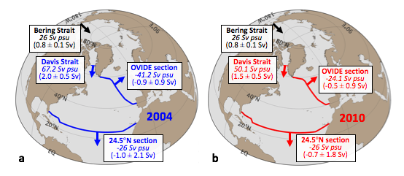

Figure S2. Salt conservation constraint as estimated in this study for a) 2004 and b) 2010. Numbers in italics account for salt transports, numbers in parenthesis for volume transports.

Figure S3. Evaporation (E), precipitation (P) and P-E in the North Atlantic Box and Mediterranean Sea in 2004 (upper panels) and 2010 (lower panels).

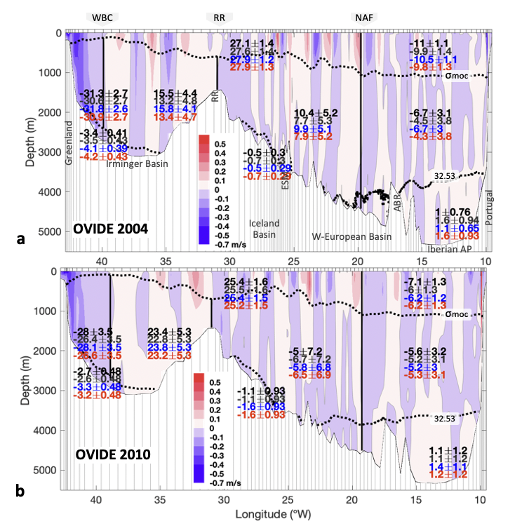

Figure S4. Velocity (shadding, in m/s) perpendicular to the OVIDE sections for the a) 2004 and b) 2010 cruises. The isopycnals used as density horizons for the transport estimates are also indicated (dotted lines): σMOC refers to σ1 isopycnal 32.15 kg m-3 (σ1 is the potential density referenced to 1000 dbar), separating the upper and lower limbs of the Atlantic Meridional Overturning Circulation (Mercier et al., 2015); σ1=32.53 kg m-3 ; σ4=45.9 kg m-3 (σ4 is the potential density referenced to 4000 dbar). Numbers represent net transports ± uncertainties (in Sv) by subregions (negative, southwards). Legend colour: black, results as in Lherminier et al. (2010) and Mercier at al. (2015); grey, test1 control run - joint inversion with original setup; red, test 2 - new inversion with original setup plus salinity conservation applied and new wind product; and blue, test 3 – same as in test 2, but no SADCP used as constraint (see text S5 for details).
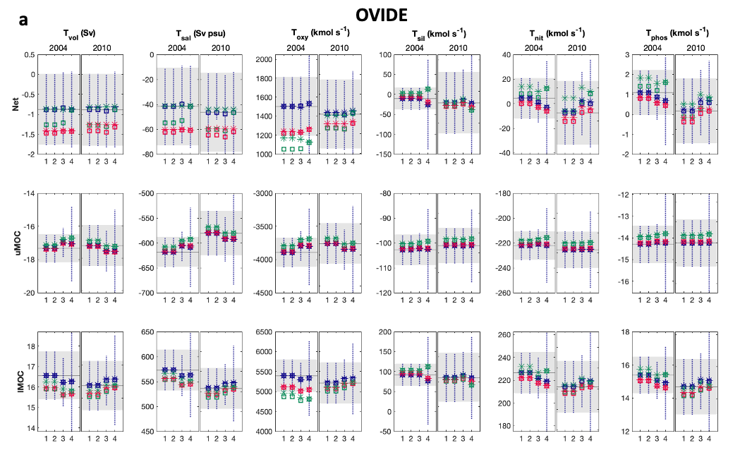
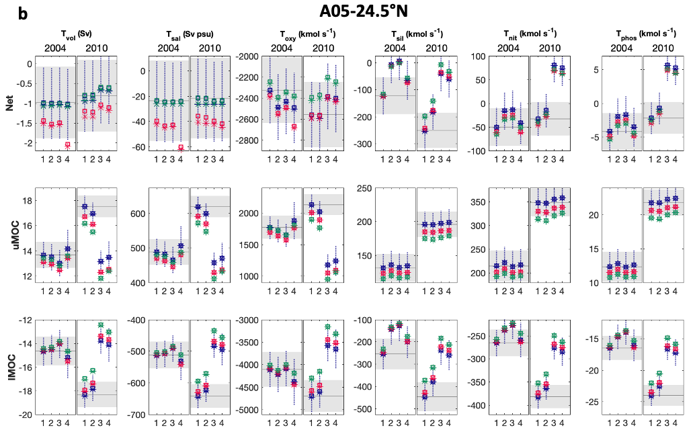

Figure S5. Summary of sensitivity tests of transports across a) A05-24.5°N and b) OVIDE. The horizontal (x) axis displays test numeration: test 1, annual Ekman (and annual Florida Straits transport); test 2, annual Ekman (and annual Florida Straits transport) and use of a redefined (shallower) reference level in the West Boundary Wedge (west of 76.75°W) at A05-24.5°N (see text for details); test 3, time-of-the-cruise Ekman (and annual Florida Straits transport) and shallower western boundary reference at A05-24.5°N; test 4, time-of-the-cruise Ekman (and annual Florida Straits transport) and shallower western boundary reference at A05-24.5°N and RAPID Western boundary transport used as constraint. Color legend: blue, bottom triangles assuming constant velocity; red, bottom triangles assuming linearly decreasing velocity to 0 at bottom; green, no bottom triangles. Symbol legend: open square, salt conservation constraint with an uncertainty of 25 Sv psu; star, salt conservation constraint with an uncertainty of 0.5 Sv psu (see text for details). Negative (positive) values mean inward (outward) transports.

Figure S6. Summary of sensitivity for the budget estimates. Positive values mean convergence (d([N]/dt>0)) and/or nutrient consumption exceeding regeneration (steady-state assumption). Likewise, negative values mean nutrient divergence (d([N]/dt<0)) and/or net nutrient regeneration (steady-state assumption). The horizontal (x) axis displays test numeration: test 1, annual Ekman (and annual Florida Straits transport); test 2, annual Ekman (and annual Florida Straits transport) and use of a redefined (shallower) reference level in the West Boundary Wedge (west of 76.75°W) at A05-24.5°N (see text for details); test 3, time-of-the-cruise Ekman (and annual Florida Straits transport) and shallower western boundary reference at A05-24.5°N; test 4, time-of-the-cruise Ekman (and annual Florida Straits transport) and shallower western boundary reference at A05-24.5°N and RAPID Western boundary transport used as constraint. Color legend: blue, bottom triangles assuming constant velocity; red, bottom triangles assuming linearly decreasing velocity to 0 at bottom; green, no bottom triangles. Symbol legend: open square, salt conservation constraint with an uncertainty of 25 Sv psu; star, salt conservation constraint with an uncertainty of 0.5 Sv psu (see text for details).

c
d
a
b

Figure S7. Upper panels: Comparison of the current meter (blue lines) vs. geostrophic velocity profiles (red lines) in the Western Boundary Wedge (region between Bahamas and 76.75°W). Current meter profiles are those corresponding to the same cruise sampling periods in the region (a) from Apr 7th 21:00 to Apr 8th 8:15, 2004 cruise; (b) from Jan 8th 19:00 to Jan 9th 14:00, 2010 cruise). First geostrophic velocity profile east of 76.75°W was also included (green line). Lower panels: Temporal variability of the current-meter velocity profile in the Western Boundary Wedge (WBW, between Bahamas and 76.75°W). Current meter profiles are those corresponding to the same cruise sampling periods in the region (c) from Apr 7th 21:00 to Apr 8th 8:15, 2004 cruise; (d) from Jan 8th 19:00 to Jan 9th 14:00, 2010 cruise).

Figure S8. Total Western Boundary Wedge (WBW, between Bahamas and 76.75°W) absolute transports. Grey line shows the 12-h WBW time series, and grey numbers are the corresponding WBW transport values averaged for the time of each cruise. Green line is 10-day low-pass filtered WBW transports, and black line represent the 3-month low-pass filtered. Red numbers are the hydrography-based estimates.

Table S1. Secondary QC GLODAPv2.2019 (Olsen et al., 2019) multiplicative factors of correction for oxygen and nutrient bottle data.
Section | Cruise Year | Oxygen | Silicate | Nitrate | Phosphate
A05-24.5°N | 2004 | 1 | 0.975 | 0.975 | 0.975
 | 2010 | 1.025 | 0.945 | 0.965 | 0.985
OVIDE | 2004 | 1 | 0.98 | 0.975 | 1.1
 | 2010 | 1 | 0.98 | 0.99 | 1.1

Table S2. External sources (inputs) of silicate, nitrate and phosphate (other than advection across the hydrographic OVIDE and A05-24.5°N sections) to the subtropical box (box boundaries shown in Figure 1). Global, NA-box or NA, refer to a global-based, NA-box-based or North-Atlantic-based estimate, respectively; M or O refer to model-based or observation-based estimates, respectively.
Source | Nutrient flux*  (kmol s⁻¹) | Ref. year** | Ref. region | Ref. data | References
Silicate | 2004: 71 ± 11  2010: 64 ± 11
Atm. deposition | 0.7 $±$ 0.7 | No time ref. | Global | O | Tréguer et al. (1995, 2013)
Fluvial inputs and ice-sheet meltwaters | 26 $±$ 11 | No time ref. | Global | O | Tréguer et al. (2013), Dürr et al. (2011), Hawkings et al. (2017)
Davis Strait | 37.3, 27.8 | 2004, 2010 | NA-box | O | Torres-Valdés et al. (2013), Curry et al. (2014)
Gibraltar Strait | 3.9 $±$ 0.3 | 2005-2008 | NA-box | O | Huertas et al. (2012)
Other (seafloor weathering, ground water, hydrothermal sources) | 4.6 ± 1.5 | No time ref. | Global | O | Tréguer et al. (1995, 2013)
Nitrate | 2004: 73 ± 11 (+ DON*: 84 ± 12)  2010: 64 ± 11 (+ DON*: 77 ± 12)
Atm. deposition | 4.5 $±$ 4.5 | 2005 | NA-box | M | Jickells et al. (2017)
Fluvial inputs | 2.2 $±$ 0.5 | 2000 | NA-box | M | Mayorga et al. (2010), Sharples et al., (2016)
Davis Strait | 26.4 $±$ 4.0, 19.5 $±$ 4.0 | 2004, 2010 | NA-box | M | Torres-Valdés et al. (2013), Curry et al. (2014)
Gibraltar Strait | 4.4$±$ 0.1 | 2005-2008 | NA-box | O | Huertas et al. (2012)
N₂ fixation | 33 $±$ 9 | No time ref. | NA-box/NA | M/O | Jickells et al. (2017), Singh et al. (2013)
Phosphate | 2004: 3.3 ± 0.4 (+ DOP*: 6.3 ± 1.1)  2010: 2.6 ± 0.4 (+ DOP*: 5.6 ± 1.1)
Atm. deposition | 0.03 $±$ 0.03 | No time ref. | NA | M | Mahowald et al. (2008)
Fluvial inputs | 0.13$±$ 0.06 | 2000 | NA-box | M | Mayorga et al. (2010), Sharples et al., (2016)
Davis Strait | 3.0 $±$ 0.4, 2.3 $±$ 0.4 | 2004, 2010 | NA-box | O | Torres-Valdés et al. (2013), Curry et al. (2014)
Gibraltar Strait | 0.15$±$ 0.01 | 2005-2008 | NA-box | O | Huertas et al. (2012)
* See Text S1 for derivation of numbers; ** Period of time the value accounts for.

Table S3. List of hydrographic cruises at the Florida Straits. P.I. denotes principal investigator, #St the number of stations.
Cruise no. | Cruise ID | Day | Month | Year | Vessel | P.I. |  | #St
1 | NOAA FC1505 | 26-27 | May | 2015 | R/V Walton Smith | J.A. Hooper, M.O. Baringer |  | 9
2 | NOAA FC1507 | 14-15 | Jul | 2015 | R/V Walton Smith | J.A. Hooper, M.O. Baringer |  | 9
3 | NOAA FC1509 | 8-9 | Sep | 2015 | R/V Walton Smith | J.A. Hooper, M.O. Baringer |  | 9
4 | NOAA FC1511 | 10-11 | Nov | 2015 | R/V Walton Smith | J.A. Hooper, M.O. Baringer |  | 9
5 | DY040* | 10-12 | Dec | 2015 | RRS Discovery | B. King |  | 13
6 | NOAA FC1603 | 23-24 | Mar | 2016 | R/V Walton Smith | J.A. Hooper, M.O. Baringer |  | 9
7 | NOAA FC1605 | 16-17 | May | 2016 | R/V Walton Smith | J.A. Hooper, M.O. Baringer |  | 9
8 | NOAA FC1607 | 13-14 | Jul | 2016 | R/V Walton Smith | J.A. Hooper, M.O. Baringer |  | 9
9 | NOAA FC1609 | 15-16 | Sep | 2016 | R/V Walton Smith | J.A. Hooper, M.O. Baringer |  | 9
10 | NOAA FC1612 | 12-13 | Dec | 2016 | R/V Walton Smith | J.A. Hooper, M.O. Baringer |  | 9
11 | NOAA FC1702 | 7-8 | Feb | 2017 | R/V Walton Smith | J.A. Hooper, M.O. Baringer |  | 9
* DY040 cruise was carried out across the whole A05-24.5°N section.

Table S4a. Volume (T_{vol}) and nutrient (T_{sil}, T_{nit}, T_{phos}) transports across Davis Straits by vertical levels (see Torres-Valdés et al. (2013) for layer definitions). TW accounts for the transport weighted properties, as obtained from Torres-Valdés et al. (2013). T_{sil}, T_{nit} and T_{phos} at given layer result from multiplying the TW property at the given layer by the volume transport of that layer (volume transport estimates by Curry et al., 2014). Finally, total transport weighted nutrients* were estimated as the total nutrient transport divided by the total volume transport.
 | T_{vol} | TW-sil | TW-nit | TW-phos |  | T_{sil} | T_{nit} | T_{phos}
 | (Sv) | (μmol kg⁻¹) |  |  |  | (kmol s⁻¹)
2004
Surface Water | 1.4 | 7.79 | 6.49 | 0.11 |  | 8.7 | 9.3 | 1.09
Subsurface Water | -1.75 | 9.74 | 8.76 | 0.13 |  | -21.0 | -15.8 | -2.10
Upper Atlantic Water | -1.5 | 12.17 | 12.98 | 0.10 |  | -25.0 | -20.0 | -2.00
Total | -1.9 | 20.16* | 14.28* | 1.63* |  | -37.3 | -26.4 | -3.0
2010
Surface Water | 1.1 | 7.79 | 6.49 | 0.11 |  | 6.8 | 7.3 | 0.86
Subsurface Water | -1.5 | 9.74 | 8.76 | 0.13 |  | -18.0 | -13.5 | -1.80
Upper Atlantic Water | -1 | 12.17 | 12.98 | 0.10 |  | -16.7 | -13.3 | -1.33
Total | -1.4 | 19.87* | 13.93* | 1.63* |  | -27.8 | -19.5 | -2.3

Table S4b. Volume and salt transports at Davis Straits by water masses as defined by Curry et al. (2014). Salt transports (T_{sal}) by water mass were computed as the volume transport (T_{vol}) multiplied by the mean salinity of a given water mass. The total salt transport was then estimated as the sum of the contribution of all water masses. Finally, a transport weighted salinity* was re-estimated as total salt transport divided by the total volume transport.
 | T_{vol} | Mean salinity | T_{sal}
 | (Sv) |  | (Sv psu)
2004
Arctic Water | -1.8 | 33.10 | -59.6
West Greenland Irminger Water | 0.9 | 34.57 | 31.1
West Greenland Shelf Water | 0.4 | 33.30 | 12.7
Transitional Water | -1.5 | 34.29 | -51.4
Total | -2.0 | 33.29* | -67.2
2010
Arctic Water | -1.6 | 32.90 | -52.6
West Greenland Irminger Water | 0.6 | 34.55 | 20.7
West Greenland Shelf Water | 0.4 | 33.30 | 12.7
Transitional Water | -0.9 | 34.29 | -30.9
Total | -1.5 | 32.97* | -50.1

