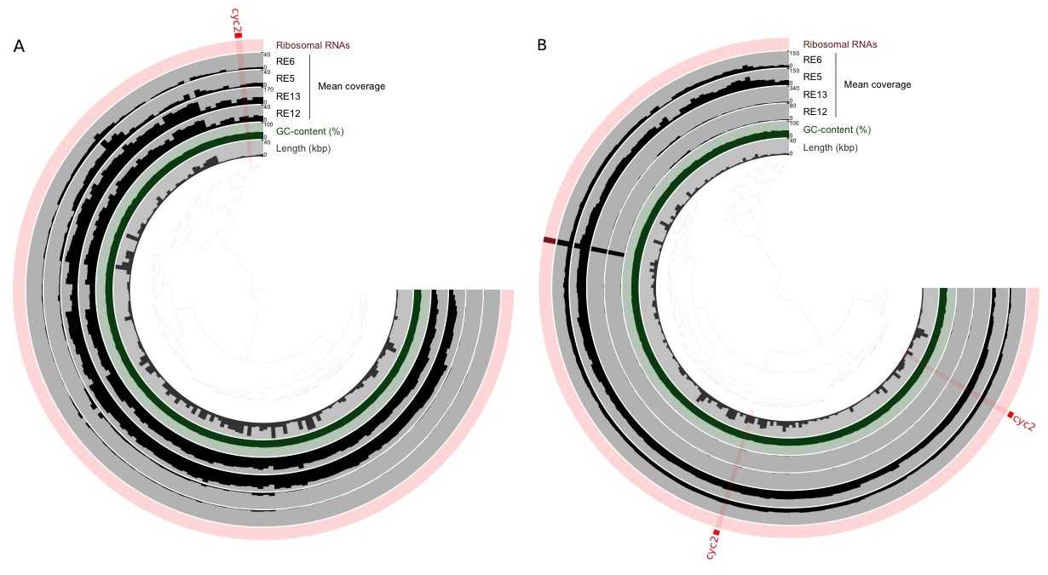
Additional File 13. Differential coverage of contigs within Zetaproteobacteria bins. Static image from the anvi’o refine display for A. RB_MAG_00008 and B. TAG_MAG_00014. From inner to outer layers: clustering based on sequence composition and differential coverage with Euclidian distance and Ward clustering method, length layer (shows the actual length of a split), auxiliary layer with information about contigs stored in the contig database (GC-content), four view layers with information about MAGs across samples stored in the profile database (mean coverage), and Ribosomal RNA presence. Splits containing the cyc2 genes are highlighted in red. (PDF 129kb).

