Supplementary Material

North Atlantic basin-scale multi-criteria assessment database to inform effective management and protection of Vulnerable Marine Ecosystems
Telmo Morato^{1,2*}, Christopher K. Pham^{1,2}, Laurence Fauconnet^{1,2}, Gerald H. Taranto^{1,2}, Giovanni Chimienti^{3,4}, Erik Cordes⁵, Carlos Dominguez-Carrió^{1,2}, Pablo Durán Muñoz⁶, Hrönn Egilsdóttir⁷, José-Manuel González-Irusta^{1,2,8}, Anthony Grehan⁹, Dierk Hebbeln¹⁰, Lea-Anne Henry¹¹, Georgios Kazanidis¹¹, Ellen Kenchington¹², Lenaick Menot¹³, Tina Molodtsova¹⁴, Covadonga Orejas¹⁵, Berta Ramiro-Sánchez^{11,16}, Manuela Ramos^{1,2}, Murray J. Roberts¹¹, Luís Rodrigues^{1,2}, Steve W. Ross¹⁷, José L. Rueda¹⁸, Mar Sacau⁶, David Stirling¹⁹, Marina Carreiro-Silva^{1,2}
¹Okeanos Research Centre, Universidade dos Açores, Departamento de Oceanografia e Pescas, 9901-862 Horta, Portugal
²IMAR Instituto do Mar, Universidade dos Açores, Departamento de Oceanografia e Pescas, 9901-862 Horta, Portugal
³Department of Biology, University of Bari Aldo Moro, Bari, Italy
⁴Consorzio Nazionale Interuniversitario per le Scienze del Mare CoNISMa, Rome, Italy
⁵Department of Biology, Temple University, Philadelphia, USA
⁶Instituto Español de Oceanografía, Centro Oceanográfico de Vigo, Vigo, Pontevedra, Spain
⁷Marine and Freshwater Research Institute, Reykjavík, Iceland
⁸Instituto Español de Oceanografía, Centro Oceanográfico de Santander, Santander, Spain
⁹Earth and Ocean Sciences, National University of Ireland Galway, Ireland
¹⁰MARUM - Center for Marine Environmental Sciences, University of Bremen, Germany
¹¹School of GeoSciences, Grant Institute, University of Edinburgh, United Kingdom
¹²Bedford Institute of Oceanography, Fisheries and Oceans Canada, Dartmouth, NS, Canada
¹³L'Institut Français de Recherche pour l'Exploitation de la Mer IFREMER, EEP/LEP, Centre de Bretagne, Plouzané, France
¹⁴P.P. Shirshov Institute of Oceanology, Russian Academy of Sciences, Moscow, Russia
¹⁵Instituto Español de Oceanografía, Centro Oceanográfico de Baleares, Palma, Spain
¹⁶Biologie des Organismes et Ecosystèmes Aquatiques (BOREA), Centre National de la Recherche Scientifique, Muséum National d’Histoire Naturelle, Institut de Recherche pour le Developpement, Sorbonne Université, Université de Caen Normandie, Université des Antilles, Paris, France
¹⁷Center for Marine Science, University of North Carolina at Wilmington, Wilmington, NC, USA
¹⁸Instituto Español de Oceanografía, Centro Oceanográfico de Málaga, Málaga, Spain
¹⁹Marine Laboratory, Marine Scotland Science, Aberdeen, Scotland, UK
* Correspondence:
Telmo Morato
t.morato@gmail.com
Keywords: deep-sea, deep-sea fisheries, marine protected areas, area-based management tools, sponges, cold-water corals, vulnerable marine ecosystems, ecologically or biologically significant marine areas

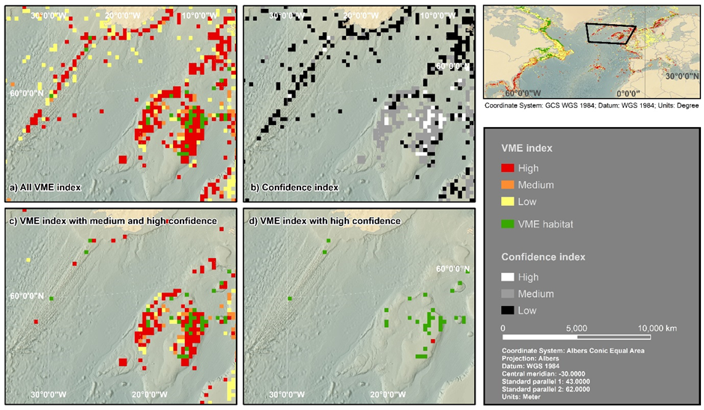
Supplementary Figure 1. Application of the North Atlantic basin-scale VME and confidence indexes datasets in Hatton-Rockall Bank and southern Iceland. a) VME index for all cells with data in the VME database; b) Confidence Index for all cells with data in the VME database; c) VME index for cells with medium and high confidence; and d) VME index for cells with high confidence.

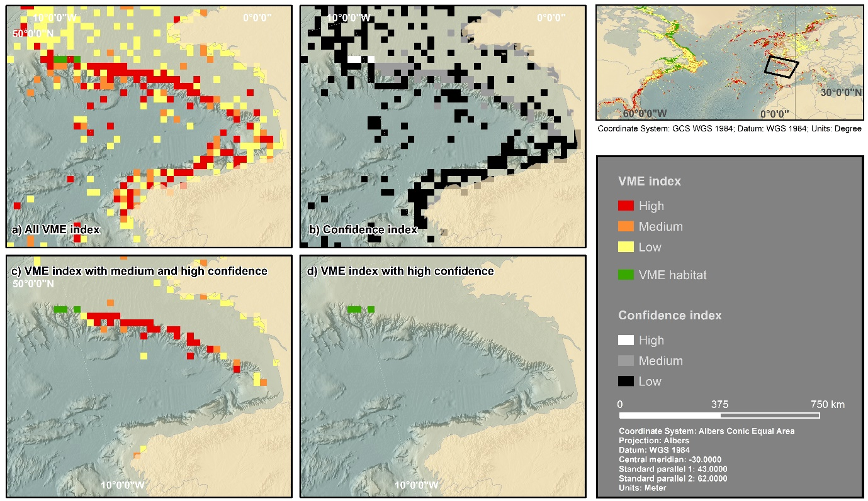
Supplementary Figure 2. Application of the North Atlantic basin-scale VME and confidence indexes datasets in the Bay of Biscay. a) VME index for all cells with data in the VME database; b) Confidence Index for all cells with data in the VME database; c) VME index for cells with medium and high confidence; and d) VME index for cells with high confidence.

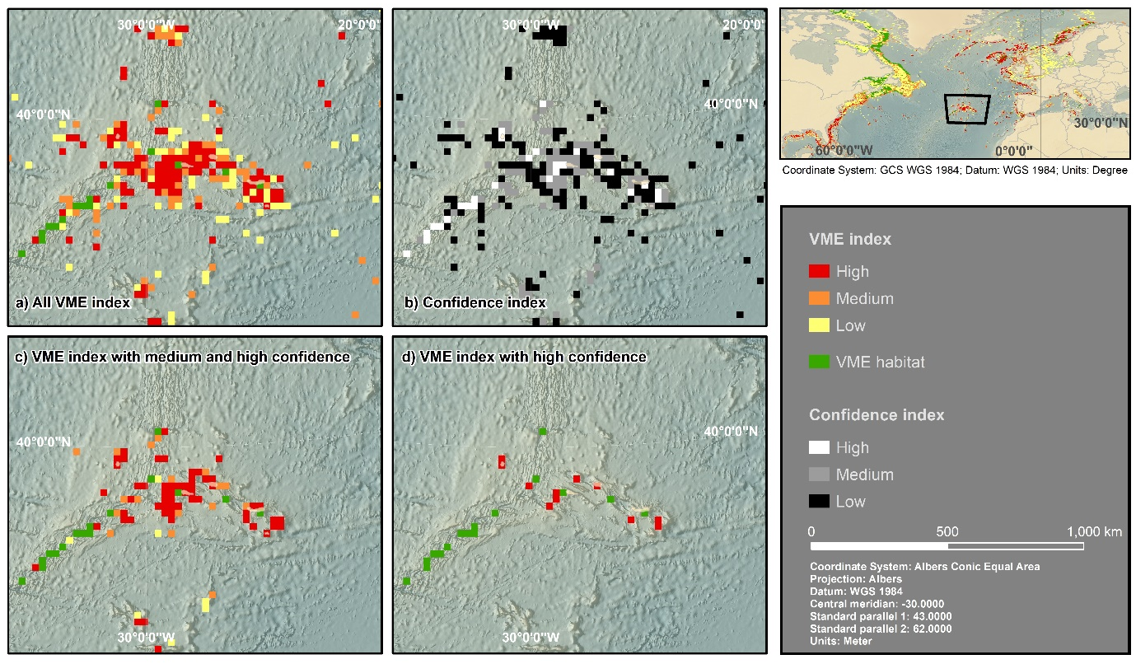
Supplementary Figure 3. Application of the North Atlantic basin-scale VME and confidence indexes datasets in the Azores. a) VME index for all cells with data in the VME database; b) Confidence Index for all cells with data in the VME database; c) VME index for cells with medium and high confidence; and d) VME index for cells with high confidence.

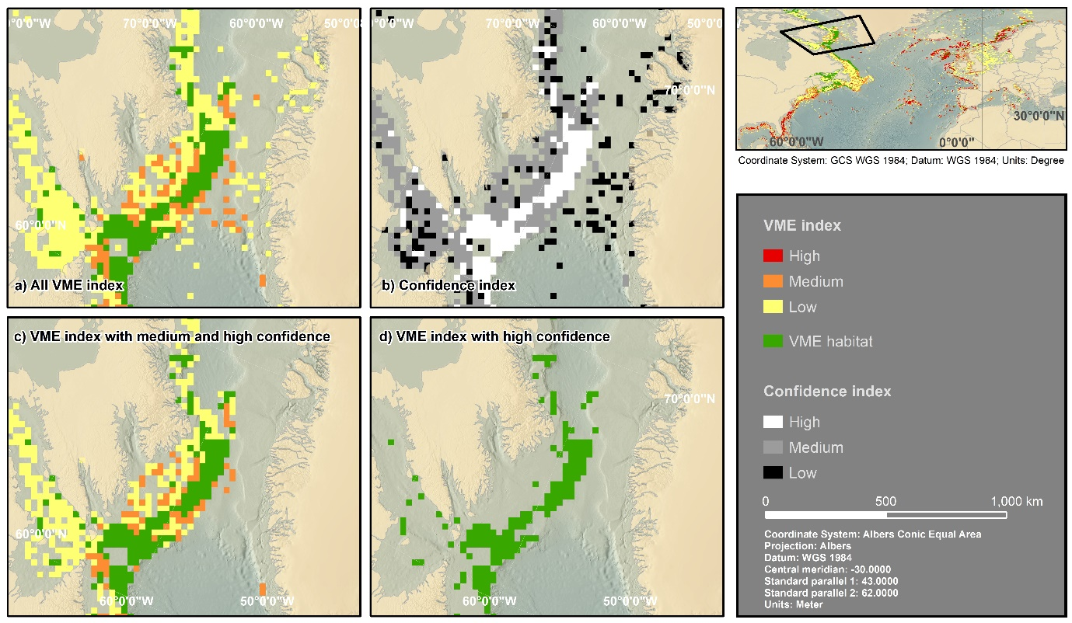
Supplementary Figure 4. Application of the North Atlantic basin-scale VME and confidence indexes datasets in the Davis Strait. a) VME index for all cells with data in the VME database; b) Confidence Index for all cells with data in the VME database; c) VME index for cells with medium and high confidence; and d) VME index for cells with high confidence.

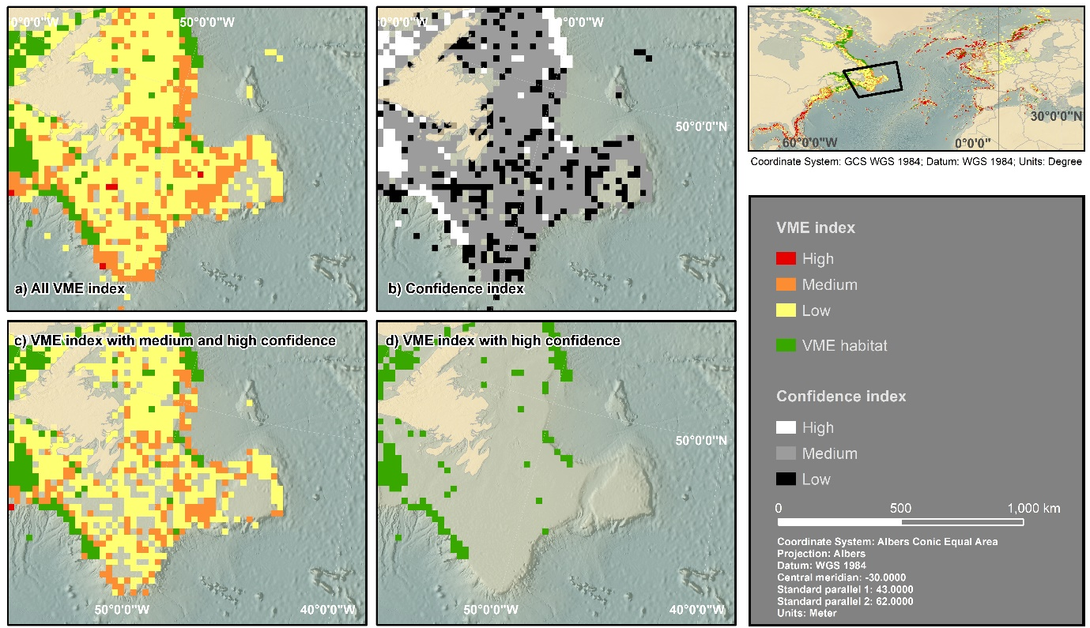
Supplementary Figure 5. Application of the North Atlantic basin-scale VME and confidence indexes datasets in the Flemish Cap. a) VME index for all cells with data in the VME database; b) Confidence Index for all cells with data in the VME database; c) VME index for cells with medium and high confidence; and d) VME index for cells with high confidence.

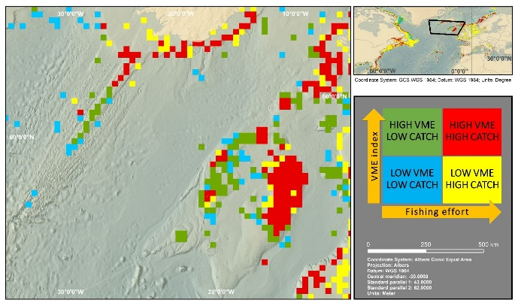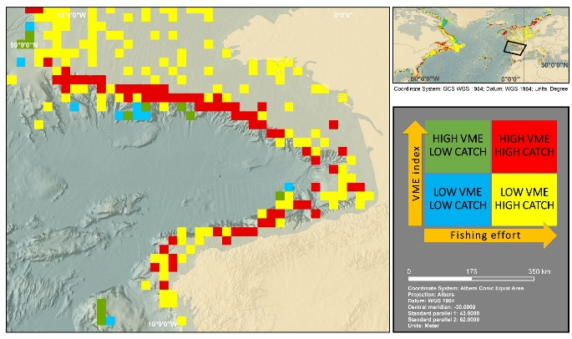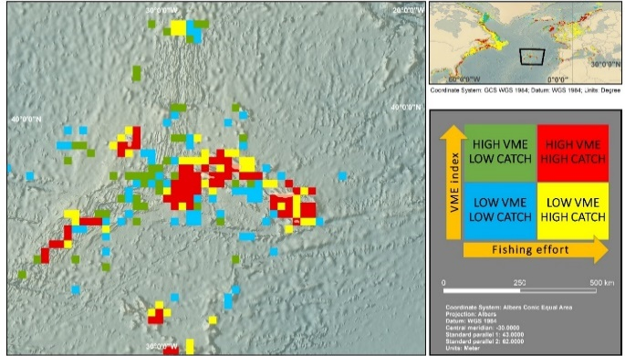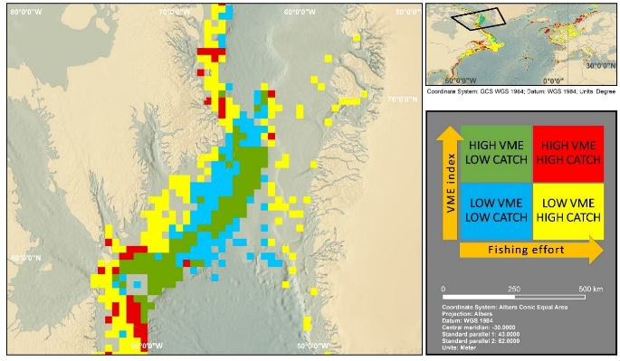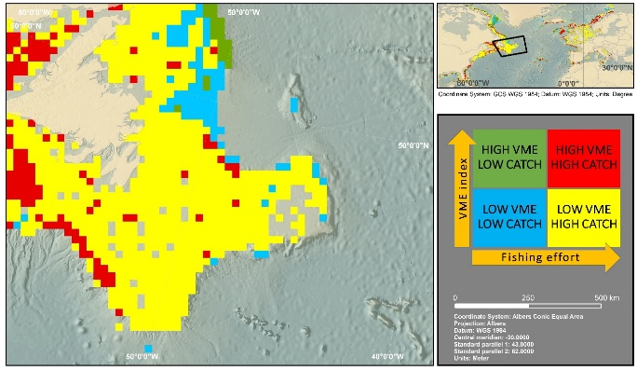
Supplementary Figure 6. Application of the portfolio categories concept to the Rockall-Hatton Bank and southern Iceland (top-left), the Bay of Biscay (top right), the Azores (mid-left), the Davis Strait (mid right), and the Flemish Cap (bottom-left). Blue cells are low VME – low catch, yellow cells are low VME – high catch, green cells are high VME – low catch, and red cells are high VME – high catch.

