Supplementary Figures
Supplementary Figures S1 to S16
Records of seagrass species occurrence across the Pacific Island Countries and Territories (PICTs), from Table S1. Includes additional field species occurrence observations from the Solomon Islands (McKenzie et al., 2016), Palau (Ohba et al., 2007) and Pohnpei (McKenzie and Rasheed, 2006).

Figure S1. Occurrence of Cymodocea rotundata Ehrenberg and Hemprich ex Ascherson across the PICTs
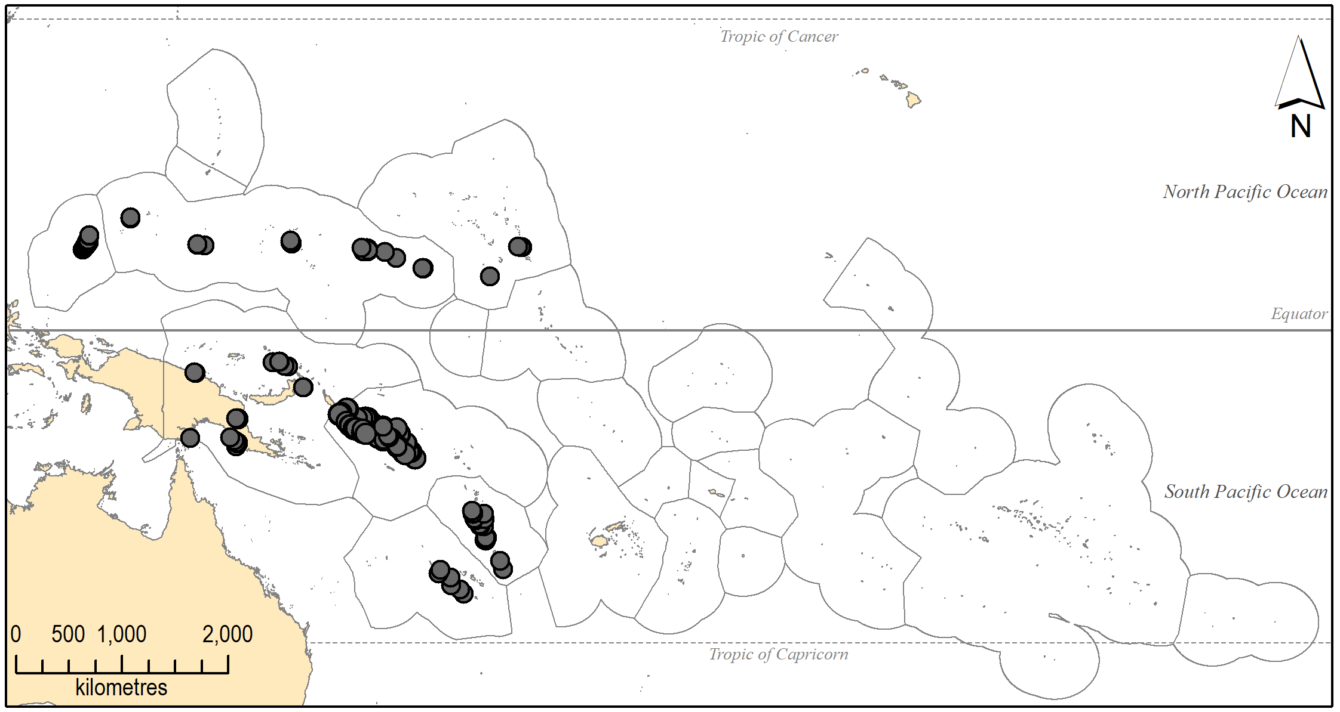

Figure S2. Occurrence of Cymodocea serrulata (R.Brown) Ascherson & Magnus across the PICTs
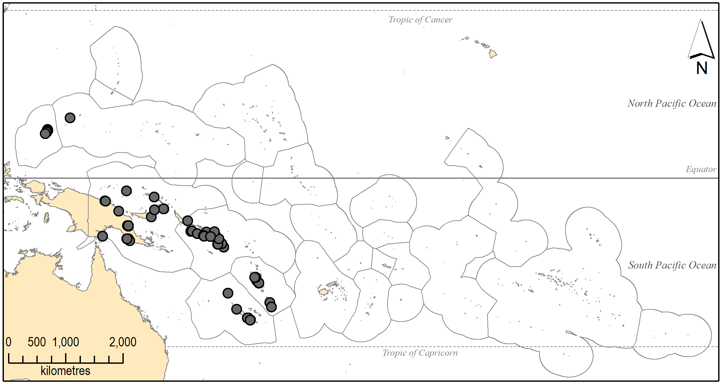

Figure S3. Occurrence of Enhalus acoroides (L.f.) Royle across the PICTs
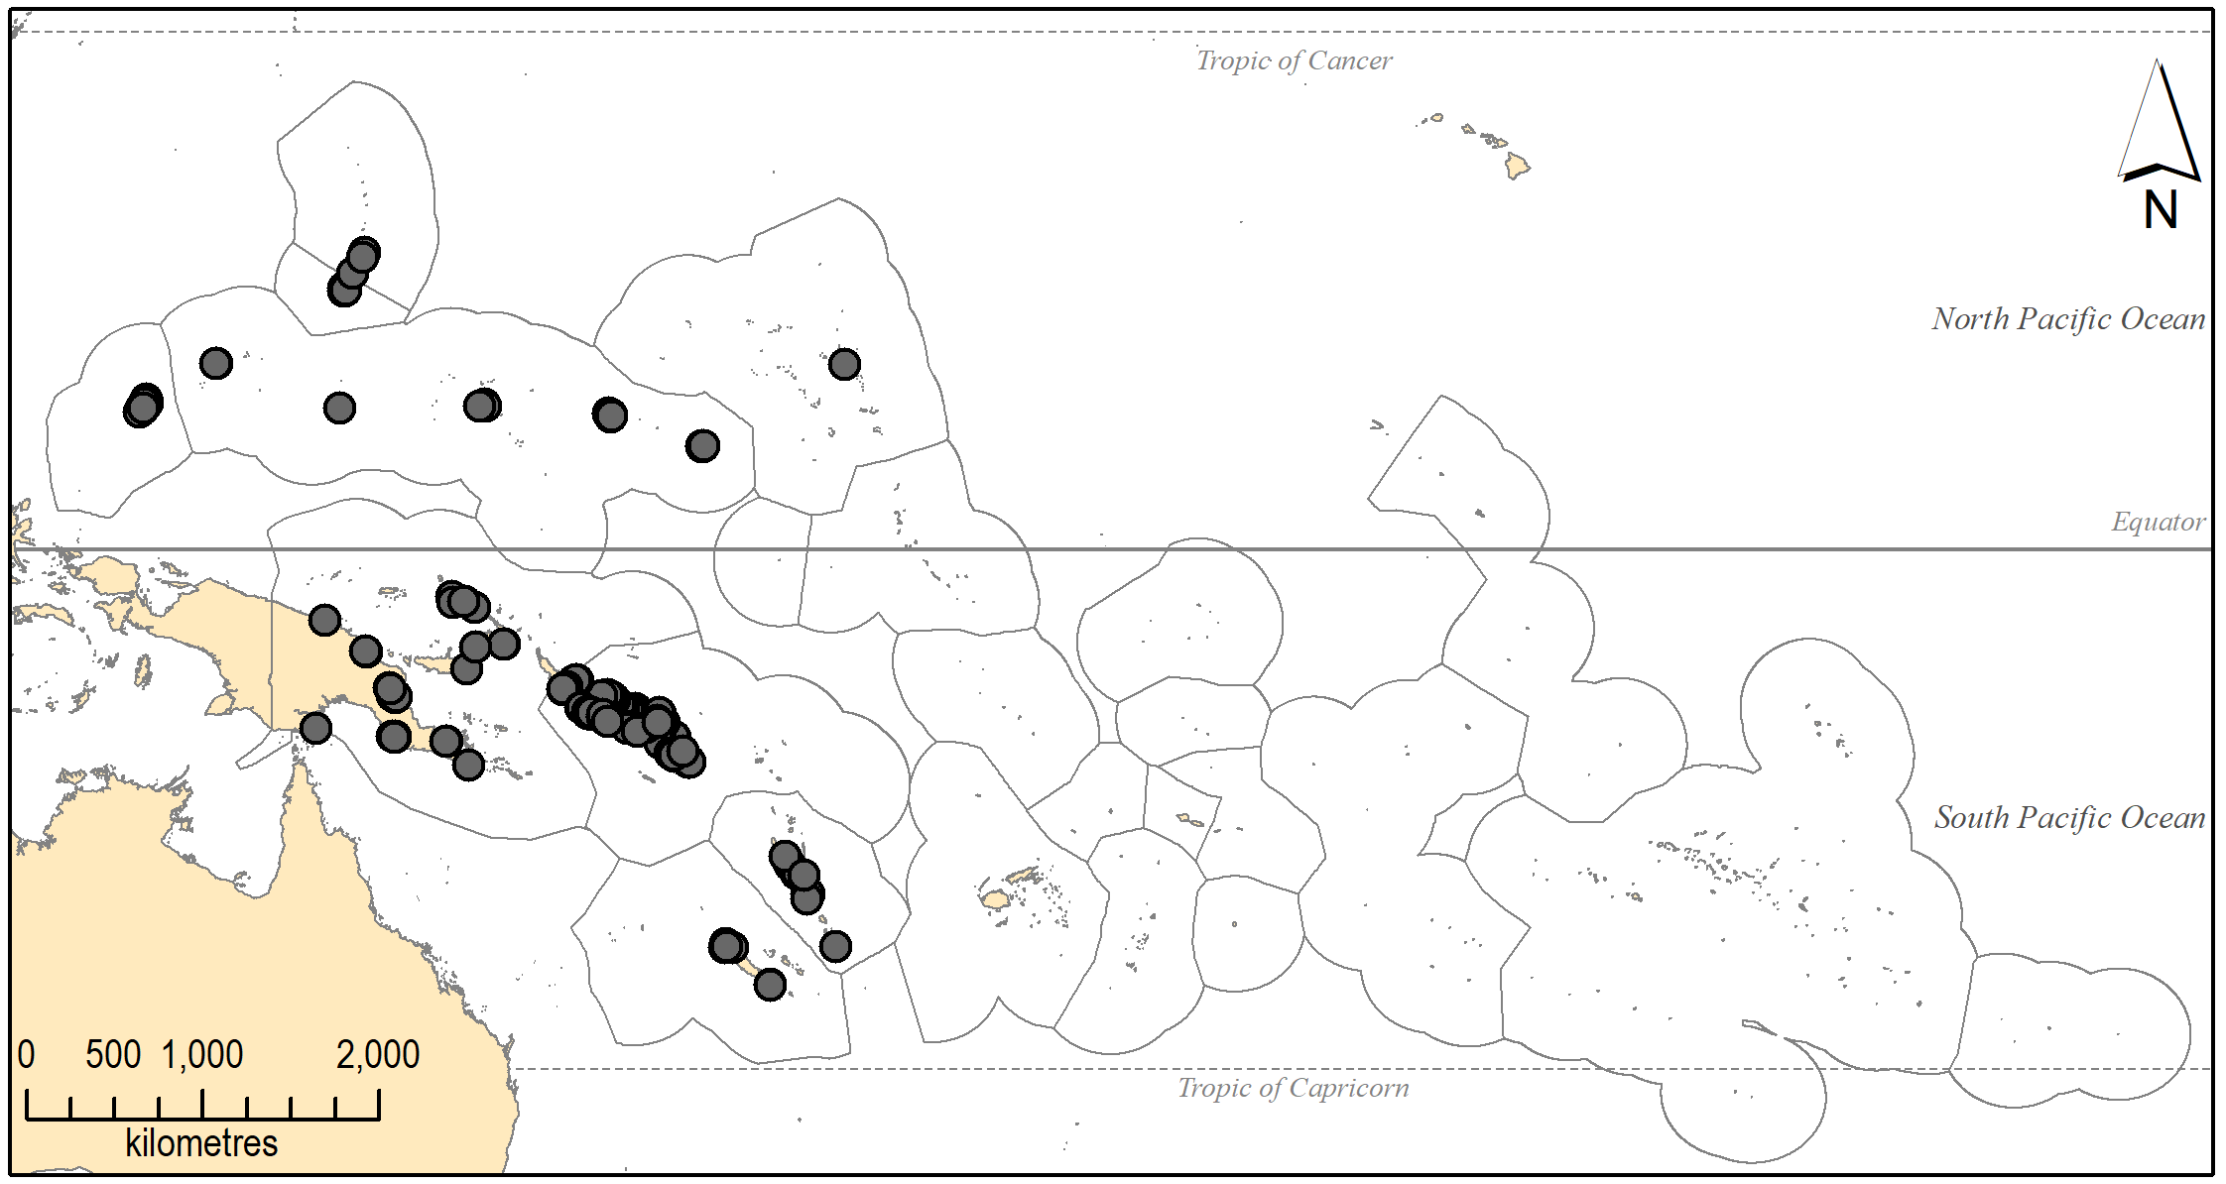

Figure S4. Occurrence of Halodule pinifolia (Miki) den Hartog across the PICTs
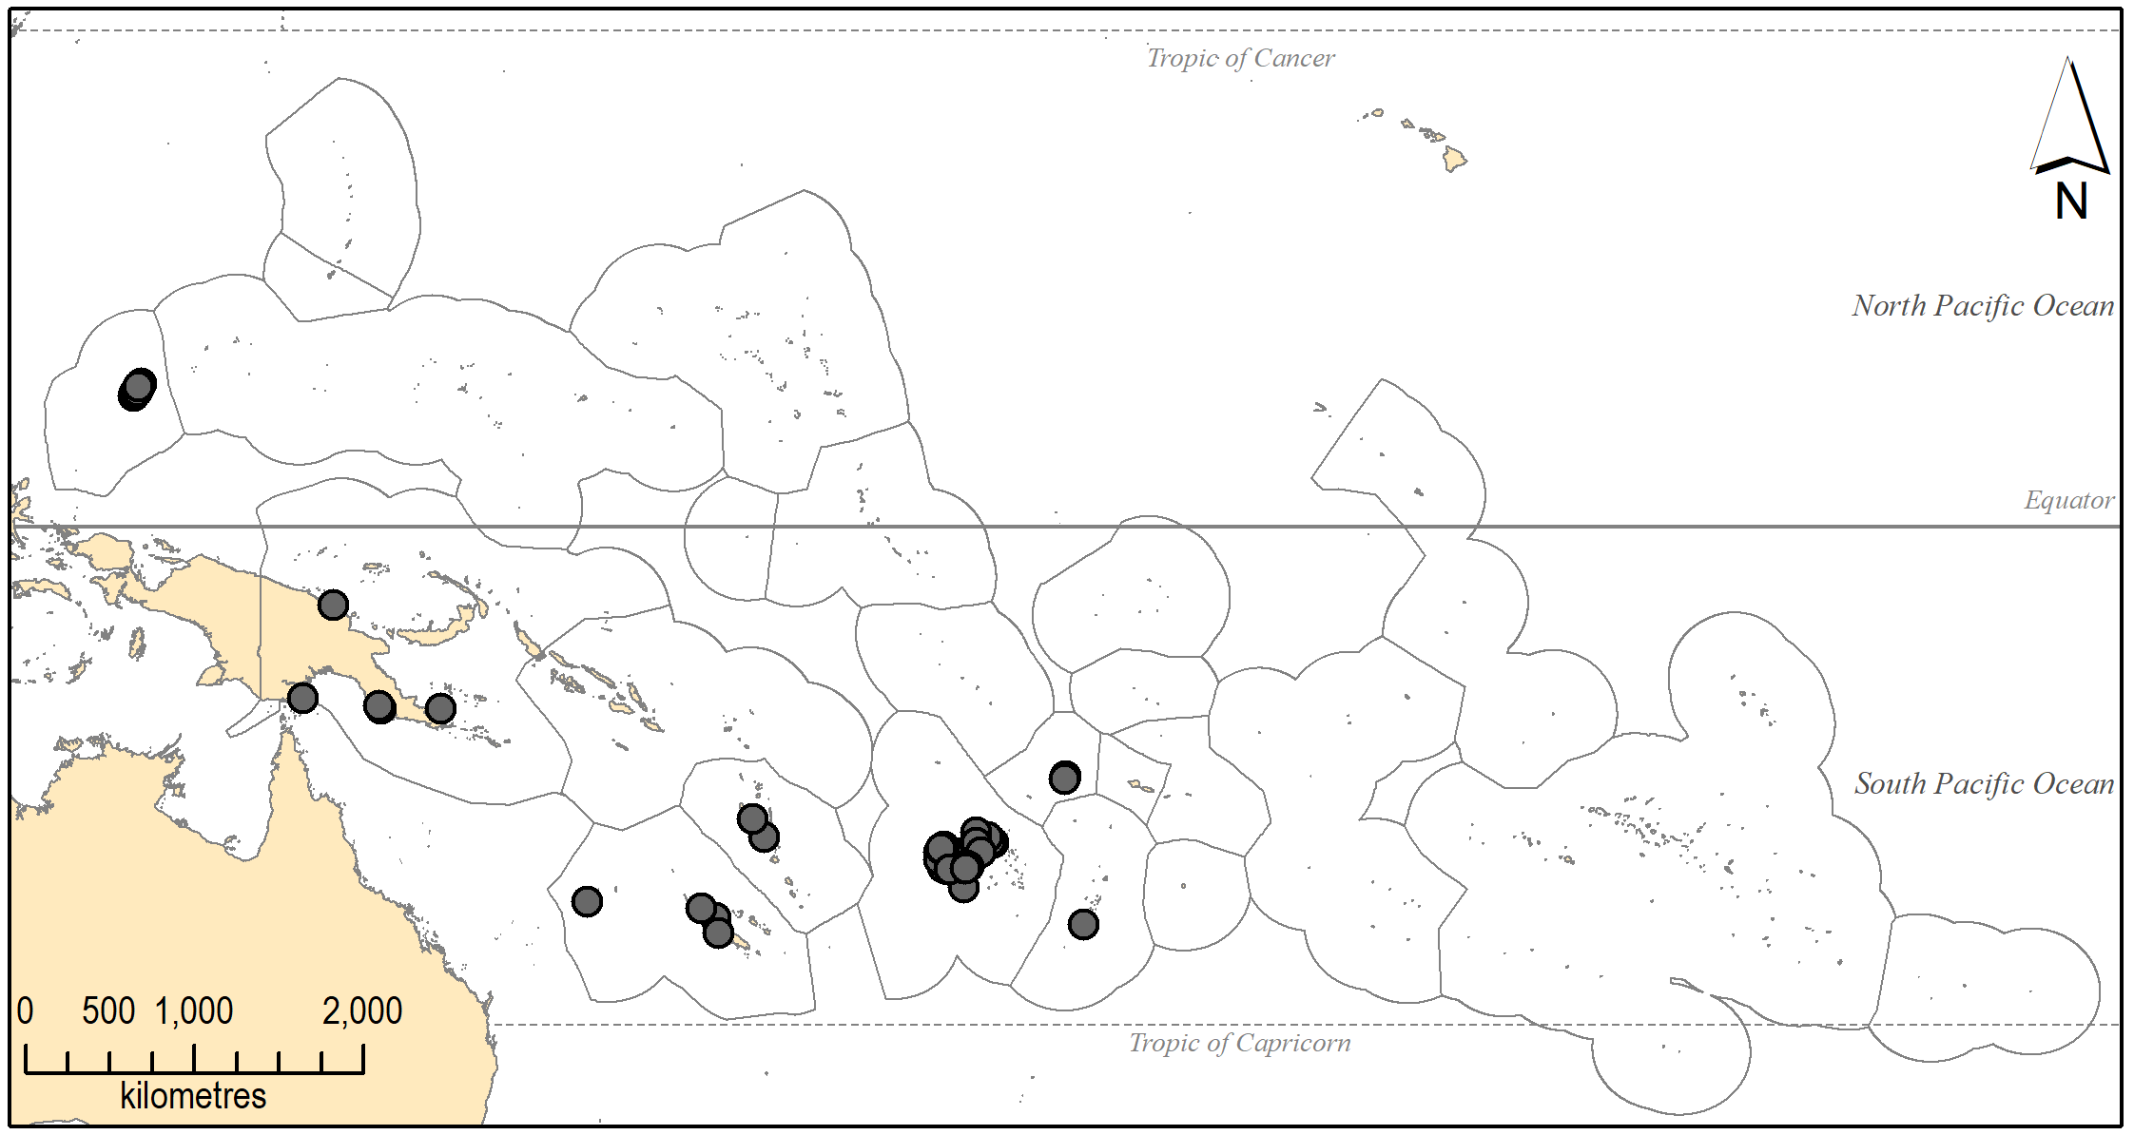

Figure S5. Occurrence of Halodule uninervis (Forsskål) Ascherson across the PICTs
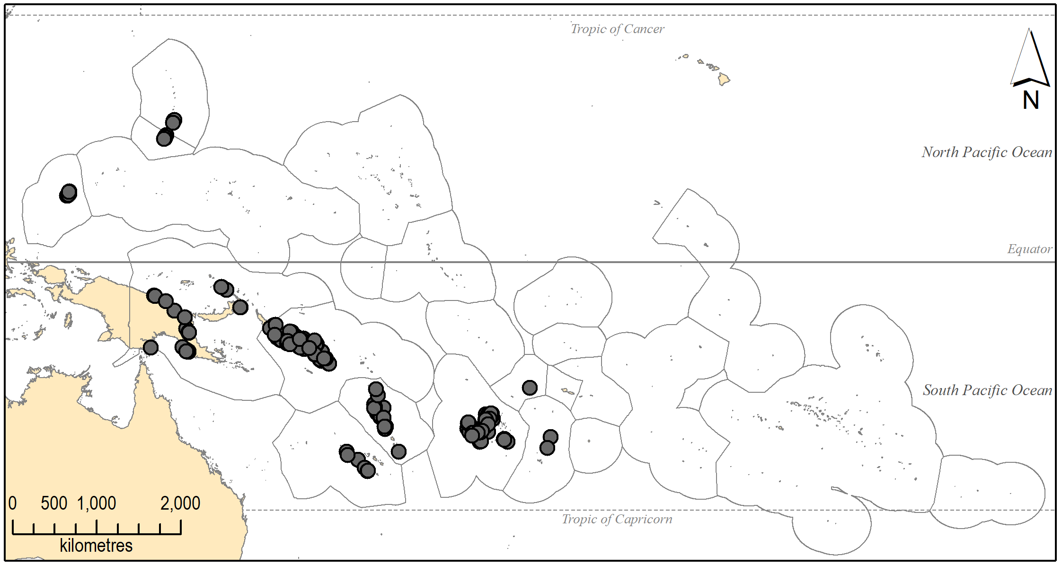

Figure S6. Occurrence of Halophila capricorni Larkum across the PICTs
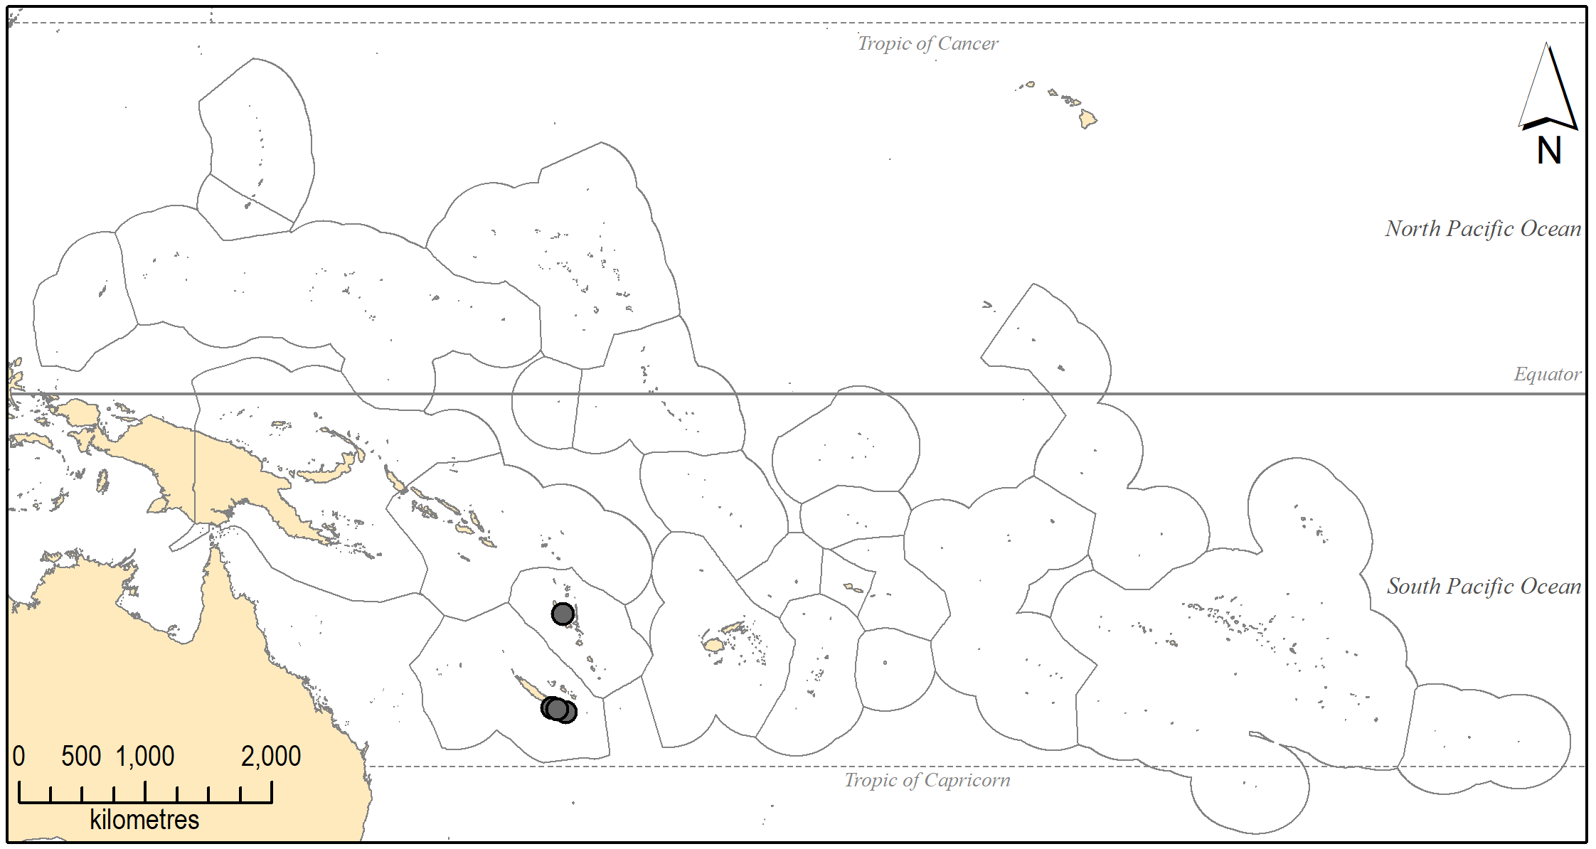

Figure S7. Occurrence of Halophila decipiens Ostenfeld across the PICTs
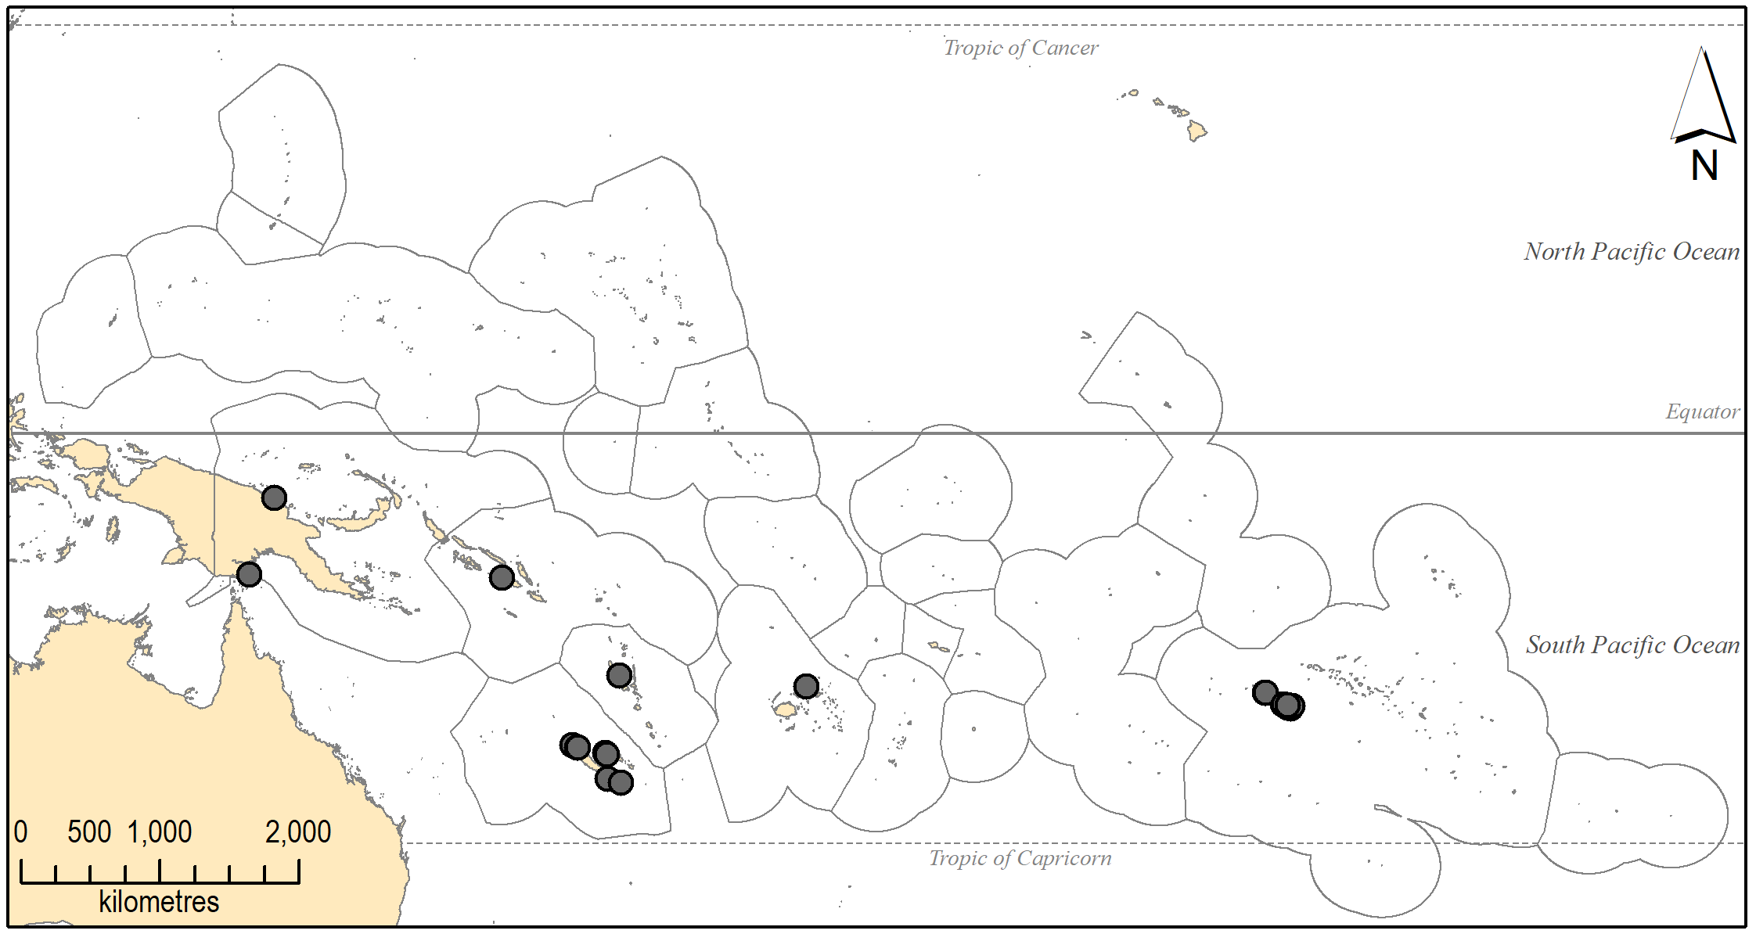

Figure S8. Occurrence of Halophila gaudichaudii J. Kuo across the PICTs
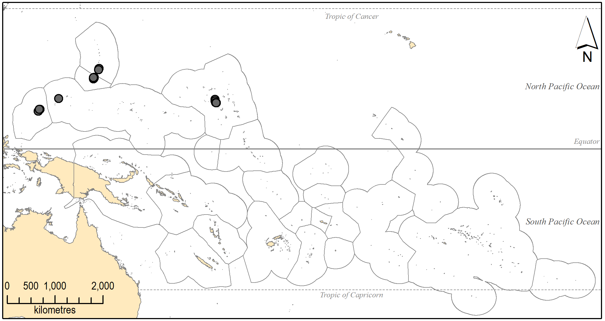

Figure S9. Occurrence of Halophila minor (Zoll.) den Hartog across the PICTs
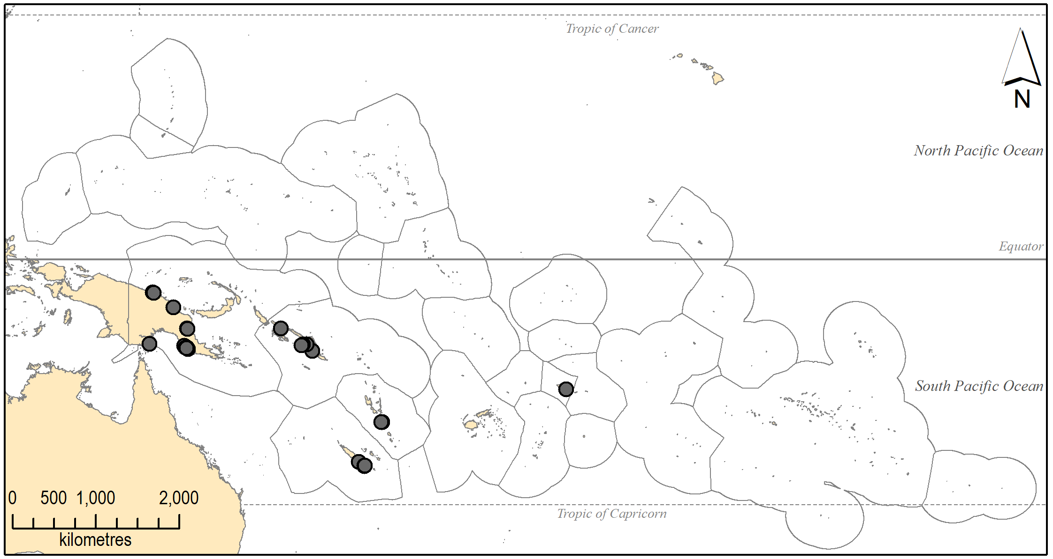

Figure S10. Occurrence of Halophila ovalis (R. Brown) J.D. Hooker across the PICTs
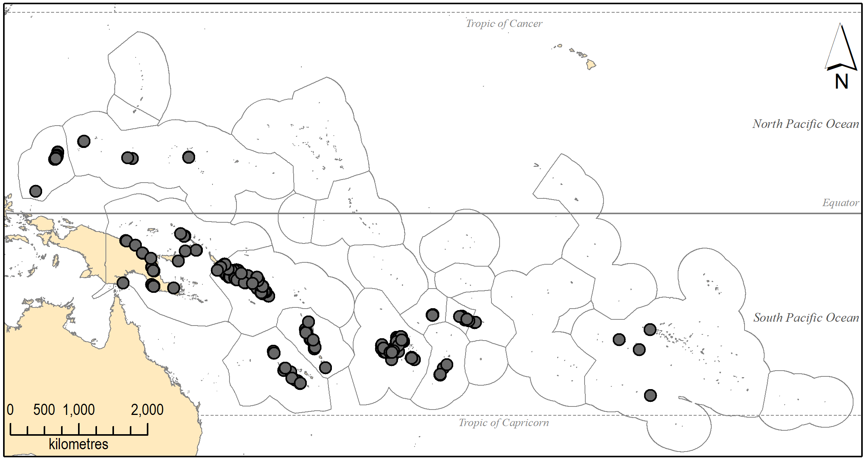

Figure S11. Occurrence of Halophila spinulosa (R. Brown) Ascherson across the PICTs
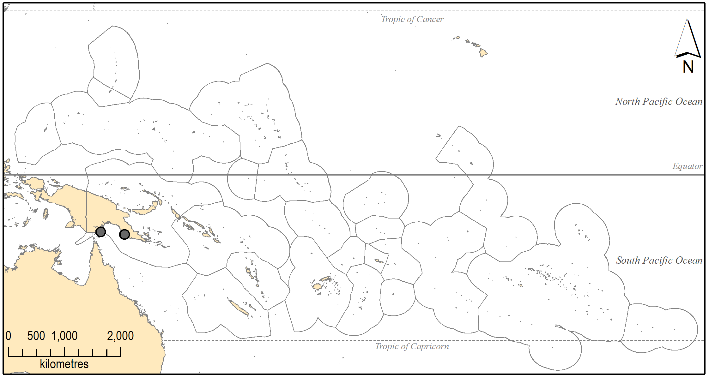

Figure S12. Occurrence of Ruppia maritima Linnaeus var. pacifica H. St. John & Fosberg across the PICTs
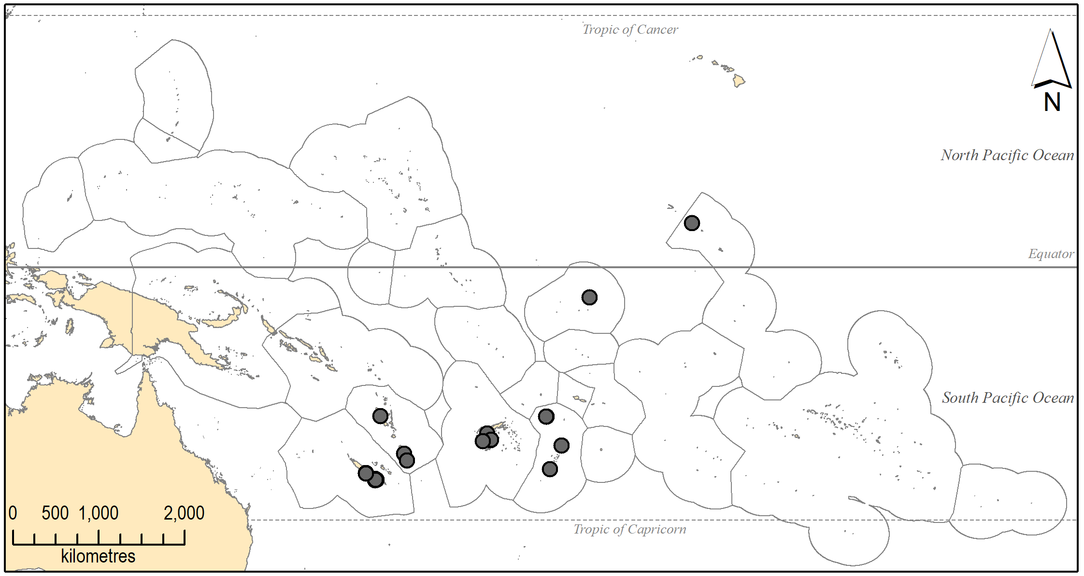

Figure S13. Occurrence of Syringodium isoetifolium (Ascherson) Dandy across the PICTs
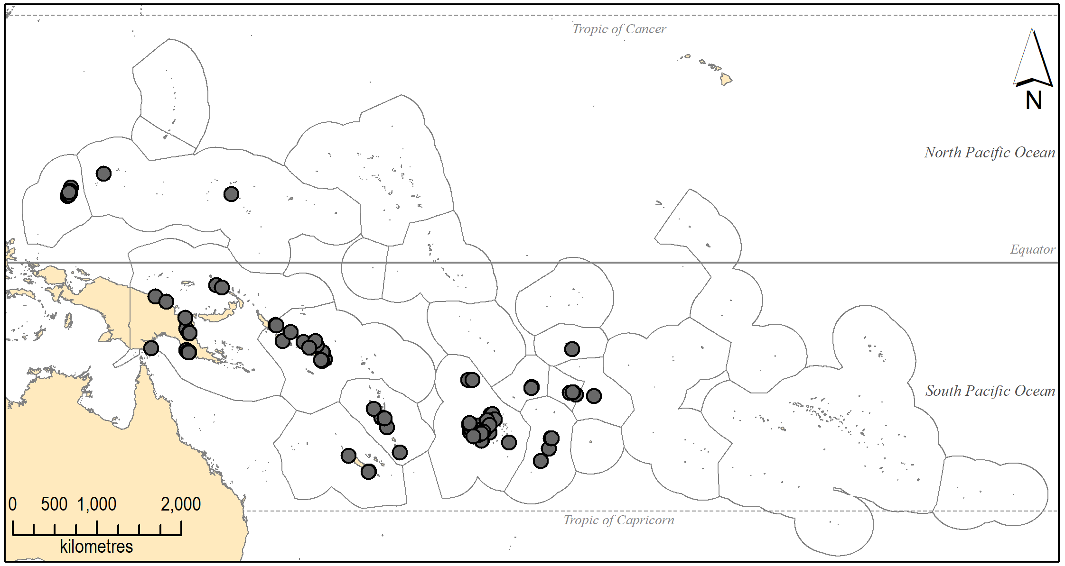

Figure S14. Occurrence of Thalassia hemprichii (Ehrenberg) Ascherson across the PICTs
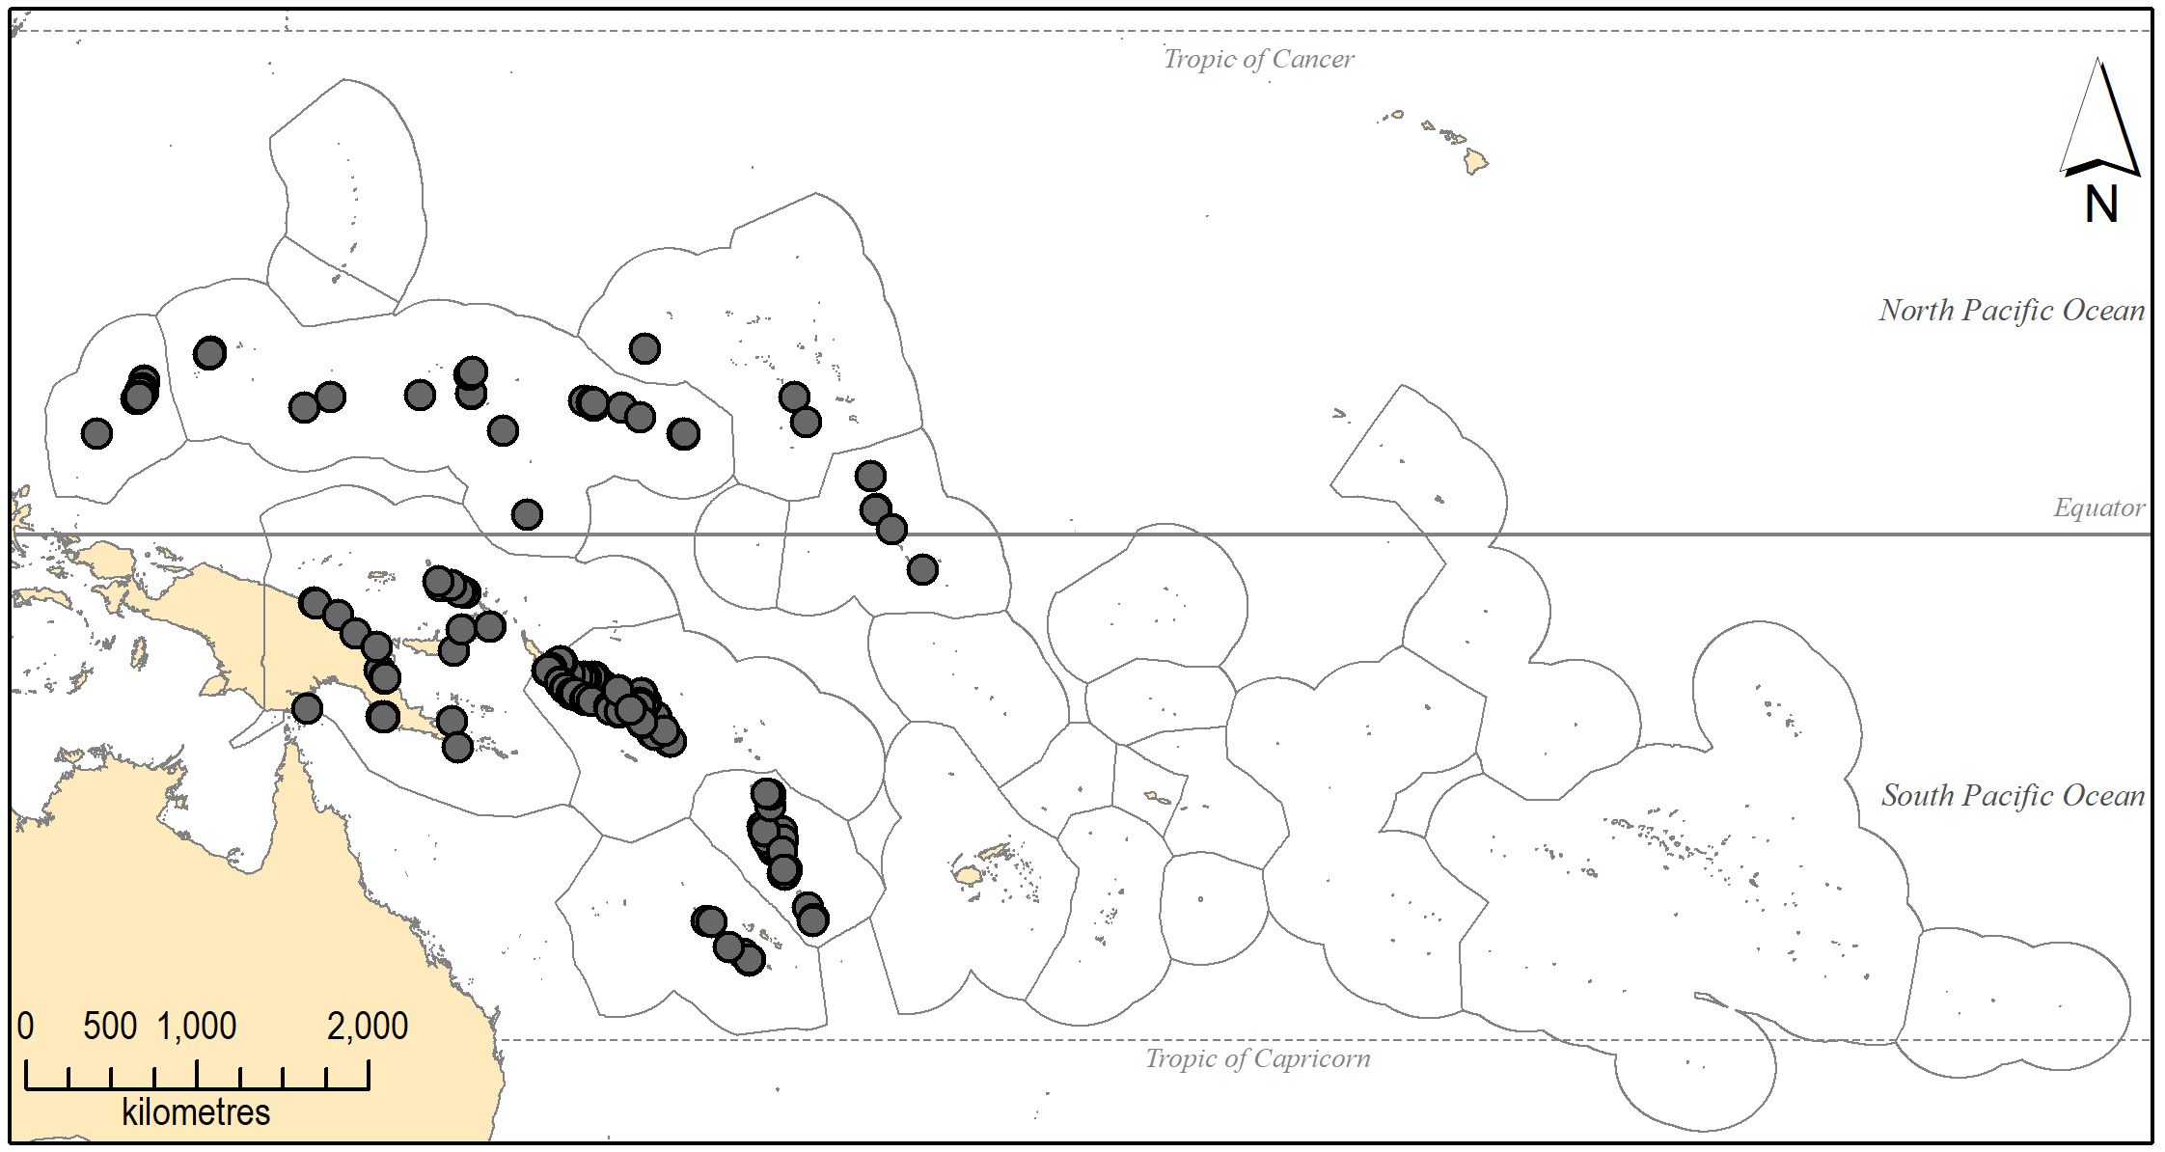

Figure S15. Occurrence of Thalassodendron ciliatum (Forsskål) den Hartog across the PICTs
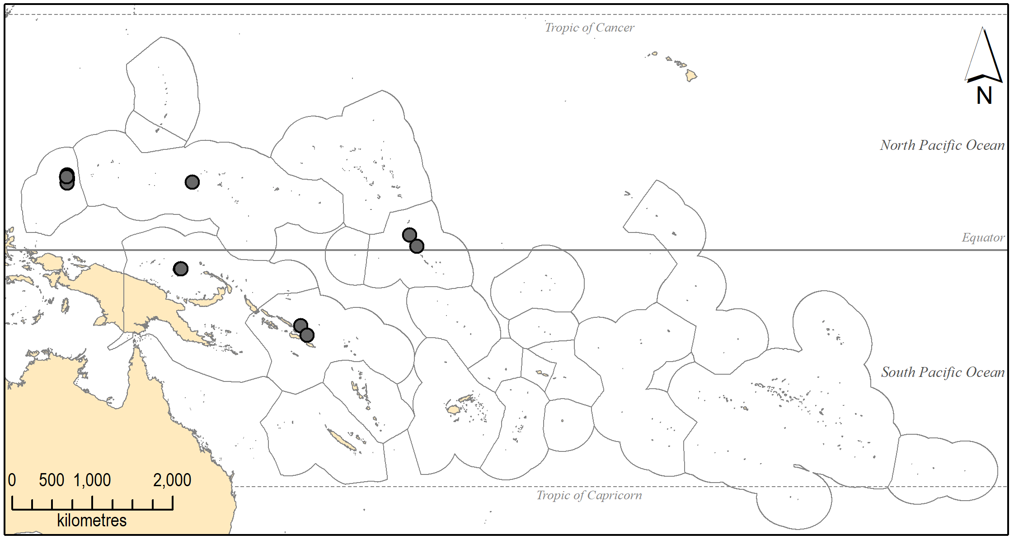

Figure S16. Occurrence of Zostera muelleri subsp. capricorni (Ascherson) S.W.L.Jacobs across the PICTs
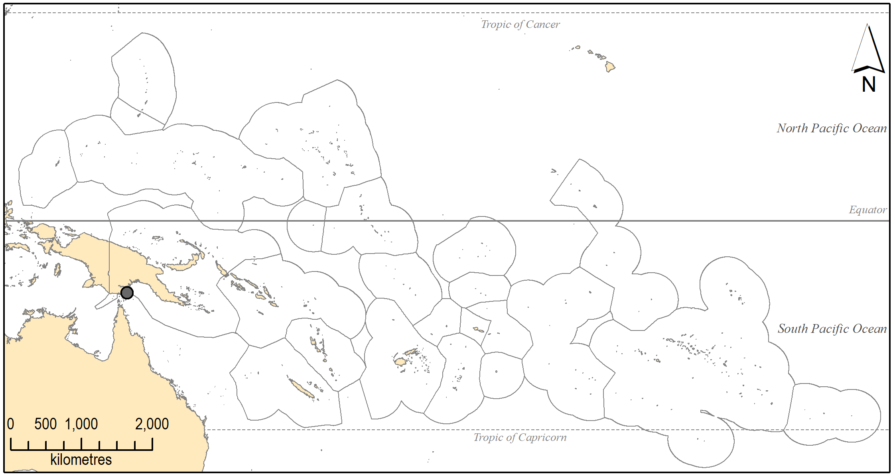

Figure S17. Changes in the seagrass meadow along the western shore of Kayangel Island (Kayangel Atoll, Palau) between 1946 and 2013: (a) meadow was a relatively narrow fringe, 1946; (b-c) meadow had expanded away from beach and along the shore, 1967 and 1971; (d) meadow had expanded into the atoll lagoon, 1992; (e) meadow expanded further into lagoon, September 2013; (f) little evidence of change in the meadow in December 2013, after Typhoon Haiyan (November 6th), despite extreme damage to buildings and vegetation on land. The lack of damage to the meadow is attributed to the western beach having been in the lee of wind and waves during the storm.
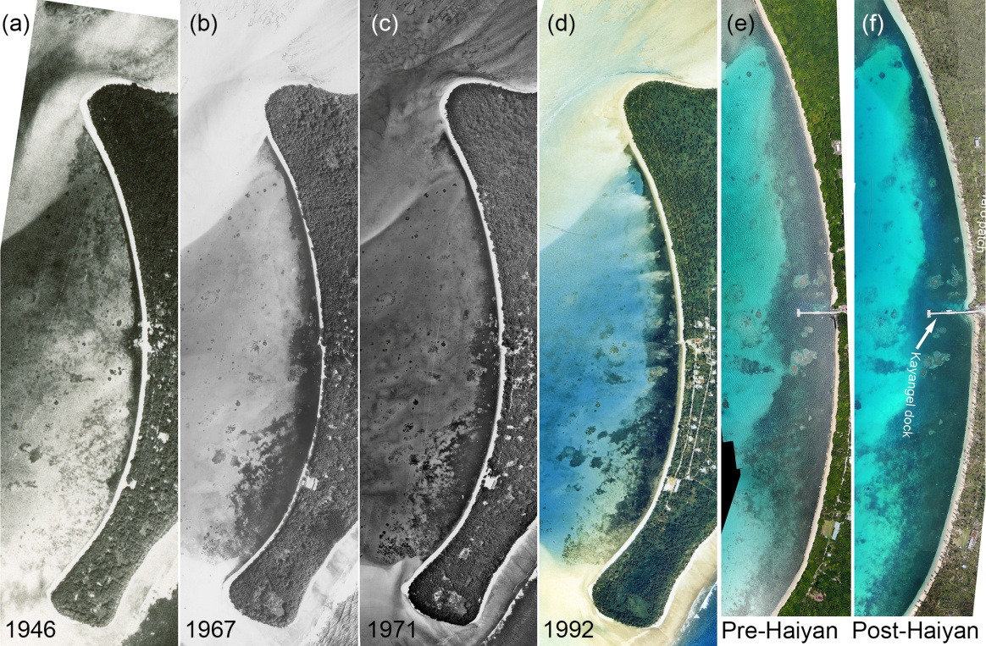

Figure S18. Impact of excavation dredging for coral sand fill material off Melekeok (a), and Ngiwal (b), Babeldaob, Palau. The construction of the Palau Compact Road (2000-2006), the largest works project ever undertaken in Palau, required significant fill material. In the late planning stages, it was realized the “cut and fill” earth moving on Babeldaob would not provide enough material for construction and more fill material was needed. The engineering solution was to dredge calcareous fill materials from several inshore locations on Babeldaob. These shallow sediments bottoms supported abundant seagrass meadows, but objections to damage from the dredging were minor due to the urgency to complete the project. An additional benefit from the dredging (and an important consideration in the overall approval) was that the sites chosen would become small-boat harbor areas along the shore after completion of the project.

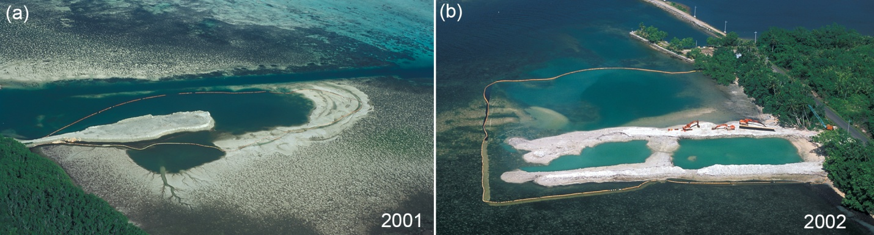

Figure S19. Impact of dredging conducted in 2002 for construction and access to Kayangel dock (Palau): (a) lagoon area in 2003, showing the area of bottom dredged to increase depth alongside the dock; (b) aerial view of same area in 2014 showing seagrass meadow recovery (minor areas of sand remain due to incomplete regrowth and effects of boat propellers on the seagrass).
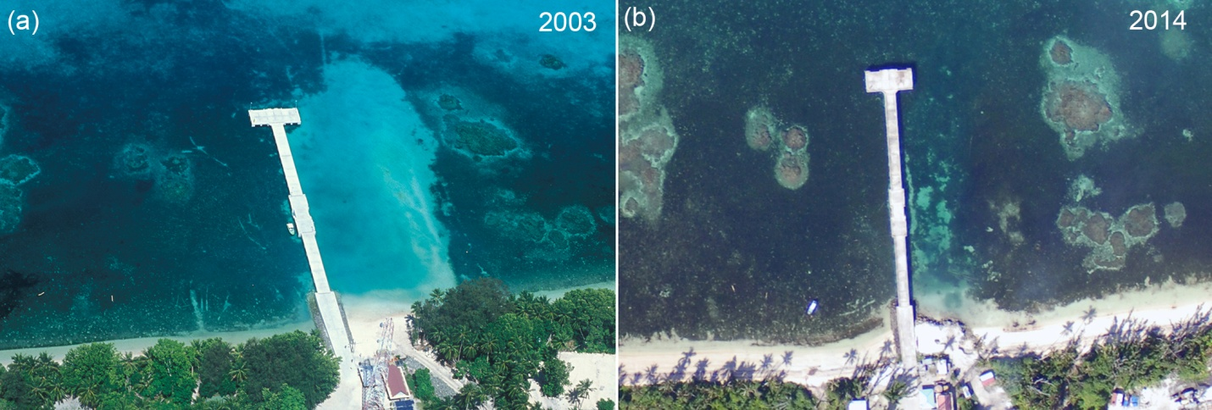

Supplementary References
McKenzie, L.J., Campbell, S.J., Lasi, F., 2016. Seagrass meadows of the Solomon Islands, derived from field surveys conducted 13 May and 16 June 2004, PANGAEA. 10.1594/PANGAEA.868773.
McKenzie, L.J., Rasheed, M.J., 2006. Seagrass meadows of Pohnpei and And Atoll, Federated States of Micronesia, derived from field surveys conducted 26 October-03 November, 2005, PANGAEA. 10.1594/PANGAEA.875721.
Ohba, H., Victor, S., Golbuu, Y., Yukihira, H., 2007. Tropical Marine Plants of Palau. Palau International Coral Reef Center (PICRC), Koror, Republic of Palau.

