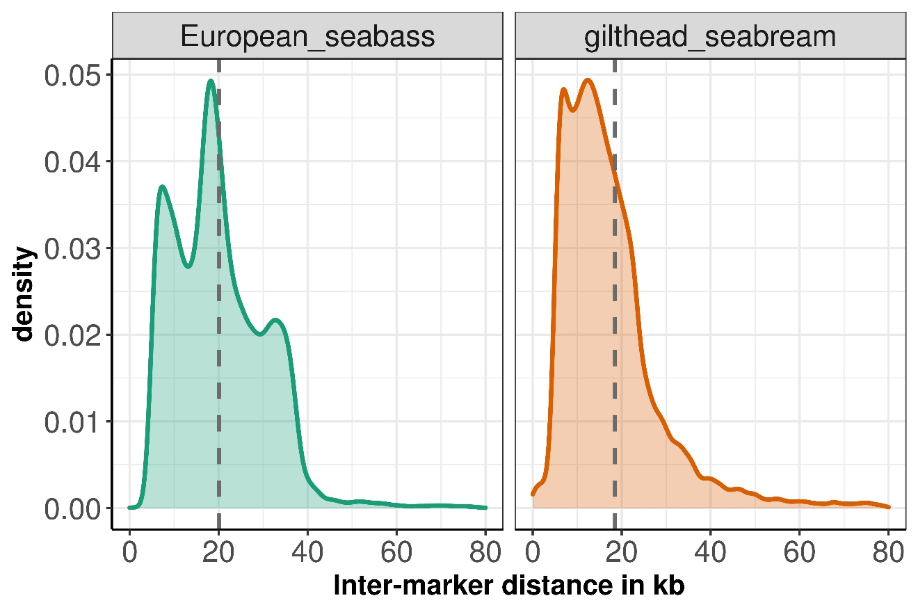

Figure S1. Density plots showing the distribution of the inter-marker distances of the markers on the combined-species SNP array.

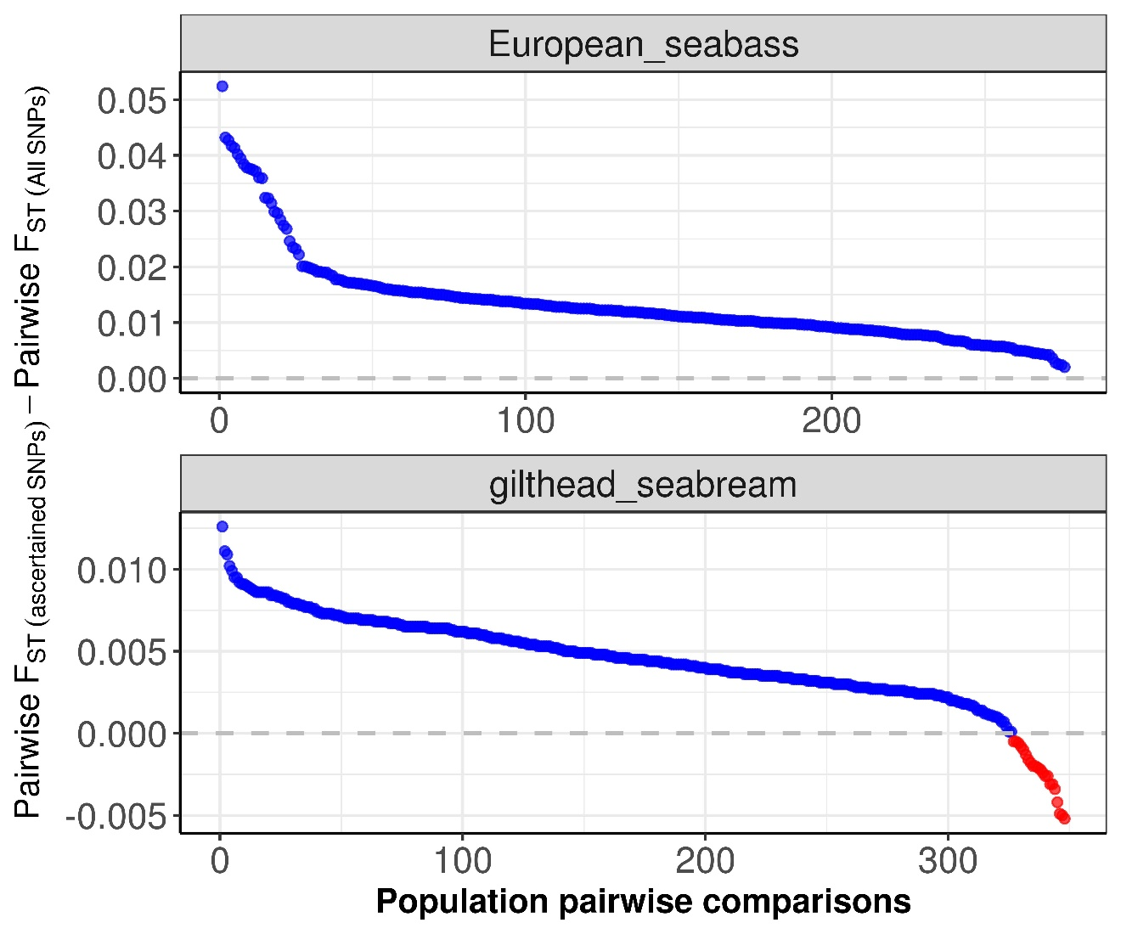
Figure S2. Higher pairwise F_{ST} values were obtained for populations from both species when using a panel that only contained genotype data at the genomic positions of the array markers (‘ascertained’ dataset) compared to the full SNP panel (‘non-ascertained’ dataset).

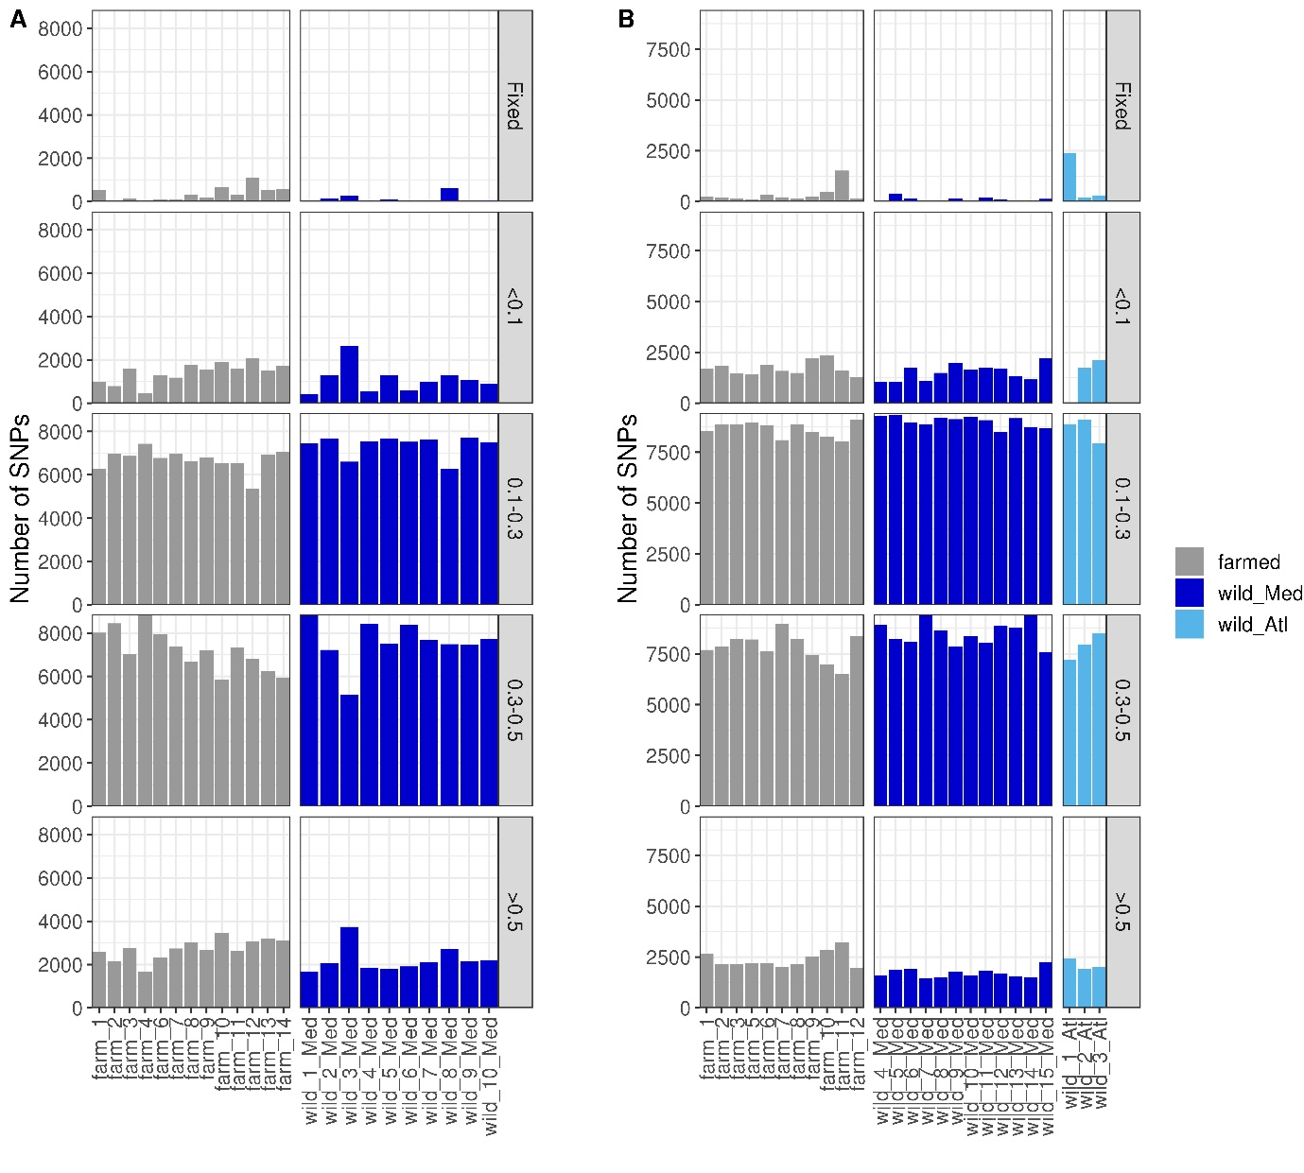
Figure S3. Allele frequency of the SNPs typed with the combined species SNP array across different farmed and wild (A) European seabass and (B) gilthead seabream populations. Panels are stratified by allele frequency as indicated in the labels along the y-axes on the right side. Populations are coloured coded according to their known origin, as shown in the legend at the right.

