Supplementary Material
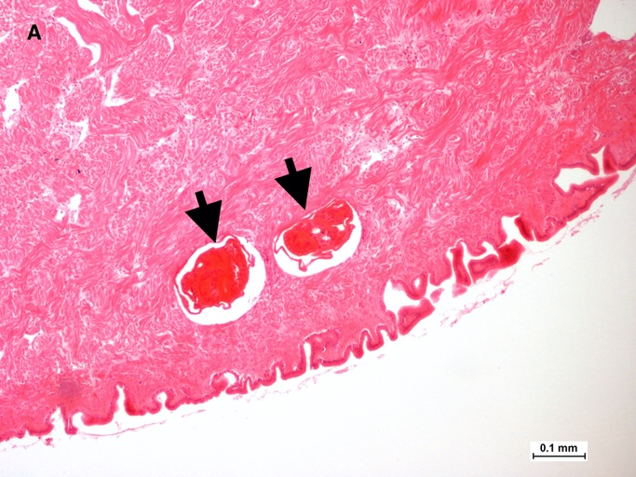 | 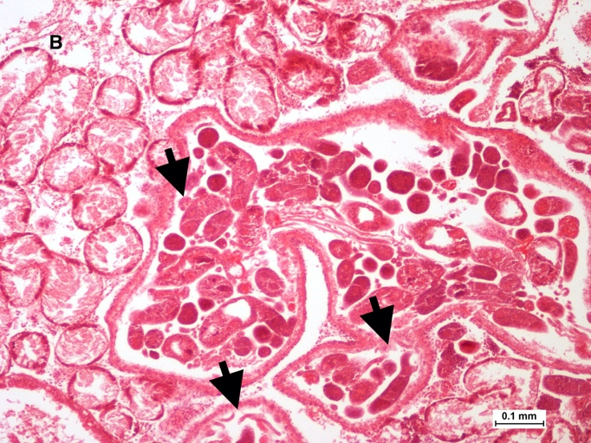
Figure S1.1. Representative images of (A) trematode metacercariae located in the foot of Cerastoderma edule and (B) trematode sporocysts located in cockle digestive tissue tissue. Arrows point to the respective trematode stages.
Table S1.1. Numbers of cockles examined by histology, for each bed and month.
 | Arcachon | Aveiro | Carlingford | Dundalk Bay |  | Cork Harbour
 | Arguin | Aveiro | Oyster Farm | Annagassan | Cooley | Ringaskiddy | Cuskinny
Apr-18 | 30 | 30 | 30 | 0 | 0 | 30 | 25
Jun-18 | 30 | 30 | 30 | 0 | 0 | 30 | 19
Jul-18 | 30 | 0 | 0 | 30 | 30 | 0 | 0
Aug-18 | 0 | 29 | 29 | 30 | 30 | 28 | 14
Oct-18 | 30 | 30 | 15 | 30 | 30 | 28 | 23
Dec-18 | 30 | 28 | 30 | 31 | 30 | 5 | 9
Feb-19 | 30 | 30 | 24 | 30 | 30 | 24 | 15
Apr-19 | 30 | 30 | 30 | 29 | 29 | 30 | 29
Jun-19 | 29 | 30 | 28 | 0 | 0 | 28 | 8
Aug-19 | 0 | 28 | 0 | 30 | 30 | 27 | 16
Oct-19 | 0 | 17 | 13 | 30 | 30 | 10 | 9

Table S1.2. Result of Dunn Tests with Bonferroni correction to determine if the percentage of indeterminate individuals differed between sites, H₀ rejected when p<0.025.
 | Arcachon | Aveiro | Carlingford | Cork
Aveiro | 0.999 | -
Carlingford | 0.026 | 0.036 | - | -
Cork | 0.661 | 0.939 | 0.801 | -
Dundalk | 0.056 | 0.080 | 0.999 | 0.999
Table S1.3. Result of Dunn Tests with Bonferroni correction to determine if mean length at spawning differed between sites, H₀ rejected when p<0.025.
 | Arcachon | Aveiro | Carlingford | Cork
Aveiro | 0.999 | -
Carlingford | <0.001 | <0.001 | - | -
Cork | <0.001 | <0.001 | 0.999 | -
Dundalk | <0.001 | <0.001 | 0.999 | 0.999
Table S1.4. Results of Dunn Tests with Bonferroni correction to determine if number of growth rings of spawning individuals differed across sites, H₀ rejected when p<0.025.
 | Arcachon | Carlingford | Cork
Carlingford | 0.003 | - | -
Cork | 0.488 | 0.021 | -
Dundalk | 0.003 | <0.001 | <0.001

Table S1.5. Results of a chi square test examining if the proportions of metacercariae infected individuals varied across sites
Comparison | Adjusted Chi Square p value
Arcachon vs Aveiro | <0.001
Arcachon vs Carlingford | <0.001
Arcachon vs Cork | <0.001
Arcachon vs Dundalk | <0.001
Aveiro vs Carlingford | <0.001
Aveiro vs Cork | <0.001
Aveiro vs Dundalk | <0.001
Carlingford vs Cork | <0.001
Carlingford vs Dundalk | <0.001
Cork vs Dundalk | <0.001

Table S1.6. Results of chi square test examining if the proportions of metacercariae infected individuals differed at each stage of gametogenesis.
Comparison | Adjusted Chi Square p value
Indeterminate vs Early Developing | 0.3640
Indeterminate vs Late Developing | 0.9999
Indeterminate vs Ripe | 0.0802
Indeterminate vs Spawning | 0.0802
Indeterminate vs Spent | 0.6350
Early Developing vs Late Developing | 0.5760
Early Developing vs Ripe | 0.8550
Early Developing vs Spawning | 0.8550
Early Developing vs Spent | 0.7940
Late Developing vs Ripe | 0.2940
Late Developing vs Spawning | 0.2940
Late Developing vs Spent | 0.8220
Ripe vs Spawning | 0.9999
Ripe vs Spent | 0.3120
Spawning vs Spent | 0.3120

Table S1.7. Results of chi square test examining if the proportions of metacercariae and sporocyst coinfected individuals differed at each stage of gametogenesis.
Comparison | Adjusted Chi Square p value
Indeterminate vs Early Developing | 0.4680
Indeterminate vs Late Developing | 0.8280
Indeterminate vs Ripe | 0.0077
Indeterminate vs Spawning | 0.0077
Indeterminate vs Spent | 0.4680
Early Developing vs Late Developing | 0.9220
Early Developing vs Ripe | 0.3730
Early Developing vs Spawning | 0.7600
Early Developing vs Spent | 0.9200
Late Developing vs Ripe | 0.1120
Late Developing vs Spawning | 0.2650
Late Developing vs Spent | 0.9999
Ripe vs Spawning | 0.8280
Ripe vs Spent | 0.1120
Spawning vs Spent | 0.1710

Table S1.8. Mean length (mm) and number of growth rings for cockles infected with trematodes at all study sites, ± 1 standard deviation. Growth ring data absent for the Ria de Aveiro. All cockles refers to both infected and uninfected individuals.
Site | Metacercariae |  | Sporocysts |  | All Cockles
 | Length | Growth Rings | Length | Growth Rings | Length | Growth Rings
Carlingford Lough | 33.7 ± 3.9 | 4.2 ± 1.6 | 33.6 ± 4.0 | 4.1 ± 2.3 | 33.8 ± 3.9 | 4.2 ± 1.6
Dundalk Bay | 33.5 ± 5.8 | 3.4 ± 1.6 | 35.1 ± 5.2 | 3.1 ± 1.1 | 32.7 ± 5.7 | 2.9 ± 1.5
Cork Harbour | 35.5 ± 7.8 | 4.2 ± 2.0 | 36.9 ± 4.0 | 3.3 ± 1.1 | 32.9 ±8.4 | 3.6 ± 1.8
Arcachon Bay | 29.4 ± 4.3 | 3.9 ± 1.2 | 30.3 ± 4.1 | 3.7 ± 1.5 | 28.6 ±4.5 | 3.7 ± 1.4
Ria de Aveiro | 26.2 ± 6.9 | - | 29.3 ± 3.6 | - | 25.8 ±5.3 | -

