Electronic Supplementary Materials (ESM)

High nutrient loading and climatic parameters influence the dominance and dissimilarity of toxigenic cyanobacteria in northern bays of Lake Victoria

Mark Olokotum^{a,b*}, Marc Troussellier^{c}, Arthur Escalas^{c}, Sahima Hamlaoui^{d}, William Okello^{b}, Ronald Semyaloª, Jean-François Humbert^{e} and Cécile Bernard^{d*}

ªDepartment of Zoology, Entomology and Fisheries Sciences, Makerere University, Kampala, Uganda

^{b}National Fisheries Resources Research Institute (NaFIRRI), Jinja, Uganda

^{c}MARBEC, CNRS-Univ Montpellier-IFREMER-IRD, Montpellier, France

^{d}UMR 7245 Molécules de Communication et Adaptations des Microorganismes (MCAM), CNRS-MNHN, Muséum National d’Histoire Naturelle, Paris, France

^{e}INRAE-Institute of Ecology and Environmental Sciences of Paris (iEES), Sorbonne University, Paris, France

*Corresponding author: cecile.bernard@mnhn.fr

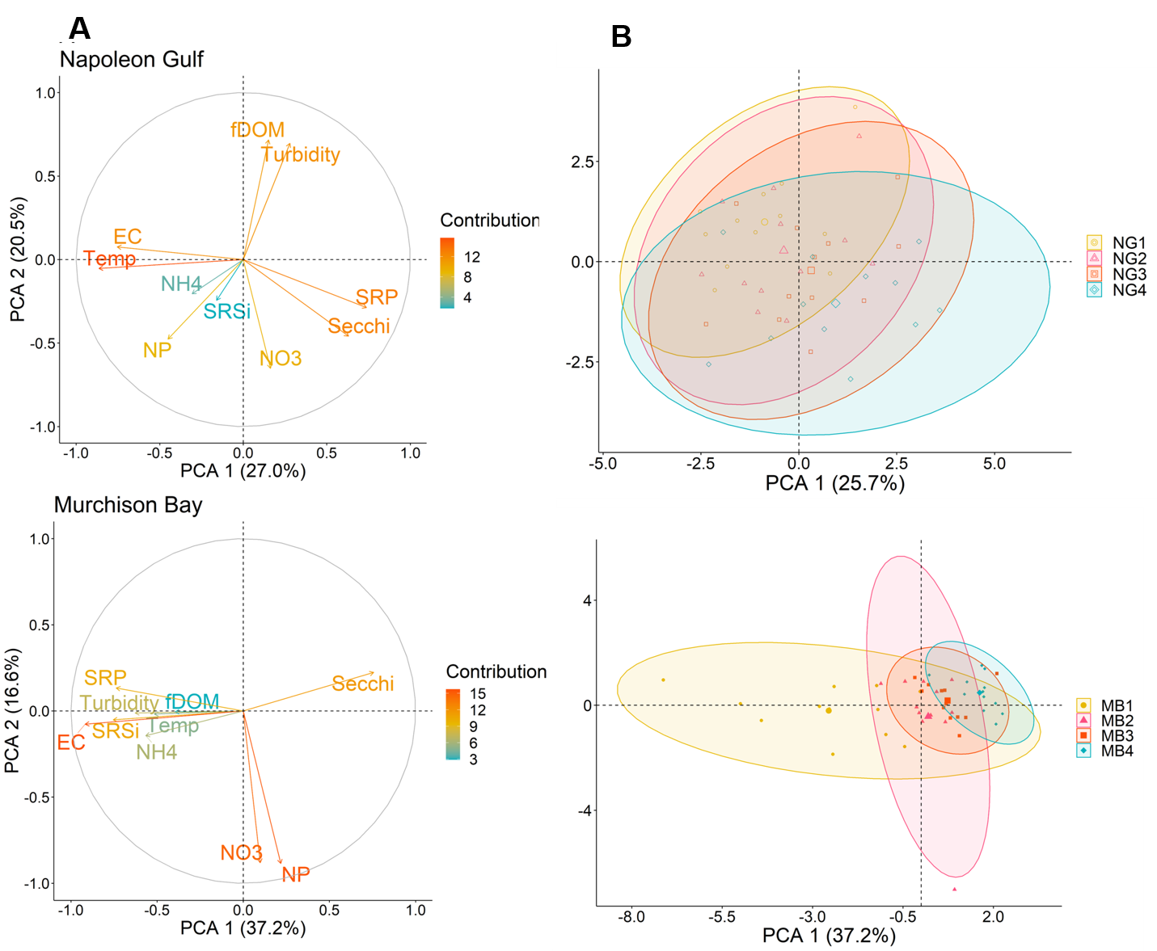

Supp Figure 1: Environmental gradients in Napoleon Gulf (NG) and Murchison Bay (MB). PCA on Euclidean distance based on limnological variables. A circle of correlation representing the contribution of environmental variables to the first two dimensions. The distance gradient from the shore is represented by an ellipse of different colours. Each data point corresponds to sampling stations of given months (November 2017 to October 2018) for NG (top, NG1-4) and MB (bottom, MB1-4).
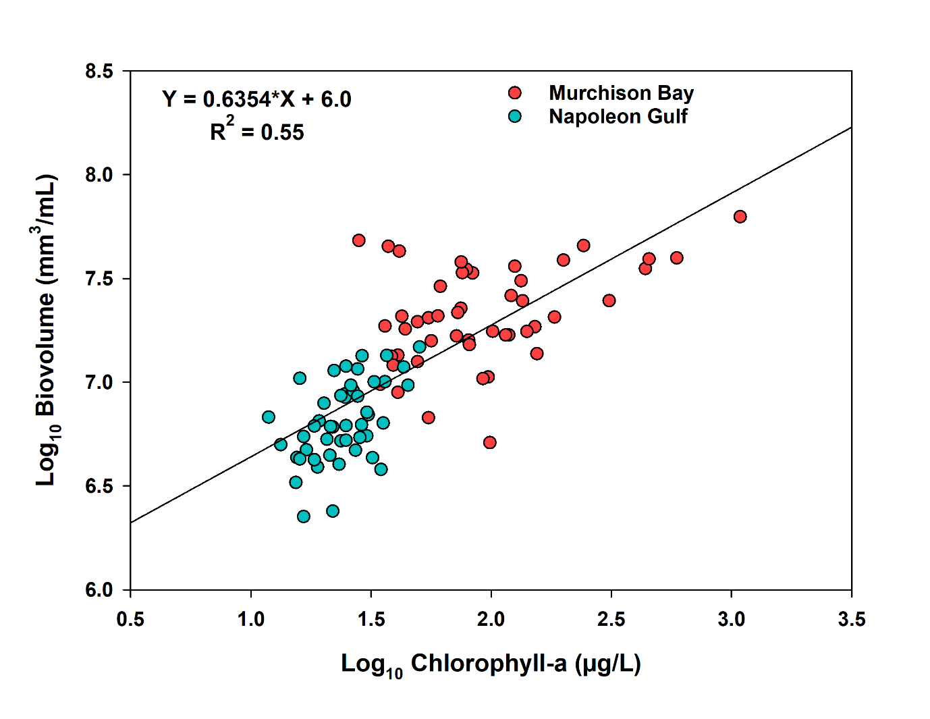
Supp Figure 2: The correlation between total phytoplankton biovolume, phytoplankton abundance and chlorophyll-a biomass in Napoleon Gulf and Murchison Bay northern Lake Victoria

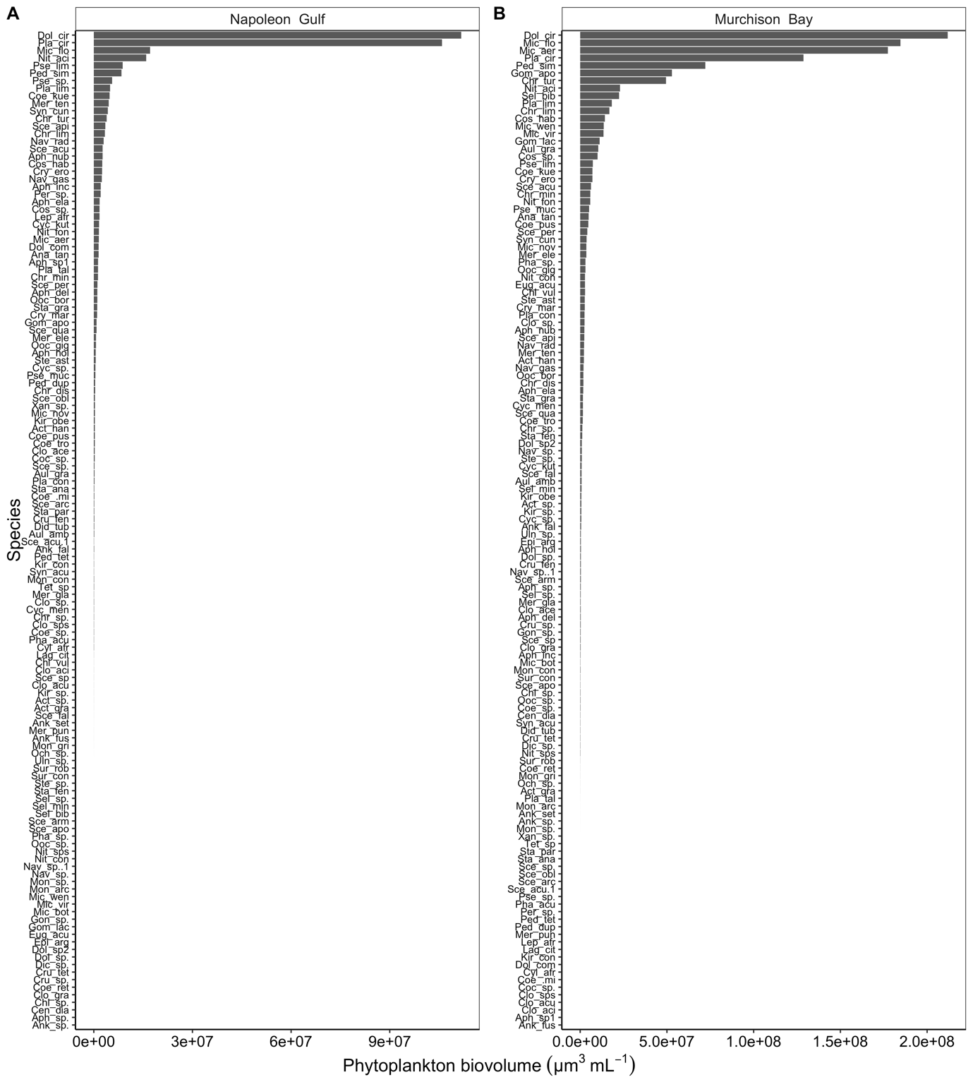
Supp Figure 3: The total phytoplankton biovolume rank diagram in Napoleon Gulf and Murchison Bay northern Lake Victoria.
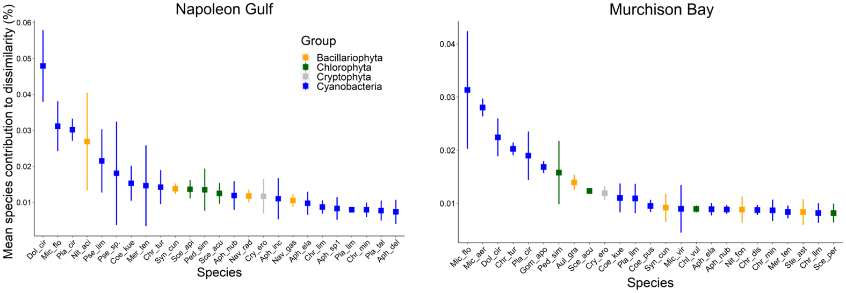

Supp Figure 4: Average taxa contribution to dissimilarity between phytoplankton communities from the two bays. The values are averaged across all pairs of the phytoplankton communities.
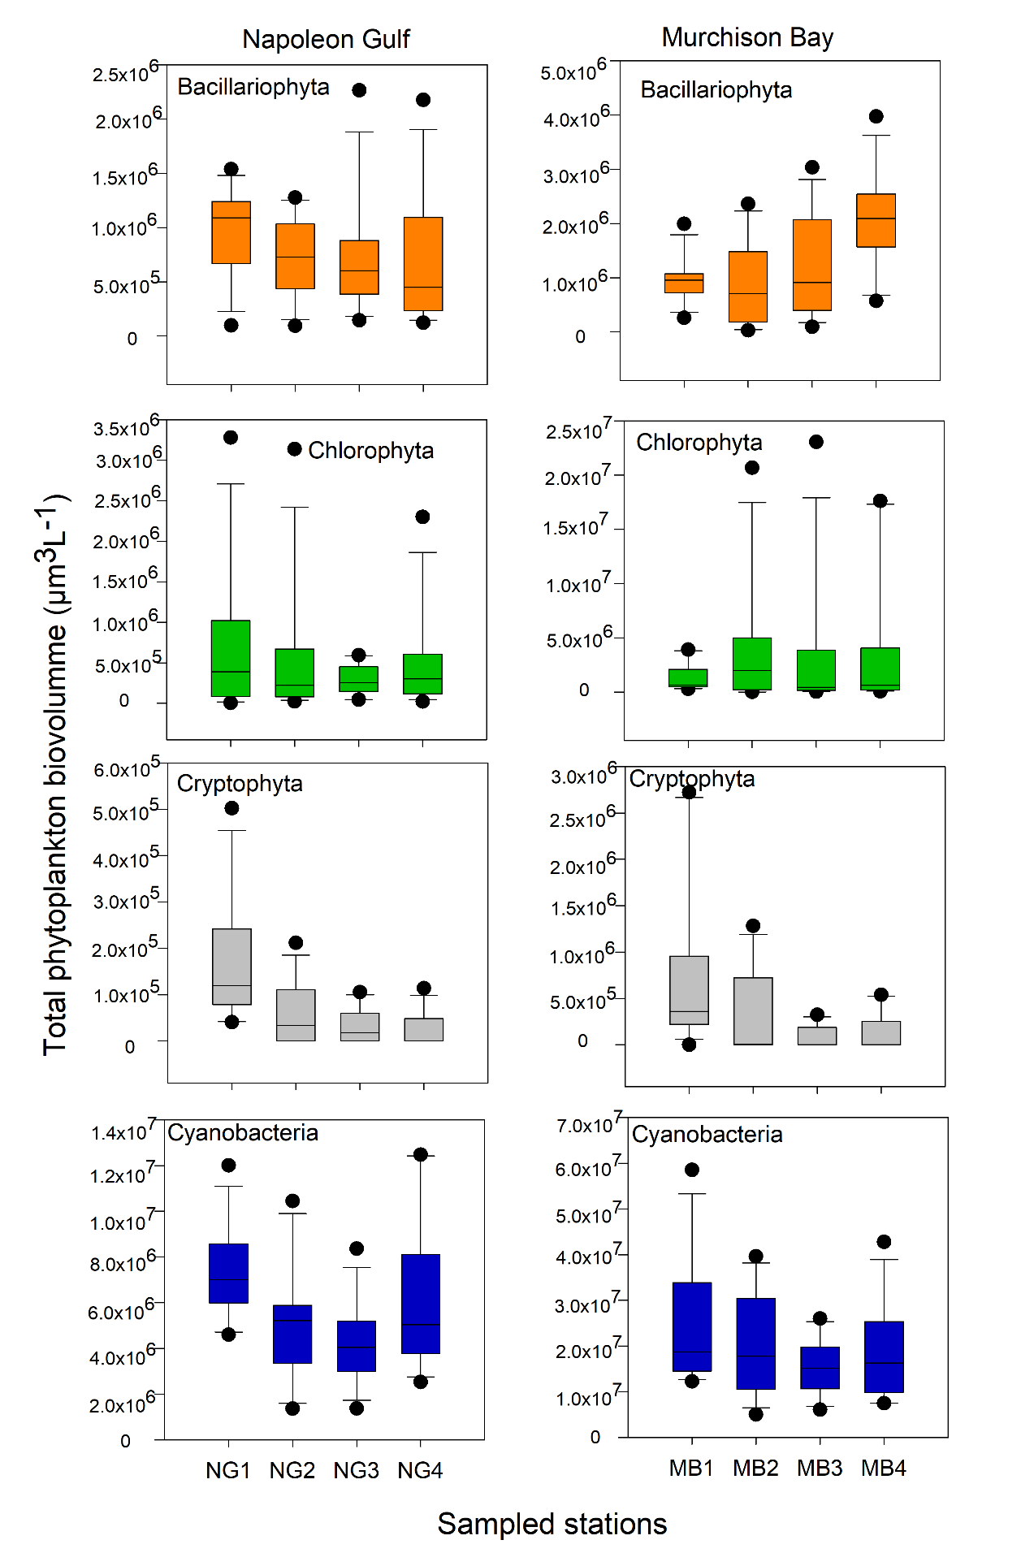
Supp Figure 5: Spatial variation of the biovolume of the phytoplankton groups along the distance gradient in Napoleon Gulf (Left panel) and Murchison Bay (Right panel) between November 2017 and October 2018.
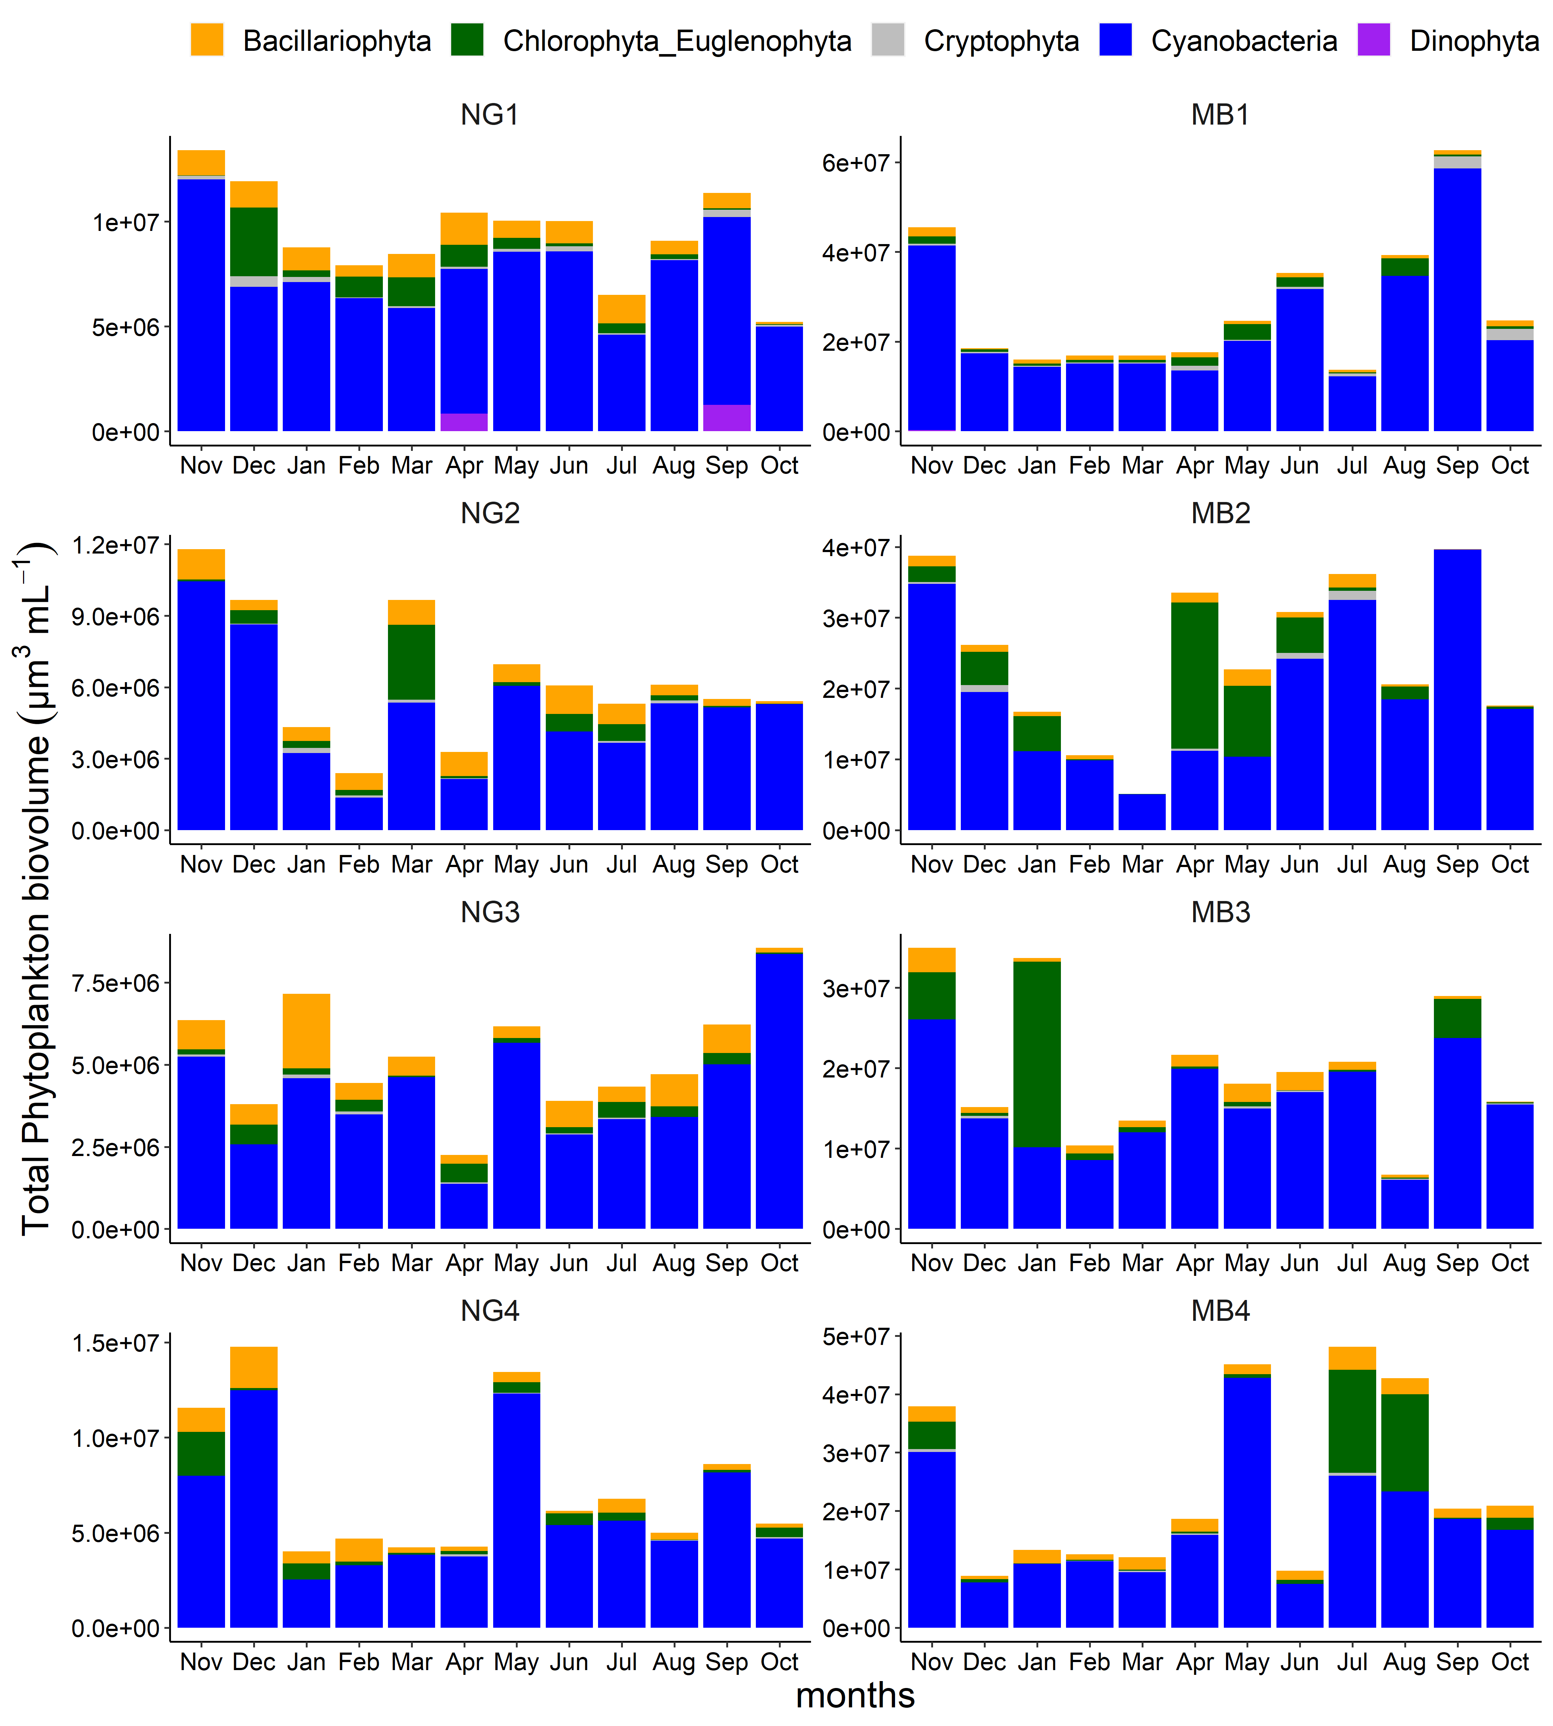
Supp Figure 6: Temporal variation of total phytoplankton biovolume along the distance gradient in Napoleon Gulf (NG1-4) and Murchison Bay (MB1-4) between November 2017 and October 2018.

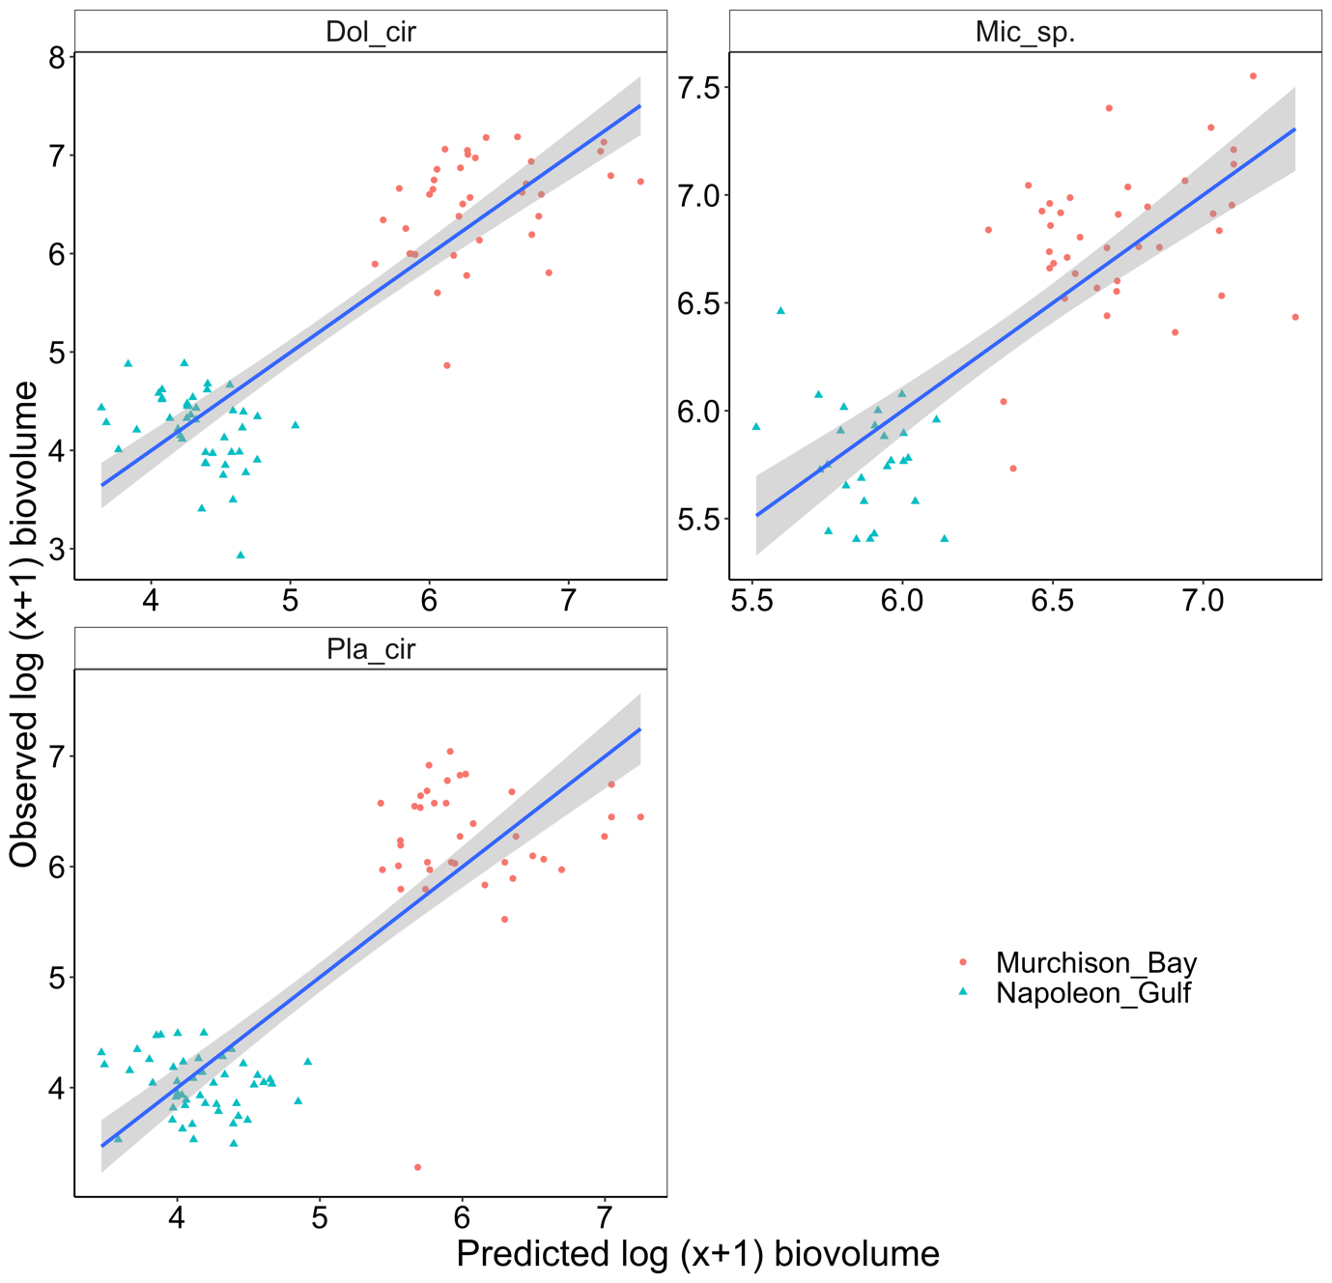
Supp Figure 7: The observed versus predicted biovolumes of the dominant taxa by the PLS model in NG and MB

Supp Table S 1: Summary statistics for the environmental and nutrient variables evaluated at the eight sites along the environmental gradients established in Napoleon Gulf (NG) and Murchison Bay (MB). Note: The negative values of fDOM means cells with little or no fluorescence
 | MB1 |  |  | MB2 |  |  | MB3 |  |  | MB4
Parameters | Mean±SD | Min | Max | Mean±SD | Min | Max | Mean±SD | Min | Max | Mean±SD | Min | Max
Depth (m) | 1.8±0.3 | 1.4 | 2.5 | 5.4±0.5 | 4.8 | 6.6 | 14.0±2.3 | 9.4 | 18.4 | 12.7±0.5 | 12 | 14
Secchi (m) | 0.5 ±0.1 | 0.3 | 0.7 | 0.6±0.1 | 0.4 | 0.8 | 0.9 ±0.2 | 0.7 | 1.3 | 1.2±0.2 | 0.8 | 1.6
Temp (°C) | 25.5±0.7 | 24.2 | 26.4 | 25.3±0.5 | 24.3 | 26 | 25.3±0.6 | 24 | 25.9 | 25.2±0.6 | 23.9 | 26.2
EC (µS/cm) | 183.4±45.4 | 124.4 | 251.5 | 126.4±9.0 | 112.8 | 146.1 | 121.6±8.2 | 105.6 | 132.3 | 106.1±3.9 | 102 | 116
fDOM (QSU) | 25.2±10.6 | 15.7 | 45.8 | 20.9±2.9 | 15.8 | 25.4 | 19.5±3.8 | 12.6 | 27 | 11.8±19.4 | 4.1 | 73.1
Turbidity (NTU) | 78.9±63.9 | 8.9 | 197.2 | 30.6±18.7 | 9.7 | 73.7 | 14.0±8.8 | 4.4 | 32.9 | 10.9±8.6 | 2.1 | 30.9
DO (mg/L) | 5.8±2.4 | 2.7 | 9.6 | 7.2±1.6 | 4.7 | 10.2 | 5.9±1.2 | 4 | 7.7 | 7.2±0.6 | 6.3 | 8.2
pH | 8.2±0.4 | 7.6 | 8.9 | 8.6±0.5 | 8 | 9.4 | 8.3±0.3 | 7.8 | 8.8 | 8.6±0.3 | 8.1 | 9.1
TP (µg/L) | 151.7±150.8 | 18 | 521.9 | 80.3±69.9 | 18.2 | 264.4 | 50.4±37.1 | 14.4 | 139.3 | 59.2±74.3 | 10.4 | 275.6
SRP (µg/L) | 73.6±107.8 | 7.1 | 380.3 | 7.3±3.8 | 0.9 | 15.8 | 6.4±2.9 | 3.4 | 13.3 | 7.1±9.6 | 0.9 | 36.7
TN (µg/L) | 3,008.6±170.5 | 153.1 | 21,633.60 | 1,036.2±877.9 | 170.5 | 3,294.60 | 1,020.0±1104.0 | 162.6 | 3,955.60 | 950.4±930.1 | 149.1 | 3,108.10
NO3 (µg/L) | 88.4 ±100.9 | 19 | 380.4 | 146.8±258.4 | 8.5 | 940.1 | 84.1±67.4 | 7.3 | 231.4 | 64.7±55.1 | 9.7 | 170.1
NH4 (µg/L) | 337.1±370.5 | 0.7 | 1,206.90 | 26.9±37.7 | 0.5 | 133.4 | 32.5±46.6 | 0.4 | 163.9 | 18.4±27.6 | 0 | 81.4
SRSi (µg/L) | 1,089.8±922.7 | 282 | 3,081.90 | 483.0±243.0 | 139.5 | 932.1 | 385.3±185.7 | 112.4 | 685.6 | 235.9±196.1 | 9 | 596.9
 | NG1 |  |  | NG2 |  |  | NG3 |  |  | NG4
Parameters | Mean±SD | Min | Max | Mean±SD | Min | Max | Mean±SD | Min | Max | Mean±SD | Min | Max
Depth (m) | 6.4±0.5 | 5.7 | 7.2 | 9.2±0.6 | 8 | 9.8 | 13.1±1.2 | 11.4 | 15.8 | 18.1±1.3 | 16.7 | 21.5
Secchi (m) | 1.3±0.3 | 0.9 | 1.8 | 1.3±0.2 | 1 | 1.7 | 1.4±0.2 | 1.1 | 1.7 | 1.6 ±0.2 | 1.3 | 2
Temp (°C) | 26.3±0.6 | 25.4 | 27.3 | 26.0±0.6 | 25.2 | 27 | 25.8±0.5 | 24.9 | 26.7 | 25.7±0.5 | 24.8 | 26.6
EC (µS/cm) | 105.3±4.7 | 99.8 | 115.7 | 102.8±4.2 | 97.9 | 112.2 | 101.0±2.8 | 97 | 106 | 100.5±3.1 | 96 | 105.5
fDOM (QSU) | -0.2±0.6 | -1.3 | 1 | - 0.5 ±0.5 | -1.6 | 0.4 | - 0.6±0.5 | -1.6 | -0.2 | - 0.8 ±0.4 | -1.5 | 0
Turbidity (NTU) | 15.0±15.9 | 0.7 | 58.1 | 12.7±17.3 | 0.5 | 61.2 | 12.2±13.9 | 0.2 | 40 | 6.9±6.9 | 0 | 17.3
DO (mg/L) | 7.3±1.0 | 5.5 | 8.8 | 7.4±0.8 | 6.4 | 8.8 | 7.1±0.7 | 5.8 | 8.1 | 7.0 ±0.8 | 4.9 | 7.9
pH | 8.8±0.3 | 8.4 | 9.4 | 8.8±0.2 | 8.4 | 9.3 | 8.8±0.3 | 8.2 | 9.3 | 8.7±0.3 | 8 | 9.2
TP (µg/L) | 37.9±36.6 | 8.9 | 145.1 | 44.0±24.9 | 8.2 | 168.4 | 40.6±31.4 | 10.1 | 128.1 | 36.9±22.8 | 8.6 | 94
SRP (µg/L) | 4.5±1.9 | 0.6 | 8 | 5.2±2.3 | 0.7 | 9.5 | 6.4±3.1 | 0.7 | 11 | 8.8 ±5.3 | 0.7 | 18.2
TN (µg/L) | 712.1±474.7 | 129.7 | 1,664.70 | 380.8±150.6 | 134.1 | 633.6 | 530.8±321 | 148.5 | 1,210.20 | 570.3 ±352.4 | 154.1 | 1,122.60
NO3 (µg/L) | 28.6±22.0 | 2.1 | 68.5 | 41.6±43.5 | 1.9 | 153.9 | 50.4±46.0 | 1.1 | 170.2 | 121.0±262.2 | 2.1 | 947.4
NH4 (µg/L) | 6.9±8.8 | 1.2 | 32.7 | 8.1±10.4 | 0.6 | 31 | 7.8±16.7 | 0.4 | 59.1 | 11.6 ±21.1 | 0.5 | 76.4
SRSi (µg/L) | 302.9±194.2 | 99.9 | 635.4 | 308.2±210.1 | 81.9 | 717.8 | 327.1±194.5 | 80.2 | 629.9 | 368.8±262.6 | 73.4 | 903.9

Supp Table 2: Summary statistics for climatic parameters for Jinja and Kampala stations around Napoleon Gulf (NG) and Murchison Bay (MB) on the day of sampling and 5 days before sampling (D5). Data acquired from Uganda National Meteorological Authority (UNMA)

 | Napoleon Gulf |  |  | Murchison Bay
Parameters | Mean ±SD | Min | Max | Mean ±SD | Min | Max
Rainfall | 3.52±8.19 | 0 | 28 | 4.61±6.07 | 0 | 17
Min Temp | 16.45±1.28 | 13.5 | 18 | 19.01±1.02 | 17 | 20.5
Max Temp | 28.04±2.47 | 22.1 | 32.2 | 28.16±1.85 | 24.6 | 31.8
Mean Temp | 22.25±1.34 | 19.05 | 24.2 | 23.58±1.23 | 21.5 | 26.1
Max Wind | 8.67±1.40 | 7.3 | 11.9 | 15.45±2.40 | 11.58 | 19.83
Mean Wind | 3.68±0.42 | 3.1 | 4.4 | 5.12±1.04 | 3.227813 | 7.495938
Max Solar | 884.13±249.22 | 199.2 | 1083.3 | 866.64±204.99 | 290 | 1059.5
Mean Solar | 199.03±89.95 | 24 | 310.5 | 353.32±129.77 | 116.3447 | 532.3213
Rainfall_D5 | 12.47±16.51 | 0 | 61.1 | 9.93±10.84 | 0 | 34.3
Min Temp_D5 | 15.98±0.76 | 14.6 | 17 | 18.95±0.52 | 18.04 | 19.84
Max Temp_D5 | 28.18±1.92 | 24.72 | 31.86 | 28.09±1.53 | 25.9 | 31.14
Mean Temp_D5 | 22.08±0.97 | 20.3 | 23.54 | 23.52±0.88 | 22.11 | 25.17
Max Wind_D5 | 9.10±0.93 | 7.9 | 10.7 | 15.09±2.40 | 11.942 | 20.458
Mean Wind_D5 | 3.73±0.42 | 3.14 | 4.68 | 5.25±1.05 | 3.707667 | 8.107396
Max Solar_D5 | 954.61±69.06 | 792.7 | 1022.74 | 879.06±55.16 | 780.98 | 985.66
Mean Solar_D5 | 220.94±29.25 | 169.86 | 279.88 | 362.00±59.67 | 244.1796 | 451.7604

Supp Table 3: The presence-absence checklist of the phytoplankton taxa recovered and identified in NG and MB between November 2017 and October 2018.

Phytoplankton  taxa | Short name | Napoleon Gulf |  |  |  | Murchison Bay
 |  | NG1 | NG2 | NG3 | NG4 | MB1 | MB2 | MB3 | MB4
Chlorophyceae
Actinastrum_gracillimum G.M. Smith | Act_gra | - | - | - | + | + | - | - | -
Actinastrum_hantzschii Lagerh | Act_han | - | + | + | + | + | + | - | +
Actinastrum_sp. | Act_sp. | + | - | - | - | + | - | + | -
Ankistrodesmus_falcatus (Corda) Ralfs | Ank_fal | + | + | + | + | + | + | + | +
Ankistrodesmus_falcatus var. Tumidus G.S. West | Ank_tum | + | + | - | - | + | - | - | -
Ankistrodesmus_fusiformis Corda | Ank_fus | - | + | - | + | - | - | - | -
Ankistrodesmus_sp. | Ank_sp. | - | - | - | - | + | - | - | -
Chlorella_sp. | Chl_sp. | - | - | - | - | - | + | + | -
Chlorella_vulgaris Beijerinck | Chl_vul | + | + | + | + | + | + | + | +
Closterium_acerosum (Shrank) Ehr. Ex Ralfs | Clo_ace | - | + | + | - | - | - | + | +
Closterium_aciculare T. West | Clo_aci | - | - | - | + | - | - | - | -
Closterium_acutum Brébisson – Ralfs | Clo_acu | - | - | + | - | - | - | - | -
Closterium_gracile Brébisson Ex Ralfs | Clo_gra | - | - | - | - | + | - | - | +
Closterium_sp. | Clo_sp. | - | + | + | - | - | + | + | +
Closterium_sps. | Clo_sps | - | - | + | - | - | - | - | -
Coelastrum_microporum var. Microporum Näg | Coe_mic | - | - | - | + | - | - | - | -
Coelastrum_reticulatum var. reticulatum Dang. Senn. | Coe_ret | - | - | - | - | + | - | - | -
Cosmarium_“habitat” sp1. | Cos_hab | - | + | - | + | - | + | + | +
Cosmarium_sp2. | Cos_sp. | - | + | + | - | + | + | - | -
Crucigenia_fenestrata (Schmidle) Schmidle | Cru_fen | + | + | + | + | + | - | + | -
Crucigenia_sp. | Cru_sp. | - | - | - | - | + | + | - | -
Crucigenia_tetrapedia (Kirchn.) W & G.S.West | Cru_tet | - | - | - | - | - | - | + | -
Dictyosphaerium_sp. | Dic_sp. | - | - | - | - | + | - | - | -
Didymocystis_tuberculata Korš. | Did_tub | - | + | + | - | + | - | - | -
Euglena_acus Ehren. | Eug_acu | - | - | - | - | + | - | - | -
Kirchneriella_contorta Schmidle | Kir_con | - | - | + | - | - | - | - | -
Kirchneriella_obesa (W.West) Schmidle | Kir_obe | + | + | + | + | + | + | + | +
Kirchneriella_sp. | Kir_sp. | + | - | - | - | - | - | + | +
Lagerheimia_citriformis (Snow) Coll. | Lag_cit | + | - | + | - | - | - | - | -
Monoraphidium_arcuatum (Korš.) Hind. | Mon_arc | - | - | - | - | - | - | + | +
Monoraphidium_contortum (Thur.) Kom. – Legn. | Mon_con | + | + | + | + | + | + | + | +
Monoraphidium_griffithii (Berk.) Kom. – Legn. | Mon_gri | - | + | + | + | + | - | - | +
Monoraphidium_sp1. | Mon_sp1 | - | - | - | - | - | + | - | -
Oocystis_borgei Snow | Ooc_bor | - | - | + | + | - | - | - | +
Oocystis_gigas W.Archer | Ooc_gig | + | + | + | - | + | + | - | -
Oocystis_sp. | Ooc_sp. | - | - | - | - | + | - | - | -
Pediastrum_duplex Meyen | Ped_dup | - | - | + | + | - | - | - | -
Pediastrum_simplex Meyen | Ped_sim | + | + | + | + | + | + | - | +
Pediastrum_tetras (Ehrenb.) Ralfs. | Ped_tet | - | - | + | - | - | - | - | -
Phacus_acuminatus A. Stokes | Pha_acu | - | + | - | - | - | - | - | -
Phacus sp. | Pha_sp. | - | - | - | - | + | - | - | -
Scenedesmus_acuminatus (Lagerh.) Chod. | Sce_acum | + | + | + | + | + | + | + | +
Scenedesmus_acutus Meyen | Sce_acut | - | + | - | - | - | - | - | -
Scenedesmus_apiculatus (W. &G.S. West) Chod. | Sce_apic | + | + | + | + | + | - | + | -
Scenedesmus_ecornis (Ehren.) Chod. | Sce_eco | - | - | - | - | - | - | - | +
Scenedesmus_arcuatus (Lemm.) Lemm. | Sce_arc | - | + | - | - | - | - | - | -
Scenedesmus_armatus Chod. | Sce_arm | - | - | - | - | + | - | - | +
Scenedesmus_falcatus Chod. | Sce_fal | - | - | + | - | - | - | - | +
Scenedesmus_obliquus (Turp.) Kütz. | Sce_obl | + | - | - | - | - | - | - | -
Scenedesmus_perforatus Lemm. | Sce_per | + | + | + | + | + | + | + | +
Scenedesmus_quadricauda Hortob. | Sce_qua | - | + | + | + | + | - | + | +
Scenedesmus_sp | Sce_sp | - | - | - | + | - | + | - | -
Scenedesmus_sp1. | Sce_sp1 | + | - | - | - | - | - | - | -
Selenastrum_bibraianum Reinsch | Sce_bib | - | - | - | - | + | - | + | -
Selenastrum_minutum (Näg.) Coll. | Sel_min | - | - | - | - | - | + | - | -
Selenastrum_sp. | Sel_sp. | - | - | - | - | - | - | + | +
Staurastrum_anatinum Cooke Et Wills | Sel_ana | - | + | - | - | - | - | - | -
Staurastrum_furcigerum (Bréb.) W.Archer | Sta_fur | - | - | - | - | + | - | - | -
Staurastrum_gracile Ralfs | Sta_gra | + | + | - | + | + | - | - | +
Staurastrum_paradoxum Meyen Ex Ralfs | Sta_par | - | + | - | - | - | - | - | -
Tetraedon_sp | Tet_sp | - | + | - | + | - | - | - | -
Xanthidium_sp. | Xan_sp. | - | - | - | + | - | - | - | -
Cyanobacteria
Anabaenopsis_tanganyikae* (G.S West) Wol. Et Mill | Ana_tan | + | + | - | + | + | - | + | -
Aphanocapsa_delicatissima West & G.S West | Aph_del | + | + | + | + | + | + | + | +
Aphanocapsa_elachista West & G.S West | Aph_ela | + | + | + | + | + | + | + | +
Aphanocapsa_holsatica (Lemm.) G.Crond. & Kom. | Aph_hol | + | + | - | + | + | + | + | +
Aphanocapsa_incerta (Lemm.) G.Crond. & Kom. | Aph_inc | + | + | + | + | + | + | + | +
Aphanocapsa_nubilium Kom. & H.J.Kling | Aph_nub | + | + | + | + | + | + | + | +
Aphanocapsa_sp. | Aph_sp. | - | - | - | - | + | + | + | +
Aphanocapsa_sp1. | Aph_sp1 | + | + | + | + | - | - | - | -
Chroococcus_dispersus (Keis.) Lemm. | Chr_dis | + | + | + | + | + | + | + | +
Chroococcus_limnetica Lemm. | Chr_lim | + | + | + | + | + | + | + | +
Chroococcus_minutus (Kütz.) Näg. | Chr_min | + | + | + | + | + | + | + | +
Chroococcus_sp. | Chr_sp. | + | + | - | - | - | + | + | +
Chroococcus_turgidus (Kütz.) Näg. | Chr_tur | + | + | + | + | + | + | + | +
Coelomoron_pusillum (Van Goor) Kom. | Chr_pus | + | + | + | + | + | + | + | +
Coelomoron_sp. | Coel_sp. | + | - | - | - | - | - | + | -
Coelomoron_tropicale P.A.C Senna, A.C. Peres & Kom. | Coel_tro | + | + | + | + | + | + | + | +
Coelosphaerium_kuetzingnium Näg. | Coe_kue | + | + | + | + | + | + | + | +
Cylindrospermopsis_africana* Kom. & Kling | Cyl_afr | + | + | + | - | - | - | - | -
Cylindrospermopsis_raciborskii* (Wol.) Seen. Et Sub.Raj | Cyl_rac | - | - | - | + | - | - | - | -
Dolichospermum_circinale* Rab. Ex Bor. Et Flah | Dol_cir | + | + | + | + | + | + | + | +
Dolichospermum_compactum* Nygaard | Dol_com | - | + | - | - | - | - | - | -
Dolichospermum_sp1*. | Dol_sp1 | - | - | - | - | - | + | - | -
Dolichospermum_sp2*. | Dol_sp2 | - | - | - | - | - | - | - | +
Gomposphaeria_aponina Kütz. | Gom_apo | - | + | - | - | + | + | + | +
Gomposphaeria_lacustris Chod. | Gom_lac | - | - | - | - | + | + | - | +
Leptolyngbya_africana (Lemm.) Anagn. & Kom. | Lep_afr | - | - | + | - | - | - | - | -
Merismopedia_elegans A.Braun Ex Kütz. | Mer_ele | + | - | + | + | - | - | - | +
Merismopedia_glauca (Ehr.) Näg. | Mer_gla | - | + | - | - | - | + | - | -
Merismopedia_punctata Meyen | Mer_pun | + | - | - | - | - | - | - | -
Merismopedia_tenuissima Lemm. | Mer_ten | + | + | + | + | + | + | + | +
Microcystis_aeruginosa* (Kütz.) Kütz. | Mic_aer | + | + | - | + | + | + | + | +
Microcystis_botrys* Teiling | Mic_bot | - | - | - | - | - | - | - | +
Microcystis_flos-aquae* (Wittr.) Kirch. | Mic_flo | + | + | + | + | + | + | + | +
Microcystis_novacekii* (Kom.) Compére | Mic_nov | + | - | - | - | + | - | - | -
Microcystis_viridis* (A. Braun) Lemm. | Mic_vir | - | - | - | - | + | + | + | +
Microcystis_wensenbergii* Kom. | Mic_wen | - | - | - | - | + | + | + | +
Planktolyngbya_circumcreta (G.S.West) Anagn. & Kom. | Pla_cir | + | + | + | + | + | + | + | +
Planktolyngbya_contorta (Lemm.) Anagn. & Kom. | Pla_con | + | - | - | - | + | + | - | -
Planktolyngbya_limnetica (Lemm.) Komá-Legn. & Cronb. | Pla_lim | + | + | + | + | + | + | + | +
Planktolyngbya_tallingii Kom. & Kling | Pla_tal | + | + | + | + | + | + | + | +
Planktolyngbya_undulata Kom. & Kling | Pla_und | - | + | - | + | - | - | - | -
Pseudanabaena_limnetica (Lemm.) Kom. | Pse_lim | + | + | + | + | - | + | + | -
Pseudanabaena_mucicola (Naum. & Huber-Pesta.) Schwabe | Pse_muc | + | - | - | - | + | - | - | -
Pseudanabaena_sp. | Pse_sp. | + | - | + | + | - | - | - | -
Bacillariophyceae
Aulacoseira_ambigua (Grun.) Sim. | Aul_amb | + | - | - | - | - | + | + | -
Aulacoseira_granulata (Ehr.) Sim. | Aul_gra | - | + | + | - | + | + | + | +
Centric_diatom | Cen_dia | - | - | - | - | - | - | - | +
Cocconeis_sp. | Coc_sp. | - | + | - | + | - | - | - | -
Cyclotella_kutzingiana (Kütz.) Brun. | Cyc_kut | + | - | + | - | + | - | + | +
Cyclotella_meneghiniana Kütz. | Cyc_men | - | + | - | + | - | - | + | -
Cyclotella_sp. | Cyc_sp. | + | + | - | + | + | - | - | -
Cyclotella_spp. | Cyc_spp | - | - | - | + | - | - | - | -
Epithemia_argus (Ehren.) Kütz. | Epi_arg | - | - | - | - | - | - | - | +
Navicula_gastrum (Ehren.) Kütz. | Nav_gas | + | + | + | + | + | - | - | +
Navicula_radiosa Kütz. | Nav_rad | + | + | + | + | - | - | + | +
Navicula_sp. | Nav_sp. | - | - | - | - | - | + | - | -
Navicula_sp1 | Nav_sp1 | - | - | - | - | + | - | - | -
Nitzschia_acicularis (Kütz.) W. Smith | Nit_aci | + | + | + | + | + | + | + | +
Nitzschia_acicularis var. constricta (W. Greg.) Grunow | Nit_con | - | + | + | - | + | + | - | +
Nitzschia_fonticola (Grunow) Grunow | Nit_fon | + | + | - | + | + | + | + | +
Nitzschia_sps. | Nit_sps | - | - | - | - | + | - | - | -
Stephanodiscus_astraea Kütz. | Ste_ast | + | + | + | + | + | + | + | +
Stephanodiscus_sp. | Ste_sp. | - | - | - | - | + | - | - | -
Surirella_constricta W. Smith | Sur_con | - | - | - | - | - | - | + | -
Surirella_robusta Ehren. | Sur_rob | - | - | - | - | + | - | - | -
Synedra_acus Kütz. | Syn_acu | + | - | - | - | - | - | - | +
Synedra_cunningtonii G.S. West | Syn_cun | + | + | + | + | + | + | + | +
Ulnaria_sp. | Uln_sp. | - | - | - | - | - | + | - | -
Dinophyceae
Goniochloris_sp. | Gon_sp. | - | - | - | - | + | - | - | -
Peridinium _sp. | Per_sp. | + | - | - | - | - | - | - | -
Cryptophyceae
Cryptomonas_erosa Ehren. | Cry_ero | + | + | + | + | + | + | + | +
Cryptomonas_marssonii Skuja | Cry_mar | + | + | + | - | + | + | - | +
Chrysophyceae
Ochromonas_sp. | Och_sp. | - | + | + | - | - | - | + | +
Species richness (S) |  | 61 | 69 | 59 | 60 | 74 | 57 | 58 | 65
Shannon – Weaver diversity index (H’) |  | 2.69 | 2.72 | 2.61 | 2.58 | 2.59 | 2.76 | 2.92 | 2.69

Supp Table 4: The average dissimilarity amongst stations and taxa contribution to dissimilarity within the Napoleon Gulf (NG1-4) and Murchison Bay (MB1-4): Note (only > 3.5% contribution shown)

Phytoplankton taxa | Average biovolume |  | Mean ± SD dissimilarity | Contribution (%) | Cumulative contribution (%)
Napoleon Gulf stations NG1-4
 | NG1 | NG2 (Mean = 53.89)
Dolichospermum_circinale | 1550.72 | 1283.08 | 3.61±1.23 | 6.7 | 6.7
Pseudanabaena_sp. | 563.93 | 0 | 3.11±2.3 | 5.77 | 12.46
Planktolyngbya_circumcreta | 1731.71 | 1368.85 | 3.07±1.45 | 5.7 | 18.16
Microcystis_flos-aquae | 539.23 | 318.95 | 2.87±1.09 | 5.32 | 23.49
Pseudanabaena_limnetica | 555.03 | 43.13 | 2.85±1.33 | 5.29 | 28.78
Merismopedia_tenuissima | 99.91 | 482.46 | 2.2±1.59 | 4.08 | 32.86
Pediastrum_simplex | 294.66 | 147.23 | 2.04±0.61 | 3.78 | 36.64
 | NG1 | NG3 (Mean =53.64)
D._circinale | 1550.72 | 1180.29 | 3.84±1.31 | 7.16 | 7.16
P._circumcreta | 1731.71 | 1197.16 | 3.39±1.57 | 6.32 | 13.48
M._flos-aquae | 539.23 | 90.92 | 3.16±0.99 | 5.9 | 19.38
Pseudanabaena_sp.. | 563.93 | 60.59 | 3.06±2.03 | 5.7 | 25.08
Pseudanabaena_limnetica | 555.03 | 291.54 | 2.77±1.36 | 5.16 | 30.24
 | NG2 | NG3 (Mean =51.90)
D._circinale | 1283.08 | 1180.29 | 4.75±1.34 | 9.16 | 9.16
M._tenuissima | 482.46 | 88.57 | 2.62±1.58 | 5.05 | 14.21
P._circumcreta | 1368.85 | 1197.16 | 2.5±1.21 | 4.82 | 19.03
M._flos-aquae | 318.95 | 90.92 | 2.2±0.89 | 4.23 | 23.26
 | NG1 | NG4 (Mean =64.77)
Aphanocapsa_nubilium | 75.43 | 1174.23 | 4.53±2.01 | 7 | 7
D._circinale | 1550.72 | 1955.68 | 4.25±1.33 | 6.56 | 13.55
M._tenuissima | 99.91 | 1044.55 | 3.69±1.52 | 5.7 | 19.25
Aphanocapsa_sp1 | 38.31 | 910.25 | 3.51±1.35 | 5.43 | 24.68
M._flos-aquae | 539.23 | 1128.16 | 3.4±1.48 | 5.25 | 29.93
Aphanocapsa_delicatissima | 24.64 | 684.13 | 2.76±0.94 | 4.26 | 34.19
Nitzschia_acicularis | 671.48 | 0 | 2.71±2.71 | 4.19 | 38.37
Aphanocapsa_holsatica | 14.93 | 579.44 | 2.3±0.81 | 3.55 | 41.92
 | NG2 | NG4 (Mean =63.03)
D._ circinale | 1283.08 | 1955.68 | 5.28±1.31 | 8.37 | 8.37
A._nubilium | 204.16 | 1174.23 | 4.42±1.86 | 7.01 | 15.38
M._flos-aquae | 318.95 | 1128.16 | 4.14±1.59 | 6.57 | 21.95
Aphanocapsa_sp1 | 152.39 | 910.25 | 3.63±1.48 | 5.76 | 27.71
M._tenuissima | 482.46 | 1044.55 | 3.1±1.32 | 4.91 | 32.62
A._delicatissima | 160.33 | 684.13 | 2.96±1.08 | 4.7 | 37.33
N._acicularis | 606.85 | 0 | 2.66±2.67 | 4.23 | 41.55
A._holsatica | 86.91 | 579.44 | 2.53±0.87 | 4.02 | 45.57
 | NG3 | NG4 (Mean =65.94)
D._circinale | 1180.29 | 1955.68 | 5.63±1.38 | 8.53 | 8.53
M._flos-aquae | 90.92 | 1128.16 | 5.1±1.74 | 7.73 | 16.26
Aphanocapsa_nubilium | 275.43 | 1174.23 | 4.37±1.78 | 6.63 | 22.89
M._tenuissima | 88.57 | 1044.55 | 4.18±1.55 | 6.34 | 29.23
Aphanocapsa_sp1 | 132.79 | 910.25 | 3.81±1.43 | 5.78 | 35.01
A._delicatissima | 91.81 | 684.13 | 3.09±1 | 4.69 | 39.7
N._acicularis | 605.91 | 0 | 2.74±3.34 | 4.16 | 43.86
Aphanocapsa_elachista | 176.08 | 586.47 | 2.65±0.99 | 4.02 | 47.88
Murchison Bay stations MB1-4
 | MB1 | MB2 (Mean =59.62)
Microcystis_aeruginosa | 1913.4 | 1490.08 | 5.62±1.47 | 9.43 | 9.43
M._flos-aquae | 2199.86 | 2097.74 | 4.57±1.32 | 7.67 | 17.1
D._circinale | 1422.77 | 1525.27 | 4.35±1.4 | 7.3 | 24.39
P._simplex | 253.6 | 921.38 | 3.17±0.73 | 5.32 | 29.72
Chroococcus_turgidus | 803.54 | 898.27 | 2.85±1.36 | 4.78 | 34.49
P_ circumcreta | 1086.81 | 907.63 | 2.54±1.25 | 4.25 | 38.75
Gomposphaeria_aponina | 535.83 | 526.95 | 2.52±0.78 | 4.23 | 42.98
 | MB1 | MB3 (Mean = 58.35)
M._aeruginosa | 1913.4 | 1046.71 | 5.68±1.4 | 9.73 | 9.73
M._flos-aquae | 2199.86 | 1428.68 | 4.48±1.31 | 7.67 | 17.4
D._circinale | 1422.77 | 1736.69 | 3.6±1.39 | 6.16 | 23.56
C._turgidus | 803.54 | 799.99 | 2.66±1.35 | 4.55 | 28.12
P._circumcreta | 1086.81 | 1595.34 | 2.65±1.41 | 4.54 | 32.66
G._aponina | 535.83 | 460.72 | 2.45±0.78 | 4.2 | 36.86
 | MB2 | MB3 (Mean =57.91)
M._flos-aquae | 2097.74 | 1428.68 | 4.98±1.35 | 8.6 | 8.6
D._circinale | 1525.27 | 1736.69 | 4.77±1.43 | 8.24 | 16.84
M._aeruginosa | 1490.08 | 1046.71 | 4.26±1.28 | 7.35 | 24.19
P._circumcreta | 907.63 | 1595.34 | 3.76±1.23 | 6.49 | 30.68
P._simplex | 921.38 | 0 | 3.15±0.61 | 5.44 | 36.12
C._turgidus | 898.27 | 799.99 | 3.09±1.4 | 5.34 | 41.46
G._aponina | 526.95 | 460.72 | 2.76±0.77 | 4.77 | 46.24
 | MB1 | MB4 (Mean = 66.65)
M._flos-aquae | 2199.86 | 50 | 7.16±1.79 | 10.74 | 10.74
M._aeruginosa | 1913.4 | 1181.93 | 5.86±1.3 | 8.79 | 19.54
D._circinale | 1422.77 | 2346.67 | 5.04±1.41 | 7.57 | 27.11
P._circumcreta | 1086.81 | 1999.39 | 3.87±1.72 | 5.8 | 32.91
P._simplex | 253.6 | 674.43 | 2.45±0.62 | 3.68 | 36.59
C._turgidus | 803.54 | 300.96 | 2.38±1.23 | 3.57 | 40.15
G._aponina | 535.83 | 434.21 | 2.27±0.71 | 3.41 | 43.57
 | MB2 | MB4 (Mean =65.70)
M._flos-aquae | 2097.74 | 50 | 7.41±1.62 | 11.28 | 11.28
D._circinale | 1525.27 | 2346.67 | 6.04±1.33 | 9.19 | 20.47
P._circumcreta | 907.63 | 1999.39 | 5.06±1.38 | 7.7 | 28.17
M._aeruginosa | 1490.08 | 1181.93 | 4.81±1.31 | 7.33 | 35.5
P._simplex | 921.38 | 674.43 | 4.36±0.76 | 6.63 | 42.13
C._turgidus | 898.27 | 300.96 | 2.86±1.26 | 4.36 | 46.49
G._aponina | 526.95 | 434.21 | 2.61±0.71 | 3.97 | 50.46
 | MB3 | MB4 (Mean = 59.40)
M._flos-aquae | 1428.68 | 50 | 5.11±1.49 | 8.6 | 8.6
D._circinale | 1736.69 | 2346.67 | 4.87±1.51 | 8.2 | 16.8
M._aeruginosa | 1046.71 | 1181.93 | 4.49±1.28 | 7.56 | 24.37
P._circumcreta | 1595.34 | 1999.39 | 3.85±1.31 | 6.48 | 30.85
G._aponina | 460.72 | 434.21 | 2.52±0.71 | 4.25 | 35.1
C._turgidus | 799.99 | 300.96 | 2.47±1.17 | 4.16 | 39.26
P._simplex | 0 | 674.43 | 2.02±0.44 | 3.4 | 42.66

