Supplementary Materials
  - Intensified organic carbon burial on the Australian Shelf after the Middle Pleistocene Transition

Gerald Auer^{1,2}, Benjamin Petrick³, Toshihiro Yoshimura², Briony L. Mamo⁴, Lars Reuning⁵, Hideko Takayanagi⁶, David De Vleeschouwer⁷, Alfredo Martinez-Garcia³

¹University of Graz, Institute of Earth Sciences (Geology and Paleontology), NAWI Graz Geocenter, Heinrichstraße 26, 8010 Graz, Austria.
²Research Institute for Marine Resources Utilization (Biogeochemistry Research Center), Japan Agency for Marine-Earth Science and Technology (JAMSTEC), 2-15 Natsushima- cho, Yokosuka, Kanagawa 237-0061, Japan.
³Max Planck Institute for Chemistry, Climate Geochemistry Department, Hahn-Meitner-Weg 1, 55128, Mainz, Germany
⁴Macquarie University, Department of Biological Sciences, North Ryde, 2109, NSW Australia
⁵Kiel University, Institute for Geosciences, Ludewig-Meyn-Str. 10, 24118, Kiel, Germany
⁶Institute of Geology and Paleontology, Tohoku University, Aobayama, Sendai, 980-8578, Japan
⁷MARUM-Center for Marine and Environmental Sciences, Klagenfurterstraße 2-4, Bremen, 28359, Germany

The following file contains supplementary Figures S1, showing the original REDFIT analysis outputs and figure S2, showing the comparison between the pacific surface water temperature gradient between ODP Site 806 and DSDP 593.
All presented data, including the tie points of the age-depth model, are available in the supplementary data file (“Supplementary-DataFile.xlsx”):

ExcelFile Sheet “Age Depth Model”: This datasheet contains the final 19 tie points of the parsimonious tuning approach described in section 4.1 of the main manuscript.

ExcelFile Sheet “Nannofossils”: Limited assemblage and total nannofossil abundance data together with the total nannofossil and alkenone producing nannofossil accumulation rates collected on samples derived from Hole U1460A.

ExcelFile Sheet “GeoChem”: Geochemistry data used in the present study, including total organic carbon (TOC), calcite equivalent carbonate content (CaCO3eq.) and TOC mass accumulation rates measured on samples derived from Hole U1460A.

ExcelFile Sheet “Org-GeoChem”: C₃₇ Alkenone Data as well as the TEX₈₆ Bayspar Sea Surface Temperature (SST) data derived from data initially generated for Petrick et al. (2019). Note that this data was generated from Hole U1460B. Finally, the SST gradient between published data from DSDP Site 593 and ODP Site 806 (see Fig. S2 below) is contained in this sheet.

ExcelFile Sheet “Uranium”: This sheet contains the natural gamma radiation (NGR) derived (see De Vleeschouwer et al., 2016 for the methodology) Uranium content in µg/g measured from core sections of Hole U1460A.

ExcelFile Sheet “XRF-Proxies”: X-ray fluorescence derived elemental ratios ln((Al+K)/Ca) and ln(Si/(Al+Ca) calculated from data originally published in Petrick et al. (2019). Note that this data was generated for Hole U1460B

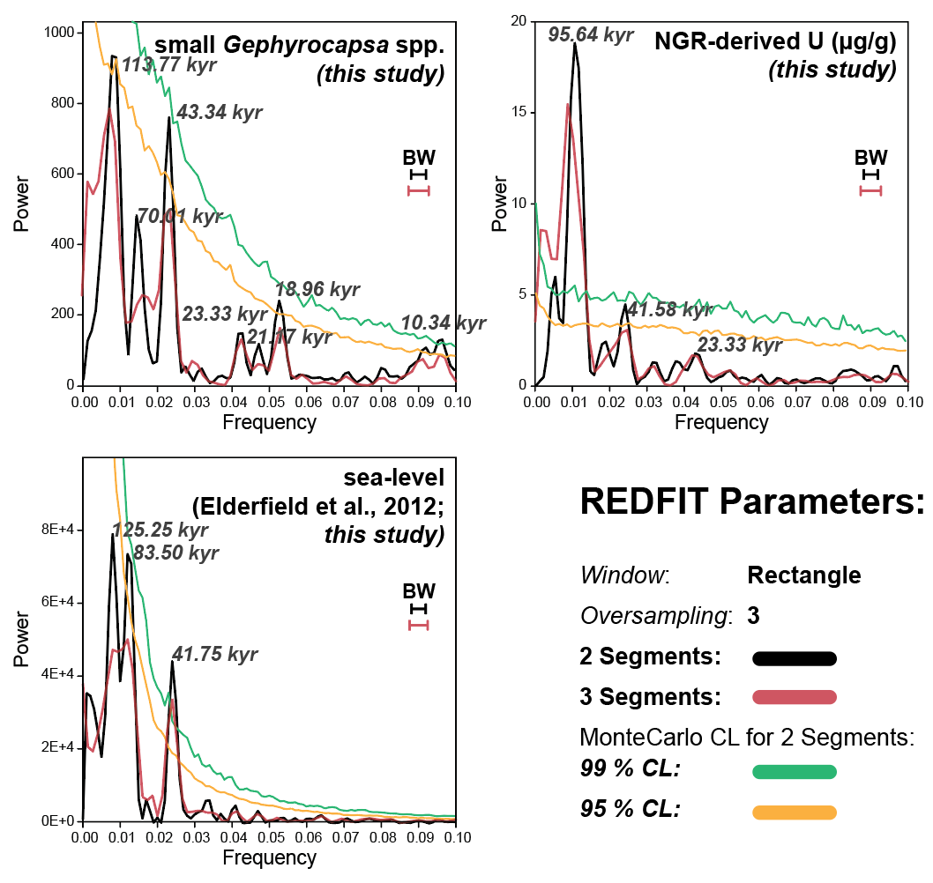
Supplementary Figure S1: REDFIT power spectra of the sea level data from Elderfield et al. (2012), natural gamma-ray derived U content (µg/g) as well as the relative abundance of small Gephyrocapsa spp. specimens in the calcareous nannofossil assemblage. REDFIT analysis was performed using a rectangle window, a standard oversampling setting of 3, for two runs with a segmentation of 2 (black line) and 3 (red line), respectively. All power spectra show the 99% (green) and 95% (orange) Monte Carlo analysis corrected confidence level (CL) for the analysis with two segments. Significant peaks in each spectrum are labeled in kyr as listed in table 1 in the main text. Bandwith is shown for both analyses in their respective colors (black = 2 segments; red = 3 segments).

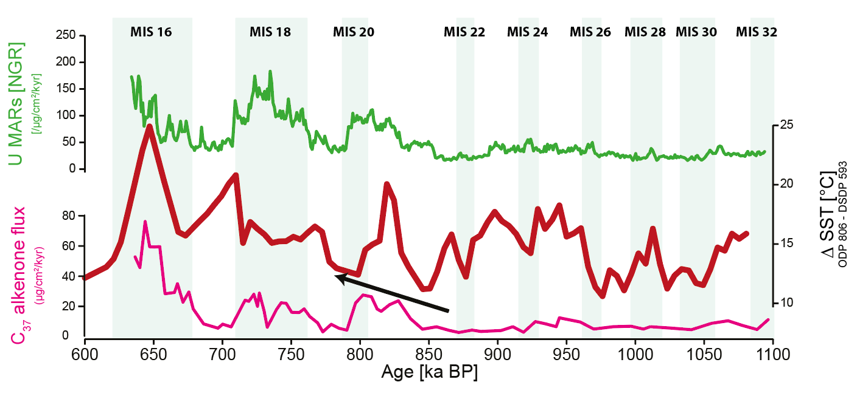
Supplementary Figure S2: Comparison of U1460 productivity records C₃₇ Alkenones (Petrick et al., 2019) and the natural gamma radiation derived U mass accumulation rates with the southern hemisphere sea surface temperature gradient (ΔT in °C) between Pacific tropical site ODP 806 (McClymont and Rosell-Mele, 2005) and sub-tropical Site DSDP 593 (McClymont et al., 2016). The ΔT between both sites was calculated after interpolating the age data of both sites to a 5kyr resolution.

