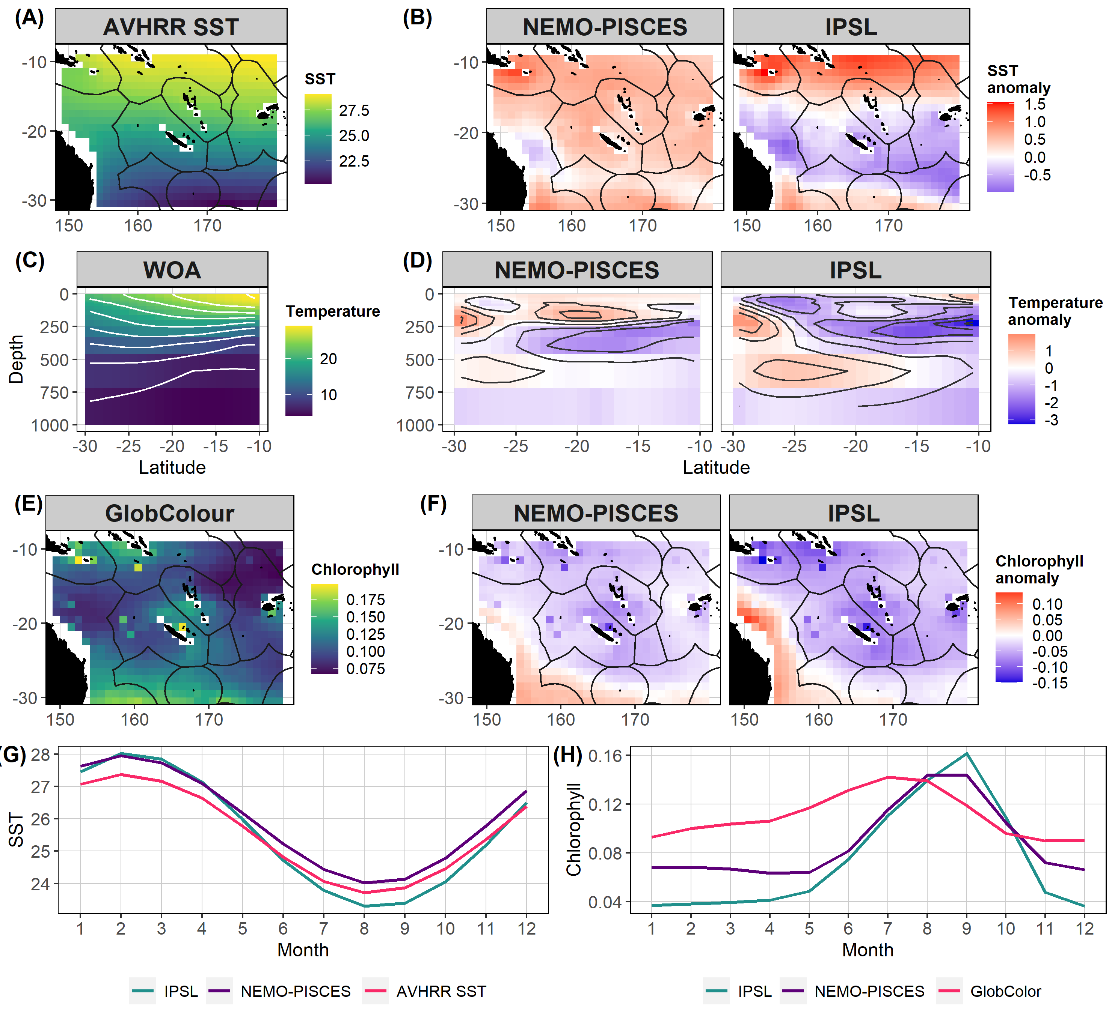
Figure S1: Observed SST (Sea Surface Temperature) (°C, AVHRR) (A); and SST anomalies between the NEMO-PISCES, and CMIP5 IPSL and the AVHRR SST (B) for the present 1979-2009 period. Vertical transect extracted at the longitude 170°E along latitudes for the observed WOA (World of Atlas) temperature (C) and vertical temperature anomalies between the NEMO-PISCES, and CMIP5 IPSL and the WOA temperature (D). Observed surface chlorophyll concentration (mgCHL/m³) from the GlobColour project (E); and chlorophyll anomalies between the NEMO-PISCES, and CMIP5 IPSL and the GlobColour chlorophyll (F). Seasonal cycles of SST (A) and of chlorophyll (B) for the different sources for the present 1979-2009 period (i.e., values averaged over the whole region by month).

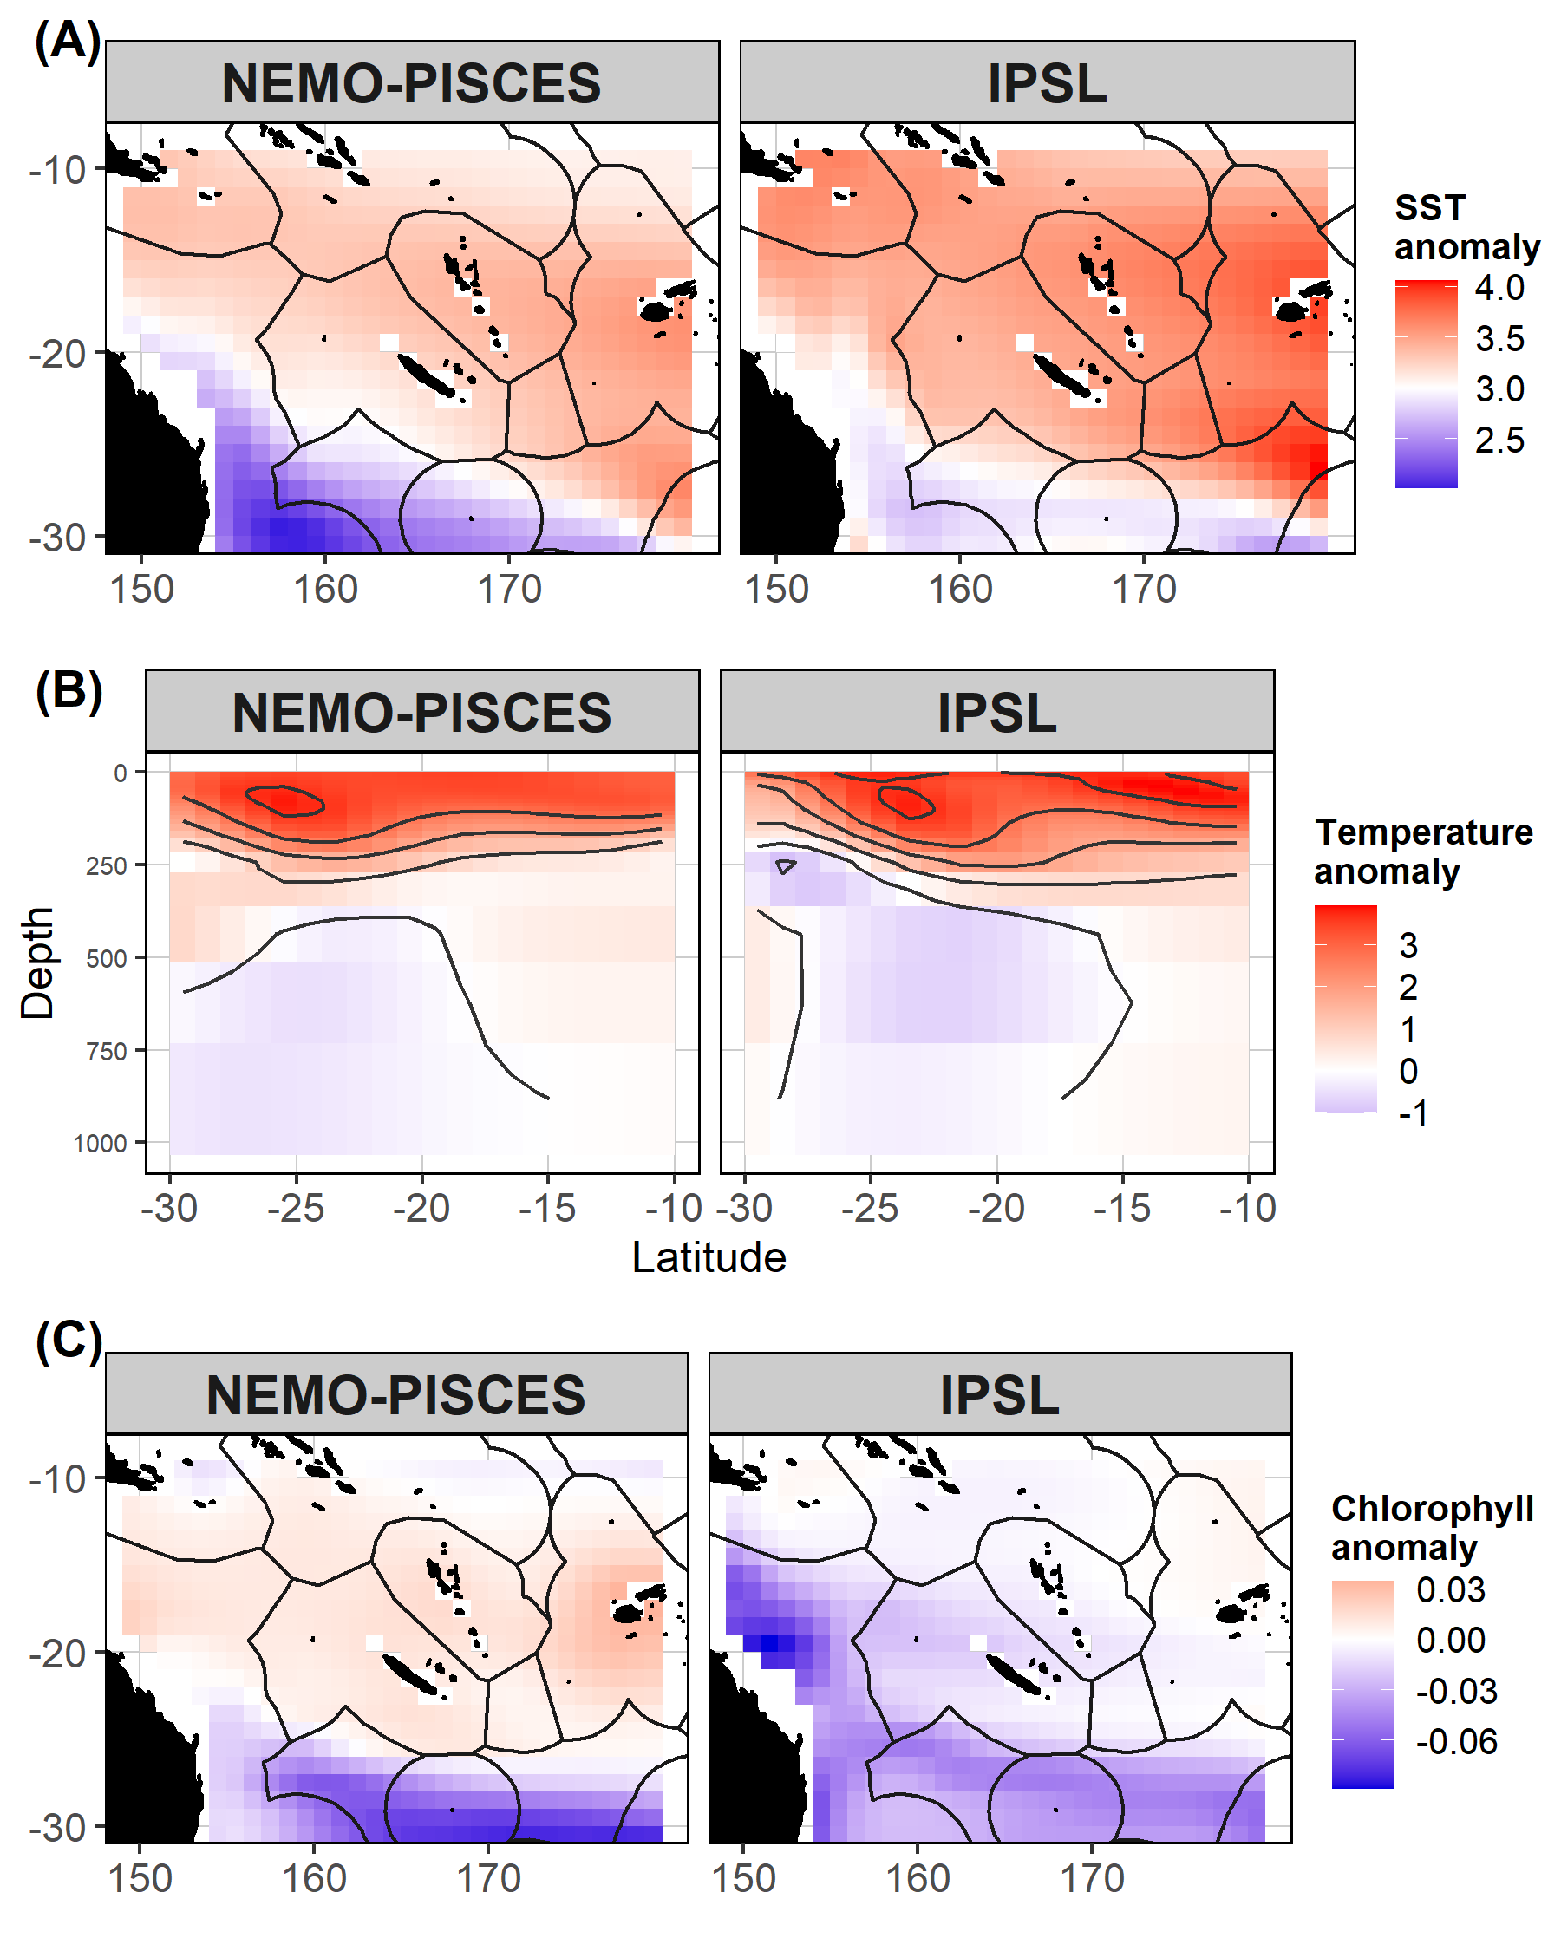
Figure S2: Anomalies (i.e., difference between the periods 2070–2100 and 1979–2009) for the NEMO-PISCES simulations used in the present study (left panels) and for the CMIP5 IPSL simulations (right panels) for the SST (°C, A; please note that the color-scale is centered on 3°C to highlight the patterns), the vertical temperature along the longitude 170°E (B); and the surface chlorophyll (mgCHL/m³, C).

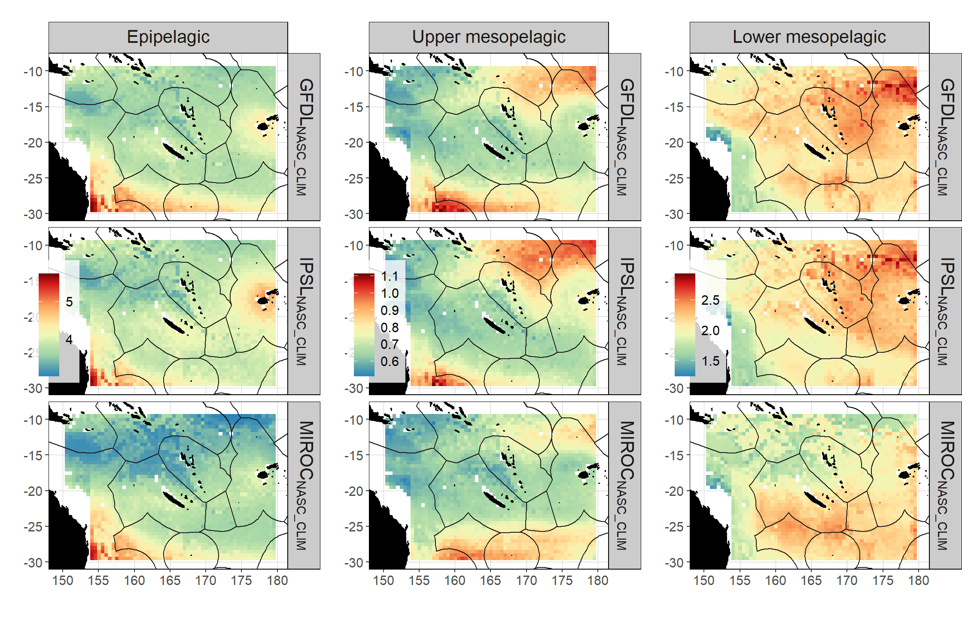
Figure S3: Future-day (2070–2100) micronekton biomass simulated by the acoustic model (m²nmi⁻²) by bias-mitigated forcing (rows) and by vertical layer (columns).

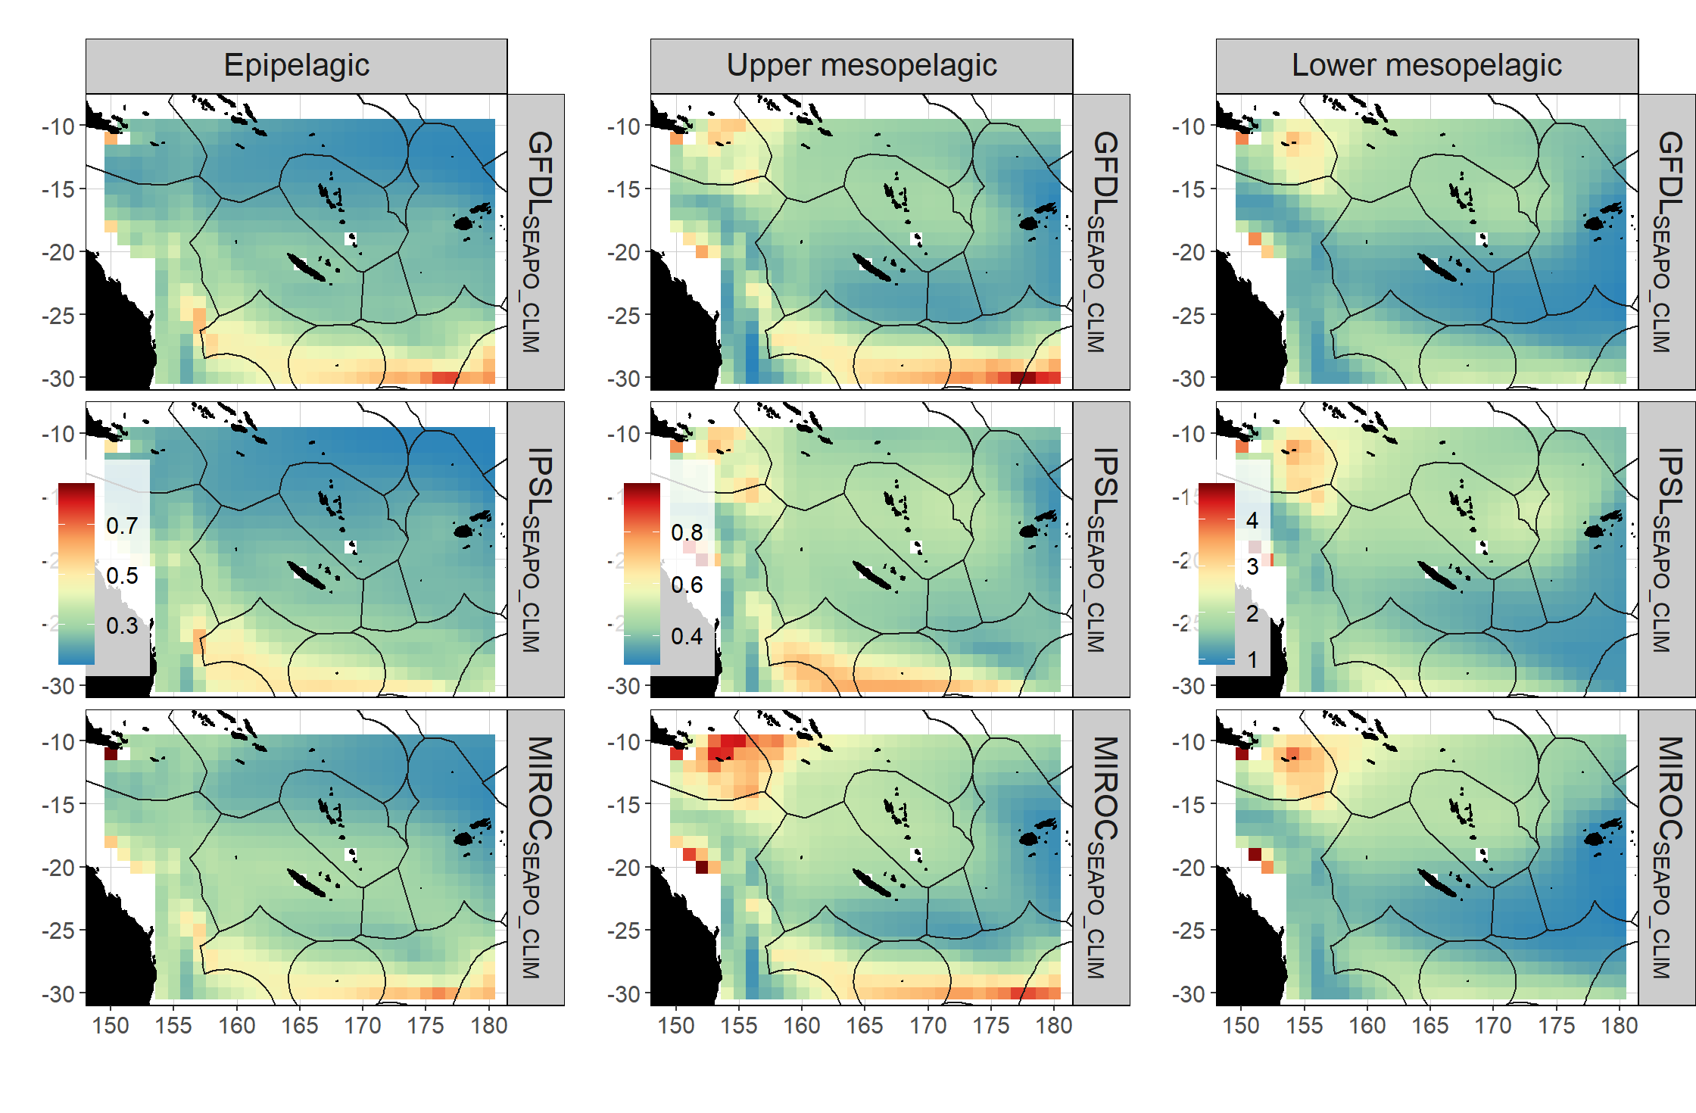
Figure S4: Future-day (2070–2100) micronekton biomass simulated by SEAPODYM model (g.m⁻²) by bias-mitigated forcing (rows) and by vertical layer (columns).
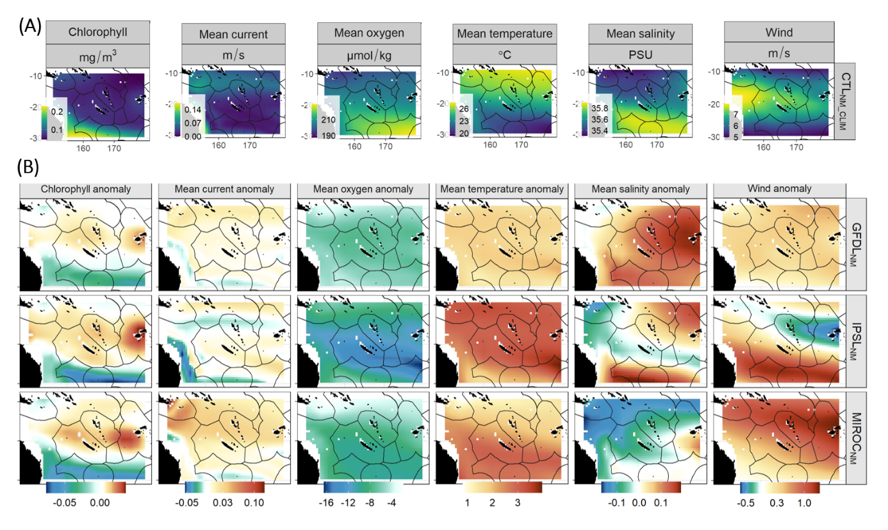
Figure S5: Surface chlorophyll, 0-600m mean oxygen, 0-600m mean temperature, 0-600m mean salinity and winds on average for the present-day climate (CTL_{NM_CLIM} 1979-2009) simulated by NEMO-PISCES (A) and projected anomaly for three different climate scenario between 2070–2100 and 1979–2009 (B) (see Section 2 for details).

