Supplementary data
Table S3: Taxa full names and eventual groups
Nb | Full name | Shortcut
1 | Actinocyclus | Actinocyclus
2 | Akashiwo sanguinea | A_sanguinea
3 | Alexandrium | Alexandrium
4 | Amphidinium | Amphidinium
5 | Amphidomataceae | Amphidomataceae
6 | Asterionella formosa | A_formosa
7 | Asterionellopsis glacialis | A_glacialis
8 | Bacillaria paxillifera | B_paxillifera
9 | Bacillariaceae | Bacillariaceae
10 | Bacillariophyceae | Bacillariophyceae
11 | Bacteriastrum | Bacteriastrum
12 | Bellerochea | Bellerochea
13 | Biddulphia | Biddulphia
14 | Brockmanniella brockmannii | B_brockmannii
15 | Cerataulina pelagica | C_pelagica
16 | Chaetoceros | Chaetoceros
17 | Chaetoceros diadema | C_diadema
18 | Chaetoceros didymus + protuberans | e-species(C_didymus)
19 | Chaetoceros socialis + socialis f. radians | Chaetoceros socialis + socialis f. radians
20 | Chrysophyceae | Chrysophyceae
21 | Ciliophora | Ciliophora
22 | Cochlodinium | Cochlodinium
23 | Corethron | Corethron
24 | Coscinodiscus + Stellarima | Coscinodiscus + Stellarima
25 | Cryptophyceae | Cryptophyceae
26 | Cylindrotheca closterium + Nitzschia longissima | C_closterium + N_longissima
27 | Dactyliosolen fragilissimus | D_fragilissimus
28 | Detonula | Detonula
29 | Dictyocha | Dictyocha
30 | Dinobryon | Dinobryon
31 | Dinophyceae | Dinophyceae
32 | Dinophysis | Dinophysis
33 | Diploneis | Diploneis
34 | Diplopsalis + Diplopelta + Diplopsalopsis + Preperidinium + Oblea | e-genus(Diplopsalis)
35 | Ditylum brightwellii | D_brightwellii
36 | Entomoneis | Entomoneis
37 | Eucampia zodiacus | E_zodiacus
38 | Euglenia | Euglenia
39 | Fragilariaceae | Fragilariaceae
40 | Gonyaulax | Gonyaulax
41 | Gonyaulax spinifera | G_spinifera
42 | Guinardia delicatula | G_delicatula
43 | Guinardia flaccida | G_flaccida
44 | Guinardia striata | G_striata
45 | Gymnodiniaceae | Gymnodiniaceae
46 | Gymnodiniales | Gymnodiniales
47 | Gymnodinium | Gymnodinium
48 | Gyrodinium | Gyrodinium
49 | Helicotheca | Helicotheca
50 | Heterocapsa | Heterocapsa
51 | Heterocapsa triquetra | H_triquetra
52 | Katodinium | Katodinium
53 | Lauderia + Detonula | e-genus(Lauderia)
54 | Lepidodinium chlorophorum | L_chlorophorum
55 | Leptocylindrus | Leptocylindrus
56 | Leptocylindrus, complexe danicus groupe des larges (danicus + curvatus + mediterraneus + aporus + convexus + hargravesii + adriaticus) | Leptocylindrus, complexe danicus
57 | Leptocylindrus, complexe minimus groupe des fines (L. minimus + Tenuicylindrus belgicus) | Leptocylindrus, cplx minimus
58 | Licmophora | Licmophora
59 | Lithodesmium | Lithodesmium
60 | Mediopyxis | Mediopyxis
61 | Melosira | Melosira
62 | Melosiraceae | Melosiraceae
63 | Mesodinium rubrum | M_rubrum
64 | Meuniera membranacea | M_membranacea
65 | Navicula + Fallacia + Haslea + Lyrella + Petroneis | e-genus(Navicula)
66 | Naviculaceae | Naviculaceae
67 | Noctiluca scintillans | N_scintillans
68 | Odontella | Odontella
69 | Odontella sinensis | O_sinensis
70 | Paralia sulcata | P_sulcata
71 | Phaeocystis | Phaeocystis
72 | Plagiogramma | Plagiogramma
73 | Plagiolemma | Plagiolemma
74 | Plagiolemma distortum | P_distortum
75 | Pleurosigma + Gyrosigma | Pleurosigma + Gyrosigma
76 | Polykrikos | Polykrikos
77 | Porosira | Porosira
78 | Proboscia | Proboscia
79 | Prorocentrum | Prorocentrum
80 | Prorocentrum balticum + cordatum | e-species(P_balticum)
81 | Prorocentrum gracile | P_gracile
82 | Prorocentrum micans + arcuatum + gibbosum + scutellum | e-species(P_micans)
83 | Prorocentrum triestinum | P_triestinum
84 | Protoperidinium + Peridinium | Protoperidinium + Peridinium
85 | Protoperidinium bipes | P_bipes
86 | Pseudo-nitzschia | Pseudo-nitzschia
87 | Pseudo-nitzschia, complexe americana (americana + brasiliana) | Pn, cplx americana
88 | Pseudo-nitzschia, complexe delicatissima, groupe des fines (calliantha + delicatissima + pseudodelicatissima + subcurvata) | Pn, cplx delicatissima
89 | Pseudo-nitzschia, complexe seriata, groupe des effilées (multiseries + pungens) | Pn, cplx seriata elong
90 | Pseudo-nitzschia, complexe seriata, groupe des larges (australis + fraudulenta + seriata + subpacifica) | Pn, cplx seriata large
91 | Pseudo-nitzschia, groupe des larges asymétriques (australis + seriata + subpacifica) | Pn, larges asym
92 | Pseudo-nitzschia, groupe des larges symétriques (fraudulenta) | Pn, larges sym
93 | Pseudo-nitzschia, groupe des sigmoïdes (multistriata) | Pn, sigm
94 | Pyrocystis | Pyrocystis
95 | Raphidophyceae | Raphidophyceae
96 | Rhaphoneis + Delphineis | Rhaphoneis + Delphineis
97 | Rhizosolenia imbricata + styliformis | e-species(R_imbricata)
98 | Rhizosolenia setigera + setigera f. pungens | e-species(R_setigera)
99 | Scenedesmus | Scenedesmus
100 | Scrippsiella | Scrippsiella
101 | Skeletonema | Skeletonema
102 | Striatella | Striatella
103 | Synedra + Toxarium | Synedra + Toxarium
104 | Thalassionema | Thalassionema
105 | Thalassiosira + Porosira | Thalassiosira + Porosira
106 | Thalassiosira gravida | T_ gravida
107 | Thalassiosira levanderi + minima | e-species(T_levanderi)
108 | Tiarina | Tiarina
109 | Torodinium | Torodinium
110 | Trigonium alternans | T_alternans

Table S4: The main taxa’s mean abundance (cells/ L) per season (all sites). The colours highlight gradient from high densities (red) to low densities (blue). The order given correspond to the frequency of appearance (but some taxa in between are not represented because of low mean seasonal abundance). The detailed nomenclature for each taxa is in Table S3.
Taxa | Spring | Summer | Autumn | Winter
Phaeocystis | 4 142 692 | 1 015 604 | 20 313 | 23 470
Chaetoceros socialis + socialis f. radians | 171 087 | 841 352 | 374 631 | 58 630
Pn, cplx delicatissima | 112 174 | 35 853 | 23 256 | 2 374
Chaetoceros | 103 023 | 558 904 | 61 240 | 5 064
A_glacialis | 75 742 | 168 751 | 9 641 | 8 415
D_fragilissimus | 74 959 | 48 593 | 2 686 | 532
Pn, larges asym | 73 932 | 76 175 | 660 | 1 398
Thalassiosira + Porosira | 70 227 | 8 401 | 2 584 | 8 210
e-species(T_levanderi) | 57 157 | 5 865 | 6 257 | 9 502
G_delicatula | 54 999 | 50 197 | 11 654 | 1 193
Plagiogramma | 50 268 | 4 147 | 3 846 | 4 389
Skeletonema | 49 114 | 202 301 | 27 938 | 42 702
Pn, cplx seriata large | 40 798 | 18 200 | 2 500 | 1 198
Cryptophyceae | 38 774 | 227 855 | 55 254 | 15 168
Pn, cplx seriata elong | 27 842 | 24 176 | 7 216 | 3 679
T_ gravida | 22 129 | 7 908 | 2 381 | 4 110
e-genus(Lauderia) | 18 484 | 2 750 | 3 050 | 1 802
e-species(R_imbricata) | 16 779 | 22 458 | 9 270 | 540
H_triquetra | 15 705 | 1 322 | 597 | 788
Leptocylindrus | 13 228 | 135 932 | 84 378 | 17 453
Leptocylindrus, cplx danicus | 12 877 | 105 590 | 14 955 | 150
Pn, larges sym | 10 147 | 7 681 | 425 | 3 278
B_brockmannii | 9 635 | 5 213 | 2 284 | 5 125
Rhaphoneis + Delphineis | 8 952 | 5 508 | 18 575 | 10 715
D_brightwellii | 8 561 | 4 785 | 693 | 817
e-species(R_setigera) | 5 620 | 5 243 | 563 | 254
E_zodiacus | 5 419 | 45 746 | 6 017 | 800
C_pelagica | 5 092 | 4 657 | 995 | 401
Odontella | 4 987 | 1 777 | 928 | 1 957
P_sulcata | 4 838 | 4 348 | 6 066 | 6 385
Leptocylindrus, cplx minimus | 3 646 | 119 882 | 28 928 | 1 310
C_closterium + N_longissima | 2 795 | 6 240 | 1 975 | 1 808
G_striata | 2 767 | 14 360 | 8 531 | 243
Gymnodinium | 2 348 | 9 816 | 1 906 | 1 048
Pn, cplx americana | 1 662 | 27 389 | 3 677 | 1 202
B_paxillifera | 1 484 | 717 | 725 | 1 428
Scrippsiella | 764 | 6 356 | 13 749 | 237
Heterocapsa | 603 | 6 429 | 694 | 1 362
Prorocentrum | 600 | 17 531 | 1 679 | 139
M_rubrum | 410 | 2 441 | 191 | 253
Pn, sigm | 300 | 7 806 | 22 753 | 592
e-species(P_micans) | 230 | 6 613 | 1 795 | 165
P_triestinum | 150 | 25 295 | 772 | 459
Dinophysis | 100 | 2 050 | 840 | 100
L_chlorophorum | <LD | 156 378 | 2 740 | <LD

Table S5 : CTA seasonal scores for the first and second axis for each site.
 | Axis 1 | Axis 2
Spring | 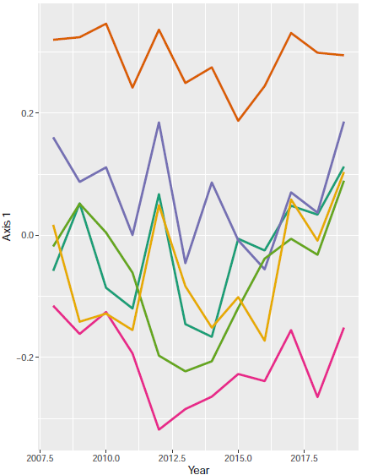 | 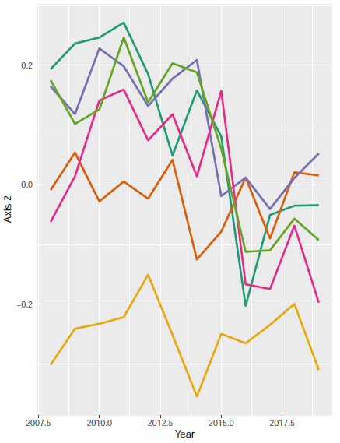
Summer | 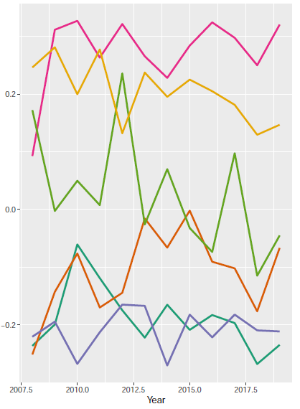 | 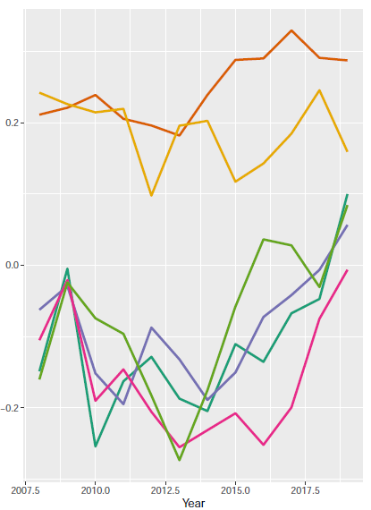
Autumn | 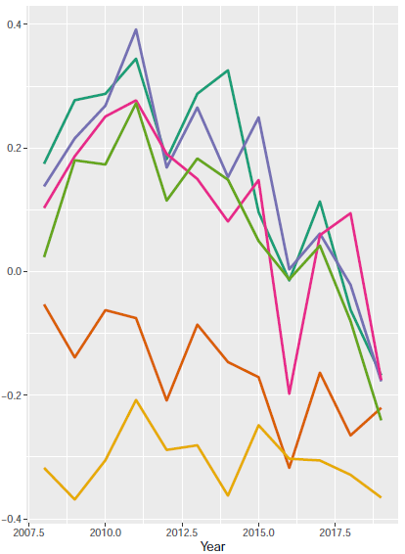 | 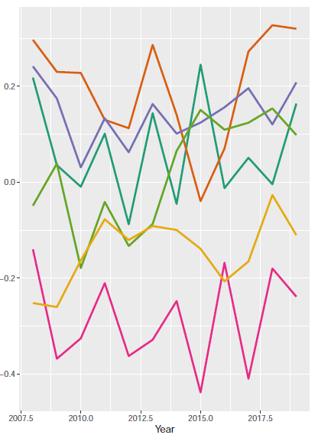
Winter | 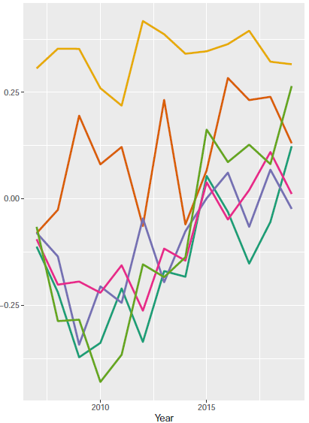 | 