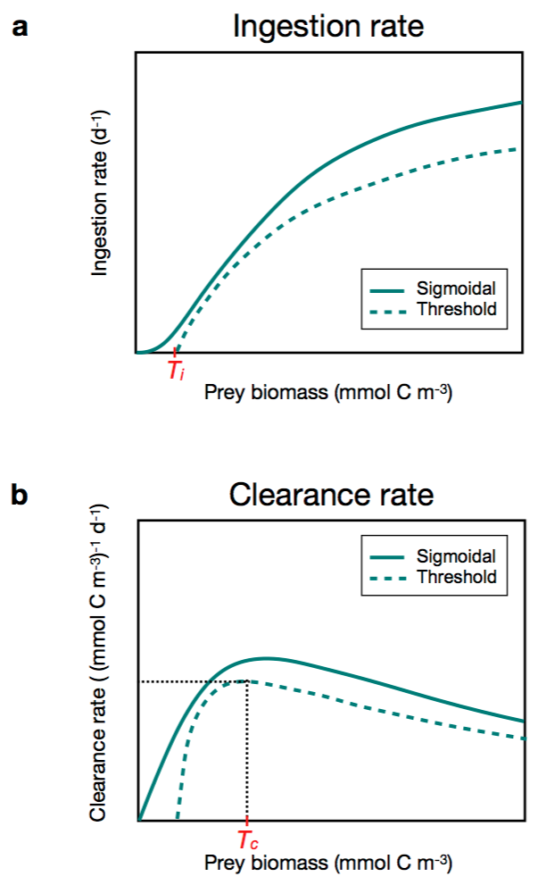
S1 Fig. Schematic representation of (a) ingestion rate and (b) clearance rate for a classic sigmoidal functional response (solid line) vs. a response considering a feeding threshold T_{i} and T_{c}, (for ingestion rate and for clearance rate, respectively) (dashed line).

