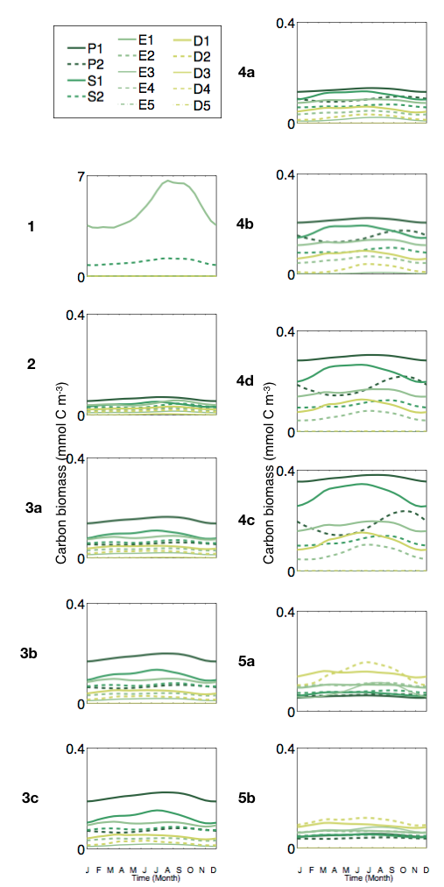
S2 Fig. Seasonal variation of detailed pfts accounting for emergent phytoplankton size classes (in mmol C m⁻ ³).

